An Evaluation of the DJI Fly 2 Mini and Matterport Pro2 as a Method of Assessing Beach Topography Change at the Site of Rhossili Bay, South Wales.
Milo Fleming
1902803
University of Wales Trinity Saint David
08/04/2023

Abstract
Recently, there has been a spate of interest in how to use new technology in coastal management. Thus, the studies surrounding new technology has a great importance to all key stakeholders involved in coastal management. The most popular technology there has been a recent interest in is that of Unmanned Aerial Vehicles (UAVs) and 3D technology. Previous studies have focused on gaining knowledge upon its benefits and creating a standardized methodology for the use of this new equipment within the assessing of the coastal zone however there is still a gap in knowledge surrounding best practice in using the technology. This study investigates and evaluates the suitability of a DJI Fly mini 2 (UAV) and a Matterport Pro2 as a method of assessing beach change. Data collection was conducted across a one-month study period at the site of Rhossili Bay, South Wales. The analysis of the results showed the potential of UAVs in measuring beach change whilst also proving that the use of a Matterport Pro2 is not advisable on an open sandy beach if a 3D model is to be obtained. It is concluded that moving forward UAVs that have real time kinematic positioning (RTK) and automated flight planning available to them, therefore becoming the standard requirements for UAVs that seek to assess beach change. It is decided that terrestrial laser scanning (TLS) should be used and not photogrammetry when creating a 3D model on an open sandy beach environment.
Declaration
I declare that the work presented for assessment in this dissertation is my own, that it has not formerly been presented for alternative assessment, and that my debts (for words, data, arguments and ideas) have been suitably recognized.
Acknowledgments
This study would like to acknowledge the kindness of Mike Jenkins to provide his Matterport pro2 device to be evaluated as a method of measuring beach change. Also, a mention goes to Rhys Poulton, Professor Alan Williams and Professor Matt Drummond for their knowledge and guidance surrounding Unmanned Aerial Vehicles. Also, to Chris House for his patience and understanding when guiding this project. A special mention to Kate Morgan for ensuring motivation was not lost.

Contents
List of Table and Figures 4
List of Abbreviations 4
Introduction 4
1.1 5
1.2 8
1.3 9
Literature Review 9
2.1 Critique of existing methods of rapidly assessing beach change 10
2.2 The current use of UAVs in Society 10
2.3 Coastal UAVs 12
2.4 Review of beach height measurement tools in coastal management 14
2.5 Previous UAV studies in coastal management practices. 19
2.6 Challenges in using UAVs in coastal zone management 23
2.7 3D DEMs on beaches 24
Methodology 27
3.1 Introduction 27
3.2 Research method 28
3.3 Data collection methods 29
3.4 Sampling 30
3.5 Access and consent 30
3.6 Equipment and software 31
3.7 Pilot study 32
3.7 Unmanned Aerial Vehicle Data Collection Step by Step 32
3.8 Matterport 3D Scanning Data Collection Step by Step 36
3.9 Research method limitations 38
Results 38
4.1 39
4.2 DJI Fly 2 mini-UAV Results 39
4.3 Matterport Pro2 3D Scanning Results 45
4.4 Limitations of Research Project 46
Discussion 48
References 60
Appendices 83

List of Table and Figures
Table 1: Summary of literature review 26

Figure 1:DJI Fly 2 Mini UAV (DJI, 2021). 30
Figure 2: Matterport Pro2 3D scanning device (Matterport, 2021). 31
Figure 3: Maps highlighting area of study 33
Figure 4: First day of data collection, from 50m. 39
Figure 5: Last day of data collection, from 50m. 40
Figure 6: A graph showing UAV flight capabilities. 42
Figure 7: 3D scanning device in use at site. 45
Figure 8: Mike Jenkins operating the Matterport 3D pro 2 device. 45
Figure 9: Flow chart to outline the most important steps to ensure accurate UAV data collection. 55
Figure 10: Flow chart to outline the critical planning steps when creating methodology that uses TLS as a method of measuring beach change. 56

List of Abbreviations
UAV | Unmanned Aerial Vehicle
TLS | Terrestrial Laser Scanner
RTK | Real Time Kinematic Positioning
DEM | Digital Elevation Model
GCP | Ground Control Point

Introduction
In recent times, there has been a rise in interest regarding new technologies within coastal management planning and monitoring with researchers becoming increasingly attracted to the use of Unmanned Aerial Vehicles (UAVs) and 3D photogrammetry laser scanning within planning and monitoring practices. The possibility and likely probability that these technologies could drastically better the field of coastal management has generated a rush to gain more knowledge upon how they could be used by researchers in the field to better past practices of data collection. The complexity of the various ways in which new technologies could be implemented within coastal management research raises questions of considerable interest to researchers. This report seeks specifically to better understand and evaluate how the use of a DJI Fly 2 mini-UAV and Matterport Pro2 could be used to aid coastal research.

1.1
Knowledge of how best to use new technologies within the topic has great importance to coastal researchers as coastal zones are typically very dynamic areas which are influenced rapidly by various environmental forcing agents (Komar, 1998, Woodroffe, 2002, Selvavinayagam, 2008 and Pranzini and Williams, 2013). With findings newly confirming that by 2100, we can be expecting average sea level to increase by 1m (Church et al.,2013 and Nicholls et al., 2014). The rapid, straightforward assessment of the mean high-water line has never been more important (Hoggart, Buller and Black, 2014). In Wales and England, 30% of the inhabitants reside in property within 10km of the beach with £120 billion worth of infrastructure and resources in threat of coastal flooding along with an additional £10 billion in danger of erosion from the sea (de la Vega-Leinert & Nicholls, 2008). Given the continued increasing population of coastal societies and remarkably great cost of assets at the coast, if best available practice is not applied in evaluating the effects of climate change the damages can be shocking (Hoggart, Buller and Black, 2014). The calculation of the changes of taking place at the coast and the connected shoreline research such as beach height measurement are important to the development of suitable management methods (Anfuso, Pranzini and Vitale, 2011) Thus, how to ever improve management and monitoring techniques of these areas has become an important component of recent research surrounding coastal management. It has been suggested that the use of UAV’s may be simple to use, cost effective and not require too much time (Small and Nicholls, 2003). With the initial realization of the potential of photogrammetry in the Earth sciences (James and Robson, 2012, Westoby et al., 2012 and Fonstad et al., 2013) that there has been a dramatic rise in the number of recent publications that use this method. This study will further contribute to this bank of knowledge. This may solve the classic problem in coastal research of what the most efficient way is to gather data upon a coastal area. Could it be that it is by replacing old practices and their problems with this new technology?
In recent years there has been a clamour to discover how the fast-developing new world of UAV’s may help alleviate some of the previous problems with past techniques. Unmanned Aerial Vehicles (UAV’s) have rose to prominence in recent years with its use in various areas of geoscience in order to gather topographic data aiding gully erosion (Marzolff and Poesen, 2009), rocky cliff erosion (Mancini et al., 2017), tidal inlet evolution (Long et al., 2019), beach dune system evolution (Mancini et al, 2013, Goncalves and Henriques, 2015, Brunier et al., 2016, Turner, Harley and Drummond, 2016 and Guisado-Pintado, Jackson and Rogers, 2019). UAVs in these studies have been noted to be easy to deploy as well as being a comparatively cheap way to gather data at a local scale. This has led to their increased use within ecological research and management over the last decade (Anderson and Gatson, 2013)
There is now beginning to be a fast-moving switch towards UAV’s and new technology such as 3D photogrammetry within the field of coastal research with drones and 3D technology now being widely known to have the potential to provide a low risk, low cost fast method of monitoring coastal zones (Goncalves and Henriques, 2015 and Cook, 2017). Despite this, it is accepted that UAV and 3D application is still relatively novel, specifically in coastal systems (Hugenholtz et al., 2012, Whitehead and Hugenholtz, 2014 and Vincent, Weden and Ditmer, 2014). So far, as mentioned applications involve topographical and geomorphological mapping (Delacourt et al., 2009, Hugenholtz et al., 2013 and Turner, Harley and Drummond, 2016) and erosion discovery and coastal hazard detection (Chong, 2007 and Pereira et al., 2009). UAV’s can gather ariel observations at user decided frequencies (daily, monthly) and are relatively inexpensive which has led too drone surveys being used at a higher frequency in recent years (Mancini et al., 2013, Casella et al., 2016, Turner, Harley and Drummond, 2016 and Duffy et al., 2017). Regardless of the notable improvement made in recent years, it is not regarded as a new development as it originated out of the evolution of technologies being experimented with during the 20th century (Colomina and Molina, 2014).
There is also a race to understand techniques that generate 3D data of the landscape it studies. One of the ways of doing this is using photogrammetry to digitally generate 3D models. This is the new generation of field techniques for understanding coastal environments geomorphometry. The manipulation and challenges surrounding this technique are still novel. The Matterport pro 2 model this research paper evaluates uses a combination of photogrammetry and LiDAR (Light detection and ranging) technology to generate highly accurate 3D models of spaces. Previous studies using this technique in the field of coastal research have been reviewed by French and Bunningham (2011). For example, coastal cliffs have been studied by Westoby et al., (2012) while coastal boulders using this technology have been studied by Gienko and Terry (2014). It is noted in these studies and other papers how the texture of surfaces, particularly in low texture or flat research site environments make 3D image construction very difficult (Mancini et al., 2013 and Eltner et al., 2015). It is an aim of this paper to see if the Matterport pro 2 3D device may be used following consultations with experts in the field to successfully create a methodology that can gather results on an open sandy beach. This equipment has not been extensively studied and so any new research surrounding the topic is of importance to coastal researchers.
Despite the move towards UAVs and 3D scanning within coastal research there still lies a research gap in a standardized methodology outlining how Unmanned ariel vehicles and 3D scanning equipment could be used in coastal zone management. Coastal zone management has become a recognized structure in balancing the need for development against the need to protect natural resources in these coastal zones. Coastal zone management is imperative for generating and implementing the data needed to manage and monitor conservation areas. The ever-increasing threat of climate change coupled with anthropogenic activities has led coastal researchers to develop and then use new and improved tools to manage and monitor the coastal zone.

1.2
In this paper we aim to contribute to the existing research surrounding the use of Unmanned Aerial Vehicles (UAV’s) and 3D photogrammetric equipment by evaluating two pieces of equipment (DJI Fly 2 mini and Matterport pro2) performance during data collection. First the research projects aims and objectives will be outlined before a literature review will be conducted looking at all previous knowledge surrounding the use and potential of UAVs in coastal management. Past beach height methods will be touched upon before a table presents the main findings of the review and how it will inform this research. Then the creation of a methodology agreed by Professor Alan Williams, an expert in coastal Geomorphology will be explained, showing how and why this projects data collection was undertaken. The results of this methodology will then be presented, with observation analysis conducted on the photogrammetry data provided by the UAV. Following both positive and negative findings of this study combined with a resulting interview with Professor Matt Drummond a set of instructions that will help advise other coastal researchers of the best ways in which to use 3D scanning and UAV techniques as a method of assessing beach change. A comprehensive conclusion of the study’s findings and recommendations for the future will then conclude this report.

1.3

Project aim
To evaluate the use of UAV and 3D scanning technology as a method of assessing beach change at the site of Rhossili Bay, Gower
Project objectives
- To compare the results collected from a UAV with Matterport pro2 3D scanning device as a method of measuring beach change.
- Critically analyse the merits of using drones as a method to measure beach change.
- To propose a set of instructions to advise coastal zone managers on the effective use of UAVs and 3D scanning equipment in coastal management practices.

Literature Review

Unmanned Aerial Vehicles (UAVs) have become increasingly popular tools for coastal research and management due to their versatility, efficiency and cost effectiveness. Coastal UAVs have been used in a wide range of applications, including coastal erosion monitoring, beach profiling, marine wildlife surveys, oceanographic data collection and pollution monitoring. In recent years, the use of coastal UAVs has expanded rapidly, and researchers have been exploring new ways to enhance their capabilities and improve their effectiveness. This literature review aims to provide an overview of the current state of research on coastal UAVs, highlighting their applications, limitations and future directions. By synthesizing existing literature, this review will identify gaps in current knowledge that may be built upon with the findings of this paper in order to aid and advance the use of coastal UAVs in management and conservation. The review will first look at the current uses of UAV technology in society before delving deeper into their use in a coastal management sense where previous studies are looked at with their advantages and disadvantages noted. Then a brief outline and review of previous methods of beach height measurement will follow. Then, a look into 3D technology and its use on the coastal zone will follow. The literature review will be conducted following extensive reading around the chosen topic in order to better understand the use of technology in coastal monitoring as well as understanding how the new UAV methods may improve past practices.

2.1 The current use of UAVs in Society

In the last decade there has been a demand for adaptable cost-effective hands-on initiatives in society as technology advances. UAVs have been one area of specific interest and growth in both the scientific and civilian world allowing for a new era of remote sensing and study of the environment to begin (Valavanis and Kontitsis, 2007). According to Valavanis and Kontitsis (2007), UAVs first appeared in the first world war where they were used in a military sense. Although, he also noted that humans first started the birth of UAVs around 2500 years previous, whereby we started imitating birds in creating objects that could fly, in this sense, the beginnings of UAVs may be linked to the field of aeronautics. The technological design of UAV’s has no doubt drastically changed if we look at the drones of today against those used throughout history. At present, there are many different types of UAV that vary depending on which assignment it may be used for. Overall, UAVs have the ability to attain aerial photos and videos with ease, which can then be used for analysis in multiple fields using varying techniques.
UAVs are also becoming highly useful for the general population of today. They can be used for everyday tasks in order to manage, collect, map and analyse information they are able to gather. They have been studied in numerous fields of knowledge, with Geospace being one of the most prominent. Authors have also found that UAVs are a beneficial device in data collection within forestry, civil engineering, geophysics, geology, geomorphology, geography, urban studies, architecture, agriculture and photogrammetry (Eisenbeiss and Sauerbier, 2011, Colomina and Molina, 2014, Cigna 2018, Garg et al., 2018 and Niedzielski et al., 2018).
UAVs are classified by Dalamagkidis (2015) as an unmanned aircraft which is supported by a remote-control system. There are also other terms such as UAS (Unmanned aerial system), RPV (Remotely Piloted Vehicle, drones or RPAS (Remotely Piloted Aircraft System). UAV is largely used photogrammetry, computational science, robotics and AI (Artificial intelligence).
The limitations and advantages of UAV’s have been studied by several different authors with some advantages noted that UAVs may be used in a high-risk situation in a very remote area (Boccali et al., 2017 and Nikolakopoulos et al., 2018). Also, that they are cheaper and have fewer operating fees than a manned aircraft (Akcay, 2015, Barlow, Gilham and Cofra, 2017 and Afif et al., 2019), as well as this they can collect data rapidly (Ahmad et al., 2013 and Barrile, Bilotta and Nunnari, 2017). Some limitations have been stated as the fact that it may be difficult to use some models in harsh weather conditions (Chou et al., 2010, Koshitzki et al., 2017, Ardi et al., 2018 and Fiorucci et al., 2018). Lazar, Beguz and Vulic (2018) and Ghorbanzadeh et al., (2019) also reported that cheap UAVs may experience problems with their sensors in comparison to high end models. This is also the problem with the engines of cheaper models, which have a limited rechargeable altitude compared to the high-end models (Danzi et al., 2013 and Sun et al., 2019).

2.2 Coastal UAVs
Unmanned aerial vehicles (UAVs) are being used more and more for cost effective environmental monitoring in order to gather data that is useful in coastal management practices (Ouellette and Getinet, 2016). As previously stated, enhancements in both the accessibility and affordability of Unmanned Aerial Vehicles have led to the growth in different types of applications that can enhance coastal management fields, these include the monitoring of wildlife (Kelaher et al., 2019), fisheries compliance (Bloom et al., 2019), marine habitat mapping (Joyce et al., 2018), topographic mapping (Goncalves and Henriques, 2015), assessing storm damage (Turner, Harley and Drummond, 2016), modelling wave run up (Casella et al., 2014) as well as erosion (Clark, 2017). As the benefits and capabilities undoubtedly increase together with the efficiency of cost, UAV application in coastal management will continue to grow at a rapid rate.
Small UAVs (less than 7kg) such as the one used in this report, are compact and affordable making them perfect for monitoring with little disturbance to both wildlife as well as people (Linchant et al., 2015). Christiansen et al., (2016a) further backed this up by noting how the sound made by a small UAV cannot be heard below the water. As a result, UAVs have been widely used in the monitoring of coastal wildlife, for example whales (Aniceto et al., 2018), dugongs (Hodgson, Kelly and Peel, 2013), rays and sharks (Kiszka et al., 2016, Raoult and Gaston, 2018 and Colefax et al., 2019), dolphins and manatees (Ramos et al., 2018), numerous wetland species (Han, Yoo and Kwon, 2017), sea turtles and crocodiles (Bevan et al., 2018) and coastal birds such as penguins (Goebel et al., 2015). In addition to this, UAV studies have also been seen to focus on gathering data upon entire populations of species of bigger marine fauna on sandy beaches, this has allowed for marine populations to be compared both temporally and spatially (Kelaher et al., 2019). Another area of coastal monitoring which uses drones is the ground-breaking biological recording of marine sea life, an example of this is the collection of sampling from whale blow, the benefit of drones being the research boats can be kept at safe distances without being invasive to the wildlife (Pirotta et al., 2017 and Geoghegan et al., 2018).
Unmanned aerial vehicles also have the potential too survey and monitor marine protected areas and fisheries in a cheap and discreet manner (Jimenez Lopez and Mulero-Pazmany, 2019 and Nyman, 2019). The UAVs used here may also be used to better protect against illegal fishing and the resultant impacts (Toonen and Bush, 2018). Bloom et al., (2019) also successfully tested trying to detect the use of fishing gear which is illegal and that which is abandoned. Unmanned aerial vehicles also have previously positively aided the stock assessments of fisheries, by enabling a quick, effective way of biomass estimates for jelly fish (Raoult and Gaston, 2018) as well as measuring the quantity of salmon nests at the time which they spawn (Groves et al., 2016).
The usage of coastal areas can also be monitored using unmanned aerial vehicles (UAVs). Management strategies use human data to better inform decisions made when trying to ensure sustainability of the over exploited coastal zone in an economic and ecological sense (King and McGregor, 2012). It is important UAV data such as this is gathered as beaches are vital assets for coastal areas and act as honeypots in attracting tourists on a yearly basis. These people often partake in activities such as fishing, surfing and swimming. This recreational use of the coastal environment can cause the degradation of the coastal zone if not properly managed which then in turn reduces the areas ecological, economic and recreational value (Lucrezi and Van Der Walt, 2016). For this reason beach management through the use of UAVs and 3D technology has been noted to be imperative in order to stop unsustainable levels of use, this aids dune protection, access problems, run off control, revegetation strategies and water quality monitoring (Chen and Teng 2016, Papakonstantinou, Topouzelis and Pavlogeorgatos, 2016). UAVs signify a highly helpful step towards an improved assessment of recreational beach use which undoubtedly aids coastal management decisions. Previously manual counting has been undertaken by researchers (King and McGregor, 2012) as well as other methods such as manned aerial surveys (Blackweir and Beckley, 2004) and community surveys (Dwight et al., 2007).

2.3 Review of beach height measurement tools in coastal management

In this section techniques of assessing beach heigh measurement are outlined and reviewed. These include ground survey along transects, LiDAR, the satellite-based waterline method, stereophotogrammetry from satellites and aircrafts, bathymetry measurement by SAR imaging of wave current interaction and SAR (Synthetic Aperture Radar) interferometry from both satellites and aircraft. A brief description of each method is followed by potential advantages and disadvantages of the technique.
Ground surveys are typically made up of measurements taken at even distances down the beach. It uses conventional survey methods using total stations and theodolites. In order to gain a longitudinal point of view when looking at the beach, shore-parallel transects may be used. The profiles used often reach past the average high-water mark and into the space in which storms may affect. A further detailed review of the various parts of beach transect assessment can be found in (Gorman, Morang and Larson, 1998). There are numerous advantages to the use of ground surveys with some being the high accuracy of the surveys, easy repeatability is possible and the entire beach and near shore area can be monitored fairly simply. It is also possible to record other data during the survey such as the type of beach material found. Some of the drawbacks of this method are that it is a labour-intensive technique with often two or more people required also large areas can be surveyed easily on a regular basis due to logistical problems and this method only allows for a 1D view making it hard to map spatial data.
The next method investigated is that of Airborne stereophotogrammetry whereby aircraft is used to cover a larger area in a relatively short amount of time. It uses stereoscopic imaging from two different views of a 3D item by obtaining overlapping pictures from two different aircraft positions. Airborne photography which is built upon by photogrammetric interpretation of stereo-pairs to create a digital elevation model (DEM), this can then give results at numerous different scales dependent on what the application is required for (Neill 1994). Balson et al., (1996) has given an example of where airborne stereophotogrammetry produces a DEM of a narrow beach. The advantages of this method are that spatial data can be mapped and large areas can be recorded at a high accuracy. Some of the disadvantages of this method are that only in good weather can data be gathered; it can be problematic to gain a reference point on flat areas (such as open sandy beaches) and it can be very costly. In order to find a way around the problem associated with this technique in recording flat open areas Holland and Holman (1997) put forward an alternative variant of this method which instead uses trinocular stereophotogrammetry to retrieve foreshore topographic data from a group of overlapping videos, this allows the equipment to discover the location of the shoreline and overcome the problem of not having features to focus on in open sandy beaches. This can gather beach height data at a relatively low cost.
LiDAR (Airborne scanning laser altimetry) facilitates rapid and accurate mapping of elevation measurements (Flood and Gutelius, 1997 and Gutelius, 1998). LiDAR operates by gauging the time and direction of laser pulses sent from the aircraft towards the ground and then back up, it then uses kinematic GPS to assess the location of the aircraft before measuring its heading, pitch and roll values using the navigation system located internally. Following this, a dense map of heights is gathered by laser scanning and sampling different heights every couple of meters. The area which the laser concentrates on can be measured to a planimetric accuracy of ca. 1m and a vertical height accuracy of ca.15cm on flat open sandy beaches (Huising and Pereira, 1998). The main benefits of using this method are that it is very accurate, spatial data can be recorded, areas with a high coverage can be mapped with ease and it is rapid in production of the results. Some of the drawbacks of this method are that there can be no cloud present below the LiDAR scanning, and it can be costly in comparison with other techniques such as UAVs.
Airborne interferometry uses two SAR antennae which are both located on the same aircraft and simultaneously capture data, therefore mitigating some of the problems associated with the satellite-based technique. Adams et al., (1996) and Madsen, Martin and Zebker (1995) discovered that this technique when mounted on a jet aircraft enables the monitoring of a full tidal range in bad weather possible in a short amount of time. This technique also has a high accuracy, spatial data can be gathered and various data apart from just height can be recorded. This technique does not however allow the near shore zone to be recorded and planimetric and vertical accuracy are fairly low.
The next technique that can be used for beach topography mapping is the Waterline method which uses the sea as an altimeter and only functions within the intertidal zone (Collins and Madge, 1981, Mason et al., 1995, Koopmans and Wang, 1995 and Ramsey, 1995). The waterlines position is calculated using an image processing method once a remote sensing image has been captured. The average sea level measurements are superimposed on the water line by combining surge water elevations and the total tide of that area. By using this data, a set of heightened waterlines can be calculated, and a raster DEM is able to be added. This method allows an intertidal DEM to be created of a big area, it is suitable for flat, wide beaches and allows spatial data to be mapped. This method can also unlike some of the others be used in all weather conditions and can be used for beaches which aircraft cannot reach. It however only allows the intertidal are to be covered and has an inaccurate planimetric accuracy.
Another method which has historically been used for beach topography mapping is satellite interferometry. It works by collecting two SAR images which are captured with a short time frame between and a slightly different antenna location during acquisition (Massonnet, 1997 and Henderson and Lewis, 1998). This data may be analysed in order to gather information upon the height. Research using this method has shown that it may be difficult to gather data on open sandy beaches as sand changes in colour as it dries in the time between the two images meaning coherence is lost (Mason et al., 1995). This method however does allow changes to be monitored accurately with a large area able to be recorded and spatially mapped. The disadvantages of this method are that as stated gathering data over sand may be problematic and there is a low planimetric and vertical accuracy.
Optical satellite data may also be used in order to create a DEM from SPOT or Landsat data by understanding stereopairs (Tateishi and Akutsu, 1992) or using the waterline technique previously mentioned (Koopmans and Wang, 1995). Using this method, it can be difficult to gather data on the entire tidal range due to orbit times, whilst cloud cover can affect the collection of data and low planimetric and vertical accuracy can also be present. It does allow a large area to be recorded and data apart from just height can be gathered.
From the methods discussed, Airborne stereo comes across as the best technique because it is highly accurate and can cover large areas, this is also the case with airborne LiDAR which is seen to be useful because of its rapid assessment. Ground survey is noted to be productive, however accuracy can be lower than the previous two methods mentioned. Despite these historic methods having their advantages as well as disadvantages, they are still costly in comparison to UAVs and will take more time to collect data. The remote sensing methods mentioned can be accurate and reliable when compared to the conventional field studies such as ground survey which may be laborious and costly (Mumby et al., 1999). Various studies have also used Landsat and Satellite imagery mentioned to asses variations within coastal zones (Vanhellemont and Ruddick, 2014, Diaz-Delgado, Cazacu and Adamescu, 2018, Schulz-Stellenfleth & Staneva, 2019 and Yang et al., 2019). The potential of UAV and novel 3D scanning devices to improve the practice of beach topographic mapping is endless with this study attempting to prove how they can match some of the advantages of these methods whilst also eliminating the disadvantages. This is partly down to the fast-developing world of computer applications allowing data to be processed rapidly with a high spatial resolution accuracy. This has been proven in the studies of coastal change and coastal processes by (Chabot et al., 2018, Chen et al., 2018, Collin et al., 2018 and Jaud et al., 2019).
Previously, satellite-based remote sensing images have been widely used in the reports upon environmental dynamics for the monitoring and mapping of land use changes (Yang and Lo, 2002, Muller and Zeller, 2002 and Cardille and Foley, 2003), riparian and forest ecosystem (Johansen and Phinn, 2006 and Johansen et al., 2007), oil spill events (Brekke and Solberg, 2005) and animal behaviour (Fiedler and Bernard, 1987 and Coyne and Godley, 2005). However, the remote sensing imagery often has a very high spatial resolution within its data and therefore can be very costly which means it is not easily available to the wider scientific society because of financial limitations. This study aims to see if a cost effective UAV may be useful as a method of assessing beach change in comparison with studies mentioned above and the Matterport pro2.

2.4 Previous UAV studies in coastal management practices.

Drones or UAVs have been used increasingly in coastal zone management with unmanned aerial vehicles being enhanced in areas such as software, navigation systems, video sensors and photographic capabilities (Klemas, 2015). The cheaper UAVs can have go pros attached as well as hyperspectral and thermal sensors. As mentioned above UAVs can often be cheaper and more efficient in speed of collecting data, this is seen in the studies of (Casella et al., 2016, Barlow, Gilham and Cofra, 2017, Appeaning Addo et al., 2018, Chen et al., 2018, and Jaud et al., 2019). As well as this, they have been complimented for their ability to map large areas at a low cost, some of the potential drawbacks of other techniques reviewed (Casella et al., 2016, Sturdivant et al., 2017, Chabot et al., 2018 and Chen et al., 2018).
Unmanned aerial vehicles (UAVs) can help mitigate some of the negatives associated with other methods of coastal monitoring. Next, a few studies in which UAVs are used are reviewed with their benefits outlined. A DJI phantom 2, the same one as was used in this study, was used in French Polynesia to explore shark and ray densities (Kiszka et al., 2016). This report showed that over a short amount of time, unmanned aerial vehicles could be used to assess marine fauna densities within coastal lagoons, with the use of the DJI Phantom 2 proving to be a success. Cao et al., (2018) also proved the effectiveness of unmanned aerial vehicles in classifying mangrove vegetation. Previously using other methods of remote sensing techniques this has been seen to be difficult, this is now possible using the hyperspectral images provided by UAVs combined with image processing methods recently developed. Multispectral images provided by unmanned aerial vehicles have also been assessed in the monitoring of the ecology of wetlands over a long period of time by Diaz-Delgado, Cazacu and Adamescu (2018). This report found that there is immense potential in using UAVs in the study of wetland ecological studies. Multispectral UAV imagery has also been used by Chabot et al., (2018) who utilized object centred image processing techniques in order to chart the aquatic vegetation in shallow coastal waters. It was discovered that the spectral, temporal and spatial resolution that is provided by unmanned aerial vehicles can be useful in assessing fluctuations in the vegetation of coastal wetland areas, which previously has been very difficult and laborious for field surveys. Furthermore, it has been proved by Doughty and Cavanaugh (2019) that if multispectral unmanned aerial vehicle images are united with regular field recordings by using two different sensors to determine a basic mapping workflow, then the approximation of salt marsh biomass is possible. Moreover, at the Tiahura lagoon located in France, Casella et al., (2016) found it is feasible to use cheap UAVs as a rapid survey method in the mapping of height and spectral specifications upon coral reefs within shallow waters. Casella proved that in conditions of calm waters, low sun glint and low winds that a DJI Phantom 2 unmanned aerial vehicle could be successfully used.
In the surveying of the intertidal zone, several investigations have been conducted by researchers such as Barlow, Gilham and Cofra (2017) who measured variations in chalk sea cliffs using point cloud and spectral information. The findings showed that UAV imagery can offer a beneficial basis for research on the coast surrounding slope stability. UAV’s ability to map large scale geomorphic alterations at the coast was proved by Chen et al., (2018). The research investigation used a UAV with a quad rotor which had a non-metric sensor attached in order to aid the existing tools in assessing geomorphic and topographic variations on the beach. Over a long time period of 12 years, Jaud et al., (2019) concluded that UAV photogrammetry is able to be used in the surveying of coastal morphological changes as it is able to quickly acquire 3D topographic data at a high spatial resolution. Jaud et al., (2019) used a UAV with various differing platforms and sensors for a long-term coastal monitoring investigation for this research. The research detected features like beach cusps and cross shore movements, with the use of a UAV a success. Shaw et al., (2019) conducted research that showed both RGB camera and a UAV LiDAR system are appropriate for evaluating beach change following a 6-month comparison of the two.
Next, literature upon intertidal sediment studies indicated the likely usefulness of UAV applications in surveying structural geology at the coast with Ko and Lee (2019) using a DJI Phantom 2 UAV in Korea to detect geological structures. In mapping intertidal sediments Fairley et al., (2018) suggested a simple UAV workflow. In this study, UAVs with multispectral and thermal cameras where directed to fly over three different sand and mud based research areas. This report found that while the use of a thermal camera in mapping sediment did not work well due to changing environmental factors such as changing temperature over the intertidal zone, the relationship between multispectral and colour reflectance against surface moisture was able to be recognised. Overall, the report found UAVs to be a good method in the remote sensing of the intertidal sediment.
UAVs have been used in coastal areas to survey marine litter accumulation rate by assessing the distribution and type of litter in a number of studies (Deidun et al., 2018, Martin et al., 2018, Fallati et al., 2019 and Merlino et al., 2020). Specifically, a plan was devised to observe and identify the marine debris by Deidun et al., (2018) together with the Marine Strategy Framework Directive (MSFD) by using a cheap UAV. This plan was seen to be a good addition to marine management practice as it was noted how a large survey area could be recorded in a short time period. A DJI Phantom 4 was also used in a study over a longer time period by Merino et al., (2020) who assessed the dynamics of beach debris in Italy. These reports findings highlighted how there was a solid relationship between the UAV findings and the findings of normal field studies where counting was used as a method. These reports showed the effectiveness of UAVs in this area of coastal monitoring.
The use of UAVs has also been trialled in assessing the effects of coastal flooding and coastal erosion. A study using a drone was conducted by Appeaning Addo et al., (2018) whose findings outlined the threat of sea level rise upon rural areas with its processes shown using a UAV to destroy 77 properties for the period between 2005 and 2007. As well as this, Duo et al., (2018) found there to be numerous advantages of integrating the use of a DJI Phantom 2 drone with local experiences in the surveying of coastal damage proving UAV usefulness in this field following its post storm observations in Feb 2015.
Coastal land mapping has been a further area of coastal monitoring that has positively benefitted from the use of UAVs with its use proving to be highly efficient. It was found by Sturdivant et al., (2017) that UAV imagery can aid the mapping of land and its use in coastal areas with the report highlighting how the use of the UAV significantly enhances the ability to gather data surrounding elevation and mapping data. Furthermore Yang et al., (2019) showed that the UAV multispectral mapping techniques can add to the already gathered satellite data where there is a dearth of sufficient data, proving that the use of UAVs can aid coastal land cover mapping and use data collection.

2.5 Challenges in using UAVs in coastal zone management

These studies reviewed above have various advantages in the field as mentioned when using UAVs in the coastal zone as highlighted, however there are drawbacks to these methods as next reviewed. Firstly, in the study using a fixed ground control point (GCP) by Jaud et al., (2019) it was found to be difficult in long term assessment as the beach was ever changing. It was noted that various alternative targets as GCPs should be used in order to make sure accuracy is high in the data gathered (Jaud et al., 2019). The reflectivity of water in the investigations of (Casella et al., 2016 and Cao et al., 2018) upon coral reefs proved to be a drawback while in the studies conducted by (Kiszka et al., 2016, Deidun et al., 2018 and Fairley et al., 2018) it was apparent that flight restrictions negatively affected the use of the UAV. Further problems highlighted were technical difficulties to do with the analysis and ability to process a big number of images that had been gathered (Chabot et al., 2018 and Fairley et al., 2018). A large problem in several studies was that there was regularly a problem in consistently setting GCPs which the negatively affected the reliability and accuracy of studies.
Overall, Unmanned Aerial Vehicles have been shown to be highly effective tools in gathering remote sensing information in coastal areas for coastal zone management practices. They have been seen to enable important data to be collected for the monitoring of inter tidal investigations, coastal land use, damage assessment, tracking coastal organisms and land cover mapping. This use of UAVs in coastal monitoring is expected to keep increasing as thew cost of the equipment becomes cheaper over time. Also, as the technology improves year by year coastal research will continue to benefit with the data gathered expected to become of a higher quality with possible disadvantages being mitigated as time progresses. The results so far on the usefulness of UAVs and the potential moving forward is very exciting for coastal researchers around the globe.

2.6 3D DEMs on beaches

Three-dimensional digital elevation models otherwise known as DEMs are usually used to measure morphological changes and trends as touched on above (Pike, 1995, Pike, 2000, Evans et al., 2003 and Hengl and Reuter, 2008). Monitoring these changes requires high resolution DEMs that can capture what may be significant changes to the coastal landscape after actions like coastal storms (Guisado-Pintado and Jackson, 2018). Photogrammetry is a world-renowned technique that uses digital image processing to create 3D DEM models. The first applications of this method focused on creating DEMs through the use of photogrammetric ideas and GPS (Lane, Richards and Chandler 1994, Lane, 2000 and Brasington, Langham and Rumsby, 2003). In recent times there has been the creation and improvement of structure from motion (SFM) techniques that are derived from principles of stereoscopics have proved to help create 3D surface models that use images that overlap from varying viewpoints (James and Robson, 2012 and Fonstad et al., 2013). Past studies such as Micheletti, Chandler and Lane (2015) work have fuelled a large group of researchers from the field of geo sciences made up from both experts and non-experts that have used photogrammetry as an important method in the generation of 3D models in order to develop digital surface mapping over various scales (Eltner et al., 2016). Likewise, the use of laser scanning to generate 3D models in coastal locations has risen in the past decade; reports of beach nourishment (Pietro, O’Neal and Puleo, 2008), observing of small bedforms and aeolian systems (Mancini et al., 2013, Montreuil et al., 2013, Pelletier and Jerolmack, 2014, Baddock, Nield and Wiggs, 2017; Fabbri et al., 2017 and Smith et al., 2017) are various examples. Nonetheless, several limits of this method are still present, as an example, understanding the impacts of the varying design of surveys when complex morphologies that include ground control points in image processing are still in the early stages of understanding, these are substantial deliberations that need to work out (Micheletti, Chandler and Lane, 2015, Convey and Roberts, 2017 and James et al., 2017). Furthermore, the calibration of the camera, the distortion of the lens and a took ‘doming’ effect also contribute as an important factor in the resulting final data model (James and Robson, 2012, Eltner and Schneider, 2015, Carbonneau and Dietrich, 2017 and O’Connor, Smith and James 2017). It is also noted in other studies how the texture of surfaces, particularly in low texture or flat research site environments make 3D image construction very difficult (Mancini et al., 2013 and Eltner and Schneider, 2015). As well as this, the different altitude the camera is located at relative to the ground will also complicate image matching (James et al., 2017). All the above noted factors are vital in achieving a good quality of data for the final 3D surface model. Some of the mentioned factors are not yet sufficiently addressed within the topic of geomorphology meaning problems are still expected to be present as researchers seek to discover what is good and bad practice. This study will evaluate the use of a 3D Matterport pro2 in order to evaluate its performance.
In conclusion, this literature review has highlighted the significant potential of coastal UAVs and 3D DEMs for a variety of applications, including coastal monitoring, mapping and surveying. The advantages of UAVs over traditional surveying methods, such as cost effectiveness, flexibility and high-resolution imagery make them an attractive option for researchers and professionals working in coastal environments. However, challenges such as flight regulations, technical limitations and environmental conditions must also be considered. The use of UAVs in combination with other technologies, such as 3D DEMs can provide valuable insights into coastal dynamics and contribute to the development of effective management strategies for coastal environments. Further research is needed to create a pre agreed standardized methodology for the use of UAV and 3D technology in coastal management. As technology advances and more studies such as this paper add further bricks in the wall of knowledge surrounding new technology in coastal management, the more reliable and useful the information gathered will be to all key stakeholders involved in coastal management.
Table 1: Summary of literature review
Author | Topic | Findings | Future research
Eisenbeiss and Sauerbier, 2011 Colomina and Molina, 2014  Cigna, 2018  Garg et al., 2018  Niedzielski et al, 2018 | UAVs in society | UAVs are increasingly being used in modern data collection in areas such as forestry, civil engineering, geophysics, geology, geomorphology, geography, urban studies, architecture, agriculture and photogrammetry. | To further investigate how the use of UAVs may aid coastal management strategies.
Linchant et al., 2015  Christiansen et al., 2016a | Coastal UAVs | Small UAV’s (less than 7kg) are compact and affordable making them perfect for monitoring. | To add to the literature surrounding the positives and negatives of smaller UAVs in coastal management.
Adams et al., 1995  Madsen, Martin and Zebker, 1995 Huising and Pereira, 1998  Flood and Gutelius, 1997  Gutelius, 1998 | Beach height measurement tools in coastal management | Airborne stereo and Airborne LiDAR have been observed to be highly accurate in providing rapid assessment of the coastal zone. | To compare the use of UAVs to the existing methods of beach height measurement.
Kiszka et al., 2016  Deidun et al., 2018, Fairley at al., 2018,  Chabot et al., 2018  Jaud et al., 2019 | Previous challenges to UAVs in coastal management studies | There were drawbacks surrounding flight restrictions, setting fixed ground control points, technical difficulties and weather conditions in the studies reviewed. | To examine how this coastal monitoring process could be improved following these results combined with the results of this study to better inform future coastal management practices.
Mancini et al., 2013 Eltner and Schneider 2015 | 3D Photogrammetry | The texture of surfaces, particularly in low texture or flat research site environments make 3D image construction very difficult. | To evaluate whether this is also the case with a Matterport pro2 scanning device.

Methodology

3.1 Introduction
This research project aims to combine two different methods of assessing beach change to collect coastal zone management topographic data at the site located at the northern end of Rhossili Bay, Gower, Wales. As outlined, UAVs can capture high resolution imagery of the Earth’s surface, this coupled with the advanced photogrammetry software from a Matterport pro 2 means detailed and accurate data can be gathered at the selected research site to provide information surrounding the critical task of beach management and conservation. To measure beach change using the DJI Fly 2 mini UAV and Matterport pro 2 the methodology involves several key steps. Firstly, the UAV is flown over the desired area, capturing aerial videos and photographs that may be used to asses beach topography changes over time. The Matterport pro 2 will also use a combination of photogrammetry and lasers to scan the beach environment to stitch together a walkthrough 3D image. A Landsat will be used to give the location of image capture and start and end points of the flight before photoshop and Matterport cloud will be used to analyse data collected. The methodology was created with the projects research objectives in mind. These were:
- To compare the results collected from a UAV with Matterport pro2 3D scanning device as a method of measuring beach change.
- Critically analyse the merits of using drones as a method to measure beach change.
- To propose a set of instructions to advise coastal zone managers on the effective use of UAVs and 3D scanning equipment in coastal management practices.

3.2 Research method
The techniques used in this research methodology as listed below were selected after consultations with experts in the field (Jenkins, Poulton and Williams, 2021, pers.comm) whom agreed this was method of data collection was the best course of action to take in order to meet the research projects objectives. Prof Williams is an expert in coastal geomorphology, following an interview conducted with him the methodology stated below was moulded and approved as the correct way to use the available equipment in order to meet the projects aims and objectives. Experts with knowledge of 3D scanning techniques were also consulted in order to find the most likely method that would allow the UAV and 3D scanning equipment to work on the notoriously difficult open sandy beach. An interview was conducted with Rhys Poulton and Mike Jenkins (Poulton, Jenkins, 2021, pers. comm) (Head and assistant of operations at PictureIt360 Virtual Tours) in order to gain access and understand how best to use the Matterport pro2 scanning device. The methodology surrounding the Matterport 3D scanning device, specifically the use of dustbin lids and the scan to be completed early in the morning so the beach would be less reflective and more favourable light conditions were done with these recommendations in mind (Poulton and Jenkins, 2021, pers.comm). Furthermore, the following methodology allowed the project to best test the UAVs suitability to recording sand change by gathering data at various heights. It was decided data collection would be conducted at 10m to take a view into the intimate intricacies of the beach environment, and then 50m to gain a wider perspective of the area surrounding the high-water mark (Poulton, 2021 pers.comm). Following meetings with Rhys Poulton, an expert in the use of drone data footage (Poulton, 2021, pers.comm) it was decided that aerial footage would be used to overlay all of the videos on top of one another using photoshop in order to colour code the differences in beach height elevation over time in order to gain quantitative data. In order to compare video footage to photographic footage it was decided (Poulton, Jenkins, Williams, 2021, pers.comm) that a photograph at the beginning of each flight would be taken so observation analysis could be conducted to provide the study with qualitative data. The entire methodology was overseen and agreed by professor Alan Williams, expert in coastal geomorphology (Williams, pers.comms).
Footnote
- Interview conducted with prof Alan Williams, a coastal geomorphologist expert. (May, 2021)
- Interview conducted with Rhys Poulton and Mike Jenkins – Head of operations and assistant of operations at Picture it 360 virtual tours. (May, 2021) (https://pictureit360.com/uk-home)

3.3 Data collection methods
A DJI Fly mini 2 was selected as the UAV of choice for this projects data collection as it met all the required needs whilst also being within the projects budget of £700. This project required a drone which could collect data to a height of 50m, had a flight time of at least 30 minutes and a 4k video resolution. The DJI fly mini 2 ticked all these boxes. When looked at in comparison to other UAVs within the budget the DJI fly mini 2 was able to shoot videos at 4k resolution and withstand winds of 24mph with its powerful motors. It was slightly faster than the rival DJI Mavic mini model which topped out at 2.7k resolution therefore counting against it. The more powerful motors were anticipated to be important in a windy research site with the mini 2 having top speeds of 16m/s compared to 13 m/s of its predecessor. The mini 2 also allows the shooting of DNG raw photos which isn’t available on the JPEG-only Mavic Mini. This allowed a greater editing flexibility on apps such as photoshop. The UAV which represented the best value for money whilst hitting all key specs was chosen. The Matterport pro2 3D scanners were chosen as they were the model this project had access too, (Jenkins, 2021, pers.comms) with other 3D monitoring equipment proving too costly to purchase or rent for this particular study. It was decided that an evaluation would be conducted based upon how the available equipment performed (Williams, 2021, pers.comms).

3.4 Sampling
UAV data collection was collected over a 1-month period throughout the summer months where every available day in which a flight could feasibly take place was conducted. The UAV was flown at 2 different altitudes (10 and 50m) over a 100m transect at the Northern end of Rhossili Bay, Gower. Matterport pro 2 3D scans are to be conducted twice, once the day prior to the first ariel data collection and once the day following the completion of UAV data collection.

3.5 Access and consent
Access to the study site was through a car park at Broughton caravan park followed by a 10-minute walk through the sand dunes along a public footpath in a westerly direction to the Northern end of Rhossili Bay. The two local campsite owners, Mr Gareth Howells of Hillend campsite and Mr Robert Elson of Broughton caravan site were spoken to (Howells, Williams, 2021, pers.comms) in order to gain permission to film on the beach which borders their campsites with Hillend being a mile to the South and Broughton being a mile to the east. Also, the landowner of the island of Burry Holmes which is situated to the North of the research site by 150m was also contacted and Cathy Rees also granted permission for the data collection to go ahead (Rees, 2021, pers.comms). Local beach goers were also informed prior to data collection that there would be a UAV recording overhead. They were respectfully asked to vacate the area where possible for 15 minutes.
Footnote
- Interviews with Mr Gareth Howells and Mr Robert Elson, local campsite owners of Hillend and Broughton sites to gain consent to film. (May, 2021)
- Interview with Cathy Rees -owner of Burry Holms to gain consent. (May, 2021)

The equipment needed to undertake this study is listen below, before a step-by-step guide is outlined detailing and explaining the methodology used during this research projects data collection.

3.6 Equipment and software
- DJI Fly 2 mini UAV
- iPhone and DJI Fly 2 Mini App
- Landsat
- Matterport 3D Pro 2
- Photoshop
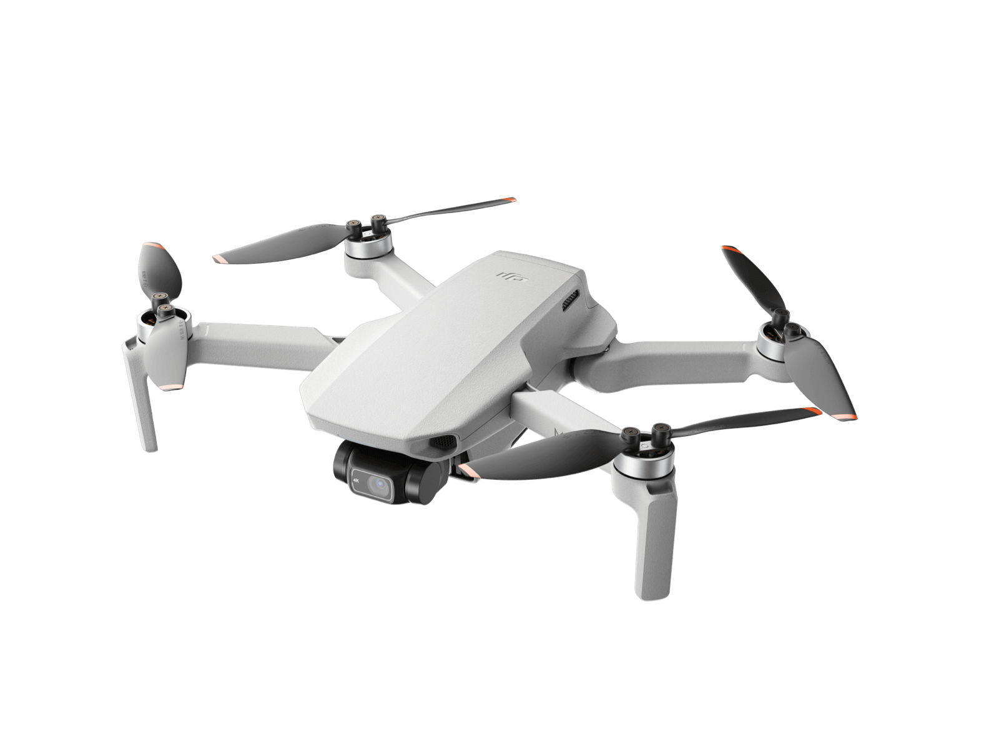
- Matterport cloud

Figure 1:DJI Fly 2 Mini UAV (DJI, 2021).
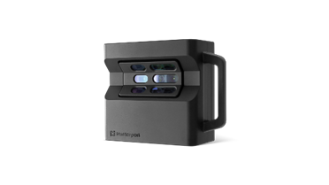

Figure 2: Matterport Pro2 3D scanning device (Matterport, 2021).

3.7 Pilot study
A pilot study was conducted prior to the beginning of the research. In this pilot study the UAV DJI Fly 2 mini was flown over the pre agreed flight path along the high-water mark at Rhossili Bay for 100m. Firstly the UAV was flown at a height of 10m and travelled North in a straight line along the transect of 100m whilst recording a video. This process was repeated at 50m. A Landsat was used to give the correct start point for each flight. When the UAV was at the start point of each flight, an aerial photograph was taken using the DJI remote control. The UAV worked well with fine weather and low winds allowing for successful data collection. A pilot study was not able to be conducted using the Matterport Pro 2 due to difficulty in accessing the equipment due to cost of the apparatus. The pilot study using the UAV showed the Landsat to work well in giving the correct ground control points.

3.7 Unmanned Aerial Vehicle Data Collection Step by Step
- Flight path and frequency of flight
- A study site and transect length for this projects research was then chosen following consultation with experts in the field, personal observations and google maps. The site decided was a 100m transect (Williams, 2021, pers.comms) at the Northern end of Rhossili Bay, Gower, Wales. This was chosen due to its proximity to the Lougher estuary to the North which has the second largest tidal range in the world allowing for large movements of water which will affect the study area selected (Williams, 2021, pers.comms). This large movement of water from the estuary through the gully onto Rhossili Bay combined with refraction of water off Burry Holmes means this transect should have a greater rate of shoreline change than other possible study locations. It is also a West facing beach meaning it is exposed to the prevailing South Westerly winds and storms that regularly hit the Gower Peninsular. The UAV will fly along the shoreline at a consistent altitude and speed to ensure that the images and videos captured are uniform and can be accurately processed.
- Following consultations with experts in the field surrounding transect length, it was decided that two altitudes were to be flown during data collection, these being 10m and 50m in order to gain varying perspectives of the beach change during the study.
- The project was to be conducted during the month of July daily as the weather during this time period is more likely to be optimal UAV flying conditions.
- The daily flights were planned around the daily tide times where local data was analyzed. It was decided flight times would not be within 2 hours of high tide that day, so that the foreshore would remain visible.
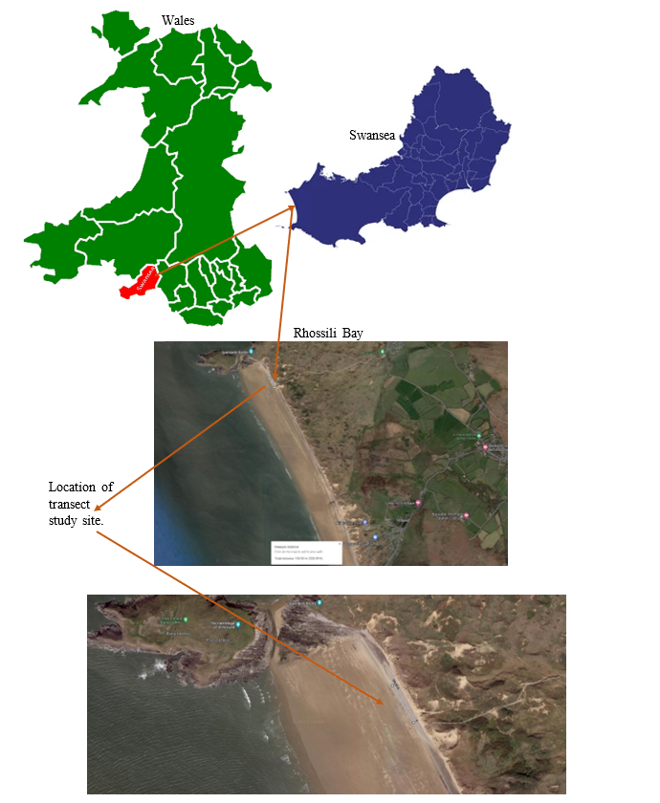
Figure 3: Maps highlighting area of study, white line to show transect location.

The above figure shows our area of interest. The green map is a map of Wales, and highlighted in red is Swansea. The navy map is a map of Swansea, and the arrow coming from this map leads to our point of study, Rhossili Bay.

- Weather Conditions
- The weather conditions and tide times will be studied prior to data collection with each check being done the day proceeding data collection. The windy app will be used to determine if wind speeds may be too high (above 25mph at time of data collection) or to check what time of day rain is forecast so that it can be avoided if possible.

- Safety considerations
- It is checked that there are no people or obstacles in the flight path.

- Test flight
- The protective equipment surrounding the gimble camera should be removed, with a test flight undertaken to ensure the camera is working. The tests should include the connection of the UAV to the DJI Fly 2 mini app on the iPhone which is connected to the remote control, adjusting the focus of the UAV camera whilst looking at the results on the iPhone app, testing the aperture, shutter speed and checking of the light conditions. It should also be checked at the higher altitude of 50m, how the wind is affecting the flight path of the UAV. If it is unable to be safely flown, the data collection is to be stopped.
- Image capture
- The UAV will first take a photograph at the beginning of each flight, whilst the UAV is stationary using the Landsat to provide the same location Then, following successful photograph image capture, begin recording a video for the duration of its flight across each of the two pre-determined flight paths at specified altitudes.

- Data capture
- Each day during data collection, A Landsat is to be used to give the same ground control point at the start and end of each transect for the UAV flight to be completed each day at the same location. The UAV is to be flown directly above the Landsat supplied ground control point before data capture begins.
- The UAV is to be launched at the Landsat location and flown over each of the two 100m flight paths directly North across the transect where photogrammetry is to be used to collect aerial video footage. This will be done by first taking an image whilst the UAV is stationary before starting recording at the beginning of the transect then stopping recording when the end of the transect is reached. It will measure the length of flight on the DJI Fly 2 mini app, With the Landsat to be used at the end of each flight to ensure it is finishing in the correct position.
- Once data has been captured and the two videos are obtained, the UAV will then be safely landed with protective equipment reapplied.

By carefully planning the data collection process and following these steps, the UAV should be able to capture high quality data which can then be analysed to measure beach change over time. This can be used to identify areas of erosion and sediment deposition, monitor the effectiveness of remediation efforts and to inform future beach management strategies.
With the use of the UAV outlined above, next the methodology will explain the steps taken whilst using the Matterport pro2.

3.8 Matterport 3D Scanning Data Collection Step by Step

Prior to the beginning of the months UAV ariel study a Matterport 3D scanner was to be placed upon the same transect with the aim of gathering 3D images from the ground which would then be uploaded onto a video platform once processed to be analysed. These steps are to be repeated once prior to the months data collection and once following the months data collection.
- Equipment and software selection
- A Matterport Pro2 3D scanner was chosen as this was the equipment that the study had access to, its specifications enabled it to collect the required data and generate high resolution 3D images. Matterport is the standard for 3D space capture with it being able to turn 360 panoramic images into 3D spaces. Once collected the data was to be uploaded to the Matterport cloud in order to be processed and converted by the Matterport servers. This study wanted to evaluate its use on an open, sandy beach.

- Site selection and preparation
- Prior to collection, tide times were considered with the scans being undertaken on a morning in which the tide is less than 2 hours from high at first light.
- The 3D scans are to be conducted at first light to give the scanners the most likely chance of working as they need dim conditions with targets to bounce their lasers off (Jenkins, 2021, pers.comms).
- A study site of 100mx5m was selected with it being the same transect the UAV was flown over in order for comparison able to be conducted on the same stretch of beach between the two methods of measuring beach change (Williams, 2021, pers.comms). Four posts with lids on were placed at each corner of the 100mx5m research site in the hope that the scanners would bounce off these allowing for an enclosed 3D image (Jenkins, 2021, pers.comms).

- Set up the scanning device.
- Posts were made from 3m tall wooden posts with dustbin lids attached to the top. Landsat was used to gather the location of the posts so as this method could be repeated in the same place when re conducted.

- Conduct the scan.
- Once the study site has been established, the 3D scanning equipment was placed within the study area in order to begin recording, once the first scan is completed it will be moved 10m down the transect every 10m until it reaches the opposite end of the study area so that the entire area has been scanned and is able to be stitched together.

- Process and analyze the data.
- Once completed, the data is to be uploaded to the Matterport cloud in order to convert the 360 images into a 360 walk through tour. This can be used to observe sediment and slope change using maps and visualizations. It may be used to inform management decisions, such as where to place nourishment or take action to mitigate erosion.

The use of Matterport 3D scanning equipment to measure beach change involves selecting suitable equipment and software, preparing the site, conducting the scan, processing and then analysing the data before presenting the study’s findings. With good planning and execution this methodology can provide valuable insights into how beaches are changing over time to inform management decisions and protect these valuable natural resources.
The study aimed to see the changes of the dune landscape and specifically the strandline through aligning UAV footage for the same pre decided section of land and beach. For each height in which the UAV was flown, videos would be overlaid on top of each other in a video editor (photoshop) in order to colour code beach height measurements across the study. Also, 4k photos will be taken and uploaded to photoshop in order to overlay a grid on top of them, in order to analyse specific areas and visual notes to be made. Data collected by Matterport 3D scanners are to be uploaded to a 3D platform (Matterport cloud) in order to merge scans together and create a walkthrough 3D image that will be observed and analysed creating both qualitative and quantitative data.

3.9 Research method limitations

The research method limitations that have been identified whilst outlining the methodology are that there was no pilot study for the Matterport pro 2 3D scanning device. The best UAV that was possible for the task was chosen however it is accepted this comes with limitations relative to the specifications of the DJI fly mini-2.

Results

4.1
In this research project a DJI Mini 2 UAV was used to measure beach change in the coastal area of Rhossili Bay through the gathering of aerial videos and photographs. The primary objective of this study was to assess the effectiveness of UAVs as a method of measuring beach change and to provide data showing changes in beach morphology over time. The secondary objective of this study was to compare the use of the UAV to that of Matterport 3D scanners in measuring beach change over the duration of this studies data collection. The use of the DJI Fly 2 mini-UAV was seen to have several advantages over the Matterport pro 2 as it was observed to enable the analysation of high-resolution images gathered from a large area in a short space of time. The use of Matterport 3D scanning devices was observed to be problematic with it proving difficult to gather images compatible to a 3D scan on an open sandy beach. This showed how the UAV was better suited to the gathering of data than the Matterport pro 2 as is outlined in the results section below.

4.2 DJI Fly 2 mini-UAV Results

The qualitative data collected in this study by the DJI Fly 2 mini consisted of aerial photographs taken at the start point of each flight which were used to make observations on beach change over time. The UAV performed 14 out of 30 days data collection at the required recording height of 10m and 13 out of 30 days data collection at 50m (see appendices). The initial processing of the 27 aerial videos (JPEG) gathered across the two altitudes (video resolution 4k/30fps) and the final processing of these videos at the height of 50m are shown and outlined below. The processing of the data was performed using photoshop, available for free online.
Figure 4 shows an image captured at 50m altitude at the first day’s data collection. Next, Figure 5 shows an image captured at the end of the 1-month study, a grid was overlaid on top of both image captures so results could be visualised to illustrate spatial and temporal patterns of beach change.
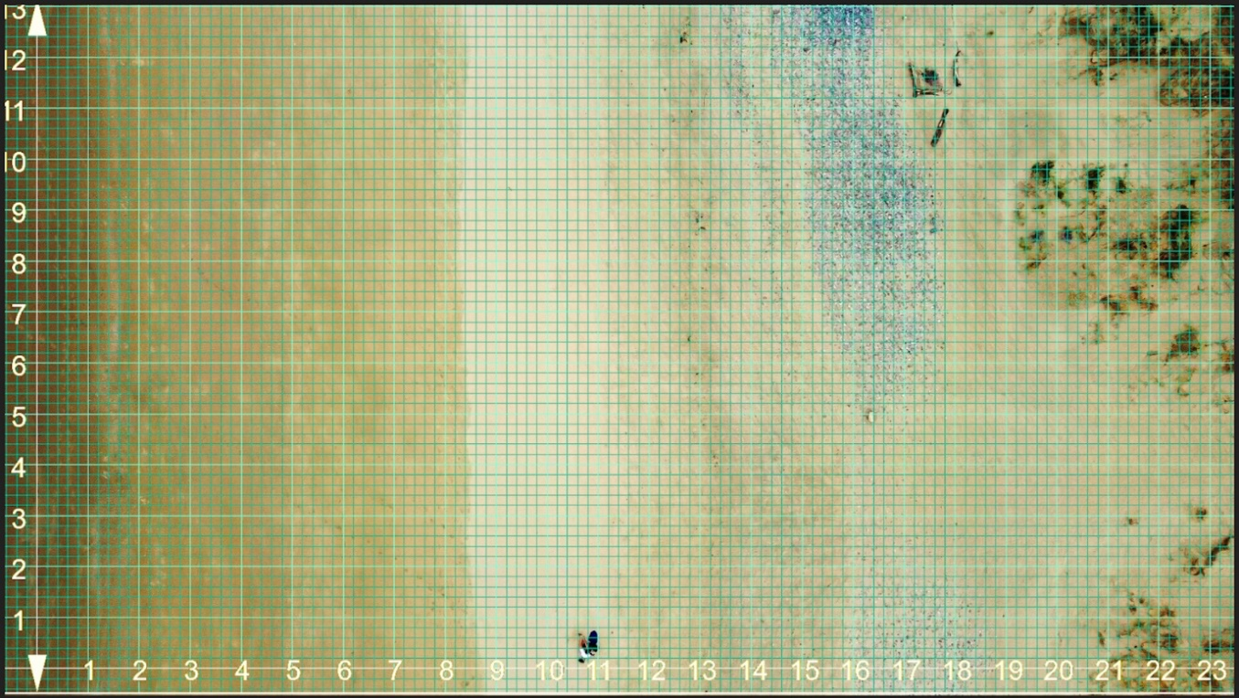
Figure 4: First day of data collection, from 50m.
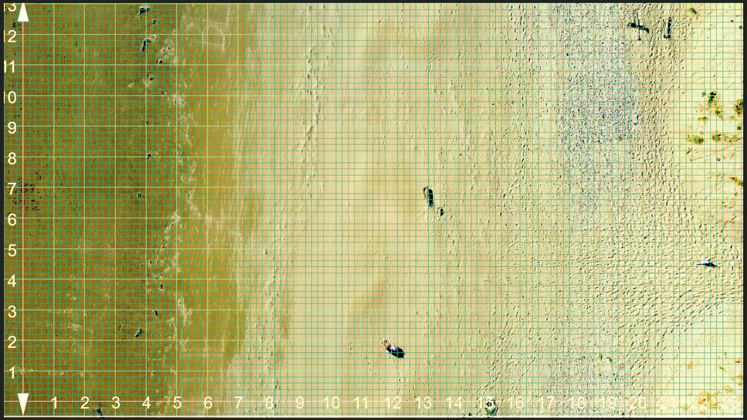
Figure 5: Last day of data collection, from 50m.

The main themes that were observed between the first (Figure 4) and last days (Figure 5) data collection at the height of 50m included accretion, erosion and human impacts. It is observed that the changes between data collection at the start and end of the UAV ariel data collection are subtle, however, some noticeable differences are worth noting.

Firstly, at grid 5,7 the overall structure of this tide line has shifted. Initially at the start of data collection see a very West facing high tide mark. By the end we see a high tide mark which has altered to the West-north-west direction. This is thought be to do with the vast amount of SW swell that was hitting Burry Holmes and having a knock-on effect on the tidal mark. Secondly, looking at grid 18,9, we see the pebble line has decreased and become slightly shorter but wider. It is accepted this could be difficult to judge as pebbles can get covered easily by strong wind. Despite this, change has been noticed, with the UAV enabling this difference to be seen. Lastly, with respect to grid 22,7, we see that the footpath has become more defined, due to wind and the approach of the summer season, more tourists meaning a human impact on the study area can be observed to perhaps damage the beach ecosystem. These results have proved in theory that a DJI Fly 2 mini-UAV may be used to asses beach change with changes in the coastal zone showing to be able to be observed over time as detailed above.

Next, the results from the aerial photographs taken at a height of 10m are analysed by observing the images gathered and taking notes. Each day’s data can be found in the appendices of this project. It is noted that the images allow changes in the beach environment to be noted. The gap between day 7 and day 8 (appendix 7 and 8) shows an increase in human footsteps, this could be a factor in dune erosion. Furthermore, at day 5 (appendix 5) we see a large change in the landscape with stronger lines of sand built up possibly from overnight storms/swell. It is accepted that as the images across the data collection are taken at varying times of the day there is changes of light present at the lower height of 10m causing shadows meaning images are incomparable. Occasionally the ISO on the UAV is too high meaning the images are out of focus and incomparable. Overall, the study height of 10m allows the project to closely observe the beach environment and take a view into the inner workings of erosion and accretion. It highlights the importance of gathering photographic data at this height when creating strategies for beach management and conservation by showing that changes in the beach environment can be seen. Despite this, improvements moving forward following the results of this study may be made, such as the gathering of data at the same time each day to ensure comparable light and shadow conditions. This will be further discussed in the discussion section of the research project.
As previously stated in the research project’s methodology section above, the study aimed to use aerial videos gathered at the varying altitudes of 10m and 50m to colour code the differences in beach topography change over time using image processing software (Photoshop). This was planned to be completed by overlaying all the videos gathered at 50m on top of each other in a video editor before using the programming to provide a colour coded data set of how the beach environment changed day to day, this was also planned to be completed at the measurement height of 10m. However, the results of the data collection showed that this was unable to be conducted. This was due to the UAV being unable to be flown in a perfectly straight line across the transect each day, along with perhaps the main problem that the UAV was also unable to be flown at identical speeds across the transect each day during data collection. These factors combined has resulted in the studies original methodology being unsuccessful, a drawback of the method. It is accepted that wind speed and manual flight caused this drawback, meaning the gathering of accurate and reliable aerial footage that was able to be compared day to day in the way this study required was not possible. Following this discovery, it was analysed at which wind speeds at ground level translated into useable data collection, whereby the DJI Fly 2 mini UAV was able to be flown in a straight line, at the same speed accurately. This would therefore ensure successful gathering of aerial video footage that would be able to be successfully uploaded to a video editor for the colour coded differences in beach height change to be shown.

Figure 6: A graph showing UAV flight capabilities.

At ground level, there is a layer of wind known as the boundary layer where the wind speed is lower than the UAV will experience during its flight. The above graph was developed using the results of this study to outline at what altitude the UAV could be successfully flown at depending on the ground level wind conditions. This has been developed following the conclusion of this data collection, with the aim of informing future researchers of the limitations of this method if aerial videos are to be used as data. Figure 6 was created following the analysing of the aerial footage on photoshop from the data collected during this study. It was plotted on the graph above at what height the drone was stable and straight enough to use the data. For example, at 10m altitude the highest wind speed at ground level the data was useable for was 22mph. Any higher than this during data collection and the footage was not useable. The same principle has been applied to the height of 50m. As plotted, the highest wind speed at ground level where the data was stable enough to be used was 8mph. These two points have been plotted to give an r value which can be used to inform future researchers.
This section has outlined the results of the DJI fly 2 mini in collecting aerial data footage. It has been shown how aerial photography may be successfully used to observe structural beach change over time at an altitude of 50m using an overlaid grid. It has also been shown that a UAV may be used to take a more detailed look at beach change at a height of 10m. It is accepted this height is not the optimal height to observe change, with the higher the altitude data is collected from, the more is able to be seen. With the low-cost model UAV this study used, it is noted how video data collection is only able to be accurately gathered at certain altitude, relative to ground level wind speed. This study has shown how on an open sandy beach, at high altitude, video data collection proves difficult if as this study required that the UAV needs to travel at the same speed in a dead straight line each time in order to overlay videos.

4.3 Matterport Pro2 3D Scanning Results

Next, the results of the Matterport Pro2 3D scanning device are presented. A Matterport 3D scanning device was used to scan the research site. Four 3m high posts with dustbin lids on were placed at each corner of the research site with the aim of the laser scanners refracting off them to create an enclosed image. The Matterport 3D scanning device can be seen in Figure 2 and 8. Two of the four dustbin lid posts which were placed at the Northern end of the transect can be seen in figure 7.
Following data collection, the scans were to be uploaded to the Matterport cloud. Unfortunately, these failed to upload due to the photogrammetry technology not having enough to refract off on the highly reflective open sandy beach. It is accepted that this is not an ideal way of measuring beach topography change, especially as was the case during this study where the operating cost and access to the equipment was high and limited, meaning there was no room for pilot studies, trial and error or practice using the highly technical equipment on a challenging research site. It is concluded following this study that Matterport pro 2 3D scanning equipment is not best suited to gathering data on Rhossili Bay. It is shown that the UAV whilst with its problems, did outperform the Matterport pro 2 3D scanner comfortably. However, just as the methodology for the DJI mini 2 could be improved, so could the methodology for the Matterport pro 2 3D scanners. In the discussion section below, a revised and improved method for measuring beach change using a UAV and Matterport pro 2 3D scanner is outlined building upon the results detailed above in this study. It is planned that these improvements could be made, and the study could be re trialled with the long-term view of creating a widely accepted, accurate, reliable method for assessing beach change using a UAV and 3D DEM technology.

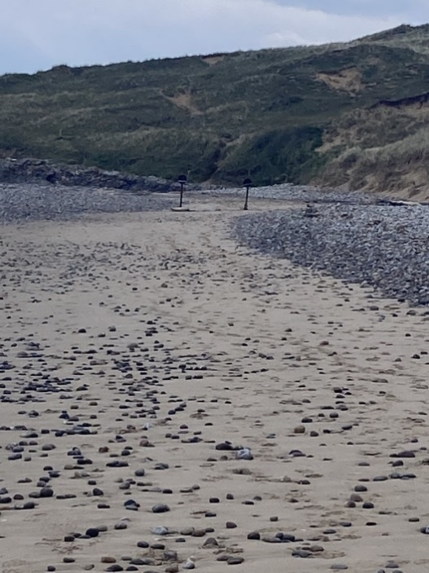

Figure 7: 3D scanning device in use at site.

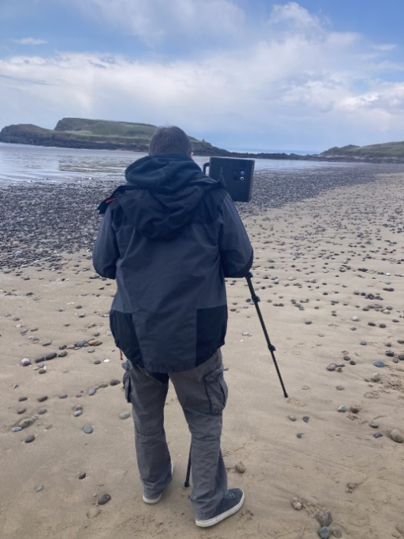

Figure 8: Mike Jenkins operating the Matterport 3D pro 2 device.

4.4 Limitations of Research Project

There were some notable limitations that presented themselves when analysing the DJI fly mini 2 data. Firstly, the altitude in which was data collected by the DJI Fly mini 2 would have been more revealing the higher it was collected. Perhaps heights of 100m and 250m would have collected images that would have been of more use to coastal researchers. If the UAV was able to be flown at 100m, the structure of the dunes, sandbanks, high water mark and footpaths could all have been analysed at once. Furthermore, if the UAV was to be flown at 250m it would have also enabled the rock line and dune change to be added to this. These flights would have to take place specifically on days where there was less than 5mph wind at ground level, and so in retrospect, perhaps data collection could have been spread out over a longer time frame so that data collection could be openly conducted when weather conditions were optimal. This perhaps could be conducted at first light on a very still day where wind speed is expected to be less. A further limitation was that due to work commitments and tidal changes, some days data collection was conducted in the morning, sometimes the evening. If this was conducted again, either the morning or evening mid/low tide would be stuck to so as the light would hit the sand at the same intensity in each picture. This would alleviate the problem as noted that sun glint is an issue that needs addressing in order to enhance the use of UAVs for coastal zone research (Jaud et al., 2019). A further issue that stopped the UAV performing optimally was due to varying wind directions, the UAV would not always travel at the same speed across the transect selected. This prevented the overlaying of videos in a video editor for detailed analysis. For this to work, UAV flight would need to be flown at identical speed each day, strong headwinds from the North or tailwind from the South prevented this from happening. Also due to wind speed at high altitudes, the UAV would not always travel in a perfectly straight line, so perhaps mounting semi-permanent masts from one end of the transect to the other would aid data collection as these could be followed during flight. The graph in figure 6 could also be followed to ensure the UAV was flown in conditions that allow it to perform optimally.

Discussion

As previously stated, UAVs or drones have transformed topographic surveying with in being employed in many varying environments (Eisenbeiss and Sauerbier, 2009, Ryan et al., 2015, Casella et al., 2017, Dąbski et al., 2017 and Chirayath and Earle, 2016). This change has not been any more apparent than in the study of our coastline (Mancini et al., 2013, Gonçalves and Henriques, 2015, Klemas, 2015 and Turner, Harley and Drummond, 2016). The results of this study combined with the previous literature have allowed this project to critically analyse the use of UAVs as a method of measuring beach topography change. In this research project, we utilized UAVs and Matterport 3D equipment to gather data before analysing and comparing the results to gain an insight into the advantages and disadvantages of the effectiveness of this technology for coastal monitoring. In this discussion section, the project will examine the results of this study in relation to specified positives and negatives in order to help inform future practitioners of the ways this technology can be used. Then, challenges that presented themselves during the project will be discussed and investigated. Following this, the information presented so far combined with interviews with experts in the field will be used to create an instruction manual to better inform future research that wishes to use similar technology in the hope that it will enhance and optimize our understanding of using technology to study coastal areas.
The primary advantages noted within this study was the UAV’s ability to acquire high resolution aerial imagery in a rapid cost-effective way. It also was shown to be safe and non-invasive in regard to the study area.
It took under an hour to measure the beach topography change at the study transect of 100m when collecting data, this is far quicker than other methods such as traditional surveying techniques which can often be time highly time consuming. The UAV was able to cover a large area of beach quickly allowing for frequent and efficient monitoring of changes over time. During the collection it is possible to rapidly repeat photography and video collection in case of an error. Due to the small amount of time taken allowing it to be a method that can be used very quickly. This means it may be useful when assessing damage from storms to allow a shorter response time from management which will then benefit all key stakeholders involved.
As seen in appendix 14, at a measurement height of 10m it is observed that shoreline features can be clearly and accurately seen. This shows that the use of a UAV in assessing beach change can be highly valuable to researchers who wish to monitor and measure shoreline changes. It presents itself as a viable method not only in this field, but also in other areas in where the monitoring of remote areas is of critical importance. The UAV in this study has been shown to be agile and successful in gathering images rapidly. This study gathered images over a month-long period effectively, allowing for a comparison from results at the start against the results at the end of the study period. It is essential in monitoring practices that this can be done. Aasen et al., (2018) recently noted that UAVs can provide us with information higher in spatial and temporal resolutions whilst complimenting very high-quality plane and satellite systems. The work of this study builds upon and backs up his findings.
Another key positive noted when looked at through the eyes of the researcher is that of safety and accessibility, The use of the UAV in this study was observed to eliminate the need to personally travel across the research site, whereby instead it was able to be flown from a safe spot. Due to the high distances all UAV models including the one used in this study can travel, it was noted how in other studies where workers must traverse across more dangerous terrain such as steep cliffs or unstable slopes how it could highly reduce the risk of injury. As it can also access remote beach areas thought previously out of reach the method can provide a comprehensive understanding of the entire beach system. Erdelj et al., (2017), found use for UAVs in disaster management. They found that UAVs could not only help survey the affected areas, but also assist and aid communication links between survivors and the nearest telephone masts. The findings of this study add evidence to this point.
Another important factor that was noted when analysing the positives of the UAV was that it is non-invasive, the collection of the data was possible without disturbing the study area of the beach transect chosen. This is important in coastline monitoring where this method could be used to minimize the impact on wildlife and vegetation.
While UAVs offer many benefits for measuring and monitoring beach topography change as outlined and analysed above, there are some potential disadvantages to consider as well including, Weather dependence, limited flight time, technical complexity, legal and regulatory challenges as well as the risk of accidents and damage. Perhaps the main disadvantage of the use of UAVs as a method of measuring beach topography change this study brought to light was how highly dependent the DJI fly 2 mini UAV was on the weather with bad conditions such as rain, fog and strong winds limiting its ability to collect the required data. This builds upon the findings of (Chou et al., 2010, Koshitzki et al., 2017, Ardi et al., 2018 and Fiorucci et al., 2018) as outlined in the literature review.
UAVs in general have certain flight specifications, when the UAV used in this study was analysed, due to it being a low-cost model, its ability to deal with high winds was less than that of a more expensive model. The DJI fly 2 to can withstand winds of 24mph whereas the can considerably more costly Autel EVO 2 can withstand winds of 39mph. This is noted to be a problem in hindsight as even if the wind was relatively low at ground level, once it was flown to a height of 50m to collect data, it was hard to get it to fly in a straight line along the transect at the shoreline as the methodology required. This then caused the data collected to regularly be insufficient in its primary aim of overlaying all the videos collected on top of each other in order to colour code the differences in beach height change. This is seen to be a major disadvantage of UAVs in beaches whereby the average wind speeds are usually high. On the other hand, if a costlier model was chosen as mentioned, this could possibly be mitigated further. Despite this, data was able to be collected when wind speed was low, with the UAV performing well and meeting the aims of data collection. Perhaps it was not foreseen how high the wind would be at the heights in which the UAV needed to be flown at, with this maybe being a drawback of the method if the UAV was required to be flown at higher altitude, such as at 250m in order to see the entire beach environment to gain optimal data which would be done if this project was repeated. It is accepted that with the UAV being unable to be flown repeatedly over the same flight path because of wind effecting flight stability, that this method lacks in guaranteed accuracy of data collection if this model is chosen. Furthermore, it is unable to be flown in the rain. This is a disadvantage of the method as data is needed to be collected at set times where rain can and did cause the cancellation of data collection. This is accepted to be a problem in this study and may be in other similar studies. As this study was conducted in Wales, a typically wet and windy country, it was shown how UAVs may be unreliable if the time in which data is able to be collected is not able to be scheduled around adverse weather. This also must be noted as a disadvantage of measuring the effects following a storm if conditions are still bad, then the UAV may be unable to be flown meaning its key advantage of being able to be conducted rapidly is lost. This study builds upon findings of Li, Sun and Talpur (2022), in which they noted experiencing problems with the wind when flying a quadrotor UAV. The UAV would experience blade-flapping, dramatic fluctuations in propeller lift and extra movement on the body, which has significant impact on the UAVs stability. They acknowledge that wind disturbance (and other disturbances) should be considered in the controller design, in order to maximise UAV performance. It is aimed that figure 6 should help inform researchers of the future mitigate these problems.
The UAV as mentioned was easy to operate, however despite this, it may not be simple to some organisations or individuals with no transferrable experience or knowledge. It is accepted some time would have to be taken to learn, with numerous pilot studies needing to be conducting for the individual to gain confidence flying the model before data collection. Data processing using the UAV also required some technical skill and knowledge which may not be readily available. Also, UAVs have technical limitations such as limited payload capacity and limited range which may affect the resolution of the data collected.
Overall, while UAVs offer many advantages for measuring and monitoring beach topography change, there are some limitations and challenges that should be considered when deciding whether to use this method. Proper planning, training and risk management can help mitigate these disadvantages and ensure the safe and effective use of UAVs for beach monitoring. In a report on UAV incidents and accidents from Williams (2004), it found that electrical and mechanical accidents are just as common as accidents caused from human error and that those caused by human error are heavily dependent on the system being used.
The results of this study show that when the use of a UAV in monitoring beach change is compared to the use of 3D photogrammetry, that the UAV is proven to be superior. The use of 3D photogrammetry is proven to not be a recommended method of assessing beach change based on this studies results. It is proven to be very difficult to ensure the scans can be stitched together when data is required to be gathered from an open sandy beach.
Next, a set of instructions that could be used as framework for future researchers wishing to create and undertake studies using a UAV and a 3D scanning device is proposed. Following the results of this study and a resulting interview with (Drummond, 20223, pers.comms) it is proposed a DJI phantom 4 UAV with RTK is used by future researchers wishing to measure beach change using a UAV. Whilst is accepted that this is a more expensive UAV, it is also accepted that having a UAV with real time kinematic positioning (RTK) is vital to ensure reliable and accurate results with data proving to be very difficult to successfully gather without this present.
As well as a DJI Phantom RTK UAV, a GNSS base station is needs to be established at the study site. It is vital that the GNSS base station is set up at a known location on the beach. This should be a fixed, unmoveable point (Drummond, 2023, pers.comms). The location of this base station is then where a GNSS rover should be placed. This should then be connected to the UAV with RTK (DJI Phantom 4) (Poulton, 2023, pers.comms).
Following the results of this study and the interview with Drummond (2023, pers.comm) it is proposed moving forward that automated flight planning is essential in any future methodology surrounding the measuring of beach change using a UAV (Drummond, 2023, pers.comms). It is recommended that the ground station app is chosen as it is compatible with this UAV (Drummond, 2023, pers.comms). It will also allow the study to plan a specific flight path by specifying start and end points that will be automatically flown at the desired altitude and flight speed. This will allow problems in this study to be overcome by using this slightly more expensive equipment (DJI mini 2 - £500 vs DJI Phantom 4 - £5000) however it can be rented at £100 per day which may be more cost effective. This will allow the UAV to take a series of overlapping images automatically that can be stitched together to create an auto mosaic.
A further important step when creating future methodology is ground sampling distance (GSD). This is the distance on the ground represented by each pixel in an image captured by the UAV. It is vital that the GSD is correct as it directly relates to the resolution of the data captured (Drummond, 2023, pers.comms). To calculate GSD: GSD + (Altitude * Sensor Size) / Focal Length (Drummond, 2023, pers.comms). This should be followed by all future studies as an important step that cannot be missed when creating UAV methodologies in measuring beach change.
Once GSD, A base station, ground control app and the UAV have been established and connected, it is possible to begin data collection. These factors and technicalities should not be overlooked if reliable data is to be gathered. Following the gathering of data, the best way to analyse and present the data is that of a digital terrain model (DTM) which can be created using relevant software such as QGIS or Global mapper to convert the data from the ground station app into a DTM. The data gathered in the ground station app will use the RTK and base station to accurately georeference the location the data captured to ensure the Orth mosaic data is accurately positioned in the correct geographic space. This can then be compared to existing or future topographic data.

Determine the study area and project objectives (will guide selection of GSD and altitude settings)
Select correct equipment – UAV with RTK

Use an automated flight app (ground station)

Set a base station ground control point.

Figure 9: Flow chart to outline the most important steps to ensure accurate UAV data collection.
Next a set of instructions that are then summarised in a flow chart are presented for the use of terrestrial laser scanning (TLS) technology. Following the results of this study outlining how photogrammetry 3D data collection has its issues, it is recommended TLS is the desired technology for creating 3D data to measure beach change.
Following consultations with experts in the field (Drummond, 2023, pers.comms) the equipment recommended is a Matterport with BLK as this is more suited to outdoor use. It is a compact, lightweight and highly accurate laser scanner than can capture 360 degree panoramic images and 3D point cloud data. The scanner is manufactured by Leica Geosystems, a well-known brand in the surveying and geomatics industry and is designed to work seamlessly with Matterport 3D capture and visualisation platform. A Tripod, GNSS Receiver with the relevant TLS data processing software such as CloudCompare is the other equipment needed. First, the TLS should be set up upon the desired study site. It is noted that this is a far more costly piece of equipment compared to.
When conducting data collection an important part of this is to place a mirror filter over the mirror on the TLS to make sure that sand does not affect the sensor (Drummond, 2023, pers.comms). This could result in broken equipment and a very large repair cost. The TLS and tripod should be moved around the beach to capture images and data from all angles and positions. It is also advisable that numerous poles be placed in the surrounding areas that the equipment can base its scans off. Once the scan has been completed, the data needs to be georeferenced using the GNSS receiver which should be attached to the tripod prior to the scan being completed, making sure it is stable and not moving. By using GNSS to reference the captured data, it is ensured that the 3D model accurately reflects the correct location of the environment that has been scanned. The data should then be processed to create a digital elevation model (DEM) using CloudCompare to extract elevation data at the beach surface. Volume changes could then be calculated over time (Drummond, 2023, pers.comms)
Select the correct equipment (Matter port BLK)
Place poles for the 3D scan to use as reference points

Place filter over sensor

Select the correct software to process the data

Figure 10: Flow chart to outline the critical planning steps when creating methodology that uses TLS as a method of measuring beach change.

Whilst all steps and instructions outlines are critical in planning and executing a 3D scan for measuring beach change, above some important factors are outlined following consultations with experts in the field (Drummond, 2023, pers.comms). Any error or oversight during planning and execution can impact the accuracy of the survey and the reliability of the data collected.
It is accepted that the cheapest available UAV and 3D photogrammetry equipment used in this study results in inaccurate and unusable beach topography data. Moving forward, it is noted that better equipment must be chosen with certain technicalities not to be overlooked. The use of this technology in coastal management decision making has been proven to have immense potential however more work needs to be done to both improve the cheaper equipment over time to allow all models to gather sufficient data. As well as this more work needs to be done to create a standardized methodology for all researchers to use. It is hoped the results of this study can add a brick of knowledge to this research gap so that mistakes made here are not repeated with the recommendations stated followed to ensure future success.
Conclusion
Over the past few years, this project has embarked on a research project aimed at understanding and evaluating how a DJI Fly 2 mini and a Matterport pro 2 can be utilized to measure beach change. Beaches are dynamic environments that experience constant changes due to various natural and anthropogenic factors, making it essential to monitor and quantify these changes accurately (de la Vega-Leinert & Nicholls, 2008). In this study we have highlighted the potential of coastal UAVs in accurately and efficiently measuring beach change. This research project conducted upon Rhossili Bay, South Wales demonstrates the effectiveness of UAVs as a method of measuring beach change.
By comparing the aerial photographic and video data gathered by the UAV to the topographic data attempted to be collected and turned into a 3D model by the Matterport pro 2, it has allowed us to evaluate the technologies use by comparing them to previous literature and each other through a literature review, results and discussion.
The high-resolution imagery and comprehensive coverage provided by UAVs enable accurate photographs of beach morphology to be obtained. It also highlights essential steps that must be followed when using this technology. It has highlighted the drawbacks with cost effective equipment, showing that in order to gather the most reliable and accurate data, more expensive models of UAV and 3D scanning equipment need to be used. This study also identified some limitations of the UAV based method, including potential errors caused by high wind speed at high altitude.
The use of the Matterport Pro 2 is shown to be problematic, however an instruction guide following the results of this study is proposed to future researchers, with the potential for this equipment to contribute to coastal management able to be seen should the detailed improved instructions be followed and successfully work.
The results show how UAV imagery can, if used correctly, provide detailed imagery on shoreline dynamics, including erosion and accretion helping identify the areas of vulnerability and aid planning to avoid coastal disasters. Whilst there are limitations such as weather conditions and the need for highly skilled operators, the potential benefits of the technology outweigh the challenges. This study does challenge the work (Goncalves and Henriques, 2015 and Cook, 2017) who state low cost equipment may be used to asses coastal zones. Whilst it is appreciated that some affordable models may be used, it is not yet possible to use the cheapest, most basic models on the market to measure beach change with a high degree of confidence.
Moving forward, it is crucial to continue exploring the potential for UAVs and 3D photogrammetry to address the remaining challenges. The results of this study, combined with future research papers should further aid the development of the bank of knowledge in order to develop standardized protocols for UAV and 3D based assessments of beach change.
By writing this report we inform coastal management decision makers upon both good and bad practice in regard to the technology used by providing an evaluation of the DJI Fly 2 mini and Matterport pro 2. It is concluded that for data collection objectives of this study to be successfully met, it would have been advisable to use the slightly more costly DJI Phantom 4 UAV with RTK to gather UAV data. It is outlined how vital automated flight planning and RTK are in the gathering of accurate data. This is also the case for the 3D scanning equipment, whereby it is advisable for the more expensive Matterport BLK to be used to its enhanced ability to gather scans outside. This should be used whilst paired with a GNSS receiver to ensure accuracy. This paper backs up the work of (Mancini et al., 2013 and Eltner et al., 2015) who argue 3D photogrammetry is very difficult upon open sandy beaches.

References
Aasen, H., Honkavaara, E., Lucieer, A. and Zarco-Tejada, P.J. (2018). ‘Quantitative remote sensing at ultra-high resolution with UAV spectroscopy: a review of sensor technology, measurement procedures, and data correction workflows’, Remote Sensing, 10(7), pp.1-42.
Adams, G.F., Ausherman, D.A., Crippen, S.L., Sos, G.T., Williams, B.P. and Heidelbach, R. (1996). ‘The erim interferometric sar: Ifsare’, IEEE Aerospace and Electronic Systems Magazine, 11(12), pp.31-35.
Afif, H. A., Rokhmatuloh, R., Saraswati, R. and Hernia, R. (2019). ‘UAV Application for Landslide Mapping in Kuningan Regency, West Java’, ES3 Web of Conferences, 125, pp.1-4.
Ahmad, A., Tahar, K. N., Udin, W.S., Hashim, K.A., Darwin, N., Room, M.H.M., Hamid, N.F.A., Azhar, N.A.M. and Azmi, S.M. (2013). ‘Digital Aerial Imagery of Unmanned Aerial Vehicle for Various Applications’, 2013 IEEE International Conference on Control System, Computing and Engineering, pp.535-540.
Akcay, O. (2015). ‘Landslide Fissure Inference Assessment by ANFIS and Logistic Regression Using UAS-Based Photogrammetry’, ISPRS International Journal of Geo-Information, 4, pp.1-28.
Anderson, K. and Gaston, K.J. (2013). ‘Lightweight unmanned aerial vehicles will revolutionize spatial ecology’, Frontiers in Ecology and the Environment, 11(3), pp.138-146.
Anfuso, G., Pranzini, E. and Vitale, G. (2011). ‘An integrated approach to coastal erosion problems in northern Tuscany (Italy): Littoral morphological evolution and cell distribution’ Geomorphology, 129(3-4), pp.204-214.
Aniceto, A.S., Biuw, M., Lindstrøm, U., Solbø, S.A., Broms, F. and Carroll, J. (2018). ‘Monitoring marine mammals using unmanned aerial vehicles: quantifying detection certainty’, Ecosphere, 9(3).
Appeaning Addo, K., Jayson-Quashigah, P.N., Codjoe, S.N.A. and Martey, F. (2018). ‘Drone as a tool for coastal flood monitoring in the Volta Delta, Ghana’, Geoenviron Disasters, 5(17), pp.1-13.
Ardi, N.D., Iryanti, M., Asmoro, C.P., Nurhayati, N. and Agustine, E. (2018). ‘Mapping Landslide Potential Area using Fault Fracture Density Analysis on Unmanned Aerial Vehicle (UAV) Image’, IOP Conference Series: Earth and Environmental Science, 145, pp.1-5.
Baddock, M.C., Nield, J.M. and Wiggs, G.F. (2017). ‘Early‐stage aeolian protodunes: Bedform development and sand transport dynamics’, Earth Surface Processes and Landforms, 43(1), pp.339-346.
Bagli, S. and Soille, P. (2003). ‘Morphological Automatic Extraction of Pan-European Coastline from Landsat ETM+ Images’. International Symposium on GIS and Computer Cartography for Coastal Zone Management, October 2003, Geneva.
Balson, P.S., Tragheim, D.G., Denniss, A.M., Waldram, D. and Smith, M.J. (1996). ‘A photogrammetric technique to determine the potential sediment yield from recession of the Holderness coast’, Samara Publishing Ltd., Cardigan (UK).
Barrile, V., Bilotta, G. and Nunnari, A. (2017). ‘3d Modeling with Photogrammetry By Uavs And Model Quality Verification’ ISPRS Annals of the Photogrammetry, Remote Sensing and Spatial Information Sciences, 4, pp.129-134.
Barlow, J., Gilham, J. and Cofra, I. I. (2017) ‘Kinematic analysis of sea cliff stability using UAV photogrammetry’, International Journal of Remote Sensing, 38(8-10), pp.2464-2479.
Bevan, E., Whiting, S., Tucker, T., Guinea, M., Raith, A. and Douglas, R. (2018). ‘Measuring behavioral responses of sea turtles, saltwater crocodiles, and crested terns to drone disturbance to define ethical operating thresholds’, PLoS One, 13(3).
Blackweir, D.G. and Beckley, L.E. (2004). ‘Beach usage patterns along the Perth Metropolitan coastline during shark surveillance in summer 2003/04’, School of Environmental Science, Murdoch University.
Bloom, D., Butcher, P.A., Colefax, A.P., Provost, E.J., Cullis, B.R. and Kelaher, B.P. (2019). ‘Drones detect illegal and derelict crab traps in a shallow water estuary’, Fisheries Management and Ecology, 26(4), pp.311-318.
Boccali, C., Biolchi, S., Zavagno, E. and Zini, L. (2017). ‘Rock fall characterization in climbing spots: The case study of the "Napoleonica" tourist route (Trieste, NE Italy)’, Advancing Culture of Living with Landslides, Volume 2: Advances in Landslide Science, pp.107-115.
Brasington, J., Langham, J. and Rumsby, B. (2003).’ Methodological sensitivity of morphometric estimates of coarse fluvial sediment transport’, Geomorphology, 53(3-4), pp.299-316.
Brekke, C. and Solberg, A.H.S. (2005). ‘Oil spill detection by satellite remote sensing’, Remote Sensing of Environment, 95(1), pp.1-13.
Brunier, G., Fleury, J., Anthony, E.J., Gardel, A. and Dussouillez, P. (2016). ‘Close-range airborne Structure-from-Motion Photogrammetry for high-resolution beach morphometric surveys: Examples from an embayed rotating beach’, Geomorphology, 261, pp.76-88.
Cao, J., Leng, W., Liu, K., Liu, L., He, Z. and Zhu, Y. (2018). ‘Object-based mangrove species classification using unmanned aerial vehicle hyperspectral images and digital surface models’, Remote Sensing, 10(1), p.89.
Carbonneau, P.E. and Dietrich, J.T. (2017). ‘Cost‐effective non‐metric photogrammetry from consumer‐grade sUAS: implications for direct georeferencing of structure from motion photogrammetry’, Earth surface processes and landforms, 42(3), pp.473-486.
Cardille, J.A. and Foley, J.A. (2003). ‘Agricultural land-use change in Brazilian Amazônia between 1980 and 1995: Evidence from integrated satellite and census data’, Remote Sensing of Environment, 87(4), pp.551-562.
Casella, E., Rovere, A., Pedroncini, A., Mucerino, L., Casella, M., Cusati, L. A., Vacchi, M., Ferrari, M., and Firpo, M. (2014) ‘Study of wave runup using numerical models and low-altitude aerial photogrammetry: A tool for coastal management’, Estuarine, Coastal and Shelf Science, 149, pp.160-167.
Casella, E., Rovere, A., Pedroncini, A., Stark, C.P., Casella, M., Ferrari, M. and Firpo, M. (2016). ‘Drones as tools for monitoring beach topography changes in the Ligurian Sea (NW Mediterranean)’, Geo-Marine Letters, 36, pp.151-163.
Casella, E., Collin, A., Harris, D., Ferse, S., Bejarano, S., Parravicini, V., Hench, J.L. and Rovere, A. (2017). ‘Mapping coral reefs using consumer-grade drones and structure from motion photogrammetry techniques’, Coral Reefs, 36, pp.269-275.
Chabot, D., Dillon, C., Shemrock, A., Weissflog, N. and Sager, E.P. (2018). ‘An object-based image analysis workflow for monitoring shallow-water aquatic vegetation in multispectral drone imagery’, ISPRS International Journal of Geo-Information, 7(8), p.294.
Chen, C.L. and Teng, N. (2016). ‘Management priorities and carrying capacity at a high-use beach from tourists’ perspectives: A way towards sustainable beach tourism’, Marine Policy, 74, pp.213-219.
Chen, B., Yang, Y., Wen, H., Ruan, H., Zhou, Z., Luo, K. and Zhong, F. (2018). ‘High-resolution monitoring of beach topography and its change using unmanned aerial vehicle imagery’, Ocean & Coastal Management, 160, pp.103-116.
Chirayath, V. and Earle, S.A. (2016). ‘Drones that see through waves–preliminary results from airborne fluid lensing for centimetre‐scale aquatic conservation’, Aquatic Conservation: Marine and Freshwater Ecosystems, 26, pp.237-250.
Chong, A.K. (2007). ‘HD aerial video for coastal zone ecological mapping’, University of Otago, Dunedin, New Zealand.
Christiansen, F., Rojano-Doñate, L., Madsen, P.T. and Bejder, L. (2016a). ‘Noise levels of multi-rotor unmanned aerial vehicles with implications for potential underwater impacts on marine mammals’, Frontiers in Marine Science, 3, p.277.
Christiansen, F., Dujon, A.M., Sprogis, K.R., Arnould, J.P. and Bejder, L. (2016b). ‘Noninvasive unmanned aerial vehicle provides estimates of the energetic cost of reproduction in humpback whales’, Ecosphere, 7(10).
Chou, T.Y., Yeh, M.L., Chen, Y.C. and Chen, Y.H. (2010). ‘Disaster monitoring and management by the Unmanned Aerial Vehicle technology’, 100 Years ISPRS Advancing Remote Sensing Science, 38, pp.137-142.
Church, J.A., Clark, P.U., Cazenave, A., Gregory, J.M., Jevrejeva, S., Levermann, A., Merrifield, M.A., Milne, G.A., Nerem, R.S., Nunn, P.D., Payne, A.J., Pfeffer, W.T., Stammer, D. and Unnikrishnan, A.S. (2013). Sea Level Change. In: Climate Change 2013: The Physical Science Basis. Contribution of Working Group I to the Fifth Assessment Report of the Intergovernmental Panel on Climate. Cambridge University Press, Cambridge, United Kingdom and New York, NY, USA.
Cigna, F. (2018). ‘Observing Geohazards from Space’, Geosciences, 8(2), pp.1-6.
Clark, A. (2017). ‘Small unmanned aerial systems comparative analysis for the application to coastal erosion monitoring’, GeoResJ, 13, pp.175-185.
Clark, D.G., Ford, J.D. and Tabish, T. (2018). ‘What role can unmanned aerial vehicles play in emergency response in the Arctic: A case study from Canada’, PLoS One, 13(12), pp.1-16.
Colefax, A.P., Butcher, P.A., Pagendam, D.E. and Kelaher, B.P. (2019). ‘Reliability of marine faunal detections in drone-based monitoring’, Ocean & coastal management, 174, pp.108-115.
Collins, B.J. and Madge, B. (1981). ‘A new method for monitoring beach movement’, Chartered Land Surveyor/Chartered Minerals Surveyor, 3, pp.4-11.
Collin, A., Ramambason, C., Pastol, Y., Casella, E., Rovere, A., Thiault, L., Espiau, B., Siu, G., Lerouvreur, F., Nakamura, N. and Hench, J.L. (2018). ‘Very high resolution mapping of coral reef state using airborne bathymetric LiDAR surface-intensity and drone imagery’, International Journal of Remote Sensing, 39(17), pp.5676-5688.
Colomina, I. and Molina, P. (2014) Unmanned aerial systems for photogrammetry and remote sensing: A review’, ISPRS Journal of Photogrammetry and Remote Sensing, 92, pp.79-97.
Cook, L.K. (2017). ‘An evaluation of the effectiveness of low-cost UAVs and structure from motion for geomorphic change detection’ Geomorphology, 278, pp.195-208.
Coveney, S. and Roberts, K. (2017). ‘Lightweight UAV digital elevation models and orthoimagery for environmental applications: data accuracy evaluation and potential for river flood risk modelling’ International Journal of Remote Sensing, 38(8-10), pp.3159-3180.
Coyne, M.S. and Godley, B.J. (2005). ‘Satellite Tracking and Analysis Tool (STAT): an integrated system for archiving, analyzing and mapping animal tracking data’, Marine Ecology Progress Series, 301(1-7), pp.1-7.
Dąbski, M., Zmarz, A., Pabjanek, P., Korczak-Abshire, M., Karsznia, I. and Chwedorzewska, K.J. (2017). ‘UAV-based detection and spatial analyses of periglacial landforms on Demay Point (King George Island, South Shetland Islands, Antarctica)’, Geomorphology, 290, pp.29-38.
Dalamagkidis, K. (2015). Definitions and terminology. In: Valavanis KP and Vachtsevanos GJ (eds.), Handbook of Unmanned Aerial Vehicles. Springer, p.3022.
Danzi, M., Di Crescenzo, G., Ramondini, M. and Santo, A. (2013). ‘Use of unmanned aerial vehicles (UAVs) for photogrammetric surveys in rockfall instability studies’, Rendiconti Online Societa Geologica Italiana, 24, pp.82-85.
Deidun, A., Gauci, A., Lagorio, S. and Galgani, F. (2018). ‘Optimising beached litter monitoring protocols through aerial imagery’, Marine Pollution Bulletin, 131, pp.212-217.
Delacourt, C., Allemand, P., Jaud, M., Grandjean, P., Deschamps, A., Ammann, J., Cuq, V. and Suanez, S. (2009). ‘DRELIO: An Unmanned Helicopter for Imaging Coastal Areas’, Journal of Costal Research, 56(2), pp.1489-1493.
de la Vega-Leinert, A.C. and Nicholls, R.J. (2008). ‘Potential Implications of Sea-Level Rise for Great Britain,’ Journal of Coastal Research 24(2), pp. 342-357. doi: 10.2112/07A-0008.1.
Díaz-Delgado, R., Cazacu, C. and Adamescu, M. (2018). ‘Rapid assessment of ecological integrity for LTER wetland sites by using UAV multispectral mapping’, Drones, 3(1), p.3.
Doughty, C. L., and Cavanaugh, K. C. (2019). ‘Mapping coastal wetland biomass from high resolution unmanned aerial vehicle (UAV) imagery’, Remote Sensing, 11(5), p.540.
Duffy, J. P., Cunliffe, A. M., DeBell, L., Sandbrook, C., Wich, S. A., Shutler, J. D., Myers-Smith, I. H., Varela, M. R., and Anderson, K. (2017) ‘Location, location, location: considerations when using lightweight drones in challenging environments’, Remote Sensing in Ecology and Conservation, 4(1), pp.7-19.
Duo, E., Trembanis, A.C., Dohner, S., Grottoli, E. and Ciavola, P. (2018). ‘Local-scale post-event assessments with GPS and UAV-based quick-response surveys: a pilot case from the Emilia–Romagna (Italy) coast’, Natural Hazards and Earth System Sciences, 18(11), pp.2969-2989.
Dwight, R.H., Brinks, M.V., SharavanaKumar, G. and Semenza, J.C. (2007). ‘Beach attendance and bathing rates for Southern California beaches’, Ocean & Coastal Management, 50(10), pp.847-858.
Eisenbeiss, H. and Sauerbier, M. (2011). Investigation of uav systems and flight modes for photogrammetric applications, The Photogrammetric Record, 26(136), pp.400-421.
Eltner, A., Baumgart, P., Maas, H.G. and Faust, D. (2015). ‘Multi‐temporal UAV data for automatic measurement of rill and interrill erosion on loess soil’, Earth Surface Processes and Landforms, 40(6), pp.741-755.
Eltner, A. and Schneider, D. (2015). ‘Analysis of different methods for 3D reconstruction of natural surfaces from parallel‐axes UAV images’ The Photogrammetric Record, 30(151), pp.279-299.
Eltner, A., Kaiser, A., Castillo, C., Rock, G., Neugirg, F. and Abellán, A. (2016). ‘Image-based surface reconstruction in geomorphometry–merits, limits and developments’, Earth Surface Dynamics, 4(2), pp.359-389.
Erdelj, M., Natalizio, E., Chowdhury, K.R. and Akyildiz, I.F. (2017). ‘Help from the sky: Leveraging UAVs for disaster management’, IEEE Pervasive Computing, 16(1), pp.24-32.
Evans, I.S., Dikau, R., Tokunaga, E., Ohmori, H., Hirano, M., (2003). ‘Concepts and Modelling in Geomorphology: International Perspectives’, Terrapub, Tokyo, p.253.
Fabbri, S., Giambastiani, B.M., Sistilli, F., Scarelli, F. and Gabbianelli, G. (2017). ‘Geomorphological analysis and classification of foredune ridges based on Terrestrial Laser Scanning (TLS) technology’, Geomorphology, 295, pp.436-451.
Fairley, I., Mendzil, A., Togneri, M. and Reeve, D.E. (2018). ‘The use of unmanned aerial systems to map intertidal sediment’, Remote Sensing, 10(12), p.1918.
Fallati, L., Polidori, A., Salvatore, C., Saponari, L., Savini, A. and Galli, P. (2019). ‘Anthropogenic Marine Debris assessment with Unmanned Aerial Vehicle imagery and deep learning: A case study along the beaches of the Republic of Maldives’, Science of The Total Environment, 693, pp.1-12.
Fiedler, P.C. and Bernard, H.J. (1987). ‘Tuna aggregation and feeding near fronts observed in satellite imagery’, Continental Shelf Research, 7(8), pp.871-881.
Fiorucci, F., Giordan, D., Santangelo, M., Dutto, F., Rossi, M. and Fausto Guzzetti, F. (2018). ‘Criteria for the optimal selection of remote sensing optical images to map event landslides’, Natural Hazards and Earth System Sciences, 18(1), pp.405-417.
Flood, M. and Gutelius, B. (1997). ‘Commercial implications of topographic terrain mapping using scanning airborne laser radar’, Photogrammetric Engineering & Remote Sensing, 63 (7), pp.327-366.
Fonstad, M.A., Dietrich, J.T., Courville, B.C., Jensen, J.L. and Carbonneau, P.E. (2013). ‘Topographic structure from motion: a new development in photogrammetric measurement’ Earth surface processes and Landforms, 38(4), pp.421-430.
French, J.R. and Burningham, H. (2011). ‘Coastal geomorphology’, Progress in Physical Geography, 35(4), pp.535-545.
Garg, S., Singh, A., Batra, S., Kumar, N. and Yang, L.T. (2018). ‘UAV-Empowered Edge Computing Environment for Cyber-Threat Detection in Smart Vehicles’ IEEE Network, 32(3), pp.42-51.
Geoghegan, J.L., Pirotta, V., Harvey, E., Smith, A., Buchmann, J.P., Ostrowski, M., Eden, J.S., Harcourt, R. and Holmes, E.C. (2018). ‘Virological sampling of inaccessible wildlife with drones’, Viruses, 10(6), p.300.
Ghorbanzadeh, O., Meena, S.R., Blaschke, T. and Aryal, J. (2019) ‘UAV-Based Slope Failure Detection Using Deep-Learning Convolutional Neural Networks’, Remote Sensing, 11(17), pp.1-24.
Gienko, G.A. and Terry, J.P. (2014). ‘Three‐dimensional modeling of coastal boulders using multi‐view image measurements’, Earth surface processes and Landforms, 39(7), pp.853-864.
Goebel, M.E., Perryman, W.L., Hinke, J.T., Krause, D.J., Hann, N.A., Gardner, S. and LeRoi, D.J. (2015). ‘A small unmanned aerial system for estimating abundance and size of Antarctic predators’, Polar Biology, 38, pp.619-630.
Goncalves, J.A. and Henriques, R. (2015). ‘UAV photogrammetry for topographic monitoring of coastal areas’, ISPRS Journal of Photogrammetry and Remote Sensing, 104(101-111), pp.1-11.
Gorman, L., Morang, A. and Larson, R. (1998). ‘Monitoring the coastal environment; part IV: mapping, shoreline changes, and bathymetric analysis’, Journal of Coastal Research, 14(1), pp.61-92.
Groves, P.A., Alcorn, B., Wiest, M.M., Maselko, J.M. and Connor, W.P. (2016). ‘Testing unmanned aircraft systems for salmon spawning surveys’, Facets, 1(1), pp.187-204.
Guisado-Pintado, E. and Jackson, D.W.T. (2018). ‘Multi-scale variability of storm Ophelia 2017: The importance of synchronised environmental variables in coastal impact’, Science of the Total Environment, 630, pp.287-301.
Guisado-Pintado, E., Jackson, D.W.T. and Rogers, D. (2019). ‘3D mapping efficacy of a drone and terrestrial laser scanner over a temperate beach-dune zone’, Geomorphology, 328, pp.157-172.
Gutelius, B. (1998). ‘Engineering applications of airborne scanning lasers: reports from the field’, Photogrammetric Engineering and Remote Sensing, 64(4), pp.246-253.
Han, Y.G., Yoo, S.H. and Kwon, O. (2017). ‘Possibility of applying unmanned aerial vehicle (UAV) and mapping software for the monitoring of waterbirds and their habitats’, Journal of Ecology and Environment, 41, pp.1-7.
Harley, M.D., Turner, I.L., Short, A.D. and Ranasinghe, R. (2011). ‘Assessment and integration of conventional, RTK-GPS and image-derived beach survey methods for daily to decadal coastal monitoring’, Coastal Engineering, 58(2), pp.194-205.
Henderson, F.M. and Lewis, A.J. (1998). ‘Principles and applications of imaging radar’, Manual of Remote Sensing, 2.
Hengl, T. and Reuter, H.I. (eds.) (2008). Geomorphometry: concepts, software, applications. Elsevier, Amsterdam, p.772.
Hodgson, A., Kelly, N. and Peel, D. (2013). ‘Unmanned aerial vehicles (UAVs) for surveying marine fauna: a dugong case study’, PloS one, 8(11).
Hoggart, K., Buller, H. and Black, R. (2014). Rural Europe: Identity and Change. London: Routledge.
Holland, K.T. and Holman, R.A. (1997). ‘Video estimation of foreshore topography using trinocular stereo’ Journal of Coastal Research, 13(1), pp.81-87.
Hugenholtz, C.H., Moorman, B.J., Riddell, K. and Whitehead, K. (2012). ‘Small unmanned aircraft systems for remote sensing and earth science research’, Eos, Transactions American Geophysical Union, 93(25), p.236.
Hugenholtz, C.H., Whitehead, K., Brown, O.W., Barchyn, T.E., Moorman, B.J., LeClair, A., Riddell, K. and Hamilton, T. (2013). ‘Geomorphological mapping with a small unmanned aircraft system (sUAS): Feature detection and accuracy assessment of a photogrammetrically-derived digital terrain model’, Geomorphology, 194, pp.16-24.
Huising, E.J. and Pereira, L.G. (1998). ‘Errors and accuracy estimates of laser data acquired by various laser scanning systems for topographic applications’, ISPRS Journal of photogrammetry and remote sensing, 53(5), pp.245-261.
James, M.R. and Robson, S. (2012). ‘Straightforward reconstruction of 3D surfaces and topography with a camera: Accuracy and geoscience application’, Journal of Geophysical Research: Earth Surface, 117(F3).
James, M.R., Robson, S., d'Oleire-Oltmanns, S. and Niethammer, U. (2017). ‘Optimising UAV topographic surveys processed with structure-from-motion: Ground control quality, quantity and bundle adjustment’, Geomorphology, 280, pp.51-66.
Jaud, M., Delacourt, C., Le Dantec, N., Allemand, P., Ammann, J., Grandjean, P., Nouaille, H., Prunier, C., Cuq, V., Augereau, E. and Cocquempot, L. (2019). ‘Diachronic UAV photogrammetry of a sandy beach in Brittany (France) for a long-term coastal observatory’, ISPRS International Journal of Geo-Information, 8(6), p.267.
Jiménez López, J. and Mulero-Pázmány, M. (2019). ‘Drones for conservation in protected areas: present and future’, Drones, 3(1), p.10.
Johansen, K. and Phinn, S. (2006). ‘Mapping Structural Parameters and Species Composition of Riparian Vegetation Using IKONOS and Landsat ETM Data in Australian Tropical Savannahs’, Photogrammetric Engineering & Remote Sensing, 72(1), pp.71-80.
Johansen, K., Coops, N.C., Gergel, S.E. and Stange, Y. (2007). ‘Application of high spatial resolution satellite imagery for riparian and forest ecosystem classification’ Remote Sensing of Environment, 110(1), pp.29-44.
Joyce, K.E., Duce, S., Leahy, S.M., Leon, J. and Maier, S.W. (2018). ‘Principles and practice of acquiring drone-based image data in marine environments’, Marine and Freshwater Research, 70(7), pp.952-963.
Kelaher, B.P., Colefax, A.P., Tagliafico, A., Bishop, M.J., Giles, A. and Butcher, P.A. (2019). ‘Assessing variation in assemblages of large marine fauna off ocean beaches using drones’, Marine and Freshwater Research, 71(1), pp.68-77.
Khuzaimah, Z., Nawi, N.M., Adam, S.N., Kalantar, B., Emeka, O.J. and Ueda, N. (2022). ‘Application and Potential of Drone Technology in Oil Palm Plantation: Potential and Limitations’, Journal of Sensors.
King, P. and McGregor, A. (2012).’ Who's counting: an analysis of beach attendance estimates and methodologies in southern California’, Ocean & Coastal Management, 58, pp.17-25.
Kiszka, J.J., Mourier, J., Gastrich, K. and Heithaus, M.R. (2016). ‘Using unmanned aerial vehicles (UAVs) to investigate shark and ray densities in a shallow coral lagoon’, Marine Ecology Progress Series, 560, pp.237-242.
Klemas, V.V. (2015). ‘Coastal and environmental remote sensing from unmanned aerial vehicles: An overview’, Journal of Coastal Research, 31(5), pp.1260-1267.
Ko, K. and Lee, H.J. (2019). ‘Detecting geological structures in coastal areas with unmanned aerial vehicle photogrammetric surveys’, Journal of Coastal Research, 90(SI), pp.362-368.
Koopmans, B.N. and Wang, Y. (1995). ‘ERSWAD Project: Measurement of land-sea transition from ERS-1 SAR at different phases of tidal water: Final report (ERS-1 Verification Project Coastal Zones NL 8)’, Netherlands Remote Sensing Board (BCRS).
Komar, P.D. (1998) ‘Beach processes and sedimentation’, Upper Saddle River, NJ: Prentice-Hall.
Koshitzki, R., Schwalbe, E., Cardenas, C. and Maas, H.G. (2017). ‘Photogrammetric monitoring concept for remote landslide endangered areas using multi-temporal aerial imagery’, 2017 First IEEE International Symposium of Geoscience and Remote Sensing (GRSS-CHILE), pp.1-6.
Lane, S.N., Richards, K.S. and Chandler, J.H. (1994). ‘Developments in monitoring and modelling small‐scale river bed topography’, Earth Surface Processes and Landforms, 19(4), pp.349-368.
Lane, S.N. (2000). ‘The measurement of river channel morphology using digital photogrammetry’, The Photogrammetric Record, 16(96), pp.937-961.
Lazar, A., Beguž, T. and Vulič, M. (2018).’ Monitoring of the Belca rockfall’, Acta Geotechnica Slovenica, 15, pp.2-15.
Li, S., Sun, Z. and Talpur, M.A. (2022). ‘A finite time composite control method for quadrotor UAV with wind disturbance rejection’, Computers and Electrical Engineering, 103, pp.1-13.
Linchant, J., Lisein, J., Semeki, J., Lejeune, P. and Vermeulen, C. (2015). ‘Are unmanned aircraft systems (UAS s) the future of wildlife monitoring? A review of accomplishments and challenges’, Mammal Review, 45(4), pp.239-252.
Long, N., Millescamps, B., Guillot, B., Pouget, F. and Bertin, X. (2016). ‘Monitoring the topography of a dynamic tidal inlet using UAV imagery’, Remote Sensing, 8(5), pp. 1-18.
Lucrezi, S. and van der Walt, M.F. (2016). ‘Beachgoers’ perceptions of sandy beach conditions: demographic and attitudinal influences, and the implications for beach ecosystem management’, Journal of coastal conservation, 20, pp.81-96.
Madsen, S.N., Martin, J.M. and Zebker, H.A. (1995). ‘Analysis and evaluation of the NASA/JPL TOPSAR across-track interferometric SAR system’, IEEE Transactions on Geoscience and Remote Sensing, 33(2), pp.383-391.
Mancini, F., Dubbini, M., Gattelli, M., Stecchi, F., Fabbri, S. and Gabbianelli, G. (2013). ‘Using unmanned aerial vehicles (UAV) for high-resolution reconstruction of topography: The structure from motion approach on coastal environments’, Remote Sensing, 5(12), pp.1-19.
Mancini, F., Castagnetti, C., Rossi, P., Dubbini, M., Fazio, N.L., Perrotti, M., Lollino, P. (2017). ‘An Integrated Procedure to Assess the Stability of Coastal Rocky Cliffs: From UAV Close-Range Photogrammetry to Geomechanical Finite Element Modeling’, Remote Sensing, 9(12), pp.1-21.
Martin, C., Parkes, S., Zhang, Q., Zhang, X., McCabe, M.F. and Duarte, C.M. (2018). ‘Use of unmanned aerial vehicles for efficient beach litter monitoring’, Marine Pollution Bulletin, 131, pp.662-673.
Marzolff, I. and Poesen, J. (2009). ‘The potential of 3D gully monitoring with GIS using high-resolution aerial photography and a digital photogrammetry system’, Geomorphology, 111(1-2), pp.48-60.
Massonnet, D. (1997). ‘Satellite radar interferometry’, Scientific American, 276(2), pp.46-53.
Mason, D.C., Davenport, I.J., Robinson, G.J., Flather, R.A. and McCartney, B.S. (1995). ‘Construction of an inter‐tidal digital elevation model by the ‘Water‐Line’Method’, Geophysical Research Letters, 22(23), pp.3187-3190.
Merlino, S., Paterni, M., Berton, A. and Massetti, L. (2020). ‘Unmanned aerial vehicles for debris survey in coastal areas: Long-term monitoring programme to study spatial and temporal accumulation of the dynamics of beached marine litter’, Remote Sensing, 12(8), p.1260.
Micheletti, N., Chandler, J.H. and Lane, S.N. (2015). ‘Investigating the geomorphological potential of freely available and accessible structure‐from‐motion photogrammetry using a smartphone’, Earth Surface Processes and Landforms, 40(4), pp.473-486.
Mills, J.P., Buckley, S.J., Mitchell, P.J. and Edwards, S.J. (2005). ‘A geomatics data integration technique for coastal change monitoring’. Earth Surface Processes and Landforms, 30(6), pp.651-664.
Montreuil, A.L., Bullard, J.E., Chandler, J.H. and Millett, J. (2013). ‘Decadal and seasonal development of embryo dunes on an accreting macrotidal beach: North Lincolnshire, UK’, Earth Surface Processes and Landforms, 38(15), pp.1851-1868.
Muller, D. and Zeller, M. (2002). ‘Land use dynamics in the central highlands of Vietnam:
a spatial model combining village survey data with satellite imagery interpretation’, Agricultural Economics, 27(3), pp.333-354.
Mumby, P.J., Green, E.P., Edwards, A.J. and Clark, C.D. (1999). ‘The cost-effectiveness of remote sensing for tropical coastal resources assessment and management’, Journal of Environmental Management, 55(3), pp.157-166.
Nicholls, R.J., Hanson, S.E., Lowe, J.A., Warrick, R.A., Lu, X. and Long, A.J. (2014). ‘Sea-level scenarios for evaluating coastal impacts’, Wiley Interdisciplinary Reviews Climate Change, 5(1), pp.128-150.
Niedzielski, T., Szafert, D., Mizinski, B., Spallek, W., and Witek-Kasprzak, M. (2018). ‘Snow extent mapping as a tool for refining UAV-SfM snow depth reconstructions’, Geophysical Research Abstracts, 20.
Nikolakopoulos, K.G., Antonakakis, A., Kyriou, A., Koukouvelas, I. and Stefanopoulos, P. (2018). ‘Comparison of terrestrial laser scanning and structure-frommotion photogrammetry for steep slope mapping’, Earth Resources and Environmental Remote Sensing.
Neill, L.E. (1994). ‘The accuracy of heighting from aerial photography’, Photogrammetric Record, 14(84), pp.917-22.
Nonami, K., Kendoul, F., Suzuki, S., Wang, W. and Nakazawa, D. (2010). Autonomous Flying Robots: Unmanned Aerial Vehicles and Micro Aerial Vehicles. London: Springer.
Nyman, E. (2019). ‘Techno-optimism and ocean governance: New trends in maritime monitoring’, Marine Policy, 99, pp.30-33.

O’Connor, J., Smith, M.J. and James, M.R. (2017). ‘Cameras and settings for aerial surveys in the geosciences: Optimising image data’, Progress in Physical Geography, 41(3), pp.325-344.
Ouellette, W. and Getinet, W. (2016). ‘Remote sensing for marine spatial planning and integrated coastal areas management: Achievements, challenges, opportunities and future prospects’, Remote Sensing Applications: Society and Environment, 4, pp.138-157.
Papakonstantinou, A., Topouzelis, K. and Pavlogeorgatos, G. (2016). ‘Coastline zones identification and 3D coastal mapping using UAV spatial data’, ISPRS International Journal of Geo-Information, 5(6), p.75.
Pelletier, J.D. and Jerolmack, D.J. (2014). ‘Multiscale bed form interactions and their implications for the abruptness and stability of the downwind dune field margin at White Sands, New Mexico, USA’, Journal of Geophysical Research: Earth Surface, 119(11), pp.2396-2411.
Pereira, E., Bencatel, R., Correia, J., Felix, L., Goncalves, G., Morgado, J. and Sousa, J. (2009). ‘Unmanned air vehicles for coastal and environmental research’, Journal of Costal Research, 56, pp.1557-1561.
Pietro, L.S., O'Neal, M.A. and Puleo, J.A. (2008). ‘Developing terrestrial-LIDAR-based digital elevation models for monitoring beach nourishment performance’, Journal of Coastal Research, 24(6), pp.1555-1564.
Pirotta, V., Smith, A., Ostrowski, M., Russell, D., Jonsen, I.D., Grech, A. and Harcourt, R. (2017).’ An economical custom-built drone for assessing whale health’, Frontiers in Marine Science, p.425.
Pike, R.J. (1995). ‘Geomorphometry: progress, practice and prospect’, Zeitschrift fur Geomorphologie NF SupplementBand, 101, pp.221-238.
Pike, R.J. (2000). ‘Geomorphometry-diversity in quantitative surface analysis’, Progress in Physical Geography, 24(1), pp.1-20.
Pranzini, E. and Williams, A.T. (2013). Coastal erosion and protection in Europe. London: Routledge.
Ramos, E.A., Maloney, B., Magnasco, M.O. and Reiss, D. (2018). ‘Bottlenose dolphins and Antillean manatees respond to small multi-rotor unmanned aerial systems’, Frontiers in Marine Science, 5, p.316.
Ramsey III, E.W. (1995). ‘Monitoring flooding in coastal wetlands by using radar imagery and ground-based measurements’, International Journal of Remote Sensing, 16(13), pp.2495-2502.
Raoult, V. and Gaston, T.F. (2018). ‘Rapid biomass and size-frequency estimates of edible jellyfish populations using drones’, Fisheries Research, 207, pp.160-164.
Rose, C. (2013). Amazon’s Jeff Bezos looks to the future. CBS News. Available at: http://www.cbsnews.com/news/amazons-jeff-bezos-looks-to-the-future/
Ryan, J.C., Hubbard, A.L., Box, J.E., Todd, J., Christoffersen, P., Carr, J.R., Holt, T.O. and Snooke, N. (2015). ‘UAV photogrammetry and structure from motion to assess calving dynamics at Store Glacier, a large outlet draining the Greenland ice sheet’, The Cryosphere, 9(1), pp.1-11.
Schulz-Stellenfleth, J. and Staneva, J. (2019). ‘A multi-collocation method for coastal zone observations with applications to Sentinel-3A altimeter wave height data’, Ocean Science, 15(2), pp.249-268.
Selvavinayagam, K. (2008). ‘ShoreLine Change Monitoring in Coastal India, Using Remote Sensing and GIS Tools’, Ezine Articles, 05 May. Available at: http://ezinearticles.com/?ShoreLine-Change-Monitoring-in-Coastal-India,-Using-RemoteSensing-and-GIS-Tools&id=1154397. (Accessed: 14 December 2022).
Shaw, L., Helmholz, P., Belton, D. and Addy, N. (2019). ‘Comparison of UAV Lidar and imagery for beach monitoring’, The International Archives of Photogrammetry, Remote Sensing and Spatial Information Sciences, 42, pp.589-596.
Small, C., and Nicholls, R. J. (2003). ‘A Global Analysis of Human Settlement in Coastal Zones’, Journal of Coastal Research, 19(3), pp. 584–599.
Smith, A., Gares, P.A., Wasklewicz, T., Hesp, P.A. and Walker, I.J. (2017). ‘Three years of morphologic changes at a bowl blowout, Cape Cod, USA’, Geomorphology, 295, pp.452-466.
Sturdivant, E.J., Lentz, E.E., Thieler, E.R., Farris, A.S., Weber, K.M., Remsen, D.P., Miner, S. and Henderson, R.E. (2017). ‘UAS-SfM for coastal research: Geomorphic feature extraction and land cover classification from high-resolution elevation and optical imagery’, Remote Sensing, 9(10), p.1020.
Sun, S., Li, S., Li, L., Shi, S., Wang, J., Hu, J. and Hu, C. (2019). ‘Slope stability analysis and protection measures in bridge and tunnel engineering: a practical case study from Southwestern China’, Bulletin of Engineering Geology and the Environment, 78, pp.3305-3321.
Tateishi, R. and Akutsu, A. (1992). ‘Relative DEM production from SPOT data without GCP’, International Journal of Remote Sensing, 13(14), pp.2517-2530.
Toonen, H.M. and Bush, S.R. (2018). ‘The digital frontiers of fisheries governance: fish attraction devices, drones and satellites’, Journal of Environmental Policy & Planning, 22(1), pp.125-137.
Turner, I.L., Harley, M.D. and Drummond, C.D. (2016) ‘UAVs for coastal surveying’, Coastal Engineering, 114, pp.19-24.
Valavanis, K. and Kontitsis, M. (2007). A Historical Perspective on Unmanned Aerial Vehicles. In Valavanis K (ed.), Advances in Unmanned Aerial Vehicles, Springer Netherlands, 33, pp.15-46.
Vanhellemont, Q. and Ruddick, K. (2014). ‘Landsat-8 as a precursor to Sentinel-2: Observations of human impacts in coastal waters’, ESA Special Publication, 726, pp.1-8.
Vincent, J.B., Weden, L.K. and Ditmer, M.A. (2015). ‘Barriers to adding UAVs to the ecologist’s toolbox’, Frontiers in Ecology and the Environment, 13(2), pp.74-75.
Westoby, M.J., Brasington, J., Glasser, N.F., Hambrey, M.J. and Reynolds, J.M. (2012). ‘Structure-from-Motion’photogrammetry: A low-cost, effective tool for geoscience applications’, Geomorphology, 179, pp.300-314.
Whitehead, K. and Hugenholtz, C.H. (2014). ‘Remote sensing of the environment with small unmanned aircraft systems (UASs), part 1: A review of progress and challenges’ J. Unmanned Veh. Syst, 2, pp.1-17.
Williams, K.W. (2004). A summary of unmanned aircraft accident/incident data: Human factors implications. Oklahoma, U.S. Department of Transportation.
Woodroffe, C.D. (2002). Coasts: Form, process and evolution. Cambridge: Cambridge University Press.
Yang, X and Lo, C.P. (2002). ‘Using a time series of satellite imagery to detect land use and land cover changes in the Atlanta, Georgia metropolitan area’. International Journal of Remote Sensing, 23(9), pp.1775-1798. doi: 10.1080/01431160110075802.
Yang, B., Hawthorne, T.L., Torres, H. and Feinman, M. (2019). ‘Using object-oriented classification for coastal management in the east central coast of Florida: A quantitative comparison between UAV, satellite, and aerial data’, Drones, 3(3), p.60.

Footnote
- Interview conducted with prof Alan Williams, a coastal geomorphologist expert. (May, 2021)
- Interview conducted with Rhys Poulton and Mike Jenkins – Head of operations and assistant of operations at Picture it 360 virtual tours. (Specialized in the use of UAV and 3D technology) (May, 2021) (https://pictureit360.com/uk-home)
- Interviews with Mr Gareth Howells and Mr Robert Elson, local campsite owners of Hillend and Broughton sites to gain consent to film. (May, 2021)
- Interview with Cathy Rees -owner of Burry Holms to gain consent. (May, 2021)

Appendices

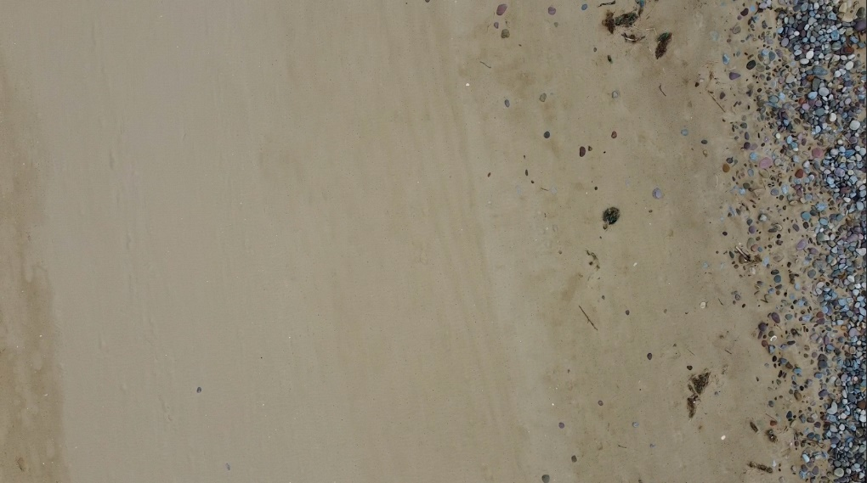
Appendix 1: day one of data collection, extremely windy conditions made it difficult to assess however the land seems flat and wind swept (taken from 10m).
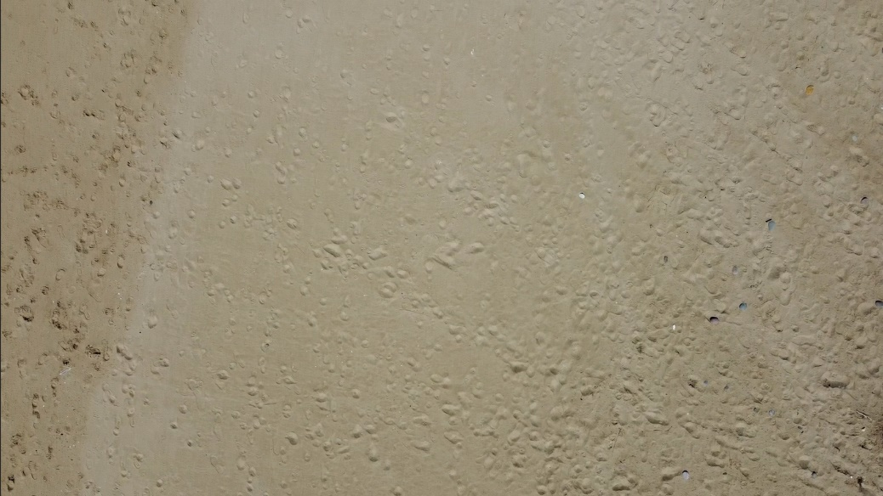
Appendix 2: day two. This footage is a lot clearer as there was less wind and therefore less wobble from the drone. You can visibly see lumps of sand formed from overnight wind (taken from 10m).
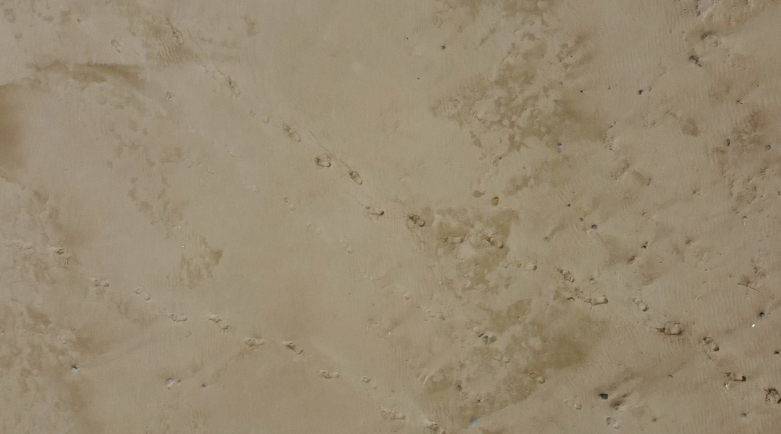
Appendix 3: day three of data collection. The land seems to have flattened and the drone footage was nice and smooth, so the wind speed but have been low (taken from 10m).
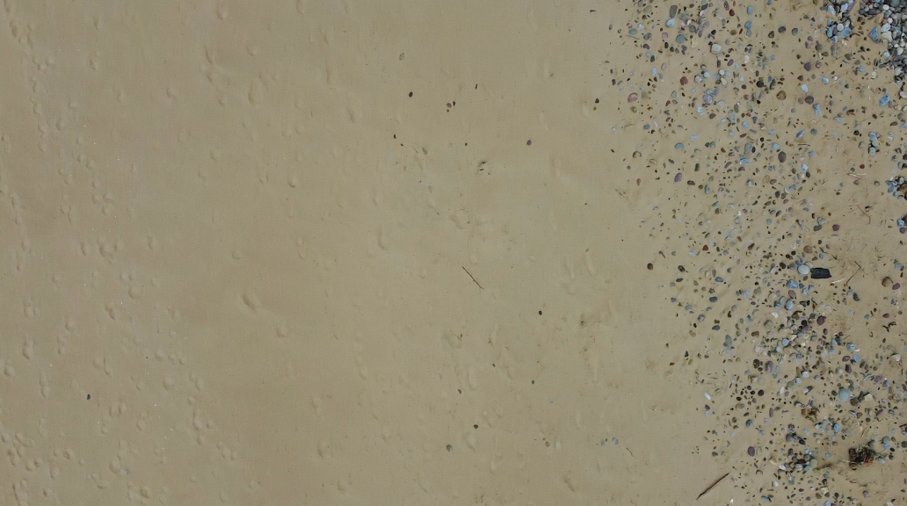
Appendix 4: day four of data collection found rocks uncovered due to overnight wind and swell (taken from 10m).
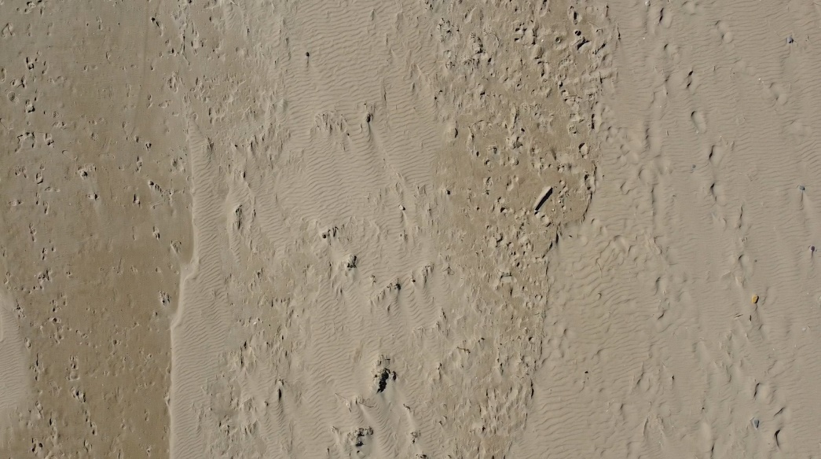
Appendix 5: day five saw the biggest change in the landscape. You can notice stronger lines of sand built up (taken from 10m).
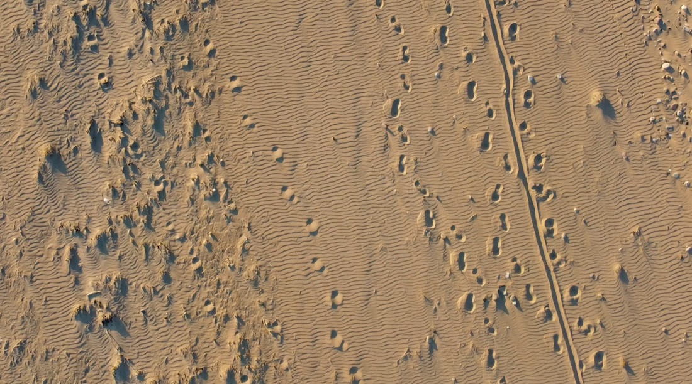
Appendix 6: day six of data collection was similar to day five in regards to visible strong lines shown. However, there is a change of light due to the sun on the sand dunes which is a slight issue as it makes the images harder to compare as the light creates harsher shadows (taken from 10m).
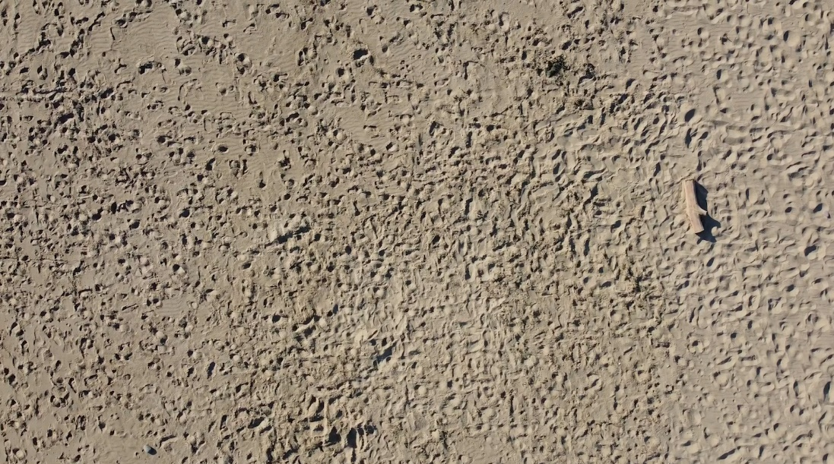
Appendix 7: day seven of data collection. The high water line seems to have disappeared from our path that we set out to film. There is also an increase of human footsteps and a section of log that has been washed in by the tide overnight (taken from 10m).
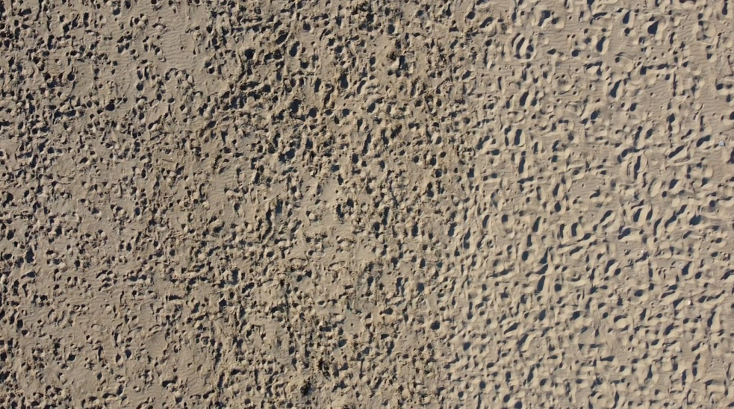
Appendix 8: day eight was similar to day sevens data collection. An increase in human footsteps, hard to distinguish the high tide line and the log has been taken out by the tide (taken from 10m).
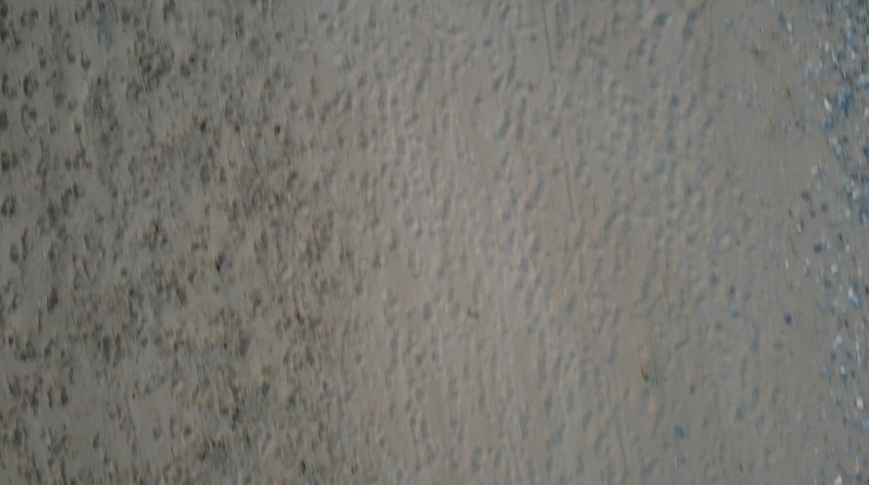
Appendix 9: drone appears to be out of focus on day nine. Usually the ISO is too high (taken from 10m).
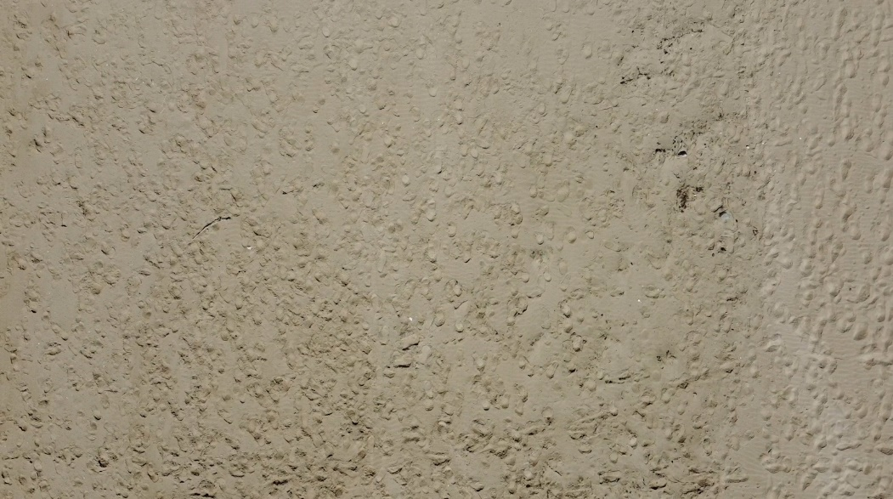
Appendix 10: day ten saw an increase in sand build up, suggesting higher wind speeds (taken from 10m).

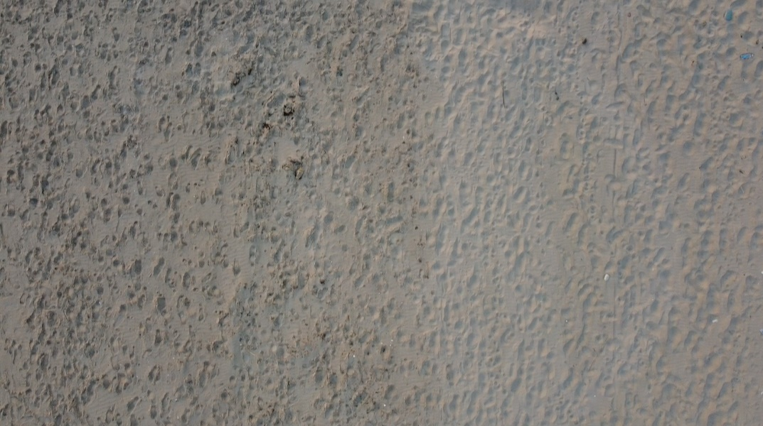
Appendix 11: day eleven of data collection saw an increase in human footsteps again and a clear distinction between hard and soft sand (taken from 10m).
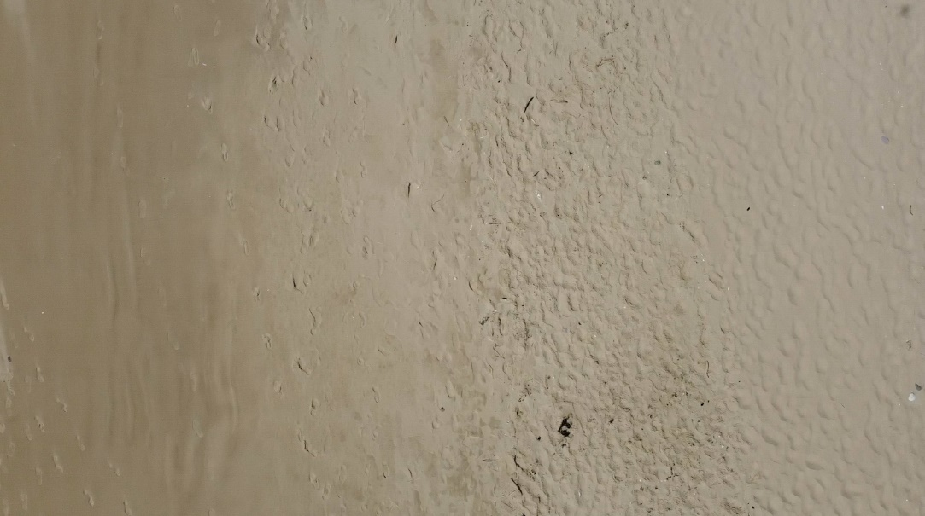
Appendix 12: on day twelve of data collection, we found fewer build ups of sand than seen previously, but still a distinct high-water line (taken from 10m).
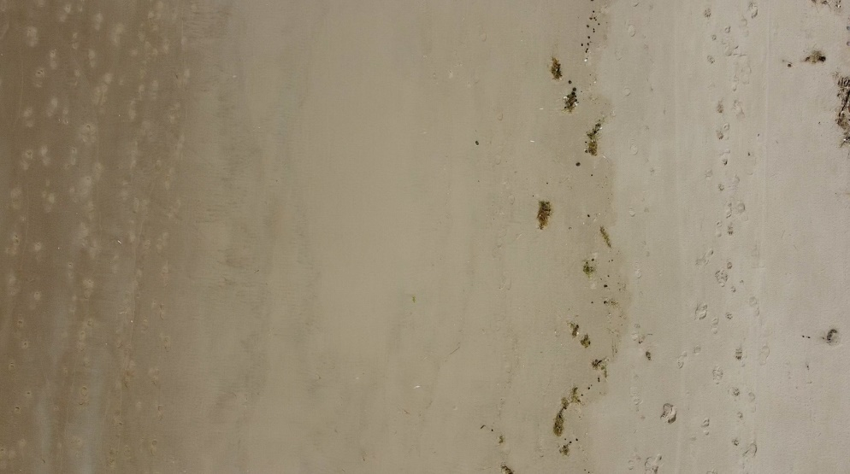
Appendix 13: day thirteen is similar to the previous day, a distinct hightide line is shown, perhaps with more wind as seaweed and rocks have been brought in (taken from 10m).
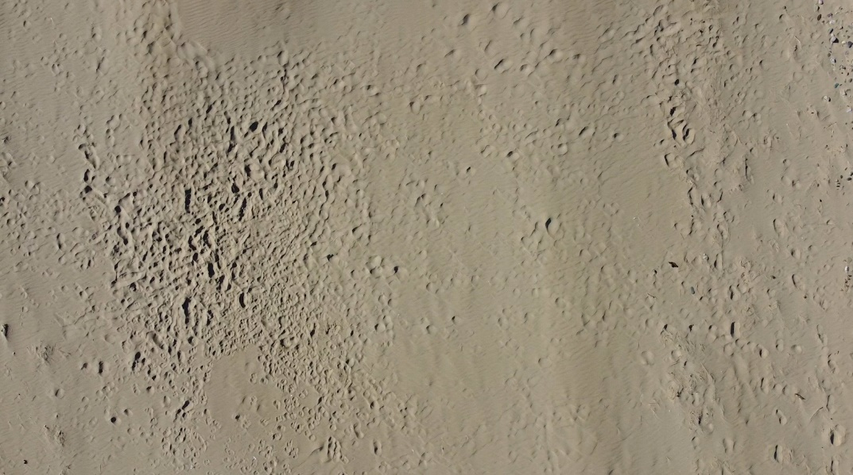
Appendix 14: day fourteen of data collection was very windy, as seen from the visible lumps and marks in the sand (taken from 10m).
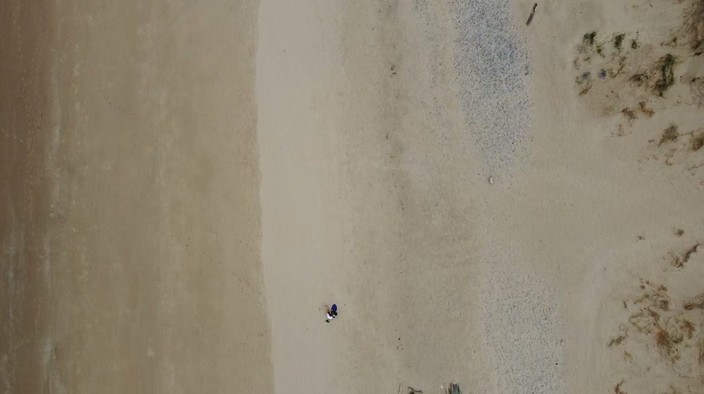
Appendix 15: day one again but taken from the nearest point of similarity at 50m.
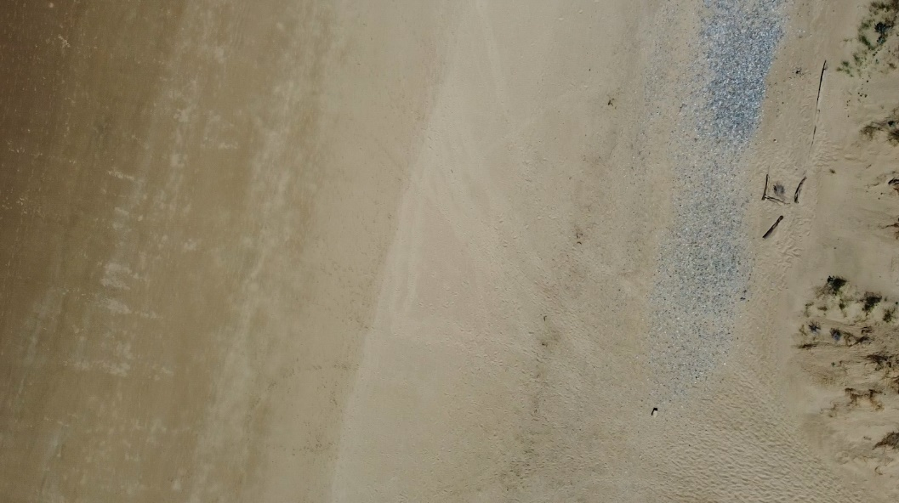
Appendix 16: day two taken from 50m. Visible changes in the sand, suggesting strong wind.
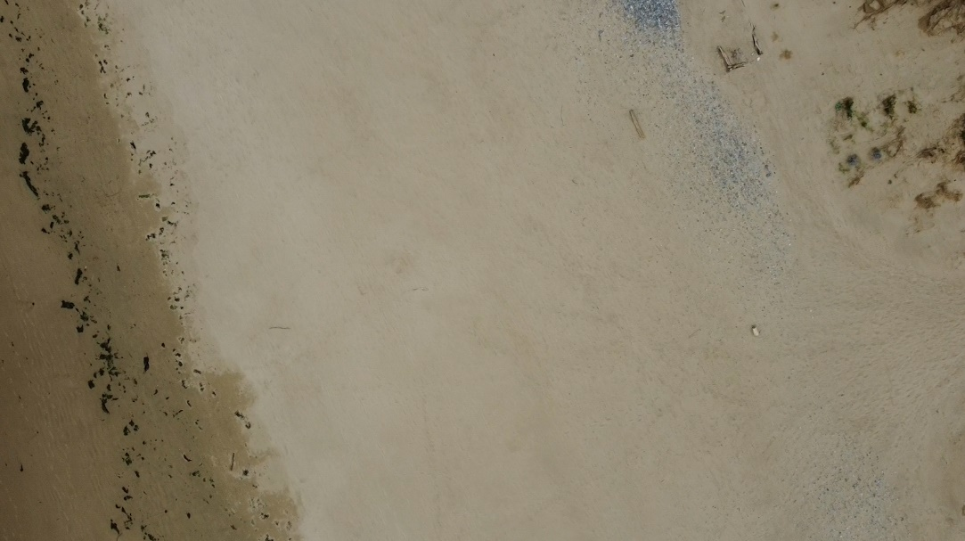
Appendix 17: day three taken from 50m. The land seems nice and flat and there is a distinct high-tide line. You can see differences from the previous day (wood drifted).
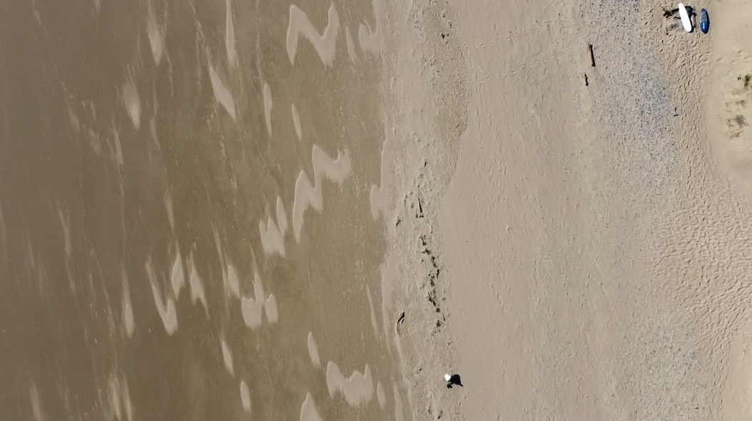
Appendix 18: day four taken from 50m. Lots of changes in the sand, wood has drifted again.
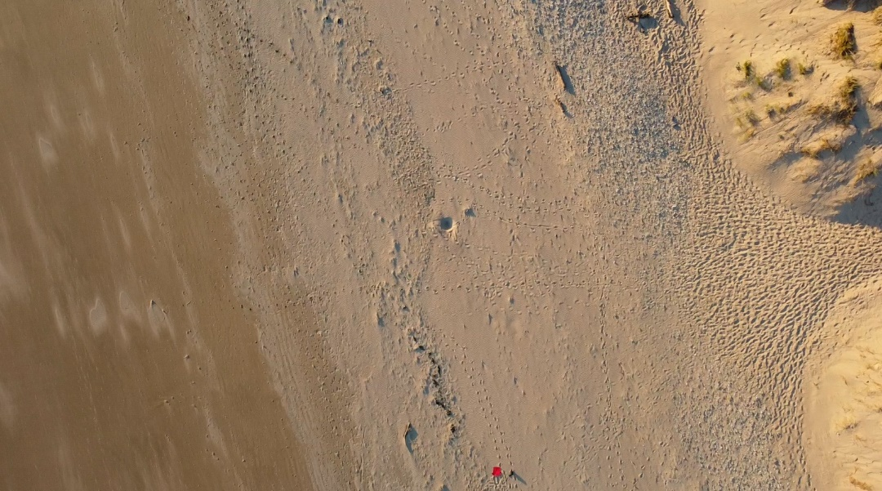
Appendix 19: day six of data collection taken from 50m. Lots of strong lines shown again but hard to compare as the sun from the sand dune creates harsh shadows.
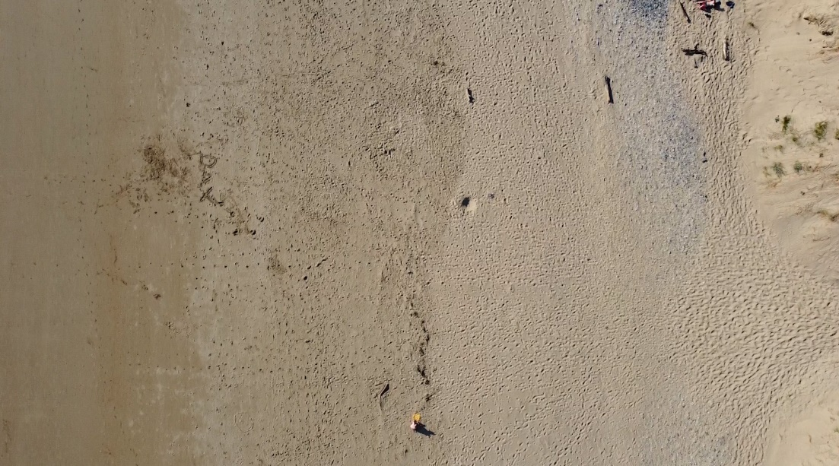
Appendix 20: day seven of data collection taken from 50m. Here you can see lots of lines and movement within the sand, suggesting wind overnight. More wood movement and an increase in human footsteps.
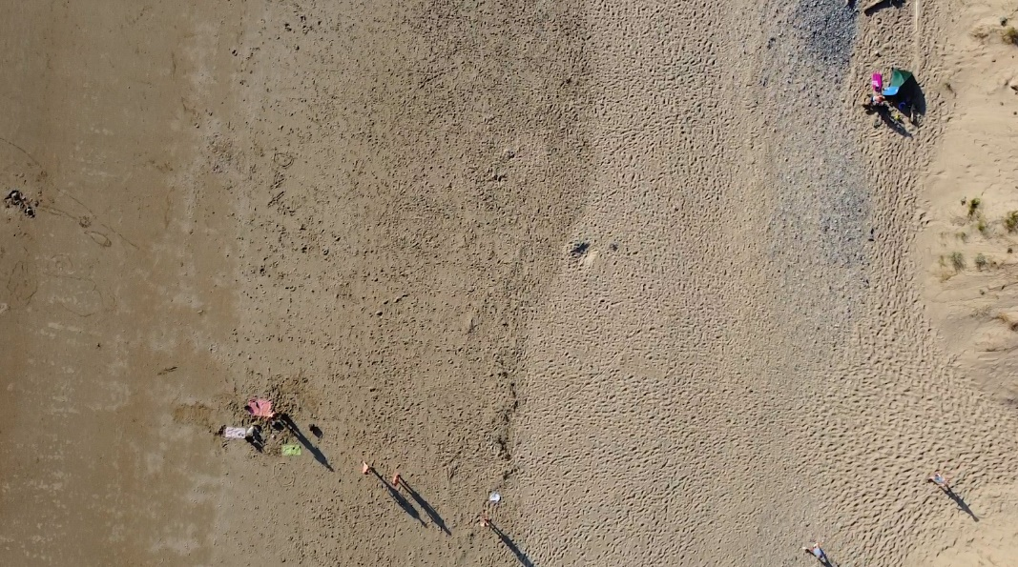
Appendix 21: day eight of data collection from 50m. Similar to day seven, still an increase in human footsteps (visibly busier too). Lots of lines and lumps in the sand.
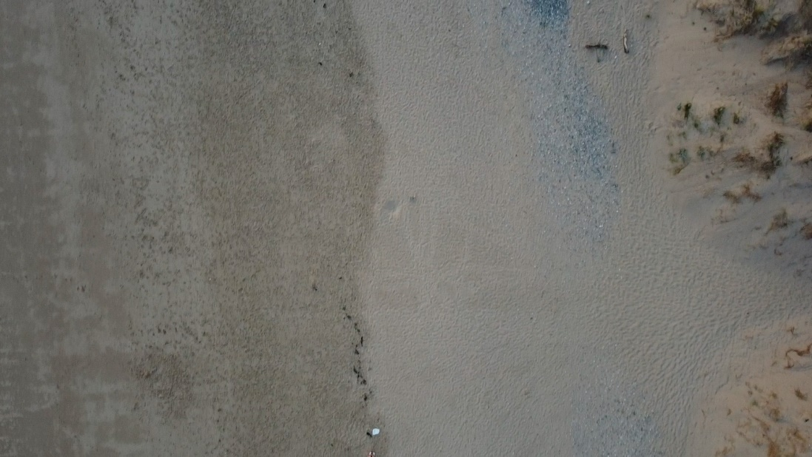
Appendix 22: day nine of data collection from 50m. A change in lighting makes it harder to read and compare but still solid lines visible and changes seen in sand.
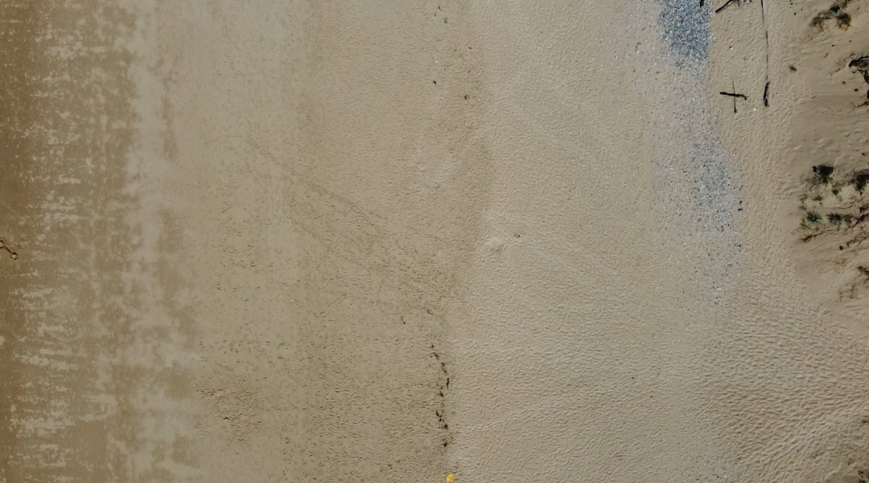
Appendix 23: day ten of data collection from 50m. Lots of sand change and build up of sand.
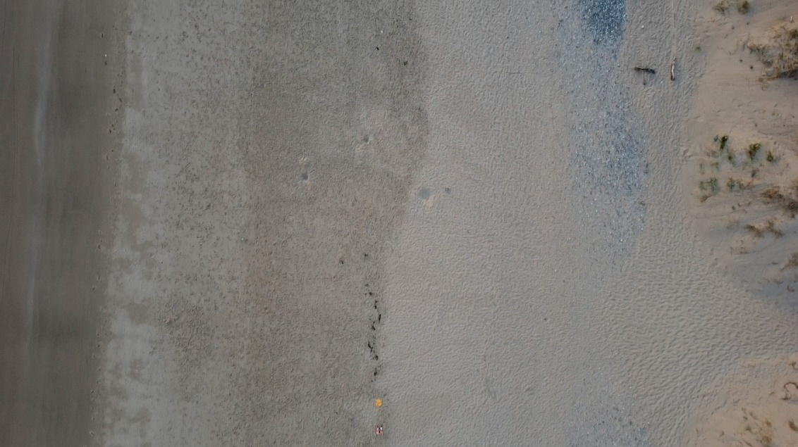
Appendix 24: day eleven of data collection from 50m. An increase in human footsteps can be seen again, as well as sand movement from wind and tide.
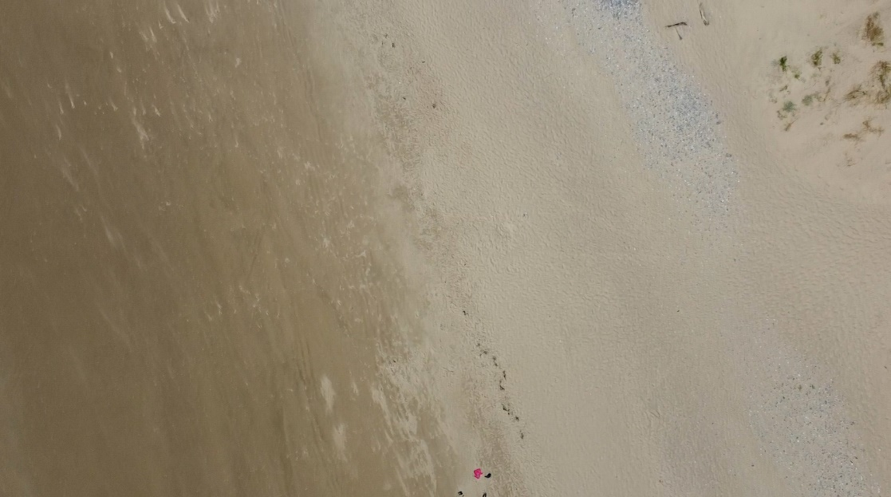
Appendix 25: day twelve captured from 50m.
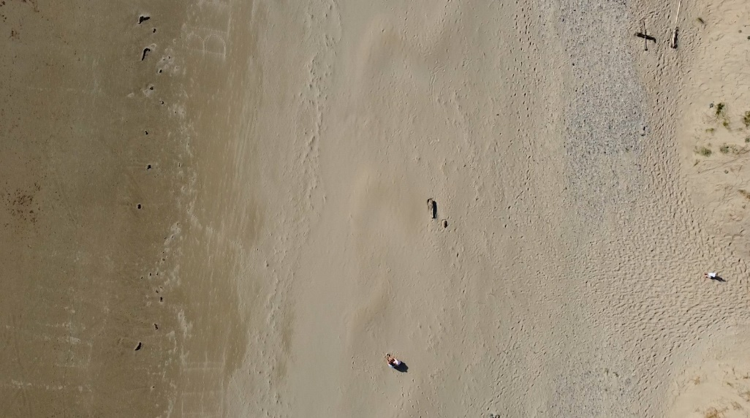
Appendix 26: day thirteen captured from 50m.
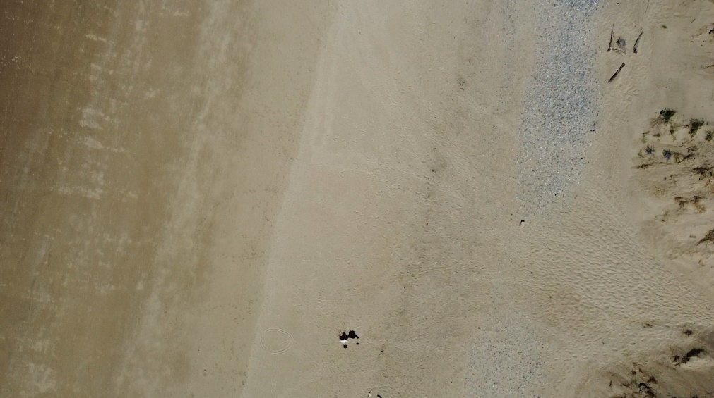
Appendix 27: day fourteen captured from 50m.

