Aging animal bones.

In regard to aging animal bones, the key concepts would be why we age them and how. Determining the age at death can provide vital information into what was happening at a particular time with humans, land and animals (Davis, 1987. P. 39). For example, calves being killed could mean they were killed for meat for human consumption, a herd with a wide variety of ages could indicate they were either eradicated by disease, or there was an over population of the animal to human ratio. Older cows could indicate they were dairy cows and no longer have value, or they were needed for leather.
The main ways to determine age at death are bone fusion, teeth eruption and analysing cementum increments (O’ Connor, 2004. P. 80).
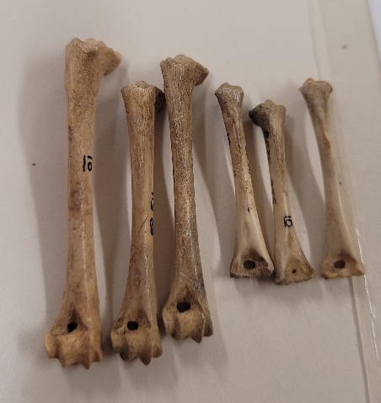
This picture (figure 1) shows six lepus humeri bones. The three on the left have fused on the bottom whereas the three on the right have not. This indicates the three on the right were juveniles at age of death and the three on the left were adults.
Silver (n.d) has done in-depth research into which bones fuse with each other and at what stage, depending on the species. For example, a distal radius on an ovis will fuse at roughly three years old, whereas on a lupus it is at around a year old. If more bones are present from the same animal, it is possible to narrow down the age at death (Davis, 1987. P. 39). For example, an ovis proximal epiphysis humerus fuses at three to three and a half years, and the distal epiphysis tibia fuses at one and a half to two years, so if the distal tibia is fused and the distal humerus is not, this would indicate the ovis was at least one and a half years old but not older than three and a half years old.
Figure 1 lepus humeri
This research is useful, but limited; firstly, the research does not include lepus and it can only narrow it down to two categories, juvenile or adult, and depending on how many bones one has from the same animal, narrowing it down further may not be possible.
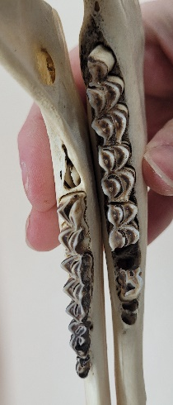
Another way to determine age at death would be through teeth. Tooth eruption is another way to determine whether an animal was a juvenile or an adult at death. Discrepancies arise when determining whether a tooth is classed as erupted or not which varies between species (O’Connor, 2004. P. 84).
Figure 2 compares a juvenile mandible and an adult mandible. From this angle it is clear to see the M₃ on the juvenile is below the gum line but erupted in the adult.
Senior adults will have more wear on their teeth than younger adults, therefore reducing the height of teeth. The more the teeth are worn indicates the older the animal was when it died (O’Connor, 2004. P. 80). Measuring the cementum increments can give an accurate age of death, but the accuracy can differ between species and gender (O’Connor, 2004. P. 82).
Figure 2 ovis juvenile mandible and adult mandible.
References:
Davis, S.J.M. (1987) The archaeology of animals. London: Batsford.
O’Connor, T. (2004) The archaeology of animal bones. Pbk. ed. Stroud: Sutton.

Images:
Figure 1- taken at UWTSD Lampeter, 20/02/2023.
Figure 2- taken at UWTSD Lampeter, 27/02/2023.

