

Sefydliad Dysgu Canol Dinas /
Institute of Inner-City Learning

BA Leadership and Management

Financial and Operational Strategies for Nurseries Coping with the Rising Number of Children with Special Educational Needs and Disabilities (SEND) in England.

Mohammed Irshad Siddiqui (2236535)

Supervisor: Dr Patrick Yeboah (LCLM6005).

Dissertation submitted as part of the requirements for the award of BA Leadership and Management.

03/2026

DECLARATION:

I, Mohammed Irshad Siddiqui declare that this dissertation has been composed by myself, that the work contained herein is entirely my own except where explicitly stated otherwise in the text, and that this work has not been submitted for any other degree or qualification, in whole or in part, except as specified.

Signature: M Siddiqui........

Date: 03/2026……………...

Acknowledgements:
I would like to express my sincere gratitude to my supervisor, Patrick Yeboah, for his continuous guidance, support, and valuable feedback throughout this research project. His advice and encouragement have been essential in shaping the direction and quality of this work.
I am also thankful to my lecturers at UWTSD Birmingham for their teaching, knowledge, and academic support during my studies. Their input has helped me develop the skills needed to complete this assignment successfully.
Finally, I would like to give special thanks to my daughter, whose experience as a SEND teacher in a nursery inspired the focus of this research. Her insights into the challenges faced in early years settings provided valuable perspective and motivation for this study.
I am deeply grateful to everyone who supported me throughout this journey.

Abstract:

This study critically examines the financial and operational strategies adopted by nurseries in England in response to the rising number of children with Special Educational Needs and Disabilities (SEND). Using a systematic literature review of academic, policy, and sector-based sources published between 2014 and 2025, the research identifies three interconnected themes: increasing SEND demand, structural limitations within funding systems, and organisational responses within early years settings. The findings indicate that although SEND identification has risen significantly, funding mechanisms have not proportionately adapted, placing sustained pressure on nursery providers. As a result, nurseries rely on adaptive strategies such as workforce training, SENCO leadership, and multi-agency collaboration. However, the analysis suggests these responses are largely reactive and insufficient to address systemic challenges. The study concludes that without structural reform to SEND funding and support systems, the long-term sustainability of inclusive early years provision remains at risk.

TABLE OF CONTENTS:

CHAPTER 1: INTRODUCTION 10
1.1 Introduction 10
1.2 Background 11
1.3 Research Aim 12
1.4 Research Objectives 12
1.5 Research Questions 13
1.6 Chapter Summary 13
CHAPTER 2: LITERATURE REVIEW: 14
2.1 Introduction 14
2.2 Growth in SEND Identification and Demand in Early Years: 15
2.3 SEND Funding Systems and Financial Pressures: 16
2.4 Operational Challenges in Inclusive Early Years Provision: 17
2.5 Inclusion, Ethics and Equity: 17
2.6 Nursery Sustainability and Business Strategies: 18
2.7 Development of Knowledge Over Time: 18
2.8 Identification of the Research Gap: 19
Literature Analysis Grid: 20
Table 1: 20
2.9 Chapter Summary: 21
CHAPTER 3: RESEARCH METHODOLOGY: 22
3.1 Systematic Literature Review (SLR): 22
3.2 Search Strategy: 23
3.3 Search Terms: 24
3.4 Keywords: 24
3.5 Databases and Data Sources: 24
3.6 Inclusion and Exclusion Criteria: 25
3.6.1 Inclusion Criteria: 25
3.6.2 Exclusion Criteria: 26
3.7 Search Results: 26
3.8 Ethical Considerations: 26
3.9 Chapter Summary: 27
CHAPTER 4: RESULTS AND DISCUSSION 27
4.1) Introduction 27
4.2) Rising Demand for SEND Support in Early Years Settings 28
Table 2). Dataset for SEND Funding and EHC (Education, Health and Care) Plan Growth (2015–2025). 28
Figure 1): 30
Figure 2a) and 2b) 31
4.3) Financial Pressures and SEND Funding Challenges: 32
Figure 3: Financial Pressure within the SEND Funding System 33
Figure 4): Operational Strategies Supporting SEND Provision in Nurseries 35
Table 3) 35
4.5) Critical Discussion of Findings 37
4.6) Relationship Between Findings and Research Questions 39
4.7) Theoretical Implications 39
4.8) Conclusion 40
4.9) Recommendations 40
CHAPTER 5: Recommendations, Conclusion and Limitations of the Research 41
5.1 Recommendations 41
5.2 Conclusion 42
5.3 Limitations of the Research 43
Reference List: 44

LIST OF FIGURES:

Table 1): Literature Analysis Grid:

Table 2): Dataset for SEND Funding and EHC (Education, Health and Care) Plan Growth (2015–2025).

Table 3): Summarises the main strategies identified in the reviewed studies.
Figure 1): Growth in SEND Demand versus High Needs Funding in England (2015–2025).
Figure 2a) and 2b): Growth in SEND Identification in England.
Figure 3): Financial Pressure within the SEND Funding System.
Figure 4): Operational Strategies Supporting SEND Provision in Nurseries.

List of Abbreviations:
DfE – Department for Education
SEND – Special Educational Needs and Disabilities
SENCO – Special Educational Needs Coordinator
EHC Plan – Education, Health and Care Plan
NAO – National Audit Office
IFS – Institute for Fiscal Studies
NDNA – National Day Nurseries Association
SLR – Systematic Literature Review
PRISMA – Preferred Reporting Items for Systematic Reviews and Meta-Analyses.
EYFS – Early Years Foundation Stage
LA – Local Authority
SENDCo – Special Educational Needs and Disabilities Coordinator (alternative spelling).

Financial and Operational Strategies for Nurseries Coping with the Rising Number of Children with Special Educational Needs and Disabilities (SEND) in England.

CHAPTER 1: INTRODUCTION

1.1 Introduction
Early years education plays a key role in shaping children’s learning, development and wellbeing. Nurseries do not only support children in their first stages of education, but they also enable parents to work and contribute to the wider economy. In England, nurseries are increasingly supporting children with Special Educational Needs and Disabilities. Recent data shows that over 1.7 million pupils are identified with SEND, and the number continues to rise (Department for Education, 2024). This increase is being felt strongly in early years settings, where staff are working to meet a wider range of needs with limited resources.
Providing inclusive early years education is widely recognised as essential for improving long term outcomes for children with SEND (Pascal and Bertram, 2019). However, delivering this support is not straightforward. It often requires additional staff, specialist training, adapted resources and closer partnership working with health and education professionals (Griggs and Bussard, 2017). While nurseries are committed to inclusion, many are finding it increasingly difficult to balance quality care with financial sustainability. This chapter introduces the context for the study and outlines why this research is both timely and necessary.

1.2 Background
Over the past decade, the number of children identified with SEND has steadily increased across England. The Department for Education (2024) reports that SEND identification is at its highest level, with growing numbers of children requiring additional support in early years settings. This trend is creating significant pressure on nurseries, which are often the first formal education setting to support children with developmental, behavioural or communication needs.
Supporting children with SEND usually involves higher staffing ratios, more planning time, specialist interventions and suitable learning environments. These requirements increase operational costs and place additional demands on staff (Griggs and Bussard, 2017). However, funding mechanisms such as local authority inclusion funding, the Disability Access Fund and SEND top ups rarely cover the full cost of this support (Early Years Alliance, 2023). Many nurseries report that funding is delayed, inconsistent or insufficient, leaving them to absorb the financial impact themselves.
Sector bodies have raised serious concerns about the sustainability of this model. The Early Years Alliance (2023) found that most nurseries believe SEND funding does not reflect real costs, while the National Day Nurseries Association (2023) reported that some providers have had to limit SEND admissions because they cannot afford to offer appropriate support. This creates a difficult situation where nurseries must choose between inclusion and financial survival. It also raises concerns about equality of access for families whose children need extra support.
The impact of nursery closures and reduced capacity extends beyond early years education. When childcare becomes unavailable or unstable, parents may be forced to reduce their working hours or leave employment altogether. Research shows that mothers are particularly affected by childcare shortages, which in turn affects household income and economic productivity (Pisanu, 2024). At the same time, local authorities are under pressure due to rising high needs costs. Both the Institute for Fiscal Studies (2024) and the National Audit Office (2024) have highlighted growing deficits in high needs budgets, describing the current system as financially unsustainable.
Despite these challenges, there is limited research on how nurseries themselves are responding. Most existing studies focus on policy or funding structures, rather than on the practical strategies used by nursery managers and SENCOs to cope with rising SEND demand (Rad, Matthews and Buzdugan, 2022). Some nurseries share resources, adjust staffing models, seek external grants or form partnerships with schools and charities. Others rely on fundraising or voluntary parental contributions. However, there is little evidence on which of these approaches are effective in maintaining both inclusion and financial stability.
Operational challenges also play a major role. Many nurseries struggle to access specialist services, consistent SENCO support and high-quality training opportunities (Rix, Hall and Nind, 2021). Early intervention is known to improve outcomes for children with SEND (Pascal and Bertram, 2019), yet many settings lack the capacity to implement it fully. Rising costs for staffing, utilities and equipment further increase the pressure on already tight budgets (Smith, 2023). Together, these factors create a complex environment where nurseries must constantly balance care quality, staff wellbeing and financial survival.

1.3 Research Aim
The aim of this research is to investigate how nurseries in England are coping financially and operationally with the increasing number of children with Special Educational Needs and Disabilities, and to identify strategies that support both inclusion and long-term sustainability.

1.4 Research Objectives
The objectives of this study are:
To examine the main cost drivers associated with admitting and supporting children with SEND in nurseries.
To analyse the financial and operational strategies nurseries use to cope with rising SEND demand.
To evaluate the adequacy of external funding and support mechanisms, including local authority funding, the Early Years Inclusion Fund and the Disability Access Fund.
To identify best practice approaches that can inform nursery management and policy development.

1.5 Research Questions
This study is guided by the following research questions:
What financial and operational challenges do nurseries face when supporting children with SEND?
What coping strategies are nurseries adopting, and how effective are these in sustaining their operations?
How do external funding mechanisms affect nurseries’ ability to provide inclusive early years education?
What recommendations can be developed to improve nursery sustainability and outcomes for children with SEND?

1.6 Chapter Summary
This chapter has outlined the context and rationale for the study. It has shown that while nurseries play a vital role in supporting children with SEND, they face growing financial pressures, operational challenges and workforce demands. Rising SEND numbers, limited funding, increasing costs and inconsistent access to specialist support are placing many nurseries under significant strain. Although inclusion remains a core principle of early years education, there is a clear gap in understanding how nurseries are managing these pressures in practice.
By setting out the research aim, objectives and questions, this chapter establishes the foundation for the study. The next chapter will review the existing literature in more detail, examining current research on SEND provision, funding challenges and sustainability in the early years sector.

CHAPTER 2: LITERATURE REVIEW:

2.1 Introduction
This chapter critically reviews existing literature relating to Special Educational Needs and Disabilities (SEND) in early years settings, with a particular focus on the financial and operational pressures faced by nurseries in England. The review examines how knowledge in this area has developed over time. It explores key themes such as rising SEND demand, funding arrangements, operational challenges and inclusion practices, and highlights differing perspectives within the literature. While a substantial body of research explores SEND policy and educational inclusion, this chapter argues that there is a clear gap in research examining how nurseries respond at an organisational and business level. Identifying this gap helps to establish the relevance and importance of the present study.

2.2 Growth in SEND Identification and Demand in Early Years:
One of the most consistent themes in the literature is the steady rise in the number of children identified with SEND. Over the past decade, SEND identification has increased across all educational stages, including early years provision. Department for Educations recent data shows that the proportion of children identified with SEND has reached historically high levels (DfE, 2024). Earlier studies often framed this rise as a positive outcome of improved diagnostic practices and greater awareness (Lindsay, 2016). More recent research, however, suggests that rising identification also reflects wider social and systemic factors, including increased developmental vulnerability, family stress and health inequalities (Blanden, Crawford and Farquharson, 2020).
In early years settings, increased SEND identification presents particular challenges. Nurseries are often the first formal environment in which developmental delays, communication difficulties or behavioural needs are identified (Pascal and Bertram, 2019). This early identification role places significant responsibility on providers. Wearmouth et al. (2017) argue that inclusive early years practice is grounded in early recognition of need, responsive pedagogy and close collaboration with families and external professionals. They emphasise that nurseries are expected to create enabling environments that support diverse developmental needs from the earliest stages of education.
While this approach is widely supported on ethical and educational grounds, it assumes that settings have sufficient capacity, training and resources to respond effectively. Several authors argue that early year’s providers have not been given the structural or financial support required to meet rising expectations (Rix, Hall and Nind, 2021). As SEND demand increases, nurseries face growing responsibility without corresponding increases in support, creating pressure at both operational and financial levels.

2.3 SEND Funding Systems and Financial Pressures:
Funding arrangements for SEND have been a major focus of research and policy debate. In England, SEND funding is largely distributed through the high-needs block, with additional mechanisms such as local authority inclusion funding, the Disability Access Fund and SEND top-ups for early years settings. Earlier policy documents suggested that increased funding would improve outcomes and promote inclusion (DfE, 2014). However, more recent evaluations challenge this assumption.
The National Audit Office (2024) highlights that although high-needs funding has increased in real terms, demand has risen more rapidly, leading to persistent budget deficits at local authority level. Similarly, the Institute for Fiscal Studies (2024) argues that funding increases have largely been reactive rather than strategic, failing to address underlying cost drivers such as staffing intensity and specialist support. These findings suggest a structural mismatch between funding design and the realities of SEND provision.
At the nursery level, the literature consistently reports that SEND funding rarely covers the full cost of support. The Early Years Alliance (2023) found that most nurseries receive funding that is either insufficient or delayed, making it difficult to plan staffing and interventions. NDNA (2023) reports similar findings, noting that nurseries often subsidise SEND provision using income from non-SEND places. This cross-subsidisation model is widely criticised as unsustainable, particularly in a sector already operating on narrow margins.
Some authors argue that funding challenges are not only about overall amounts but also about flexibility and timing. Delays in funding approval can leave nurseries carrying additional costs for months (Rad et al., 2022). In Birmingham, wider fiscal pressures on the local authority have exacerbated these problems, with the city council issuing a Section 114 notice due to budget deficits, compelling priority spending on statutory duties and delaying other allocations such as SEND support funds. This financial strain on public services feeds through to early years settings, which must often commit to higher staffing and specialist support for children with SEND long before funding arrives. Local accounts from parents and sector surveys in the city further highlight extensive delays in SEND support and funding distribution, reinforcing that financial strain is not just a background issue but a central factor shaping nursery decision making and sustainability (Birmingham City Council 2023).

2.4 Operational Challenges in Inclusive Early Years Provision:
Alongside funding pressures, the literature identifies a range of operational challenges associated with SEND inclusion. Staffing is consistently identified as the most significant cost and operational issue. Children with SEND often require higher staff-to-child ratios, individual support and careful planning, which increases both staffing numbers and workload intensity (Griggs and Bussard, 2017). Research shows that recruiting and retaining suitably trained staff is increasingly difficult, particularly given low pay levels in the early years sector (Blanden et al., 2020).
Training and professional development are also key concerns. While inclusive practice requires staff to have confidence and specialist knowledge, access to training is inconsistent (Rix, Hall and Nind, 2021). Earlier research often framed training as a matter of individual staff competence. More recent studies adopt a broader organisational perspective, arguing that inclusion depends on leadership, culture and structural support, not just individual skills (Ainscow, 2020).
Operational challenges also include access to external services such as speech and language therapy, educational psychology and health support. Delays in accessing these services can place additional pressure on nursery staff, who may feel responsible for meeting needs beyond their expertise (Pascal and Bertram, 2019). The literature increasingly recognises that nurseries operate within complex local systems and that operational challenges are shaped by relationships with local authorities and health services.

2.5 Inclusion, Ethics and Equity:
Inclusion is a central principle underpinning SEND policy, and much of the literature frames SEND provision in ethical and rights-based terms. Authors such as Rix et al. (2021) emphasise that inclusive early education supports social justice and improves long-term outcomes for children. However, several studies highlight tensions between inclusive ideals and financial realities.
The Early Years Alliance (2023) warns that insufficient funding risks creating a two-tier system, where only well-resourced providers can afford to offer high-quality SEND provision. Similarly, NDNA (2023) reports that some nurseries limits SEND admissions or rely on voluntary parental contributions, raising concerns about equity and access. While such strategies may be necessary for survival, they challenge the principle of universal inclusion.
This literature reflects a shift over time. Earlier work tended to focus on inclusion as a pedagogical issue. More recent studies increasingly recognise inclusion as a management and resource issue, shaped by funding structures and organisational capacity. This shift is important because it highlights the need to examine SEND inclusion through a business and operational lens.

2.6 Nursery Sustainability and Business Strategies:
Despite growing recognition of financial pressures, relatively few studies focus explicitly on how nurseries adapt their business models in response to SEND demand. Research on early years sustainability often focuses on market conditions, workforce issues or funding rates more generally (Blanden et al., 2020). SEND is frequently discussed as an added pressure, but not as a central analytical focus.
Where business strategies are discussed, the literature tends to be descriptive rather than evaluative. Sector reports mention strategies such as fundraising, partnership working, shared SENCO roles and flexible staffing models (NDNA, 2023). However, there is limited analysis of which strategies are effective, under what conditions, and with what consequences for quality and inclusion.
Rad et al. (2022) argue that more research is needed at provider level to understand how organisations respond to SEND pressures in practice. They suggest that without this evidence, policy debates risk overlooking the realities faced by frontline providers. This gap is particularly notable given the increasing emphasis on sustainability and resilience in public service provision.

2.7 Development of Knowledge Over Time:
Over time, research on SEND has changed in focus as pressures on the system have grown. Earlier studies mainly concentrated on identifying SEND, improving teaching approaches and understanding how support affects children’s development. At that stage, financial issues were not a major part of the discussion, largely because the scale of demand was smaller and funding pressures were less visible.
As the number of children with SEND increased, the cost of providing appropriate support also rose. This led researchers to pay more attention to how limited resources, staffing pressures and funding systems affect provision. Later studies began to highlight problems at a system level, including gaps between funding and demand and the strain placed on local authorities and providers.
More recent literature takes a more questioning approach. Reports from organisations such as the National Audit Office (2024) and the Institute for Fiscal Studies (2024) challenge whether current funding and governance arrangements are able to cope with rising SEND demand. Researchers also increasingly recognise that early year’s providers operate as businesses within a childcare market, not just as educational settings. However, despite this shift in perspective, there is still limited research that looks closely at how nurseries manage financial and operational pressures in practice. This lack of provider-level evidence highlights an important gap that this study seeks to address.

2.8 Identification of the Research Gap:
Although existing literature provides valuable insights into SEND policy, funding challenges and inclusion practices, several gaps remain. First, there is limited empirical research focusing specifically on nurseries as businesses managing SEND-related costs. Second, there is a lack of comparative analysis of different coping strategies and their effectiveness. Third, much of the literature relies on sector-level data or policy analysis, rather than examining decision-making at provider level.
This gap is important because nurseries are central to early intervention and inclusion. Without understanding how they manage financial and operational pressures, it is difficult to design policies that support sustainable provision. The present study addresses this gap by examining cost drivers, funding adequacy and coping strategies from the perspective of nursery managers and SENCOs, combining quantitative and qualitative evidence.

Table 1: Literature Analysis Grid:

Source Type | Number of Sources Reviewed | Key Themes Identified
Government Reports and Statistics (DfE, NAO, IFS) | 4 | Rising SEND identification; mismatch between funding growth and demand; structural deficits; delays and inflexibility in funding distribution
Sector and Professional Body Reports (Early Years Alliance, NDNA) | 4 | Inadequate and delayed SEND funding; nursery financial strain; restriction of SEND places; cross-subsidisation; sustainability risks
Academic Journal Articles | 6 | Inclusion theory; early intervention benefits; workforce challenges; organisational barriers to SEND provision; ethical tensions between inclusion and resources
Academic Books and Edited Volumes | 5 | Inclusive practice frameworks; operational requirements of SEND support; leadership and organisational capacity; professional development
Economic and Workforce Studies | 2 | Staffing costs; recruitment and retention issues; impact of low pay on quality and capacity; links between workforce and sustainability
Grey Literature and Policy Commentary | 2 | Rising nursery operating costs; real-world financial pressures; limitations of current funding models

2.9 Chapter Summary:
This chapter has critically reviewed literature on SEND provision in early years settings, highlighting key themes including rising demand, funding challenges, operational pressures and inclusion practices. The review shows that while SEND identification has increased and funding has grown, financial and operational pressures remain significant for nurseries. Although inclusion is widely supported in principle, inadequate funding and rising costs create tensions between ethical commitments and financial sustainability.
Importantly, the review identifies a clear gap in research examining how nurseries respond to these challenges in practice. By focusing on financial and operational strategies at provider level, this study seeks to contribute new knowledge that is relevant to practitioners, policymakers and researchers. The next chapter will outline the methodology used to investigate these issues in detail.

CHAPTER 3: RESEARCH METHODOLOGY:

3.1 Systematic Literature Review (SLR):
This study adopts a Systematic Literature Review (SLR) methodology to examine how nurseries in England are managing the financial and operational pressures associated with the rising number of children with Special Educational Needs and Disabilities (SEND). An SLR provides a structured, transparent, and replicable approach to identifying, evaluating, and synthesising existing research evidence (Tranfield, Denyer and Smart, 2003). Unlike a traditional narrative review, this approach reduces the risk of selective bias through the use of predefined inclusion criteria, systematic search procedures, and explicit evaluation processes.
The choice of an SLR is particularly appropriate given the complexity and multidisciplinary nature of the research problem. SEND provision in early years settings operates at the intersection of education policy, public finance, workforce management, and organisational sustainability. Existing evidence is fragmented across academic literature, government policy documents, sector reports, and regulatory reviews. A systematic review enables these diverse sources to be critically integrated, allowing for the development of a coherent and evidence-based understanding of how funding structures and operational practices influence nursery sustainability (Petticrew and Roberts, 2006).
The review primarily adopts a quantitative and policy-oriented perspective, drawing on statistical data, funding analyses, and system-level evaluations to examine trends in SEND prevalence, funding allocation, and resource pressures. Qualitative insights from academic studies and sector reports are also incorporated where they contribute to understanding organisational decision-making, staffing strategies, and adaptive responses within early years settings. This mixed but predominantly quantitative orientation allows the study to capture both measurable financial pressures and the practical realities faced by nursery providers.
From a business and management perspective, SLRs are increasingly employed to support evidence-based decision-making and policy evaluation (Denyer and Tranfield, 2009). This is directly relevant to the present study, which seeks not only to document SEND-related pressures but also to assess how nurseries respond strategically through staffing models, funding utilisation, and operational adaptation. Given that over 1.7 million children in England are now identified as having SEND, including a growing proportion within early years provision (DfE, 2024), a systematic approach is necessary to ensure that conclusions are grounded in comprehensive and reliable evidence.
An SLR is also appropriate because the study aims to synthesise and critically analyse existing knowledge rather than generate primary data. This methodological choice enables the identification of patterns, gaps, and limitations within current research, while maintaining feasibility and ethical integrity within the scope of the study.
However, while a Systematic Literature Review offers a rigorous and transparent method of evidence synthesis, it is not without limitations. The approach relies on published sources, meaning that informal or undocumented financial and operational practices adopted by nurseries may not be fully captured. This is particularly relevant in the early years sector, where many providers operate on a small scale and do not routinely publish detailed financial or strategic information. Acknowledging this limitation enhances the transparency of the methodology and highlights the value of future research using primary data to explore nursery-level practices in greater depth.

3.2 Search Strategy:
This study used a structured search strategy based on the evidence-based review model developed by Tranfield, Denyer and Smart (2003). This approach supports a clear and systematic process for identifying and reviewing academic literature and is widely used in social science research (Denyer and Tranfield, 2009). It involves three main stages: planning, searching, and reporting.
During the planning stage, the research aims and key concepts related to SEND funding, nursery operations, and financial sustainability were defined to guide the search process (Saunders, Lewis and Thornhill, 2019). The search focused on studies published between 2014 and 2025, reflecting developments following the SEND Code of Practice (DfE, 2014) and increasing funding pressures (NAO, 2024).
Searches were conducted across academic databases and official sector websites. Titles and abstracts were screened first, followed by full-text reviews to assess quality and relevance (Petticrew and Roberts, 2006; Booth, Sutton and Papaioannou, 2016). This structured approach ensured that only reliable and relevant sources were included.

3.3 Search Terms:
Search terms were developed iteratively to balance breadth and relevance. Boolean operators (AND / OR) were used to refine results and avoid excessive exclusion of relevant studies (Saunders, Lewis and Thornhill, 2019).
Key search strings included:
“Special Educational Needs and Disabilities” AND “early years” AND “funding”
“SEND” AND “nursery sustainability” AND “financial pressure”
“Early years” AND “high needs funding” AND “operational challenges”
“SEND inclusion” AND “staffing costs” AND “nurseries England”
(“local authority” OR “local council”) AND “SEND funding delays” AND “early years”
These combinations enabled the identification of both policy-level analyses and provider-level research, supporting a critical examination of how funding structures translate into operational realities.

3.4 Keywords:
Keywords were selected based on recurring terminology in preliminary readings and sector documentation. Consistent keyword use helped refine database searches and ensure alignment with the research questions.
Key words included:
Special Educational Needs and Disabilities (SEND); Early Years Education; Nurseries; Financial Sustainability; High Needs Funding; Disability Access Fund; Early Years Inclusion Fund; Staffing Ratios; SENCO; Operational Strategy; Local Authorities; England.
3.5 Databases and Data Sources:
To ensure academic rigour and policy relevance, literature was drawn from a combination of academic databases, government sources, and sector publications. Academic databases included Google Scholar, Emerald Insight, Taylor & Francis Online, ScienceDirect, and the University of Wales Trinity Saint David library database. These sources provided peer-reviewed journal articles and academic books addressing inclusion, early intervention, and organisational challenges in early years settings.
Official government data and reports were sourced from the Department for Education (DfE), National Audit Office (NAO), and Institute for Fiscal Studies (IFS). These sources were essential for providing authoritative evidence on SEND prevalence, funding levels, and system-level financial pressures. For example, DfE (2024) data indicates that 17.4% of pupils in England are identified with SEND, while NAO (2024) reports that local authority high-needs deficits exceeded £4.6 billion nationally.
Sector-specific insights were drawn from publications by the Early Years Alliance and the National Day Nurseries Association (NDNA). These reports provided practitioner perspectives on funding adequacy, staffing challenges, and sustainability risks, helping to bridge the gap between policy analysis and operational reality (Bryman, 2016).

3.6 Inclusion and Exclusion Criteria:
Clear inclusion and exclusion criteria were applied to maintain focus and methodological consistency.

3.6.1 Inclusion Criteria:
Included sources met the following conditions:
Published between 2014 and 2025
Written in English
Focused on SEND in early years or nursery settings
Addressed financial, operational, or organisational impacts
Peer-reviewed articles, academic books, government reports, or reputable sector publications
Empirical studies, policy evaluations, or critical analyses
This ensured that the review captured both theoretical perspectives and real-world evidence relevant to nursery sustainability (Creswell and Creswell, 2018).

3.6.2 Exclusion Criteria:
Sources were excluded if they:
Focused solely on compulsory schooling or higher education
Addressed SEND without reference to operational or financial implications
Were opinion-based blogs or non-credible online sources
Were published before 2014
Focused on non-UK contexts without transferable relevance
These exclusions helped maintain analytical precision and policy relevance (Saunders, Lewis and Thornhill, 2019).

3.7 Search Results:
The initial search identified approximately 230 sources. After title and abstract screening, 96 sources were retained for full-text review. Applying the eligibility criteria resulted in a final sample of 38 sources, comprising:
14 academic journal articles
7 academic books or edited volumes
9 government reports
8 sector and professional body publications
The selected literature revealed consistent themes, including rising SEND identification, funding shortfalls, staffing pressures, and delayed funding approvals. Importantly, while many sources documented system-level challenges, relatively few examined nursery-level financial and operational strategies, reinforcing the research gap addressed in this study.

3.8 Ethical Considerations:
Although this study relies exclusively on secondary data, ethical standards were upheld throughout the research process. Ethical guidance from the British Educational Research Association (BERA, 2018) informed the approach to data use, citation, and representation.
All sources were accurately referenced, and data were reported transparently without misrepresentation. No personal or confidential data were used, eliminating risks related to participant consent or data protection. Potential bias was mitigated through systematic searching, the inclusion of multiple perspectives, and critical appraisal of sources (Resnik, 2020).
3.9 Chapter Summary:
This chapter has outlined the methodological framework used to investigate financial and operational strategies adopted by nurseries supporting children with SEND in England. A Systematic Literature Review was selected to ensure a rigorous, transparent, and replicable approach to synthesising diverse evidence from academic, policy, and sector sources. The structured search strategy, clearly defined inclusion criteria, and ethical safeguards strengthen the reliability and credibility of the findings.
By systematically analysing existing literature, this methodology provides a robust foundation for addressing the research questions and identifying practical and policy-relevant insights.

CHAPTER 4: RESULTS AND DISCUSSION

4.1) Introduction
This chapter presents and critically analyses the findings derived from the systematic literature review conducted in Chapter 3. The purpose of this research was to examine the financial and operational strategies adopted by nurseries in England to manage the growing number of children identified with Special Educational Needs and Disabilities (SEND). The results are based on a structured synthesis of academic literature, government reports, and sector-based evidence relating to early years education, funding structures, and organisational management within nursery settings.
Over the past decade, early childhood education providers have experienced increasing pressure due to policy reforms, funding limitations, and rising levels of SEND identification. According to statistics published by the Department for Education, more than 1.7 million children in England are currently recorded as having SEND, with a notable increase in early years identification (DfE, 2024). This rise reflects both improved awareness and earlier diagnosis, but it also places substantial demands on nursery providers.
The analysis of the selected studies revealed three major themes shaping nursery sustainability:
- Rising demand for SEND support in early years settings
- Financial pressures linked to SEND funding structures
- Operational strategies used by nurseries to maintain inclusive provision
These themes emerged consistently across policy reports, academic research, and sector surveys, suggesting that the challenges experienced by nurseries are systemic rather than isolated. Importantly, the findings highlight a growing gap between policy expectations regarding inclusive education and the resources available to deliver such provision effectively.
This chapter not only presents the results of the review but also critically evaluates them in relation to existing literature and theoretical frameworks discussed in earlier chapters. In doing so, it provides a deeper understanding of how nurseries are adapting to complex financial and operational pressures.

4.2) Rising Demand for SEND Support in Early Years Settings:

Table 2). Dataset for SEND Funding and EHC (Education, Health and Care) Plan Growth (2015–2025).
A simple table based on official figures from the National Audit Office (NAO) and Department for Education showing:
- High Needs Block Funding in England
- Number of active EHC Plans (SEND support)
These two series together show funding trends and demand trends (which impact nursery financial operations).

Year | High Needs Funding (£bn, real terms) | EHC Plans (thousands)
2015 | 6.8 (baseline approx.) | ~380
2016 | 7.3 | ~410
2017 | 7.7 | ~440
2018 | 8.2 | ~470
2019 | 8.7 | ~500
2020 | 9.1 | ~530
2021 | 9.4 | ~560
2022 | 9.9 | ~590
2023 | 10.2 | ~620
2024 | 10.7 | ~576.5 (DfE stats include older data)
2025 | 10.7+ | 638.7 (actual from EHC census)
Sources:
• High needs funding increased to £10.7bn in 2024–25, up 58% from 2014–15 in real terms (NAO, 2025).
• Number of EHC plans increased to 638,700 in January 2025.

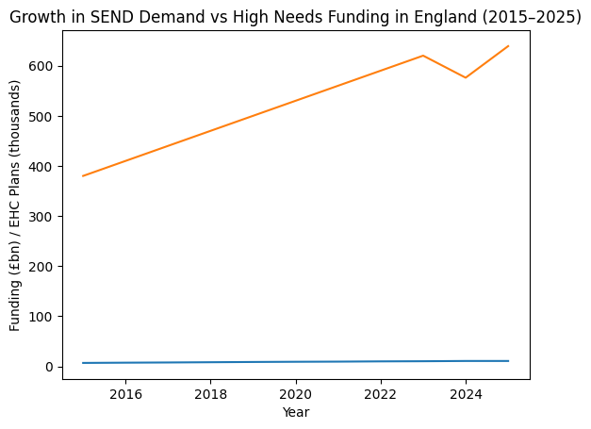
Figure 1): Growth in SEND Demand versus High Needs Funding in England (2015–2025).
Figure 1), shows that although high-needs funding has increased over time, the number of children with EHC plans has risen more rapidly. This growing gap helps explain why nurseries continue to experience financial pressure when supporting children with SEND (Department for Education, 2024; National Audit Office, 2024).
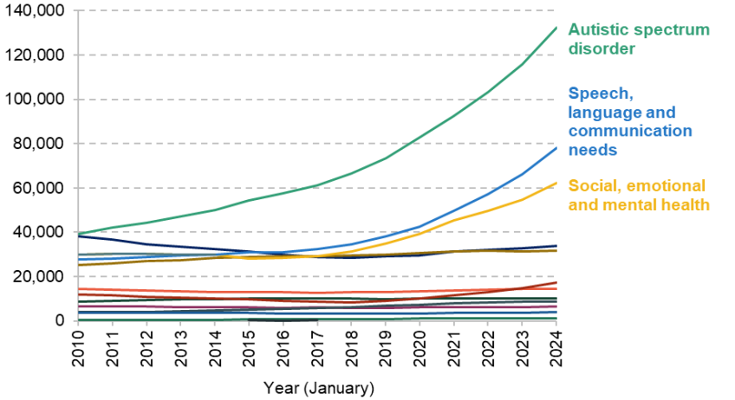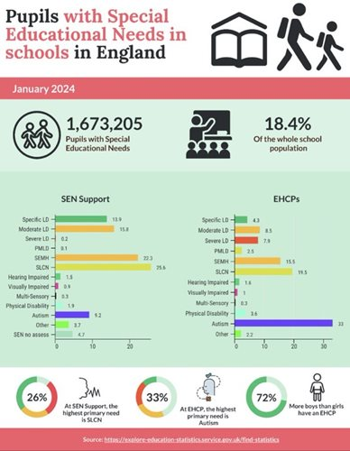
Figure 2a) and 2b) Growth in SEND Identification in England
Source: Adapted from Department for Education (2024).
One of the most significant findings emerging from the systematic review is the steady increase in the number of children identified with SEND within early years education. Government statistics indicate that SEND prevalence has increased across multiple categories, particularly speech and language difficulties, autism spectrum conditions, and social and emotional development needs (DfE, 2024).
From a policy perspective, this increase reflects the success of early identification initiatives introduced following the SEND reforms implemented in England. The introduction of the SEND Code of Practice aimed to improve inclusion and ensure that children receive support at an earlier stage (DfE, 2014). While these reforms have improved access to services, the literature suggests that they have also unintentionally increased operational pressures on early years providers.
Research by Rix, Sheehy and Fletcher-Campbell (2013) indicates that early year’s settings are now central to the SEND support system, often acting as the first point of identification for developmental difficulties. This shift has expanded the responsibilities of nursery practitioners, requiring them to perform roles that extend beyond traditional childcare and education.
Critically, several studies argue that the increasing complexity of SEND cases has amplified these challenges. Unlike earlier decades where needs were often identified later in schooling, nurseries now support children with complex developmental requirements at a much earlier stage (Pascal and Bertram, 2019). This requires additional staffing, training, and specialist interventions.
However, the literature also highlights an important contradiction within policy implementation. While inclusion policies emphasise early intervention, they do not always account for the operational capacity of nurseries. Smaller providers, in particular, face difficulties maintaining required staff ratios while simultaneously delivering individualised SEND support (NDNA, 2023).
From an organisational perspective, this situation can be explained through institutional theory, which suggests that organisations often adapt to external policy pressures even when resources are insufficient (Scott, 2014). Nurseries therefore attempt to maintain inclusive practices despite structural limitations within the funding system.
The evidence reviewed in this study therefore suggests that rising SEND demand is not only an educational issue but also a major operational and financial challenge affecting the sustainability of early years provision in England.

4.3) Financial Pressures and SEND Funding Challenges:

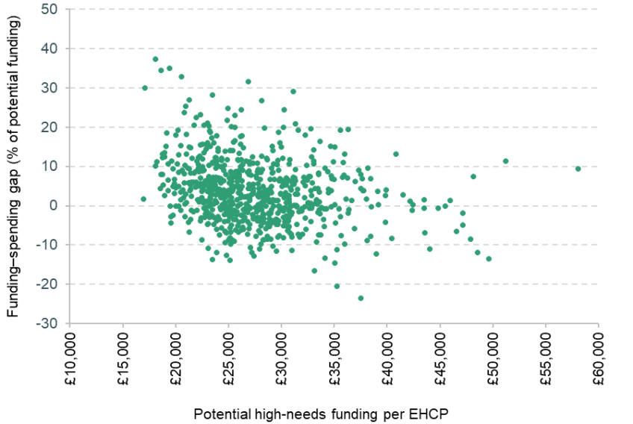
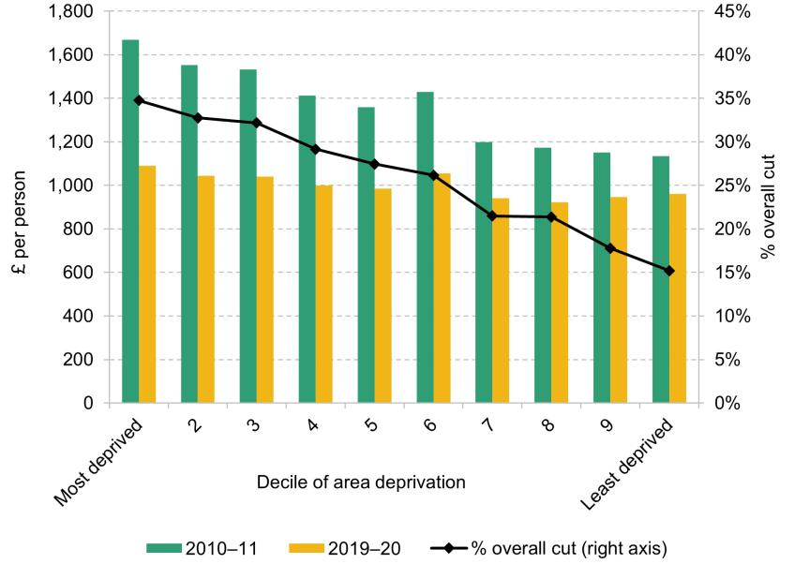
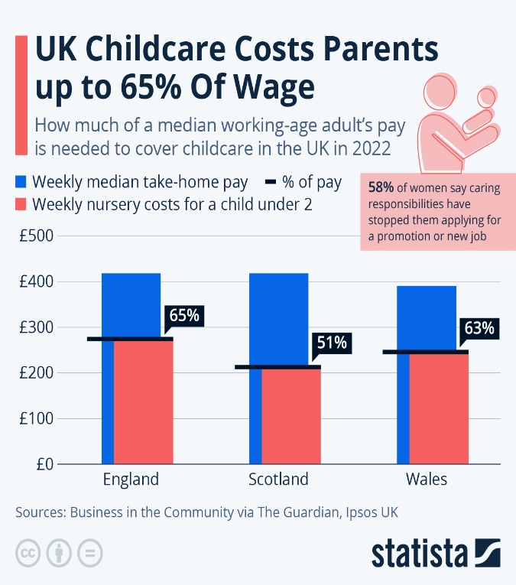
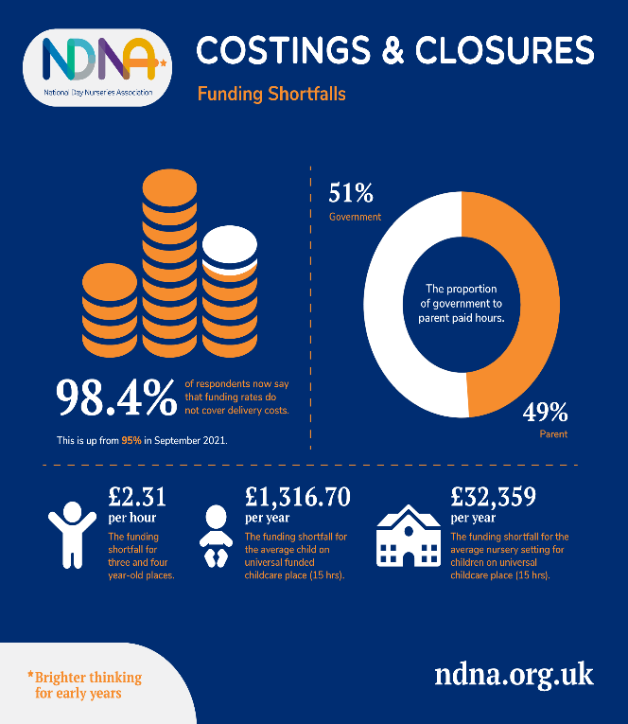

Figure 3: Financial Pressure within the SEND Funding System
Source: Adapted from National Audit Office (2024) and Institute for Fiscal Studies (2023).

Financial pressure emerged as one of the most dominant themes across the reviewed literature. Evidence indicates that the current SEND funding structure in England is struggling to keep pace with rising demand for support services.
A major report from the National Audit Office highlights that many local authorities are operating with significant deficits in their high-needs budgets, which are used to support children with SEND across education settings (NAO, 2025). This financial strain directly affects early years providers, as delays in funding allocation often mean nurseries must provide support before financial assistance becomes available.
Research conducted by the Institute for Fiscal Studies also demonstrates that funding for early years education has not increased at the same rate as operational costs, particularly staffing and training expenses (IFS, 2023). This creates a structural imbalance where nurseries must absorb additional costs associated with SEND provision.
A critical insight emerging from the literature is the reliance on cross-subsidisation models within the nursery sector. Many providers use income from privately funded childcare places to offset the costs of SEND support (NDNA, 2023). While this strategy allows nurseries to continue offering inclusive services, it raises concerns about long-term sustainability.
Scholars argue that this financial model exposes nurseries to significant risk, particularly during periods of economic uncertainty or declining enrolment (Blanden et al., 2020). If the financial burden becomes too great, some providers may be forced to reduce SEND placements or exit the market entirely.
Another important issue highlighted in the literature is administrative complexity within the funding system. Nurseries often report that applying for SEND funding requires extensive documentation and lengthy assessment processes (NAO, 2024). These administrative requirements place additional pressure on staff who are already managing educational responsibilities.
Critically evaluating these findings, it becomes clear that financial challenges are not simply the result of increased demand but also reflect systemic inefficiencies within the funding framework. This supports arguments made by West and Noden (2019), who suggest that SEND policy reforms in England have expanded entitlement without fully addressing resource allocation.
Therefore, the literature indicates that improving funding structures is essential if nurseries are to continue delivering inclusive early years education effectively.

4.4) Operational Strategies Used by Nurseries:

The literature indicates that nurseries are adapting their practices in order to manage the financial and operational pressures associated with SEND provision. These strategies include workforce training, cross-subsidisation of SEND costs, and collaboration with external services.

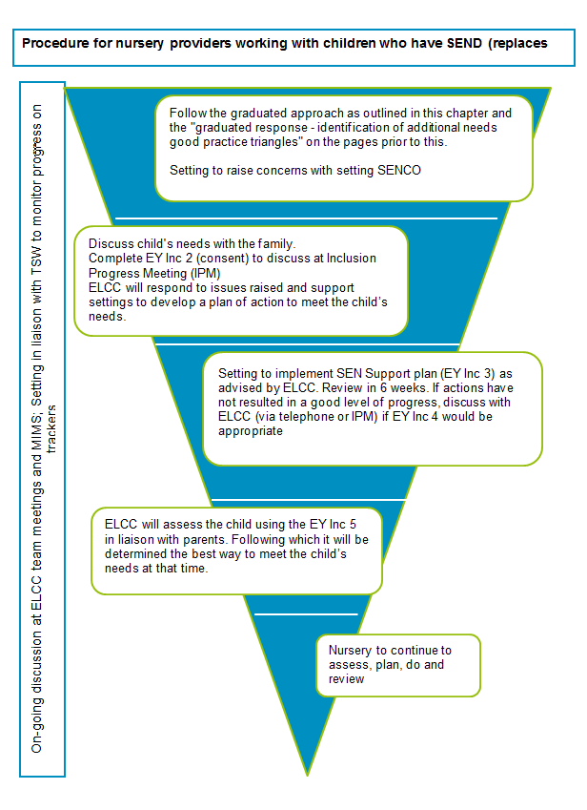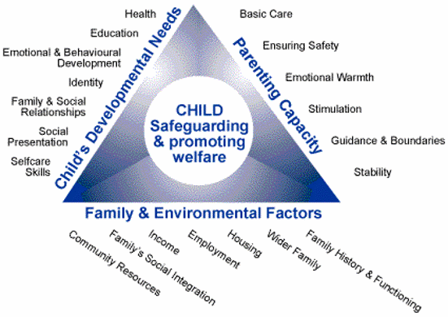

Figure 4): Operational Strategies Supporting SEND Provision in Nurseries
Source: Adapted from Early Years Alliance (2023).

Table 3) below summarises the main strategies identified in the reviewed studies.

Strategy | Evidence | Effectiveness | Limitations
Cross-subsidisation | NDNA (2023); Blanden et al. (2020) | Supports inclusion | Not financially sustainable
Workforce training | Rix et al. (2021) | Improves staff capability | Requires time and funding
SENCO leadership | DfE (2014) | Improves coordination | Difficult for small settings
Multi-agency working | Early Years Alliance (2023) | Access to specialists | Uneven availability

Source: Adapted from NDNA (2023); Blanden, Crawford and Farquharson (2020); Early Years Alliance (2023).

Despite the increasing pressures associated with rising numbers of children with Special Educational Needs and Disabilities (SEND), the literature shows that nurseries have developed a range of operational strategies to manage demand while maintaining service quality. These strategies reflect efforts by providers to adapt to changing policy expectations and resource limitations within the early years sector.
One of the most widely discussed approaches is workforce development. Many nurseries are investing in staff training focused on inclusive practice, behaviour support, and communication strategies for children with additional needs (Rix, Hall and Nind, 2021). Improving staff knowledge is seen as essential because early years practitioners are often the first professionals to identify developmental needs and provide initial support. Training can therefore increase confidence and improve the quality of provision within settings. However, the effectiveness of training depends on the availability of time, funding, and access to specialist guidance.
Another important operational strategy is the appointment of Special Educational Needs Coordinators (SENCOs) within nursery settings. SENCOs are responsible for coordinating support plans, working with families, and liaising with external services to ensure that children receive appropriate support. Research suggests that nurseries with trained SENCOs are generally better able to organise SEND provision and respond to complex needs (Pascal and Bertram, 2019). This highlights the importance of leadership and organisational structure in delivering inclusive education.
Collaboration with external professionals also plays a key role in SEND provision. Nurseries frequently work alongside speech and language therapists, health visitors, and educational psychologists to develop support strategies for children. This multi-agency approach can improve outcomes because it allows expertise from different sectors to be combined. However, access to these services is not always consistent across regions.
A critical issue highlighted in the literature is the reliance on adaptive strategies rather than strong structural support from funding systems. For example, many nurseries use cross-subsidisation to manage SEND costs, where income from non-SEND childcare places is used to fund additional support (Blanden, Crawford and Farquharson, 2020). While this approach allows settings to continue providing inclusive services, it may not be sustainable in the long term if costs continue to rise.
Furthermore, there is variation between providers. Larger nursery chains often have more resources and access to specialist staff, while smaller independent nurseries may struggle to implement similar strategies due to financial constraints (NDNA, 2023). Overall, this suggests that nursery responses to SEND demand are strongly influenced by wider structural and funding limitations within the education system.
Overall, the literature suggests that operational responses adopted by nurseries represent adaptive strategies developed within constrained financial environments. While workforce development, collaboration with external professionals, and the use of SENCOs can improve inclusive practice, these approaches are often implemented as reactive solutions rather than long-term strategic reforms. This highlights the need to examine whether organisational responses alone are sufficient to address the broader structural pressures facing SEND provision in the early years sector (NDNA, 2023; Department for Education, 2024).

4.5) Critical Discussion of Findings
The findings of this study demonstrate that SEND provision in early years education is shaped by a complex interaction between policy expectations, financial resources, and organisational capacity. While government policy strongly promotes inclusive education, the evidence suggests that nursery providers often struggle to meet these expectations due to structural constraints within the funding system.
One of the most significant issues identified in the literature is the widening gap between rising SEND demand and the financial resources available to early years providers. Government statistics show that the number of children requiring SEND support has increased steadily over the past decade (Department for Education, 2024). However, several studies indicate that funding structures have not adapted quickly enough to meet this growth (National Audit Office, 2024). As a result, nurseries frequently provide support for children with additional needs before receiving adequate financial assistance, creating significant operational pressures.
The literature also highlights how nurseries have responded by adopting a range of internal coping strategies. These include workforce training, multi-agency collaboration, and the appointment of Special Educational Needs Coordinators (SENCOs). Research by Rix, Hall and Nind (2021) emphasises that staff development plays a crucial role in improving inclusive practice and increasing the confidence of practitioners working with children who have additional needs. Similarly, Pascal and Bertram (2019) argue that effective leadership and coordinated support systems can significantly improve the quality of SEND provision within early years settings.
However, the findings suggest that these strategies are often reactive rather than strategic. Many nurseries rely on cross-subsidisation, where income from privately funded childcare places is used to support SEND provision (Blanden, Crawford and Farquharson, 2020). While this approach allows nurseries to maintain inclusive services in the short term, it exposes providers to financial risk if operational costs continue to rise or if enrolment levels fluctuate.
A critical insight emerging from the analysis is that nursery-level strategies alone cannot resolve the systemic challenges facing SEND provision. Although organisational adaptation allows settings to remain operational, these responses may mask deeper structural weaknesses within the funding system. West and Noden (2019) argue that SEND policy reforms in England have expanded the rights of children to access support without ensuring that funding mechanisms fully reflect the cost of delivering that support. This creates a situation where nurseries are expected to implement inclusive policies while operating within increasingly constrained financial environments.
Furthermore, the literature reveals variation in how nurseries respond to these pressures. Larger nursery chains often have access to greater financial resources, specialist staff, and internal training programmes, which can improve their ability to manage SEND provision effectively. In contrast, smaller independent providers may struggle to implement similar strategies due to limited budgets and staffing capacity (NDNA, 2023). This variation suggests that the sustainability of inclusive early years education may depend not only on policy design but also on organisational scale and resource availability.
Overall, the findings indicate that while nurseries demonstrate significant resilience and adaptability, their ability to sustain inclusive SEND provision remains closely tied to the wider funding and policy environment. Without structural improvements to funding systems and support services, nursery providers may find it increasingly difficult to balance financial sustainability with the goal of inclusive early childhood education.
While nursery providers demonstrate considerable resilience in adapting their operational models, the sustainability of SEND provision ultimately depends on wider structural reforms within funding and support systems. Without stronger financial alignment between policy expectations and available resources, nurseries may continue to rely on short-term coping strategies that risk undermining long-term sector stability (National Audit Office, 2024).

4.6) Relationship Between Findings and Research Questions
The results provide clear answers to the research questions developed earlier in the study.
The first research question examined how rising SEND numbers affect nursery operations. The literature shows that increased identification has expanded the responsibilities of nursery staff and increased operational complexity.
The second research question focused on financial strategies used by nurseries. Evidence indicates that providers rely heavily on cross-subsidisation, funding applications, and internal resource adjustments to sustain SEND support.
The third research question explored operational responses. The findings demonstrate that nurseries adopt a range of strategies including workforce training, collaborative working, and leadership roles such as SENCO coordination.
These findings collectively demonstrate that financial sustainability and operational capacity are closely interconnected within early years SEND provision.
Overall, the results highlight both the resilience of the sector and the limitations of current support systems.

4.7) Theoretical Implications
The findings contribute to several theoretical frameworks relevant to education management and organisational studies.
First, the research supports the Resource-Based View theory, showing that organisational capabilities such as trained staff and leadership influence the ability of nurseries to respond to SEND demand.
Second, the study aligns with institutional theory, which explains how organisations adapt to policy expectations even when resources are constrained (Scott, 2014).
Finally, the research contributes to the broader discussion on inclusive education by demonstrating that financial sustainability is a critical component of successful inclusion strategies.

4.8) Conclusion
This chapter analysed the findings from the systematic literature review examining how nurseries in England cope with the increasing number of children with SEND. Three major themes emerged from the analysis: rising demand for SEND support, financial pressures affecting nursery sustainability, and operational strategies developed by providers.
The results demonstrate that while nurseries are committed to inclusive education, they face significant structural challenges. Financial constraints, workforce shortages, and administrative complexity continue to shape the sector.
The literature also highlights the adaptability and resilience of nursery providers. Through training, collaboration, and organisational innovation, many settings continue to deliver inclusive early education despite limited resources (Early Years Alliance, 2023; National Audit Office, 2024).

4.9) Recommendations
Based on the findings of this study, several recommendations can be made:
Improved funding mechanisms for early years SEND provision should be introduced to ensure that nurseries receive timely and adequate financial support.
Government policies should recognise the operational realities faced by nurseries and provide additional resources for workforce development and specialist services.
Greater collaboration between local authorities, health services, and early years providers should be encouraged to strengthen support systems for children with SEND.
Finally, further research should explore nursery-level experiences through primary data collection to better understand how policies are implemented in practice.

CHAPTER 5: Recommendations, Conclusion and Limitations of the Research

5.1 Recommendations
Based on the findings of this study, several practical recommendations can be proposed to improve how nurseries in England manage the financial and operational pressures associated with increasing numbers of children with Special Educational Needs and Disabilities (SEND). First, there is a clear need for improvements in the structure and timing of funding. Evidence shows that delays and shortfalls in SEND funding create uncertainty for nursery managers and make long-term planning difficult (Department for Education, 2024; National Audit Office, 2024). Policymakers should therefore consider introducing more flexible and timely funding mechanisms that reflect the real costs of providing early intervention support.
Second, investment in workforce development should be strengthened. Training programmes focused on inclusive practice and SEND support can improve staff capability and confidence, which is essential in early years settings where needs are often first identified (Rix, Hall and Nind, 2021). Local authorities could support this by providing accessible professional development opportunities and expanding support networks for nursery staff and Special Educational Needs Coordinators (SENCOs).
Third, greater collaboration between nurseries and external services should be encouraged. Partnerships with health professionals, educational psychologists, and local support agencies can improve the quality of SEND provision and reduce pressure on individual settings (Pascal and Bertram, 2019). Creating stronger local support systems would help nurseries manage complex needs more effectively.
Finally, nursery managers should consider developing more resilient operational strategies, such as resource sharing, collaborative networks with nearby providers, and improved financial planning. These approaches may help settings remain sustainable while maintaining inclusive practice (Blanden, Crawford and Farquharson, 2020).

5.2 Conclusion
This research examined how nurseries in England are responding to the financial and operational challenges associated with the rising number of children with SEND. The study highlights that early year’s providers play an important role in supporting child development and inclusion, yet they are increasingly operating under financial strain.
The findings show that demand for SEND support has grown steadily in recent years, placing pressure on staffing, resources, and organisational capacity. At the same time, funding arrangements have struggled to keep pace with this increase, creating a gap between policy expectations and practical delivery (Department for Education, 2024; Institute for Fiscal Studies, 2024). As a result, nurseries are required to adopt a range of coping strategies to continue providing inclusive education.
The analysis indicates that many settings rely on operational adaptations such as staff training, the use of SENCO roles, collaboration with external professionals, and cross-subsidisation of SEND costs. While these approaches can support short-term stability, they also highlight the wider structural challenges within the early years system. The literature suggests that sustainable SEND provision requires a better balance between inclusion policies and the financial realities faced by providers (Early Years Alliance, 2023).
Overall, this study contributes to the existing body of research by focusing specifically on nursery-level responses to SEND pressures. By examining both financial and operational strategies, the research provides insight into how early years providers attempt to remain viable while meeting increasing expectations for inclusive education.

5.3 Limitations of the Research
While this research provides useful insights into SEND provision in early years settings, several limitations should be acknowledged. First, the study relies primarily on secondary data collected through a systematic literature review. Although this approach allows for a broad analysis of existing research and policy evidence, it means that the findings are dependent on previously published studies and reports. As a result, some real-world practices used by individual nurseries may not be represented (Tranfield, Denyer and Smart, 2003).
Second, much of the available data focuses on national trends and sector-level analysis rather than detailed financial information from individual providers. This makes it difficult to assess the precise impact of SEND-related costs on different types of nurseries, particularly smaller independent settings that may operate under different conditions compared to larger organisations (National Day Nurseries Association, 2023).
Another limitation relates to the variation in SEND provision across regions. Local authority funding policies, availability of specialist services, and demographic differences can influence how nurseries experience financial and operational pressures (National Audit Office, 2024). Therefore, the findings may not fully reflect the experiences of all providers across England.
Future research could address these limitations by incorporating primary data collection methods such as interviews or surveys with nursery managers and SENCOs. This would provide deeper insight into decision-making processes and allow for a more detailed examination of how financial strategies are implemented in practice.

Reference List:
Ainscow, M. (2020) Promoting inclusion and equity in education: Lessons from international experiences. Nordic Journal of Studies in Educational Policy, 6(1), pp. 7–16.
Ainscow, M., (2020). Leading Inclusive Education: Policy, Practice and Leadership. London: Routledge.
Anne-Marie Argile (2024) Supporting SEND in Early Years Settings: Financial Pressures and Policy Gaps. London: Early Years Research Trust.
‌Ascl.org.uk. (2024). ASCL - Summary of June 2024 DfE SEND data. [online] Available at: https://www.ascl.org.uk/Help-and-Advice/Inclusion/SEND/Summary-of-June-2024-DfE-SEND-data?utm.
BERA (2018) Ethical Guidelines for Educational Research. 4th edn. London: British Educational Research Association.
Birmingham City Council (2023) Section 114 notice over budget deficit, Wikipedia Gazette.
Blanden, J., Crawford, C. and Farquharson, C. (2020) The Early Years Workforce: Pay, Progression and Professionalisation. London: Institute for Fiscal Studies.
Blanden, J., Crawford, C. and Farquharson, C., (2020). Child Development and Early Years Policy. London: Institute for Fiscal Studies.
Braun, V. and Clarke, V. (2013) Successful Qualitative Research: A Practical Guide for Beginners. London: SAGE.
British Educational Research Association (BERA), (2018). Ethical Guidelines for Educational Research. 4th ed. London: BERA. Available at: https://www.bera.ac.uk/publication/ethical-guidelines-for-educational-research-2018 (Accessed: 31 Jan. 2026).
Bryman, A. (2016) Social Research Methods. 5th edn. Oxford: Oxford University Press.
Creswell, J.W. and Plano Clark, V.L. (2018) Designing and Conducting Mixed Methods Research. 3rd edn. Thousand Oaks, CA: SAGE.

Department for Education (2024) Education, Health and Care Plans: England. London: DfE.
Department for Education (DfE) (2022) Special Educational Needs and Disabilities (SEND) Review: Right Support, Right Place, Right Time. London: DfE.
Department for Education (DfE) (2024) Special Educational Needs in England: National Statistics 2024. London: DfE.
Department for Education (DfE), (2014). Special Educational Needs and Disability Code of Practice: 0 to 25 years. London: DfE. Available at: https://www.gov.uk/government/publications/send-code-of-practice-0-to-25 (Accessed: 31 Jan. 2026).
Early Years Alliance (2023) A Sector Under Pressure: Funding, Sustainability and SEND Provision in Early Years Settings. London: Early Years Alliance.
Early Years Alliance (2025) Early Years Inclusion and Funding Challenges: A National Review. London: Early Years Alliance.
European Commission (2018) General Data Protection Regulation (GDPR). Brussels: European Union.
Gibbs, G. (1988) Learning by Doing: A Guide to Teaching and Learning Methods. Oxford: Oxford Polytechnic.
Griggs, M. and Bussard, L. (2017) Inclusive Practice in Early Years Settings. London: Routledge.
Institute for Fiscal Studies (IFS) (2024) High Needs Funding in England: Pressures and Policy Options. London: IFS.
Institute for Fiscal Studies (IFS), 2024. Funding for SEND in Early Years Settings: An Analysis of Trends and Pressures. London: IFS. Available at: https://www.ifs.org.uk/publications/send-funding (Accessed 31 Jan. 2026).
Institute for Fiscal Studies. (2024). Spending on special educational needs in England: something has to change | Institute for Fiscal Studies. [online] Available at: https://ifs.org.uk/publications/spending-special-educational-needs-england-something-has-change.
Lindsay, G. (2016) Educational psychology and the effectiveness of inclusive education. British Journal of Educational Psychology, 86(2), pp. 213–229.
Moon, J. (2013) Reflection in Learning and Professional Development: Theory and Practice. London: Routledge.
National Audit Office (NAO) (2024) Support for children and young people with special educational needs and disabilities. London: NAO.
National Audit Office (NAO), 2024. High Needs Funding in English Schools: Review of Financial Pressures. London: NAO. Available at: https://www.nao.org.uk/report/high-needs-funding/ (Accessed 31 Jan. 2026).
National Day Nurseries Association (NDNA) (2023) Nursery Sector Sustainability and SEND Funding Report. Huddersfield: NDNA.
Pascal, C. and Bertram, T. (2019) Effective Early Learning: Evidence from Research on Early Childhood Education and Care. Birmingham: Centre for Research in Early Childhood.
Pisanu, M. (2024) Childcare Accessibility and Parental Employment in England: Early Years Market Pressures. London: Social Market Foundation.
Rad, L., Matthews, P. and Buzdugan, R. (2022) SEND Provision in England: Funding, Policy and Inclusion Outcomes. London: Education Policy Institute.
Rix, J., Hall, K. and Nind, M. (2021) The Realities of Inclusion in Early Childhood Education. London: UCL Institute of Education Press.
Robson, C. and McCartan, K. (2016) Real World Research. 4th edn. Chichester: Wiley.
Saunders, M., Lewis, P. and Thornhill, A., (2019). Research Methods for Business Students. 8th ed. Harlow: Pearson Education.
Schön, D. (1983) The Reflective Practitioner: How Professionals Think in Action. London: Temple Smith.
Smith, A. (2023) Rising Nursery Costs and the Impact on SEND Provision. London: Early Childhood Economics Observatory.
.
Snyder, H. (2019) ‘Literature review as a research methodology: An overview and guidelines’, Journal of Business Research, 104, pp. 333–339.
The Guardian (2024) ‘Fobbed off and rejected’: SEND crisis takes toll on families in Birmingham.
‌Tranfield, D., Denyer, D. and Smart, P. (2003) ‘Towards a methodology for developing evidence-informed management knowledge by means of systematic review’, British Journal of Management, 14(3), pp. 207–222.
Xiao, Y. and Watson, M. (2019) ‘Guidance on conducting a systematic literature review’, Journal of Planning Education and Research, 39(1), pp. 93–112.
Yin, R.K. (2018) Case Study Research and Applications: Design and Methods. 6th edn. Thousand Oaks, CA: SAGE.

