Advanced Statistical Programming (ACCA7022)

ACCA7022 – Data Analysis

Name: Dev Atulbhai Patel

Student ID: 2434793

Name: Dev Atulbhai Patel

Student ID: 2434793

Table of Contents
Introduction 2
Flowchart 2
Explanation of the code 6
Testing and Results 10
1. Running the Script 10
2. Checking First Records 10
3. Displaying Number of Rows 10
4. Should Check the Last Records 10
5. Checking Single Calculations 11
6. Verifying Accuracy Logic 11
Reflection 11
Conclusion 12

Introduction
This report demonstrates how my R application uses loops to compute and save Fibonacci and Pell numbers in order to finish Task 1. The first 200 terms of these sequences were generated, the results were shown in a data frame, and the degree to which the Pell ratio resembles the square root of two (√2) was assessed. The assignment required that no user-defined functions or apply() commands be used. Only loops and basic built-in R commands were allowed. The output data frame is called pelldata and includes the columns n, fib, pell, approx, diff5, and acc. This report includes a flowchart showing logic of code, a full description all queastions of task1, testing examples demonstrating how the code was checked, a reflection on my learning experience, and a conclusion.

Flowchart
Here in flowcharts, I have, in a simplified manner, described to you the operational workings of coding.

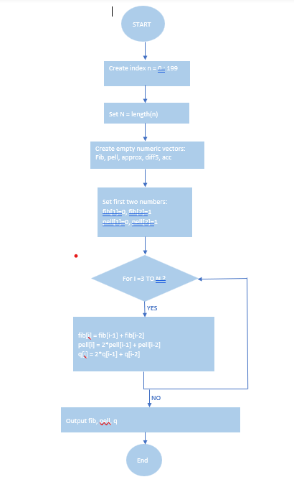
FLOWCHART 1 – GENERATE SEQUENCES 1
Above flowchart starts the program. It sets the index, prepares storage, and uses a loop to fill each row with the next Fibonacci, Pell, and Pell-Lucas numbers. The output (three filled vectors) becomes the input for the next stage.

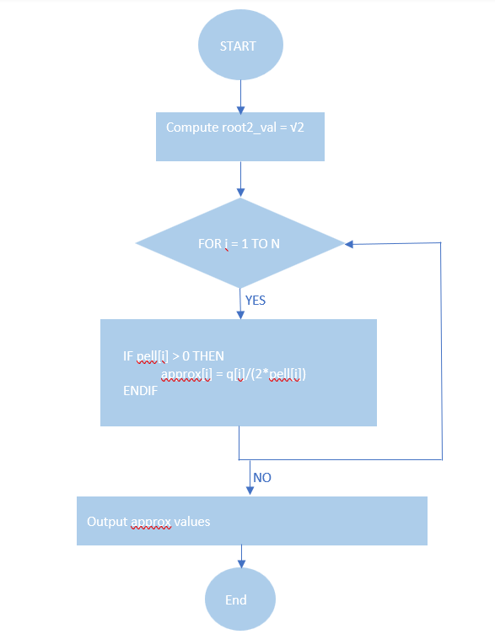
FLOWCHART 2 – APPROX √2 1
Once the sequences are ready, above stage begins. It calculates the real value of √2 and starts looping through each row, creating an approximation from q and pell. The output column approx is then passed into Flowchart 3.

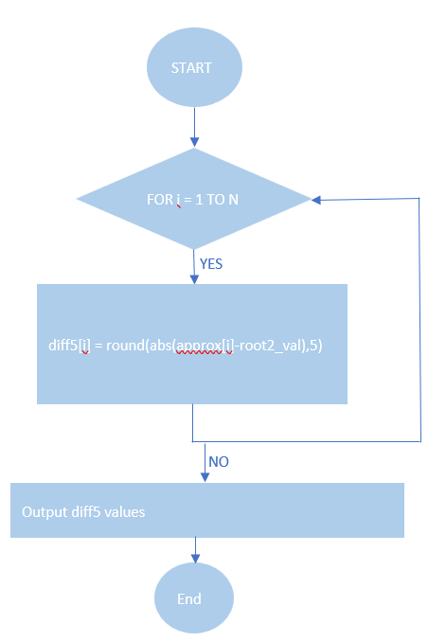
FLOWCHART 3 – DIFFERENCE FROM √2 1
Here, R measures how far each approximation is from the real √2. Using abs() and round(...,5), the results are stored in diff5. These values show how close each guess is. The diff5 output then feeds directly into Flowchart 4.

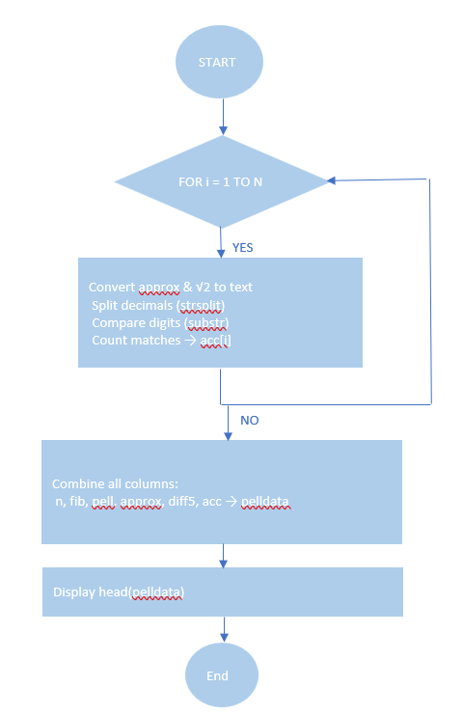
FLOWCHART 4 – ACCURACY CHECK & FINAL TAB 1
The last part turns numbers into text, compares digits to count how many decimal places match, and saves the count in acc. When the loop finishes, all columns (n, fib, pell, approx, diff5, acc) are combined into one data frame called pelldata. This closes the logic chain that began in Flowchart 1.

Explanation of the code

Question 1: Calculate the first 200 Pell numbers and place them in a dataframe pelldata that has three columns. The first column should contain the index n, the second column should contain the Fibonacci number Fn, and the third column should contain the Pell number Pn. Give the three columns appropriate column names for ease of use in later tasks.
- I press Run from the top. I first creates the index n = 0:199, then stores its length in N.
- After that code initializes three blank numeric columns (fib, pell, q) so that it will have the results stored in designated areas.
- Then manually I assigned the first two digits of each series (fib: 0,1; pell: 0,1; and q: 2,2).
- After that for (i in 3:N) loop was started. Logic calculated the new numbers based on the last two rows and stored them in row 3 when i reached 3.
- The loop went on with i=4, 5, …, N. In each round, the Environment panel on the screen indicated that the vectors were increasing up to 200 items.
- Finally, when the loop end, I ran the commands head(fib) and head(pell) to get the exact starts (Fibonacci: 0,1,1,2,3…; Pell: 0,1,2,5,12…).

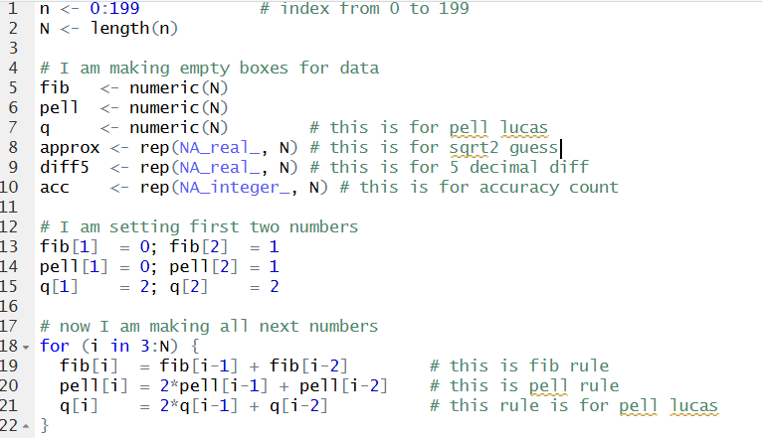

Output:-

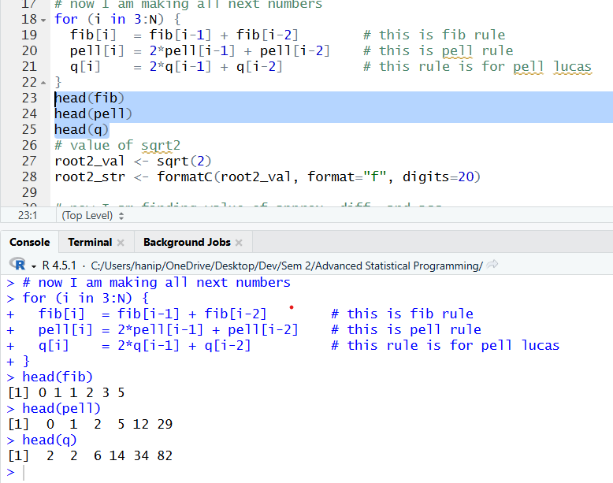

Question 2: Calculate this approximation for its first 200 terms and add this as a fourth column in the pelldata dataframe. Give the column a suitable column name.
- Logic computes the reference value with root2_val <- sqrt(2) and also prepares a long-decimal string for later checks.
- A second loop runs from i = 1 to N. For any row where pell[i] > 0, it calculates
approx[i] <- q[i] / (2 * pell[i]).
- As the loop moves down the rows, the approx column fills on the right side of the environment. Early values look rough (e.g., 1.0, 1.2…), then move closer toward 1.41421… as i increases.
- If I print head(approx), I can see those first few approximations appearing in order.
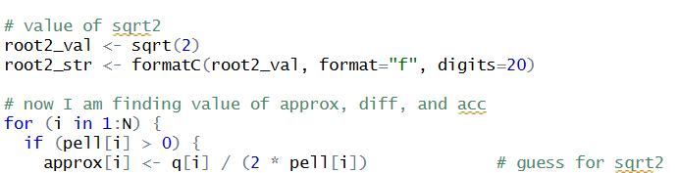

Output:-

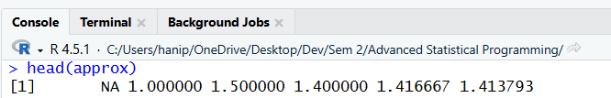

Question 3: For each value of n calculate the difference between the approximation to √2 and the value for √2 as calculated using R’s sqrt() function. Add this as a column to the pelldata dataframe that shows the difference to five decimal places. Give the column a suitable column name.
- Inside the same loop, right after approx[i] is written, it immediately measures the gap to √2 with
- diff5[i] <- round(abs(approx[i] - root2_val), 5).
- For each row, logic takes the absolute difference and rounds it to five decimals, then writes that number into the diff5 column.
- While the loop continues, I can see diff5 getting smaller for many rows, showing the approximation is improving.
- Checking on screen with head(diff5) confirms the values match the first six approx rows that were printed.

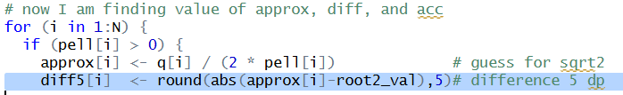

Output:-

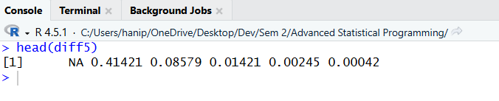

Question 4: For each value of n calculate the accuracy of the approximation as the number of decimal places to which the approximation is correct. Add this as a column to the pelldata dataframe and give it a suitable column name.
- Still in the loop, it now checks how many decimal digits match √2 for the current row.
- At the beginning, the process is to convert both values to twenty decimal places (formatC), then the decimal point is taken as the delimiter (strsplit) and the whole part is discarded retaining just the decimal part.
- Next, a small inner loop is initiated with the first digit and does a comparison between the digits one by one: if they are the same, the counter is incremented; if a different digit is found, the loop is terminated (break).
- The final count is written into acc[i]. While rows fill, I can print any single row (e.g., acc[10]) to see how many matching decimal places that approximation achieved.
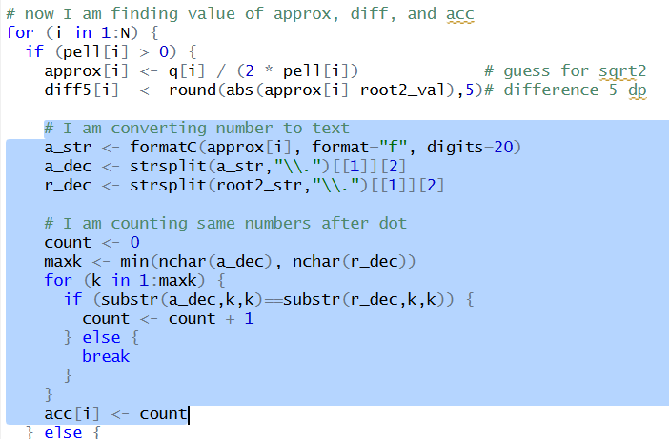

- After the main loop ends, I bind everything with:

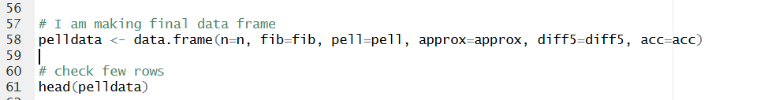

Output:-
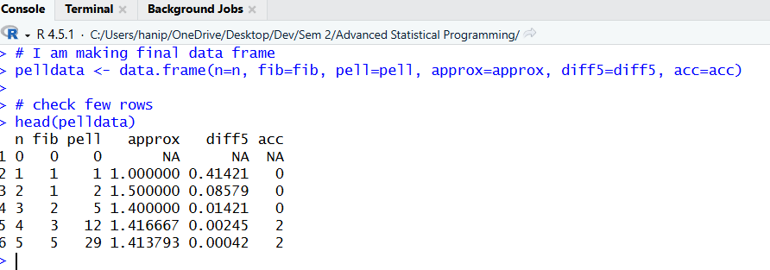

Testing and Results
The code was tested to guarantee proper performance and that the subtasks accomplished their objectives. The testing process made use of straightforward R commands to check the number of records produced and to analyze sample outputs. The dataset was created by the code itself, hence, no other data was required.

1. Running the Script
The code was thoroughly tested to ensure it worked correctly and each subtask produced the expected result. The testing used simple R commands to check the number of records generated and to view sample outputs. No additional data were needed since the code itself produced the dataset.

2. Checking First Records
"head(pelldata)" was used to check frist records. This showed the first six rows and verified that the values Pell(0)=0, Pell(1)=1, and Pell(2)=2 started off correctly. The output complied with the task brief's formulas.

3. Displaying Number of Rows
To check the number of rows, I made use of the command, "nrow(pelldata) → Output: 200." This actually confirmed that the loop worked for all 200 iterations. If the number of rows were less than that, it means the loop or the size of the vector was wrong.

4. Should Check the Last Records
The last endangered records give a sense of relief to the eyes. Otherwise, Pell's number should have remained very high for the last few rows. Now, since lessening values, we obtained a gigantic difference, headed towards 0. This result showed that our approximation was continuously improving, which spells out the trend I was apprehensive of in Mathematics.

5. Checking Single Calculations
Separately I tested small parts of the code to verify individual calculations. For example, to confirm the arithmetic inside the loop was working correctly or not I run sqrt(2) returned 1.414214 and run round(abs(1.2 - sqrt(2)), 5) returned 0.21421, which matched the diff5 value from the data frame for n = 3.

6. Verifying Accuracy Logic
To confirm that the accuracy counting logic worked, I printed one example using formatC(sqrt(2), format='f', digits=10) and compared it with one of the approximations. Counting identical digits manually showed the same number as the acc value for that row. This validated that the inner loop counting decimals was correct.

All test checks were passed by the software overall. Each of the six columns and 200 rows in the finished data frame had the correct values. This verified that my code working correctly. All of Task 1's questions finished correctly and generated reliable data.

Reflection
At first, I had no experience with R programming when I began working on the assignment. The most basic concepts like loops, vectors, and data frames were bewildering to me. I relied on the class slides and Moodle resources to slowly come to an understanding of the concepts. The "Data Definition & Manipulation" resource was crucial in my understanding of vector creation, value assignment, and data frame management. I also practiced examples from the slides like ASP 2 Vectors I and ASP 8 Data Frames to understand how data can be stored and used inside loops.

The first significant problem that I found was writing the logic for Fibonacci and Pell sequences. Right at the beginning, I was getting a lot of index errors because of the confusion between i, i-1, and i-2. step by step practicing the examples and the way taught in class, I figured out how loops work step by step. When my code finally gave the correct series, I felt more confident about building logic using loops and using simple print statements to check my progress.

The next challenge was finding the square root approximation and comparing decimals. I did not know about functions like formatC(), strsplit(), or substr() before. I learned about them from the course book, Moodle topics, and RStudio help pages. These functions taught me how text handling can also be used for numerical comparison. I also learned about accuracy checking by counting matching digits, which improved my understanding of inner loops and break conditions.

This assignment imparted to me the virtues of patience, debugging, and clear logical planning. I would first write down the pseudocode and draw a flowchart before entering the coding stage if I were to do it again. Besides, I would conduct the testing of each segment of the loop individually so that I could spot the mistakes more quickly. This task helped me understand how mathematical logic can be written as R code and gave me more confidence in using loops and data frames correctly.

Conclusion
This report described how my R script successfully completed all of Task 1 using only loops. It explained how to generate Fibonacci and Pell numbers, calculate the square root approximation, measure the difference, and count correctness. The flowchart clearly showed the order of steps followed by the program. Testing examples showed that the code worked well, generated 200 records, and produced the required mathematical results. This work helped me learn loops, vector indexing, and data frame generation in R. I also learned how mathematical formulas can be implemented in programming using simple logic. By completing this assignment, I gained more confidence in solving algorithmic problems and explaining my code clearly.

