Assignment 1
Environmental Analysis of Automobile Industry

STUDENT NAME: LUNCA AURELIA
STUDENT ID: 1917712
MODULE CODE: LCBB4005
MODULE TITLE: THE GLOBAL BUSINESS ENVIRONMENT
LECTURER: NADEEM MIRZA

Page of Contents
Introduction 3
Overview of the company 3
Significant External Business Environment Challenges for Rolls-Royce Motor 4
PESTEL Analysis 5
Porter’s Five Forces Model 7
SWOT Analysis 8
Value Chain 10
Significant Internal Business Environment Challenges at Rolls-Royce Motor 11
VRIO 12
RECOMMENDATIONS 13
CONCLUSION 14
References 15

Introduction
In the present global market environment, worldwide commerce is very difficult to achieve (Dobson, P.W., Starkey, K. and Richards, J., 2009). Furthermore, global rivals are adept at grabbing market share. To compete effectively on a global scale, entrepreneurs must first grasp their foreign market environment. In order to bring value to businesses, entrepreneurs need also embrace chances inside the global market context. For a number of reasons, international market dynamics are becoming increasingly important and ubiquitous to global businessmen. In addition, this paper discusses the worldwide environment, including a short examination of Rolls-Royce Limited’s (RRL) overseas market situation.

Overview of the company
Charles Rolls and Henry Royce founded Rolls-Royce, a British luxury automobile and subsequently an aero-engine manufacturing company, in Manchester, United Kingdom, in 1904.
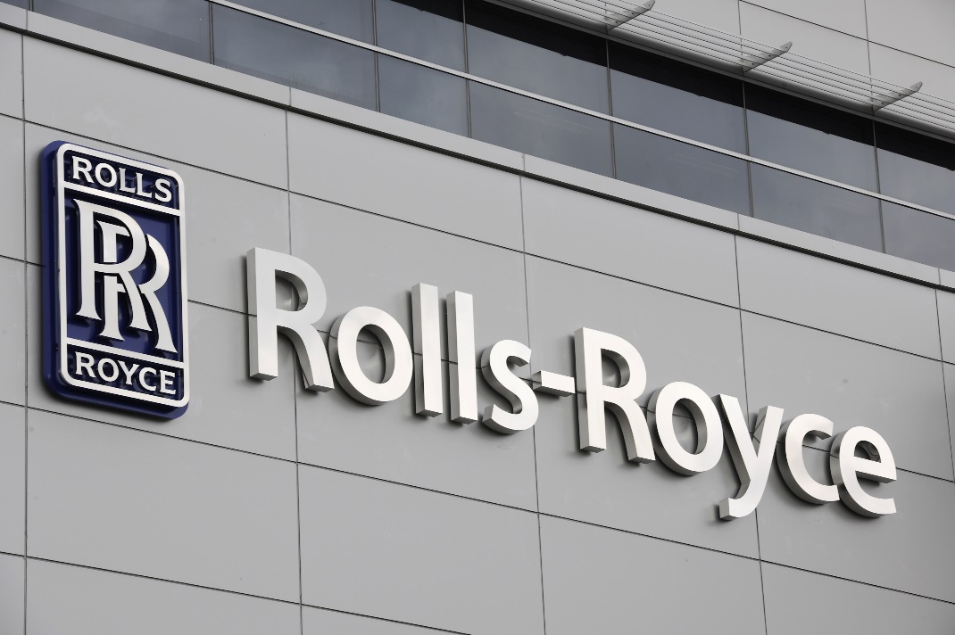
They soon earned a reputation for great engineering by producing the "best vehicle in the world," drawing on Royce's reputation for cranes. During the First World War, they were involved in the production of aircraft engines. Jet engines were jointly developed and put into production in 1940. Rolls-Royce has a long history of developing and manufacturing engines for military and civil aircraft.

Significant External Business Environment Challenges for Rolls-Royce Motor
When it comes to making the best decisions for a team's growth, it would seem that external influences are quite crucial to consider (Dobson, P.W., Starkey, K. and Richards, J., 2009). They employ Pestle and swot analysis, which is integrated with SWOT analysis to discover opportunities and threats, to get a bigger picture.

PESTEL Analysis
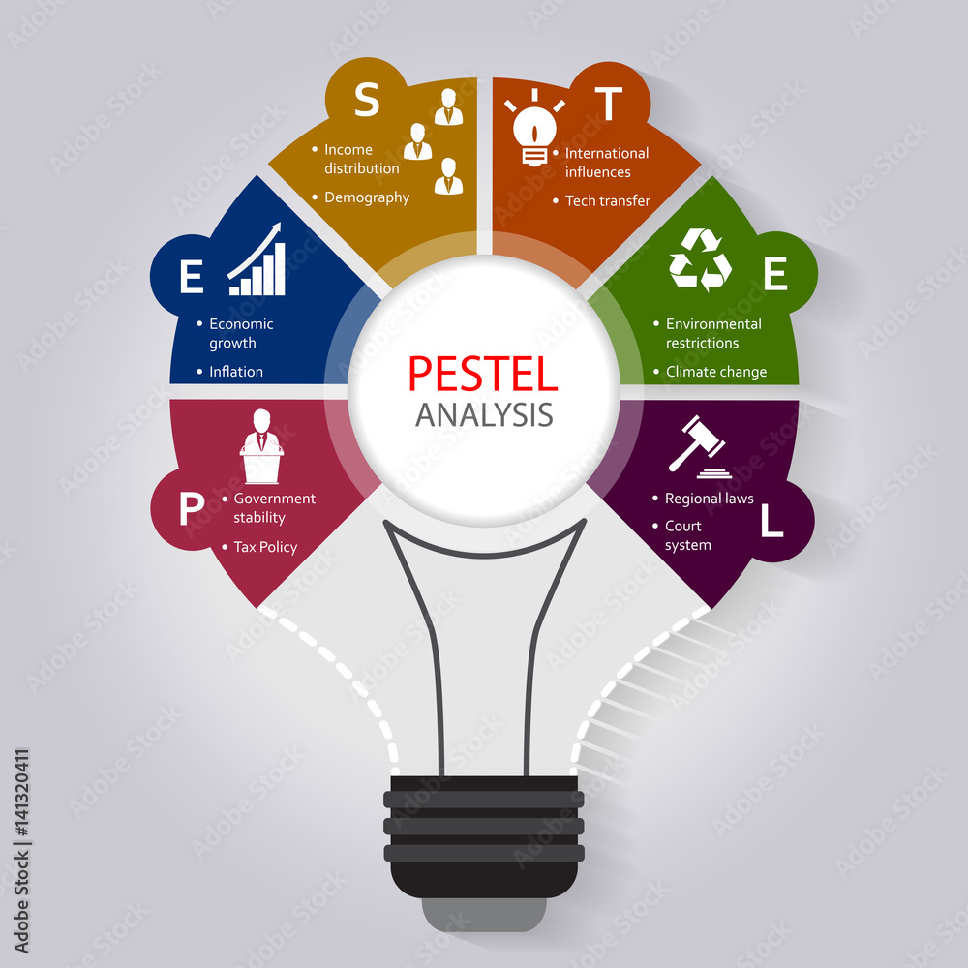
Figure 1 PESTLE(Elearn, 2008)
Factors of politics: The politics of a country have a huge impact on the businesses that are located near its frontiers (Elearn, 2008). Officials in a number of nations have enacted legislation to regulate the manufacture of vehicle parts and components. A company's licence will also most likely be revoked if it does not meet these requirements. Furthermore, the automobile sector is depending on federal government choices on exporters.
Factors of the economy: The economics from a certain state determines everyone's manner of life (Gitman, 2018). As a result, it's probable that it'll have an influence on the automobile industry. Taxes levied by state governments have raised the cost of luxury products. It's probable that this may result in a drop in amount of high vehicles. However, if a large number of businesses provide autos at similar prices, this may attract more purchasers.
Factors of society: The socio-cultural aspects of a location have an influence on the local enterprises. With such a densely populated and huge number of kids, a densely populated country often has a significant market for larger vehicles such as SUVs. According to some predictions, auto ownership may decline in states with great public transit systems. Apart from that, individuals in industrialised nations have a proclivity towards purchasing one or more automobiles.
Factors related to technology: To maintain the protection and reliability of its cars, the automobile industry is significantly reliant on contemporary technology. To ensure that their autos are really as safe as possible, companies must make large expenditures in new technology. Businesses must make pollution reduction a major priority. Organizations may be capable to do this by using existing technology.
Environmental factors: Environmental issues get the potential to cause significant impact on the car industry (Elearn, 2008). As the public becomes more aware of pollution, public opinion of their firm may decline. The PESTEL study of the car sector exposes the industry's potential environmental concerns. The research illustrates how businesses may cut their greenhouse gas emissions while simultaneously contributing to a slower pace of emission production.
Factors of the law: Different nations' legislation might have had an effect on the operation of individual automobile firms(Elearn, 2008). Many nations have severe restrictions limiting the number of cars permitted on the street, which might assist to reduce emissions risks to the environment. To compete in the global market, a vehicle manufacturer must adhere to all applicable tax and sustainability rules.

Porter’s Five Forces Model
Porter's five Forces Analysis is a valuable tool for identifying and analysing the five competitive forces that affect any sector (Elearn, 2008). It is also used to assess a company's strengths and flaws.
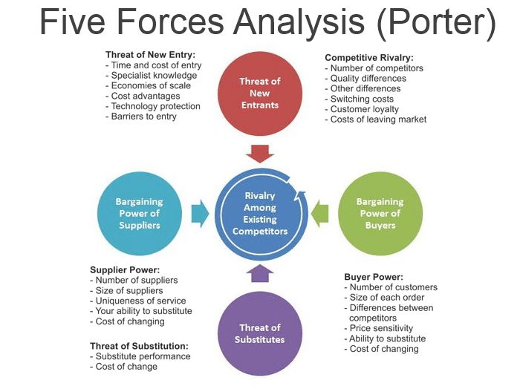
Figure 2Porter's five forces(Godfrey, 2015)

New arrivals pose a threat
Foreign firms with access to cash, technological know-how, and good process management have destroyed the customer bases of many automobile manufacturers (Godfrey, 2015). In recent years, globalisation, often called as the internationalisation of economics and sector, has had a significant impact on the automobile industry.
Substitute threats
The increasing cost of fuel seems to have a significant impact on customers' judgments about which cars to buy. People are more inclined to prefer alternate forms of transportation if the expense of owning and running a car is higher. Spite of the fact that cars and trucks and pickup trucks make more money, they use far more gas than automobiles and business vehicles.
Rivalry intensity
Because of the rising cost of competing, sectors with a lot of competition yield poor returns. In general, the automobile industry is thought to be oligopolistic. Automobile manufacturers understand that price competition does not necessarily lead to greater market share. Changes may result in significant disruptions and issues, as well as higher expenses as a result.
The Purchasing Power of Suppliers
Automobile manufacturing is a decentralised industry with a high number of small businesses. In order to get a variety of things, a huge percentage of individuals are likely to remain with one or two vehicle manufacturers. If a car manufacturer decides to change suppliers, the consequences for the previous provider's company might be disastrous. The more time a vehicle spends on the road, the more replacement components it will need.
Bargaining power of the buyers
Automobile manufacturers have unequalled negotiating strength in the sector. Buyers may grow unsatisfied with a preponderance of a manufacturer's goods and seek alternatives, specifically in the context of imported automobiles. Customers, on the other hand, lack purchasing power since they seldom purchase large quantities of automobiles, despite the reality that they will be nonetheless price sensitive.

SWOT Analysis
Individuals and businesses use the Analysis to determine and assess their strengths, weaknesses, opportunities, and threats in order to increase their company's competitive edge or plan a specific project (Hill, 2011).

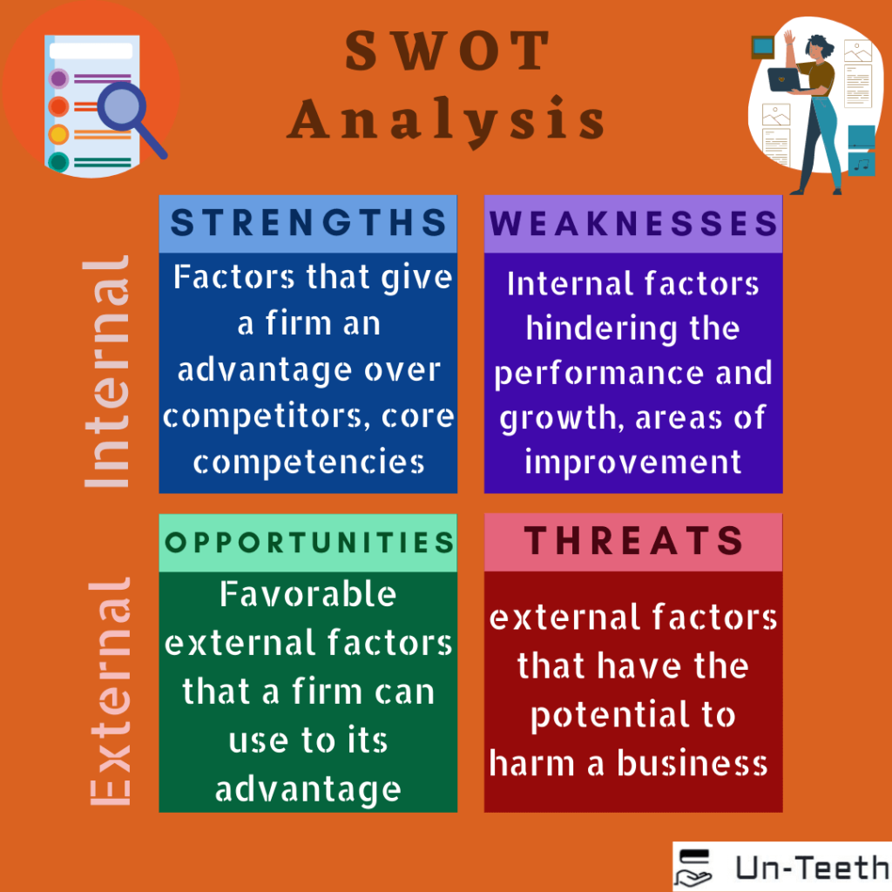
Figure 3 SWOT(Hill, 2011)
Strengths: As the economies of emerging regions such as China, Pakistan, as well as other Asian countries rise, Rolls-Royce is increasing its activities there (Godfrey, 2015). For automakers, international trade has grown increasingly crucial as a method of participating in well-established markets. Because the vast majority of clients in these nations like to travel by vehicle, VFM goods would have included fuel and higher autos. Trucks for long-distance transit, as well as high aircraft that can drive long distances using centrifugal compressors, are required in advanced nations.
Weaknesses: This shift from demand toward supply had resulted in a plethora of models, heated competition among manufacturers, and a wide choice of options for customers to choose from. A growing number of individuals believe that automobiles should be withdrawn from the market due to technical defects or failure to fulfil government-mandated safety requirements. The government may control the pace of expansion of its car industry by enacting laws such as taxable income, a prohibition on the admission of foreign vehicles into the state, a reduction in the validity of the register period, and fuel price fluctuations.
Opportunities: Automobiles fuelled by gasoline will continue to be the standard in international markets for the foreseeable future. Strategic partnerships may be beneficial to companies in the automobile business. Automobile demand is expected to rise in response to outside markets such as Southeast Asia and the BRIC nations. In order to attain this aim, OEMs may need to change their business strategy.
Threats: Automobile makers must compete against a host of other producers as well as fluctuating gas costs. The automobile industry is expected to be focused with socioeconomic, economic contraction, and other economic concerns for the foreseeable future. As a result, businesses are transferring their attention to emerging nations, where they are constructing infrastructure and R&D centres. It's unclear how much money gets spent as a result of this.

Value Chain
Basic Responsibilities
Rolls-Royce Motor Company's core operations are design, capacity development, manufacturing, sales and marketing, and eventually customer service (Hunger, 2011). Design work has swiftly become one of the company's identifying characteristics. Rolls-Royce automobiles, when equipped with the right equipment, may project an impression of power and physicality, since cars have grown increasingly similar in recent years. Rolls-Royce is now attempting to develop cars that are not always powerful, but also incredibly fuel efficient.
Resources are acquired
The choice of the appropriate material is critical for Rolls-Royce Motor Company; as evidenced by Porter's 5 framework, vendors have very little influence on the organisation; in other sense, the organisation may nearly always choose its desired price over a provider's pricing.
Productions
Rolls-Royce Limited (RRL)is one of Europe's top automakers, having manufacturing facilities in both the United Kingdom and the United States (Morrison, 2020). However, their tactics have proven ineffective, since they consistently produce much more than is required for the task. Rolls-Royce has struggled to capture the general public's attention with his marketing and sales efforts so far. Vehicle shops may do via showcasing automobiles, making public statements, and other methods. Rolls-Royce uses trucks and railroads to deliver goods to and from merchants.
Assistance and Customer Service
Although they are not directly involved in the production process, support functions aid the Rolls-Royce Motor Company's day-to-day operations. Rolls-Royce offers a toll-free Phone number for customers to contact if they need assistance or even have a general question about the firm (Taylor, 2021). This entails the closure of the Heathrow plant and the relocation of manufacturing to more cost-effective locations in the UK and internationally. According to Rolls-Royce , it decreased its personnel by 25% in order to enhance effectiveness and save $billion euros. It has no power over economic issues such as the currency rate, inflation, or other such factors.

Significant Internal Business Environment Challenges at Rolls-Royce Motor
Resource Availability and Efficiency
Physical resources include capital capability, purchased, and human resources. You're condemned to fail if Rolls-Royce can't recruit and retain the tools and talent it needs to survive and develop (Craig, 2012). Financial resources include cash on hand, collection, and the capacity to borrow more money from a range of lenders. Human capital seems to be the factor that organizes all other asset variables throughout the economic cycle. "Intellectual resources" include employees' talents, manufacturing methods, and technology. This category includes mineral wealth, manufacturing facilities, and final commodities.

VRIO
VRIO is an economical analysis technique that is included into a company's strategic plan to assist it create good business choices.
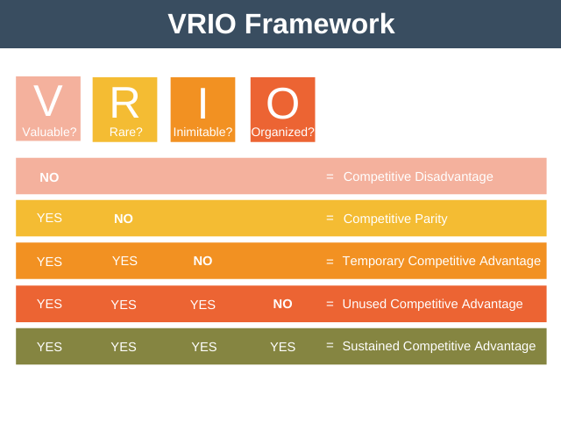
Figure 4 VARIO framework(Taylor, 2021)

Value
Essentially, this relates to a company's capacity to enhance the whole customer experience via its resources (Taylor, 2021). The consumer wants the car to run smoothly and effectively in order to be happy that he is getting excellent value for his money. Customers who think they are receiving the greatest deal for their money are more likely to remain loyal.

Rare
This is a link to a piece of content generated by the organisation. The Rolls-Royce vehicle made its debut before all other rivals, which is an outstanding example. The firm will gain from this as the initial differentiation strategy in that area of the new automobile market.
Inimitable
This implies that the company is capable of developing difficult-to-replicate resources. By intellectual property rights all of the company's ideas, it may be able to prevent them from just being copy-pasted: Although difficult in the situation of Straits, it must have been required since all of the firm and its products were scrutinised and scrutinised by your rivals.
Organisation
This statement focuses on the interactions of all organisations in order to accomplish the organization's goals and objectives, as well as the convergence of all organisations to achieve the organization's goals and objectives. According the Financial Times, this industry did little to persuade people to remain in this profession rather than pursue other opportunities. As there is no space for mistake in the actual world, top-tier experts may find it challenging to stay in the industry.

RECOMMENDATIONS
The corporation has offered the following fundamental opinions on how Rolls-Royce Motor Corporation Limited might increase its European effectiveness:
Rolls-Royce has the potential to change the league's managerial structure. They might focus their efforts, for example, on the profitable European market segment. Rolls-Royce should wait till the economy recovers before making additional investments in the EU. Develop miniature automobiles that are presently widespread to transform the way the EU does business. These folks should think about adding extra features to their vehicles.

CONCLUSION
The term "internationalism" is now used to describe a broad variety of things, including the physical cosmos (Tonder, E. v., 2013). Breaking into a new worldwide market has never been easier because to globalisation. On the other hand, the business sector has faced a lot of difficulties as a result of the circumstances. Trade restrictions, cultural hurdles, political turmoil, economic insecurity, and other factors have made doing business in China very difficult and complex. In recent years, the Rolls-Royce Motor Company's company has risen at a breakneck speed. When it relating to economic difficulties, on the other extreme, they've gotten a lot of attention. To put it another way, running a successful international corporation requires a high level of expertise. Because this company has a great company image and shown its capacity to compete successfully in the global market when particular methods are applied.

References
- Dobson, P.W., Starkey, K. and Richards, J., 2009. Strategic management: issues and cases. John Wiley & Sons.
- Craig, T., 2012. Organisations and the Business Environment. s.l.:Taylor & Francis.
- Elearn, 2008. Business Environment. s.l.:Taylor & Francis.
- Andersen, T. J., 2013. Short Introduction to Strategic Management. s.l.:Cambridge University Press.
- Brinkman, J., 2014. Unlocking the Business Environment. s.l.:Taylor & Francis.
- Gitman, L. J., 2018. Introduction to Business. s.l.:OpenStax College, Rice University.
- Godfrey, R., 2015. Strategic Management: A Critical Introduction. s.l.: Routledge.
- Taylor, S., 2021. Work and Employment in a Changing Business Environment. s.l.:Kogan Page.
- Tonder, E. v., 2013. A Theoretical Framework For Managing CSR Plans And Related Initiatives In The Modern Business Environment. A Theoretical Framework For Managing CSR Plans And Related Initiatives In The Modern Business Environment, Volume 11, p. 12.
- Wetherly, P., 2018. The Business Environment: Themes and Issues in a Globalizing World. s.l.:Oxford University Press.
- Hill, C. W. L., 2011. Essentials of Strategic Management. s.l.:Cengage Learning.
- Hunger, J. D., 2011. Essentials of Strategic Management. s.l.:Prentice Hall.
- Kapoor, M., 2019 . Global Business Environment. s.l.:SAGE Publications.
- Morrison, J., 2011. The Global Business Environment. s.l.:Palgrave Macmillan.
- Morrison, J., 2020. The Global Business Environment. s.l.:Bloomsbury Publishing.
- Paperback, 2009. Global Business Environment. s.l.:GRIN Verlag.

