Pictures provided to participants – t-test study

Black and White | Colour
Telephone | Tennis ball
Dice | Watch
Rugby ball | Paintbrush
Bananas | Flower
Keys | Candle
Pizza | Tractor
Pens | Coffee
Dog | Stapler
Train | Monkey
Cat | Marshmallows

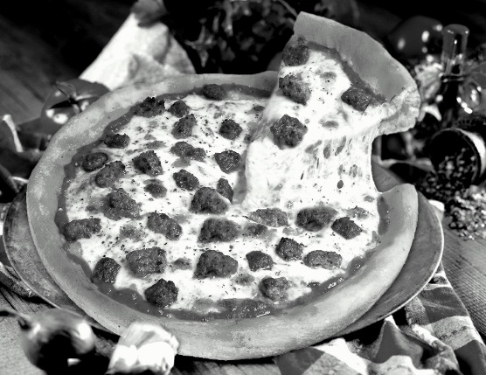
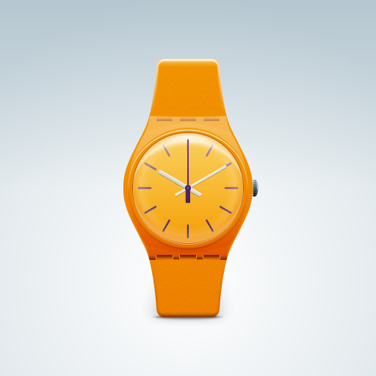
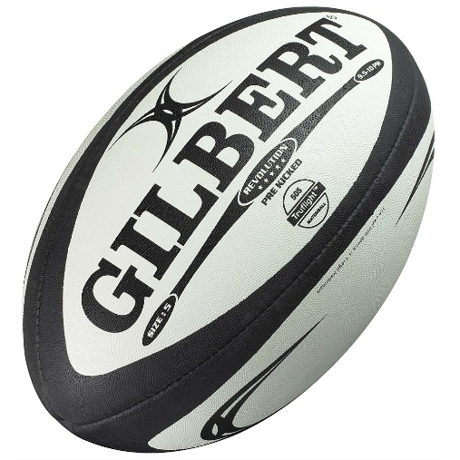
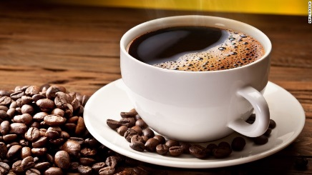
e.gs.,

