Davion Linton Gowie (2216147)
2216147@student.uwtsd.ac.uk

STUDENT NAME: DAVION LINTON GOWIE
LECTURER NAME: DR FAHAD AHMED
MODULE CODE: ACCB6017
STUDENT ID: 2216147
SUBMISSION DEADLINE: 17/08/2026
applied computing
Usability Engineering

Table of Contents
1. Introduction 2
2. Full Colour Storyboard Design Work 4
3. Graphics & Colour Scheme 6
4. Changes Made After Wireframe Feedback 7
5. User Testing Evidence 18
6. Conclusion 20

- Introduction
This report is the final storyboard design for a mobile game adaptation of the cooperative board game Pandemic, redesigned around the University of Wales Trinity Saint David (UWTSD) London campus. The project was intended to be a fun co-op strategy game where players cooperate to stop an infectious outbreak spreading across the university campus. The design process followed a User-Centred Design (UCD) approach with potential users involved throughout the development process. User research, personas, wireframes, prototype testing and peer evaluation were all used in the refinement of the final storyboard design.
The report discusses the development of the full-colour storyboards, the design decisions that went into the graphics and colour scheme, changes made after wireframe feedback, evidence gathered during usability testing, proposed methods for collecting user data from a released version of the game, and a reflection on how usability principles and user experience influenced the overall design.
[1] [2] [3] [4] [5]

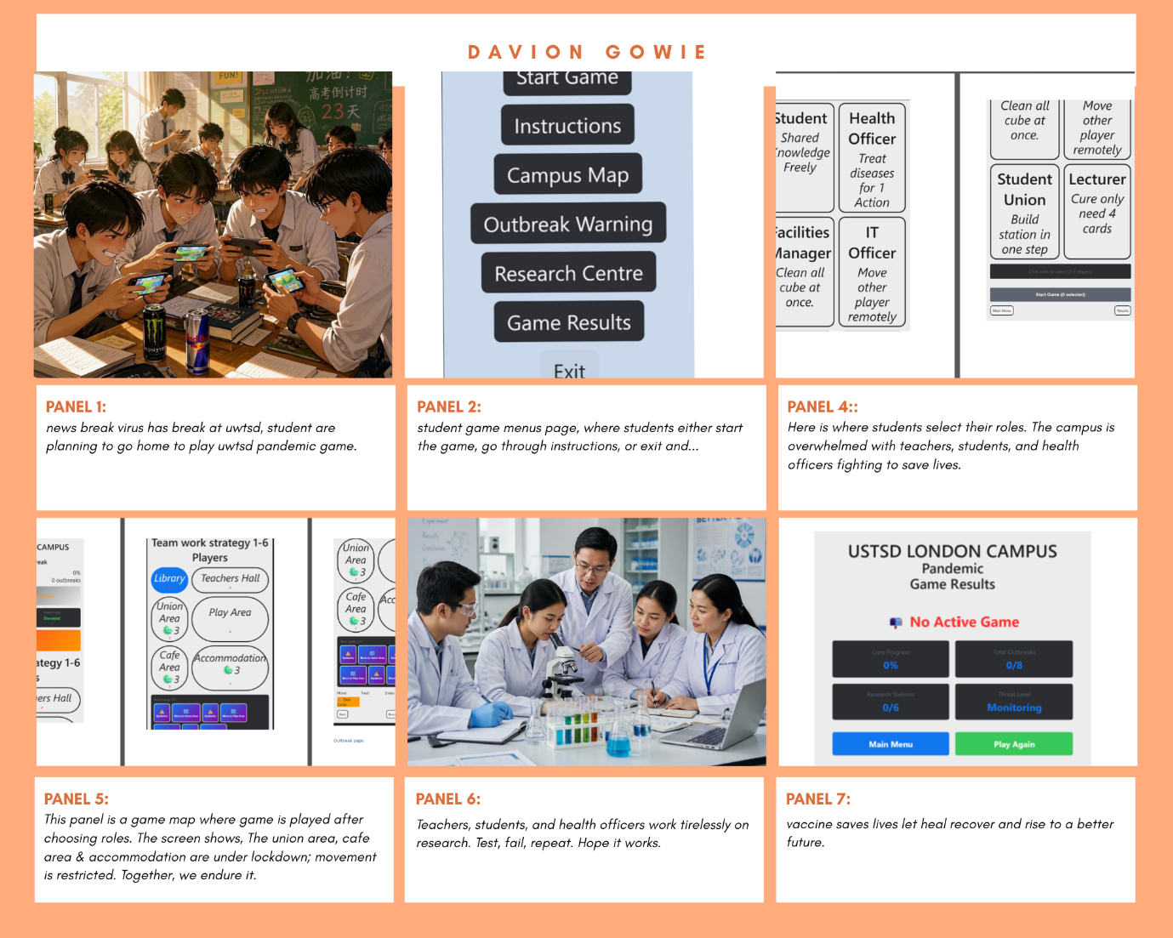

Full Colour wireframe Storyboard Feedback
Students: Buba Green, Efi Taylor, Samanthi Author, Anthony Smith.
I used the System Usability Scale to rate the importance of fixes and to identify which users are commonly okay with the development. Raw score 1/10 and multiple choice qualitative questionnaire as it’s easy to use and straight forward.

- Does the storyboard clearly communicate the narrative from beginning to end?
Very Satisfied, Satisfied, neither satisfied nor dissatisfied, Dissatisfied, or very dissatisfied.
Buba Green: Very satisfied
Efi Taylor: Very satisfied
Samanthi Author: Very Satisfied
Anthony Smith: Very satisfied

- Are the key gameplay mechanics effectively conveyed through the visual panels?
Yes, No, or Not sure.
Buba Green: Yes
Efi Taylor: Yes
Samanthi Author: Yes
Anthony Smith: Yes

- Is (UWTSD campus) clearly established and recognisable throughout?
1/10 SUS

Buba Green: 9 out of ten
Efi Taylor: 9 out of ten
Samanthi Author: 10/10
Anthony Smith: 9 out of 10

- Does the storyboard show a logical cause-and-effect progression between panels?
Extremely effective, very effective, somewhat effective, not so effective, or not at all effective.

Buba Green: very effective
Efi Taylor: very effective
Samanthi author: very effective
Anthony Smith: extremely effective

- Are the emotional stakes and tone shifts clearly represented?
Extremely effective, very effective, somewhat effective, not so effective, or not at all effective.
Buba Green: very effective
Efi Taylor: very effective
Samanthi author: very effective
Anthony Smith: extremely effective

- Full Colour Storyboard Design Work
The final storyboard covers the entire gameplay from opening the application to finishing a game. The storyboards were designed to be viewed on a mobile phone display and contain the major functionality identified in the earlier design stages.
The storyboard includes six main screens: [6]
• Main Menu Start game
• Select your role
• Campus map
• Outbreak Warning
• Research Centre
• Results of games
exit

The way you switch between screens is straightforward and consistent. In the Main Menu, the user can play a new game, check instructions or exit the application. The player is taken directly to the Role Selection screen with the "Start Game" option. Once roles are selected, players are taken to the Campus Map, where the gameplay happens. When the infection level gets too high, the Outbreak Alert screen pops up for players to choose what to do before returning to the map. In addition, players can enter the Research Centre to contribute resources towards the development of a cure. After the game is over, win or lose, the Results screen will show your overall performance and allow you to play again or return to the main menu. [7]

The full interaction flow is illustrated through the storyboard, showing each screen and the transitions between them.
Every screen was designed with a purpose, both for gameplay and usability. The Main Menu provides users with a clear starting point; easy navigation and the most important options are visible immediately. [8]On the Role Selection screen, players can see the six university roles side by side, view their unique abilities, and select the role that best fits their ideal style of play. This helps players understand how teamwork helps achieve the overall objective.

The Campus Map is the main screen for gameplay and shows the university buildings, player locations, infection levels, available resources and outbreak indicators. Information is structured with a clear visual hierarchy so that players can easily identify the most important tasks during gameplay. [9] When infection levels reach a critical point, the Outbreak Alert screen will appear and stop normal gameplay. It will immediately draw the player's attention to the location in question and present the available response options. Players can combine the resources they have collected in the Research Centre to develop a cure and to keep track of the overall progress of the team. The Game Results screen summarises the team's performance, showing infection data, the number of outbreaks that occurred, resources used and whether the players successfully protected the campus. [10]

The interaction flow between these screens was designed to be logical and predictable, reducing unnecessary navigation and supporting efficient decision-making. Buttons are always in the same place, icons are familiar, and transitions are simple. It is easy for a player to go from one phase of the game to the next without confusion. [11] This storyboard reflects the user-centred design approach adopted throughout the project to ensure the interface is easy to understand, visually organised and suitable for both inexperienced first-time mobile game players as well as experienced players.

3. Graphics & Colour Scheme
The colour scheme was selected to assist with usability and the university setting of the game. The interface is mainly styled with a blue colour palette since blue is generally associated with trust, calmness and reliability. The game is not a fast-action game but a strategic decision-making game, so a calm visual environment helps the players concentrate.
Green displays safe campus locations, successful actions and the progress of the cure. Red is used only for outbreak warnings, danger notifications and critical infection levels. Yellow is used to highlight caution messages that require player attention, and grey is used to provide neutral backgrounds that reduce visual clutter.
The colours were selected to be high contrast to increase accessibility for visually impaired players. Icons were designed with text labels so that users with colour vision deficiencies can still recognise important information. Participants’ feedback indicated that some of the building names were difficult to read, so larger fonts were introduced. [12]
The graphics were deliberately kept simple and consistent throughout the interface. University buildings such as the Library, Student Union, Cafeteria and Lecture Theatre were represented by easily recognisable icons, rather than highly detailed illustrations. This reduced the cognitive load but also allowed players to quickly identify locations. [13]
The interface conforms to accepted usability guidelines by keeping button placement consistent, using standard navigation controls and clear visual hierarchy. [14]
The colours were chosen to fit the emotional experience of the game and convey information without unnecessary decorative elements. Shifting from green to yellow and red allows players to quickly recognise increasing levels of risk, supporting faster decision-making during cooperative play.
Consistency was maintained by using the same colours, icons, button styles and navigation throughout the interface. This helps first-time users learn the application and improves efficiency for experienced players, supporting Nielsen's usability heuristic of consistency and standards
. [7]
Accessibility requirements influenced the graphical design through larger text, high-contrast interfaces, descriptive labels, symbols, larger touch targets and increased spacing, making the interface easier to read and use on mobile devices.
The graphics use simplified university environments and flat-design icons to reduce visual clutter, improve mobile performance and keep gameplay information in focus, balancing aesthetics, usability and accessibility.
. [7]

4. Changes Made After Wireframe Feedback
The original wireframes were tested, and many important improvements were made.
During the usability testing, one of the big problems was that the current progress indicator was too small and hard to see. The final storyboard features a much larger progress bar that resides permanently at the top of the gameplay screen, allowing players to check progress without needing to open the Research Centre. [7]
Participants also reported that alerts about outbreaks were not well attended to. To deal with this, the final design has flashing warning banners, bigger notification icons and subtle animations when an outbreak happens.
Building labels were made larger, and more space was inserted between the interface elements. This improved the readability, especially for users with accessibility needs. [12]
Another common recommendation was for a tutorial to be included. The last storyboard presents a brief onboarding sequence detailing movement, infection management, player roles and resource collection before the gameplay begins. [15]
Short ability summaries and graphical icons were also added to role descriptions. This way, new players can get a feel for what each character is good at before they make their choice.
These changes were based on the feedback received during usability testing and peer evaluation, and recognised usability heuristics such as visibility of system status, consistency, recognition rather than recall and error prevention. [7]
The iterative design process was used to update the storyboard based on user feedback, ensuring the interface reflected the needs of new players, experienced mobile gamers and users with accessibility requirements.
Making the cure progress indicator bigger improves the visibility of one of the game's main objectives. Displaying the progress bar on the main gameplay screen provides continuous feedback, helping players make better strategic decisions without interrupting gameplay.
[14]
The outbreak notification system was redesigned with larger icons, simple animations and flashing banners to improve awareness of critical events, helping players respond more quickly and reducing missed warnings.
Accessibility was improved through larger spacing, larger building names, clearer icons and the addition of a tutorial screen. These changes make the game easier to read on mobile devices and help first-time players understand the core mechanics more quickly.
[12]

Overall, these changes demonstrate how user input can contribute to better design through repeated testing and revision. Thus, the final storyboard provides a more intuitive, accessible and engaging experience while adhering to established user-centred design principles and recognised usability guidelines.
Prototype: Pandemic UWTSD GAME.zip
https://uowtsd-my.sharepoint.com/:u:/g/personal/2216147_student_uwtsd_ac_uk/IQDIVlABVStQQoyiZF9p_x40ASLdWLMglEwm6aqLP-e4s1A

Prototype feedback questionnaire:
I used interview questionnaire so users can emphasis and elaborate on questions a bit more it understand the interviewee point of view concisely.

Game menu page where users can either start or exit game or navigate around the game options:

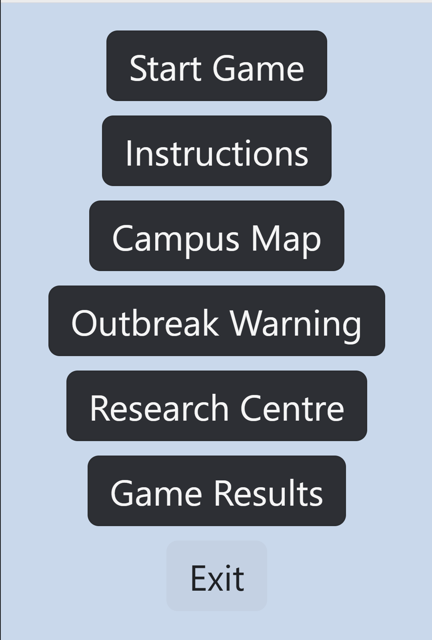

Role selection page before game starts:

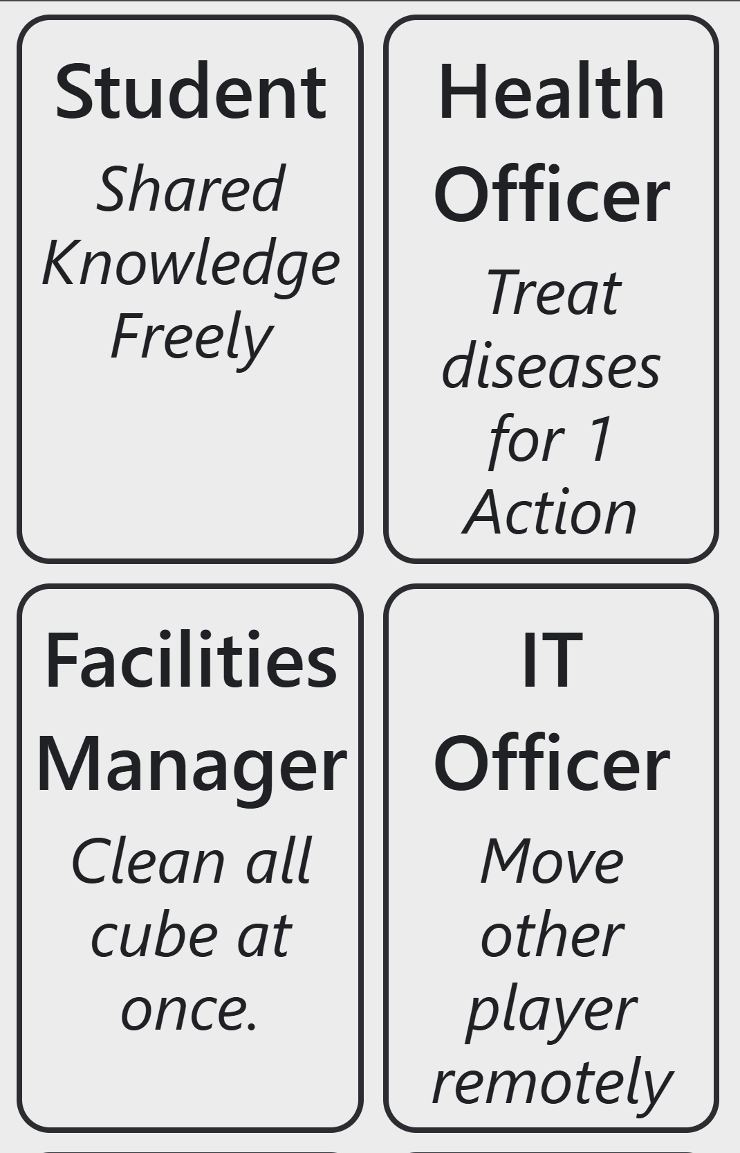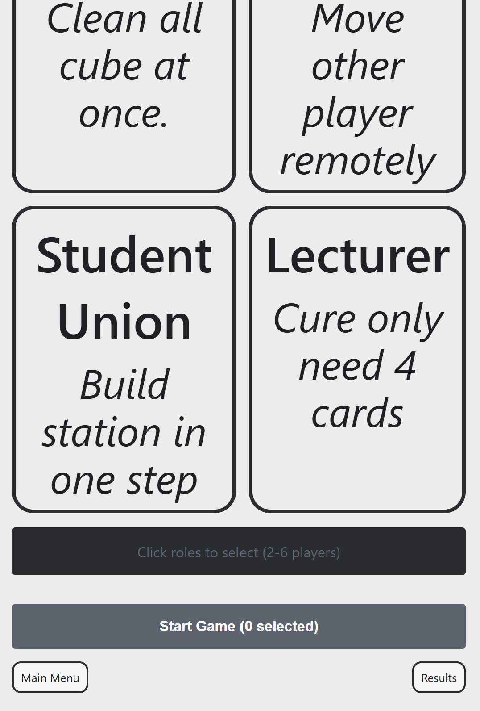

Instructions page:

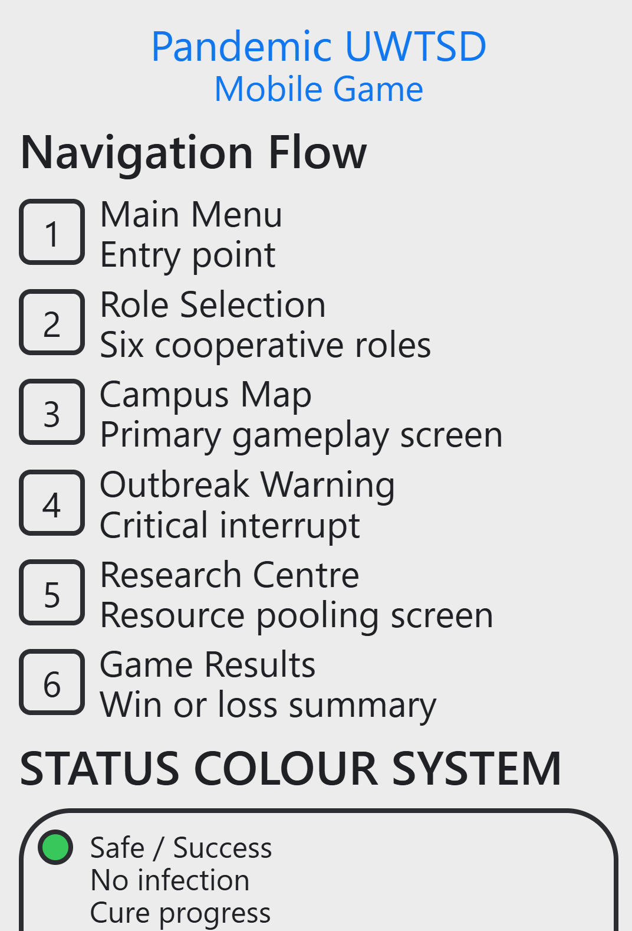

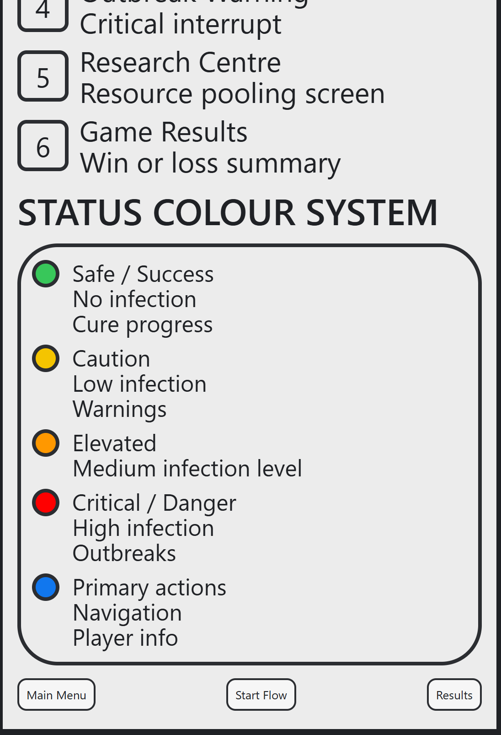
Game map page where game is played:
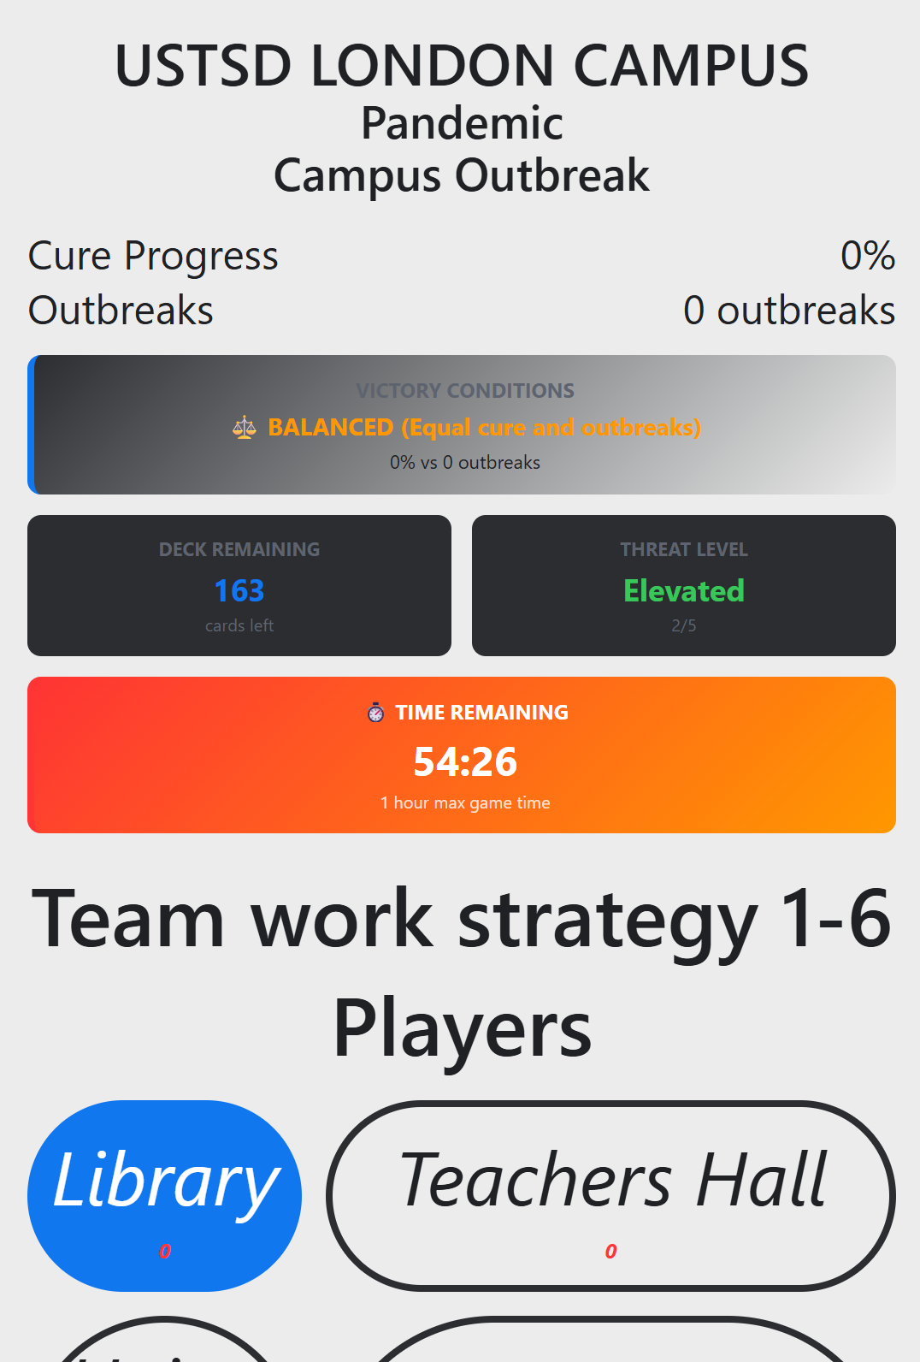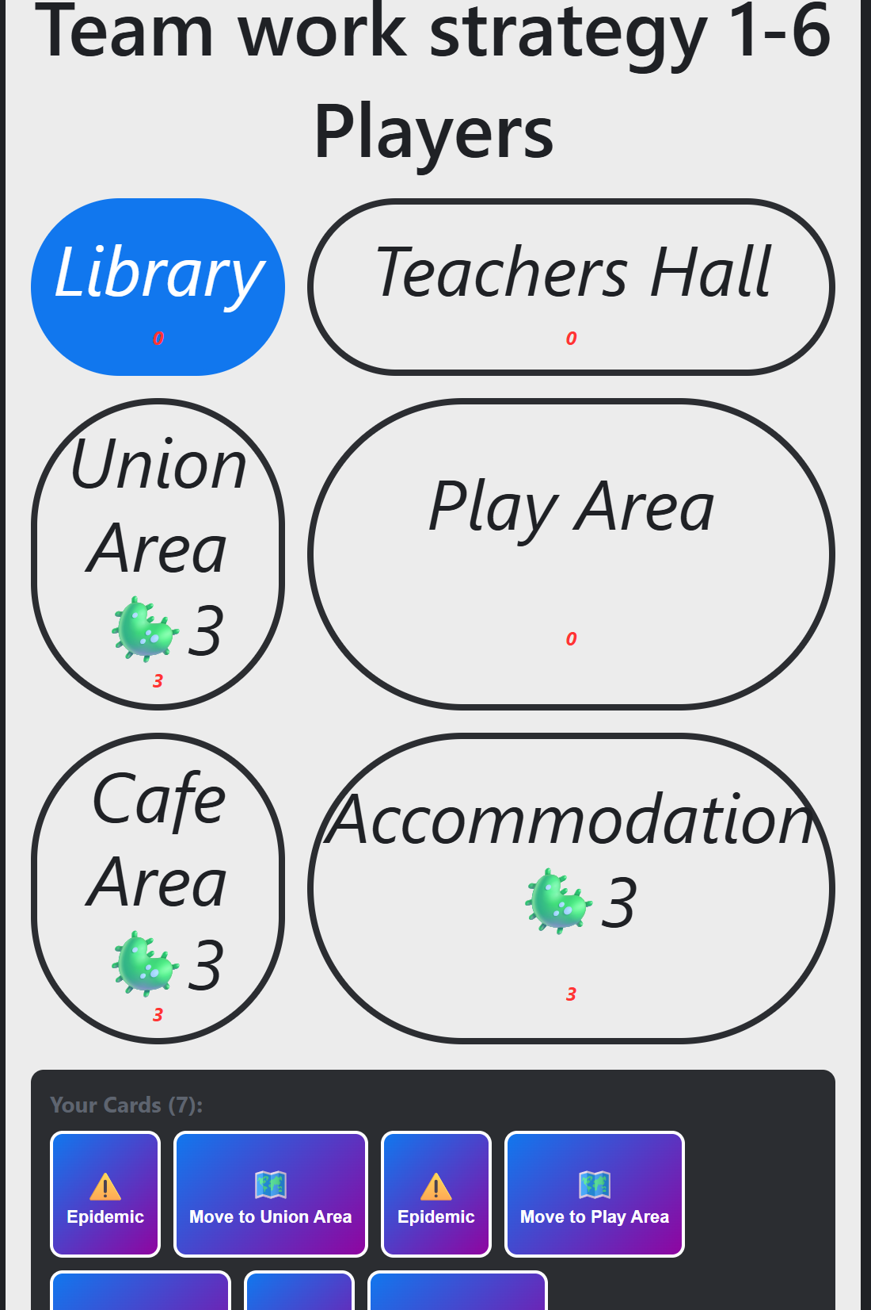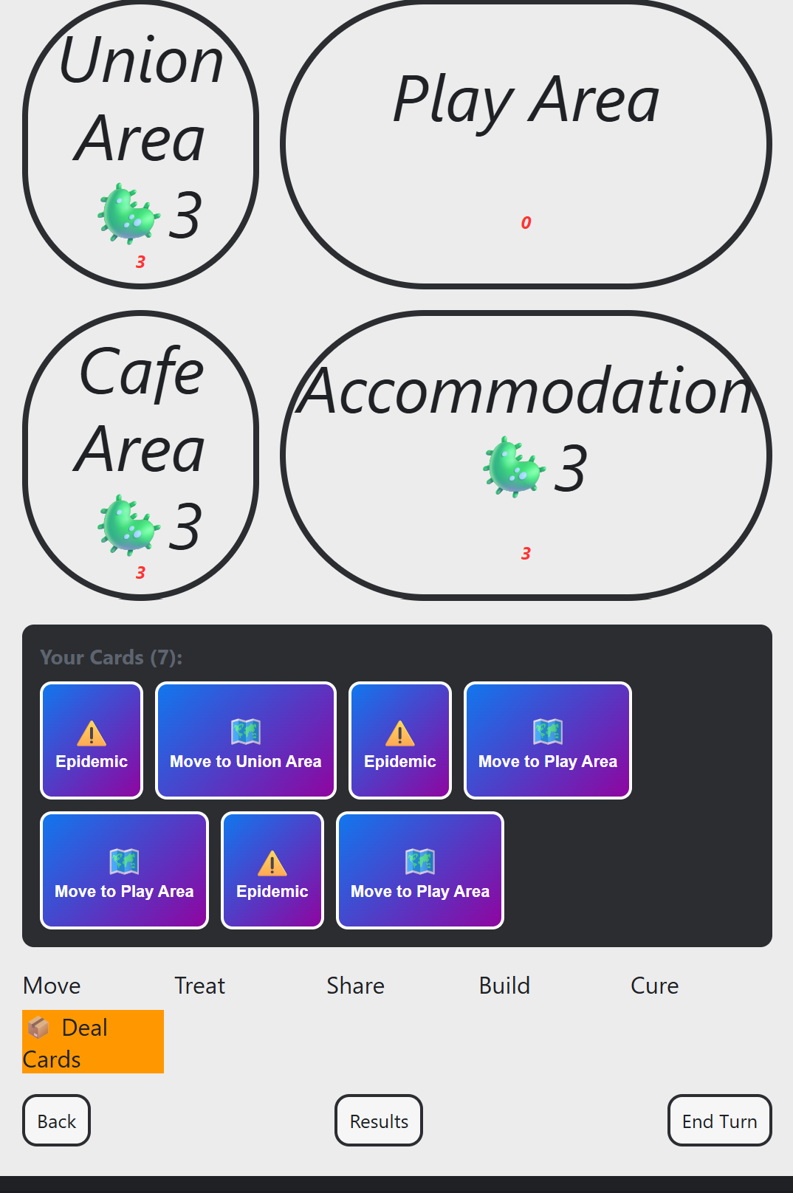

Outbreak page:

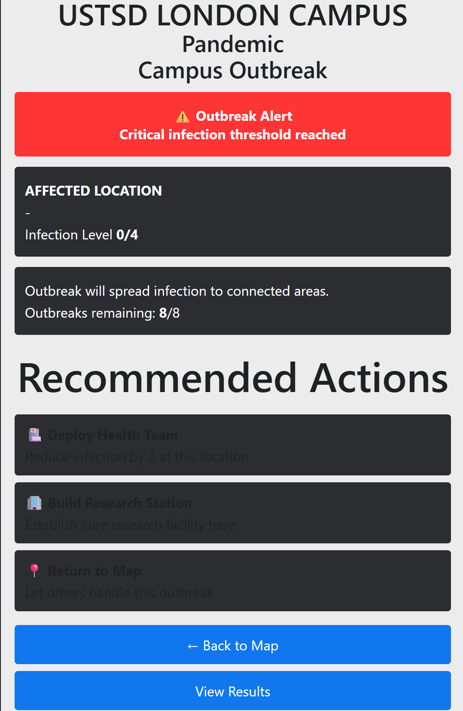

Core progress page and cards selected:

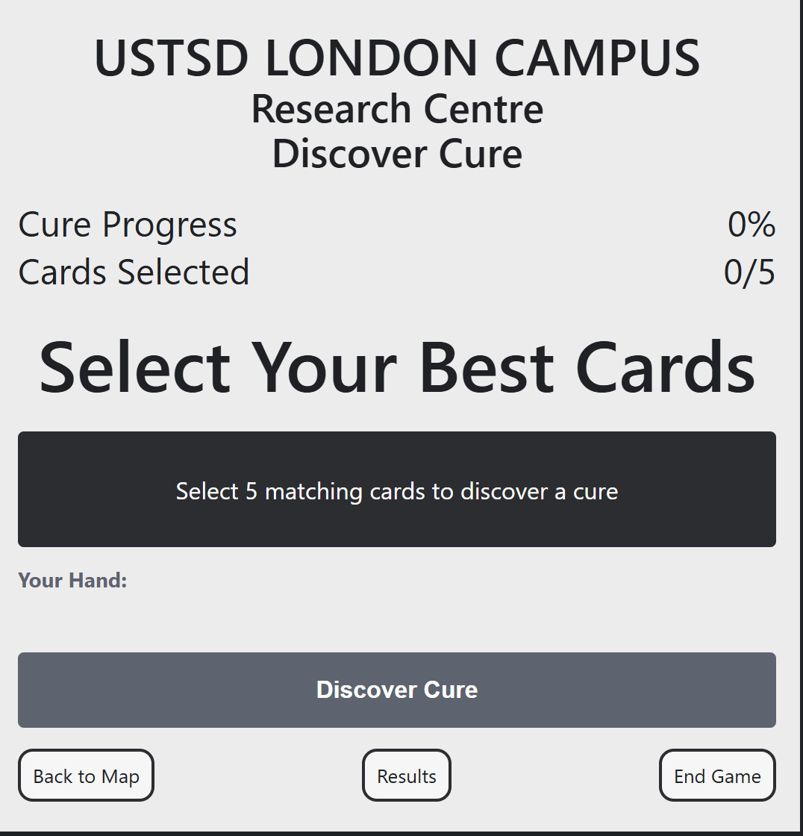

Result page:

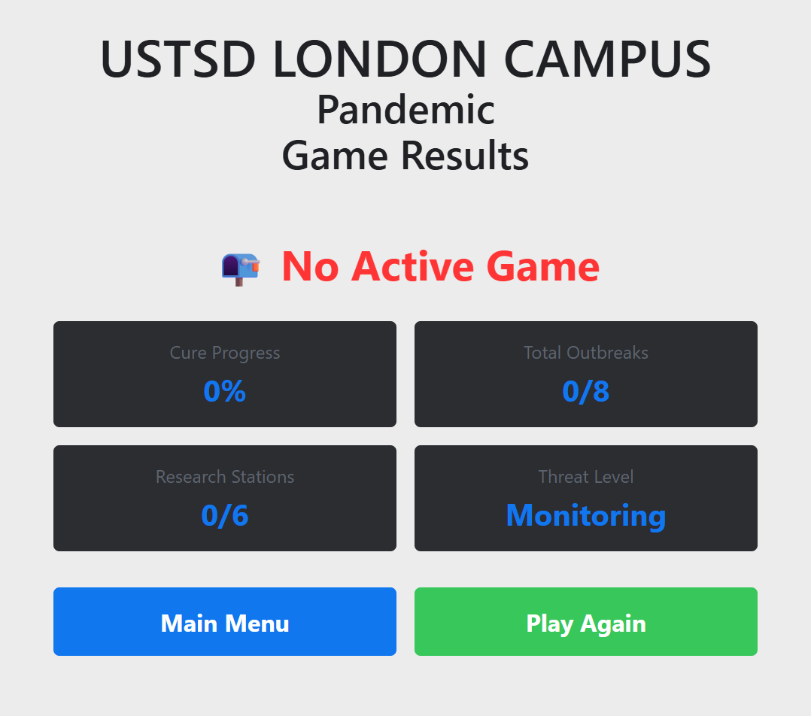

5. User Testing Evidence
Before producing the final storyboard, usability tests were performed on the wireframe prototypes.
Four participants, each representing one of the previously designed personas, performed a series of realistic gameplay tasks. Participants included a regular mobile strategy gamer and undergraduate students with diverse gaming experience, one of whom required accessibility support. [1]
All participants were engaged in the following activities:
• Move through the main menu.
• Choose a player position.
Respond to an outbreak.
• Find a cure.
• Fill the game’s objective.

The think-aloud protocol was used during testing. Participants were asked to describe what they expected each screen to do, what they found confusing and whether they were able to complete each task successfully.
Overall, users successfully performed the main tasks, indicating that the navigation structure was intuitive. Participants especially liked the simplified campus map, the role selection screen and the cooperative gameplay.
However, testing also uncovered a number of usability problems. No visibility of cure progress, some labels were too small, and first-time users wanted more guidance. The results directly impacted the modifications made to the final storyboard. [7]
The revised storyboard thus shows an iterative design process where user feedback was constantly taken into account to improve usability, accessibility and overall user satisfaction.
Usability Testing was designed to measure users’ effectiveness in completing common gameplay tasks and to identify difficulties experienced when interacting. The evaluation was done by participants from the previously developed personas, which made the evaluation more representative of the needs of different types of users, and not feedback from a single user group. Having participants with varying gaming experience and accessibility needs provided a wider view of how well the interface catered for a diverse audience. [1]
The think-aloud protocol enabled participants to explain their decision-making while using the prototype, identifying why users hesitated, misunderstood interface elements or expected different outcomes. This revealed usability issues beyond task completion alone.
The feedback showed that navigation was clear, the university environment was familiar, and the collaborative gameplay provided a positive user experience. The adaptation of Pandemic to the UWTSD campus matched user expectations.
Feedback also identified areas for improvement, including the visibility of the cure progress indicator, the need for more guidance and accessibility concerns. These issues were addressed through larger text, a clearer visual hierarchy and a tutorial system.
[12]
The usability testing highlighted the significance of user involvement in the design process. Feedback gathered informed meaningful design improvements which enhanced navigation, accessibility and gameplay clarity whilst supporting recognised user-centred design principles. Performing iterative usability evaluations made sure that the final storyboard was more aligned with user expectations and offered a more intuitive and engaging experience for future players. [7]

6. Conclusion
The final storyboard demonstrates how a user-centred iterative design process improved the usability and user experience of the mobile game. Based on usability testing and peer feedback, improvements included a larger cure progress indicator, clearer outbreak alerts, improved accessibility, clearer role descriptions and a tutorial. The graphics and colour scheme provided a clear visual hierarchy, improved readability, supported accessibility and maintained a consistent university theme, helping players recognise information and navigate the game more confidently. [12]Usability testing showed that participants understood the gameplay, navigation and cooperative mechanics while identifying areas for improvement. The feedback enhanced clarity, accessibility and player engagement. This project demonstrates the value of combining usability principles with user-centred design. The final storyboard provides a strong foundation for future development, where further usability evaluation can continue to improve the gaming experience.
. [12]

References

[1] | J. G. John Pruitt, “Personas: practice and theory,” DL.ACM.ORG, p. https://dl.acm.org/doi/10.1145/997078.997089, 2003.
[2] | Kate Moran and Kelley Gordon, “How to Conduct a Heuristic Evaluation,” nngroup.com, pp. https://www.nngroup.com/articles/how-to-conduct-a-heuristic-evaluation/, 2023.
[3] | Marc Hassenzahl, “User experience (UX): towards an experiential perspective on product quality,” dl.acm.org, p. https://dl.acm.org/doi/10.1145/1512714.1512717, 2008.
[4] | Ming-Yu Chen, Jyh-Da Wei, Jeng-Hung Huang, D. T. Lee, “Design and applications of an algorithm benchmark system in a computational problem solving environment,” dl.acm.org, p. https://dl.acm.org/doi/10.1145/1140124.1140159, 2006.
[5] | Thomas M. Connolly, Elizabeth A. Boyle,Ewan MacArthur, Thomas Hainey, James M. Boyle., “A systematic literature review of empirical evidence on computer games and serious games,” sciencedirect.com, p. https://www.sciencedirect.com/science/article/pii/S0360131512000619?via%3Dihub, 2012.
[6] | MARTIN MAGUIRE, “Methods to support human-centred design,” sciencedirect.com, p. https://www.sciencedirect.com/science/article/pii/S1071581901905038?via%3Dihub, 2001.
[7] | Jakob Nielsen, “10 Usability Heuristics for User Interface Design,” nngroup.com, pp. https://www.nngroup.com/articles/ten-usability-heuristics/, 2024.
[8] | Don Norman, “Emotion & design: attractive things work better,” dl.acm.org, vol. 9, no. 4, p. https://dl.acm.org/doi/10.1145/543434.543435, 2004.
[9] | D. Norman, “Emotion & design: attractive things work better,” dl.acm.org, vol. 9, no. 4, p. https://dl.acm.org/doi/10.1145/543434.543435, 2002.
[10] | Penelope Sweetser, Peta Wyeth, “GameFlow: a model for evaluating player enjoyment in games,” dl.acm.org, vol. 3, no. 3, p. https://dl.acm.org/doi/10.1145/1077246.1077253, 2005.
[11] | Jakob Nielsen, “10 Usability Heuristics for User Interface Design,” nngroup.com, pp. https://www.nngroup.com/articles/ten-usability-heuristics/, 2024.
[12] | Rachael Bradley Montgomery , “Web Content Accessibility Guidelines (WCAG) 2.2,” w3.org, pp. https://www.w3.org/TR/WCAG22/#interpreting-normative-requirements, 2024.
[13] | John Sweller, “Cognitive Load During Problem Solving: Effects on Learning,” onlinelibrary.wiley.com, vol. 12, no. 2, p. https://onlinelibrary.wiley.com/doi/10.1207/s15516709cog1202_4, 1988.
[14] | Norman, D. A., “the design of everyday thinking,” jnd.org, pp. https://jnd.org/books/the-design-of-everyday-things-revised-and-expanded-edition/, 2013.
[15] | E. O. Y.-E. L. R. S. J. L. D. T. S. C. Z. P. Erik Andersen, “The impact of tutorials on games of varying complexity,” dl.acm.org, p. https://dl.acm.org/doi/10.1145/2207676.2207687, 2012.

Appendix

Prototype feedback questionnaire?
I use a qualitative interview questionnaire because it’s easy to use and straightforward, and it can also be used to get users' overall thought processes on the development.
- How easy was it to follow the game flow from the menu to the result page?
Students:
- Buba Green: It was quite easy to follow. The game flow was clear, and I could understand how to move from the main menu through the different stages to the result page. However, some transitions could be made clearer.
- Efi Taylor: The game flow was easy to follow from the main menu to the result page. Each page followed a clear and logical order.
- Samanthi Author: It is easy to follow the game
- Anthony Smith: It is easy to navigate the menu because the navigation is clearly marked.

- Did you know what to do at each stage, especially on the instructions and role selection pages?
Students:
- Buba Green: Yes, I generally understood what I needed to do. The instructions were helpful, and the role selection page was easy to understand. More detailed guidance or examples could make it even clearer for first-time users.
- Efi Taylor: Yes, I understood what to do at each stage. The instructions were helpful, although the role-selection page could briefly explain how each role supports the team.
- Samanthi Author: Yes, I can easily understand.
- Anthony Smith: Yes, instructions are clear and step-by-step

- How was the navigation of the game map and the movement through the available options?
Students:
- Buba Green: The map was relatively easy to navigate, and the available options were understandable. However, clearer indicators showing where I could move next would make the navigation smoother.
- Efi Taylor: Navigation around the game map was mostly clear. The available actions and buttons were easy to find, but the movement options could be labelled more clearly.
- Samanthi Author: Yes, it is.
- Anthony Smith: It is extremely easy to understand and follow.

- Did the outbreak and core progress pages help you to understand how you were doing in the game?
Students:
- Buba Green: Yes. These pages helped me understand my progress and the current situation in the game. The information was useful, although some elements could be presented more clearly so that progress could be understood more quickly.
- Efi Taylor: Yes, the outbreak and cure-progress pages helped me understand the team’s performance. The colours, progress levels and warnings made the game status clear.
- Samanthi Author: Yes, I know how to do it.
- Anthony Smith: Yes. It has instructions on what to do.

- What was the most interesting part of the prototype? What was confusing or unnecessary?

Students:
- Buba Green: The most interesting part was interacting with the game map and making decisions based on the outbreak situation. It made the prototype feel more interactive and engaging. Some information on the screens was slightly confusing or could be simplified. Clearer instructions and less unnecessary information would improve the overall experience.
- Efi Taylor: The most interesting part was choosing roles and working as a team to control the outbreak. The card-selection system was slightly confusing at first and could include a short explanation. Nothing seemed unnecessary.
- Samanthi Author: Navigation bars are visible, and the whole areas clear and easy to understand.
- Anthony Smith: The most interesting aspect is the simplicity and ease of following—no criticisms whatsoever of the design.

3. Personas: Background, Goals, User Experience Requirements, Frustrations



