 | Targed/target | Yr hyn yr wyf wedi'i wneud yn yr aseiniad hwn  What I have done in this assignment...
Targed/Target 1
Targed/Target 2
Targed/Target 3

How a school develops one aspect of its SDP: a report that critically reflects on the actions, impact and evidence base.
The aspect of the school’s development plan that this assignment will focus on is the importance of the school council and the promotion of a pupil voice within the educational environment. A literature review will detail a variety of different approaches regarding giving pupils an opportunity to promote their views and opinions. The review will consider the legal obligations and the lawful requirements in giving pupils the opportunity to have a say on how the school is run, while providing a platform for arguments, both for and against, encouraging pupils to take an active part in whole-school planning and decision making. This assignment will scrutinise the targets within the SDP and make references on how they are currently being addressed and achieved. Quantifiable data will be provided to support any conclusions.
The placement school has approximately 885 pupils on roll and is an 11-16 community school. The Estyn report of 2015 describes it as being in a deprived area with 37% of pupils with special educational needs and 60% of pupils living in the 20% most deprived areas in Wales. The school is successful and achieved ‘excellent’ in all categories throughout the report.
Grigg (2014 p. 21) states that the business term ‘stakeholders’ has become increasingly used within education to represent anyone who has an interest in the success of a school. Of the ‘internal stakeholders’, the teachers and managers control what happens within the school, whilst the learners themselves, represented by the school council, might be considered to be the most important group.
The United Nations Convention of the Rights of the Child, which was adopted by the UK government in 1991, legally entitles children to express their views freely. The importance of a pupil voice is stressed within the Welsh Government’s national mission Action plan 2017–21, which clearly states that “We must ensure that every voice is heard, and no child is left behind”. The School Councils (Wales) Regulations (2005) has now made it a statutory requirement that schools form a School Council which must convene for a minimum of six times a year and supervised by staff. The council must consist of a minimum of one pupil from each year group who is elected by secret ballot and have two elected pupils on the school’s governing body. In addition, the Governing Body, or/and Headteacher must respond to any communications initiated by the council.
In 1999 the National Curriculum placed importance in installing moral values which included “a commitment to valuing ourselves, our families and other relationships”. In response to this, Duckworth (2009) notes that several schools adopted a value-based educational programme. This is one in which a pupil learns to respect oneself and others and is a programme that “fosters positive relationships and quality education”. The very concept of installing moral values and instilling a mutual respect for others and their opinions is also central to Donaldson’s Four Purposes (2015). Promoting a set of values will consequently contribute to creating individuals that are able to participate “confidently in different social contexts”.
Meanwhile, in 2004 more than 1600 schools opted to participate in UNICEF’s Rights Respecting Schools Award (RRSA). This award is based on the United Nations Convention on the Rights of the Child and is presented to schools if they have met a variety of standards and can prove that the “children become active and involved in school life and the wider world” and participate in decision making within the school community (UNICEF 2022). Mechanisms of pupil participation include the school councils, school committees, RRSA steering groups and local advisory groups. In the final report by Sebba and Robinson (2010), it was noted that in a survey of 31 schools adopting the RRSA, decision making, relationships and behaviour had improved, while the number of bullying incidents had reduced. Pupils had also “developed a moral sense of respect for the environment and a sense of compassion and injustice when learning about those whose rights are denied”.
There can be enormous benefits in encouraging pupils to become actively involved in decision making. Lubelska (2018) notes that having a school council “promotes democracy and (pupil) aspirations” while a strong school council generates a link between the parents, pupils and staff. Davies (2006), states that encouraging pupils to take responsibility for their own actions has a positive impact on pupil behaviour within the school. Consequently, several schools have witnessed a reduction in fixed term and permanent exclusions. Garner (2005) supports this by stressing the importance of instilling the outcomes of decision making when “choice is guided by responsibility and leads to positive or negative consequences according to the choice made by the pupil”.
Pulis (2016) agrees there can be little doubt that encouraging pupils to participate in decision making can result in positive outcomes. However, promoting participation can also provide the school with a challenge as there is a very wide spectrum of pupil involvement. Hart (1992) indicates that it is the degree of responsibility on offer that is the “subject of strongly divergent opinion”. For this reason, Hart proposed a metaphorical ‘ladder’ in which the eight runs of the ladder correspond to the degree of pupil participation within the school community. Hart’s ladder was originally based on Arnstein’s 1969 “A Ladder of Citizen Participation,” but refined to reflect pupil participation in schools. The first run of Hart’s ladder is ‘manipulation’, in which children have no understanding of the issues, do not understand their actions or their role in that process. This lack of participation often occurs when pupils’ opinions are viewed with caution, and Grigg (2015 p. 22) gives an example of a school in which staff and the Headteacher felt that pupils were not competent enough to be able to make important decisions or judgements.
In contrast, some schools encourage pupils to have an input into important processes such as appraisals and staff appointments. The summit of Hart’s ladder goes beyond this and is a category that empowers “young people to have a significant impact on policies, decisions, or outcomes that were traditionally under the exclusive control and direction of adults” (Hart, 1992). In modern society, examples of this are rare. There have, however, been examples of radical pupil participation within some establishments and Griggs (2015 p. 286) refers to a school which had created its own student inspection team called ‘Instead', in which pupils observed over 200 individual lessons and then created a report on their findings.

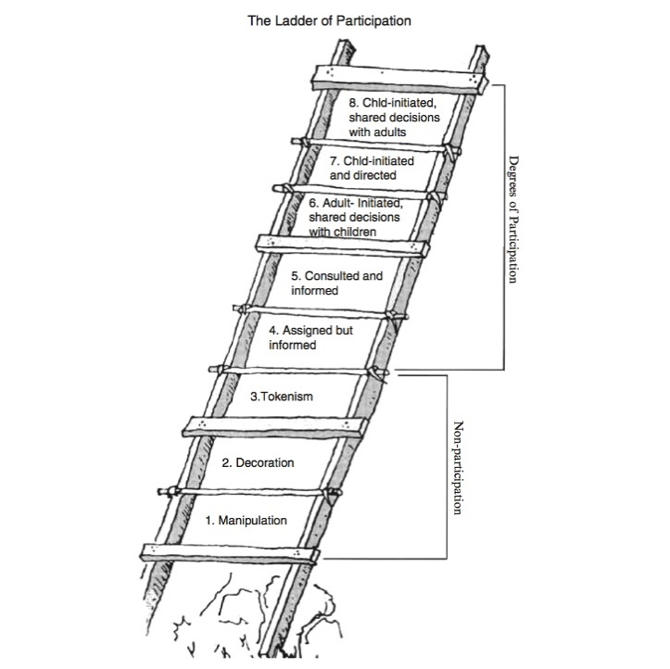

The objectives of a SDP are clearly set out as a statutory requirement by the Welsh Government (Department of Education, 2014). The principal aim of the SDP as a school document is to raise standards and maximise learner outcomes. It will make specific reference to strategies in raising standards in literacy, numeracy and reducing the impact of poverty on educational attainment, therefore reflecting national educational priorities. Schools are bound by many legal requirements such as religious education, time allocation to key academic subjects and promotion of the Welsh language. The actual requirements of the SDP are, however, quite flexible and schools are left to produce one that works best for them as a local education establishment.
The format of the SDP is clearly set out within the Welsh Government Guidelines. The document will cover a three-year period and is one of continuous refinement, following a four-stage reoccurring cyclic pattern. These stages are Self-Evaluation, Planning, Action followed by a Review and analysis of all outcomes relating to any targets set. Diagram 2, from the Welsh Government Guidelines clearly demonstrates how raising standards is at the heart of this four-stage process, a continuous process of refinement in striving to meet the school’s vision statement. 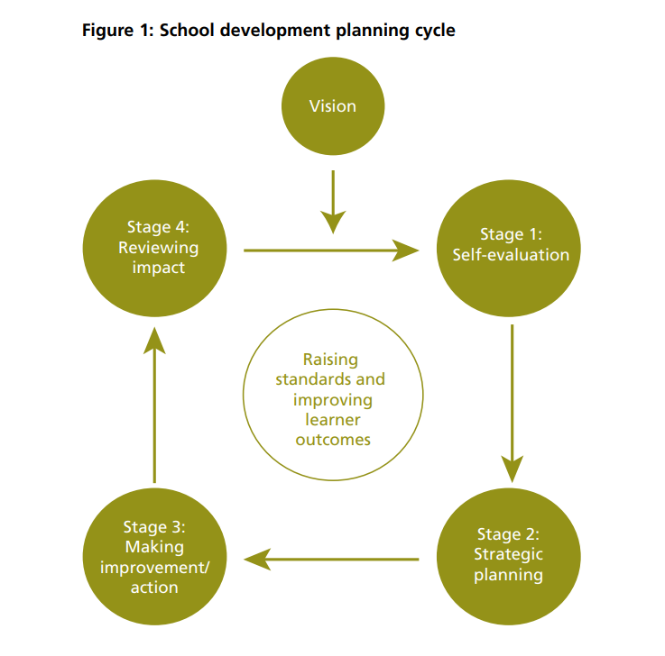
Department of Education Wales (2014)
The vision statement of the school is unique to the establishment. It is a declaration that has a clear purpose on what the school is aspiring to achieve with specific relevance to the type of school, environment, and local community. The Guidelines clearly state that it should be “motivational, achievable, and is underpinned by solid practical strategies”.
The initial stage of this cyclic process begins with the Self-Evaluation stage. This is where the school asks itself ‘where are we now and what needs to be improved?’ The use of ‘quantitative data’ is essential in being able to ‘benchmark’ the school. This is a process by which a school can compare its performance with other schools of similar “numbers, intake, social-economic location, pupil-ability” together with the “numbers of pupils on a statement of educational needs” (Davies 2006 p. 186). Using quantitative data can also be used to evaluate any previous targets and to monitor the value-added performance of the pupils within the school. It is also very important to consider any targets set by Estyn during the Self-Evaluation stage.
With the gathered information and identified areas for improvement, the planning stage can commence. Teachers with responsibility suggest strategies for development within their area and any other suggestions which will benefit the school. At this time the guidelines state the school must “involve all school partners and stakeholders” in the planning process. Teachers and administrative staff are given an opportunity to make suggestions, while parents usually contribute ideas directly to the Head or through the parents’ association. It is here that the guidelines clearly state that the learners themselves should be involved, and that good schools will positively encourage contributions from the pupils via the school council.
With the necessary paperwork completed by the first of September, the action stage can commence. Clear accountability, areas of responsibility and timescales for realistic targets must be in place by this date. The SDP is considered a ‘live document’ and effective teachers with a responsibility will be periodically referring to the plan to ensure that targets are on track and will be achieved within the time allocated.
An annual evaluation of the SDP will take place and it is a legal requirement for the Governors to “monitor, review and update” the SDP during the Review Stage. Quantitative data is now crucial for assessing whether targets have been met, and to be able to benchmark the performance, and improvements of the school with national standards and schools similar in nature.
The present SDP issued by my allocated placement school is divided into three sections. In accordance with the Guidelines, the first section sets out three-year strategic priorities with many references to literature and numeracy. The second section is on medium/year priorities and the last section is entirely devoted to pupil voice and the school council, reflecting the high level of importance that the school places on encouraging pupil participation.
The placement school has weekly delegated meetings held in form rooms to discuss council issues and the minutes of the council meetings are displayed in classrooms. To evaluate the impact of the council, and to monitor how well the school is meeting its targets, I created a questionnaire. This was completed by a year 8 class during the delegated discussion time and was based on a one-to-five Leuven Scale, (as seen below). The mean-average for each response by the class was recorded. The results were compared to the targets mentioned in the SDP within three designated categories: Promotion, Influence, and Effectiveness of the Council.
- Strongly Disagree 2. Disagree 3. No opinion 4. Agree 5. Strongly Agree
Promotion of the School Council
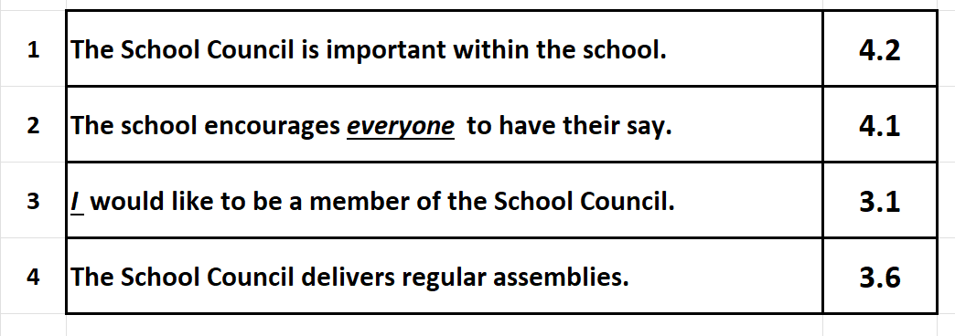
Adhering closely to Donaldson’s (2015) philosophy promoting an “education for every child” with a need to take “account of their views” there were many positive responses within the survey. A score of 4.1 indicated that the school is making every effort to promote pupil voice and encourage participation in decision making. Despite the best efforts from the school, there are still several pupils that are reluctant to take an active role in the council. The school can take no blame for this, as it will always be difficult to encourage pupils to ‘give-up’ their own free time while encouraging naturally shy pupils to contribute to meetings will always be a challenge. The school appears, however, to be missing the opportunity to utilise assemblies, a stated target on the SDP, but this may be due to time restrictions caused by Covid 19.
Influence
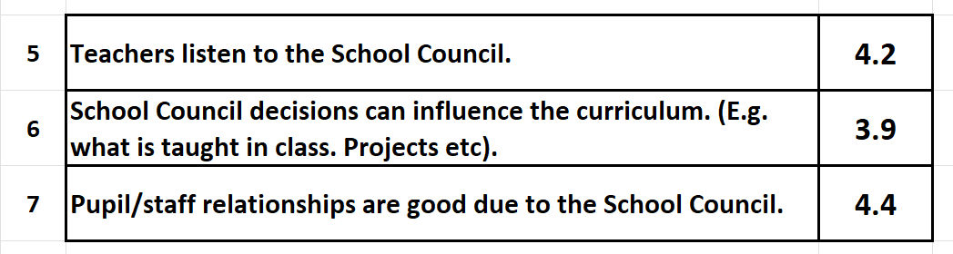
Pupils clearly felt that teachers listened to the contributions made by the pupils. This will have a direct, positive impact on pupil/staff relations which scored the highest mark in the survey, a pleasing achievement clearly indicating a school that advocates, and achieves, an atmosphere of mutual respect between pupils and staff. The Estyn inspection report (2015) also highlighted the important role the council played beyond the school walls, noting that the school “includes liaison with local community representatives through membership of groups such as the school council”.
Effectiveness
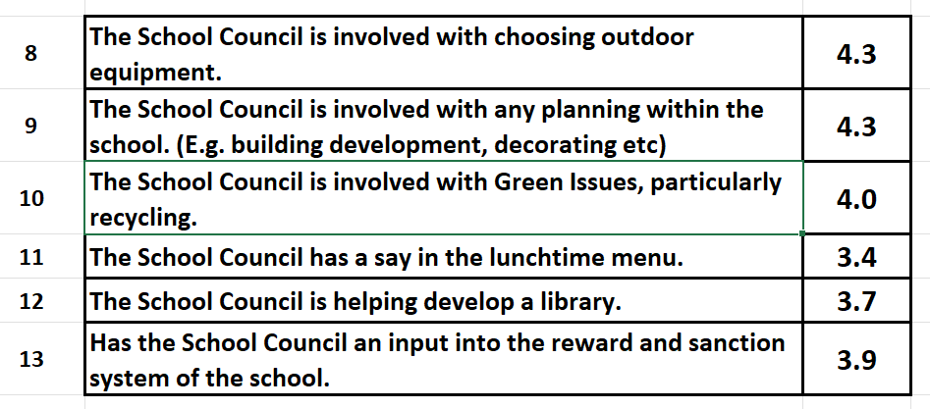
The Estyn report of 2011 claimed that the school council had “made invaluable contributions to school life”. It even stated that “the school council was pro-active in the design of the new school building and the humanities group continues to influence schemes of work”. The school council’s effectiveness in helping to contribute towards management decisions is clearly apparent, a view strongly supported by the year 8 class. The influence on the school menu system with a score of 3.4 was disappointing, but the choice of food is always an area of contention with children.
Completing this assignment has made me aware of the importance and role of a SDP. All stakeholders have a moral duty to exercise corporate responsibility and work towards fulfilling the school vision plan. The Professional Standards for Teaching and Leadership (2019) points to staff actively contributing “to the aims and development of the school” with staff making every effort to promote the “school’s ethos and the successful fulfilment of the school’s vision”. This will help the school obtain its targets and lead to a successful school and a healthier educational environment. When joining a school my personal targets regarding the SDP would include: -
- Have a complete understanding of what the school vision is aspiring to
- Be aware of school development targets
- Periodically refer to the targets set within my academic area or role of responsibility
- Raise any concerns with AoLE leaders if it appears that targets will not be met
Regarding pupil voice, I have been fortunate to have joined a placement school that shares features of levels 6, 7 and 8 on Hart’s Ladder of Participation. It is a school that encourages involvement, whilst creating a positive atmosphere of mutual respect. After observing for myself the positive results of pupils’ voice, I feel enthused in supporting staff/pupil initiatives and even ‘leading colleagues, projects and programmes’ within this area as outlined in the Professional Standards for Teaching and Leadership (2019). Reflecting on all issues regarding pupil involvement, if given the opportunity to work within a school my personal targets regarding pupil voice would include: -
- Follow all legal guidelines regarding pupil voice
- Ensure that any minutes of meetings are displayed within the classroom and in line with any school policies
- Encourage all pupils to participate and contribute to decisions at the highest level
- Take an active role in the promotion and organisation of pupil voice within the school

References.
Arnstein, S. (1969) 'A Ladder Of Citizen Participation', Journal of the American Planning Association, 35: 4, 216 — 224 (Accessed 25 June 2022) DOI: 10.1080/01944366908977225
[XXXXXXXXXXX Community School] (2021 – 2022). School Development Plan. Available at: https://www.XXXXXXXXXX.net/index.php/information/school-development-plan (Accessed 3 June 2022).
Department of Education Wales (2014): School development plans Guidance: October 2014. Available at:https://gov.wales/sites/default/files/publications/2018-03/school-development-plans.pdf (Accessed 17 June 2022).
Department of Education Wales (2017). Education in Wales: Our national mission, Action plan 2017–21. Available at:https://gov.wales/sites/default/files/publications/2018-03/education-in-wales-our-national-mission.pdf (Accessed: 14 June 2022).
Department of Education Wales (2019): Professional standards for teaching and leadership. Available at: https://hwb.gov.wales/api/storage/19bc948b-8a3f-41e0-944a-7bf2cadf7d18/professional-standards-for-teaching-and-leadership-interactive-pdf-for-pc.pdf (Accessed: 26 June 2022).
Davies, S. (2006). The Essential Guide to Teaching. Edinburgh: Pearson Education Limited.
Donaldson, G. (2015). Successful Futures. Available from: successful-futures.pdf (gov.wales) - English version. Independent Review of Curriculum and Assessment Arrangements in Wales.
Duckworth, J. (2009). The Little Book of Values. Carmarthen: Crown House Publishing.
Estyn Inspection Report. (2011). Available at: https://www.estyn.gov.wales/system/files/2020-08/Inspection_Report_Cefn_Hengoed_Community_School_ENG_2011_English_only.pdf (Accessed: 5 April 2022).
Estyn Inspection Report. (2015). Available at: https://www.estyn.gov.wales/provider/6704031 (Accessed: 5 April 2022).
Garner, P. (2005). Learning to Teach in the Secondary School. London: Routledge.
Grigg, R. (2014). Becoming an Outstanding Primary School Teacher 2nd Ed. London: Routledge.
Hart, R. (1992). Children's Participation: From tokenism to citizenship, Innocenti Essay no. 4. London: UNICEF UK. Available at: http://www.unicef-irc.org/publications/pdf/childrens_participation.pdf (Accessed: 21 June 2022)
Lubelska A. (2018). How to be a Peaceful School. London: Jessica Kingsley Publications.
Pulis, A. (2016) ‘Pupil voice in quality assurance of schools’. [BERA blog]. 29 April. Available at: https://www.bera.ac.uk/blog/pupil-voice-in-quality-assurance-of-schools (Accessed: 21 June 2022).
Sebba, J. and Robinson, C. (2010) Evaluation of UNICEF UK’s Rights Respecting Schools Award. London: UNICEF UK. Available at: https://www.unicef.org.uk/rights-respecting-schools/wp-content/uploads/sites/4/2014/12/RRSA_Evaluation_Report.pdf (Accessed: 4 June 2022).
The National Curriculum. (1999) Handbook for primary teachers in England. London: Department of Education and Employment. Available at: http://www.educationengland.org.uk/documents/pdfs/1999-nc-primary-handbook.pdf (Accessed: 21 June 2022)
The School Councils (Wales) Regulations 2005. Available at: https://www.legislation.gov.uk/wsi/2005/3200/contents (Accessed: 12 June 2022).
UNICEF UK (2022). What is a Rights Respecting School? Available at: https://www.unicef.org.uk/rights-respecting-schools/about-us-new/(Accessed: 26 June 2022).

