DESIGNING AN INTEGRATED INFORMATION SECURITY, GOVERNANCE, AND COMPLIANCE FRAMEWORK FOR CLOUD-BASED FINANCIAL SERVICES: A CASE STUDY OF FINSURE BANK

1. Abstract
Digital banking has significantly increased the reliance on cloud-based systems, exposing finance premises to a wide range of cybersecurity threats. The dependency on cloud platforms, the emergence of the practice of Bring Your Own Devices (BYOD), and the absence of the security governance and compliance models are significant threats to FinSure Bank (FSB), a digital-only financial services provider. To establish whether they are appropriate in addressing these problems, this report covers information security structures that are eminent and they are Information Technology Infrastructure Library (ITIL) and ISO/IEC 27001 among others.
The detailed security, governance and compliance model, which is specific to the FSB operational environment, is developed by applying an analysis. The solution proposed incorporates risk management activities, security controls, regulatory compliance and technical protection controls in the effort to reduce the risks of data breaches, insider attacks and cyber fraud. This indicates that a flexible and stable model can be beneficial to be more resilient to organisations in order to make them comply with regulators and secure sensitive financial and personal data in an increasingly diverse digital environment.

Table of Contents
1. Abstract 2
2. Introduction 4
3. Literature Review: Security Frameworks & Models 4
3.1 ITIL Framework 4
3.2 ISO/IEC 27001 5
3.3 NIST Cybersecurity Framework 6
3.4 Comparative Analysis 7
4. Proposed Security, Governance & Compliance Framework for FSB 7
4.1 Assumptions 7
4.2 Governance Framework 8
4.3 Risk Management Strategy 9
4.4 Security Architecture Design 10
4.5 Security Policies 11
4.6 Compliance & Regulatory Framework 11
4.7 Contingency Planning 12
4.8 Protection Mechanisms 13
4.9 Service Level Agreements (SLA) 13
5. Critical Discussion: Need for Updated Regulations & Standards 13
6. Conclusion 14
References 16

2. Introduction
Digital banking and cloud computing have revolutionised the financial services industry and allowed organisations to provide scalable, efficient, and accessible services to their customers worldwide. Nonetheless, such change has been accompanied by profound cybersecurity threats such as data breaches, identity theft, and advanced cyberattacks on financial resources and personal data. The importance of sound security, governance, risk management, and regulatory compliance are now critical due to organisations shifting to cloud infrastructure and mobile technologies.
FinSure Bank (FSB) is an upcoming virtual first financial institution which operates on cloud platforms. Even though this model is flexible and can be scaled fast, it also induces major vulnerabilities. The recent expansion in the organisation has led to the adoption of the Bring Your Own Device (BYOD) practices where employees and third-party partners can use their own gadgets to access internal systems. This increases vulnerability to endpoint security risks, data leakage and unauthorized access. Further, absence of general security policies, governance models and formal compliance controls has contributed to a dispersed information security model within the organisation.
This report aims to analyze the existing security frameworks, i.e., ITIL and ISO/IEC 27001, and apply their ideas to develop full governance, risk, and compliance model, which is specific to FinSure Bank.

3. Literature Review: Security Frameworks & Models

3.1 ITIL Framework
The Information Technology Infrastructure Library (ITIL) is a trendy framework that provides best practice in managing IT service (ITSM) with the aim of maintaining alignment of IT services to the business requirements. ITIL is created as a service lifecycle model which includes service strategy, service design, service transition, service operation and the continuous service improvement stages (Katari and Vangala, 2025). This lifecycle has security management as a fundamental element with information security controls woven into service delivery processes.
ITIL is concerned with the importance of maintaining confidentiality, integrity, and availability (CIA triad) of information assets as part of information security. It also promotes the implementation of security controls in service design and operation such that risks are dealt with proactively rather than reactively (Hassan, Hassan and Khan, 2023). ITIL also supports incident management processes and problem management processes that are required to mitigate security breaches and minimize the effects on operations.
One of the most significant resources of ITIL is its ability to introduce security to the overall management of IT services because it enhances the efficiency of the work and the quality of services. ITIL enables organisations to deliver safe and trustworthy services without customer distrust by ensuring that IT processes are linked to business objectives.

3.2 ISO/IEC 27001
ISO/IEC 27001 is an international standard of information security management systems (ISMS) that provides a methodological approach to the management of sensitive information. The standard is concerned with risk-based approach that requires organisations to identify, assess and respond to information security threats by instituting appropriate controls. It is developed on a continuous improvement framework, often referred to as the Plan-Do-Check-Act (PDSA) cycle, that ensures that security practices remain effective over the long term (Alshar'e, 2023).
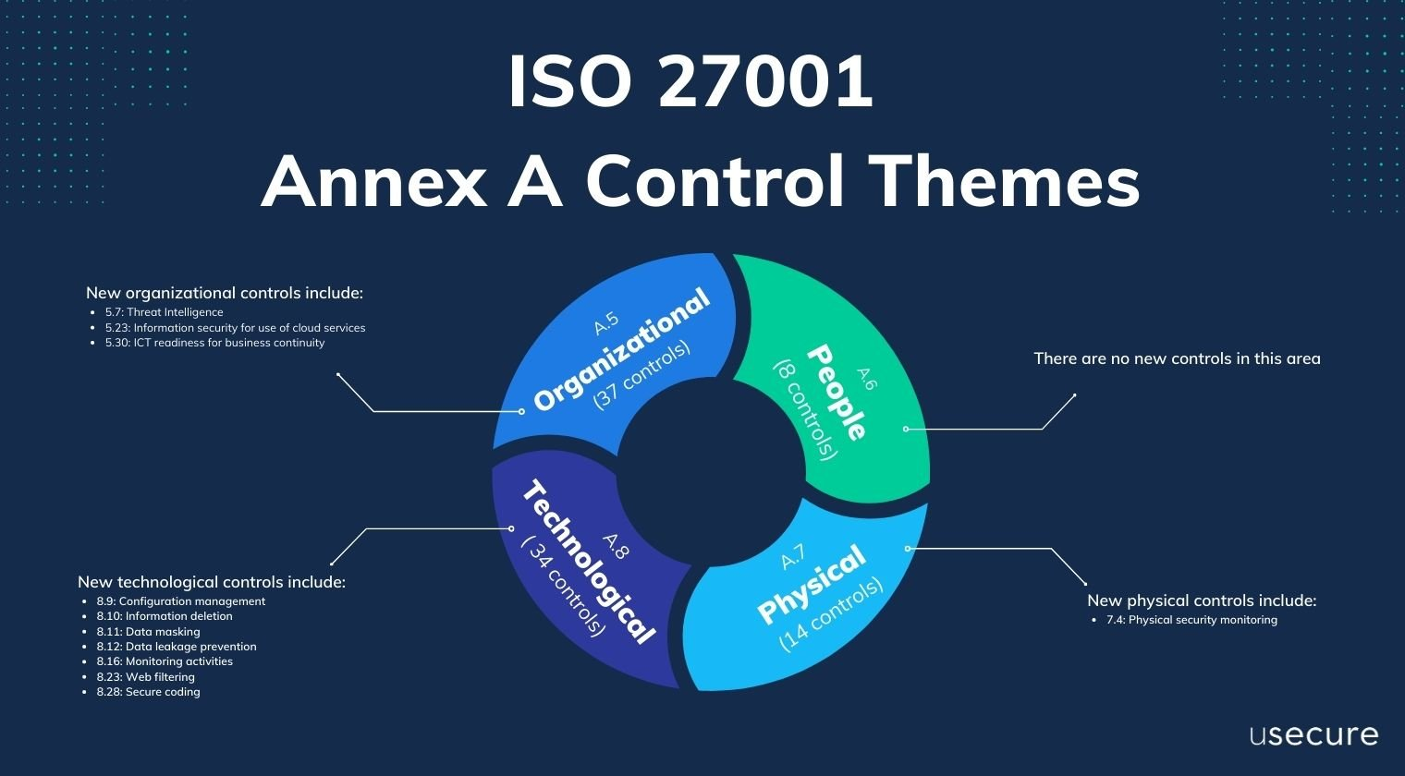
Figure 1: ISO/IEC 27001 ISMS Model
(Source: blog.usecure.io, 2026)
The significant point of ISO/IEC 27001 is that it has a comprehensive list of controls, which are presented in the form of Annex A and that also has such areas as access control, cryptography, physical protection, incident management, and supplier relationship. The reason is that these controls help organisations to create effective security controls that constitute both the technical and organisational elements of information security. The standard also emphasizes documentation, accountability, and regular audits and ensures that security practices are exercised and observed frequently (Batte, 2025).
One of the major strengths of ISO/IEC 27001 lies in its great conformance with the regulatory requirements including the data protection laws such as the General Data Protection Regulation (GDPR). By using an ISMS, organisations can demonstrate compliance, improve risk control and increase the level of trust amongst stakeholders.
Despite the above, implementation of ISO/IEC 27001 is resource-consuming and complex, particularly in organisations that are less security mature. Much expertise and organisational commitment is required in risk assessment, control and ongoing monitoring process choice. In addition, the standard is not prescriptive and provides organisations with the freedom to flexibilities to their environment despite a robust framework.

3.3 NIST Cybersecurity Framework
NIST Cybersecurity Framework (CSF) is a widely used model that can be employed to help organisations mitigate and mitigate cybersecurity threats in a loose and organised way. The framework was designed at the National Institute of Standards and Technology, and is particularly applicable in organisations where the environment includes complex and highly risky conditions such as the financial services. It has been developed into five core functions that constitute Identify, Protect, Detect, Respond and Recover. These functions provide end-to-end lifecycle to tackle the issue of cybersecurity risks management, enabling organisations to monitor their current security level and apply appropriate controls (Shinde, Patil and Wadkar, 2023).
Asset management is defined as asset management, governance, and the ability to assess risks and understand the nature of their systems and weaknesses. Protect means the provision of protection services including access control, encryption, and awareness training. Detect is a company specialized in detecting anomalies and continuous monitoring to determine possible security events. Responds features incident management and mitigation procedures, and Recover provides services and processes to recover resilience and services following an attack (Molnar and Sabodashko, 2024).
The high-risk management concern and the flexibility can be regarded as one of the most significant advantages of the NIST framework. It allows organisations to tailor controls based on their risk appetite and business requirements, which is appropriate in dynamic environments like FinSure Bank.

3.4 Comparative Analysis
A comparison of ITIL, ISO/IEC 27001 and the NIST Cybersecurity Framework indicate that the three are complementary in the management of information security. ITIL is more of a service based product, which dwells on the process of incorporating security into IT service management so as to gain efficiency in the operations and quality of services. On the contrary, ISO/IEC 27001 provides a structured, compliance-based approach with an Information Security Management System and is abundant in controls and audit mechanisms. The NIST Cybersecurity Framework is focused on risk management and organisational resilience and provides an adjustable set of models to establish, remove, and react to cybersecurity threats (Omolere, 2025).
Despite the individual merits of each of the frameworks, none of them is sufficient to address the multifaceted security challenges facing modern organisations such as FinSure Bank. Therefore, an integrated approach which integrates service management, compliance, and risk-based security controls is required to achieve overall protection and governance.

4. Proposed Security, Governance & Compliance Framework for FSB

4.1 Assumptions
Several key assumptions regarding operational and technological environment of FinSure bank form the basis of this proposed framework. FSB presupposes that it is a medium-to-large multinational financial institution, operating across several jurisdictions, which is why it is regulated by international regulatory requirements, including the General Data Protection Regulation (GDPR). The company operates on a cloud-first platform with high reliance on third-party service providers, such as AWS or Microsoft Azure, to store critical systems and data (Folorunso et al., 2024). The second assumption is that the organisation has a medium-high budget on investment in cybersecurity but is low in its security maturity due to the absence of well-organised governance and risk management systems. In addition, endpoint security is a higher risk with Bring Your own device (BYOD).

4.2 Governance Framework
The accountability, authority to make decisions, and alignment of the strategy between business goals and the safety of information must be established by the proper system of governance. FinSure bank should consider a formal governance structure, where a Chief Information Security Officer (CISO) reports to the executive management or board of directors. This will render it a strategic priority rather than technical concern on cyber security (Jain and Mitra, 2025).
The governance model should be top-down where the board outlines security policies and risk appetite, and top management translates such policies into working strategies. IT security team has the role of making controls, monitoring of threats and adhering to the requirements of regulation. They should establish effective communication channels and lines of reporting that will assist in ensuring transparency and accountability throughout the organization (Al Harthy, 2022).
Further, the governance should include regular security audits, performance reviews and continuous improvement processes to remain current with the evolving threats. The combination of governance practices and ISO/IEC 27001 and NIST frameworks provides consistency and effectiveness. This official approach will assist FinSure Bank to migrate ahead to counter threats, maintain in check with the rules as well as to enhance its security status overall.
Table: Roles and Responsibilities
Role | Responsibilities
Board of Directors | Define security strategy, risk appetite, and compliance requirements
CISO | Lead security program, develop policies, ensure governance alignment
IT Security Team | Implement controls, monitor systems, manage incidents
Compliance Officer | Ensure adherence to GDPR and regulatory standards
Employees & Contractors | Follow security policies, report incidents

4.3 Risk Management Strategy
The comprehensive risk management plan is necessary in identifying, assessing, and mitigating security risks within FinSure Bank context. As both cloud infrastructure and BYOD practices are employed in the organisation, there are several significant threats that should be investigated. These are unauthorized access on personal devices, insiders threats based on abuse of privileges, and vulnerability of the third-party cloud service provider. In addition, the risks involved in data breaches, fraud, and services will have to be estimated systematically (Qureshi, Sadeq and Manuel, 2024).
The proposed methodology aligns with risk-based approach in ISO/IEC 27001 that involves asset identification, threat and vulnerability identification, and probability and impact of potential risks. The risk assessment matrix may be used to rank the risks based on their severity, a step that could see the organisation effectively manage resources.
Risk Assessment Matrix
Risk | Likelihood | Impact | Priority
BYOD security breach | High | High | Critical
Insider threat | Medium | High | High
Cloud service failure | Medium | High | High
Phishing attacks | High | Medium | High
The FinSure bank must have an effective access control (Multi-factor authentication and role-based access management) to avoid such risks. Endpoint security solutions must monitor and protect the personal devices and encrypt them during transit and rest. Man-made threats are social engineering and phishing, which can be overcome through regular security training. They also need to be provided with constant monitoring and incident response system to make sure that the threats could be tracked and countered in real-time (Srikrishna and Murthy, 2024).

4.4 Security Architecture Design
Security architecture proposed by FinSure Bank is an integrated, layered architecture that integrates cloud security controls, Zero Trust, and strong identity and endpoint management to assist the risk environment of the organisation (Ahmadov, 2023). FSB is a strong user of cloud infrastructure and, therefore, the security must be integrated into cloud services, such as providing such configurations as secure virtual networks, datatrest and datain transit encryption, and highly restrictive access control policies. The independent monitoring solutions must be combined with the cloud providers security tools to allow visibility and control.
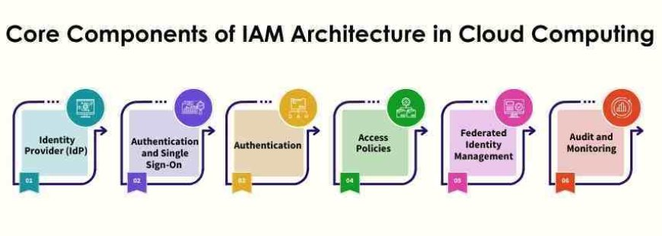
Figure 2: Conceptual Security Architecture Diagram
(Source: digitdefence.com, 2026)
This design is anchored in the concept of a Zero Trust Architecture (ZTA), which is based on the premise of “never trust, always verify.” Any access request, both internal and external, must be authenticated, authorized and continually validated. It will be particularly true of FSB as it applies BYOD and comes to access via third-party partners remotely (Almarhabi, 2024).
Identity and Access Management (IAM) plays important role in use of least privilege access. Role-Based Access Control (RBAC) will be deployed to ensure that users can get access to resources they require as far as how they work (Hasan, 2024). Multi-Factor Authentication (MFA) will be applied to all the users and this will greatly reduce the chances of unauthorized access due to stolen credentials.
The safety of the endpoints plays a significant role in managing BYOD risks. All personal devices accessing organisational systems should be registered, monitored, and secured using end point detection and response (EDR) tools.

4.5 Security Policies
The FinSure Bank information security framework is anchored in security policies that determine a clear set of rules and expectations about protecting organisational assets. A detailed policy of Bring Your Own device (BYOD) is also required to manage personal device usage. This policy should enforce the registration of devices, security settings and access to sensitive systems unless conditions of compliance are met (Nzeako and Shittu, 2024).
A data protection policy must ensure that sensitive financial and personal data are handled in a secure manner. This entails the use of encryption, restricted access to data and secure storage and transmission. The policy should also determine the data classification levels and level of data handling procedure.
The access control policy should implement the principle of least privilege, which mean that users are only allowed to access resources according to their roles. They are role-based access control, periodic access review, and high-order authentication such as multi-factor authentication (Daah, Qureshi and Awan, 2023).

4.6 Compliance & Regulatory Framework
To comply with the compliance requirement, FinSure Bank is to adopt a proper compliance structure according to the General Data Protection Regulation (GDPR) and other financial requirements. The postulates required under the GDPR compliance mean that organisations should be obliged to employ the following postulates: reduction of information, the gathering and running of data ought to be as low as possible, and restriction of purpose whereby data are utilised in the way that is coherent with the clear purposes.
Sensitive data in rest and transit also require encryption to secure confidentiality and reduce the likelihood of unauthorised access. In addition, consent options must be clear, allowing the customers to understand the process of their data processing and allowing them a chance to manage their personal data (Nutalapati, 2023).
Regular auditing should be carried out in the compliance with regulation standards. Internal audits should be done periodically to test adherence to the policies and controls, and external audits can be conducted to uncover potential loopholes. Such audits are intended to be supported by detailed documentation and reporting procedures.
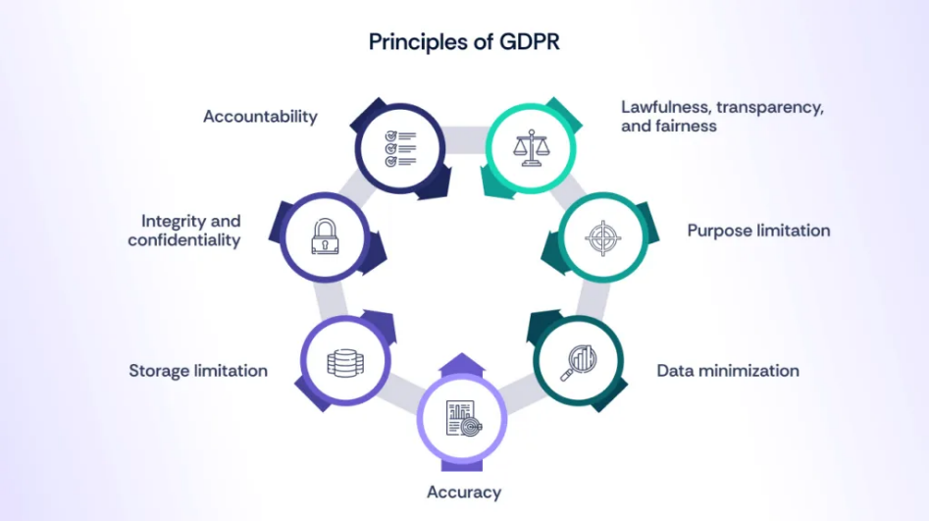
Figure 3: GDPR Compliance Framework
(Source: scrut.io, 2026)

4.7 Contingency Planning
Contingency planning is the only way in which operational resilience could be realized that minimizes the impacts of service disruption of the FinSure Bank. A Disaster Recovery Plan (DRP) needs to be integrated to enable the fast restoration of critical systems and data following these events such as cyberattacks, system failures, or natural calamities (Okunlola et al., 2025). This means recovery time objectives (RTO) and recovery point objectives (RPO) should be established, in such a way that the effects of data loss and downtime are minimal.
Business Continuity Plan (BCP) goes hand in hand with DRP because it provides the capability to ensure continuity of vital business operations during and after the disruption. This is achieved through identifying the key processes, backup workflows, and by having the key people and resources available.
Contingency planning needs backup plans. Regular automated backup is also recommended and must be held in hardened areas preferably with geographical dispersion to prevent loss of information to local events. The backup data should also be encrypted to ensure that it is confidential.

4.8 Protection Mechanisms
FinSure Bank will need to implement a variety of technical protection measures to secure the information systems and data. The first defense mechanism is firewalls since they control the inbound and outbound traffic over the network based on a set of security policies. They should be complemented by Intrusion Detection and Prevention Systems (IDS/IPS), which monitor the network traffic and anticipate potential threats in real-time (Albazaz, Almolaa and Yaseen, 2024).
Encryption is a security measure that is necessary to avoid undesirable access to sensitive data. It shall apply to stored data as well as data traversing networks and hence capable of integrity and confidentiality. Anti-malware Software is also required to detect and remove malicious software which could compromise systems or data.
In order to offer the online threat detection and respond to such cases, a Security Information and Event Management (SIEM) system has to be deployed to collect and analyze any type of security logs.

4.9 Service Level Agreements (SLA)
The service level agreement (SLA) is important in defining the responses and expectations between FinSure Bank and its cloud services providers. As FSB will rely on the external cloud infrastructure, SLAs must clearly delineate the responsibilities of a provider, including system availability, data security, and regulatory standards. Cloud providers should be accountable to ensure infrastructure security, apply security patches on time and ensure service availability.
Data protection requirements must be well defined and customer data must be handled in accordance with GDPR requirements. This includes data encryption, data storage location, and breach notification. Additionally, SLAs should specify on the timelines of incident response whereby the providers are required to report and respond to security incidents within defined period. Clear SLAs ensure accountability is more effective, reduce operational risks, and ensure that the security and compliance requirements are adequately met.

5. Critical Discussion: Need for Updated Regulations & Standards
The cybersecurity environment is dynamic, which necessitates the continuous creation of regulations and standards in line with new threats and technology. Organisations such as FinSure Bank are operating in an environment in which cyber threats are more advanced than ever, and ransomware attacks, advanced persistent threats, and AI-controlled cybercrime, abound. These dynamic threats cannot stand such fixed rules and therefore it is important that they are regularly updated to make sure that the security measures are working.
The emergence of speedy adoption of new technologies, such as cloud computing, artificial intelligence, and the Internet of Things, has further expanded the attack surface. These technologies have new vulnerabilities which do not always necessarily fall within the existing standards. To illustrate the point, cloud environments require shared responsibility paradigms, whereas AI systems introduce threats to data integrity and manipulation of algorithms.
The alterations of regulatory requirements, particularly in the field of data protection, is another significant incentive to update standards. The essence of frameworks such as the General Data Protection Regulation (GDPR) is constantly being enforced and reaffirmed, and organisations need to update their compliance policies.

6. Conclusion
The report has discussed how information security structures are vital in controlling the issues of FinSure Bank, which is a cloud-based digital financial institution. The comparison of ITIL, ISO/IEC 27001, and the NIST Cybersecurity Framework shows that these three approaches have their advantages in the areas of service management, compliance, and risk-oriented security. However, it is apparent that no single framework can be applied to address the new and dynamic environment of cybersecurity.
To avoid these obstacles, holistic security, governance, and compliance models were proposed, according to the operational environment of FSB. The model integrates governance structures, risk management strategies, security design, policies, compliance procedures and contingency planning. Such an all-encompassing approach will ensure that security is factored into all the processes within the organisation and active risk minimisation and compliance with regulations is realised.
These findings point out the necessity to spearhead a multifaceted and responsive approach to information security. The cyber threats are dynamic, and the regulatory demands are getting more strenuous; organisations must constantly revise their structures and procedures. The proposed model will enhance maturity in security, customer confidence, and adherence to international standards at FinSure Bank.

References
Katari, A. and Vangala, R., 2025. Data Privacy and Compliance in Cloud Data Management for Fintech. Academia. edu.
Hassan, A., Hassan, M.A. and Khan, M.A., 2023. Multi-Cloud Strategies for Scalable and Secure Fintech Applications. Journal of Educational Research in Developing Areas, 4(1), pp.123-133.
Alshar'e, M., 2023. Cyber security framework selection: Comparision of NIST and ISO27001. Applied computing Journal, pp.245-255.
Batte, B., 2025. ISO 27001 and Alternative Frameworks for Managing Information Security Risks. Available at SSRN 5546398.
Sanjay Shinde, I.P.S., Patil, Y. and Wadkar, P., 2023. Evolution of cybersecurity standards in financial sectors. Madhya Bharti-Humanities and Social Sciences UGC Care Group I Journal, 84(29), pp.118-123.
Molnar, V. and Sabodashko, D., 2024. Comparative analysis of cybersecurity in leading cloud platforms based on the NIST framework. Social Development and Security, 14(6), pp.68-80.
Omolere, O., 2025. Integrating Cybersecurity Frameworks (NIST and ISO/IEC 27001) into it Audit Practices: Evaluating the Effectiveness of Global Cybersecurity Frameworks in Strengthening Audit Outcomes.
Folorunso, A., Mohammed, V., Wada, I. and Samuel, B., 2024. The impact of ISO security standards on enhancing cybersecurity posture in organizations. World Journal of Advanced Research and Reviews, 24(1), pp.2582-2595.
Jain, V. and Mitra, A., 2025. Developing and Implementing Cloud Security Frameworks: A Comparative Analysis of Existing Models and Best Practices. In Risk-Based Approach to Secure Cloud Migration (pp. 115-140). IGI Global Scientific Publishing.
Al Harthy, K., 2022. A Risk Management Framework for the BYOD Environment.
Qureshi, K., Sadeq, S.H. and Manuel, P., 2024. Analysis of Security Challenges in Cloud Computing Adoption for the Banking Sector. International Journal for Computers & Their Applications, 31(4).
Srikrishna, H.V. and Murthy, J.S., 2024. Securing Mobile Workspaces in the Cloud: Navigating Bring Your Own Device Challenges with Cyber Resilience. In Cloud Security (pp. 238-262). Chapman and Hall/CRC.
Ahmadov, S., 2023. Enhancing BYOD mobile device security in a hybrid environment. Sustainable Engineering and Innovation, 5(2), pp.247-260.
Almarhabi, K.A., 2024. An improved smart contract-based bring your own device (BYOD) security control framework. Alexandria Engineering Journal, 105, pp.598-612.
Hasan, M., 2024. Enhancing enterprise security with zero trust architecture. arXiv preprint arXiv:2410.18291.
Nzeako, G. and Shittu, R.A., 2024. Implementing zero trust security models in cloud computing environments. World Journal of Advanced Research and Reviews, 24(3), pp.1234-1245.
Daah, C., Qureshi, A. and Awan, I., 2023. Zero trust model implementation considerations in financial institutions: a proposed framework.
Nutalapati, P., 2023. Zero Trust Architecture in Cloud-Based Fintech Applications. Journal of Artificial Intelligence & Cloud Computing. SRC/JAICC-E152. DOI: doi. org/10.47363/JAICC/2023 (2) E152 J Arti Inte & Cloud Comp, 2(1), pp.2-8.
Okunlola, O.A., Olaoye, J., Samuel, O.O., Okunlola, A.O. and Alao, O., 2025. Zero Trust Security Models in Cloud Environments: Compliance Implications.
Albazaz, F.A.K., Almolaa, O.S. and Yaseen, D.S., 2024, December. A Study on Examine Strategies for Ensuring Data Security and Regulatory Compliance in Cloud-Based Information Systems. In International Conference on Biologically Inspired Techniques in Many-Criteria Decision-Making Technologies (pp. 202-212). Cham: Springer Nature Switzerland.
scrut.io, 2026. How to implement a GDPR compliance audit: Checklist and template. https://www.scrut.io/hub/gdpr/gdpr-compliance-audit-checklist
blog.usecure.io, 2026. A comprehensive guide to understanding ISO 27001. https://blog.usecure.io/a-comprehensive-guide-to-understanding-iso-27001
digitdefence.com, 2026. Fundamentals of IAM Architecture in Cloud Computing. https://digitdefence.com/blog/fundamentals-of-iam-architecture-in-cloud-computing

