MODULE: DIGITAL TRANSFORMATION IN THE HEALTH AND CARE PROFESSIONS

MODULE CODE: BMHP6026

ASSIGNMENT TITLE: COMPONENT 1: WRITTEN REPORT

STUDENT NAME: Lilieana-Lavinia Victoria
STUDENT ID: 2412370
LECTURER NAME: Zakiyyah Ahmed

Table of Contents
Section 1: Introduction 2
Section 2: Impact on Service Delivery 2
Changes to Service and Process Workflow 2
Efficiency, Coordination and Continuity of Care 3
Implementation Barriers, Costs and Operational Risks 3
Critical Evaluation using Policy and UK Evidences 3
Mini-Evaluation 4
Section 3: Impact on Patient/Service User 5
Accessibility, Convenience and Choice 5
Patient Autonomy, Empowerment and Engagement 5
Digital Exclusion and Inequalities 6
Privacy, Confidentiality and Patient Trust 6
Overall Patient-Centred Judgement 7
Section 4: Conclusion and Recommendations 7
References 8

Section 1: Introduction
Digital transformation has gained more importance in the UK health and social care, changing the way services are accessed, delivered and managed. Use of digital technologies can make the otherwise routine administrative operations simpler, enhance access to health information and facilitate communication between patients and healthcare providers. The NHS Application is a major example of patient facing digital innovation and helps further modernise healthcare services.
The NHS Application was launched in 2018 and publicly launched in 2019 and allows users to access various healthcare services, such as prescriptions, GP appointments and GP health records, depending on the facilities offered via their GP practice and linked systems (Gerken, 2022). The application is, not a substitute to the whole NHS digital infrastructure or traditional interactions between the healthcare system. Rather, it offers an extra online platform whereby patients can interact with medical professionals and oversee some of their care.
This report will critically analyse the effect of the NHS Application on two areas, the service delivery and the experience of patients/service users. It focuses on operational efficiency, coordination of services, convenience, patient autonomy, digital exclusion, privacy and usability using academic evidence, evidence on NHS, government policy and appropriate legislation. Even though the application could support access and streamline regular processes, its efficiency lies in the inclusive implementation, effective technology, and fitting clinical pathways and the accessibility of alternative access routes maintained.

Section 2: Impact on Service Delivery

Changes to Service and Process Workflow
NHS Application has provided a digital pathway through which patients can access some of the focused healthcare services, modifying the way patients relate with the general practices. Provided that the user requests a repeat prescription, accesses to GP health records, and can undertake eligible appointments without having to call the reception on a phone or visit the hospital (NHS, 2018). These functions can minimise some of the day to day administration requirements, enhance convenience and enable other personnel to focus on additional duties. Nonetheless, moving the current processes to online does not necessarily enhance service delivery. The availability of appointment is conditional on the clinical capacity, staffing and local practices. As such the application can facilitate easy access to the available services, but cannot solve waiting times or workforce shortage by its own.

Efficiency, Coordination and Continuity of Care
The NHS Application can enhance efficiency by allowing patients to have convenient access to appropriate health-related information and implement routine tasks electronically (Greaves et al., 2026). Having access to GP records can aid patients in the preparation of consultations, and ease from the trouble of endless prescriptions and make the maintenance of repeat medication easier. The advantages however are dependent on how well, and readily the information is obtained. The variability in the practice-level functionality and system integration can cause discontinuity or redundancy in the administrations. Moreover, easier access to the records does not necessarily ensure that patients comprehend the contents of the records and healthcare professionals react faster. Efficiency should thus be measured both in an organisational and a patient perspective. A method of decreasing telephone calls can be beneficial to the receptionists, but problematic to the patients who have some difficulties with digital technology (KC et al., 2025).

Implementation Barriers, Costs and Operational Risks
The NHS application implementation and maintenance demand the investment of digital infrastructure, integration of the system, employee training, technical assistance and cybersecurity. Patients might not be able to complete tasks due to technical failures, the lack of coherence in interfaces and account-access issues. Another concern of healthcare organisations involves their security of confidential information against unauthorised access and adherence to relevant data-protection standards (Djuranovic, Spalevic and Ilic, 2025). The employees might also be required to handle electronic requests in addition to the telephone calls and personal contact, which can result in them getting more workloads in case their operations are not synchronized. The use of digital application might as well heighten appointment requests without any augmented clinical capacity. Therefore, the supposition that digitalisation will inevitably lower the costs or administrative burden needs to be approached carefully. Its proper execution requires a solid technology, relevant personnel backup and constant review of the functionality.

Critical Evaluation using Policy and UK Evidences
“A Plan for Digital Health and Social Care” by the Department of Health and Social Care underlines the significance of digital technologies in the better utilisation of access, information sharing and efficiency of the service (GOV.UK, 2022). On the same note, the framework “What Good Looks Like” published by NHS England gives guidelines on the creation of user-centric, integrated and safe digital services (Futures.NHS.UK, 2026). It uses a 7 pillar based framework, which helps patients to connect over the application safely, with smart foundations and well-led support, use digital information and transformation into a healthy population, while benefitting from the improved access to care.
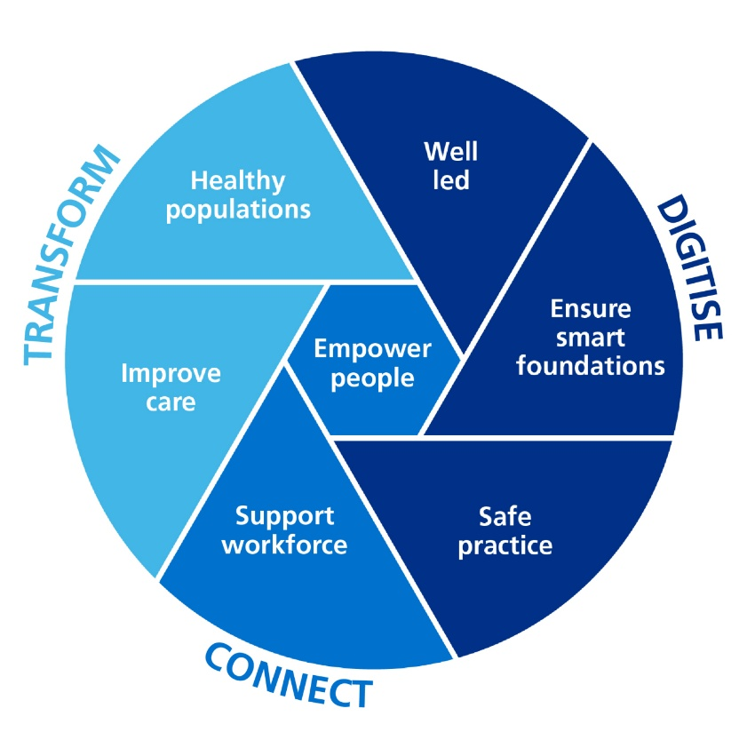
Figure 1: What Good Looks Like Framework
(Source: Futures.NHS.UK, 2026)
These policies can provide valuable parameters to assess the implementation of the NHS Application. Nevertheless, the objectives of the policies should not be compared with the proved results. The results of service delivery improvement must be quantifiable indicators, which can be measured by introducing a change in workload within the administration, patient accessibility, waiting times and user satisfaction. There are also other valuable protections to the personal information in the UK in the form of the UK General Data Protection Regulation and Data Protection Act 2018 (Bhaimia, 2018).

Mini-Evaluation
Comprehensively, the NHS Application can streamline the daily administrative tasks and enhance access to healthcare information. Nevertheless, its usefulness is based on its good integration, provision of the clinical services, proper support and inclusive application. The lack of coordination of digital systems can cause additional work or lead to the disadvantage of the patients with the inability to use them on their own. Thus, the application must be used to complement, not substitute, well-resourced healthcare services and other access points. After all, the usefulness of operational improvements is limited only to the cases when it can be used to achieve safe, efficient and accessible care in patients.

Section 3: Impact on Patient/Service User

Accessibility, Convenience and Choice
NHS Application can enhance patients access to routine healthcare by providing an opportunity to have repeat prescriptions, as well as manage health records and access eligible appointment services without fully relying on the telephone communication (NHS, 2018). These functions will be more flexible outside normal practice hours of the telephone and can help to decrease unnecessary calls or visits. At present, around 28 million people have downloaded the NHS application, and 40 million people have made a login, with majority having an active electronic patient record system (GOV.UK, 2022). However, the application might often face challenges such as limited access to the internet and the presence of devices that can support it, local GP services and personal digital capacity. Patients with technical problems or those unable to operate the application might have problems accessing the services. Convenience thus is not a determinant of universal access. In case the familiar telephone and face-to-face avenues become less accessible, the impact of the digitalisation may be negative to certain groups. The NHS Application should therefore be applied as a supplementary way of access and not a mandatory substitute to the traditional healthcare communication.

Patient Autonomy, Empowerment and Engagement
The NHS Application can enhance patient autonomy as it will allow accessing GP health records and allow individuals to have a greater part in the management of daily issues of their healthcare. Availability of medical information can assist patients to prepare questions, get to know something about their treatment and be able to communicate better with medical workers. Requesting prescription digitally can also promote the increase of access to medication management (Assiri, 2022). However, information availability does not always lead to knowledge or make informed decisions. Scientific medical terms, g test reports and strange clinical admission forms can be challenging to decipher unless done under the supervision of a professional. There can also be some anxiety of having unexpected information and lack of clarity at the moment. Thus, to truly empower patients, they must have easy to understand information, the right resource to explain their issues with those they seek medical help. The application may help it to communicate but cannot substitute professional communication and shared decision-making.

Digital Exclusion and Inequalities
Although the NHS Application has the possibility of introducing benefits, it can become a barrier to patients with poor digital skills, elderly, disabled, and those who are financially challenged. They may have limited use due to limited internet access, inappropriate devices, language issues, and limited health literacy. Cognitively impaired individuals can also need further support in order to independently use digital services (Schmidt et al., 2025). Therefore, patients unable to use the application might face increased problems with accessing information or performing standard administrative duties and especially when alternative avenues are limited. This questions the aspect of equality of access, irrespective of the healthcare need. The organisations in the NHS would encourage the development of an user-friendly interface design, offer comprehensible guidelines and render decent digital support. People who require telephone and face-to-face services should have them available for them. Digital-first could lead to more efficiency, whereas a digital-only could complicate and raise the inequalities. Thus, success of the NHS application should be measured based on aspects like fair access to healthcare and not only by the number of application registrations.

Privacy, Confidentiality and Patient Trust
NHS Application gives access to personal health details which are sensitive to an individual so privacy and confidentiality are important consideration factors. Patients can be concerned with unauthorised access to their accounts, especially in the situations when they use shared devices or have weak passwords. Being explicit in information management, proper account-security funds and secure-access protocols can help foster trust. The Data Protection Act 2018 and the UK General Data Protection Regulation impose some significant requirements when it comes to the issue of personal data protection. Nevertheless, not all of the security risks can be eradicated by legislation (Bhaimia, 2018). To ensure that privacy is effectively preserved, healthcare organisations need to maintain efficient protective measures, be transparent about their privacy policies and offer an accessible support in cases where patients have any concerns. To ensure the continuity of the people trust in the digital healthcare systems, the aspect of confidentiality protection is crucial.

Overall Patient-Centred Judgement
The NHS Application can aid convenience, facilitate patient autonomy and access to convenient healthcare information. Yet, these opportunities would be associated with access to digital, trusted technology, access to services and proper professional assistance. These benefits, when implementation fails to meet the different needs of patients, could be compromised by digital exclusion and privacy issues. A patient-centred approach must thus uphold informed choice, protect confidentiality and needs access alternative access points (Ebua, 2025). The application must also be a complement to professional care and not compromise people who cannot take advantage of digital services to benefit themselves. Its success is not solely in the increased use of digital adoption, it is in the provision of accessible, safe and equitable healthcare.

Section 4: Conclusion and Recommendations
The NHS Application is one of the key digital solutions, which offers accessibility of chosen services in terms of healthcare and information. It has the ability to enhance convenience, allow patients to participate and enhance day-to-day administration. An efficient system integration, usability, quality of implementation and clinical capacity will influence its effectiveness. This implementation can be disadvantaged by issues like digital exclusion, privacy issues and unpredictable functionality. Finally, the success of the application must be evaluated on whether it has made safe, accessible and patient-centred healthcare and not on exclusively on the rate of digital adoption.
To begin with NHS organisations and GP practices ought to enhance digital inclusion with helpful instructions, assisted digital provision, continuous telephone and face-to-face services. Despite the fact that having various access channels consumes resources, it assists in safeguarding fair access. By overseeing feedback provided by patients, digital service providers are expected to enhance the usability and make their system integration easier (Kitsios et al., 2023). Such improvements need investment but this can help to cut down redundancies and increase efficiency. Healthcare organisations need to enhance the protection of privacy by providing effective security tools, clear data management information and easy patient support. Security policies should be moderate and be able to be used. Lastly, patient satisfaction, fair access and operational efficiency and safety should be established using regular evaluations so that digital transformation can bring significant changes in healthcare.

References
Assiri, G., (2022). The impact of patient access to their electronic health record on medication management safety: a narrative review. Saudi Pharmaceutical Journal, 30(3), pp.185-194.
Bhaimia, S., (2018). The general data protection regulation: the next generation of EU data protection. Legal Information Management, 18(1), pp.21-28.
Djuranovic, B.L., Spalevic, Z. and Ilic, A.S., (2025). Protection of Patients Data in e-Health Applications: Challenges and Abuses. In Digital Transformation in Healthcare Systems for Patient Care: Dedicated to Professor Dr. Gloria Phillips-Wren (pp. 233-252). Cham: Springer Nature Switzerland.
Ebua, E.J., (2025). Ethical Considerations in Remote Healthcare: Balancing Data Privacy, Patient Confidentiality, and Informed Consent. Ethics in the Age of AI: Navigating Politics and Security, 111.
Futures.NHS.UK. (2026). What Good Looks Like Hub. Futures.NHS.UK. Available at: https://future.nhs.uk/WhatGoodLooksLikeKnowledge/grouphome (Accessed on: 09/10/2026).
Gerken. (2022). NHS app hits 30 million downloads in England. BBC. Available at: https://www.bbc.com/news/technology-63048021 (Accessed on: 09/10/2026).
GOV.UK. (2022). A plan for digital health and social care. GOV.UK. Available at: https://www.gov.uk/government/publications/a-plan-for-digital-health-and-social-care/a-plan-for-digital-health-and-social-care (Accessed on: 09/10/2026).
Greaves, F., Papoutsi, C., Kc, S., Tewolde, S., Reidy, C., Gudgin, B., Laverty, A.A., Laverty, A., Majeed, A., Costelloe, C. and Powell, J., (2026). Evaluating the national rollout of the NHS App in England using qualitative and quantitative methods. Health and Social Care Delivery Research, 14(15), pp.1-91.
KC, S., Papoutsi, C., Reidy, C., Gudgin, B., Powell, J., Majeed, A., Greaves, F. and Laverty, A.A., (2025). Ease of access to general practice, patient experience and use of the NHS App: an ecological analysis of English data. JRSM Open, 16(12), p.20542704251398918.
Kitsios, F., Stefanakakis, S., Kamariotou, M. and Dermentzoglou, L., (2023). Digital service platform and innovation in healthcare: measuring users’ satisfaction and implications. Electronics, 12(3), p.662.
NHS. (2018). Establishment of information systems for NHS services: NHS App Directions 2018. NHS. Available at: https://digital.nhs.uk/about-nhs-digital/corporate-information-and-documents/directions-and-data-provision-notices/nhs-england-directions/establishment-of-information-systems-for-nhs-services-nhs-app-directions-2018 (Accessed on: 09/10/2026).
Schmidt, S., Isbel, S., Subramanian, R. and D'Cunha, N.M., (2025). Examining technology perspectives of older adults with mild cognitive impairment: scoping review. JMIR aging, 8(e78229), pp.1-26.

