May 17, 2025
Gareth Jenkins
Student no. 99091195.

Landscape Characterisation 2025.
Excavation & Fieldwork. HPAR5004.
Landscape Characterisation 2025: Prehistory at Strata Florida, Ceredigion.

Abstract.
Situated near to the village of Pontrhydfendigaid in Ceredigion, and lying adjacent to the western slopes of the Cambrian mountains, Strata Florida is famous for the remains of its twelfth century Cistercian abbey and the historical significance of the abbey to Welsh culture. It is a remote rural area reliant on farming and tourism. The main attraction for tourists is the remains of the abbey. However, Strata Florida is a multi-period site which bears the scars of much earlier activity. This report will examine the evidence for prehistoric activity within the landscape surrounding the Abbey and attempt to address the importance of these earlier inhabitants to the landscape.
Keywords: Strata Florida, Prehistory, Mesolithic, Bronze Age, Iron Age.

Introduction.
Easily recognisable and well-known archaeological sites are merely one element of any ancient landscape (Pryor, 2022, pp. 52-55). It is necessary to view a historic landscape as a living, breathing, and working organism in order to comprehend what drove humans to live and work in a specific location (Pryor, 2022, pp. 52-55). Following the end of the last ice-age some 12,000 years ago, retreating glacial activity created an emerging and varied landscape in Ceredigion and in particular the Teifi valley (Austin, 2022, pp. 2-9). Melt water from the retreating ice created a large lake across the Teifi, which over time became a huge peat bog at Cors Caron (Austin, 2022, p. 2-9). Animals and plants quickly returned to the valley, and eventually Mesolithic hunter-gatherers started to make their way across the land (Austin, 2022, PP.2-9). This report will examine the evidence for this and later prehistoric activity in the landscape surrounding Strata Florida and address the importance of their activities to the area.
Method.
The evaluation of the prehistoric activity at Strata Florida will be made by examining a variety of scholarly publications, databases, and popular sources. The information obtained from this research will outline what evidence exists of prehistoric activity in the valleys and hills surrounding Strata Florida Abbey and by doing so attempt address the importance of such activity to the area.
Discussion.
Mesolithic.
Evidence for Mesolithic hunter-gatherer communities in Ceredigion is scarce (Bates, 2023; Brummage et al. 2023). This is most likely caused by a variety of reasons, such as contemporary land use, landscape change, and collector bias (Bates, 2023; Lillie, 2015, p. xvii). Highlighted in Figure 1. At Strata Florida as the result of excavation by the Strata Florida Trust new evidence has emerged that Mesolithic peoples were active within the landscape (Drew, 2025). During the excavation of the gatehouse and courtyard of the Cistercian monastery remains, large collections of worked flint have been found which are believed to be from the Mesolithic (Drew, 2025). More importantly during the excavation of the courtyard, charcoal samples were taken which have been radiocarbon dated, with one sample returning a date between 5920 and 5758 BC and therefore from the Mesolithic period and proving the presence of Mesolithic hunter-gatherers in the area (Drew, 2025; Current Archaeology, 2025). Appendix 1 is a copy of page 3 of the Radiocarbon Dating Analyses report supplied to the Strata Florida Trust, and which provides the Mesolithic dates mentioned above.
In the Mesolithic, spaces were not just inhabited as significant locations, they were actively created by the cutting down of trees, burning wood, working flint and the processing of animals for food (Lillie, 2015, pp. 87-95; McFadyen, 2009, p.121). It is therefore quite probable that the Mesolithic people who lived near Strata Florida began the transition of the landscape to that which is seen today.
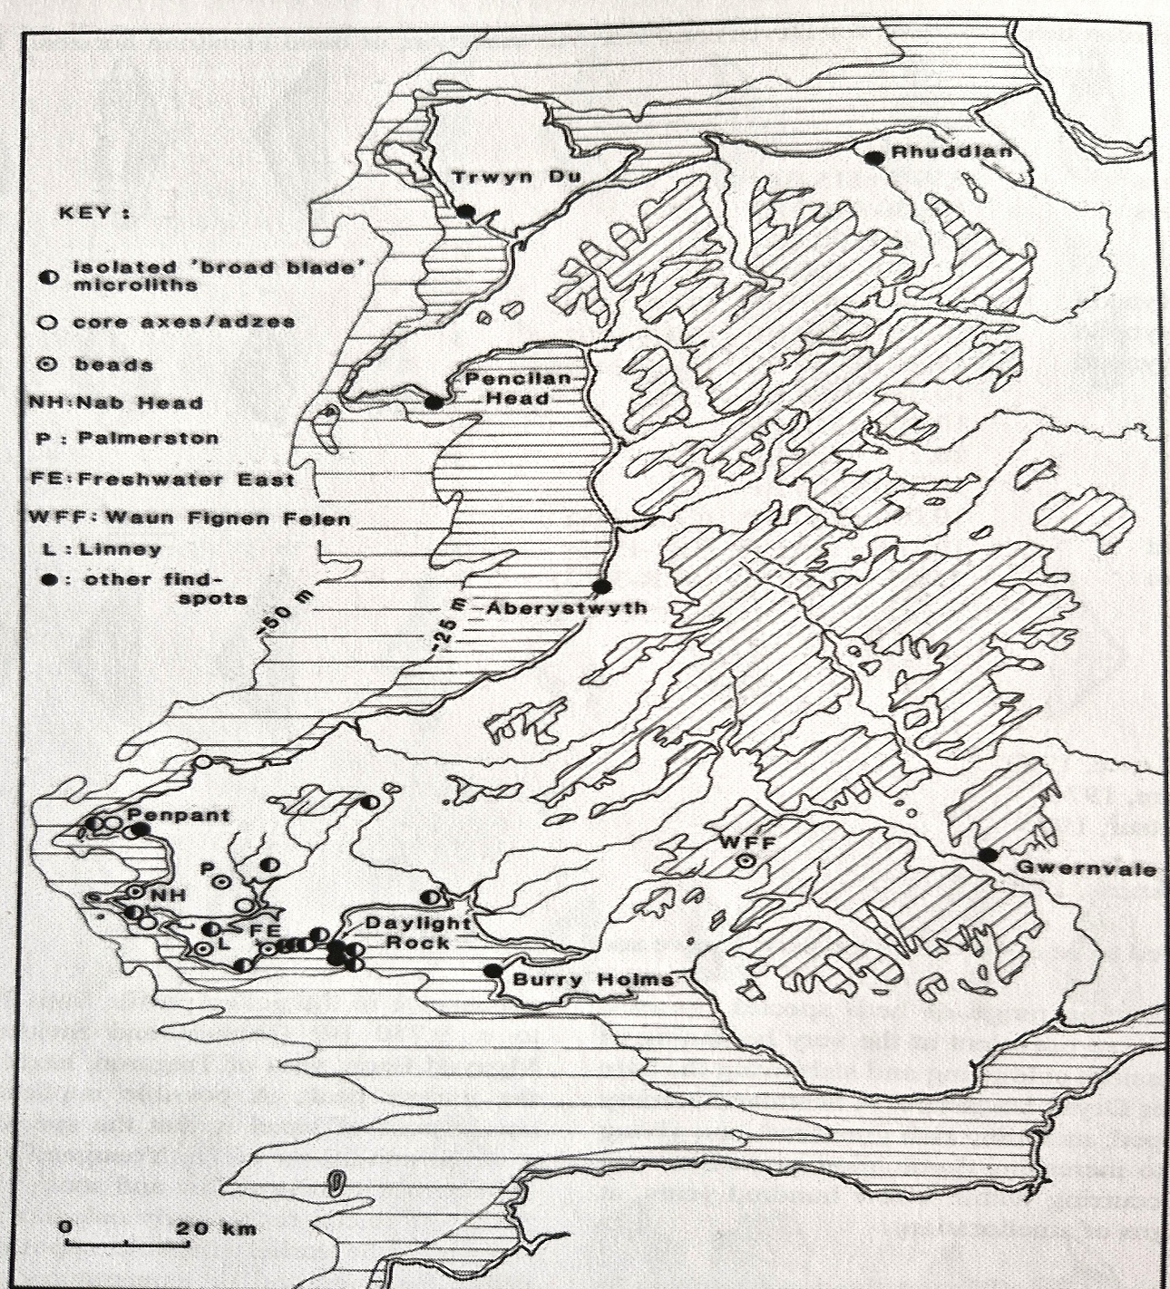
Figure 1. Distribution of Mesolithic find spots in Wales (David, 2007, p. 60).

Neolithic.
There has been a lot of discussion in archaeological literature on the transition from the use of natural resources to the incorporation of domesticated plant and animal species in the period called the Neolithic (Lillie, 2025, pp. 285-301). There are few locations in the UK where the transition from the Mesolithic to the Neolithic is straight forward (Whittle, 1999, p. 63). This period is usually attributed to occur between 4000 and 2500 BC, but there is little evidence of Neolithic farming or settlement in the area of Strata Florida (Austin, 2022, p. 10; Whittle, 1999, p. 63). Only a partially polished stone axe discovered in 1951, and a Long barrow identified in 1929 are listed on the Historic Environment Record (Archwilio, 2025). Highlighted on Figure 2.
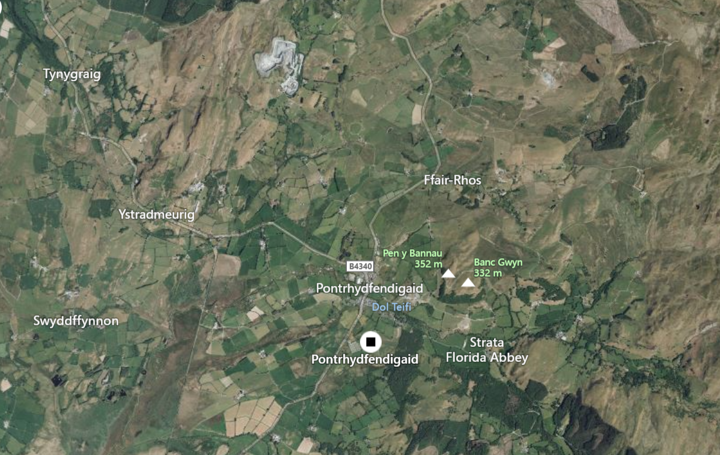
Figure 2, Historic Environment Record for the Neolithic period (Archwilio, 2025).

Bronze Age.
About 2000 BC, with the end of the Neolithic and the beginning of the Bronze Age, people started to permanently live on farms (Austin, 2022, p.10). The farms were situated on the best land above the flood-prone lowlands, and significantly more evidence remains of their presence in the landscape through their funerary monuments (Archwilio, 2025; Austin, 2022, p. 10-11). Figure 3 shows a marked increase of recorded sites on the Historic Environment record for the Bronze Age in the area, with over 70 records, including round barrows, cairn cemeteries and boundary stones (Archwilio, 2025; Heneb, 2025).
The funerary monuments are extremely prevalent landscape features, yet they are notably concentrated on high ground and its edges (Heneb, 2025). These monuments were most likely more evenly distributed, and their current distribution is at least partially the effect of post-Bronze Age agricultural techniques, particularly modern ones (Heneb, 2025). There is therefore quite an established population on the uplands, as evidenced by the abundance of these monuments in such isolated locations (Heneb, 2024). The majority of historic landscape elements in upland areas are made up of funerary and ritual monuments from the Bronze Age (Heneb, 2025).At Strata Florida this is highlighted in Figure 3
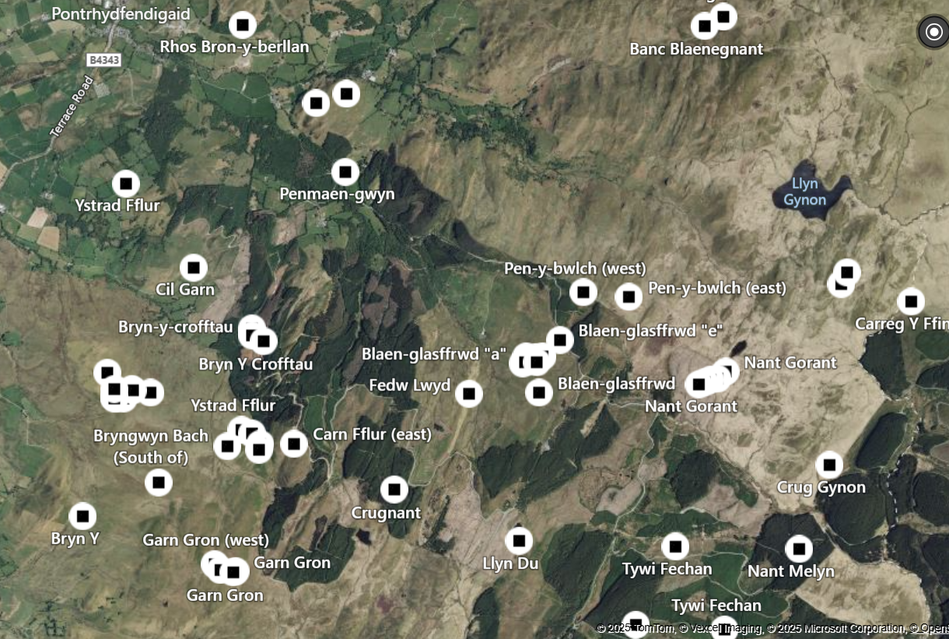
Figure 3, Historic Environment Record for the Bronze Age (Archwilio, 2025).
One of the most well know Bronze Age sites near to the abbey is at Blaen-glasffrwd. Here, a cairn cemetery comprised of a large central cairn with a visible cist is surrounded by least 5 smaller cairns and possible stone row and are an impressive feature (Ancient Monuments Uk, 2025; Austin, 2022, p.11). Figure 4 is an aerial photograph of the main cairn.
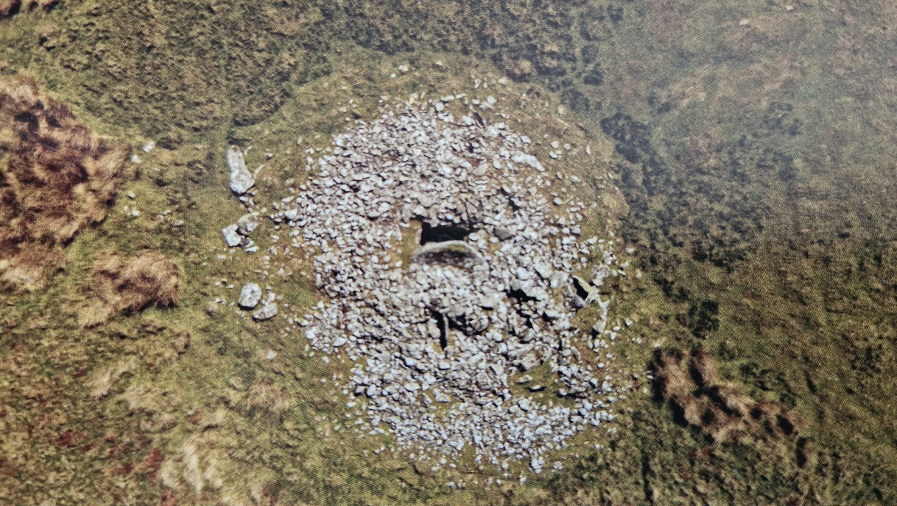
Figure 4 the main cairn at Blaen-glasffrwd (Austin, 2022, p.11).
Additionally, the hills to the north of the Strata Florida abbey complex have been exploited for their minerals, mainly lead and zinc for a considerable period of time, and it is suspected that mining had taken place there as far back as the Bronze Age (Sables, 2015, p.8).
Iron Age.
Settlements and communities grew during the Bronze Age, and into the Iron Age, which began around 700BC, until all of the land was covered by some kind of agricultural practice, that is, either grazing or the growing of crops (Austin, 2022, p.12). The location and distribution of hill forts in the region suggests the existence of intricate social structures and hierarchies at many levels, ranging from localised communities to regional tribes, and where everyday farming was carried out via kin-based networks (Austin, 2022, p.12).
Throughout Wales and beyond, great embanked enclosures began to dominate the landscape, as people fought to maintain their personal safety and maintain control over their resources (Austin, 2025, p.12). Figure 5 shows the distribution of hill-forts around Strata Florida.

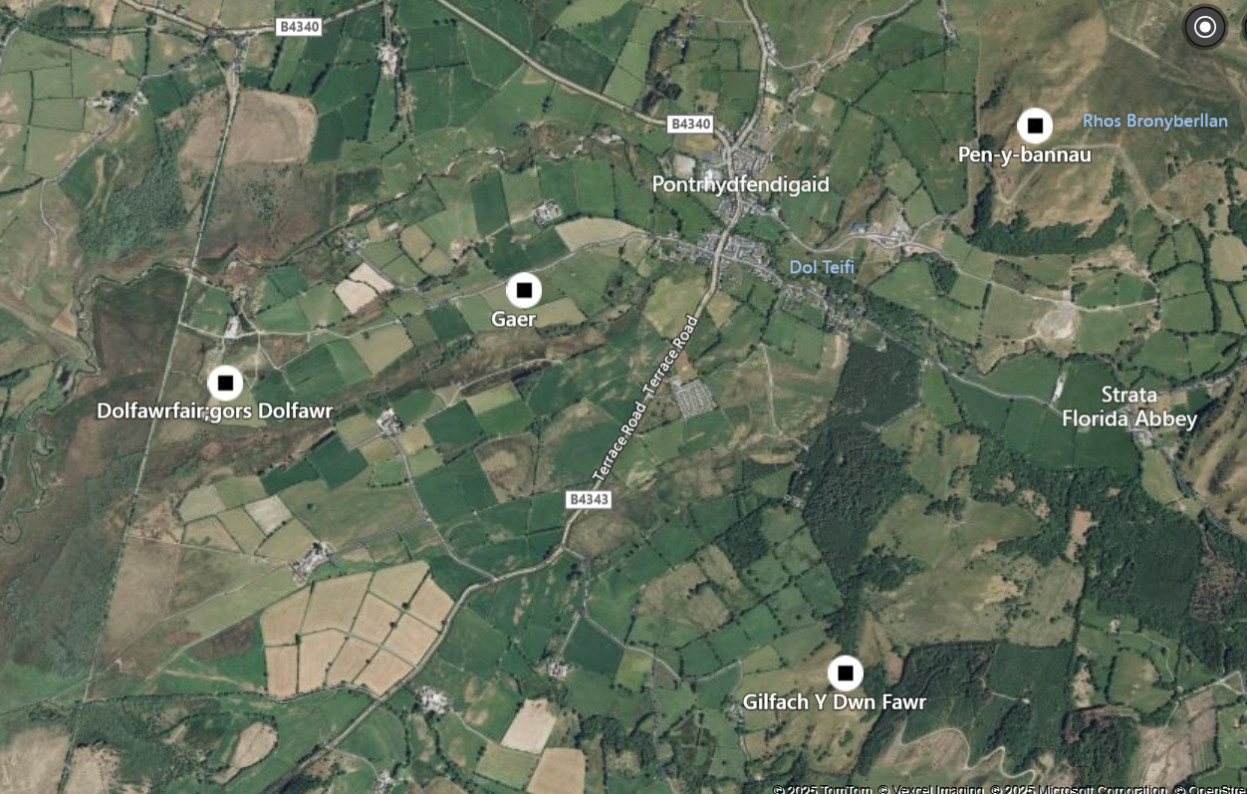
Figure 5, hill fort distribution around Strata Florida (Archwilio, 2025).

The nearest hill fort to Strata Florida is Pen y Bannau which sits on a high outcrop overlooking the village of Pontrhydfendigaid and Cors Caron (Driver, 2021, pp.136-139). Figure 6 is an artist’s impression of what it is believed the Pen y Bannau hillfort looked like during its occupation.
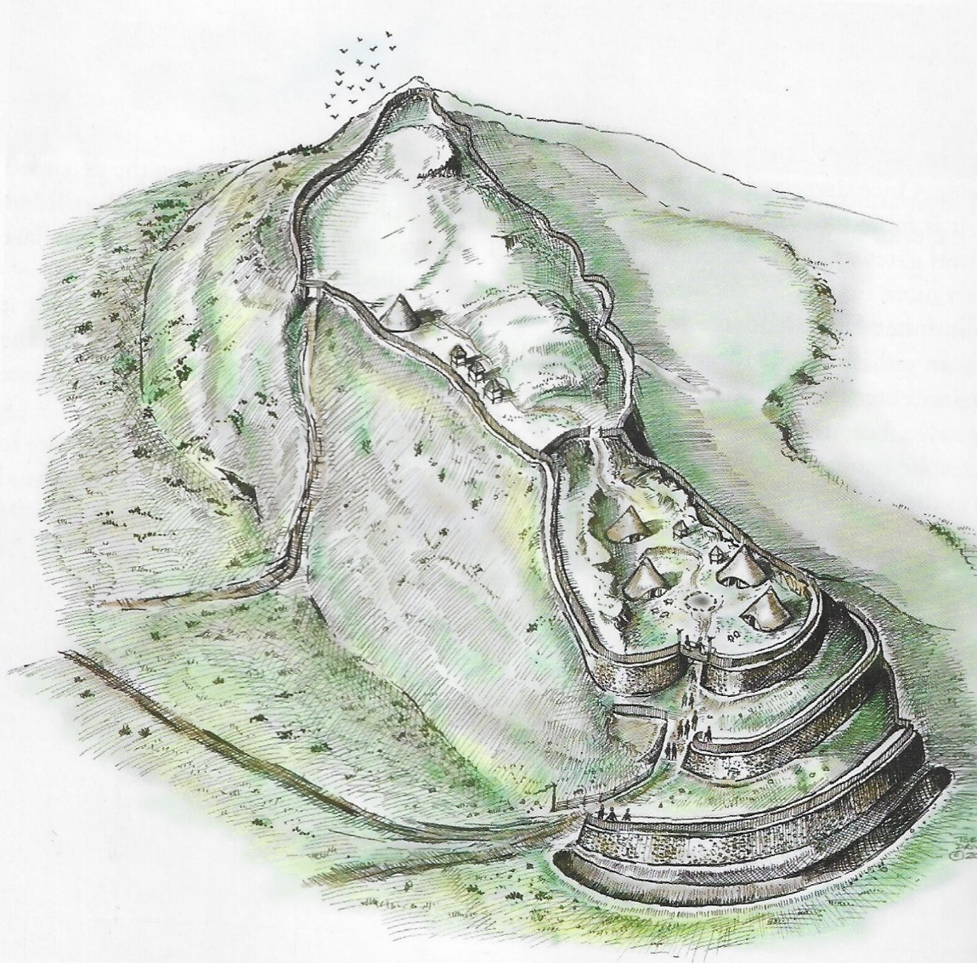
Figure 6, artist’s impression of Pen y Bannau hillfort (Driver, 2021, p.136).

In terms of the regional landscape, Pen y Bannau holds a strong position, and the main walls are thought to have been constructed to face anybody approaching across the Cambrian mountains (Driver, 2021, p.137). The unique architecture of Pen y Bannau is mirrored in two other forts that border Cors Caron: Castell Tregaron to the south and Trecoll to the west (Driver, 2021, p.139). Each of these forts has unique characteristics that set them apart from other forts in Ceredigion, suggesting that they are a regional development of a group of hillforts with similar architectural elements (Driver, 2012, p.139).

Other evidence.
In about 1900 a wooden figurine was found in the peat bog at Cors Caron, which is believed to originate from the end of the Iron Age (Austin, 2022, p.13; Treadway, 2021, pp.1-3). Between 1903 and 1970 the figurine’s whereabouts were unknown until it turned up as part of Carmarthen Museum’s collection (Treadway, 2021). Speculation has been rife about its origin, some even saying it was a North American import (Treadway, 2021, pp.1-3). A radiocarbon date was obtained by Nigel Nayling which dated the figurine to the Late Iron Age, between 43BC and 67 AD and it is was also established that it was made of boxwood (Treadway, 2021, pp.1-3). It stands at only 12.9cm high and is considered to be some kind of votive offering placed into the bog (Austin, 2022, p.12). As boxwood has been associated with death it has been hypothesised that it could represent the image of a small child that had died, and by placing it in the bog it created a collective memory for the child’s family and community (Treadway, 2021, p.2).
No other similar figures have been discovered in the area, however it is suspected that it is linked to either the Bronze Age funerary sites, or the Iron Age hillforts in the landscape (Treadway, 2021, p.2). Figure 7 is a photograph of the figurine.

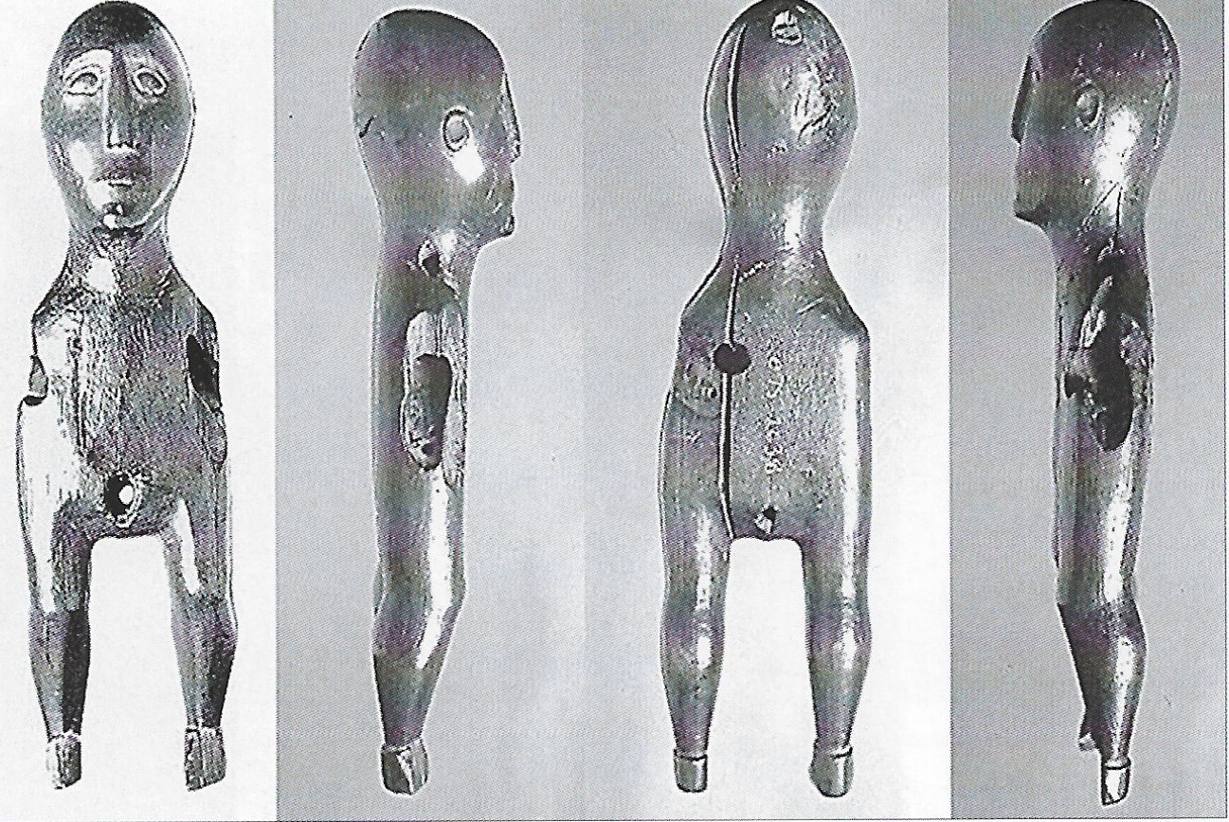
Figure 7, the boxwood figurine found in Cors Caron bog (Austin, 2022, p.13).

An 1896 article in Archaeologia Cambrensis discusses a human frontal bone which it is claimed was found during the excavations at the Strata Florida abbey by Stephen Williams between 1887-1888 (Smith, 1896, pp.94-97).
The author of this article claims that he has examined the fragment of bone and claims that it resembles very closely the features usually found in Neanderthal skulls, therefore making the presumption that it is much older than other bones that had been found at the site (Smith, 1896, pp.94-97). Smith further states that he believes the bone may have been found in a cist cairn nearby and that for some superstitious reason may have been re-interned within the confines of the abbey by one of the monks (Smith, 1896, pp. 94-97). There is no further evidence to substantiate this. Figure 8 is a copy of the photograph of this bone published in Archaeologia Cambrensis.
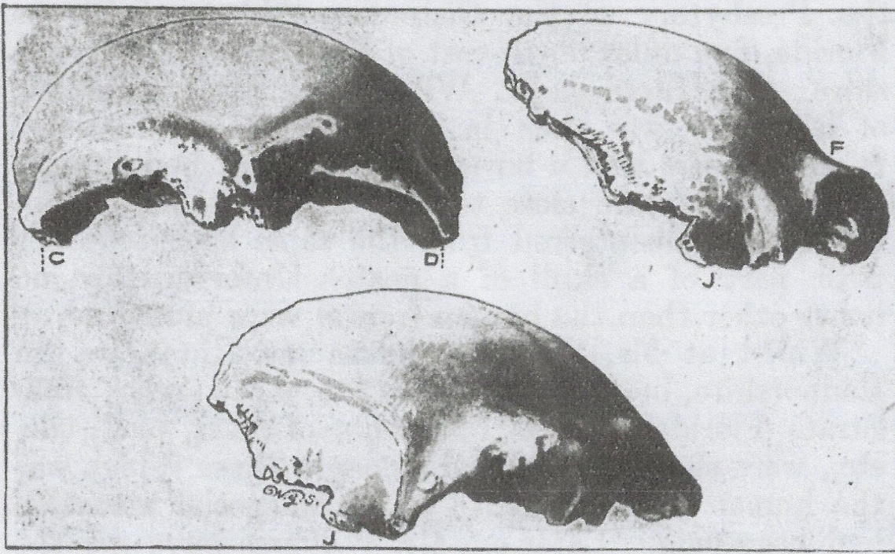
Figure 8, copy of photograph of human frontal bone from Strata Florida (Smith, 1896, p.95).

Conclusion.
Little research has been conducted in relation to the Prehistory of Strata Florida and there is therefore a risk that to the layperson there is very little prehistory to be seen or even considered (Drew, 2025). This report has highlighted that Strata Florida lies within a diverse and rich prehistoric landscape. Throughout the Mesolithic, the Bronze Age and the Iron Age, human activity has created and established the landscape. The twelfth century Cistercian abbey is a much later addition to this landscape and has ultimately added to it, but for millennia the landscape has been forged and shaped by prehistoric activity. The scars of this activity are still visible but remain invisible and possibly forgotten when considered in tandem with the medieval landscape. A detailed study of the prehistory of Ystrad Fflur therefore would add considerable value to the interpretation and understanding of this idyllic rural landscape.

References.
Ancient Monuments UK, (2025) Blaen Glasffrwd cairn cemetery: A Scheduled Monument in Ystrad Fflur, Ceredigion. Available at: https://ancientmonuments.uk/128168-blaen-glasffrwd-cairn-cemetery-ystrad-fflur (Accessed: 4 May 2025).
Archwilio (2025) Archwilio [Database]. Available at: https://archwilio.org.uk/her/chi3/arch.php?county=Ceredigion&lang=eng (Accessed: 24 April 2025).
Austin, D. (2022) Strata Florida: The History and Landscape of a Welsh Monastery. The Strata Florida Trust.
Bates, M. (2023). Searching for the Mesolithic in Ceredigion, [YouTube video]. Available at: https://www.youtube.com/watch?v=mtX2cJkqOVQ (Accessed: 17 May 2025).
Brummage, S. et al. (2023). Mesolithic-Neolithic landscapes in Ceredigion: a new site at Llanllyr. (Draft paper), University of Wales Trinity St. David, Unpublished.
CADW, (2025) Strata Florida Abbey. Available at: https://cadw.gov.wales/visit/places-to-visit/strata-florida-abbey (Accessed: 10 May 2025).
McFadyen, L. (2009) ‘Landscape’, in Conneller, C. and Warren, G. (Eds.) Mesolithic Britain and Ireland: New Approaches. The History Press.
Current Archaeology (2025) ‘The latest from the past: New insights into Strata Florida’s medieval monastery.’ Current Archaeology, Issue 421, p.8. Current Publishing
Drew, Q. (2025) Conversation with Gareth Jenkins in relation to the prehistoric landscape on 2 May.
Driver, T. (2013) ‘Architecture, regional Identity and Power in the Iron Age Landscapes of Mid Wales: The Hillforts of North Ceredigion.’ British Archaeological Reports series 583. Archaeopress.
Driver, T. (2021) The Hillforts of Cardigan Bay. Logaston Press.
Dyfed Archaeological Trust, (2024). Mesolithic Wales. Available at: https://www.dyfedarchaeology.org.uk/lostlandscapes/mesolithic.html (Accessed: 3 May 2024).
Heneb, (2025) Upland Ceredigion- Historic Landscape Character Area. Available at: https://heneb.org.uk/hcla/upland-ceredigion/ (Accessed: 24 April 2025).
Lillie, M. (2015) Hunters, Fishers & Foragers in Wales: Towards a social narrative of Mesolithic lifeways. Oxbow Books.
Pryor, F. (2022) Scenes from Prehistoric Life: From the Ice Age to the coming of the Romans. Head of Zeus Limited.
RCAHMW, (2025) Coflein: Aerial Photographs. Royal Commission on the Ancient and Historical Monuments of Wales. Available at: https://coflein.gov.uk/en/site/95764/images/?term=medieval&pg=3 (Accessed: 5 May 2025).
Sables, D. (2015) ‘The Monks Who Mined?’ Mining History, Vol.19, No. 3, pp.8-20. Peak District Mines Historical Society.
Smith, W. (1896) Human Frontal Bone from Strata Florida. Archaeologia Cambrensis, 1896, Vol. 13, pp. 94-96.
Strata Florida Trust, (2025) Strata Florida: Ystrad Fflur. Available at: https://www.strataflorida.org.uk/ (Accessed: 23 April 2025).
Treadway, T. (2021) ‘What’s in the watery box? The Strata Florida iron age figurine,’ The Pallasboy Project [blog] 9 March. Available at: https://thepallaseboyvessel.wordpress.com/2021/03/09/whats-in-the-watery-box-the-strata=florida-iron-age-figurine/ (Accessed: 4 May 2025).
Whittle, A. (1999) ‘The Neolithic Period c. 4000-2500 BC,’ in Hunter, J. & Ralston, I (Eds.) The Archaeology of Britain, 1st Ed. Routledge.

Bibliography.
Aston, M. (1995) Interpreting the Landscape: Landscape Archaeology and Local History. London: B. T. Batsford Ltd.
Austin, D., Bezant, J. & Barker, L. (2022) “The Archaeology of Abbey Wood, Strata Florida, Ceredigion, Wales”. Landscapes,Vol.23. No. 1, pp.1-47. Routledge. Available at: DOI:10.1080/14662035.2022.2145863 (Accessed: 24 April 2025).
David, A. (2007) ‘Palaeolithic and Mesolithic Settlements in Wales, with special reference to Dyfed.’ British Archaeological Reports series 448. Archaeopress.
Driver, T. (2023) The Hillforts of Iron Age Wales. Logaston Press.
Heath, J. (2013). Before farming: Life in Prehistoric Wales 300,000-4,000BC. Gwasg Carreg Gwalch.
Lock, G. and Ralston, I. 2024. Atlas of Hillforts of Britain and Ireland. Available at: https://hillforts.arch.ox.ac.uk (Accessed: 4 May 2025).
Poucher, P. (2010) Wetland Margins Survey Cors Caron. Dyfed Archaeological Trust Report No. 2009/56. Available at: heneb.org.uk/wp-content/uploads/2024/10/corscaron2010.pdf (Accessed: 4 May 2025).
Simensen, T. and Halrovsen, R. and Erikstad, L. (2018) ‘Methods for landscape characterisation and mapping: A systematic review.’ Land Use Policy, Vol.75, pp.557-569. Available at: https://doi.org/10.1016/j.landusepol.2018.04.022 (Accessed: 11 May 2025).
van der Sanden, W. & Turner, R. (2004) ‘The Strata Florida Manikin: How Exotic Is It?’, Journal of Wetland Archaeology, 4:1, 83-96, Available at: DOI: 10.1179/jwa.2004.4.1.83 (Accessed: 24 April 2025).
Wymer, J. (1991). Mesolithic Britain. Shire Archaeology.

List of Figures.
Figure 1. Distribution of Mesolithic find spots in Wales.
Figure 2, Historic Environment Record for the Neolithic period.
Figure 3, Historic Environment Record for the Bronze Age.
Figure 4 the main cairn at Glasffrwd.
Figure 5, hill fort distribution around Strata Florida.
Figure 6, artist’s impression of Pen y Bannau hillfort.
Figure 7, the boxwood figurine found in Cors Caron bog (Austin, 2022, p.13).
Figure 8, copy of photograph of human frontal bone from Strata Florida.

Appendix 1.
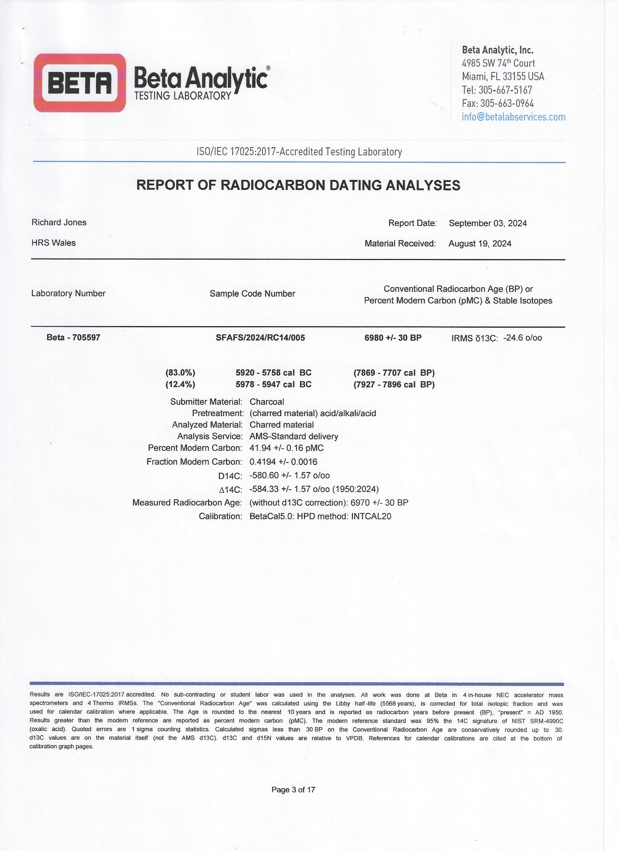
(Copy provided by kind permission of the Strata Florida Trust, 2025).

