November 1, 2022
Holly Codd (2205432)

[lEaning in the digital era]
[assignment 1: E-Portfolio]
Contents
E-Portfolio 2
Written Summary 3
Academic Poster 5
Automatic Referencing Tool 6
E-Portfolio Creation and Review 7
Reference List 10

E-Portfolio

I have not added a link to the portfolio home page as the images of the drawings have been added to the word document.

Written Summary

1) IEEE Referencing and written summary on essential academic and employment skills (350 words):
a) The development of the essential skills that I will learn on this course such as time management, teamwork, eye for detail, ability to draw, self-motivation, ability to meet deadlines, communication skills, problem-solving and so much more will help me in the future as an animator as they will give me the confidence to work on project by myself and in groups as well as the knowledge to do so.
There are many different sources that help back up having essential skills in either places of study or employment are a good thing to have and will help in further career. Here are a few examples of what I found. This is what I found on arena animation; I took a quote from the website. “Anyone who hopes to build a successful animation career needs to have a few essential skills. What are those skills and what educational background is required for animation, we unpack below.” [1]
I took a quote from career foundry “While challenging and complex, an animation designer’s job can also be immensely fulfilling. In this post, we’ll explore the essential skills (both hard and soft) and qualifications you need to break into animation design.” [2]
This is quote from business of animation “Being a successful animator requires learning about and mastering several essential animator skills. These include both hard technical skills and soft people skills.” [3]
I then looked on Zippia the career expert and this is what I found “Below we've compiled a list of the most important skills for an animator. We ranked the top skills based on the percentage of animator resumes they appeared on.” [4]

b) I then submitted my work to Turnitin to check the similarity score, the score was 42% but when I looked at the feedback it was highlighting the quotes and links I used in my work. I do not think I need to improve this as there was no direct coping from any website when completed the tasks other than the quotes I used.

Generic Assessment Criteria-
- Engagement with Literature Skills
Marks available- 20
Marks awarded- 18
I awarded myself this number of marks as I feel like I made sure that the information I used was relevant and I stayed focused on the tasks that were set. The reasons why I did not give myself 20 marks because I did not use a range of sources.

- Knowledge and Understanding Skills
Marks available- 20
Marks awarded- 20
I awarded myself this number of marks as I feel like have done everything that was outlined.

- Cognitive and Intellectual Skills
Marks available- 20
Marks awarded- 15
I awarded myself this number of marks as I feel like I could have done this better as well as make sure that I read though the guidance to make sure that I am hitting everything I need to do.

- Practical Application Skills
Marks available- 20
Marks awarded- 16
I awarded myself this number of marks as I feel like I did what I was asked but I feel like I could have done it better.

- Transferable Skills for Life and Professional Practice
Marks available- 20
Marks awarded- 20
I awarded myself this number of marks as I feel like I did everything and there is not much more I could do to make it better.
Over all marks 89/100

Academic Poster

2) Collaborative Teamwork and Professional Academic Poster (A3 Poster):

-Life is a Team Sport-

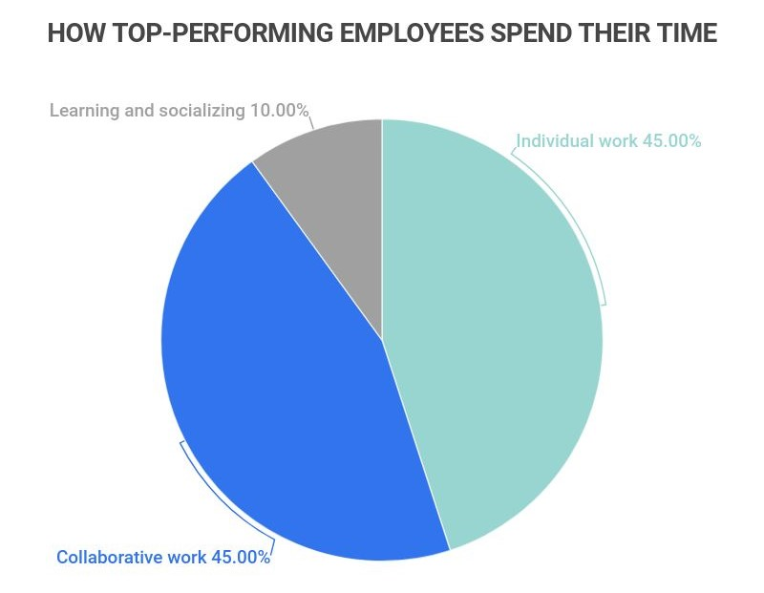

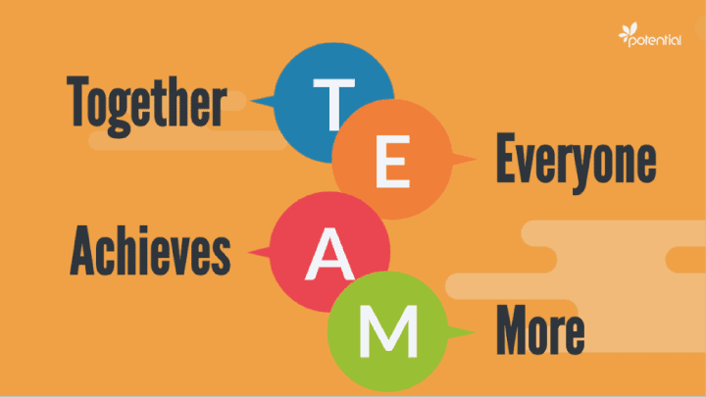
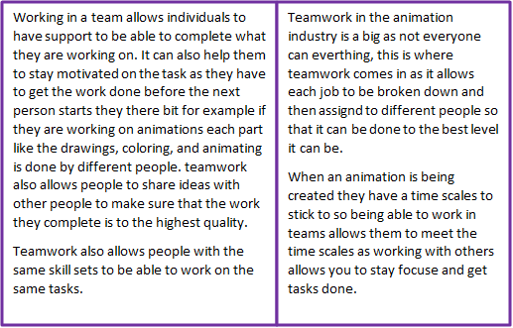
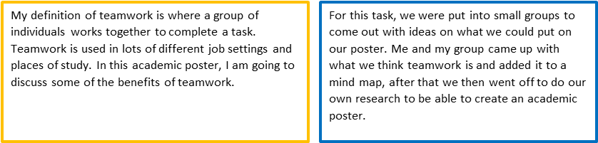
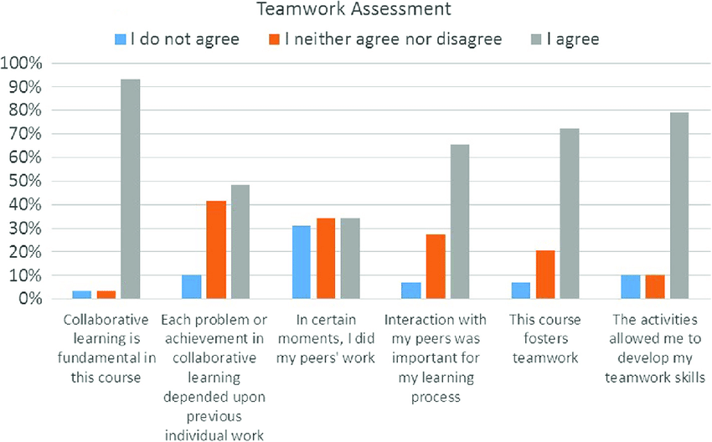

Many people like working in teams when completing tasks in work or in places of study. Teamwork can be a great tool to use, and every place of study or employment should develop this skill.
References List
Image
Team [5] Pie Chart [7]
Jigsaw [6] Bar Chart [8]

Automatic Referencing Tool

3) Automatic Referencing Tool (350 words): use an automatic referencing tool (such as Refworks) to add relevant IEEE citations and a reference list to the task below.

Unit 3- Topic 2
Section 1- Stormy Waters

Characteristics of storming

Conflict will normally start to develop between the team members. This is because some individuals will start to challenge what the team is working towards.

The dangers of avoiding conflict

Conflict avoidance can come from lack of trust, this can lead to there being honest and constrictive debating within the group making it so that they care more about being right then finding a solution.

Figure 9

The role of empathy in managing conflict within virtual teams

Empaths helps us to be better at listening to as well as being more supportive in the group, this will allow people to be more productivity within the group.

Section 2- Roles and Responsibilities

Introducing roles and responsibilities

Make sure roles and responsibilities are clear because if not then it can lead to the individuals to feel like they are overwhelmed over the workload or just frustrated as the feel like they have not made any progress.


Recognising team roles

There are lost of different roles that everyone plays in the group, it could be that someone is good at leading while someone may be great at coming up with ideas. But every role has it strengths and weaknesses. They start to become more effective at you job when you recognise and understand each role.
Figure 10

For the automatic referencing tool, I used was MyBib. “MyBib – A New FREE APA, Harvard, & MLA Citation Generator,” MyBib. https://www.mybib.com/#/projects/lDkrrB/citations (accessed Nov. 10, 2022).

E-Portfolio Creation and Review
4)E-Portfolio Creation and Review:
a) Create an Online e-portfolio
For the portfolio I did all drawings on paper, I created 10 drawings in total. I used a reference for most of them, while I did this, I also add some of my own style into one or two of them to make them more unique. The tools I used to create these drawings were card paper, paint, pencil, black fine liner, coloured pencils and posca's paint pens.
So, of the drawings I feel like they could be better for example the roof/open windows on shop front could have been drawn a lot better as well as the greenery on window drawing.
The drawing of the moon, clouds, and lanterns I went with a simple drawing with the clouds having a blue shade to them and a few white lines to look like the light hitting them.
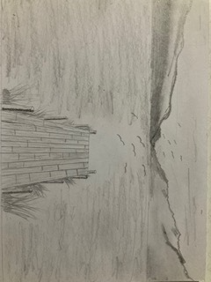
The one of Kirby was from one of the tasks we had to do in class where we mixed different things together.
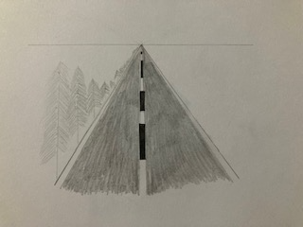
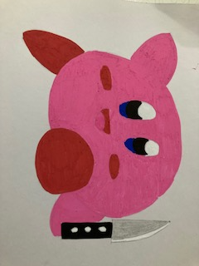

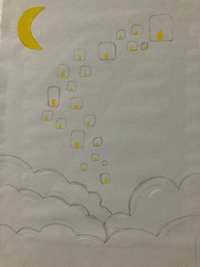
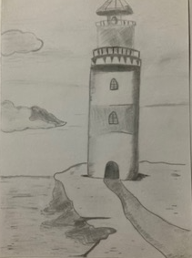
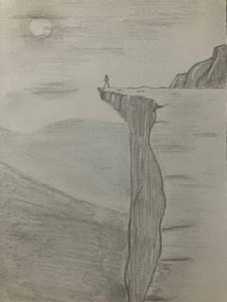

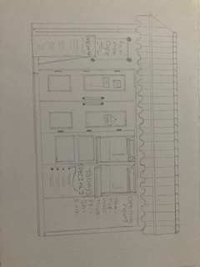
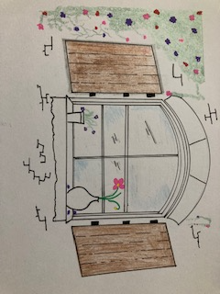

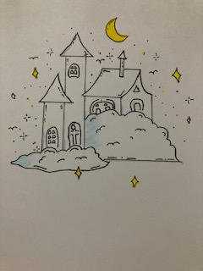
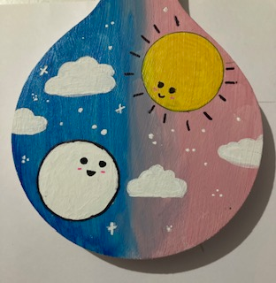

This is my e-portfolio collage as I’m more into shading types of art that was my main focus but after looking for things to draw, I started to like the drawings with the pops of colour, so I wanted to incorporate those pieces into the portfolio as well.

b) Produce an illustrative review:

The tools I used to create this e-portfolio are on word, I used word because I know why way around it and I find it the best thing to use when creating documents like this one. For the academic poster I just used text boxes and just change the outline colour to make each section stand out. For the portfolio drawings I used a range of different tools to create the different styles of drawings, the tools I used were card paper, paint, pencil, black fine liner, coloured pencils and posca's paint pens, I then add the drawings to word and added a show to the back of the image to make them stand out more. I choose to add the drawings to word instead of a portfolio builder as I feel like they stand out more like this.

Reference List
[1] arena animation (2021). Skills Needed For a Career In Animation | Animation Career. [online] Arena Animation - Park Street - Kolkata. Available at: https://www.arenaparkstreet.com/blog/animation-skills/ [Accessed 10 Nov. 2022].

[2] careerfoundry.com. (n.d.). What Skills Do You Need To Become an Animation Designer? [online] Available at: https://careerfoundry.com/en/blog/ui-design/animation-designer-skills/ [Accessed 10 Nov. 2022].

[3] Business of Animation. (n.d.). 8 Essential Animator Skills You Need to Learn. [online] Available at: https://businessofanimation.com/essential-animator-skills-every-freelancer-should-have/ [Accessed 10 Nov. 2022].

[4] www.zippia.com. (2020). Top 15 Animator Skills. [online] Available at: https://www.zippia.com/animator-jobs/skills/?src=partial-gate [Accessed 10 Nov. 2022].

[5] Potential, “Teamwork - Step by Step Guide for Effective Team Building - Potential.com,” The Online Learning Platform, Mar. 07, 2018. https://www.potential.com/articles/teamwork/ (accessed Nov. 10, 2022).

[6] K. Vogel, “Effective teamwork: lessons from your favorite TV shows,” RingCentral, Feb. 28, 2020. https://www.ringcentral.com/us/en/blog/effective-teamwork/ (accessed Nov. 10, 2022).

[7] E. Boskamp, “37 Detailed Workplace Collaboration Statistics [2021] – Zippia,” Zippia, Jan. 26, 2022. https://www.zippia.com/advice/workplace-collaboration-statistics/ (accessed Nov. 10, 2022).

[8] Research Gate, 2008. https://www.researchgate.net/figure/Students-perception-of-collaborative-learning-at-the-end-of-the-course_fig2_305876719 (accessed Nov. 10, 2022).

“UWTSD Moodle 2022/23: Log in to the site,” moodle.uwtsd.ac.uk. https://moodle.uwtsd.ac.uk/mod/scorm/view.php?id=437215 (accessed Nov. 02, 2022).

[9] “Avoiding Conflict Illustrations, Royalty-Free Vector Graphics & Clip Art - iStock,” www.istockphoto.com, 2022. https://www.istockphoto.com/illustrations/avoiding-conflict (accessed Nov. 10, 2022).

[10] “The roles every team needs to be effective,” Inc., 2022. https://www.inc.com/bruce-eckfeldt/the-roles-every-team-needs-to-be-effective.html (accessed Nov. 10, 2022).

“Behance,” www.behance.net. https://www.behance.net/search/projects/?search=pencil+work&sort=published_date&time=all&ordinal=192&after=OTg%3D (accessed Nov. 10, 2022).

“Learn Pencil Drawing like a Master. in 2022 | Architecture drawing art, Cool art drawings, Drawing scenery,” Pinterest. https://www.pinterest.co.uk/pin/learn-pencil-drawing-like-a-master-in-2022--904097693919367617 / (accessed Nov. 10, 2022).

“Coloring page - 2022 | 쉬운 그리기, 귀여운 낙서 예술, 그림,” Pinterest. https://pin.it/qhwLkZG (accessed Nov. 10, 2022).

“Nak amik ah in 2022 | Cute doodle art, Hand art drawing, Easy doodle art,” Pinterest. https://pin.it/7INUksX (accessed Nov. 10, 2022).

“Pin by 𝐉𝐮𝐡𝐚🤍 on Cre:weibo in 2022 | Diagram, Art,” Pinterest. https://pin.it/1KyIeSP (accessed Nov. 10, 2022).

“Finisima_ en 2022 | Crear,” Pinterest. https://pin.it/3WG8Zpg (accessed Nov. 10, 2022).

