

Assessment 1 – Reading Task Template
Upload your photo of your A3 in-class notes here:
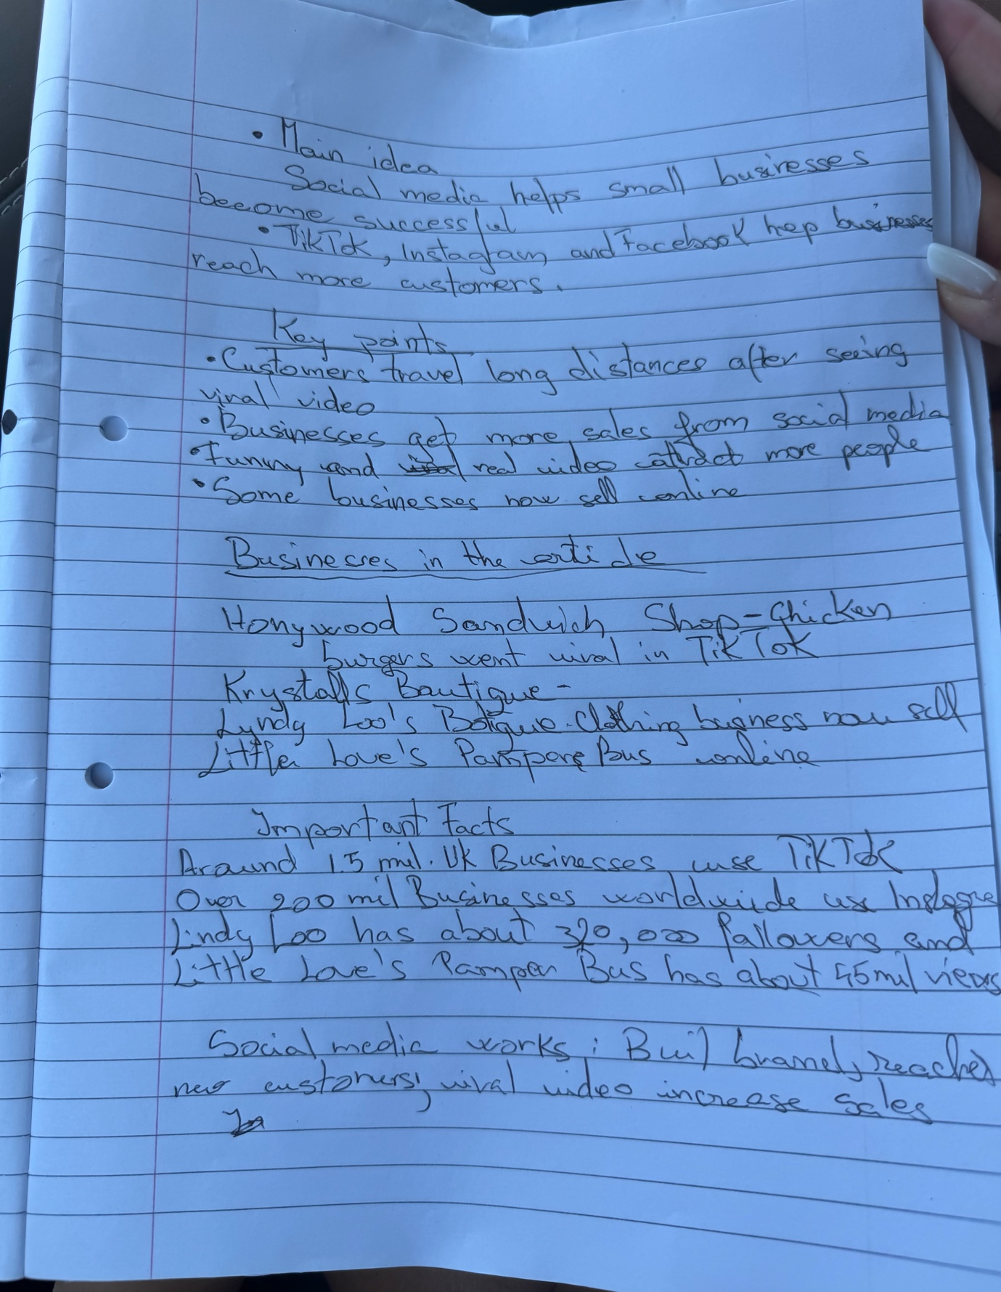

1. Answer these questions using the sentence starters below
a. What is the main idea of the text?
The main idea is that social media helps small businesses become popular and attract more customers
b. What are two key points?
One key point is That viral TikTok and instagram videos brought customers from long distance to small businesses
Another key point is that social media helped some businesses grow so much that the owners could work full-time online .
c. What part of the text did you find most important? Why?
The most important part is that social media changed businesses by increasing sales and bringing in new customers because it showes how powerful online marketing can be.
d. Was anything unclear or difficult to understand?
I was not sure about how businesses became viral so quickly on social media.
e. How did your group help you understand the text better?
My group helped me by discussing the article and explaining the main ideas and key points.
2. One sentence reflection
Question: What did you find challenging about this task?
The hardest part was finding the most important information and putting it into my own words.

