
Socket Programming and Concurrency Report
Socket Programming and Concurrency

May 16, 2025

Contents
1. Introduction 2
2. TCP and Guaranteed Delivery 2
2.1 Overview of TCP 2
2.2 Overview of UDP 3
2.2 Connection Establishment and the Two Generals’ Problem 3
2.3 Acknowledgements, Flow Control, and Retransmission 5
3. MTU Size and Its Impact on Data Transfer 6
3.1 What is MTU and Why It Matters 6
3.2 Protocol Data Units and OSI Model Context 6
3.3 IP Fragmentation and Reassembly 7
3.4 Practical Implications of MTU in Networks 7
4. Synchronicity and Asynchronicity 7
4.1 Definitions and Differences 7
Synchronous Communication 7
Asynchronous Communication 8
4.2 Use Cases for Synchronous Communication 8
4.3 Use Cases for Asynchronous Communication 8
4.4 I/O Models and Implementation Patterns 8
5. Interoperability in Networked Applications 9
5.1 What Is Interoperability? 9
5.2 Why Interoperability Matters 9
5.3 Technical Strategies to Achieve Interoperability 9
5.4 Challenges and Best Practices 10
Conclusion 10
References 11

1. Introduction
Network communication has an essential role in modern computing, it allows devices and systems to exchange data reliably and efficiently[1]. This report covers several key aspects of how this is done. The Transmission Control Protocol (TCP) is covered, it ensures reliable delivery of data between devices using a connection process called a three-way handshake[1,2]. The impact of the Maximum Transmission Unit (MTU) is also covered, this defines the largest amount of data that can be sent in a single network packet[3]. Next, the differences between synchronous and asynchronous communication is also covered, with each suited to different types of applications depending on timing and coordination[4]. Finally, the concept of interoperability is covered. This refers to how different systems can communicate and work together across platforms and networks[5].
2. TCP and Guaranteed Delivery

2.1 Overview of TCP
TCP is a core transport layer protocol in the TCP/IP model[1,3,6]. It is on Layer 4 of the OSI model and provides reliable, ordered, and error-checked delivery of data between devices[7]. Unlike UDP that quickly send packets without confirmation, TCP establishes a connection between two endpoints before transferring any application data[1,3]. Once the connection is in place, TCP breaks the data into segments, attaches sequence numbers, and ensures that each segment is received in the correct order. If any data is lost, TCP detects this using acknowledgements and retransmits the missing parts[1,3,7,8]. This makes TCP a suitable option for applications where accuracy and data completeness are more important than speed, for example, web browsing using HTTP, email through SMTP, and file transferring with FTP[1,8].
Figure 1 [8]
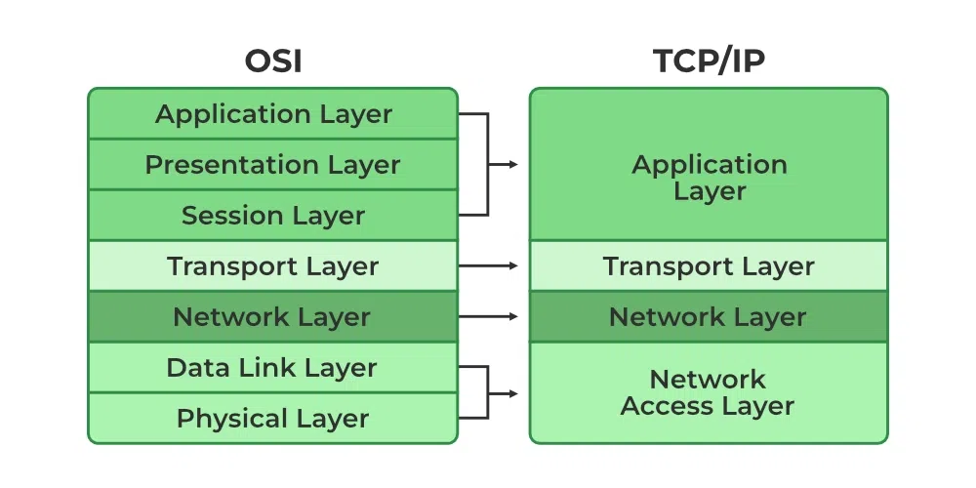
Figure 2 [8]
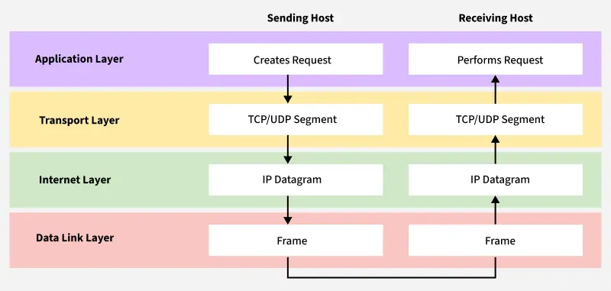

2.2 Overview of UDP
The User Datagram Protocol (UDP) is another transport layer protocol in the TCP/IP suite. It provides a connectionless communication method with no guarantees about packet delivery, order, or duplication[3,8]. Unlike TCP, it does not require a handshake before data is sent and does not use acknowledgements or retransmissions[1,3]. Each message, known as a datagram, is treated independently and may arrive late, out of order, or not at all[1,9]. UDP operates much faster than TCP because it has less overhead, making it suitable for applications such as voice and video streaming and online gaming[1]. UDP is used when the application can tolerate occasional data loss to help reduce delays. While UDP relies on the application layer to handle any missing or disordered data, its speed and simplicity make it useful in applications where real-time performance is a higher priority than reliability[1,3,8].

2.2 Connection Establishment and the Two Generals’ Problem
Before any application data is transmitted, TCP must establish a connection between two devices. This process, known as the three-way handshake, ensures that both devices agree to communicate and are properly synchronised[1,10]. The first step involves the initiating device sending a segment with the SYN (synchronise) flag set, along with its initial sequence number[10]. The receiving device responds with a segment that has both SYN and ACK (acknowledgement) flags set. This response has its own sequence number and confirms receipt of the initial request. The initiating device then sends back an ACK segment, completing the handshake. Once this process is complete, both devices can begin transferring data using the agreed sequence numbers. This prevents issues like duplicate or delayed packets from previous connections interfering with the new session[1,3,10].
Figure 3 [10]
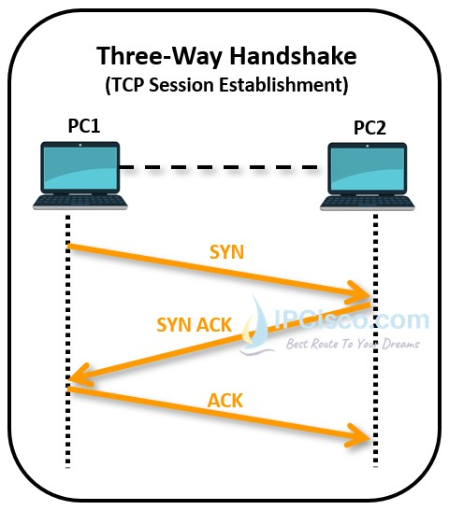
The three-way handshake is a practical attempt to solve the communication challenge explained in the Two Generals’ Problem. This is a theoretical problem in computer science where two generals, positioned on opposite sides of a valley, must agree on a time to attack. They can only communicate by sending messengers through the valley, but any messenger may be captured. Even if one message is received, the other general cannot be sure that the response confirming the message arrived successfully. This uncertainty leads to a situation where mutual agreement is impossible to guarantee. The problem highlights the difficulty of achieving perfect coordination over unreliable communication channels[11,12].
Figure 4 [12]
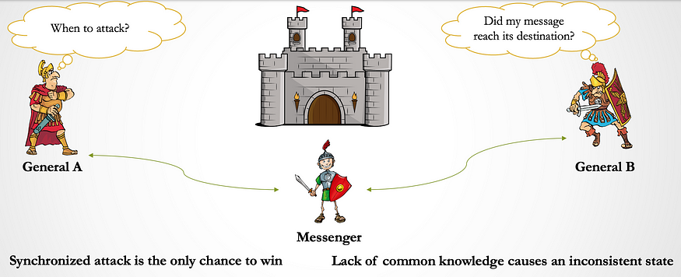
Figure 5 [12]
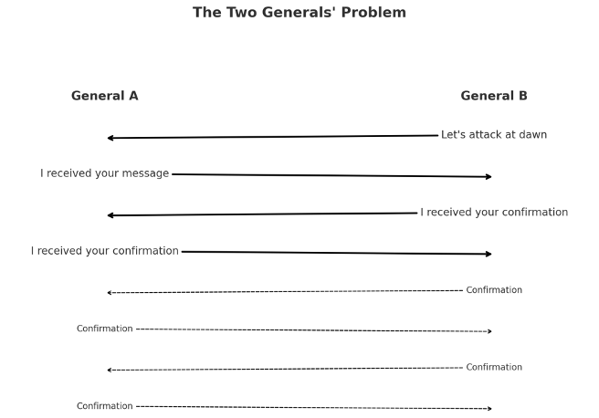
TCP does not completely solve this problem in a theoretical sense but provides an approach that works most of the time in real-world scenarios. By needing multiple messages and acknowledgements before data is transferred, TCP reduces the risk of errors. The use of timers, retransmission, and strict rules about when data can be sent ensures that both endpoints act only when they are reasonably sure the other is ready. Although absolute certainty is still impossible with this technique, TCP’s approach makes failure so unlikely that it is suitable for usage in everyday tasks on the internet[1,10,11].
A real-world example of this going wrong occurred during a Deliveroo platform outage on 18 September 2018. In this incident, users placed orders, but their devices did not receive confirmations due to delays or failures in backend systems. As a result, many users received failure error messages with try again buttons that lead to them believing their original orders had not gone through and attempted to place them again. This caused widespread duplicate charges and multiple orders for the same items. The issue resembled the Two Generals’ Problem in that the orders were placed without confirmation, and the system lacked a reliable method to signal when an action had been successfully received and processed. TCP prevents similar problems in digital communication by enforcing a handshake process and requiring acknowledgement from both sides before proceeding[11,13].

2.3 Acknowledgements, Flow Control, and Retransmission
In TCP, acknowledgements (ACKs) are used to confirm the successful receipt of data segments. Each ACK contains the sequence number of the next expected byte. This is meant to guarantee both sender and receiver maintain synchronisation. For instance, if a receiver has successfully received bytes up to 2000, it will send an ACK with the sequence number 2001. This mechanism allows the sender to identify any missing segments and take corrective action if necessary[10,14].
Flow control in TCP is managed through the sliding window protocol. This manages the amount of data a sender can transmit before requiring an ACK. The receiver advertises a window size, determining the buffer space available for incoming data. As data is received and processed, the receiver updates this window size in subsequent ACKs. The sender must adjust its transmission rate to prevent overwhelming the receiver's buffer. This adjustment ensures the maintaining of optimal performance across varying network conditions [14,15,16].
Retransmission in TCP addresses data loss during transmission. If an ACK is not received within a calculated retransmission timeout (RTO), the sender assumes the segment was lost and retransmits it. The RTO is adjusted based on round trip time measurements, allowing TCP to adapt to the network conditions. Along with this, TCP also uses a fast retransmit mechanism, where the receipt of three duplicate ACKs for the same data segment triggers an immediate retransmission, bypassing the RTO. This approach allows for quicker recovery from packet loss, enhancing reliability and efficiency in data transmission [16].

3. MTU Size and Its Impact on Data Transfer
3.1 What is MTU and Why It Matters
To reiterate MTU is the largest size of a data packet that can be sent across a network connection without being split, a process called fragmentation [2,17]. On Ethernet networks, the MTU is normally 1500 bytes[2]. The MTU value includes both the data and the headers used by network protocols [17]. Using a standard MTU on a network helps efficiency between devices by allowing packets to be large enough to carry useful amounts of data without causing problems for devices on the network with them being too large, or the opposite issue if it is too small [18]. Setting the MTU too large can result in issues if devices along the path cannot support it, which may cause packet loss or connection failures requiring large amounts of data to be resent. [2,17,18]. Conversely, if the MTU is too small, the number of packets increases, which adds more headers and uses more network resources [2,17,18]. For these reasons, correctly setting the MTU value to an appropriate amount is important to avoid performance issues and maintain stable and reliable data communication across networks [2,17,18].
3.2 Protocol Data Units and OSI Model Context
The OSI model explains how data is prepared and transferred across a network in seven layers. As data moves through each layer, it is wrapped in information known as headers. These make up the different types of Protocol Data Units (PDUs), such as frames, packets and segments, depending on the layer, for example, the transport layer adds TCP or UDP headers, the network layer adds IP headers and the data link layer creates frames with its own headers [18,19]. Each added header reduces the amount of space left for the data. If the total size becomes larger than the MTU, the packet must be fragmented [2,18,19]. This problem is managed by tracking how much space each layer uses[18,19].

3.3 IP Fragmentation and Reassembly
In IPv4, both the source host and intermediate routers can perform fragmentation. Each fragment carries an identification number, offset value, and flags to help the receiver in reassembling the original packet in the correct order[17,20,21,22]. However, if any fragment is lost during transmission, the entire original packet must be retransmitted, leading to inefficiencies and potential increased latency [20]. Along with this, fragmentation adds additional overhead, as each fragment will require its own IP header to be sent [20]. In IPv6, fragmentation is handled slightly differently. In IPv6 only the original sender is responsible for fragmenting the packets, while routers do not. If a packet is too large for the next hop, the router gets rid of it and throws an error ICMPv6 "Packet Too Big" back to the original sender [17,20,21,22]. This IPv6 approach to fragmenting simplifies router processing but adds the burden of fragmentation to the device with the file to be sent.
Reassembly of fragmented packets happens at the receiving destination host. The host uses the identification numbers and fragment offsets to remake the original packet in the correct order, no matter the order the packets were received. In IPv4, if all fragments are not received within a certain timeframe, normally 60 seconds, the reassembly process is aborted, and all fragments are deleted [17,20]. Similarly, in IPv6, the fragments are discarded Also deleted after 60 seconds, and an ICMPv6 "Time Exceeded" message may be sent to the sender [2,17,20].
3.4 Practical Implications of MTU in Networks
To address these issues with the MTU being too large or small, Path MTU Discovery (PMTUD) is used to determine the smallest MTU along the path between source and destination, allowing the sender to adjust packet sizes before sending accordingly [2,17,20,21,22]. However, PMTUD relies on receiving ICMP messages to function correctly. If these messages are blocked by firewalls or other network devices, PMTUD can fail, leading to issues like black hole connections where packets are silently dropped with no warning or message [2,17,20,21,22]. Therefore, network administrators must carefully configure MTU settings and ensure that necessary ICMP messages are allowed through security devices to maintain optimal network performance and reliability using these methods.
4. Synchronicity and Asynchronicity
4.1 Definitions and Differences

Synchronous Communication
Synchronous communication refers to real-time data transfer between the sender and receiver. Both must be simultaneously engaged with each other. It normally involves continuous data transmission in blocks or frames, requiring both parties to coordinate precisely in time [24,23]. This gives immediate responses, making it useful for real-time applications such as video chat, or online games [23,24]. The tight connection needed between sender and receiver ensures consistent data flow but introduces added complexities to the system that must be considered [4,23,24].

Asynchronous Communication
Asynchronous communication, on the other hand, allows for data exchange without the need for a constant engagement. Information is normally transmitted in discrete units, such as characters or bytes, often using start and stop bits to handle timing independently [4,23,24]. This decoupling allows the sender to transmit data without needing to wait for an immediate response, thus improving scalability and fault tolerance [4,23,24]. It is particularly suited to applications where delayed processing is acceptable, such as email, or message chats [4,23,24].
4.2 Use Cases for Synchronous Communication
Synchronous communication is useful for applications that need immediate and coordinated data exchange, such as VoIP, video conferences, and online gaming, where low latency is crucial to maintain a usable user experience [23,4]. In these situations, protocols like the Real-time Transport Protocol and Session Initiation Protocol are used to make sure real-time interactions are done correctly. RTP is used to ensure the timely delivery of sent media streams, while SIP manages session signalling and call setups, making sure that communication sessions are set up and maintained properly [23,24].
The User Datagram Protocol (UDP) is often utilised in these applications due to its low latency, which allows for faster data transmission without the overhead of establishing a connection, making it suitable for real-time applications where speed is prioritised over reliability [3]. However, synchronous communication faces challenges such as sensitivity to latency and jitter, where network delays can disrupt synchronisation and degrade service quality, an example being lag in an online game. To mitigate these issues, things like jitter buffers are used to compensate for timing variations, although too much latency can still lead to large interruptions in voice or video streams rendering it unusable in the worst situations[4].

4.3 Use Cases for Asynchronous Communication
Asynchronous communication is used in applications that do not need a real-time simultaneous data exchange. These things include things like email and messaging apps, where responses can be delayed without impacting overall function [4,23,24]. This model has benefits such as improved fault tolerance, since messages can be cached and retransmitted, and scalability, by decoupling sender and receiver processes allowing for the usage of TCP/IP with no concern for the added time[4,23,24]. Protocols like SMTP and HTTP make use of asynchronous designs by using background data delivery [4,23,24].
Asynchronous communication suits delayed or background tasks, improving system responsiveness and reliability. An example of Java’s asynchronous I/O support could be the Java NIO package, which allows for event-driven networking by using channels and selectors to handle multiple connections without blocking threads, enhancing performance in asynchronous scenarios [4,23,24,25].

4.4 I/O Models and Implementation Patterns
In network communication, the choice between synchronous and asynchronous I/O models significantly impacts the created applications performance and responsiveness. Synchronous communication requires both sender and receiver to be active simultaneously, leading to potential delays if one party is not ready to communicate [25]. Conversely, asynchronous communication allows the sender to transmit data without waiting for an immediate response, slowing for better utilisation of resources and improved scalability during the time waiting for a response [24,25]. This approach is particularly beneficial in distributed systems where components operate independently and may not be available at the same time [23,25].
Java's I/O (NIO) framework covers the addition of asynchronous communication in programming. NIO introduces non-blocking I/O operations, allowing a single thread to manage multiple channels simultaneously without being blocked by any single I/O operation [25]. This is achieved using channels, buffers, and selectors, which collectively enable efficient data handling and multiplexing [25]. By making use of these components, it is possible to build scalable network applications that maintain high performance even under heavy loads [25].
5. Interoperability in Networked Applications

5.1 What Is Interoperability?
Interoperability refers to the capability that different systems, applications, or services should be able to communicate with each other and use the shared data properly. It allows systems and applications to work together, even if they were made using different technologies or by different people. This is important in modern computing, where systems often need to exchange information across different networks. Interoperability makes it easier to share data and carry out tasks between systems. It includes horizontal interoperability, where systems at the same level, such as two apps, work together, and vertical interoperability, where systems at different levels, like a server and a user device, interact [26,27].

5.2 Why Interoperability Matters
Interoperability is needed for enhancing system integration, reducing redundancy, and minimising the need for manual data transfers. By having a seamless communication method between systems, organisations can simplify workflows, accelerate development, and have easier system upgrades. Having this done properly can lead to significant cost savings and improved operational efficiency. For instance, interoperability allows for cross-platform applications to be made. this in turn allows for legacy systems to be able to interact with newer software and support international systems in exchanging information. Having this capability in some capacity is essential in today's digital landscape, where timely and accurate data exchange is essential for decision-making and service delivery [27,28].

5.3 Technical Strategies to Achieve Interoperability
To ensure different systems work together smoothly, several technical steps are important. Using open standards like HTTP and JSON allow systems to share data in a common format, making it easier for them to understand each other [29]. RESTful APIs also support this by providing a clear method for systems to request and send information [29]. Having shared data formats and structures make sure that information is organised similarly across systems. This consistency allows for smoother data exchange and reduces the complexity in parsing the data on the receiver [27]. Keeping documentation clear and maintaining consistent versions of software helps people to know how systems should interact and what to expect from each version [27]. Middleware acts as a bridge between different systems, translating and managing data so that each system can understand it. This is especially useful when systems use different technologies or protocols [28].

5.4 Challenges and Best Practices
Despite the benefits, achieving interoperability comes with several challenges. The existence of multiple proprietary protocols and the absence of one universal standard are issues to integration between some systems. To address these issues, best practices include designing systems with modular architectures that support decoupling, allowing for backward compatibility to support legacy systems, and making use of open standards to ensure broader compatibility. Testing across different platforms and systems is also important to identify and resolve interoperability issues in the development process. [27,28].

Conclusion
This report has explored key networking topics including reliable delivery with TCP, packet sizing using MTU, synchronous versus asynchronous communication, and interoperability. These are the foundations of systems that transfer data efficiently and work across platforms. TCP, which is used in over 70% of internet applications, ensures that data arrives correctly [3]. Correctly managing MTU avoids delays and dropped packets [2,17]. Choosing between synchronous and asynchronous methods affects how systems respond to users [4]. Finally, interoperability lets different systems talk to each other, reducing cost and improving flexibility [5]. Understanding these topics helps build stronger, smarter networked applications.

References

1. Elliotte Rusty Harold. Java network programming. Beijing: O’reilly; 2014.
2. Wright G. What is the maximum transmission unit (MTU)? [Internet]. Techtarget. 2021 [cited 2025 May 15]. Available from: https://www.techtarget.com/searchnetworking/definition/maximum-transmission-unit
3. AL-Dhief FT, Sabri N, Latiff NMA, Malik NNNA, Albader MAA, Mohammed MA, et al. Performance Comparison between TCP and UDP Protocols in Different Simulation Scenarios. International Journal of Engineering & Technology [Internet]. 2018 Dec 9 [cited 2025 May 15];7(4.36):172–6. Available from: https://www.sciencepubco.com/index.php/ijet/article/view/23739
4. GeeksforGeeks. Synchronous vs. Asynchronous Communication System Design [Internet]. GeeksforGeeks. 2024 [cited 2025 May 15]. Available from: https://www.geeksforgeeks.org/synchronous-vs-asynchronous-communication-system-design/
5. Lewis S. What is interoperability? - Definition from WhatIs.com [Internet]. Techtarget. 2023 [cited 2025 May 15]. Available from: https://www.techtarget.com/searchapparchitecture/definition/interoperability
6. Nath P, Uddin M. TCP-IP Model in Data Communication and Networking. American Journal of Engineering Research (AJER) [Internet]. 2015 [cited 2025 May 15];4(10):102–7. Available from: https://www.ajer.org/papers/v4(10)/N04101020107.pdf
7. GeeksforGeeks. TCP/IP Model [Internet]. GeeksforGeeks. 2019 [cited 2025 May 15]. Available from: https://www.geeksforgeeks.org/tcp-ip-model/
8. GeeksforGeeks. TCP/IP in Computer Networking [Internet]. GeeksforGeeks. 2020 [cited 2025 May 15]. Available from: https://www.geeksforgeeks.org/tcp-ip-in-computer-networking/
9. Singh R, Tripathi P, Singh R. A SURVEY ON TCP (TRANSMISSION CONTROL PROTOCOL) AND UDP (USER DATAGRAM PROTOCOL) OVER AODV ROUTING PROTOCOL A Survey on TCP (Transmission Control Protocol) and UDP (User Datagram Protocol) over AODV Routing Protocol. International Journal of Research (IJR) [Internet]. 2014 [cited 2025 May 16];1(7). Available from: https://citeseerx.ist.psu.edu/document?repid=rep1&type=pdf&doi=8dc4583559624a71a3c3a749edd8556409652d8a
10. ipcisco. TCP Handshake | TCP Three-Way Handshake |4-Way Handshake⋆ [Internet]. IPCisco. 2023 [cited 2025 May 15]. Available from: https://ipcisco.com/lesson/tcp-handshake/
11. Tom Scott. The Two Generals’ Problem [Internet]. YouTube. 2019 [cited 2025 May 16]. Available from: https://www.youtube.com/watch?v=IP-rGJKSZ3s
12. Gelenler A. Two Generals’ Problem and Idempotency - Ali Gelenler - Medium [Internet]. Medium. 2024 [cited 2025 May 16]. Available from: https://medium.com/@ali.gelenler/two-generals-problem-and-idempotency-4d28f4b07694
13. Knapman H. Deliveroo app crash leaves customers furious as some are charged SEVEN times [Internet]. The Sun. 2018 [cited 2025 May 16]. Available from: https://www.thesun.co.uk/money/7284287/deliveroo-app-crash-customers-furious-charged-seven-times/
14. Jiang H, Dovrolis C. Passive estimation of TCP round-trip times. ACM SIGCOMM Computer Communication Review [Internet]. 2002 Jul 1 [cited 2025 May 16];32(3):75–88. Available from: https://dl.acm.org/doi/10.1145/571697.571725
15. Lam S. Sliding Window Protocol and TCP Congestion Control [Internet]. University of Texas at Austin. 2015 [cited 2025 May 16]. Available from: https://www.cs.utexas.edu/~lam/396m/slides/Sliding_window%2Bcongestion_control.pdf
16. Jay Kumar Sundararajan, Shah D, Medard M, Jakubczak S, Mitzenmacher M, Barros J. Network Coding Meets TCP: Theory and Implementation. Proceedings of the IEEE [Internet]. 2011 Jan 13 [cited 2025 May 16];99(3):490–512. Available from: https://ieeexplore.ieee.org/abstract/document/5688180
17. Behnam M, Marau R, Paulo Pedreiras. Analysis and optimization of the MTU in real-time communications over Switched Ethernet. 2011 Sep 1 [cited 2025 May 16]; Available from: https://www.researchgate.net/publication/229033901_Analysis_and_optimization_of_the_MTU_in_real-time_communications_over_Switched_Ethernet
18. Amin MS, Rahman S. An Introduction of Open System Interconnection (OSI) Model and its Architecture. 2023 May 26 [cited 2025 May 16]; Available from: https://www.researchgate.net/publication/371120497_An_Introduction_of_Open_System_Interconnection_OSI_Model_and_its_Architecture
19. Mishra S. The OSI reference Model: An Overview. MISHRA 9 International Journal of Linguistics & Computing Research [Internet]. 2017 Dec [cited 2025 May 16]; Available from: https://cphfs.in/myadmin/Submitted_pdf/IJLCR-0030.pdf
20. Custura A, Fairhurst G, Learmonth I. Exploring Usable Path MTU in the Internet [Internet]. IEEE Xplore. 2018 [cited 2025 May 16]. p. 1–8. Available from: https://ieeexplore.ieee.org/document/8506538
21. Luckie M, Stasiewicz B. Measuring Path MTU Discovery Behaviour [Internet]. 2010 [cited 2025 May 16]. Available from: https://conferences.sigcomm.org/imc/2010/papers/p102.pdf
22. Shannon C, Moore D, Claffy KC. Beyond folklore: observations on fragmented traffic. IEEE/ACM Transactions on Networking [Internet]. 2002 Dec [cited 2025 May 16];10(6):709–20. Available from: https://www.sysnet.ucsd.edu/sysnet/miscpapers/ShannonTON02.pdf
23. Gupta P. Synchronous vs. asynchronous communications: The differences [Internet]. Techtarget. 2021 [cited 2025 May 16]. Available from: https://www.techtarget.com/searchapparchitecture/tip/Synchronous-vs-asynchronous-communication-The-differences
24. GeeksForGeeks. Difference between Synchronous and Asynchronous Transmission - GeeksforGeeks [Internet]. GeeksforGeeks. 2019 [cited 2025 May 16]. Available from: https://www.geeksforgeeks.org/difference-between-synchronous-and-asynchronous-transmission/
25. Hitchens R. Java NIO. “O’Reilly Media, Inc.”; 2002.
26. Handley HAH. A Network Model for Human Interoperability. Human Factors: The Journal of the Human Factors and Ergonomics Society [Internet]. 2013 Jun 20 [cited 2025 May 16];56(2):349–60. Available from: https://journals.sagepub.com/doi/10.1177/0018720813493640
27. Jakimoski K. Challenges of Interoperability and Integration in Education Information Systems. International Journal of Database Theory and Application [Internet]. 2016 Feb 28 [cited 2025 May 16];9(1):33–46. Available from: https://pdfs.semanticscholar.org/19cb/b868f2c483f5638dc6b45a64814c95133aa1.pdf
28. Bures M, Klima M, Rechtberger V, Bellekens X, Tachtatzis C, Atkinson R, et al. Interoperability and Integration Testing Methods for IoT Systems: a Systematic Mapping Study [Internet]. arXiv.org. 2020 [cited 2025 May 16]. Available from: https://arxiv.org/abs/2007.11308
29. Elkhodr M, Shahrestani S, Cheung H. The Internet of Things : New Interoperability, Management and Security Challenges. International Journal of Network Security & Its Applications [Internet]. 2016 Mar 30 [cited 2025 May 16];8(2):85–102. Available from: https://arxiv.org/ftp/arxiv/papers/1604/1604.04824.pdf

