Programme: Business Management

Module: Community Engagement

Assessment 2: Reflection on Local Authority Community Engagement Process

Introduction
Community engagement plays an important role in governance as it underpins effective working relationships with local government and community members that provide benefits for all involved (Johnston and Lane, 2018; Planning Aid, nd). Several strategies, processes, and tools can be used for community engagement and these have to be chosen based on the project and community context to be most effective (Head, 2007).
This essay is a critical reflection on how I would effectively coordinate a community engagement programme, using the London Borough of Lambeth’s ongoing Neighbourhood Enhancement Programme (NEP) as a case study and discussing best practices, models, techniques, approaches, principles, and standards of community engagement. Started in 2010, Lambeth’s NEP seeks to provide and maintain roads and public spaces in the borough (Lambeth Council, 2013) and has been presented as an example of best practices in community engagement that lives up to the idea of engagement as a two-way process based on dialogue and trust (Carr-West and Greenhalgh, 2014; Di Napoli et al., 2019).
The essay is divided into three main further sections reflecting on Lambeth Council’s community engagement process, including justifying best practices and identifying areas for improvement, and then critically discussing the differences active consultation, effective communication, stakeholders’ participation, and inclusion can make in community engagement. The essay ends with a cogent summary of the community engagement process.

Lambeth Council’s Engagement Process
The first stage in the community engagement process should be data collection in which the aim is to effectively identify community issues and the most appropriate stakeholders for developing collective problem-solving networks (Shin and Shin, 2016). Thus, a key aspect of Lambeth’s community engagement process is research (data collection) and community mapping, as when this is done effectively, it contributes to more meaningful and successful Council activities (Shin and Shin, 2016). This is the initial phase of the NEP process but even this began as a moderate kind of engagement that was based on consultation and involvement with community members and other key stakeholders in the form of public comment, public meetings, and workshops (Head, 2007).
An example of this can be seen in the initial stages of the Loughborough Junction Plan to regenerate the area, in which several different strategies were used to collect data and conduct community mapping, as shown in Figure 1. This ‘postcard and outreach campaign’ approach has been used by the Council as part of its engagement strategy across the entire NEP process (Lambeth Council, 2013). The postcard aspect is for sensitisation, providing information to the public but not in terms of giving them pre-defined options or telling them about decisions that have already been made but instead inviting them to think about what they would like to change or improve about their local streets and provide their comments to the Council (Lambeth Council, 2013).
Figure 1: Community Engagement Steps in Phase 1 of the Loughborough Junction Project (Lambeth Council, 2016, p. 1)
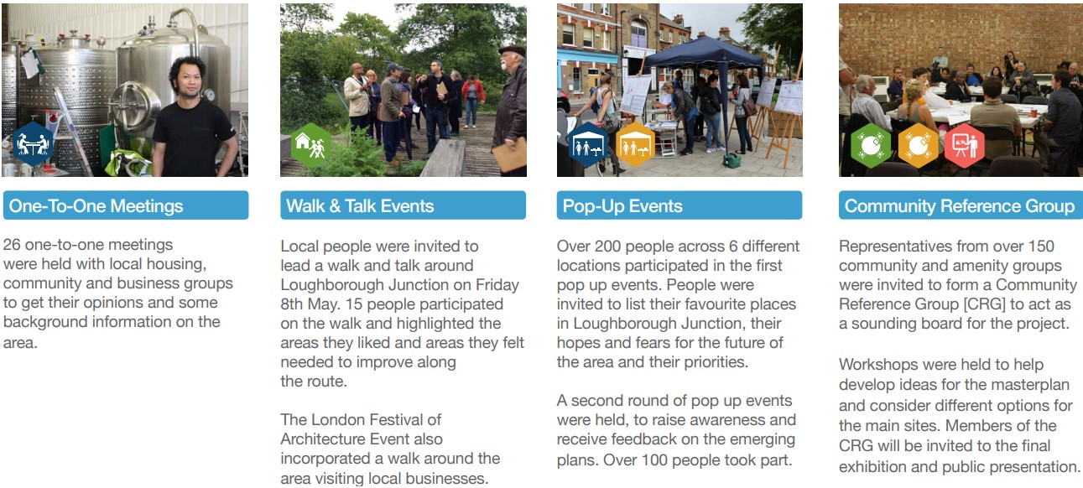

By dropping these postcards in the mail, the Council ensured that they were reaching the entire community. Nonetheless, there are still other ways in which the community’s needs and desires could also have been established, for example, by using social media for monitoring. Thus, the research and community mapping phase of Lambeth’s community engagement strategy could have been improved by mining data from social media sites like Twitter, Instagram, Facebook and TikTok to learn about sentiments and opinions on their community (Das et al., 2019; Evans-Cowley and Griffin, 2012). For example, one strategy that can be used to monitor community sentiment is ‘microparticipation’ in which posts made by stakeholders/using relevant social media hashtags are analysed to determine sentiment, motivation, engagement level, and impact on the decision-making process (Das et al., 2019; Evans-Cowley and Griffin, 2012).
Still, this does not mean that Lambeth’s social engagement through social media platforms is non-existent as the Council uses social media to tap into online communities to have ad hoc conversations with the community as well as for awareness-raising (Lambeth Council, 2015), which are both appropriate uses for social media (Steinmetz et al., 2021). The Council has used social media for tapping into the large Portuguese-speaking community in Lambeth so that it could research the needs of this population, along with other research tools such as a thorough scoping exercise and building contact lists through snowballing (Lambeth Council, 2015).
However, it appears that social media is used for low to moderate engagement with the community (inform, consult, involve) (Head, 2007) with less effort made to use it as a way of collaborating with the community. Continued improvements in technology mean that social media can be used a lot more interactively than even 5 years ago and councils could capitalise on these new capabilities. For example, social media can be used for influencer marketing to the community or for real-time communication with community members (Steinmetz et al., 2021). Where the policies and programmes being deployed by the local government agency are people-oriented, the use of good marketing strategies including digital marketing has been shown to increase civic engagement among vulnerable communities (Obukoadata et al., 2020). This would be particularly important in Lambeth, which is made up of a very diverse population including some of the most disadvantaged communities in London (Lambeth Council, 2016).
Lambeth Council should therefore have a dedicated plan for including digital communication more significantly in its engagement strategy, particularly by using social media platforms because these can be used for creating dialogue between local government and the community (Steinmetz et al., 2021; Xia et al., 2020). A more robust social media plan overall would also be useful in helping the Council “tap into the much more informal networks and ties shared by members of the working-class community,” which is one of the goals identified by one of the Councillors in seeking to promote future inclusion (Carr-West and Greenhalgh, 2014).
Additionally, Lambeth Council has several metrics that are used for monitoring and evaluating their community engagement activity, collecting information on inputs, outputs and outcomes as recommended by best practice for understanding participation (McAllister, 1999). For example, they measure inputs like Council staff and volunteer time spent on the engagement, outputs like the number of engagement events and community satisfaction with these events, and outcomes like increased interest in an issue or greater desire to participate in future events (Lambeth Council, 2015). Data for monitoring is collected using both qualitative and quantitative tools, including interviews, feedback sheets and surveys, also consistent with recommendations (McAllister, 1999). They also use ‘light touch’ approaches to getting this kind of data, such as having a signing in book and asking people to take photos and post on social media with their comments (Lambeth Council, 2015).
Finally, evaluation can take the form of process, impact, and/or economic evaluation (McAllister, 1999), although the process and impact evaluation are mostly used in evaluating community engagement activity (Lambeth Council, 2015). Evaluation should be done against the initial project aims and when considered in this way, Carr-West and Greenhalgh (2014) evaluated the NEP process up to that time as being a success although the process was not complete as there needed to be higher levels of participation and inclusion from the community.

Best practices in Lambeth’s Community Engagement Approaches
To be successful, an engagement programme has to include tools and strategies that are in line with the community context, as well as being based on the principle that all community members have the right to be informed, consulted, involved and empowered (Head, 2007). Lambeth Council has made use of this approach based on a three-pronged strategy they have used from the beginning of the NEP programme: (1) a postcard and outreach campaign, (2) a co-design phase, and (3) public consultation (Carr-West and Greenhalgh, 2014). The first prong of this strategy has been discussed above and has been argued to be low to medium on the engagement ladder. However, this can still be argued to be actively helping to develop trust among community members. Among the tools and strategies available for community engagement, those that help to build trust are particularly useful since community trust is positively associated with community engagement and is crucial for long-term, sustainable engagement and effective governance (Di Napoli et al., 2019).
Further, Lambeth’s NEP falls into the category of ‘doing with’ community members (London Councils, 2008), seen in the fact that the Council actively worked with the community in the co-design and co-production of their largest single investment in improving the community's streets (Lambeth Council, 2013). This is highlighted by Carr-West and Greenhalgh’s (2014, p. 23) evaluation of the NEP, which led them to conclude that:
…the NEP, the Loughborough Junction Plan and the Van Gogh Walk initiative importantly start to show what the council’s evolving role might look like: a role where the council moves away from doing things to making things happen; a role where the council moves away from taking local decisions to one where the council acts as a catalyst for the community making its own decisions.

This level of engagement with community members allows them to take more than a defensive role with the Council as they continuously fight against disruption to their lives (Day, 2006). Instead, they are active participants in the changes that are taking place where they live, arguably leading to a revitalisation of the community in a physical sense and the idea of community in the sociological sense (Day, 2006). However, Lambeth Council under the NEP focused on consultation, involvement, and collaboration and thus it is argued that can take one further step in the engagement process by actively empowering community members with the final decision-making (Head, 2007). This goes beyond citizen advisory committees like the Community Reference Group and participatory decision-making to giving the community final decision-making power.

The Role of Active Consultation
Community engagement aims to effectively interact with the community so that long-term and sustainable outcomes are achieved, underpinned by strong discourse, relationships, and processes that lead to effective decision-making and/or implementation (Johnston and Lane, 2018). However, there are many times that the term engagement is used but the work being done is not seeking to actively interact with community members (Xia et al., 2020). For that long-term and sustainable outcomes to be achieved, active consultation, effective communication, stakeholders’ participation, and inclusion are needed.
This can lead to more significant benefits, including more effective sharing of the responsibility for addressing complex societal and community issues and having a more egalitarian/citizen-centred approach to managing local social, economic and environmental projects (Head, 2007). For example, the active involvement of community members and relevant stakeholders in assessing the needs of the community and in deliberating about practical solutions is linked to positive outcomes such as better allocation of natural resources (Head, 2007). Additionally, having multicultural collaboration can play a vital role in resolving community-based issues and lead to better decision-making (Ball, 2016). This is supported by Carr-West and Greenhalgh’s (2014) evaluation of the Van Gogh Walk project in which they argued that it strengthened the ties between neighbours based on lots of time they spent in planning, consultation, and campaigning to achieve their common goal.

Conclusion
This assignment has critically discussed how Lambeth Council went about effectively coordinating a community engagement programme to support NEP. The discussion identified the Council as one that wanted community members to be actively engaged and thus used many moderate to high engagement strategies from the start to consult, involve, and collaborate with the community. These strategies and approaches were consistent with best practices, from research and community mapping to monitoring and evaluation. Nonetheless, areas for improvement were identified that would help the Council more effectively engage with community members and move towards more community empowerment, which can be argued to be very important in revitalising civil society (Day, 2006). This is based on the fact that active consultation, effective communication, stakeholders’ participation, and inclusion all have significantly positive impacts on community engagement and the Council should work to continuously improve their ability in these areas.

Word count: 1,995

References
Ball, C. (2016). Intercultural dialogue for civic engagement: Perspectives from the multicultural community (Doctoral dissertation, University of the Pacific).
Carr-West, J. and Greenhalgh, L. (2014). People-shaped places: How Lambeth let residents redesign the neighbourhood. Local Government Information Unit. Available at https://lgiu.org/publication/people-shaped-places-how-lambeth-let-residents-redesign-the-neighbourhood/ (accessed 13 April 2022).
Das, S., Dutta, A., Medina, G., Minjares-Kyle, L., and Elgart, Z. (2019). Extracting patterns from Twitter to promote biking. IATSS Research, 43(1), 51-59.
Day, G. (2006). Community and Everyday Life. London: Routledge.
Di Napoli, I., Dolce, P., and Arcidiacono, C. (2019). Community trust: A social indicator related to community engagement. Social Indicators Research, 145(2), 551-579.
Evans-Cowley, J. and Griffin, G. (2012). Microparticipation with social media for community engagement in transportation planning. Transportation Research Record, 2307(1), 90-98.
Head, B. (2007). Community engagement: Participation on whose terms? Australian Journal of Political Science, 42(3), 441-454.
Johnston, K. and Lane, A. (2018). Building relational capital: The contribution of episodic and relational community engagement. Public Relations Review, 44(5), 633-644.
Lambeth Council (2013). Neighbourhood Enhancement Programme Consultation Report: Oval. Available at https://www.lambeth.gov.uk/sites/default/files/NEPconsultationreportOval.pdf (accessed 15 April 2022).
Lambeth Council (2015). Lambeth’s community engagement toolkit. Available at https://www.lambeth.gov.uk/sites/default/files/Lambeth%20Community%20Engagement%20Toolkit%20Sept%202015_1.pdf (accessed 15 April 2022).
Lambeth Council (2016). State of the Borough 2016. Available at https://www.lambeth.gov.uk/sites/default/files/State%20of%20Borough%202016%20-%20v3.pdf (accessed 16 April 2022).
London Councils (2008). Community engagement: What is it and why is it important? Available at https://www.londoncouncils.gov.uk/node/5871 (accessed 13 April 2022).
McAllister, K. (1999). Understanding participation: Monitoring and evaluating process, outputs and outcomes. Rural poverty and environment working paper series; no. 2.
Obukoadata, P., Uduma, N., Eneokon, P., and Ulam, J. (2020). Deploying digital media as innovations in marketing government policies and enhancing civic engagement among vulnerable youths in Calabar. Media Watch, 11(2), 296-309.
Planning Aid (nd). Good Practice Guide to Public Engagement in Development Schemes. Available at http://camdencen.org.uk/Resources/Planning/Communities/Good%20Practice%20Guide%20to%20Public%20Engagement%20Development%20Schemes.pdf (accessed 15 April 2022).
Shin, Y. and Shin, D. (2016). Modelling community resources and communications mapping for strategic inter-organisational problem solving and civic engagement. Journal of Urban Technology, 23(4), 47-66.
Steinmetz, C., Rahmat, H., Marshall, N., Bishop, K., Thompson, S., Park, M., ... and Tietz, C. (2021). Liking, tweeting and posting: An analysis of community engagement through social media platforms. Urban Policy and Research, 39(1), 85-105.
Xia, Y., Robinson, S., Zahay, M., and Freelon, D. (2020). The evolving journalistic roles on social media: Exploring “engagement” as relationship-building between journalists and citizens. Journalism Practice, 14(5), 556-573.

