Learning In The Digital Era
ACCA4025
Component 1: E-portfolio

Submitted by: Darlington Agu

My Student number: 2529429

Date: March 2026

Table of contents
Contents
E-portfolio link 2
Screenshot of e-portfolio cover page/ welcome page 3
Task 1 3
Screenshot of ‘Essential Skills’ 4
Screenshot of ‘Reflection’ 4
Task 2 4
Screenshot of mind map 5
Link to mind map 5
Screenshot of the academic poster 5
Link to the academic poster 6
Task 3 6
Screenshot of automatic referencing tool 7
Task 4 7
Screenshot of each page of e-portfolio 8

My E-portfolio link

https://sites.google.com/view/darlington-e-portfolio/home?authuser=0

The Screenshot of my e-portfolio cover page/ welcome page
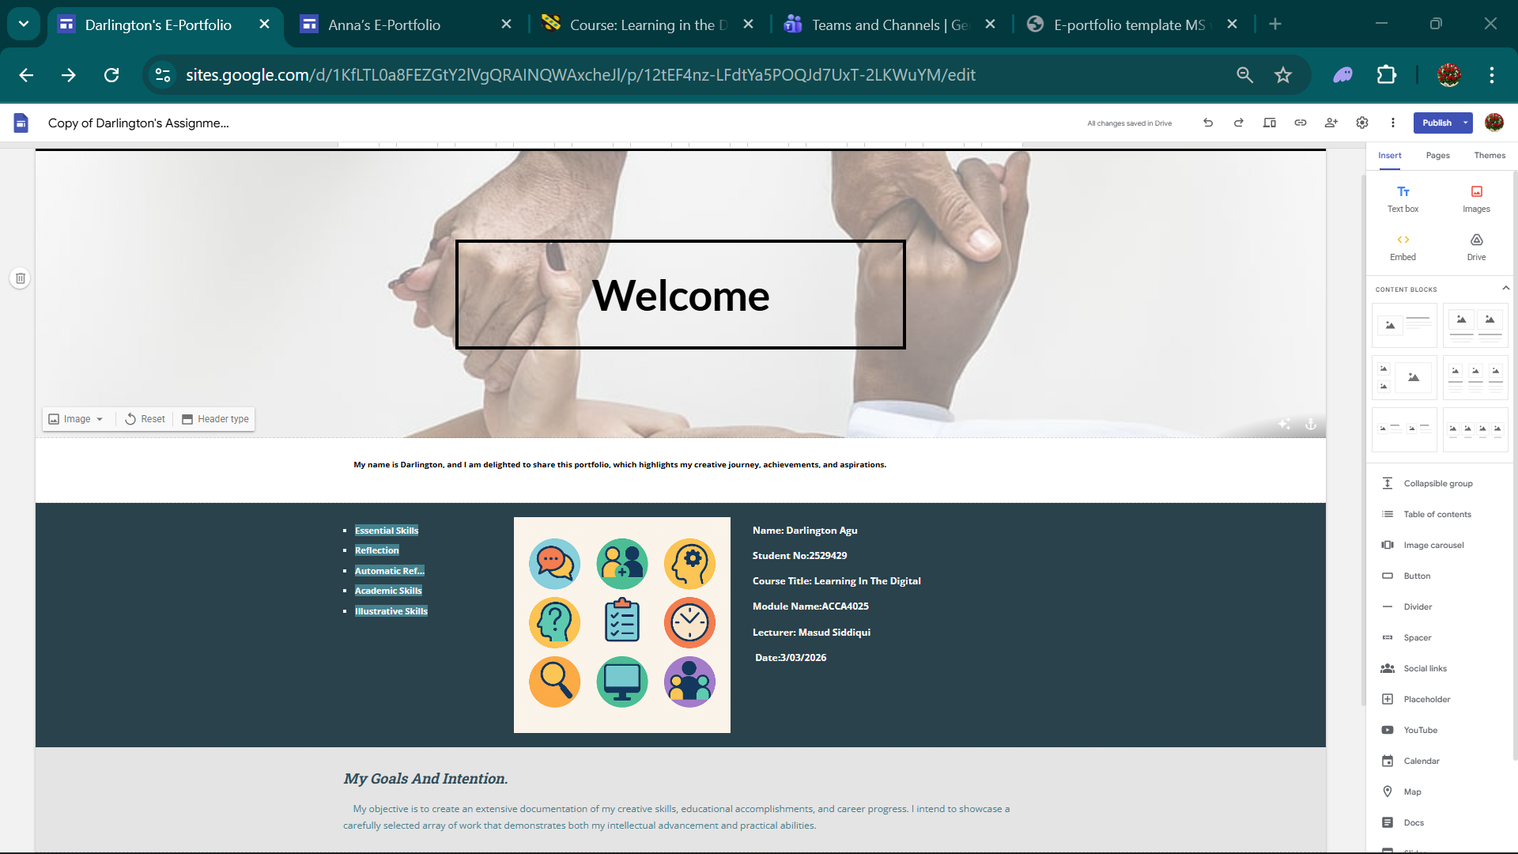
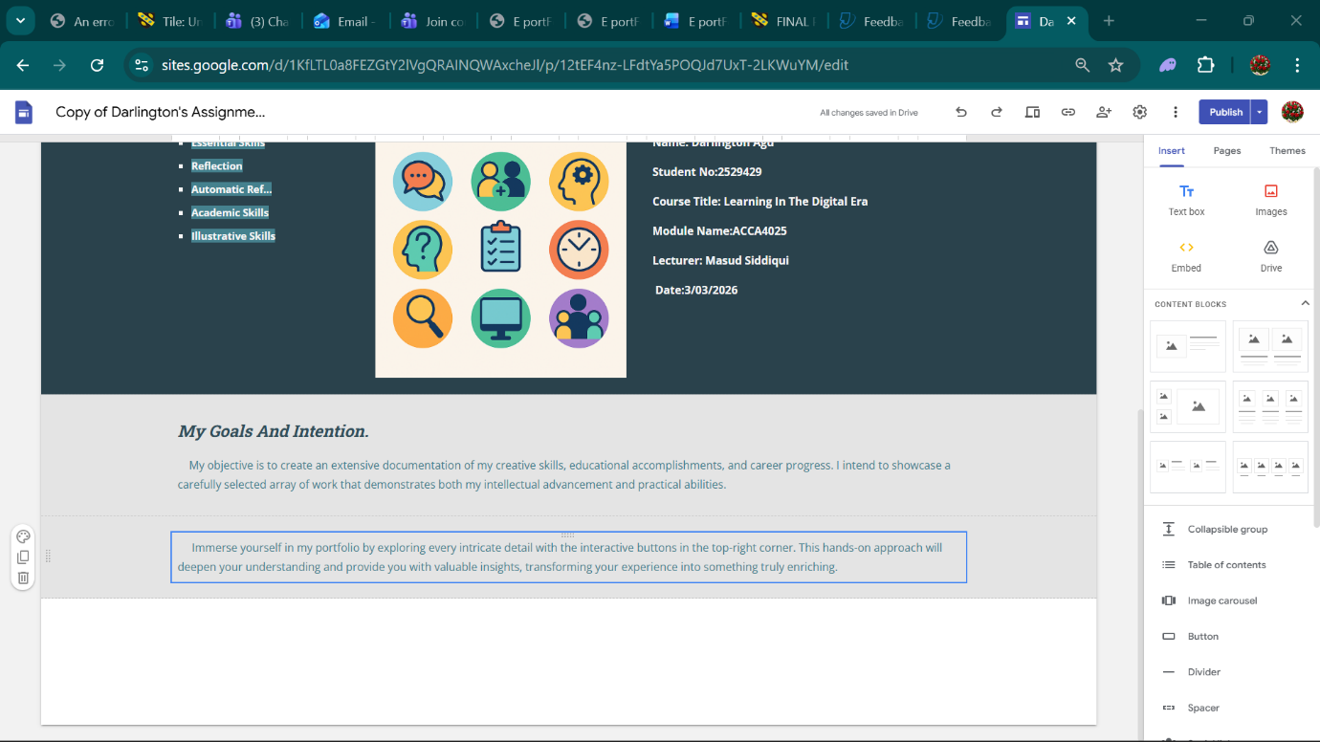

Task 1

The Screenshot of my ‘Essential Skills’

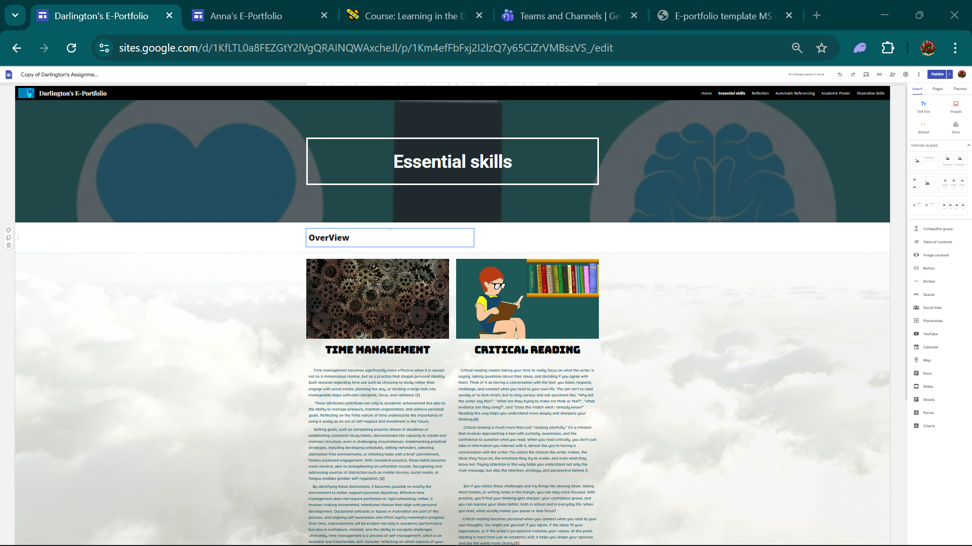
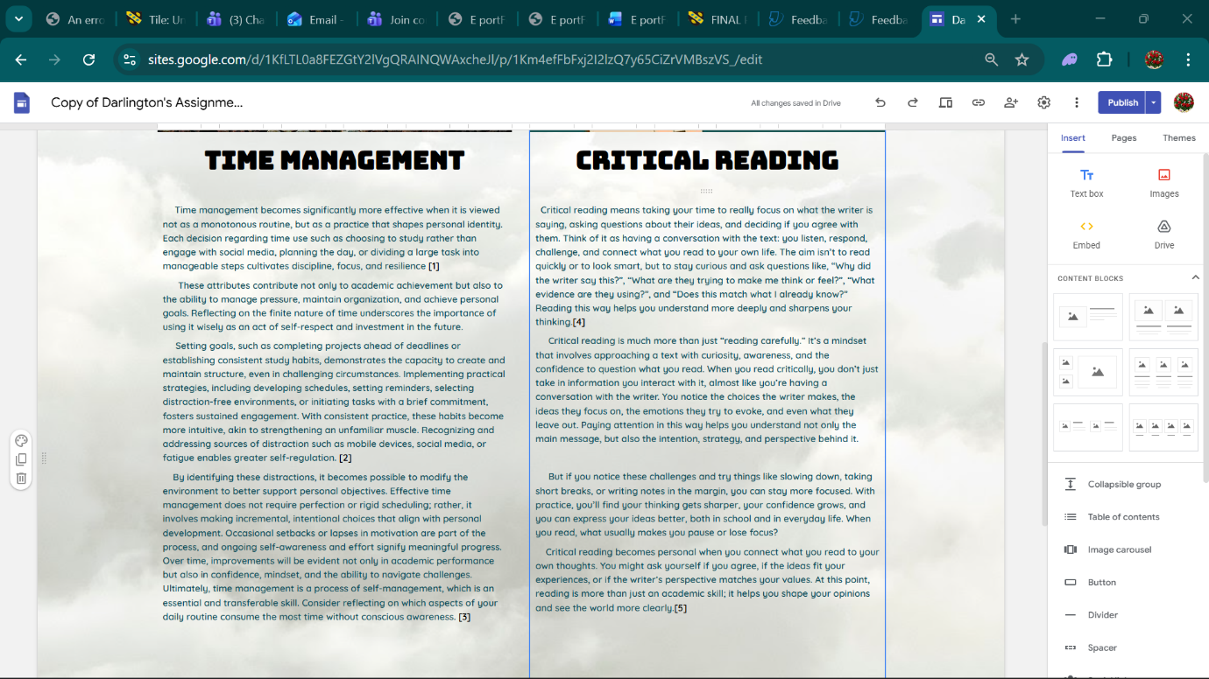

The Screenshot of my ‘Reflection’
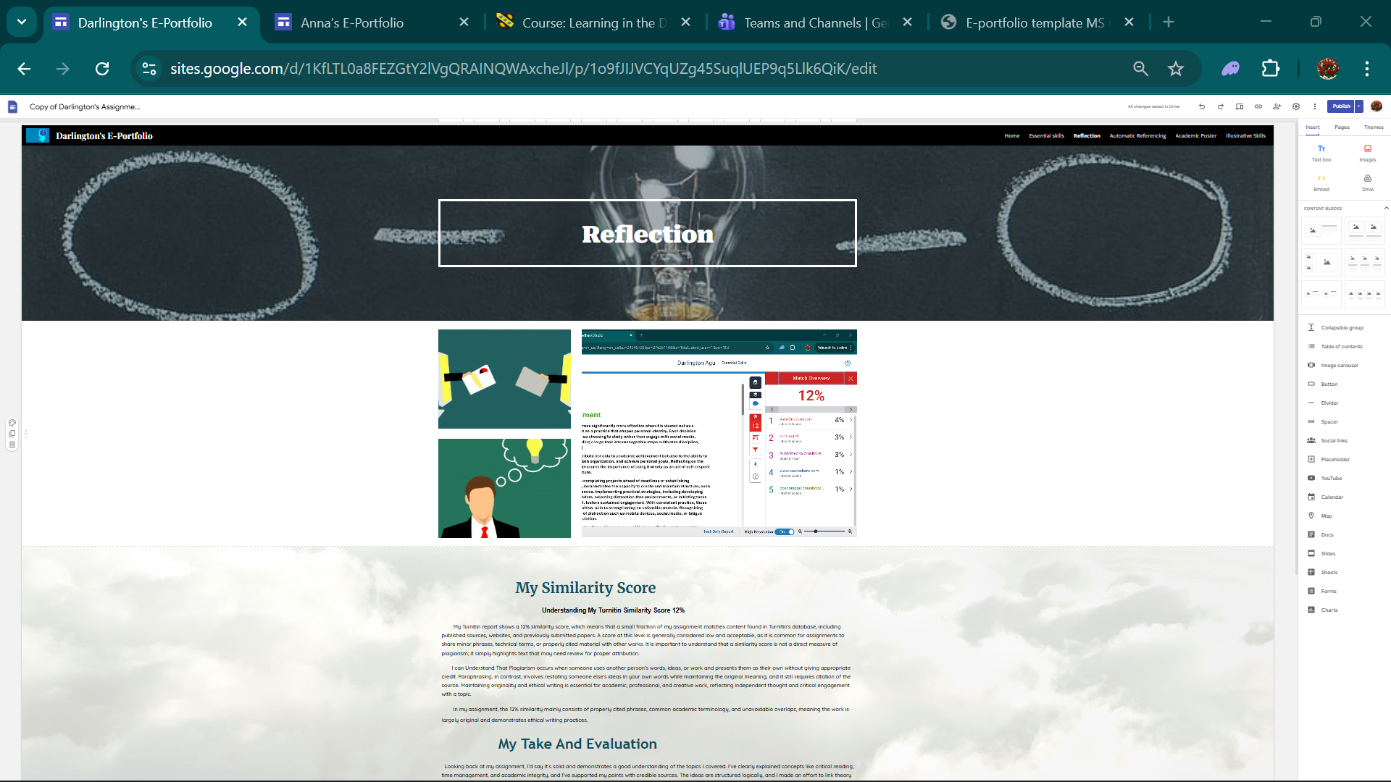

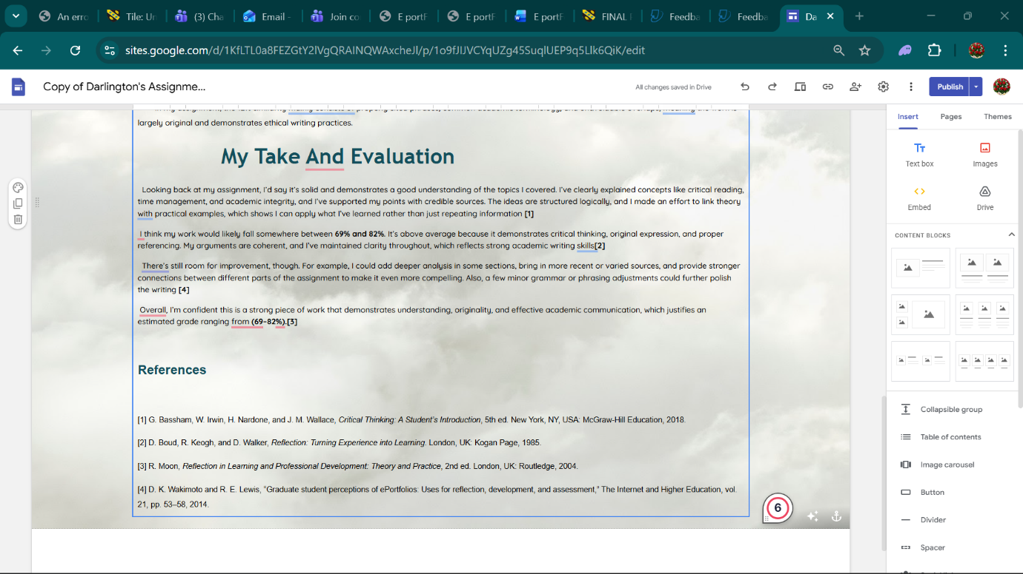

Task 2

The Screenshot of My Mind map
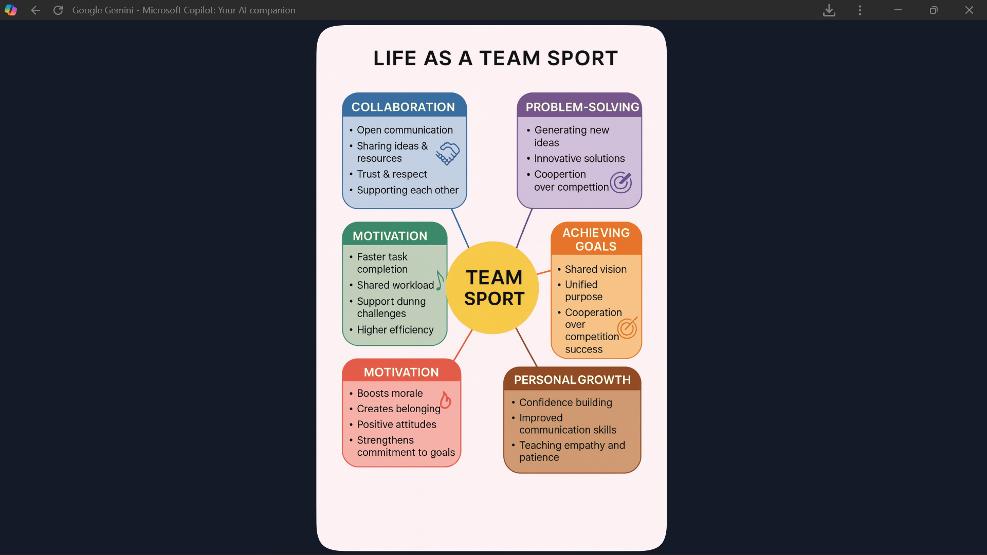

Link to MY Mind Map

www.canva.com/design/DAHCUihCHgc/J1DnBl9dnskDhKBxSYJIHQ/edit?utm_content=DAHCUihCHgc&utm_campaign=designshare&utm_medium=link2&utm_source=sharebutton

The Screenshot of My Academic Poster

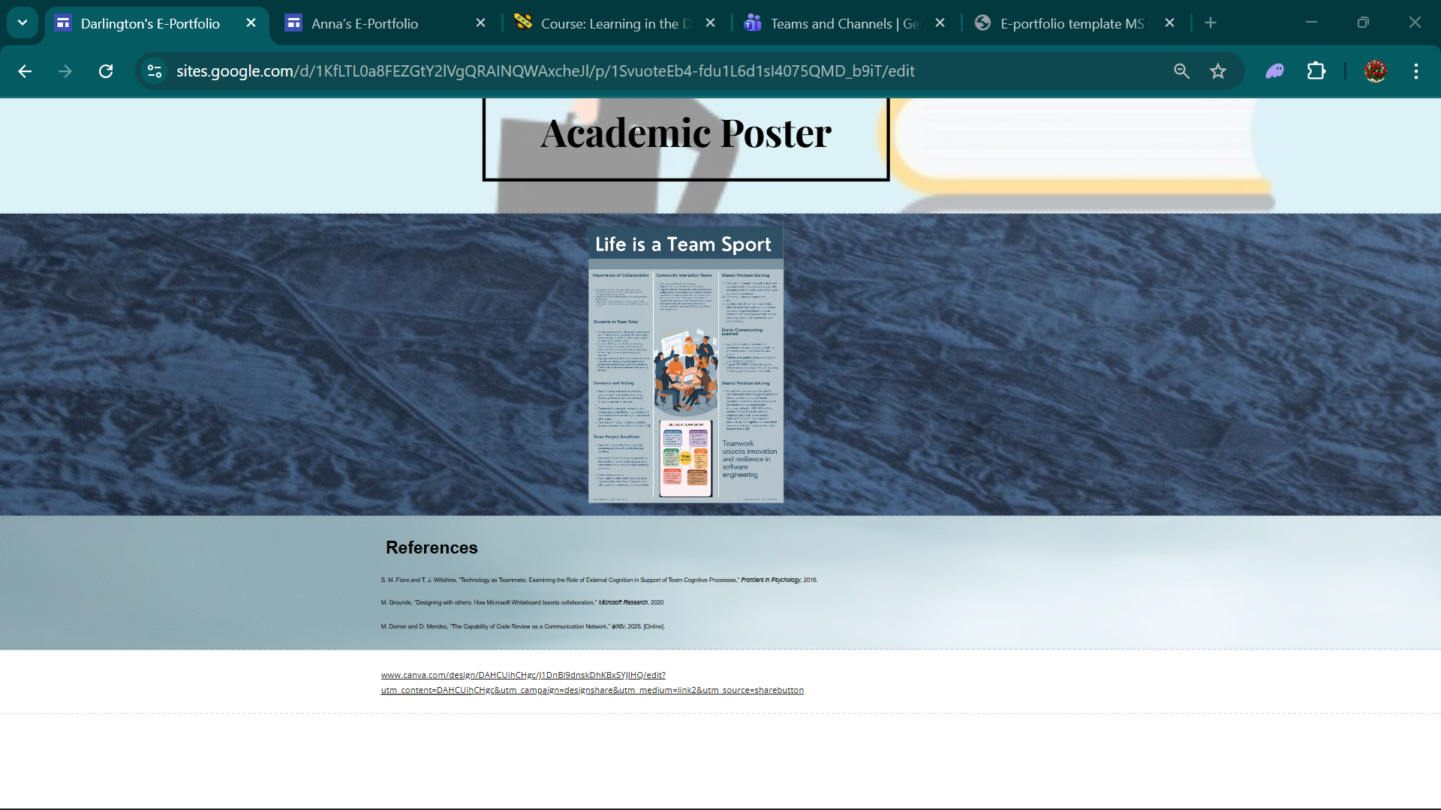

The Link to My Academic poster
https://sites.google.com/d/1KfLTL0a8FEZGtY2lVgQRAINQWAxcheJl/p/1SvuoteEb4-fdu1L6d1sI4075QMD_b9iT/edit

Task 3

The Screenshot of My Automatic referencing tool 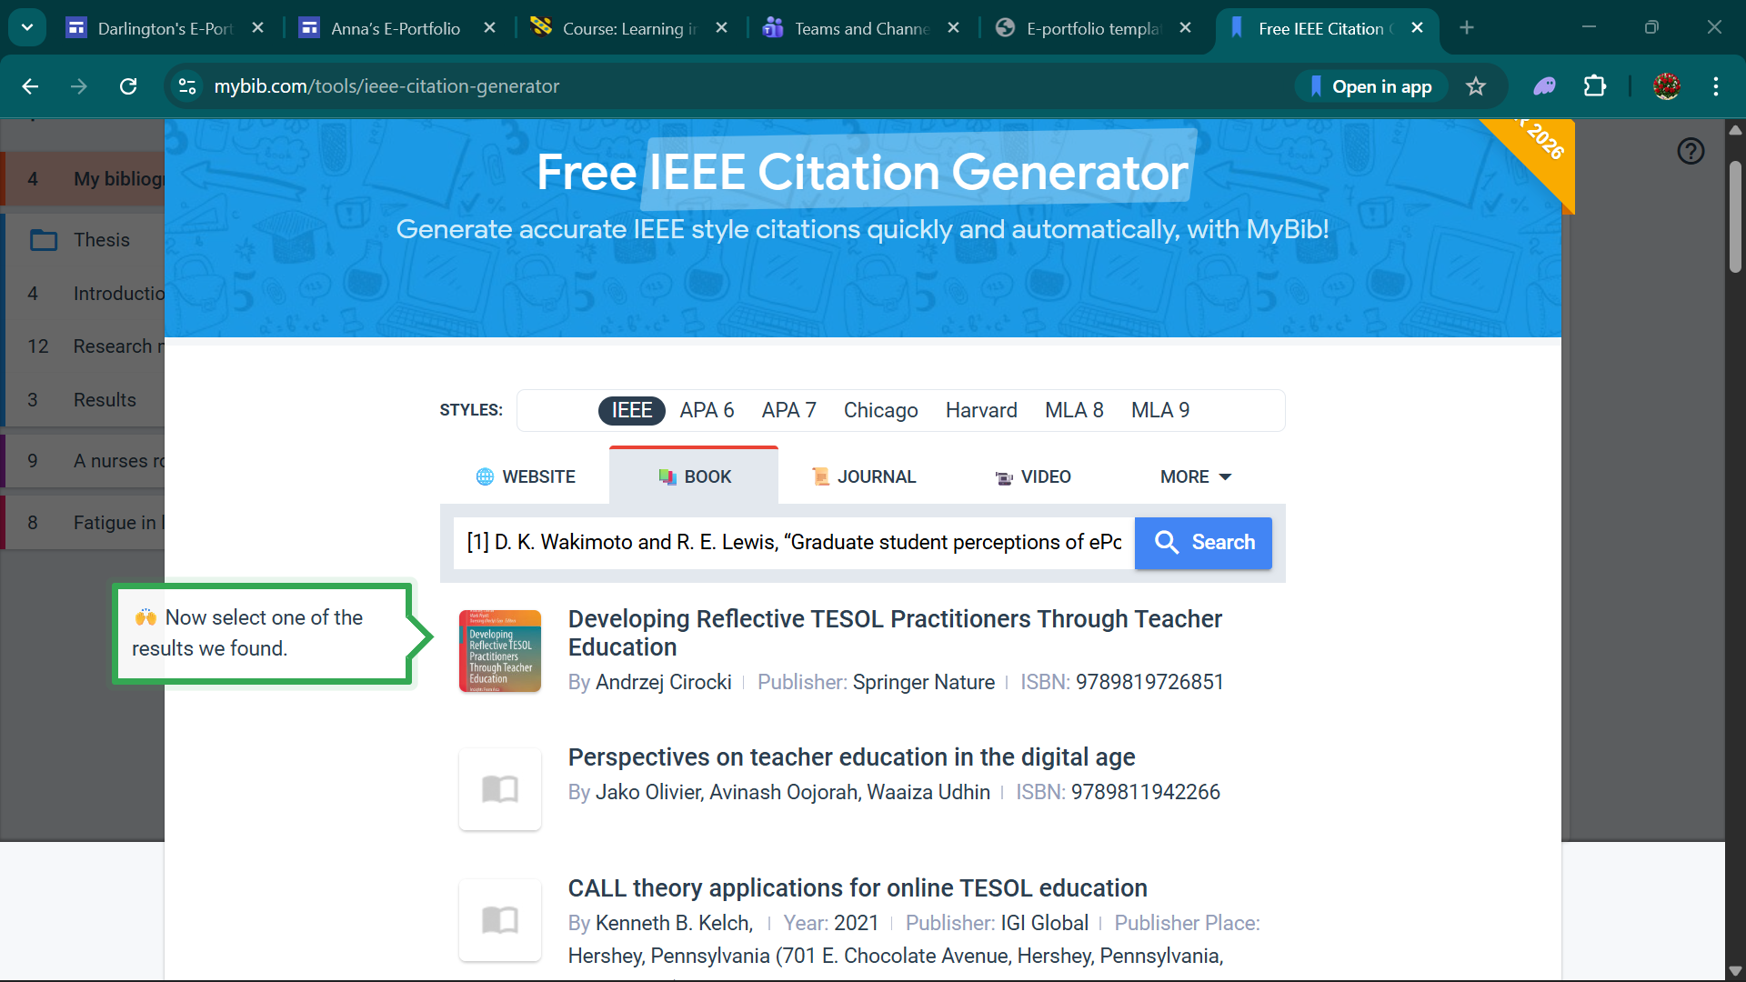
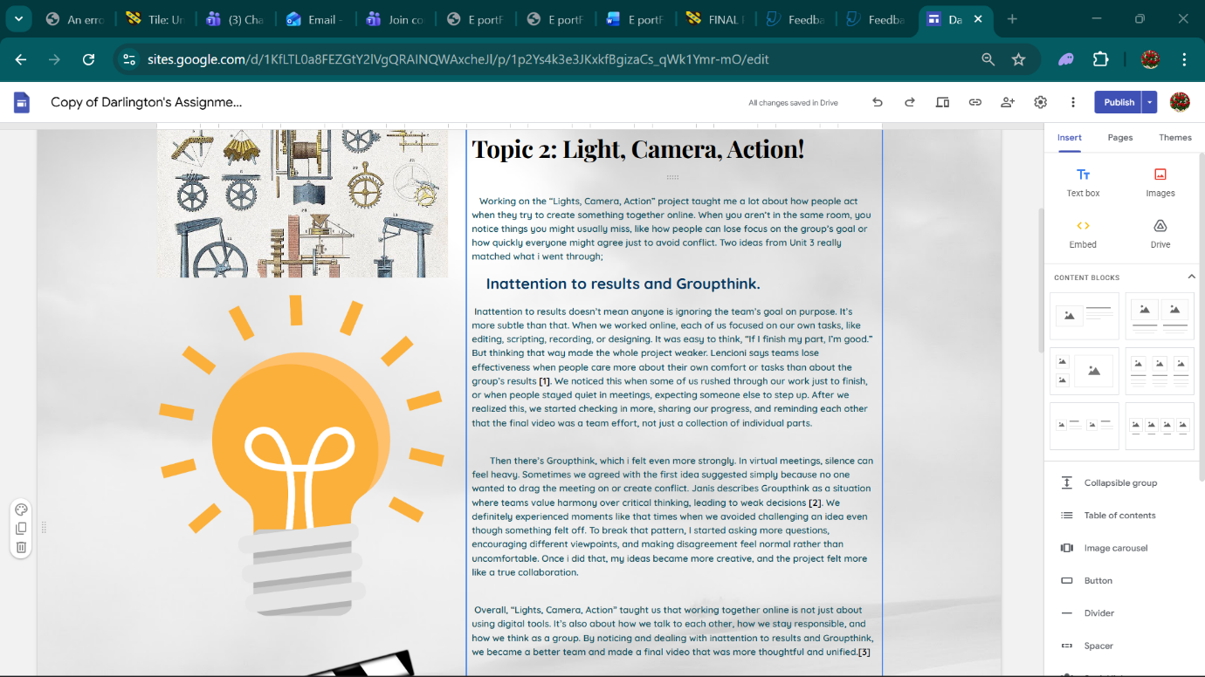

Task 4


