University of Wales Trinity Saint David

Luciana Stafi - 20130653
Submission date: 06 December 2024
Word count: 1800

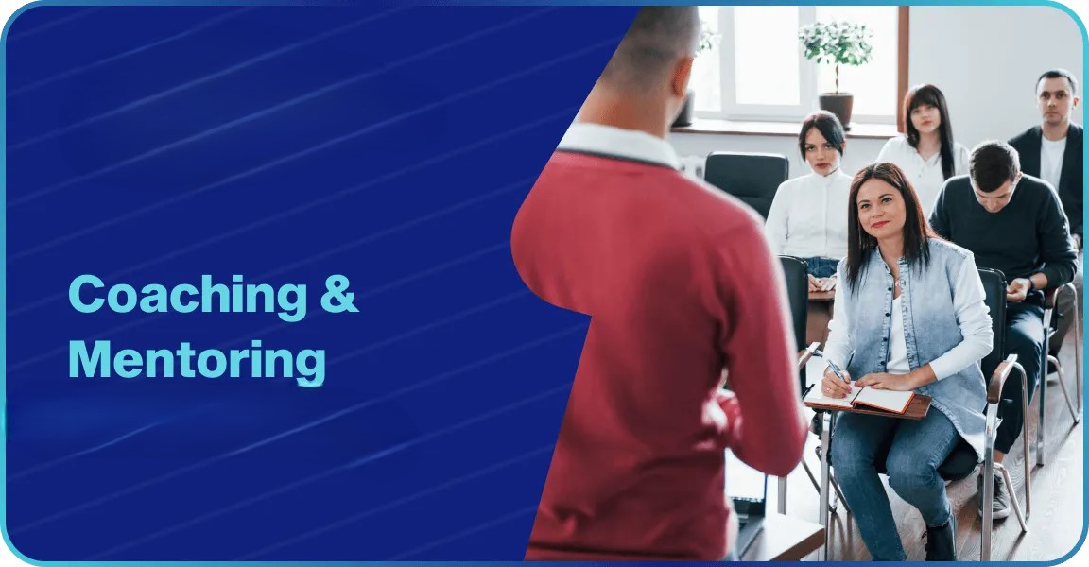

Introduction

Reflection is an essential process by which we analyse experiences to learn, improve performance and develop critical thinking. This facilitates self-knowledge and identification of strengths and weaknesses, contributing to adaptation and continuous personal and professional growth (Turner, Lucas, and Whitaker, 2018).
Coaching is an essential tool for personal and professional development, differentiating itself from other learning methods, such as mentoring or formal training, by emphasising supporting individuals in finding solutions (Clutterbuck, 2023). Unlike mentoring, which often involves giving advice and sharing experiences, coaching is based on active listening, asking questions and guiding the coachee to discover their perspectives and action plans (Parsloe and Leedham, 2022).
The COVID-19 pandemic has highlighted the need for flexible and personalised learning methods, and coaching has become an indispensable practice in this context. The rapid shift to online learning and the associated challenges, such as social isolation and lack of face-to-face interactions, have created an environment where coaching supports the development of technical and emotional skills (Hargreaves, 2021). For example, students can benefit from coaching to improve their academic performance, and teachers can use it to develop their teaching or leadership styles (Pritchard, A. 2017).
Coaching and mentoring are important for employees' professional development in an organisation. Amazon has 13 affinity groups that offer opportunities for mentorship and mutual support. The "Amazon Circles" program is a global peer-to-peer mentoring initiative combining best practices from various research in the field (staff, 2019). Employees can participate in mentoring sessions to improve their skills and advance professionally. For example, in 2021, nearly 160,000 employees participated in the mentoring program, a significant increase from 18,800 in 2016 (Colletta, 2023).
This reflection assesses my performance as a coach in a practical peer coaching exercise using the "Instant Payoff" model proposed by Landsberg (2015). The session focused on supporting Livia, the coachee, in overcoming stress and improving time management strategies for university exams. Following the structure of Gibbs' Reflective Cycle, I will explore the experience, my emotional responses, strengths, weaknesses and areas for improvement (University of Cumbria, 2020). I will also compare the model used with other theoretical frameworks, such as GROW and OSCAR, and formulate a Personal Development Plan (PDP) to support the continuous improvement of my coaching skills. A Personal Development Plan (PDP) is an essential tool for helping individuals identify their strengths and weaknesses, set clear goals, and develop strategies for achieving them (Perry, 2024).
These objectives in the PDP were selected based on the feedback received and my reflections. Improving model explanations and action planning will directly address identified gaps while enhancing question techniques and time management to ensure a more effective coaching experience.
Description of the Peer Coaching Exercise
The preparation for the coaching session was instrumental in ensuring a coherent structure and a productive atmosphere. An effective coaching session begins with establishing a clear framework and a positive relationship between the coach and coachee (Clutterbuck, 2023). For this session, I studied the "Instant Payoff" Coaching model, which provides a structured approach to identifying obstacles and developing solutions.
In the practical peer coaching exercise, I took on the role of coach to support the coachee, Livia, in managing stress and improving her time management skills for university exams. The session lasted 10 minutes and was based on applying the "Instant Payoff" model proposed by Landsberg (2015). I focused my training on using open-ended questions and encouraging the coachee to generate her solutions (Whitmore, 2017).
The "Instant Payoff" model includes several essential steps: the coachee describes the problem, identifies a desired outcome, explores roadblocks, and develops an action plan (Landsberg, 2015). During the session, I followed these steps, focusing on creating an environment of trust and encouraging Livia to find her solutions.
By applying questions such as: "Are there any blocks caused by other people or outside factors?" or "And are there any challenges related to the situation itself?", we identified three types of blocks: personal, external (pressure and distraction from friends) and situational (limited time for exams). After identifying the blockages, we tried to analyse how they prevented her from managing time. In the end, we developed a plan that included shorter study sessions, setting boundaries with friends, preparing earlier, and trying relaxation exercises before studying.

Reflection on Performance
Punctuality reflects professionalism and respect for others' time, helping to build a positive image and maintain communication efficiency (admin-modernmeetingstandard, 2024).
At the beginning of the session, I felt stressed and insecure because I was five minutes late. This situation added extra pressure, as it was my first coach experience, making me feel nervous and worried about my performance. In the first second, I wondered if I would be able to guide the coachee to solutions without giving direct answers, which is a frequent challenge in coaching (Parsloe and Needham, 2022).
As the discussion progressed, I noticed that Livia felt more and more comfortable expressing her difficulties. This strengthened my confidence, as using open questions and active listening techniques created a safe and collaborative space according to the principles of effective coaching (Clutterbuck, 2023). However, I felt disappointed that I could not use all the 15 minutes allotted for the Coaching session. Effective time management is important to increase the efficiency and productivity of activities (Coursera Staff, 2023).
Watching Livia's progress and how she began to find solutions to her challenges made me feel fulfilled, and I became more focused on supporting her. Livia stated that the session made her feel more confident and gave her a clear direction for time management:
"How do you feel now compared to when we started this conversation?
Livia: I feel a lot more confident. At first, I felt overwhelmed and unsure where to begin, but now I have a clear plan. I know what steps to take, and it feels like I have control over my time again".
This positive feedback reflects the success of the "Instant Payoff model," which allows the coachee to define their solutions and take control of the situation (Landsberg, 2015).

Evaluation of Strengths and Weaknesses
The coaching session had several positive elements that created a productive and encouraging environment for the coachee. First, we followed the "Instant Payoff" model's structure and identified the three types of blockages with the coachee: personal, external and situational.
I created an atmosphere of trust by using encouraging language such as phrases like "That is an excellent idea" and "I understand the situation". The observer also noted my non-verbal language, including eye contact and gestures of approval, which contributed to this connection (Julie Thomas).
We also used a variety of open-ended, closed-ended and probing questions to encourage introspection and stimulate the generation of own solutions. In addition, I paid attention to body language and tone of voice, using a warm and empathetic communication style, which helped build a strong connection with the coachee. The tone of voice and body language play critical roles in communication, influencing how messages are understood (Martin, 2024).
Another strength was my ability to keep the conversation structured and manage time efficiently, allowing Livia to make the most contributions. In the end, the coachee left with a clear plan of action, which demonstrated the overall success of the session.

Areas for Improvement

In a coaching session, some aspects can be improved. First, I did not explain the "Instant Payoff" model at the beginning of the session, which could have helped the coachee better understand the structure and purpose of the conversation. Gilbert and Whittleworth (2009) suggest that an effective coach must ensure that the coachee understands the structure of the process in order to fully benefit.
Second, although the session was practical, we did not use all the 15 minutes available, limiting the time allotted for detailing the action plan. This was also noted in the feedback received, which emphasised the importance of planning actions in more detail. Moreover, one last aspect would be that we spent too much time identifying obstacles and less on developing a concrete action plan. At the end of the session, although I helped the coachee identify clear steps, I did not establish a well-defined, especially SMART plan. According to Blackbyrn (2024), the SMART model used in coaching helps to set clear and achievable goals, supporting the coachee to stay focused and take concrete steps towards achieving their goals.

Analysis of Coaching Models

My performance as a coach was evaluated through the lens of the "Instant Payoff" model and the theoretical principles associated with effective coaching. The "Instant Payoff" model by Landsberg (2015) is built on a structured approach that helps the coachee identify problems, explore obstacles and generate solutions. The application of this model was a strong point of the session, especially in identifying the blocks and supporting Livia in generating her solutions. However, the lack of an explicit introduction of the model to the coachee represents a deviation from good practice, emphasising the importance of clarifying the methodology used to facilitate collaboration (Hawkins, 2021).
Compared to other coaching models such as GROW and OSCAR, "Instant Payoff" focuses more on exploring blockages in detail and establishing a clear vision of the desired outcome. For example, the GROW (Objective, Reality, Options, Will) model strongly emphasises clarifying goals and setting options but may not thoroughly explore personal, external, and situational barriers (Whitmore, 2017). Instead, OSCAR (Outcome, Situation, Choices, Actions, Review), with its exploration and challenge stages, could have provided a more dynamic framework to help the coachee overcome procrastination and better manage their distractions (Zeus and Skiffington, 2000).

Conclusion

This coaching experience gave me the opportunity to learn and apply practical techniques in supporting the coachee. Key lessons learned include the importance of clear structure during the session, the use of appropriate questions to stimulate introspection, and the need to create a detailed action plan to ensure coachee engagement. Observing Livia's progress underscored the positive impact of coaching when applied with empathy and methodology.
A critical point for improvement identified is the clear explanation of the coaching model used at the beginning of the session, which could strengthen the coachee's understanding and confidence in the process. Also, time management and extending the action planning phase are priorities for the future.
Reflecting on the whole experience, I realised that a coach's effectiveness depends not only on the knowledge of the model used but also on the flexibility to adapt the methods to the coachee's needs. We also confirmed that coaching skills such as active listening and rapport building are critical to creating a productive and collaborative learning environment.
In conclusion, this experience helped me develop my coaching skills and recognise areas where I can improve. By reflecting on these lessons and applying them in future sessions, I am convinced that I will improve my performance and contribute more effectively to the personal and professional development of those I work with.

Personal Development Plan (PDP)

What do I want/need to learn? | What will I do to achieve this? | What resources or support will I need? | What will my success criteria be? | Target dates for review and completion
To improve the ability to clearly explain the coaching model "Instant Payoff" to the coachee. | I will watch the Explaining Coaching Models - YouTube video: https://www.youtube.com/watch?v=j-kI4Mxf4t0 | Access to YouTube and the Internet. | I will be able to clearly explain the "Instant Payoff" model without hesitation during a mock session. | Revision:  20 Dec. 2024.
To extend the action planning phase in the coaching sessions. | I will read the Creating Effective Action Plans article on the Asana Website: https://asana.com/resources/action-plan. I will practice this phase in mock sessions. | Internet access. I will need a person for mock sessions. | My sessions will have a detailed and well-structured action plan with positive feedback from observers/coaches. | End:  15 Jan. 2025.
To improve the use of challenging questions to encourage the coachee's introspection. | I will watch the video The Power of Questions in Coaching on the YouTube platform https://www.youtube.com/watch?v=1dVtPDryqco. | I need to receive feedback from the person that I will have the session with. | My questions will stimulate introspection, and the coachee will generate more solutions. | Revision:  10 Feb 2025.
To better manage time in coaching sessions. | I will practice using the "Time Boxing" technique in simulated coaching sessions. | Access to tutorials on the "Time Boxing" technique. Peer support for feedback. | My sessions will respect the allotted time and include all the necessary steps according to the coaching model. | Revision:  28 Feb. 2025

Reference List

admin-modernmeetingstandard (2024) 'Punctuality - Definition & Detailed Explanation - Meeting Etiquette Glossary', Modern Meeting Standard. Available at: https://modernmeetingstandard.com/punctuality/ (Accessed: 4 Dec. 2024).
Blackbyrn, S. (2024) 'Smart coaching model: Enhancing skills with strategic techniques', Coach Foundation, 21 Mar. Available at: https://coachfoundation.com/blog/smart-coaching-model (Accessed: 3 Dec. 2024).
Clutterbuck, D. (2023) Coaching and Mentoring. London: Routledge.
Colletta, J. (2023) 'How Amazon is growing its mentorship program by almost 750%', HR Executive. Available at: https://hrexecutive.com/how-amazon-is-growing-its-mentorship-program-by-almost-750/ (Accessed: 3 Dec. 2024).
Coursera Staff (2024) 'What Is Time Management? 6 Strategies to Better Manage Your Time', Coursera. Available at: https://www.coursera.org/articles/time-management (Accessed: 3 Dec. 2024).
Cox, E., Bachkirova, T., and Clutterbuck, D.A. (2023) The Complete Handbook of Coaching. 4th edn. London: Sage Publications Limited.
Gilbert, A. and Whittleworth, K. (2009) The OSCAR Coaching Model: Simplifying Workplace Coaching. Monmouth, Wales: Worth Consulting.
Hargreaves, A. (2021) 'What the COVID-19 Pandemic Has Taught Us about Teachers and Teaching', FACETS, 6(1), pp. 1835–1863.
Hawkins, P. (2021) Leadership Team Coaching: Developing Collective Transformational Leadership. 4th edn. London: Kogan Page.
Kudzi, R. (2019) 'Different Coaching Models', YouTube. Available at: https://www.youtube.com/watch?v=j-kI4Mxf4t0 (Accessed: 5 Dec. 2024).
Landsberg, M. (2015) The Tao of Coaching: Boost Your Effectiveness at Work by Inspiring and Developing Those Around You. London: Profile Books.
Martin, C. (2024) 'What is the Importance of Body Language in Communication?', ModernGov. Partnership Media Group Ltd. Available at: https://blog.moderngov.com/why-is-body-language-important-in-communication (Accessed: 4 Dec. 2024).
Munro, M. (2012) 'Great Questions to Use When Coaching Someone', YouTube. Available at: https://www.youtube.com/watch?v=1dVtPDryqco (Accessed: 5 Dec. 2024).
Parsloe, E. and Leedham, M. (2022) Coaching and Mentoring: Practical Techniques for Developing Learning and Performance. 4th edn. London: Kogan Page.
Perry, E. (2024) 'Personal Development Plan (PDP): How to Develop One (with Examples)', BetterUp. Available at: https://www.betterup.com/blog/personal-development-plan (Accessed: 5 Dec. 2024).
Pritchard, A. (2017) Ways of Learning: Learning Theories for the Classroom. 4th edn. London: Routledge.
Raeburn, A. (2023) 'How to Create an Action Plan That Drives Results', Asana. Available at: https://asana.com/resources/action-plan (Accessed: 5 Dec. 2024).
Staff, A. (2019) 'How does peer-to-peer mentoring at Amazon work?', UK About Amazon. Available at: https://www.aboutamazon.co.uk/news/working-at-amazon/how-does-peer-to-peer-mentoring-at-amazon-work (Accessed: 3 Dec. 2024).
Turner, T., Lucas, M., and Whitaker, C. (2018) Peer Supervision in Coaching and Mentoring: A Versatile Guide for Reflective Practice. Abingdon, Oxon; New York, NY: Routledge.
Whitmore, J. (2017) Coaching for Performance: The Principles and Practice of Coaching and Leadership. 5th edn. London: Nicholas Brealey.
Zeus, P. and Skiffington, S. (2000) The Complete Guide to Coaching at Work. Sydney: McGraw-Hill.
University of Cumbria (2020) 'Gibbs' Reflective Cycle'. University of Cumbria. Available at: https://my.cumbria.ac.uk/media/MyCumbria/Documents/ReflectiveCycleGibbs.pdf (Accessed: 5 Dec. 2024).

