Student name: Zubaida Ambreen

Student ID number:1912999

Programme: BSc Health and Social Care

Module: Changemakers: Creativity and Value Creation

Module code: BMHP5014_BIRM

Lecturer: Dr Azora Hurd Internal Verifier: Dr Mark Gallagher Assignment Title: Project Outcomes

Unit 1: Topic 3 Be the Changemaker
There are 16 topics in unit one and I have chosen to describe about, 'Be the changemaker`.
Humans have created this problem; humans will have to problem solved have out of it first up this message is becoming noticeably clear and it is being galvanised by a group of well-known and previously well-known individuals' celebrities' activists' school children.it always seems impossible until it is done- Nelson Mandela.

What does ‘change maker’ mean? | Ashoka | Everyone a Changemaker, (no date) state that, `Ashoka invented the word "changemaker" in 1981 and has used it ever since``. Changemakers activates a global network of social entrepreneurs, innovators, business leaders, policy makers and activists to build an Everyone a Changemaker.
A changemaker is taking innovative action to handle a social issue. This sounds misleadingly fundamental yet diving into three bits of the importance of "changemaker" gives a manual for making an exceptional differentiation.
There are so many men/women changemakers in the history of changemakers such as William Shakespeare, Benazir Bhutto, Nelson Mandela suggested by (100 People who changed the world |, no date). according to Barratt, (2019) Yara Shahidi, her forthrightness, conviction and wisdom make her a role model for young people - particularly people of colour - wanting to make an impact on the world.
Malala’s story | Malala Fund, (2021) suggests that Malala Yusufzai incredibly young changemaker who wanted to promote education for young girls in northern areas of Pakistan was shot by a male in her head. By the grace of God, she survived and became a changemaker. she won a Nobel prize in noticeably youthful age.
Mittal, (2019) suggest that the Indian diversion world is depicted by 6.2 men to every woman showing the male-governed nature of the business. It considers the clashes of women who expected to make an engraving behind the scenes work in Bollywood which was overpowered by men. The grouping of women fuses make-up subject matter experts, scriptwriters, cosmetologists, film feature writers, editors, cooks, and choreographers some of whom have appeared to be eminent figures in TV and film. The other problems faced by women included outright sexual discrimination, wage gap, harassment, and family troubles. Many of them tried to carve a unique niche and started an alternative cinematic trend in Bollywood. In each chapter, the book discusses their personal stories and discusses how their presence slowly revolutionized the political economy of film industry and viewership as well as the employment sector in India. Farah khan, Guneet Monga, Juhi Chaturvedi, Kiran Rao and the other ladies shared their life experience how they suffered but did not stop and they became successful.
Learning about these women how they stayed positive and made impossible things possible gives me hope for my project that I want to educate men about risks of FGM and why girls should not be circumcised and be a voice for young girl`s right. I am sure I can be a changemaker it is not going to be easy, but it is possible.
Unit 2 Storytelling:
Stories are particularly important for humans. Who does not love stories everybody, loves stories babies, toddles, adults' old people it does not matter what age you are only vocabulary gets better with age? Stories are exceptionally good for children`s imagination in schoolteachers teach them so much through stories. You can travel from one world to another so quickly. Stories are not just about imagination they motivate you; you learn so much from other people `s experience.
story telling is incredibly good for human growth we learn from our older generation about their experiences. Our grandparents tell us stories about their time how the worked hard or whatever difficulties they had to face in olden days, they have met some famous changemaker/inventor such as Gandi, Abraham Lincon or John Logie Baird.

Hurst (no date) illustrate `The Importance of Storytelling and Story Creation, stories help us adapt. Stories help us with recalling and envision. Stories likewise help us with taking care of issues by giving us the freedom to evaluate various activities that may prompt various results. Stories draw into our consideration. Stories can aid us with learning about others and to discover comprehension and sympathy for them and their circumstances.
Tjale and Villiers, (2004) suggest that the use of stories can enlighten and motivate students in medical services. storytelling is a technique for communication with others and it includes and urges others to share their accounts. It is a significant method of protecting history. individuals find out about various societies, revelations, and advancements. storytelling has remedial advantages it assembles certainty, confidence, and compatibility to strengthen medical services proficient customer connections. Individuals feel more unequivocal and empathy for others after finding out about them. Their listening abilities and language become better, stories address variety and self-improvement gatherings. There are plenty of advantages of composing stories, for example, it understands human conduct, some terminal patients can peruse and understand about death and the reason for life through short stories.

According to Gurrieri and Drenten, (2019) this study employs a dual qualitative approach of visual and textual analysis of 180 Instagram posts from female breast cancer patients and survivors who use the platform to narrate their healthcare consumption experiences. This assessment presents an arrangement of visual stories for clinical benefits clients on picture-based online media. Our paper offers three key responsibilities: that visual describing develops enlightening and fellowship social help for powerless clinical consideration buyers; seeing this occurs through normalizing concealed clinical benefits usage experiences; and recognizing clinical consideration disclosures, normalizing practices, and enabling electronic affordances as vital to this collaboration.

Unit 3
Mwangi, (2016) suggests that story telling at our age is a tool used verbally or through writing to explain progress or vision of an organization. As a verbal communication tool, storytelling calls upon the person speaking to take the focus away from the technical crutches that can easily obstruct learning and ... Tell stories to persuade people to buy your products, to subscribe to your services or to invest in your company. Each moderator can upgrade, advance, or even change the story by showing to it their own specific manner. Stories are about motivation. By recounting individual experience and including your considerations and feelings en route, one can give their crowd answers for issues and move inspiration and expectation.
Storytelling and identification go together. Burke (1969) argued that there were three kinds of identification: by sympathy, by antithesis, and by unawareness. All three are relevant here.
Digital media storytelling which enhances traditional oral storytelling with images, music, and text has been a focus of recent scholarship for its potential to produce many educational benefits. Through digital media storytelling, students’ imagination, creativity, critical thinking, writing, public speaking, and organizational or planning skills may all be enhanced (Ohler, 2008).
Public speaking is another way of conveying your massage to the people. You should plan strong presentation according to your genre. First, make a mind map of what you need to discuss. write down the purpose of your speech, think who the pitch is for, who are the audience, how much time you must talk. A good pitch/presentation has introduction main discussion and conclusion.

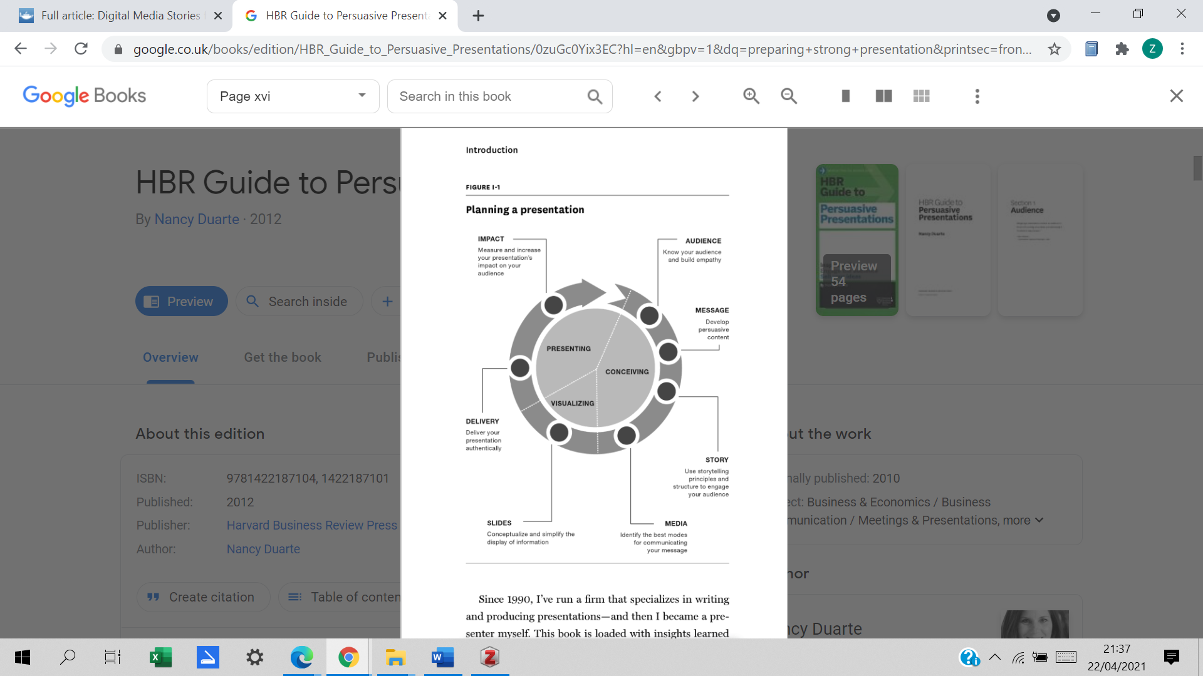
(Figure1.1,Duarte, 2012).

Give people inside that will improve their lives you introduce senior managers at your company to an exciting new way to compete in two marketplace or you showroom full of potential clients that you can save them money and time. Teach the hero to use `magical tool kit` `this is where you will show your audience how to pick up new skill or mind-set from you which will enable you to reach their goals and yours. Rehearse before presenting, run slides by someone who has successful getting ideas adopted at the executive level and who will serve as an honest coach. Is your message coming through clearly and quickly? Do your summary slides boil everything down into swimmable key insights? Are you missing anything you audience is likely to expect? Sounds like a lot of work it is but presenting to an executive team is a great honour and can open treat people with a lot of influence will become strong advocate for your ideas (Duarte, 2012).
Most grown-up expect collaboration to best ingest any material. Pose inquiries of your crowd as you talk this way you will keep them locked in. Be innovative and offer another comprehension of your point. You do not have any acquaintance with everything. As you practice the part of credibility recorded above, be appreciative and genuine when a crowd of people part difficulties you or helps you with another agreement. It is all right to snicker a piece. Particularly in exceptionally complex subjects, add a touch of humour to ease up the mindset or make changes between the ideas in your show.

Unit 4: Topic 1 what is success, Topic 3 (Trunki | Success stories | The Prince’s Trust, no date)The power of failure.

success is consistently investing fearless energy, characterizing strong destinations, understanding the difference between need and need. believing you can. Accomplishment is making a point to equalizer work with eagerness. Accomplishment is finding that two or three battles can help you win a contention. Viable people start their quarrel insightfully. Right when you understand which battles will at last help you with achieving your targets, you will be compelling.
It is not difficult to expect that achievement implies getting a particular article, like a task or societal position, and to accept that on the off chance that we get that thing, we will be effective. Nevertheless, the absolute most noteworthy victories came about because of the most noticeably awful disappointments.

Your most significant aims should be yours. An adaptable arrangement holds you back from feeling suffocated and allows you to make the most of the certifiable freedoms that stroll in your future entry. Success is always doing your best.

Rob Law was 21 when he concocted the thought for his much-cherished worldwide children’s suitcase brand, Trunki. He was declined by the mythical serpent's cave and felt embarrassed when his Trunki broke on the show however he did not stop. He realized that can try again and before the show was on air, he took the request and began his business. He knew there is light around the culmination of the part.

Since launching in May 2006, Trunki has sold over 2.8 million suitcases in over 100 countries across the globe. Celebrating its 10th anniversary this year, the company has won over 100 awards and Rob was awarded an MBE in 2011 for Services to Business. This global success story is proof that with the right support and determination, anything is possible (Trunki | Success stories | The Prince’s Trust, 2021).

As quoted in(Winston Churchill Success Quote (Page 2) - Line.17QQ.com, no date),Winston Churchill said, “Success is not final, failure is not fatal. It is the courage to continue that counts.” Which is so true we are human beings, and we learn from making mistakes and from our failures.

In the end, this module has helped me with adapting such countless advancements and innovative thoughts. I have found out about changemakers how they roll out an improvement. Challenges they needed to confront which is an incredible inspiration for me which gives me trust that I can be fruitful by bringing issues to light for FGM showing men the clinical outcomes and instructing them that it is unlawful.

Storytelling is a phenomenal method of collaborating with others particularly in wellbeing and social consideration elderly folk's individuals like tuning in to stories and telling their own encounters. narrating is a spectacular method of advancing social variety and safeguard history. It will help me later as I need to work with unique requirements kids particularly the individuals who have autism.

I like presentations better than composing tasks because of my Dyslexia; I do not have anxiety in front of large audiences, which is something worth being thankful for, yet I am not an arrogant individual.

Reference list
- 19 Definitions Of Success You Should Never Ignore (2014) Lifehack. Available at: https://www.lifehack.org/articles/communication/the-new-definitions-success.html (Accessed: 22 April 2021).
- Barratt, B. (no date) Change Makers: The Female Activists Fighting For Gender Equality, Forbes. Available at: https://www.forbes.com/sites/biancabarratt/2019/03/26/change-makers-the-female-activists-fighting-for-gender-equality/ (Accessed: 22 April 2021).
- Burke, K. (1969) A Rhetoric of Motives. University of California Press.
- Duarte, N. (2012) HBR Guide to Persuasive Presentations. Harvard Business Press.
- Jasin, A. (2017) What Does Success Really Mean to You?, SUCCESS. Available at: https://www.success.com/what-does-success-really-mean-to-you/ (Accessed: 22 April 2021).
- Leopold, L. (2010) ‘Digital Media Stories for Persuasion’, Communication Teacher, 24(4), pp. 187–191. doi: 10.1080/17404622.2010.513000.
- Malala’s story | Malala Fund (no date). Available at: https://malala.org/malalas-story (Accessed: 22 April 2021).
- Mittal, D. (2019) ‘Changemakers: Twenty Women Transforming Bollywood Behind the Scenes’, CINEJ Cinema Journal, 7(2), pp. 159–163. doi: http://dx.doi.org.ezproxy.uwtsd.ac.uk/10.5195/cinej.2019.251.
- MWANGI, J. (no date) 23 LAWS OF SUCCESS. Lulu.com.
- Ohler, J. B. (2013) Digital Storytelling in the Classroom: New Media Pathways to Literacy, Learning, and Creativity. Corwin Press.
- Robinson, T. L. (2017) The Ultimate Risk: Seven Mysteries to Unlock Your Passion and Purpose. Hay House, Inc.
- Tell me a story — a conceptual exploration of storytelling in healthcare education | Elsevier Enhanced Reader (no date). doi: 10.1016/j.nedt.2010.08.001.
- The Importance of Storytelling and Story Creation (no date). Available at: https://www.pathstoliteracy.org/playing-words/why-it-important/importance-storytelling-and-story-creation (Accessed: 19 April 2021).
- Trunki | Success stories | The Prince’s Trust (no date). Available at: https://www.princes-trust.org.uk/about-the-trust/success-stories/trunki (Accessed: 20 April 2021).
- What does ‘change maker’ mean? | Ashoka | Everyone a Changemaker (no date). Available at: https://www.ashoka.org/en-gb/story/what-does-change-maker-mean (Accessed: 21 April 2021).
- Winston Churchill Success Quote (Page 2) - Line.17QQ.com (no date). Available at: https://line.17qq.com/articles/pkkhdov_p2.html (Accessed: 22 April 2021).

