Contemporary Themes in the Hotel and Hospitality Sector (BMIH6001)

Student Name: Mohammed Zahed Minhaz Siddiquei (2017481)

Lecturer Name: Lola Villard

Theme: Organic Farming and Its Contribution to the Climate and Environment in East Anglia of UK

Abstract: “The Contemporary Themes in the Hotel and Hospitality Sector” describes the current issues of organic farming. In this research work the organic farming process is considered as the contemporary theme. In the East Anglia region of the United Kingdom, different kinds of issues are present related to the agriculture industry. Hotels in that region are now choosing different organic farming methods to create a sustainable eco-friendly environment. Throughout this research work various analysis related to the organic farming process is described. The PESTLE analysis of organic farming is the main factor of the overview of the literature part. Also, various impacts of organic farming on the hotel and hospitality sector of East Anglia is mentioned in this project. Several future management strategies are also described in this research work.
TABLE OF CONTENTS
1.0 Introduction 3
2.0 Overview of literature 3
2.1 PESTLE Analysis 3
2.2 Literature Review 5
3.0 Application of organic farming to the hotel and hospitality sector of East Anglia 8
4.0 Evaluation of future policy and management options dealing with the issue 9
5.0 Conclusion 10
6.0 Recommendation 10
Reference List 11
Appendices 14

1.0 Introduction
The contemporary theme is related to recent trends and preferences that are present in the hotel and hospitality sector. In recent times most of the hotel industry has adopted different kinds of eco-friendly practices to implement valuable impacts on the climate and environment. One of the most important eco-friendly practices that hotels have adopted recently is the process of organic farming. Organic farming is one of the most valuable processes by which a hotel can create an eco-friendly environment. With the help of organic farming, hotels are now providing freshly grown food to their customers. The hotel industry can produce not only good food but also various healthy foods by using an organic farming process. Also, the process of organic farming can create a good image in the hotel and hospitality sector from an eco-friendly point of view. It also creates a positive impact on the local farmer community. The hotels and hospitality sector of East Anglia supports organic farming because it has various problems related to the climate and water.

2.0 Overview of literature

2.1 PESTLE Analysis
A PESTLE analysis can create a strategic framework to understand any kind of external environmental, political and other factors. This analysis technique consists of six key parts which are related to different factors. In this research, a detailed PESTLE analysis of the organic farming process is described.
Factors | Impact
Political | Safety standards of the organically produced products will increase.
Economic | The price of the organic food will increased.
Social | Hotels will meet all the social preferences of the customers.
Technological | The use of digital marketing techniques will increased by the hotels.
Legal | The quality standards of the produced food products are getting increased.
Environmental | An eco-friendly image of the hotels will be created.

Table 1: PESTLE analysis
(Source: Self-created in MS Word)

The political impact of organic farming: The government of the United Kingdom supports different kinds of sustainable policies related to the agriculture industry (Bressan and Pedrini, 2020). It also has many initiatives which support organic farming in the hotel and hospitality industry of the United Kingdom. There are different policies present in the United Kingdom for example “Subsidies” and “Incentives” regarding organically created products which can encourage various hotels in East Anglia to use the process of organic farming. But there are some governmental rules and regulations also present which are related to food safety and labelling requirements (Fahad et al. 2021). The hotels and hospitality sector of East Anglia has to deal with these regulations. The organic products that are produced by these hotels have to meet various safety standards. The hotels of East Anglia need to follow these factors and guidelines when they are sourcing and serving organically produced food.
The economic factors related to organic farming: There are different economic factors present regarding the organic farming process which have an impact on the hotel and hospitality sector of East Anglia (Adewale et al. 2019). After growing awareness related to the health and sustainability process customers of East Anglia demand more organically produced foods. The hotels and hospitality sector of East Anglia can use these demands of customers to their benefit by selling the foods at high prices. The process of organic farming can be highly expensive sometimes because it does not use the conventional method. Hotels in East Anglia have to consider these factors when they are sourcing organic food. It can also increase the price of the products.
The social factors related to organic farming: The people of East Anglia are getting more aware of their health. Most of the time they are choosing organically produced food instead of conventionally produced foods (Popa et al. 2019). Hotels of East Anglia can get in these trends by serving different kinds of organically produced foods to their customers. Because organically produced foods are healthier and fresh. The population of East Anglia has a diverse culture. The preferences of these people are different. The hotels need to meet these different preferences when they are offering organic foods.
Technological factors regarding organic farming: The technology of these hotels can choose different kinds of supply chain technology in creating organic food (Durán-Lara et al. 2020). Also, these hotels in East Anglia can use the help of digital marketing in the scenario of organic farming. They can also promote their organic offerings on the internet with the help of digital marketing.
Legal factors regarding organic farming: The organic food that is produced by the hotels and hospitality industry must have different kinds of certification standards that are generated by the government of the United Kingdom (Piñeiro et al. 2020). Also, the labour law of the UK needs to be followed by the hotels of East Anglia when they are producing organic foods.
Environmental Factors Related to Organic Farming: The organic farming method is more beneficial from the environmental concern (Diacono et al. 2019). It allows the hotels of the East Anglia region to improve their eco-friendly image. Also, it creates less risk in the environment.

2.2 Literature Review
Difficulties related to climate change in organic farming
According to Clark, 2020, the process of organic agriculture has developed in a large amount in the entire world. Various research has shown that the organic farming method is more efficient instead of the conventional method of farming (Clark et al. 2020). However, the process of organic farming has faced different issues related to the change in climate and environment. Different analyses have shown that the change in climate can create different issues related to the corps health. Rising temperatures in the atmosphere can generate difficulties in the growing of foods. The change in the climate can create different kinds of diseases in plant health. Various diseases can grow among the plants that can cause the death of those plants. Also, a number of other problems are generated in the organic farming process for climate change. The change in the climate can decrease soil health.
Issues related to water shortage in organic farming
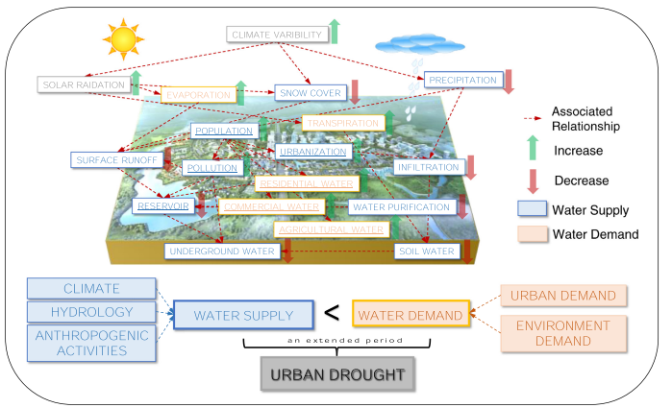
Figure 1: Water shortage process in urban areas
(Source: Zhang et al. 2019)
According to Zhang et al. 2019, in the 21st century, various cities in the entire world have faced difficulties related to the water shortage. Some parts of the United Kingdom are also present in this list. The shortage of water produces a large amount of problems in the United Kingdom. Organic farming uses mainly the water that is collected by rain (Zhang et al. 2019). The yield of crops decreases if a not appropriate amount of water is not given to the plants. Water shortage has an impact on the pest control process. Various other problems are also generated by the water shortage. These problems need to be resolved to create a smooth organic farming process.
Issues related to soil health in organic farming
According to Cooper et al. 2020, the government of the United Kingdom has declared a platform that can be used to measure different kinds of soil and water pollution levels. Throughout this paper, the researcher has discussed different kinds of soil health-related issues that are present in the United Kingdom. 324 soil samples from different locations have been collected in this research work (Cooper et al. 2020). These samples are analysed in this research work with the help of different methods. The result of these experiments demonstrates different factors that are affecting the soil health of East England. The researchers discussed various issues related to soil health in this article. The author described the nutrient imbalance in the soil samples. Organic farming does not include any kind of artificial compost. If the soil contains a low amount of nutrients it does not create any benefits in the organic farming process. Also, the researcher found a low amount of microbial diversity in the soil sample. The organic farming process involves a high percentage of microbial communities in the soil. A low amount of microbial diversity in the soil sample can cause difficulties in the organic farming process [Referred to appendix 1].

Creation of sustainability by organic farming
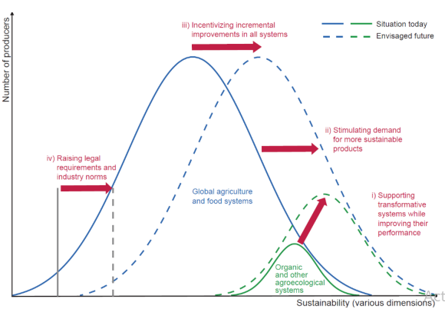
Figure 2: Food policy intervention to create sustainability
(Source: Eyhorn et al. 2019)
According to Eyhorn et al. 2019, different kinds of agriculture policies create a large impact on the process of organic farming. These policies have also a large impact on the sustainable food system in the entire world. The researcher mentioned four different policies that are used in the transition of the food system. Sustainability can be created with the help of organic farming (Eyhorn et al. 2019). The process of organic farming is an environment-friendly method that requires some eco-friendly process. After the implementation of different methods for example “Chemical free agriculture”, and “water conservation” one can create a good organic farming process. The organic farming process includes less amount of energy compared to the inorganic farming process. It decreases the use of high energy-consuming methods. By decreasing the high energy use farmers can create sustainability from the environmental point of view.

3.0 Application of organic farming to the hotel and hospitality sector of East Anglia
Organic farming is becoming an important agricultural practice that has had many good impacts on the hotel and hospitality industries in developed countries with a focus on food and beverage management. This approach focuses mainly on the theme of environmental responsibility and health consciousness (Eyhorn et al. 2019). Some areas of the hotel and hospital industries where the application of organic farming is prominent like in restaurants and dine-out services. In East Angela organic farming has different types of positive impacts on the hotel and hospitality industry (Kushwah et al. 2019). This organic farming procedure has a huge level of biodiversity, improves soil health and reduces water pollution in East Anglia. This farming procedure provides a large number of social and economic benefits that support local economies and create job opportunities (Lazaroiu et al. 2019). A study by the Game & Wildlife Conservation Trust found that organic farming tends to biodiversity in East Anglia by a large amount (Lee et al. 2019). Organic agricultural practices like crop rotation and composting help to improve soil quality in East Anglia because organic soils are rich in organic matter and contain more nutritive value that also increases water retention quality. Water pollution can be reduced by organic farming in this particular area because organic farming does not use any chemical pesticides and fertiliser for the nourishment of crops. Organic farming supports the local economy and enhances job opportunities in this area.
There are some issues like climate change and availability of water are two factors which are problematic issues of Organic farming in East Anglia (Murmu et al. 2022). In the case of climate change, Droughts are a big issue for organic farming. Climate change is responsible for the drought which is more frequent and severe in East Anglia. It is a very difficult condition for the cultivation of crops during droughts (Parizad and Bera, 2023). Climate change also tends to flood East Anglia; this can damage crops and soil and make it difficult for organic agriculture.
Water is another significant issue for the organic farming procedure in East Anglia. This region has limited resources of water and due to frequent droughts shortage of water is a big issue in this region (Krausmann and Langthaler, 2019). This condition makes organic farming more difficult for growing crops in an organic process and maintaining water supply for livestock.
There is a combined impact of climate change and water is making the situation very difficult for the farmers for organic farming in the East Anglia region (Piñeiro et al. 2020). Many organic farmers are suffering already to cope with the challenging conditions of climate change and water availability issues.

4.0 Evaluation of future policy and management options dealing with the issue
The process of organic farming in the East Anglia region of the UK’s hotel and hospitality sector defines both challenges and opportunities in relation to the sustainable theme which is contemporary (Popa et al. 2019). Evaluating the future policies and management options for dealing with issues like weather change and water supply in the East Anglia region of the UK requires a detailed management policy. It will define the impact of organic farming in the hotel and hospitality sector.
This East Anglia region of the UK which is known for its productivity in agricultural field face many challenges because of climate change. So to overcome those some future policies and management options can be taken (Rosati et al. 2021). The first one among them is sustaining water management. This particular region faces droughts from time to time, which not only affect the agriculture but also the hospitality sector. So, if the implementation of different sustainable water can be done then it may help the farmers in adaptation to different water-efficient techniques (Serrano-Baena et al. 2020). Sustainable water management includes harvesting of rainwater, improvements of irrigation efficiency and recycling of water.
The second one is the diversity of crops and resilience. The region’s agricultural resilience can be increased by the prominence of organic farming on the diversity of crop rotations and reduced synthetic inputs reliance (Siltaoja et al. 2020). The diversity of the crops should be encouraged by the policies which can influence the effect of extreme weather changes on yields. This helps to ensure a steady supply of freshly produced products to the hospitality sector and hotels.
Third is the evaluation procedure including transparency in the supply chain. The government can introduce new rules which may require disclosing of the organic ingredient sources by the hotels and health sector (Smith et al. 2019). Investment in supply chain management should be done by the hotels that provide them visibility and traceability in real-time. This strengthens the commitment to the sustainability of organic farming and also ensures the claims are verifiable.
Fourth is the adaptation to climate change by the hospitality sector and hotels in the East Anglia region of the UK (Werner et al. 2019). The changes in the weather should be adopted by the hospitality sector by implementing technologies like energy-efficient technology, and strategies including waste reduction. These policies mainly involve organic and local products. This not only decreases their footprint in environmental factors but is also connected with the preferences of the consumers for practices in sustainability.
The last one is about the infrastructure of climate-resilient. To identify the extreme weather changes the government of the UK should invest more in the infrastructure of climate-resilient areas in the East Anglia region. This infrastructure includes defences to flood and some drainage systems (Fahad et al. 2021). This particular factor not only helps to protect the farmland but also ensures that the hospital sectors can continue their businesses with organic farming even in extremely bad weather conditions. Also promoting transportation which are eco-friendly like electric buses and encouraging the effect of carbon helps to diminish the footprint of carbon in the hospitality and hotel sectors.

5.0 Conclusion
The use of organic farming has created huge effects in the hotels and hospitality sector of the East Anglia part of the United Kingdom. These hotels develop different kinds of methods related to organic farming that produce a good impact on the environment and climate. In this entire research work, different impacts of organic farming have been discussed in the hotel and hospitality sector of the East Anglia state. Various future management policies are also discussed that can be implemented by the hotels of East Anglia. After the implementation of the organic farming method, these hotels and the hospitality sector of East Anglia developed remarkably.

6.0 Recommendation
The environment of East Anglia region contains mountains and have low water resources. It is very difficult to use the conventional method of farming in this area as it is very costly. The use of organic farming in this region will help the hotels to grow food with these less resources. Different kinds of sustainable water management techniques can be used by the hotels of East Anglia. They can improve their food quality with the help of organic farming as this process creates fresh and healthy foods. These hotels can also use the method of greenhouse farming to deal with extreme weather conditions. The method of organic farming has created a large impact on the hotel industry of the East Anglia region. They can improve this technique in various ways to create an environment friendly image.

Reference List
Adewale, C., Reganold, J.P., Higgins, S., Evans, R.D. and Carpenter-Boggs, L., 2019. Agricultural carbon footprint is farm specific: Case study of two organic farms. Journal of Cleaner Production, 229, pp.795-805.
Bressan, A. and Pedrini, M., 2020. Exploring sustainable-oriented innovation within micro and small tourism firms. Tourism Planning & Development, 17(5), pp.497-514.
Clark, S., 2020. Organic farming and climate change: The need for innovation. Sustainability, 12(17), p.7012.
Cooper, R.J., Hama-Aziz, Z.Q., Hiscock, K.M., Lovett, A.A., Vrain, E., Dugdale, S.J., Sünnenberg, G., Dockerty, T., Hovesen, P. and Noble, L., 2020. Conservation tillage and soil health: Lessons from a 5-year UK farm trial (2013–2018). Soil and Tillage Research, 202, p.104648.
Diacono, M., Persiani, A., Testani, E., Montemurro, F. and Ciaccia, C., 2019. Recycling agricultural wastes and by-products in organic farming: Biofertilizer production, yield performance and carbon footprint analysis. Sustainability, 11(14), p.3824.
Durán-Lara, E.F., Valderrama, A. and Marican, A., 2020. Natural organic compounds for application in organic farming. Agriculture, 10(2), p.41.
Eyhorn, F., Muller, A., Reganold, J.P., Frison, E., Herren, H.R., Luttikholt, L., Mueller, A., Sanders, J., Scialabba, N.E.H., Seufert, V. and Smith, P., 2019. Sustainability in global agriculture driven by organic farming. Nature sustainability, 2(4), pp.253-255.
Fahad, S., Sonmez, O., Saud, S., Wang, D., Wu, C., Adnan, M. and Turan, V. eds., 2021. Sustainable soil and land management and climate change. CRC Press.
Khatter, A., 2023. Challenges and Solutions for Environmental Sustainability in the Hospitality Sector. Sustainability, 15(15), p.11491.
Krausmann, F. and Langthaler, E., 2019. Food regimes and their trade links: A socio-ecological perspective. Ecological Economics, 160, pp.87-95.
Kushwah, S., Dhir, A. and Sagar, M., 2019. Ethical consumption intentions and choice behavior towards organic food. Moderation role of buying and environmental concerns. Journal of Cleaner Production, 236, p.117519.
Lazaroiu, G., Andronie, M., Uţă, C. and Hurloiu, I., 2019. Trust management in organic agriculture: sustainable consumption behavior, environmentally conscious purchase intention, and healthy food choices. Frontiers in Public Health, 7, p.340.
Lee, T.H., Fu, C.J. and Chen, Y.Y., 2019. Trust factors for organic foods: consumer buying behavior. British Food Journal, 122(2), pp.414-431.
Mendon, S., Salins, M. and Aithal, P.S., 2019. Emerging Trends in Sustainability of Organic Farming and its Impact on Purchase Intention-a Review & Research Agenda. SCHOLEDGE International Journal of Management & Development, 6(7), pp.98-120.
Murmu, K., Das, P., Sarkar, A. and Bandopadhyay, P., 2022. Organic agriculture: as a climate change adaptation and mitigation strategy. Zeichen J, 8(3), pp.171-187.
Parizad, S. and Bera, S., 2023. The effect of organic farming on water reusability, sustainable ecosystem, and food toxicity. Environmental Science and Pollution Research, 30(28), pp.71665-71676.
Piñeiro, V., Arias, J., Dürr, J., Elverdin, P., Ibáñez, A.M., Kinengyere, A., Opazo, C.M., Owoo, N., Page, J.R., Prager, S.D. and Torero, M., 2020. A scoping review on incentives for adoption of sustainable agricultural practices and their outcomes. Nature Sustainability, 3(10), pp.809-820.
Popa, M.E., Mitelut, A.C., Popa, E.E., Stan, A. and Popa, V.I., 2019. Organic foods contribution to nutritional quality and value. Trends in Food Science & Technology, 84, pp.15-18.
Rosati, A., Borek, R. and Canali, S., 2021. Agroforestry and organic agriculture. Agroforestry Systems, 95, pp.805-821.
Serrano-Baena, M.M., Triviño-Tarradas, P., Ruiz-Díaz, C. and Hidalgo Fernández, R.E., 2020. Implications of BREEAM sustainability assessment on the design of hotels. Sustainability, 12(16), p.6550.
Siltaoja, M., Lähdesmaki, M., Granqvist, N., Kurki, S., Puska, P. and Luomala, H., 2020. The dynamics of (de) stigmatization: Boundary construction in the nascent category of organic farming. Organization Studies, 41(7), pp.993-1018.
Smith, L.G., Kirk, G.J., Jones, P.J. and Williams, A.G., 2019. The greenhouse gas impacts of converting food production in England and Wales to organic methods. Nature communications, 10(1), p.4641.
Werner, S., Lemos, S.R., McLeod, A., Halstead, J.M., Gabe, T., Huang, J.C., Liang, C.L., Shi, W., Harris, L. and McConnon, J., 2019. Prospects for New England agriculture: farm to fork. Agricultural and resource economics review, 48(3), pp.473-504.
Xu, L., Mohammad, S.J., Nawaz, N., Samad, S., Ahmad, N. and Comite, U., 2022. The role of CSR for de-carbonization of hospitality sector through employees: A leadership perspective. Sustainability, 14(9), p.5365.
Zhang, X., Chen, N., Sheng, H., Ip, C., Yang, L., Chen, Y., Sang, Z., Tadesse, T., Lim, T.P.Y., Rajabifard, A. and Bueti, C., 2019. Urban drought challenge to 2030 sustainable development goals. Science of the Total Environment, 693, p.133536.

Appendices
Appendix 1: Features of Healthy soils
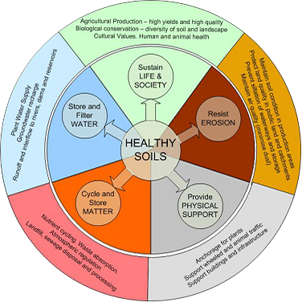
(Source: https://www.keralasoilfertility.net/en/soil_health_management.jsp)

