
Module Assignment Submission

Student Name: | Christy Leigh Mainwaring
Student Number: | 2006764
Module Code: | BMSK5001
Module Title: | Developing Workplace Critical Thinking

Statement of Confirmation of Authenticity
By the act of making this submission, the student declares that this is the work of the student named above. The work has not, in whole or in part, been knowingly presented elsewhere for assessment, or where assessment has been built on a previous assessment, this has been identified. Where materials have been used from other sources it has been properly acknowledged. If this statement is untrue, the student acknowledges that an assessment offence has been committed.
Attention is drawn to the plagiarism and unfair practice policies of the University.

Table of Contents
Introduction 3
Section 1 3
Section 2 3
Section 3 3
Section 4 4
Conclusion 4
References 5
Appendix 1 6
Appendix 2 7

Introduction

This report will demonstrate on all three of these elements, which are our attitudes, values and beliefs. How different management styles can affect these elements. We are always critically analysing our behaviour and actions, and this is certainly true when applied to our workplaces. We can critically analyse different theorists on how well their theories can be put in context to the workplace through this assessment.
We are all born in this world as blank slates. We then grow older and go to schools and learn from our teachers. Then progressing to our own careers. During the process of growing up, we all blend our beliefs, attitudes and values. All of which are vital for us to become successful. Theorists such as (Goleman, E. 1996) has assessed that all workplace behaviour stems from our development in schools. He states that we gain a EQ (emotional intelligence) through learning classroom behaviours, and as we develop in life, we apply such behaviours in our workplaces.
I will be applying the values, attitudes and beliefs in this report to my own workplace. The pandemic has affected many on how they work, and how they feel around their workplaces. Working in the tourist and hospitality industry has been a challenge the last two years. To now further scope how critical thinking has also affected my workplace will be insightful to how managers can understand their staff.

Section 1 – Critically assess the impact of beliefs, attitudes, and values on your own workplace behaviour. -Bliefs

“Something that is accepted, considered to be true, or held as an opinion: something believed” is what a belief is according to Merriam-Webster.
Beliefs can be anything, it is all based on how the person perceives a topic, or something greater, such as religion arguably. An article written by World Population Review states that in 2020 that 85% of the world population follows some sort of religion. 2.38 billion of the worlds follows Christianity.
“For some of our most important beliefs, we have no evidence at all, except that people we love, and trust hold these beliefs.” (Nobel L, D Kahneman 2002).

Working for the National Botanical Garden of Wales (NBGOW) is brilliant as no two days are the same. NBGOW is a tourist attraction that brings in thousands of people all around the world in to observe the beauty we have on offer. As a company we always strive on creating impact on visitors of the importance of the botanic gardens. We have nine different departments. We all rely on each other to ensure the success of the Botanic Gardens.

In my department we consist of 25 fantastic and individual people. All with different talents and capabilities. Each one of us have different beliefs, whether it be religion or other cultural differences. When the pandemic first hit us a few years ago, the system broke down as everyone had to be sent home and put on furlough. Understanding and dealing with everyone’s workplace behaviour is valuing their own beliefs around working with covid restrictions. Everyone has a right to working safely, and workplaces should implement any changes that need to be addressed immanently.
“People are part of a system; they need help… Many people think of machinery and data processing when I mention system.” (Deming, 1982). During the challenge of the pandemic, a lot of changes had to be made. Many having to work from home, and many having to be put on furlough until it was safe to come back to work.

(HMRC) conducted interviews with businesses on how Covid has impacted their workplace behaviour. 1,650,000 employees were put on furlough until the business would be deemed safe to come back to. National Statistics released from the government that only 26% of people were put on furlough (Davies et Al 2021). With everyone losing contact and their purpose, management would question how they would feel about coming back to work with restrictions put in place. Working in the hospitality, many changes were made to ensure safety to the public and staff.

Workplace beliefs would have altered as new procedures would have to be put in place to follow government guidelines. Anxiety levels would rise from certain “venerable” staff members, due to ill health or underlying health conditions. 41% workers said that they were not comfortable around how restrictions were lifted and were not happy to return to work due to anxiety (HR and people, 2022). With such a vast amount of people not happy around returning to work, mangers need to consider mental health and their staffs general well-being more to consider a happier and more successful workplace.

Deming makes it clear that “The system must be stated by management. Without an aim, there is no system”. Management had to alter the way they work, and how they also deal with their staff members. “Cultures, too, need to change over time, as the tasks change, as the organizations grows, or as people change” (Handy, C 1978, p5). Handy recognises that during time, tasks need to change, our change was due to Covid-19. Change can sometimes cause tension. Handy uses this terminology to concept change between employees and managers. Handy’s organizational theory can be an advantage for managers to seek out the variables in a situation, the outcome in the variables and to select the ones that would be of great use to the system.
To ensure that everyone was happy with change of workplace variables, such as social distancing, and to follow sufficient procedures regarding covid-19 restrictions was to ensure that everyone’s workplace beliefs were considered.

Beliefs change the systems behaviour over time as Belbin once said, “The types of behaviour in which people engage are infinite. But the range of useful behaviours, which make an effective contribution of team performance, is infinite. These behaviours are grouped into a set number of related clusters, to which the term ‘team role’ is applied”, (Belbin, M 1981).

To understand the way the system worked well during the pandemic, is to value everyone’s beliefs. Behaviour’s will always change during the ever-changing rules around covid-19.

Section 2 – Values and the impact on my workplace behaviour.

“To rate or scale in usefulness, importance, or general worth” is what a value defined as. Everyone on this planet has its own values. Other values might be stronger than other values, e.g., God is above all. However, some might say that God is important to them, but their other values come first.

Every company have their own values. NBGOW have written the core set of values that they implement in their working practise. As a company, everyone must follow these guidelines as this is what the company endorses.

NBGOW values are as followed:
- Contribute to the economic, social, environmental and cultural well-being of Wales for future generations.
- Advocate for and champion environmental conservation and sustainable practices.
- Promote and develop biodiversity conservation in Wales and internationally, through partnerships and in consultation with national and international organisations.
- Strive to communicate and engage with a wide diversity of audiences.
- Through internationally recognised accreditation (e.g., BGCI) demonstrate implementation of the highest standards of research and conservation practice.

In the NBGOW, we seek friendly and open-minded people who wish to learn new and exciting skills. One of the key values they enforce is progressing and learning new skills through the education system they have there to offer. All the department in the botanic gardens have a variety of courses that are on offer.
One of the key elements to offer employees is the value of learning. Learning can come in all shapes and forms to the variety of options they have. “Thinking is the ultimate human resource. Yet we can never be satisfied with our most important skill. No matter how good we become, we should always want to be better” (De Bono, E 1985, p5).
De Bono likes to use a creative approach towards critical thinking within the workplace. In the hospitality department of the botanical gardens, De Bono’s theory is applied as it increases in employees to think laterally. This increases management to implement training days for staff as the need to improve new skills are there, thus ensuring that the values are met between staff and managers.
Another theorist that intertwines with De Bono’s theory is Deming’s theory of Total Quality of Management (1939). Deming stated that in order to create quality management, that the continuous improvement of a team is what drives it to become successful. In this philosophy he created the key 14 points of management, which are as followed:
- Create constancy of purpose
- Adopt new philosophy of quality
- Cease dependence on final inspection
- Consider total cost, not just initial price
- Find problems, improve constantly
- Institute on the job training
- Institute leadership across the organisation
- Drive out fear
- Break down communication barriers between units
- Eliminate slogans, targets, exhortations for workers
- Eliminate numerical goals
- Encourage pride of workmanship
- Encourage education and self-improvement
- Take actions needed to make transformation

Deming’s 14 points is a critical way to assess my own workplace values. It is vital for my team to understand that they are important to the business. Quality can be applied to a lot of factors in my team, such as customer service, and the quality of food that we serve to the general public. In order to strive for quality, we also need to think of the inspections we could take on as a team. Environmental health (HO) could always scope the way we work, and how things can change in order to be more sufficient. As we are such a large team, working independently is required a lot of the time, so the team will always be prepared to carry out the best service possible.

To value the need of wanting to self-improve one’s education is a strong power move for any organisation. The last two years have proved to be quite a challenge when it came to organisations implementing training courses. Due to the pandemic, many had to work and develop these such skills digitally. During the lockdown, as a department, we sent all 25 members of staff on online courses to improve digital skills on till systems, and a virtual coffee training course, which proved to be a challenge for some. A study created by the department of education (DfE) stated that workers are not fully proficient in their roles in 2019. Rounding up those 1.25 million workers in the U.K are not working to their best potential. They also revealed that workplace training has hit its lowest level in 2019, making 61% of workplaces offering on the job training to their staff. Offering new incentives such as training days can improve productivity and workplace efficiency, ensuring that staff members are seen as valued part of their workplace community.
For a company to implement on the job training, it can decrease staff absences. It costs the U.K £29 billion in absences according to a report written by Employee Benefits (2018). To increase staff training, this will help not just the originations, but also how staff members feel about their own self-confidence and abilities in the workplace.

Attitude in the Workplace.

“A feeling or an emotion toward a fact of state” is what an attitude is defined as. Behind beliefs and values, you will find attitudes behind the story of them. The story being the people that work for these beliefs and values.

NBGOW have values and their own beliefs. However, do employees all share the same attitudes? Most likely not as we all have different ways of observing certain topics.

The attitude of employees differs so greatly that certain element of their workplace can play a part of how they feel in their workspace. Elements such as COIVD-19. When the pandemic hit, many had to turn to working from home. The tourist industry was affected greatly as no one was allowed to leave their homes for such a long period of time. This would have a detrimental effect on how their companies would have worked. According to an article written by (BMC 2021) 30% of employees reported that their work and private life worsened.
These impacts have a domino effect, starting from the managers down to all staff members. All staff have their own stories. Due to the pandemic, many had a change of heart on how their working life looked like. With many being put on furlough or having to work from home, their attitudes altered. 25 of the staff in our team, two mangers opted to work from home, 6 decided to reduce their working hours down to part time. Due to private lives worsening, many decided to focus on improving home lives and focus on things that are outside of work. A report conducted by CIPD (2020) state that:
- 32% of employees that are returning to workplaces are anxious about catching or spreading Covid-19 in work.
- 62% felt that not enough consultation was made adequately for returning to their workplace.

As a good manager, we need to consider all employees feelings and attitudes seriously. (Handy, C. 1976) focuses on organisational culture. He splits these cultures in four categories: power, task culture, person culture and role culture.
Within person culture this stems to how an individual feels around working and their own attitudes. Handy impalements that person culture is where they believe themselves to be better than the organisation. Some have different attitudes to working from home in my workplace, they can perceive it to be ‘lazy’ and ‘impracticable’, but it can also create beneficial conflict, as with that manager working from home, they feel less anxious and more productive, making the team work better together.
Handy’s way of observing workplace culture, self reflects on the way my own biased opinion can change during employees’ attitudes. I must use my power culture to remind the team of what is expected from the team, otherwise employees’ attitudes could turn sour.
To value how my team feel during these times, taps into Handy’s focus on how organisational culture changes over time, and how managers need to change with current time, but also to observe other perspectives such as Goleman’s theory on emotional intelligence to emotional engage well with my team.

Section 4- Apply the critical assessment of an appropriate management theory to evaluate how someone with different beliefs, attitudes and values might interpret the theory differently.

Beliefs, attitudes and values of NBGOW blend altogether in their own individual ways. All nine department strive to achieve and work towards the business plan they have put in place.
The gardens have altogether four hospitality sections. All with their own individual set of targets and standards to meet the managers goals. As the NBGOW are a relatively large company, we do like to consider ourselves a continuously learning and diverse company.

Deming used to always refer the relationship between manager and worker as the teacher and student. The teacher will always give an aim, and the student would have to conclude a solution to the aim. We have learned the way the system works through our early childhood experiences that we always aim to please. This then is adapted when we grow into our careers. To maintain quality management, (Deming, 1950) created the PDCA cycle, (attached on appendix A).

With the pandemic hitting us, we were always ever revolving our PDCA cycle. For example, in our team:
- Plan- Always plan of ever-changing rules and regulations with regards to covid within the team.
- Do- test potential solutions and see what ones work or don’t work.
- Check- check within the team if it is the best solution for our goal. Gather evidence from customers if they feel satisfied.
- Act- Implement the best solution.
Deming highlights that management can tend to look at the end goal, and never the whole process of how they managed to achieve the goal. Deming called this as “retroactive management”. “Recognition of the distinction between a stable system and an unstable system is vital for management” (Walton, M 1986, p12).
To make staff members understand that they are performing well we take annual reviews. With the pandemic in effect managers felt like reviews needed to happen more often. Twice a year in fact. During staff reviews, it makes the member of staff touch base on their emotional intelligence. Goleman’s theory applies to this critical thinking process. Goleman has split the emotional intelligent components into four categories, which are:
- Self-Awareness
- When moods are changed, this can also reflect in the workplace. Bad decisions can happen, and mistakes can occur due to this factor.

- Self-regulation
- When the individual self-reflects their mood in the workplace, this can challenge the conflict that occurs, and creates the person to be more approachable during problem solving matters.
- Motivation
- Motivation in the workplace is what we all strive to have. Not to have the job as just financial gain, but self-gratification that you’re doing this for yourself.

- Empathy
- An empath in the workplace is a great advantage. Empathy can be portrayed through body language and verbal language of course. To have a mutual understanding between manager and employee can differ between good working practise, and excellent working practise.

- Social skills
- Excellent communication is vital for a team to be successful. Without communication the team would fail.
(Goleman, 1996) focuses on how well the cognitive mind works, while Deming focuses on how to work sufficiently and orderly. Both can be applied well in the context on working in the NBGOW. Both theories blended causes staff to think analytically and creatively towards their beliefs, attitudes and values.
Goleman’s emotional view on social skills highlight on how well the team can work together during the pandemic. Working well together is what we aim to do, day in, day out. Without verbal discussions of how well we performed can leave staff members to feel isolated. Deming’s PDCA cycle can redirect lost thoughts that staff members might have.
Observing my own workplace critical thinking, the pandemic has hit us all. I can apply both Deming and Goleman’s theory to my own workplace. To be open and understanding of everyone’s needs was vital for my staff to perform at their best. I had to observe and consider everyone’s values around covid restrictions around their own attitudes towards this issue. Due to working in such a face forward career, many staff did have to self-isolate due to covid guidelines. Thus, creating more stress on management, staff, and higher up the system, HR. With staff members worrying whether they will get furlough pay again due to more lockdowns, it created even more underlying stresses for the team. (Maslow, A 1943) hierarchy of needs reflects on how workplace behaviour could alter due to changes such as the pandemic. Maslow’s pyramid of needs can alter at any time depending on any individual circumstances. (attached in Appendix 2).
To be sufficient in my role as a team leader, I need to understand that the needs of my team change over time. To be open around how everyone’s beliefs, values and attitudes differ is how a great team works. I also need to understand and apply the gardens beliefs, attitudes and values into my own work. As we all have different goals in each department, we all underpin as a system that works for the same aim. The business plan for the botanic gardens attached in (appendix 1).
With such a large team, they all have different beliefs in what they want from the company. Some are solely focused on financial gain and leave it at that. With myself, and another member of the botanic gardens deciding and believing that we can have a higher education, it has given us the confidence in becoming better team leaders.
With gaining a wealth of knowledge from quality management (Deming 1939), Deming has underlined that we as managers need to “create constancy of purpose”. A lack of purpose in any career makes employees seek to find purpose in other places. In any business plan, we seek out what we expect from employees. Without the team there aiming to reach for these goals, there wouldn’t be a success story.
In being empathetic and motivational (Goleman, 1996) to the team, it underpins how a good manager works with their team. A management style that works in harmony with this is the paternal manager. Many of us spend more time in work, than what we do at home with our families. I treat my staff how I would like to be treated as a person. Thus, creating good relationships with my staff, and knowing that they all trust my guidance is rewarding.
However, this can impact the way the team works. We employ more staff during peak times in the summer, and they go back in the autumn to continue their educational studies. As we have little time to know their values, attitudes and beliefs, it is hard to ground a solid work relationship with them. With such a large team, all of us bring different varieties of management that makes the team harmonise well.

Conclusion
To conclude this report on critical thinking, values, beliefs and attitudes all underpin how a workplace works. With theories from (Goleman, 1996) (Deming, 1982) and (Handy, 1978) support the understanding of how the critical thinking attributes go hand in hand with each other. However, not all the theories can be applied to workplaces as they do not support their values, attitudes and beliefs.

References

Belbin, M (1981) The Nine Belbin Team Roles {online source} (accessed on 6/03/2022) https://www.belbin.com/about/belbin-team-roles
CIPD (2020) Impact of COVID-19 on working lives {online source} (accessed on 12/032022) https://www.cipd.co.uk/knowledge/work/trends/goodwork/covid-impact#gref
Davies, E (2021) {online article} An Overview of workers who were furloughed in the UK: October 2021. https://www.ons.gov.uk/employmentandlabourmarket/peopleinwork/employmentandemployeetypes/articles/anoverviewofworkerswhowerefurloughedintheuk/october2021 (accessed on 22/03/22)
De, Bono, E (1985) Six Thinking Hats {online book} (accessed on 8/03/2022)
Deming, E.W. (1982) Out of the Crisis {book} (accessed on 28/02/2022)
Employee Benefits (2018) Reducing absenteeism in the workplace {online article} (accessed on 13/03/2022) https://employeebenefits.co.uk/reducing-absenteeism-workplace/
Goleman, D (1996) Emotional intelligence: why it can matter more than IQ by Daniel Goleman {online book} (accessed on 3/03/2022)
Handy, C (1978) Gods of Management: The Changing work of organizations {book] (accessed on 20/02/2022)
HR and People {online article} 41% of workers anxious to return to workplace environment https://businessnewswales.com/41-are-anxious-to-return-to-a-workplace-environment/ (accessed on 23/03/22)
https://www.merriam-webster.com/dictionary/belief
https://www.ons.gov.uk/businessindustryandtrade/business/activitysizeandlocation/articles/coronavirusanditsimpactonukhospitality/january2020tojune2021
Maslow, A (1943) A theory of Human Motivation {online book} (accessed on 11/03/2022)
NBGOW (2022) The Gardens Mission {online source} (accessed on 7/03/2022) https://botanicgarden.wales/about-the-garden/mission/
Owens, J (2020) More than one million employees not “fully proficient” at their roles, government stats reveal {online blog} (accessed on 12/03/2022) https://www.peoplemanagement.co.uk/news/articles/more-than-one-million-employees-not-fully-proficient-roles-government-figures-show#gref
R, Lewis (2018) What is a belief? And why is it so hard to change? {online article} (accessed on 29/02/22)
Ramuni, L (2021) Hospitality Furlough statistics {online source} (accessed on 11/03/22)
Tušl, M Et al (2021) Impact of the COVID-19 crisis on work and private life, mental well-being and self-rated health in German and Swiss employees: a cross sectional survey {online article} (accessed on 9/03/2022)
Wallbridge, A (2021) Daniel Goleman’s emotional intelligence in leadership: How to improve motivation in your team {online article} (accessed on 11/03/2022) https://www.tsw.co.uk/blog/leadership-and-management/daniel-goleman-emotional-intelligence/
Walton, M (1986) The DEMING Management Method {online book} (accessed on 11/03/2022)
World Population Review (2020) {online article} (accessed on 19/02/2022) https://worldpopulationreview.com/country-rankings/religion-by-country

Appendix A- PDCA Cycle (Deming, 1982)
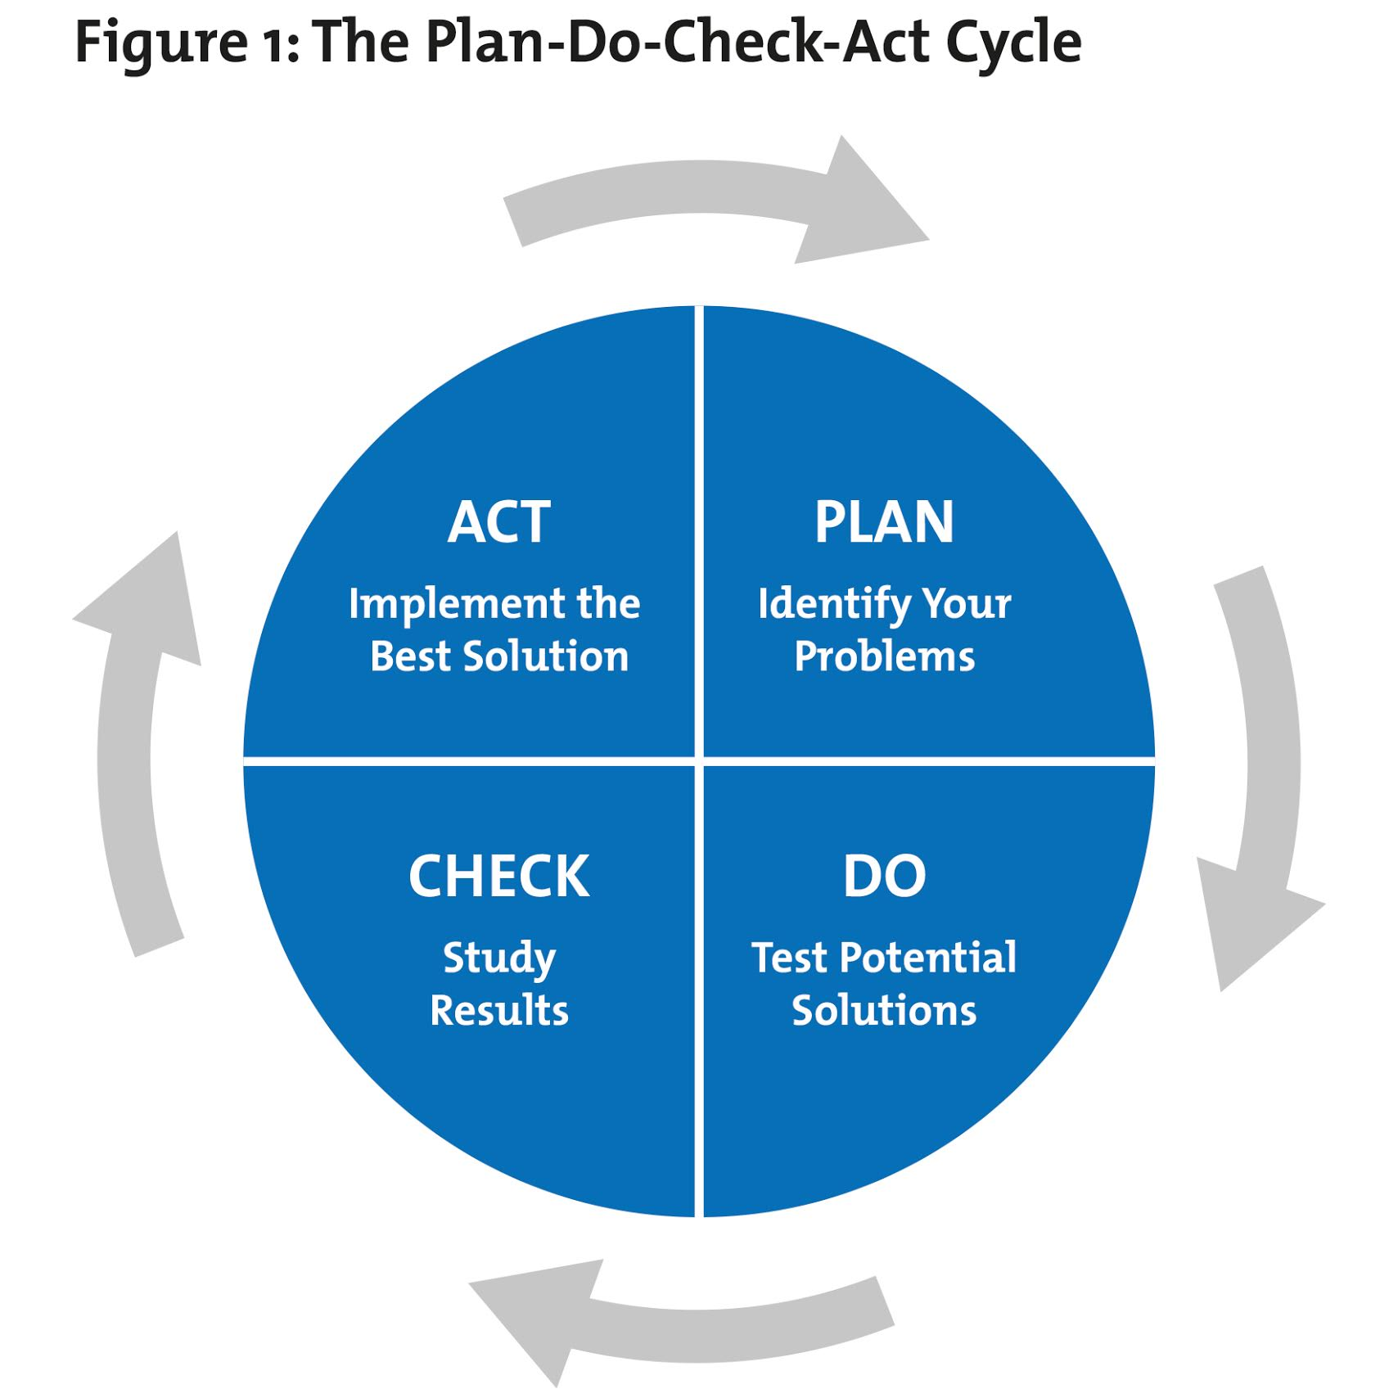

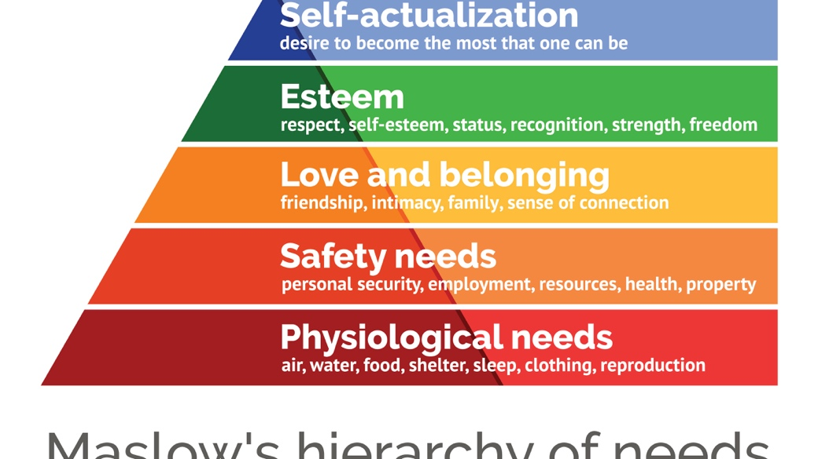
Appendix 2 – (Maslow Hierarchy of Needs, 1943)

