ACDB 4011: TITRATION
POTENTIAL HAZARD:
Chemical | Hazards
Hydrochloric acid solution  (0.1 M HCl) |   Irritant to the eyes and skin.
Sodium hydroxide solution  (0.1 M NaOH) | Irritant to the eyes and skin.
Phenolphthalein |  May cause genetic defects/ cancer/damage fertility or the unborn child; causes damages to organs/through prolonged or repeated exposure.

TITRATION GLOSSARY:
Terms you will need to be familiar with in order to understand a discussion of titration are:
titration: a technique used to measure the volume of a solution of known concentration that is required to react with a measured amount (mass or volume) of an unknown substance in solution. burette: a piece of calibrated glassware used to measure volume; a graduated glass tube about 40 cm long with a stopcock on one end. The volume measurement is made by reading the fluid level in the burette before and after the titrant, the fluid in the burette, is dispensed through the stopcock.
standard solution: a solution of exactly known concentration.
unknown: a substance or a mixture about which something is not known.
indicator: a substance which is added to the reaction system in small amounts; it indicates that the reaction is complete (has reached the endpoint) by changing colour.
endpoint: the stage in the titration at which the indicator colour change is observed, indicating that the reaction is complete.
equivalence point: point in titration at which the amount of standard solution added is just enough to completely neutralize the unknown solution.
meniscus: concave line of liquid at the top of the container.

AIM OF THE EXPERIMENT:
This experiment aims to accurately determine the concentration of an unknown sample of hydrochloric acid, HCl, by reacting it with a standard solution of sodium hydroxide, NaOH (base) using an analytical technique called titration.
THEORY:
A type of titration in which an acid and a base react to produce salt and water is called a neutralisation reaction (equation 1):
HCl (aq) + NaOH (aq) ---------- > NaCl (aq) + H₂O (l) (1)
The (aq) means that HCl and NaOH are dissolved (broken into ions) in water. (l) stands for liquid. Two products of this reaction are NaCl (sodium chloride dissolved in water), known as table salt and water. This neutralisation reaction can be written as a NET IONIC equation (2):
H⁺(aq) + OH⁻ (aq) ----------> H₂O(l) (2)
The titration proceeds until the equivalence point is reached, at which the number of moles of acid (H⁺) is equal to the number of moles of base (OH⁻). The moles of acid and base are related by the stoichiometry of the balanced equation. This equivalence point can be determined by observing a colour change in an added indicator. The moment when the colour of the indicator changes is called the endpoint.
In a titration, the standard solution (one with precisely known concentration) is in a burette, which is a piece of glassware used to accurately measure the volume of the solution. The solution that is titrated (of unknown concentration, but the volume is accurately measured with pipette) is in an Erlenmeyer (conical) flask. The schematic representation of the experimental setup is shown in the picture below (a). Examples of various types of pipettes are shown in figure (b).
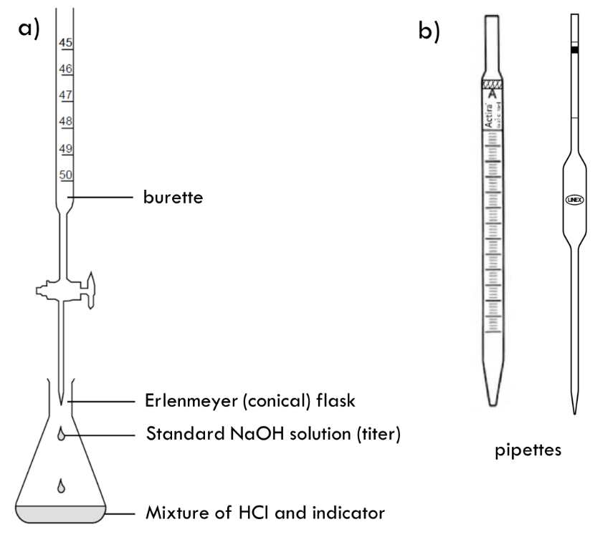
With burette and pipette the volumes are measured very precisely. The precision is ± 0.05 mL (½ of the marking on the glassware). Be sure you are reading volumes properly, from the bottom of the meniscus (see the picture below), at the level of your eyes.
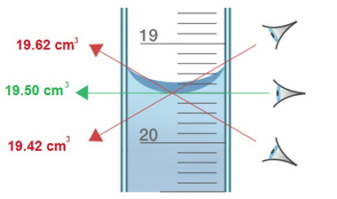

The acid is typically added to the Erlenmeyer flask in a specific volume measured very precisely with the pipette.
WHAT IS AN INDICATOR AND WHAT IS IT USED FOR?
An indicator is any substance in solution that changes its colour as it reacts with either an acid or a base. Indicators are either weak acids or weak bases, often with complex chemical structures, that exhibit one colour when in acidic form, and another colour when in basic form. A common indicator used in neutralisation reactions is phenolphthalein which in an acidic solution is colourless but turns pink when the solution becomes basic.
CALCULATIONS:
At the point when the indicator changes colour (also called the endpoint) and from the net ionic equation given above, we can see that the moles of H⁺ equal the moles of OH⁻. From the molecular chemical equation (1), we also see that the number of moles of HCl equals the number of moles of NaOH at the endpoint.
moles H⁺ = moles OH⁻
moles acid (n_{A}) = moles base (n_{B})
The equation for molarity, M = n / v can be solved for n (number of moles) and we can write:
M_{A}V_{A} = M_{B}V_{B}
where M_{B} is the molarity of the standard base solution, V_{B} is the volume of the base solution used to neutralise the acid, V_{A} is the volume of acid in the conical flask and M_{A} is the concentration of acid that must be calculated.

PROCEDURE
Put on the lab coat, safety goggles, and gloves. Make sure that long hair is tied.
In this experiment, you will perform at least three titrations of hydrochloric acid with sodium hydroxide in the presence of phenolphthalein indicator to determine the molar concentration of the acid.
IMPORTANT: Record all your observations, in the data sheets at the end of this script.
Chemicals:
- 80 mL of standard NaOH solution, M_{B} = 0.1026 mol/L in a labelled beaker
- 80 mL HCl solution with an unknown concentration in a labelled beaker
- Phenolphthalein indicator (colourless in acidic solution, pink in basic solution)
Equipment:
- 1x Burette, 50 mL attached to a burette stand with clamp
- 1x Pipette, 10 mL, with pipette filler
- 3x Erlenmeyer (conical) flasks, 100 mL
- 1x Small funnel to fill the burette
- 1x Plastic pipette
- 1x Wash bottle with deionised water
- 1x Graduated cylinder, 10 mL
- 1x White tile or white paper to go under the titration flask
- 1x Beaker for the waste
Procedure:
- Step 1: wash
  - Pipette - with deionised water from the wash bottle followed by a small volume of HCl; discard the washings
  - Burette - with deionised water from the wash bottle followed by a small amount of NaOH (discard); use the funnel to pour a few mL of NaOH
  - Erlenmeyer (conical flask) - with a small amount of deionised water
    - Step 2: Using a small funnel, fill the burette with standard NaOH solution, running some of the solution through the tap, until the bottom of meniscus is just on the zero level. Ensure that there are no air bubbles trapped.
RECORD THE INITIAL READING !!!
- STEP 3: Using the pipette filler place 25 mL of HCl solution in the three clean conical flasks
- STEP 4: Add 3-4 drops of phenolphthalein indicator to each flask with acid and swirl gently, then add approximately 10 mL of deionised water using a graduated cylinder
    - STEP 5: Using the tap of the burette run the NaOH solution in the first conical flask, mixing thoroughly, until the solution changes colour to pink. This step is called rough titration and should allow you to estimate the volume of NaOH needed to neutralise the measured volume of HCl.
RECORD THE FINAL READING !!!
- STEP 6: Repeat step 5 for the next sample of HCl
- STEP 7: This time:
  - Run the NaOH into the acid /indicator/water mix until the volume of NaOH is within 2 mL of what it was in the rough titration (Step 5)
  - At this point run the base at a slower rate (dripping it slowly and shaking the solution in the flask) so you can read the volume of HCl required to neutralise the solution to one drop (0.05 mL). Note: Take an accurate reading within 0.05 mL and take the reading at the first colour change in the solution
- STEP 8: Repeat steps 6 and 7 until a satisfactory result is obtained
- Two volumes of NaOH solution differ by no more than 0.10 mL for the same volumes of HCl

DATA SHEET to RECORD OBSERVATIONS, CALCULATIONS and RESULTS
STUDENT’S NAME: ____________________________________________________
PARTNERS’ NAMES: ____________________________________________________

REPORT IS DUE MARCH 21, 2024 submitted via Moodle

TITRATION DATA SHEET
Molarity of the standard base solution: M _{NaOH} = _____________

FLASK | 1 rough titration | 2 | 3 | 4
V _{HCl} (mL)
from pipette
Initial burette reading
Final burette reading
V _{NaOH} (mL)

Moles of NaOH

Moles of HCl

Molarity of HCl

Accuracy
You should record pipette and burette readings to the nearest 0.05 cm³ (approximately one drop). Consecutive titrations should agree to within 0.10 cm³ and, you should repeat the titration until this is achieved.

LAB REPORT:
- Introduction (100-150 words)
  - State the purpose of the experiment.
  - Write the hypotheses that are going to be tested.
  - Define the variables and/or terms and show the equations that will be used in the report.

- Materials and methods (50-150 words)
  - List all materials and equipment.
  - Describe the experimental procedure in a detailed and stepwise manner. (You can use bullet points).

- Results (150-250 words)
  - Present the experimental data in a clear and organised manner.
  - Use tables, graphs or figures to illustrate the results effectively (if relevant).
  - Briefly describe the key findings and patterns observed in the data.

- Discussion (150-250 words)
  - Interpret the experimental results and explain their significance.
  - Describe the relevance of the experiment to OME and relate the findings to the existing scientific knowledge and literature (OME specifically).
  - Address any limitations or potential sources of error in the experiment.

- Conclusions (50-100 words)
  - Summarise the main findings and evaluate whether they support the hypothesis or not.
  - Suggest potential directions for future research based on the findings.

- References

When calculations are part of the report, you are expected to use the correct number of significant figures and show all units !
MARKING:

Engagement with Literature Skills – max 15%
Knowledge and Understanding Skills – max 20%
Cognitive and Intellectual Skills – max 25%
Practical Application Skills – max 25%
Transferable Skills – max 15%

For more details on what criteria will be used, please refer to the assignment brief in Moodle.

