Assignment Title: Managing Projects in the Organisation.
Task 2- Evaluation of Project Management Plan ‘Hungry moments’
Module Code: BMSW5104
Module: Managing Projects in the Organisation
Lecturer- Olusegun Awolaran
Student- Mantas Stonys 2029520

Executive Summary
The "Hungry moments" project is a comprehensive initiative aimed at enhancing workers' lives in a major industrial company by providing accessible, on-site culinary options. With an annual budget of £748,000, the project involves key components like building and maintenance, hiring staff, and waste management. Effective communication strategies, including regular meetings, online collaboration, and a transparent feedback process, are central to the project. Risk assessment has identified potential challenges such as construction delays, noncompliance with safety laws, cost overruns, lack of stakeholder support, and supply chain failure. Mitigation strategies have been detailed to address these risks. The project embodies a multi-faceted approach that involves careful planning, stakeholder engagement, legal compliance, and risk management to achieve its objectives.

Table of Contents
Executive Summary 2
Introduction 4
The outline of the project 4
A description of the project 4
The scope of the project 4
Stakeholder analysis 5
Resources and costs 8
Resource analysis 8
Cost analysis 9
GANTT Chart and WBS 10
Project GANTT Chart 10
Project WBS 11
How will communications be conducted? 12
Project risk assessment 12
Conclusion 13
References 15
Appendix . Presentation slides 18

Introduction
The paper's author is an employee of a big manufacturing corporation in Southeast London, where he or she works in the Project and Programme Office. Roughly one thousand people are employed by the firm at the location. To keep workers on-site during lunch breaks, encourage healthy lifestyles among coworkers, cut down on absenteeism, and ease traffic in the area, the author offered a project management plan of establishing on-site food services for the staff. This report was written with the intention of presenting the proposed project to the senior management team. The project report provides a detailed description of the strategy to introduce on-site food services to the company. Beginning with a high-level overview, it goes into greater detail about the project's stakeholders, estimated costs and resources, a graphical representation of the project schedule using a Gantt chart, the creation of a WBS, and the methods of communication to be used. Finally, the report also assesses the project risks.

The outline of the project

A description of the project
A large-scale catering operation, aptly branded "Hungry moments," will be set up on the grounds of the manufacturing company that now occupies the space. The idea hopes to satisfy the varied tastes of the personnel by providing reasonably priced food and drink, with costs depending on employees' personnel IDs. The project's crowning achievement is a centrally located cafeteria that can accommodate 120 people at once and serves a wide variety of hot and cold dishes, including meals such as breakfast, lunch, soups, sweet treats, and fruits. Accessibility and diversity will be ensured by the placement of three food trucks around the site, each offering a selection of fresh sandwiches, salads, fast eats, beverages, and snacks. As part of its effort to provide comprehensive on-site catering for its staff, the project will also install ten hot and cold-water stations in various locations throughout the site.

The scope of the project
To obtain approval from the management: To verify that the initiative is in line with the organisation's strategy and has the required backing for execution, the project staff will seek clearance from upper management. Having this backing gives the initiative credibility and strategic relevance inside the organisation (Owusu et al., 2019), and it also shows that the leadership is fully behind it.
Management of the Funds Necessary for Implementation: Effective management of the funds necessary for the project's implementation is essential for allocating and using the available financial resources in an effective manner. Spending is kept under control and the project stays within its economic feasibility range when proper financial management is in place (Morris, 2013).
Choosing a Site for the Project: In order to choose the right site for the project, it is necessary to do a thorough investigation into the many aspects of the area, including its degree of accessibility and convenience, as well as its capacity to accommodate food trucks and canteens. In order for the catering service to be successful in meeting the demands of the workers, it is important to choose the correct location (Hall, 2012).
Implementation: It entails carrying out the approved plan in minute detail while sticking to the established objectives, timetables, and spending limits. For a project to be successful, its implementation phase must be carried out flawlessly (Ahmed, 2018).
Communication Within the Workplace: Transparency and buy-in from staff members need that they are kept in the loop about the project. Staff members will feel more invested in the " Hungry moments " initiative if they are kept aware of its progress and the opportunities it presents, according to research by Walker (2015).
Project completion: The completion and passing of responsibilities for a project are signified by its closure and handover. The last stage of any project is the official acceptance of its results and the incorporation of its new infrastructure into the organization's regular operations. According to Meredith, Shafer, and Mantel Jr. (2017), this demonstrates that the project was a success in that it was able to accomplish its planned aims and that it successfully transitioned into a permanent element of the company's environment.

Stakeholder analysis
Individuals and organisations that care about the outcome of the project are considered stakeholders. They have the potential to influence or be influenced by the project's results, goals, and actions. According to Brewer and Dittman (2018), the Power/Interest matrix is a strategic method for identifying and categorising stakeholders according to their influence over the project and their amount of personal investment in its success.
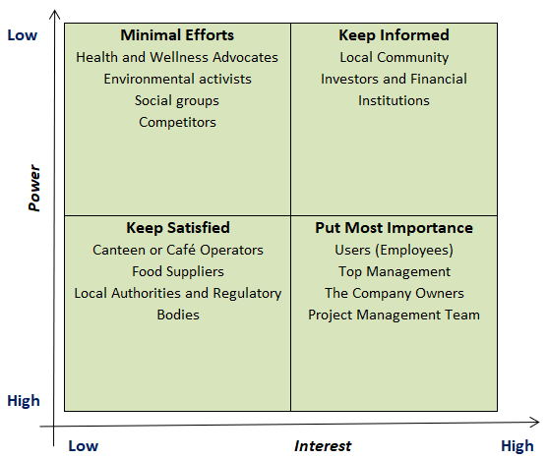
Figure 1: Stakeholders of the Hungry moments project
(Huang et al., 2021)
Users (workers and employees): The " Hungry moments " catering business mostly serves the company's employees. Food must meet high standards in terms of taste, cost, and variety. Their pleasure is crucial to attaining the goals of boosting health and decreasing absenteeism, therefore, designating them as the most significant underlines their major role in the success of the initiative. The team working on the project should prioritise learning about and catering to the client's food habits while still maintaining high standards of quality and service.
Upper management team: Strategic coordination and allocation of resources need the active participation of upper management. Their hopes centre on the project's ability to advance the company's strategic objectives and generate a profit (Kim, Chang, and Castro-Lacouture, 2020). They possess the power to make decisions and have a significant impact on the outcome of the project, making them very important stakeholders. You may meet their requirements by providing them with timely updates, ensuring that the project is in line with strategic objectives, and using efficient methods of execution.
Shareholders: The proprietors of the business have a financial stake in the accomplishment of the project as a whole and its profitability. According to Armenia et al. (2019), they anticipate that the project will contribute to the company's continued financial development as well as an improvement in the company's reputation. In order to fulfil their requirements, you will need to maintain financial and quality controls, have open lines of contact with them, and demonstrate how the project is in line with the overall goal of the organisation.
Team in Charge of Managing the Project: The Team in Charge of Managing the Project is accountable for the planning, delivery, and implementation of the project. They anticipate open lines of communication, sufficient resources, and backing from other parties (Burke, 2013). They play a crucial role in carrying out the project and should thus be given the resources, knowledge, and authority to successfully manage it. Having well-defined objectives, access to necessary resources, and consistent encouragement from upper management will satisfy their requirements.
The operator: The "Hungry moments" concept relies on the efforts of the canteen or café operators who are in charge of running the eateries on a daily basis. They depend on the project team to provide them with clear rules, a clean working environment, and a friendly working atmosphere (Larsson, Eriksson, and Pesämaa, 2018). They fall under the 'Keep Satisfied' umbrella since they are important to service continuity but lack direct control over the project. To cater to their requirements, the team working on the project have to draw up transparent agreements, offer essential assistance, and guarantee that communication is both open and constant.
Suppliers of Food: Suppliers of Food play an essential part in ensuring a steady supply of high-quality foodstuffs. According to Kerzner (2019), their expectations include receiving money in a timely manner, having straightforward discussions about demand, and maintaining a steady business relationship. Even though they don't have strategic clout, the project can't continue without meeting their demands as the primary supplier of food items. It is possible for the project team to keep them content if they devise transparent procurement methods, keep communication open at all times, and strictly adhere to the contractual terms.
Regulatory body and local authority: According to Mavi and Standing (2018), local authorities and regulatory bodies are responsible for ensuring that rules, regulations, and licences pertaining to food safety, zoning, and environmental issues are followed. Their standards concentrate on obedience and proper behaviour. Assuring legal compliance and social responsibility via their satisfaction falls under the 'Keep Satisfied' umbrella since it does not compromise the project's primary goals (Dykstra, 2018). To meet these requirements, you must have an in-depth familiarity with the applicable legislation, implement a system for continuous monitoring of compliance, and be prepared to resolve any legal or regulatory issues that may arise.

Resources and costs

Resource analysis
Supplies: Ingredients in Food and Supplies Necessary for Everyday Food Preparation It is of the Utmost Importance to Use Ingredients in Food and Supplies of the Highest Possible Quality (Heigermoser et al., 2019). Their significance rests in the fact that they are responsible for guaranteeing the diversity, quality, and flavour of the meals that are provided. In order to provide for the nutritional requirements of the workforce, it is essential to maintain a dependable source of fresh foods. The annual price tag is predicted to be £100,000.
Cooking gadgets and appliances: Kitchen appliances, such as stoves, ovens, and refrigerators, are essential for preparing and storing food. Their contribution is critical to ensuring that the food preparation process is carried out in a manner that is both effective and secure. Long-term savings may also be achieved by investing in new, energy-efficient machinery. The annual cost is predicted to be £45,000.
Hiring (Cooks, Hosts, Bosses): In order to oversee the operations of the cafeteria, make meals, and serve workers, a staff that is well-trained and professional is required. Because of their competence, the interaction with customers is always pleasant, and cleanliness requirements are always met (Zuo et al., 2018). Maintaining a good and productive atmosphere in the service industry requires effective personnel at all times. The annual cost is predicted to be £350,000.
Building and maintenance: Building and maintaining the site is crucial, including the installation of a permanent dining hall, the deployment of food trucks, and regular upkeep. This pertains to both the original construction and the ongoing maintenance of the buildings. It is essential for the success of operations to make certain that sites are kept clean and in compliance with rules; the anticipated cost each year is £170,000.
Marketing and promotions: To tell workers about the opportunities and promote engagement, internal marketing and communication activities are required. Posters, company-wide emails, and limited-time offers all fall under this category. The anticipated annual cost of this initiative is £18,000, and its primary aims are to retain staff on-site for lunch and to promote healthy eating.
Compliance: Getting the appropriate permits and maintaining a level of compliance with local health and safety requirements are essential steps in operating lawfully in any given location. It might be necessary to do audits and inspections on a regular basis. The anticipated annual cost of £20,000 is justified by the fact that proper licencing and compliance both fulfil legal duties and show the company's dedication to quality and safety.
Waste management: Responsible trash management that incorporates recycling is consistent with long-term environmental health. Improving a company's waste management may not only lessen its negative effects on the surrounding ecosystem but also boost its image (Hasan et al., 2019). A responsible business will make investments in trash management and recycling systems. The annual expenditure forecast is £45,000.

Cost analysis
The cost and budget for the project are presented in Table 1 below.
Resource | Estimated Cost per year (£)
Supplies | £ 100,000
Cooking gadgets and appliances | £ 45,000
Hiring (Cooks, Hosts, Bosses) | £ 350,000
Building and maintenance | £ 170,000
Marketing and promotions | £ 18,000
Compliance | £ 20,000
Waste management | £ 45,000
Total | £ 748,000

Table 1: The cost and budget for the project 'Hungry moments'
The table shows that the annual budget for the project will be £748,000.

GANTT Chart and WBS

Project GANTT Chart
The GANTT chart of the project is presented in Figure 2 below.
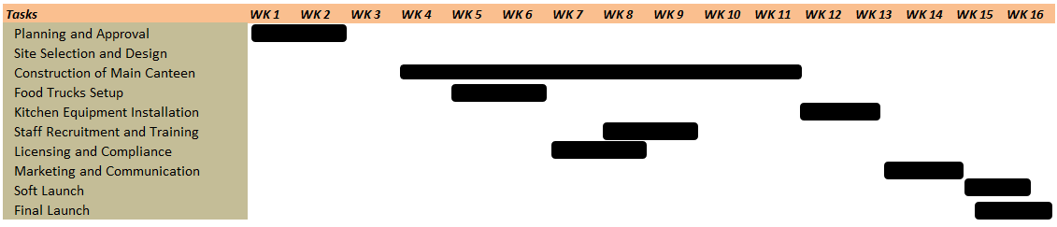
Figure 2: Project GANTT Chart

Project WBS
The work breakdown structure of the project is presented below.
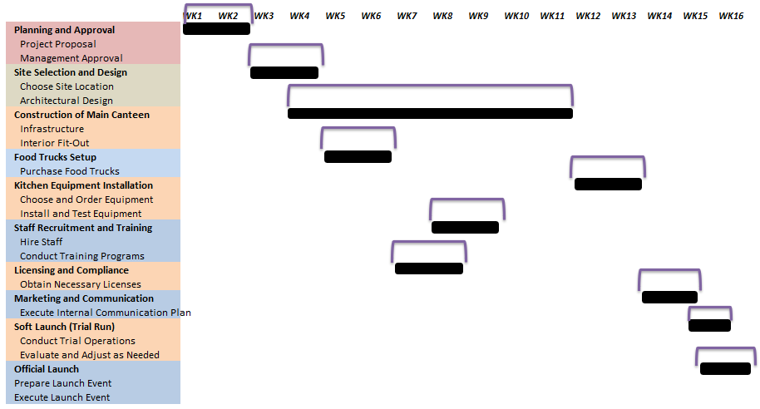
Figure 3: The work breakdown structure of the project

How will communications be conducted?
Meetings with Stakeholders on a Frequent Basis: The project's management team can better communicate with all parties involved if they organise frequent meetings with the stakeholders. This guarantees agreement on project goals stimulates teamwork and expedites the resolution of any challenges that arise. According to Levy (2018) and Kerzner (2019), having regular face-to-face meetings may help in creating trust and preserve openness, both of which are necessary for the success of the project.
Regular Progress Reports: Consistent updates on the project's development, difficulties, and successes may be provided by the distribution of weekly status reports to stakeholders. Such reports encourage openness and keep all parties informed, enabling prompt action if needed. Kerzner (2018), Nicholas and Steyn (2020) highlight the importance of this approach in sustaining project accountability and alignment.
Online platforms: Information may be shared instantly, and teams can work together in real-time using collaborative internet platforms. This method improves productivity and responsiveness by making it possible for all parties involved in the project to access the latest information and relevant resources from any location. Having a streamlined method of communication via a single platform encourages teamwork and keeps everyone on the exact same track (Hasan et al., 2019).
Crisis plan: In the event of a crisis, the project team will be better prepared to respond to the situation if they have an established crisis outreach plan in place. Assuring the timely and proper dissemination of correct information is crucial to preserving control and minimising any negative repercussions (Kerzner, 2018).
Feedback process: During the course of the project, it is important to put in place a transparent feedback process so that stakeholders may offer input, voice concerns, and ask questions. Feedback from a wide range of interested parties may provide useful insights and promote feelings of ownership and involvement. This communication method goes in both directions, which helps to ensure that the requirements and expectations of stakeholders are met (Nicholas and Steyn, 2020; Fewings and Henjewele, 2019).

Project risk assessment
Delays in the construction of the main cafeteria or the food trucks may have a substantial impact on the schedule and budget of the project. This risk may be reduced if the project team takes the time to prepare meticulously, communicate openly with contractors, and establish concrete goals. The effects of delays may be mitigated via careful planning and regular monitoring (Bosch-Sijtsema and Gluch, 2021; Fewings and Henjewele, 2019).
Noncompliance with Occupational Safety and Health Laws: Legal fines and reputational harm may result from violating health and safety laws. It is crucial to fully comprehend and abide by all applicable regulations. Continuous compliance requires regular inspections and audits (Wilson, Bhakoo, and Samson, 2018).
Increased cost: Costs above the original estimate might put the project's financial stability at risk. A strict budget, forecast, and monitoring process should be implemented by the group. To mitigate this threat, businesses should put aside emergency cash and adopt real-time monitoring of expenses against the budget (Ford and Lyneis, 2020).
Lack of Stakeholder Buy-In or Active Support: Poor stakeholder buy-in may lead to miscommunication and pushback, which in turn can derail a project. Fostering buy-in and alignment via effective communication and frequent dialogue with stakeholders. This risk may be reduced by proactively addressing concerns and meeting the demands of stakeholders (Wu, Hu, and Zheng, 2019).
Supply chain failure: Delays, higher prices, and quality difficulties may result from a breakdown in the supply chain or the inability to get sufficient quantities of high-quality food components. Wilson, Bhakoo, and Samson (2018); Fewings and Henjewele (2019) all emphasise the need of a solid supply chain management strategy, which should be implemented by the project team to ensure that any potential interruptions are dealt with effectively.

Conclusion
In a major industrial company, the "Hungry moments" project offers several chances to improve workers' lives and cut down on congestion and absence. The effort seeks to provide an easily accessible and aesthetically pleasing food solution on the premises via careful design, smart location choice, and customised food offers. Involvement from key stakeholders, compliance with health and safety requirements, careful financial planning, and a reliable supply chain will be essential to its success. Construction delays, price hikes, and supply chain failure are only some of the dangers that have been highlighted, but effective techniques for dealing with these threats have been presented.

References
Ahmed, S. (2018). A review on using opportunities of augmented reality and virtual reality in construction project management. Organization, technology and management in construction: an international journal, 10(1), 1839-1852.
Armenia, S., Dangelico, R. M., Nonino, F., and Pompei, A. (2019). Sustainable project management: A conceptualization-oriented review and a framework proposal for future studies. Sustainability, 11(9), 2664.
Bosch-Sijtsema, P., and Gluch, P. (2021). Challenging construction project management institutions: the role and agency of BIM actors. International journal of construction management, 21(11), 1077-1087.
Brewer, J. L., and Dittman, K. C. (2018). Methods of IT project management. Purdue University Press.
Burke, R. (2013). Project management: planning and control techniques. John Wiley and Sons.
Dykstra, A. (2018). Construction project management: A complete introduction. Kirshner Publishing Company.
Fewings, P., and Henjewele, C. (2019). Construction project management: an integrated approach. Routledge.
Ford, D. N., and Lyneis, J. M. (2020). System dynamics applied to project management: a survey, assessment, and directions for future research. System Dynamics: Theory and Applications, 285-314.
Gustavsson, T. K., and Hallin, A. (2014). Rethinking dichotomization: A critical perspective on the use of “hard” and “soft” in project management research. International Journal of Project Management, 32(4), 568-577.
Hall, N. G. (2012). Project management: Recent developments and research opportunities. Journal of Systems Science and Systems Engineering, 21(2), 129-143.
Harrison, F., and Lock, D. (2017). Advanced project management: a structured approach. Routledge.
Hasan, A., Ahn, S., Rameezdeen, R., and Baroudi, B. (2019). Empirical study on implications of mobile ICT use for construction project management. Journal of Management in Engineering, 35(6), 04019029.
Heigermoser, D., de Soto, B. G., Abbott, E. L. S., and Chua, D. K. H. (2019). BIM-based Last Planner System tool for improving construction project management. Automation in Construction, 104, 246-254.
Huang, Y., Shi, Q., Zuo, J., Pena-Mora, F., and Chen, J. (2021). Research status and challenges of data-driven construction project management in the big data context. Advances in Civil Engineering, 2021, 1-19.
Kerzner, H. (2018). Project management best practices: Achieving global excellence. John Wiley and Sons.
Kerzner, H. (2019). Using the project management maturity model: strategic planning for project management. John Wiley and Sons.
Kerzner, H. (2022). Project management metrics, KPIs, and dashboards: a guide to measuring and monitoring project performance. John Wiley and Sons.
Kim, S., Chang, S., and Castro-Lacouture, D. (2020). Dynamic modeling for analyzing impacts of skilled labor shortage on construction project management. Journal of Management in Engineering, 36(1), 04019035.
Larsson, J., Eriksson, P. E., and Pesämaa, O. (2018). The importance of hard project management and team motivation for construction project performance. International Journal of Managing Projects in Business, 11(2), 275-288.
Lee, C. Y., Chong, H. Y., Liao, P. C., and Wang, X. (2018). Critical review of social network analysis applications in complex project management. Journal of management in engineering, 34(2), 04017061.
Levy, S. M. (2018). Project management in construction. McGraw-Hill Education.
Mavi, R. K., and Standing, C. (2018). Critical success factors of sustainable project management in construction: A fuzzy DEMATEL-ANP approach. Journal of cleaner production, 194, 751-765.
Meredith, J. R., Shafer, S. M., and Mantel Jr, S. J. (2017). Project management: a strategic managerial approach. John Wiley and Sons.
Morris, P. W. (2013). Reconstructing project management. John Wiley and Sons.
Nicholas, J. M., and Steyn, H. (2020). Project management for engineering, business and technology. Routledge.
Owusu, E. K., Chan, A. P., DeGraft, O. M., Ameyaw, E. E., and Robert, O. K. (2019). Contemporary review of anti-corruption measures in construction project management. Project Management Journal, 50(1), 40-56.
Walker, A. (2015). Project management in construction. John Wiley and Sons.
Wilson, K. B., Bhakoo, V., and Samson, D. (2018). Crowdsourcing: A contemporary form of project management with linkages to open innovation and novel operations. International Journal of Operations and Production Management.
Wu, G., Hu, Z., and Zheng, J. (2019). Role stress, job burnout, and job performance in construction project managers: the moderating role of career calling. International journal of environmental research and public health, 16(13), 2394.
Zuo, J., Zhao, X., Nguyen, Q. B. M., Ma, T., and Gao, S. (2018). Soft skills of construction project management professionals and project success factors: A structural equation model. Engineering, Construction and Architectural Management, 25(3), 425-442.

Appendix . Presentation slides


