The University of Wales Trinity Saint David
School of Applied Computing
Wales Institute of Science and Art

Research and case scenario in Data Security and Compliance

Data Security and Compliance (ACCA5034)
Robert Iwan Jamieson (2004728)
Date of submission: 06.12.2021
Abstract
This document contains a research paper and a report. The research paper focuses on Data Security and Compliance and the topic of security technologies. Its purpose is to emphasize the importance of why data security and compliance is essential for modern organizations. The report focuses on how a fictional consultancy-based company named FlowTech can best setup its new information security unit. Therefore, recommendations, suggestions and illustrations are presented with the company’s scenario in mind to help them envision and implement the new unit and hence better secure the company.

Contents
List of figures 4
Chapter 1 Introduction 5
Chapter 2 Review of Data Security and Compliance literature 5
2.1 Security Technologies 5
2.2 Firewall program 6
2.3 Access control 6
2.4 Virtual Private Networks 7
2.5 Content Filters 8
2.6 Remote Access dial-up security technologies 9
2.7 Legal and ethical compliance 9
Chapter 3 Case Scenario – FlowTech 10
3.1 Organization structure 10
3.2 Policies 11
3.3 Compliance with Laws and Ethics 12
3.4 Governance and Strategic Planning for Security 13
3.5 Risk Management 14
3.6 Contingency planning 15
3.7 Protection Mechanisms 16
Chapter 4 Conclusion 17
Chapter 5 References 18

List of figures
Figure 1: Windows 10 Access Controls. Source: My own image. 7
Figure 2: Proposed Organization Structure for FlowTech (inspired by the NIST 800-12 security framework) [22]. 10
Figure 3: Policies, Standards, Guidelines and Procedures. Source: [6]. 11
Figure 4: Proposed governance and operations for FlowTech. Adapted from source [6]. 14
Figure 5: Proposed Risk Management process that FlowTech could adopt. Adapted from Source [27]. 14
Figure 6: Disruption recovery process. Adapted from source [6]. 15
Figure 7: Protection Mechanisms blocking/mitigating attacks on FlowTech's business operations. 16

Chapter 1 Introduction
Data Security is fundamental to an organization’s reputation. Companies need to ensure that not only their customers data is protected, but also their own internal data, such as their staff’s personal data and other confidential business information. However, there is a fine line when it comes to data security. Organizations need to consider the fact that data needs to be safeguarded – but it also needs to be accessible in a reasonable manner. Data that is not accessible to anyone may pose little to no risk, however it is also of little value.
Compliance regarding data security is needed in order to comply with the relevant regulations such as the General Data Protection Regulation (GDPR) [1] and the Data Protection Act 2018 [2]. It is important for employees within an organization to read and periodically re-read the organization’s in-house policies. These policies outline the expected employee behaviours and safety procedures which aim to further safeguard data security.
The research paper will focus on the data security and compliance in organizations. Credible and relevant research literature will be reviewed, analysed and critically evaluated in order to signify how essential it is for modern organizations to protect and safeguard their systems and data. Organizations can do this in many ways, such as by making use of cryptography and intrusion detection and prevention systems. However, this research paper will focus on the following topic:
- Security technologies – Firewalls, Access control, Virtual Private Networks (VPNs), Content Filters and Remote Access procedures.
The report aspect of this document will focus on a case scenario surrounding the fictional tech company FlowTech. FlowTech is a fast-growing consultancy-based company that offers its services to other organizations to combat cyberattacks and helps organizations recover data, manage risks and better recover from attacks.
FlowTech is seeking recommendations on how its new information security unit should be setup. The report will therefore provide the organization with recommendations on how FlowTech can best setup its organization’s structure; policies; compliance; governance and planning; risk management; contingency plans and protection mechanisms.

Chapter 2 Review of Data Security and Compliance literature
Below credible research will be analysed and critiqued in regard to how organizations can better protect and safeguard their data via their IT systems and infrastructure. The legal and ethical implications of failing to do so will also be reviewed.

2.1 Security Technologies
Security technologies greatly help protect the confidentiality of data within a network. This research paper will focus on the following security measures: firewalls [3], access controls [4], Virtual Private Networks (VPNs) [5], content filters [6], remote access procedures [6] and legal and ethical compliance.
Before delving into security measures, it is important to understand that threats and attacks to an organization’s data constantly evolve and become more sophisticated – you can only secure systems so much [7]. Organizations must keep evolving and updating their security measures to best mitigate the chances of data security breaches.

2.2 Firewall program
Firewall programs monitor networks to block malicious data from entering the network and its systems. They are configured by the network administrator and can be very strict [7].
The Journal of Computer Security paper mentions that firewalls are “useless when incorrectly configured” [8]. It is essential that organizations properly configure and update their configurations whenever a new threat or attack is discovered. A poorly configured firewall puts the entire organization’s data at risk as malicious programs can quickly infect its systems. Furthermore, a poorly configured firewall could be at risk at breaking laws and regulations [8] as many countries have strong data protection regulations; meaning client data as well as the organization’s confidential data needs to be secured adequately.
Firewalls can become very complex when there are so many rules filtering out malicious data packets. However, simplifying a firewalls ruleset to mitigate their complexity [3] is a good approach. Organizations should look back on their ruleset and identify which rules are making others redundant and remove those redundant rules. Doing so regularly would help reduce the complexity of firewalls [3] and hence make them more manageable.
Firewalls have multiple modes, including packet-filtering firewalls and proxy firewalls [9]. Packet-filtering firewalls check whether data packets respect the rules of the firewall and if they do not, they are blocked. Whereas proxy firewalls operate on an application basis – they act “as a mediator between the two end systems” [9]. Meaning servers aren’t directly exposed to potentially malicious data [6], it first must pass through the proxy firewall.
Next Generation FireWalls (NGFW) stem from regular firewalls [9]. Organizations should consider making use of them as they offer the same, yet additional functionality, including: built-in intrusion detection; application level filtering of packets and importantly “simplifies and enhances the effectiveness of applying security rules” [9].
Unfortunately, NGFW’s do have downsides. One downside is that NGFWs are very power intensive and can therefore bottleneck the network’s traffic when under stress [10]. Another downside is that if there is a technical problem with the NGFW, it could mean the entire network becomes vulnerable as it is an “all-in-one” [6] device.
Despite of its downsides, NGFWs are generally far superior to regular firewalls and hence should be considered by organizations in order to better secure their data. Failing to implement a strong firewall system will put the entire network at risk of an attack – confidential company and customer data could be compromised and the systems themselves could be damaged. It is essential for organizations to use firewalls with strict and ever-evolving rules to better safeguard data.

2.3 Access control
Access control methods help ensure only authorized users gain access to a system and/or to a certain area of a system. An access control system is based on identification, authentication, authorization and accountability [6].
Identification refers to users claiming to e.g., be a specific user of the system [6]. To verify that they are indeed who they say they are, authentication is used. Authentication requires a user to prove they have access to the system, e.g., via a correct password or via other methods such as biometric signatures [11]. Authorization limits users to portions of a system that they need access to - instead of the entire system. Whereas accountability ensures that user actions are logged. Misuse of the system can therefore be identified and traced back to the user [6].
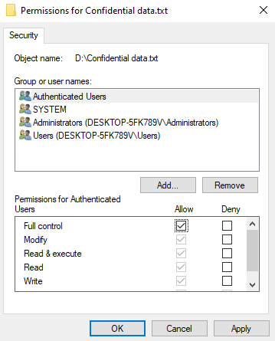
Access controls are either discretionary or nondiscretionary. Discretionary access controls are controlled by the user of the system or owner of a file – the owner can e.g., choose to openly share their files with everyone within the same network, or only to specific users [4]. Full access does not have to be given - at the user’s discretion, they can choose to allow other users to be able to edit the document or only allow others to read it – they can also deny any access to the file altogether [4].
On the other hand, nondiscretionary access controls are controlled by the administrators of the systems or network [6]. Administrators can group up employees based on their job role – meaning e.g., the cybersecurity staff gain more access to vulnerable programs and documents (see example of access control in Figure 1). Whereas a receptionist only has access to a database relating to customers.
Ben Lutkevich the Technical Writer for SearchSecurity suggests that a challenge of access control is “centralizing user directories and avoiding application-specific silos” [11]. However, e.g., Window Server gateway administrators [12] can easily create multiple groups and determine what file paths employees can access, based on their current needs. Despite of how easy it may seem on the surface to categorize users into groups, a business and its employees needs are ever evolving.
Therefore, the administrators must constantly evolve the access rights to different files/directories based on its users and organization’s evolving needs [13] and it can thus be a tiresome, never-ending process. Unfortunately, there is not really a way of getting around this problem without compromising on security. If every user within an organization had full access to confidential files, the organization would be extremely vulnerable to internal attacks from a disloyal employee.

Figure 1: Windows 10 Access Controls. Source: My own image.

This highlights how important it is for organizations to protect their data as unauthorized access to data could lead to major data leaks, thus a loss of trust from customers and potentially big fines [14].

2.4 Virtual Private Networks
Virtual Private Networks (VPNs) mask the original user’s IP address. Their purpose is to securely transfer the user’s internet activity via end-to-end encryption methods and to allow users to anonymously browse the internet [5]. VPN technologies include Trusted, Secure and Hybrid VPNs [6].
Trusted VPNs were found to be vulnerable to malicious malware and other attacks as customers relied heavily on the integrity of leased lines [15]. Meanwhile a modern VPN technology called Secure VPN offers robust protection to customers even if their data is intercepted during transfer. This is due to end-to-end encryption methods, where only the intended recipient can decrypt the data without issues.
Even though trusted VPNs are seen to have “no real security” [15], they are great when combined with secure VPN’s. When these technologies are combined, they become what are known as hybrid VPN’s [6]. Customers using a hybrid VPN can choose what data is sent securely through the VPN tunnel and potentially what data is not – hence have the choice between an optimal, faster connection or a more secure connection [16].
Tunnelling data is the act of encrypting and encapsulating raw text just before transferring the data over unsecured public networks until it reaches its destination node. Once it has reached its destination, it is decapsulated and the data is decrypted [5]. Meaning that even intruders eavesdropping [17] will not be able to read the data and will simply receive unreadable data.
However, it is not the only method. Common VPN’s also have a transport mode which has the same aim of protecting data. It differs from tunnel mode as it communicates directly with the recipient and does not encrypt the header packet [6].
Due to this, tunnel mode is the better method of transferring data from one node to another because when using transport mode, “packet eavesdroppers can still identify the destination system” [6]. Thus, allowing eager attackers to then attempt to attack and retrieve the data from the recipient of the data.
This comes to show how important it is for organizations that are sending and retrieving data over networks to make use of a VPN technology. Doing so will dramatically mitigate attacks.

2.5 Content Filters
Content filters are not to be confused with firewall filters. They offer similar protection however content filters actively prevent internal systems from accessing certain external content from the web [6]. Content filter programs therefore help prevent and mitigate internal misuse or negligence of an organization’s systems which could otherwise put the entire network at risk of attack.
It is important for organizations to make use of content filters, partly to enforce their acceptable use policies [7]. Trusting employees only goes so far, whereas completely preventing them from accessing websites or content they should not be trying to access in the first place provides organizations with more security and a peace of mind.
There should be a middle ground when it comes to blocking websites and allowing users to browse a wide range of websites.
On the one hand, allowing users to roam relatively freely could lead to user policy breaches and the danger of malicious malware entering the network. However, filtering vast amount of content could reduce productivity [6]. Not only for employees trying to access relevant information but also for the network administrators who would have to constantly update the filtering of blocked and whitelisted websites [6].
Content filters are not only used to prevent internal employees accessing inappropriate websites. “Plugins to screen email attachments” [7] are also used to reduce the risk of an employee being exposed to e.g., malware in an email attachment.

2.6 Remote Access dial-up security technologies
Remotely accessing a work system or connecting to an organization’s network opens the organization up to many vulnerabilities. Which is why technologies such as VPNs are used to ensure the security of data transactions (as described in chapter 2.4).
However, not everybody has a high-speed connection and may instead be using a “still quite common” [6] dial-up connection – which is an old and slow connection when compared to modern standards [18]. Hence, other solutions are needed to connect these users to an organization remotely and securely.
Remote Authentication Dial-In User Service (RADIUS), Terminal Access Controller Access Control System Plus (TACAS+) [19] and the Diameter protocol [6] systems are used to better secure remote connections by demanding Authentication, Authorization and Accounting (AAA) [19] measures.
RADIUS along with the other systems mentioned offer a centralized database when it comes to authenticating multiple dial-up users [6], ensuring only users with correct credentials can access an organization’s network.
The diameter protocol shares similar yet more advanced functionality to the RADIUS configuration [6]. It is more flexible and futureproof than the other systems as it has the capability of using future and more up-to-date encryption standards [6]. Organizations with employees connecting to their network via a dial-up connection should therefore strongly consider mitigating vulnerabilities by making use of the diameter protocol.

2.7 Legal and ethical compliance
The forementioned technologies used to secure organizations from attacks, vulnerabilities and threats [20] are components that especially large organizations need to consider if they are to comply with legal and ethical standards.
For instance, if a large organization does not use a firewall with robust rules, the organization runs the risk of attackers gaining access to private personal data from customers such as their home address, which is protected by laws/acts such as the GDPR [1] and DPA 2018 [2]. Organizations failing to secure their customers personal data can be fined huge sums of money – up to “£17.5 million or 4% of annual global turnover” [21] from the DPA 2018.
Key principles of the DPA 2018 state that information must be:
- “used fairly, lawfully and transparently” [2].
- “used for specified, explicit purposes” [2].
- “accurate and, where necessary, kept up to date” [2].
Furthermore, after a data leak, an organization’s reputation and profits would be massively damaged because less people would trust the organization and instead go to a competing, more trustworthy company. It is therefore in an organization’s best interest to invest in security technologies to better secure data.

Chapter 3 Case Scenario – FlowTech
As mentioned in the introduction, FlowTech is a tech company seeking recommendations on how to best setup a new information security unit. By doing so they aim to mitigate vulnerabilities, threats and attacks in order to better secure their own data and their customers data. This report will therefore offer recommendations and suggestions on how to best setup the new unit from an external entities’ perspective of the company.
Note: This report refers to a top-down security approach [6], predominantly inspired from the NIST 800-12 security framework [22].

3.1 Organization structure
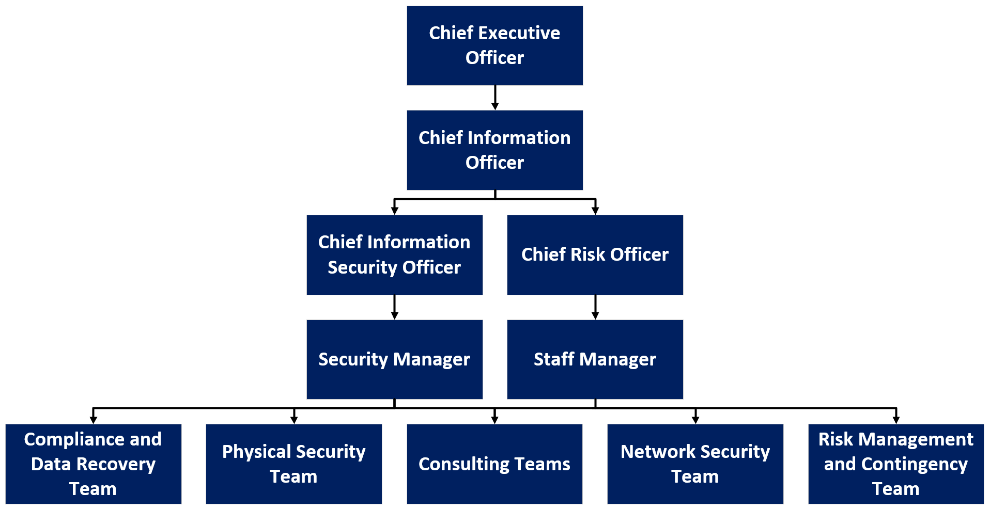
The structure of an organization is very important. Therefore, FlowTech will need a robust organization structure based on its business and security related needs. Below is a structure that FlowTech would benefit from implementing.
Figure 2: Proposed Organization Structure for FlowTech (inspired by the NIST 800-12 security framework) [22].
As seen in Figure 2, the structure would allow FlowTech to continue growing at a fast pace with security in mind. It would also allow the company to expand its workforce and hence its services so that it can keep up with all the businesses approaching it for cyberattack advice and assistance.
Below are each of the main roles (as seen in Figure 2) and how they would benefit FlowTech if implemented:
- The Chief Executive Officer (CEO) [22] – The CEO would benefit FlowTech by managing, planning, enforcing policies and coordinating with other high-level staff [6]. The CEO would provide FlowTech with a good structure to better tailer their consultancy offerings to other businesses.
- The Chief Information Officer (CIO) [22] – The role of the CIO would be to manage, employ and oversee FlowTech’s workforce. As FlowTech is a fast-growing company it needs to keep working efficiently – the CIO will be the core role behind keeping FlowTech’s processes efficient.
- The Chief Information Security Officer (CISO) [22] – The CISO would oversee the security departments of FlowTech and will ensure all security measures are up-to-date and being adhered to [6]. The CISO will help FlowTech mitigate and recover from security breaches which is essential as FlowTech’s online cloud storages and services must be kept operational.
- The Chief Risk Officer’s (CRO) [24] – The role of the CRO would be to manage the risks involved in FlowTech’s decisions regarding vulnerabilities, attacks and compliance and will therefore increase the security of FlowTech. The CRO will also be involved in ensuring the correct frameworks and tools in FlowTech’s consultancy services are chosen to better inform other businesses.
- Security Manager – The Security Manager would manage and coordinate between all the lower-level teams to make sure FlowTech keeps operating smoothly.
- Staff Manager – The Staff Manager would focus on keeping FlowTech operational and as efficient as possible without compromising the security of FlowTech.

Below are all of the proposed lower-level role’s (as seen in Figure 2) and how they could operate and benefit FlowTech if implemented:
- Compliance Team – Ensures that FlowTech’s employees comply with internal policies as well as rules and regulations (as discussed in Chapter 2.7).
- Data Recovery Team – Oversees FlowTech’s cloud storage data.
- Physical Security Team – Installs necessary physical security measures for FlowTech’s offices
- Network Security Team – Monitors and secures FlowTech’s online presence and services.
- Risk Management Team – Analyses risks and the possible impacts of them [6].
- Contingency Team – Puts measures in place to mitigate and help recover from disasters [6].

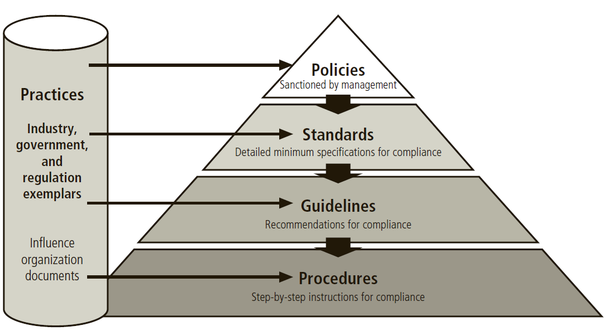
3.2 Policies
As FlowTech is a fast-growing company with a large online presence, it is important to consider strong security policies to better secure the organization. Furthermore, for FlowTech’s policies to be adhered to, it is recommended that standards, guidelines and procedures [6] are also set out (as illustrated in Figure 3). By doing so, employees of FlowTech will have an easier time understanding and complying with the policies. If the recommended organization structure is implemented, the main roles that would help develop these rules are the CISO, Security Manager and the Compliance team.
Figure 3: Policies, Standards, Guidelines and Procedures. Source: [6].

Outlined below are some key policies for FlowTech to consider implementing as they would better secure the company:
- Use Of Personal Equipment [22] – This policy would outline the acceptable use of personal equipment such as a personal laptop. For instance, employees could be instructed to only use personal equipment with an anti-virus program installed. This policy is applicable to FlowTech as many employees work from home on their personal devices already and as the company grows, more will. This policy would help FlowTech better secure its online presence by helping to mitigate attacks from malware on personal devices.
- Remote Access Procedures [22] – This policy would outline the acceptable connection to FlowTech’s networks for employees working from home or other external locations. VPNs and other technologies are recommended for remote access (as discussed in Chapter 2.4 and 2.6). This policy would better secure FlowTech’s cloud storages and services from potential attacks such as a man-in-the-middle attacks [25], which may otherwise allow attackers to gain administrative access to confidential data.
- Acceptable use of emails [23] – A policy covering the acceptable use of emails is recommended for FlowTech. FlowTech corresponds back and forth regarding their consultancy services and are therefore susceptible from attacks such as phishing attacks [26]. Ensuring employees following strict standards and guidelines from the use of emails would help avoid such attacks.
- Authentication policy – An authentication policy outlines the necessary procedures for employees to take to create a secure FlowTech account. As FlowTech is growing rapidly, the chances of an employee’s account being infiltrated rises. An authentication policy would help mitigate the risks by ensuring employees regularly change their passwords, with lower case and higher case letters as well as symbols and 16 minimum characters [6].

It is important that policies and rules are enforced because otherwise employees will quickly take notice of the leniency and may become an internal threat or vulnerability to FlowTech. FlowTech can enforce policies by having employees formally agree to the policies; regularly educating employees about them [6] and issuing strict disciplinary actions [22] when they are not abided by.
For further assistance in creating robust policies, the relevant team from FlowTech can view: The NIST Special Publication 800-12 [22] and the “Information security policies, procedures, and standards : a practitioner's reference” book by author Douglas J. Landoll [23].

3.3 Compliance with Laws and Ethics
It is important that FlowTech is aware of and complies with the relevant laws regarding data, such as the Data Protection Act 2018 (DPA) [2] (as discussed in Chapter 2.7). It is recommended that FlowTech also ensure they operate ethically. Keeping a trustworthy reputation will attract more customers, whereas operating unethically would hurt FlowTech financially.
The DPA 2018 is very relevant to FlowTech as the company stores confidential personal and business data on their cloud services. FlowTech could therefore follow the principles of the DPA 2018, as highlighted in Chapter 2.7. As FlowTech is a fast-growing and online company and may want to expand their operations outside of the UK, they would benefit from also following the laws of other countries. Including unions such as the European Union’s GDPR [1] so that it is easy to transition, operate and sell services there too.
Due diligence and due care [6] are the best ways for FlowTech to avoid lawsuits. Essentially, FlowTech could ensure laws, regulations and ethical issues are respected by creating and enforcing strong policies for all employees to follow. The CISO and managers in FlowTech would be responsible (from the proposed structure) to make sure everything possible is being done to comply.
Failing to have a system where employees respect ethical or legal responsibilities could be catastrophic for FlowTech. FlowTech relies on a strong reputation to give advice regarding compliance and cybersecurity advice to other companies and hence if it was found to fail in the very area it advices others in, FlowTech could lose all credibility.

3.4 Governance and Strategic Planning for Security
Governance and strategic planning for security determines how FlowTech can reach their organization’s goals of assisting and providing services to other companies whilst also properly securing and governing themselves. As FlowTech offers many services such as compliance, business continuity, data recovery and risk management advice and cloud storage to other companies, it needs an efficient governance system to organize all of this work in an efficient way.
FlowTech could therefore consider a robust organization structure as proposed in Figure 2. The benefits of a strong organization structure is that all operations within FlowTech would run more efficiently; the security would be vastly improved; risks would be managed and employees would be more organized and better directed on their responsibilities.
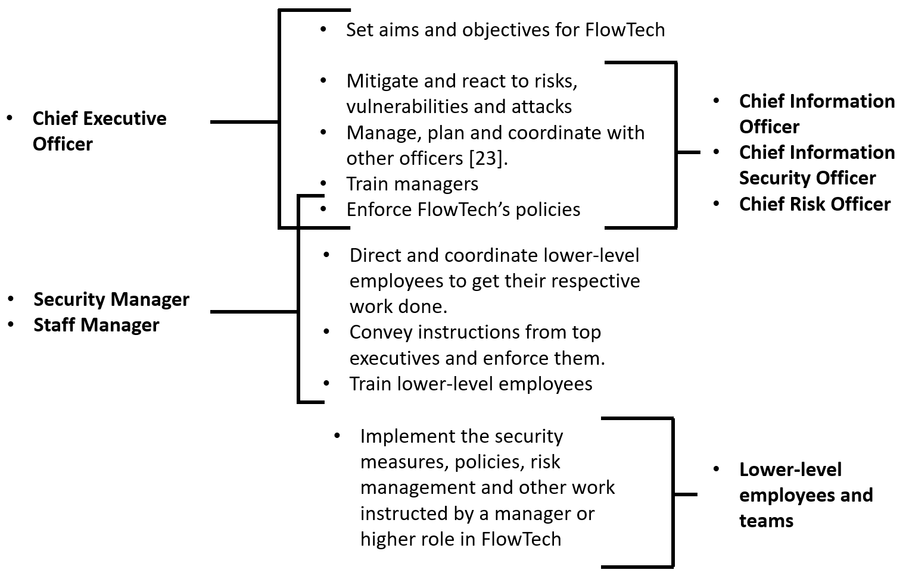
In Figure 4 as seen below is an overview of how FlowTech’s organization could govern and plan for security (adapted from source [6]).
Figure 4: Proposed governance and operations for FlowTech. Adapted from source [6].

3.5 Risk Management
As a growing company, FlowTech may be attacked more due to the important confidential data it stores. FlowTech should therefore consider implementing a Chief risk officer and risk management team to identify, evaluate, report and control [6] risks.
The team could:
- Identify the risk – What is the risk?
- Evaluate the risk – How likely is it that the risk could occur? How impactful could the risk be? Very impactful? Somewhat impactful? Tolerable? Miniscule impact?
- Report and document the risk – Report risks to the security manager and contingency team. Keep note of them.
- Control the risk – What measures could be put in place to control or mitigate the risk?
- Review the risk – Is the risk still a risk? Has it developed in severity since its last evaluation?
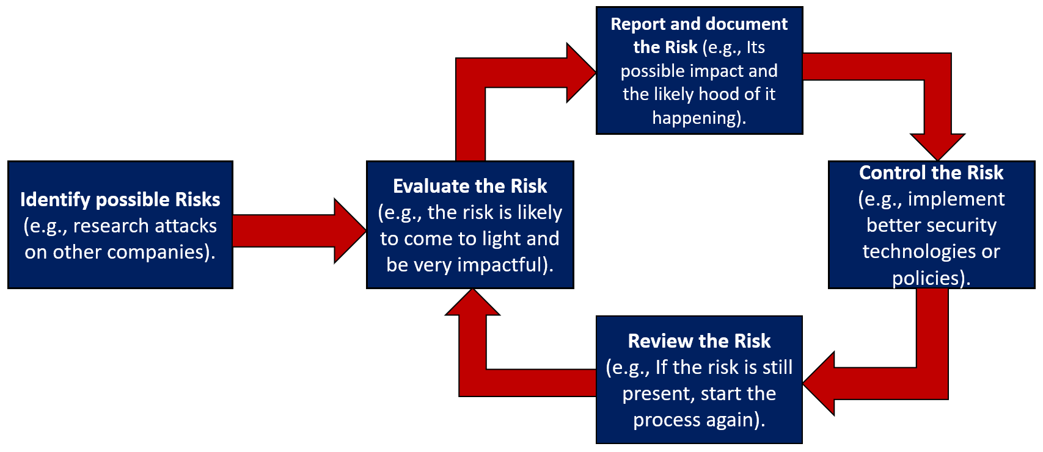
Figure 5 reveals a risk management process FlowTech could implement to help keep its services and its data secure:
Figure 5: Proposed Risk Management process that FlowTech could adopt. Adapted from Source [27].
A risk management process would be very beneficial to FlowTech’s operations because FlowTech as an online company is always facing risks such as:
- Downtime due to attacks (such as a distributed denial-of-service attack).
- Employees being easily impersonated.
- Interceptions (via e.g., man-in-the-middle attacks [25]).
- Insecure public network connection vulnerabilities (e.g., risks of shoulder surfing attack).
- Natural disasters (e.g., the server room being flooded).
Controlling risks would require constant communication with other teams within FlowTech such as the network security and physical security teams. For example, the network security team could focus on implementing better firewall filters, whilst the physical security team could focus on better securing physical access to servers.

3.6 Contingency planning
Contingency planning is important to consider as it would help mitigate natural disasters and major attacks and thus contribute to FlowTech’s business continuity [28]. Meaning, FlowTech can continue its online cloud services and consultancy services with the least disruption as possible.
The contingency planning team could coordinate closely with the risk management team so that they are aware of ways in which FlowTech could be damaged and hence do not need to repeat the same or similar work.
The contingency planning team should always try to completely prevent any disasters or disruptions occurring. However, this is not possible in many cases and hence disruptions should be mitigated as much as possible. The contingency team can do this by preparing for risks identified by the risk management team.
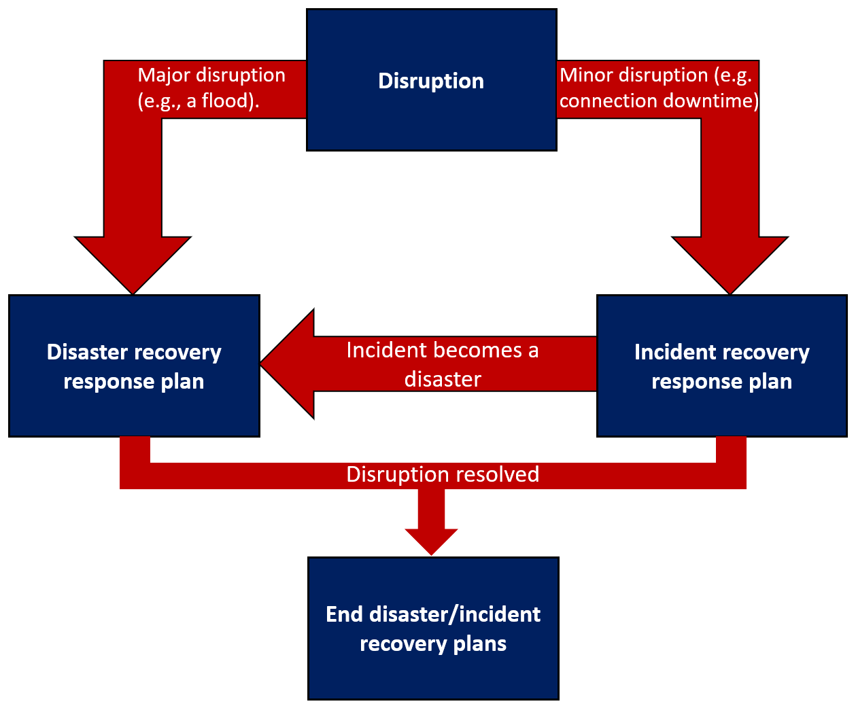
If a disruption occurs, it would be ideal for FlowTech to have a disruption recovery process, as seen in Figure 6:

Figure 6: Disruption recovery process. Adapted from source [6].
Disasters or incidents cannot always be predicted and hence the response to them may have to be planned after the fact. However, many possible disasters such as floods and fires or common incidents such as connection issues and server downtime can be planned for. Those plans should be executed to get services such as FlowTech’s cloud storage service back online as quickly as possible.

3.7 Protection Mechanisms
Protection mechanisms are extremely important, especially to online-based companies like FlowTech. FlowTech can be attacked:
- Physically via their cloud storage server rooms.
- Online via many attacks, including distributed denial-of-service attacks, man-in-the-middle attacks, brute force attacks, etc.
- Internally via an employee’s misconduct or lack of care.
It is therefore strongly advised that FlowTech implement robust security technologies (as discussed in Chapter 2.1) and policies (as discussed in Chapter 3.2).
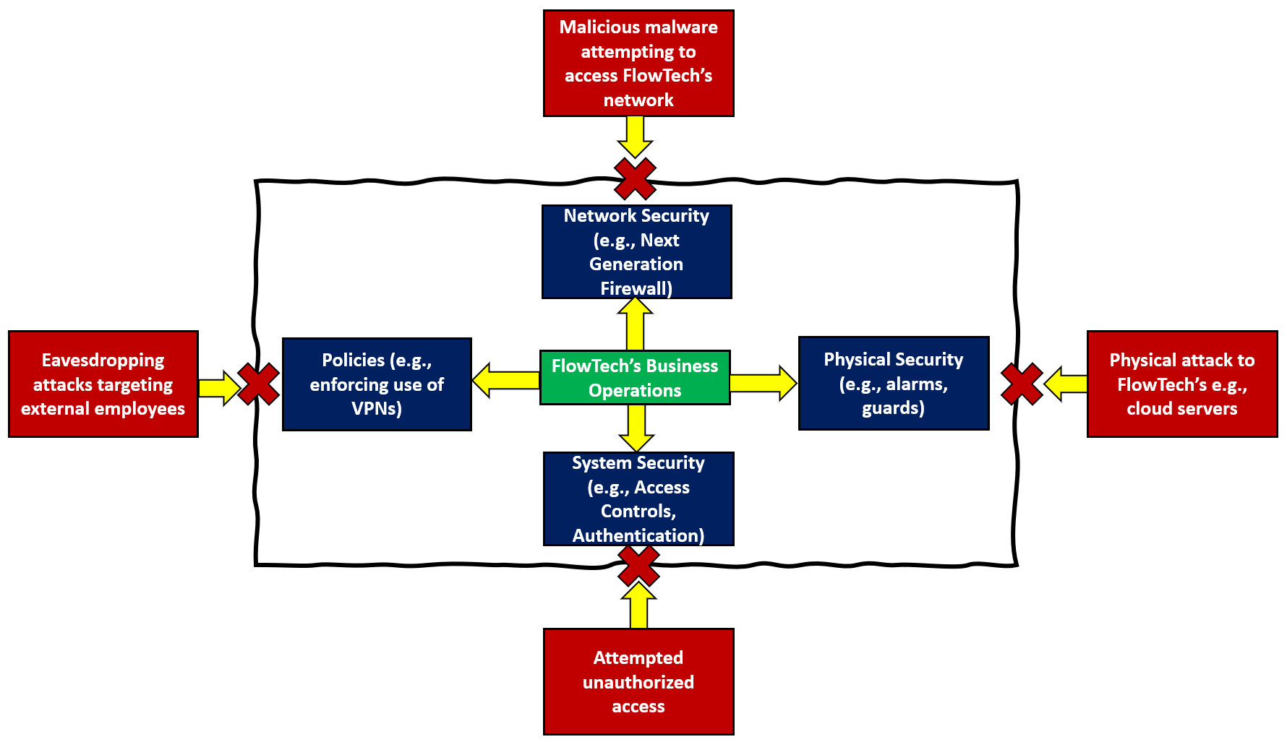
Figure 7 below illustrates the need for robust protection mechanisms as they can tremendously mitigate FlowTech from being attacked and ensure the business operates as usual.
Figure 7: Protection Mechanisms blocking/mitigating attacks on FlowTech's business operations.
The new information security unit should strongly consider implementing security technologies and robust policies to combat attacks, data leaks and fines. There are many security technologies to consider, however some key implementations the unit could implement are:
- Network security measures such as Next Generation FireWalls (NGFWs) [9]. These firewalls go a step further than regular firewalls by not only introducing filters but also intrusion detection capabilities (as discussed in Chapter 2.2). FlowTech would benefit from this because their online services need to operate smoothly without any security breaches.
- Physical security measures such as motion detectors setting off alarms. This would deter attackers from trying to gain access to FlowTech’s cloud storage servers and would alert the company of their presence. Due to data protection laws such as the Data Protection Act 2018 [2], keeping data secure is essential. If it is compromised, FlowTech could be fined millions. Not to mention, the public backlash would damage FlowTech’s reputation as a consultancy company and hence could lead to the downfall of the company.
- System security measures such as authentication methods. Ensuring e.g., passwords are robust and changed regularly would mitigate the chances of a brute force attack being successful. If it was successful, it would allow someone to impersonate an employee and possibly gain access to confidential data. This is very applicable to FlowTech because their employees can work from home and hence it would be difficult to identify impersonators solely based on their login session’s activity.
- Security policies. Key policies were discussed in Chapter 3.2. FlowTech would benefit from security policies as employees would take more care in what they do. For example, employees may take greater care when it comes to clicking on potentially malicious emails as their job is on the line if they break the acceptable use of emails policy.

Chapter 4 Conclusion
In conclusion, it is essential for modern organizations to safeguard their data and systems, not only for their own security but to also comply with laws and ethical viewpoints. Security technologies massively help organizations combat internal and external attacks and ensure strict data privacy laws are adhered to.
In regards to the new information security unit, FlowTech should consider: the strong organization structure proposed; robust security policies such as the examples listed; close compliance with not only regional but also external laws; a strong strategic security plan with the necessary governance; a risk management process to better secure the company; contingency plans to help recover from incidents and disasters and protection mechanisms to protect the company from attacks.
If the recommendations, suggestions and proposals are followed, FlowTech’s new information security unit will be paramount in ensuring that the company is able to keep growing whilst also remaining secure, efficient and seen as a reputable online-based consultancy company.

Chapter 5 References
[1] B. Wolford, "What is GDPR, the EU'S new data protection law?," Proton Technologies AG, [Online]. Available: https://gdpr.eu/what-is-gdpr/. [Accessed 4 Nov 2021].
[2] Crown, "Data protection," UK Government, [Online]. Available: https://www.gov.uk/data-protection. [Accessed 4 Nov 2021].
[3] AlgoSec, "FIREWALL MANAGEMENT: 5 CHALLENGES EVERY COMPANY MUST ADDRESS," AlgoSec, 2015. [Online]. Available: https://www.algosec.com/wp-content/uploads/2016/03/Firewall-Management-5-Challenges-Every-Company-Must-Address-WEB.pdf. [Accessed 9 Nov 2021].
[4] N. Kashmar, M. Adda and M. Atieh, From Access Control Models to Access Control Metamodels: A Survey, p. 3, 2020.
[5] Dr. Himanshu Monga, "An approach to Virtual Private Networks and security," International Journal of Advanced Research in Computer Science.
[6] Michael E. Whitman and Herbert J. Mattord, Principles of Information Security, Boston, 2018.
[7] D. Kim and M. Solomon, Fundamentals of Information Systems Security, 3rd ed., Burlington Massachusetts: Jones & Barlett Learning, 2018.
[8] C. Bodei, L. Ceragioli, P. Degano, R. Focardi, L. Galletta, F. Luccio, M. Tempesta and L. Veronese, "FWS: Analyzing, maintaining and transcompiling firewalls," Journal of Computer Security, vol. 29, pp. 1-2, 2021.
[9] Dr. A. Shaji George; A. S. Hovan George, "A Brief Study on The Evolution of Next Generation Firewall and Web Application Firewall," International Journal of Advanced Research in Computer and Communication Engineering, vol. 10, no. 5, p. 33, 2021.
[10] Josh, "Redefining Next-Generation Firewalls," Net-Ctrl, 30 Jul 2021. [Online]. Available: https://www.net-ctrl.com/redefining-next-generation-firewalls/. [Accessed 10 Nov 2021].
[11] B. Lutkevich, "access control," TechTarget, Sep 2020. [Online]. Available: https://www.techtarget.com/searchsecurity/definition/access-control. [Accessed 11 Nov 2021].
[12] Microsoft, "User access options with Windows Admin Center," Microsoft, 19 Oct 2021. [Online]. Available: https://docs.microsoft.com/en-us/windows-server/manage/windows-admin-center/plan/user-access-options. [Accessed 11 Nov 2021].
[13] W. Yaokumah and E. S. A. Okai, "Inter-Organizational Study of Access Control Security Measures," International Journal of Technology and Human Interaction, vol. 14, no. 1, p. 1, 2018.
[14] intersoft consulting, "GDPR Fines / Penalties," intersoft consulting, [Online]. Available: https://gdpr-info.eu/issues/fines-penalties/. [Accessed 15 Nov 2021].
[15] DR. P. RAJAMOHAN, "Performance Analysis and Special Issues of VPN Technologies in Communication: Trusted VPNs, Secure VPNs and Hybrid VPNs," IPASJ International Journal of Computer Science (IIJCS), vol. 2, no. 7, p. 44, 2014.
[16] NETGEAR, "What is the Hybrid VPN feature on my Nighthawk XR500 Pro Gaming router?," NETGEAR, 12 Dec 2018. [Online]. Available: https://kb.netgear.com/000060462/What-is-the-Hybrid-VPN-feature-on-my-Nighthawk-XR500-Pro-Gaming-router. [Accessed 17 Nov 2021].
[17] J. Frankenfield, "Eavesdropping Attack," Investopedia, 20 Oct 2020. [Online]. Available: https://www.investopedia.com/terms/e/eavesdropping-attack.asp. [Accessed 18 Nov 2021].
[18] B. Mitchell, "Is Dial-Up Networking Still a Thing?," Lifewire, 30 June 2021. [Online]. Available: https://www.lifewire.com/definition-of-dial-up-817779. [Accessed 19 Nov 2021].
[19] A. P. S. Sikarwar, "An Analytical and Experimental Study of AAA Model," International Journal of Computer Applications, vol. 169, p. 6, 2017.
[20] Mohamed Abomhara and Geir M. Køien, "Cyber Security and the Internet of Things: Vulnerabilities, Threats, Intruders and Attacks," Journal of Cyber Security, vol. 4, p. 71, 2015.
[21] IT Governance Ltd, "GDPR Fines," IT Governance Ltd, [Online]. Available: https://www.itgovernance.co.uk/dpa-and-gdpr-penalties. [Accessed 20 Nov 2021].
[22] M. Nieles, K. Dempsey and V. Y. Pillitteri, "An Introduction to Information Security Revision 1," NIST Special Publication 800-12, pp. 13-18, 2017.
[23] D. J. Landoll, Information security policies, procedures, and standards : a practitioner’s reference, 1st edition. Boca Raton: CRC Press, Taylor & Francis Group, 2016. doi: 10.1201/9781315372785.
[24] A. Hayes, "Chief Risk Officer (CRO)," Investopedia, 16 Jul 2021. [Online]. Available: https://www.investopedia.com/terms/c/chief-risk-officer-cro.asp. [Accessed 25 Nov 2021].
[25] Avijit Mallik, Abid Ahsan, Jia-Chi Tsou, Mhia Md. Zaglul Shahadat, "Man-in-the-middle-attack: Understanding in simple words," International Journal of Data and Network Science, pp. 1-2, 2019.
[26] Alkhalil Zainab, Hewage Chaminda, Nawaf Liqaa, Khan Imtiaz, "Phishing Attacks: A Recent Comprehensive Study and a New Anatomy," p. 1, 2021.
[27] J. Bhattacharjee, M. S. Barik, A. Sengupta and C. Mazumdar, "An Analytical Study of Methodologies and Tools for Enterprise Information Security Risk Management," in Information Technology Risk Management and Compliance in Modern Organizations, IGI Global, 2018, p. 3.
[28] M. Swanson, P. Bowen, A. W. Phillips, D. Gallup and D. Lynes, "Contingency Planning Guide for Federal Information Systems," NIST Special Publication 800-34 Rev. 1, pp. 5-10, 2010.

