Project planning for construction.
(ACBA 5001).
Student: 1910146

Contents

- Introduction………………………………………………………………………………………………………………….. pg. 3
- Management Procedure …..………………………………………………………………………………………….. pg. 4
2.1 Client – project manager …………………………………….…………………………………………….. pg. 4
2.2 Project manager – Architect ….………………..…………………………………………………………. pg. 4
2.3 Project manager – Principal contractor ………..……………………………………………………… pg. 5
2.4 Principal contractor – Sub contractors ………………………………………………..…..………….. pg. 5
2.5 Clerk of works ……………………………..………………………………………………………………………. pg. 5
3. Communication flow chart ……..…………………………………………………………………………………………….... pg. 6
4. Quality management procedure …….………………………………………………………………………………………. pg. 7
5. Quality management system ……………………………………………………..…………………………………………… pg. 7
Quality management system continued ………………………………………………………………….…. pg. 8
6. Quality assurance ………………………………………………….……………………………………………………………….. pg. 8
7. Process map ………….……………………………………………………………………………………………………………….. pg. 9
8. After sales Flow chart …………..……………………………………………………………………………………………….. pg. 10
9. Conclusion …………….…………………………………………………………………………………………………………….. pg. 11
10. References ………………………………………………………………………………………………………………………….. pg. 12
References continued ………………………………………………………………………………………………………. pg. 13

Introduction
The following report is going to look at different ways of controlling quality in a construction project, using the traditional procurement process. A traditional procurement method typically means that the design process and construction process are separate, the report will look at how this approach is carried out and how quality can be controlled.
The report will firstly look at and discuss the beginning stages of a project before the construction phase can begin, while also using a flow chart to show this. From there discussing ways in which quality control can be implemented and controlled throughout the build process using such controls quality checklists and ISO 9000/9001, (International standards on quality management).

Management Procedure
Client – Project manager
As the quality of the proposed project is of utmost importance to the client it is essential that right from the beginning the correct procedures are carried out in order to ensure the best quality outcome. Therefore, it is advised that the client appoints a Project manager (PM) at the start. The client and PM can then discuss the project, the client can outline what they want the project to be built like and the quality they expect.
The next step would be to then come up with a prequalification questionnaire ready to send out with the tender for the job. This will ensure that the quality of the construction firm to be employed is as required. The British Standards Institution (2013) stated ‘to be eligible for prequalification, it is necessary that suppliers demonstrate that they possess or have access to the governance, qualifications and references, expertise, competence, health and safety, environmental, financial and other essential capabilities to the extent necessary for them to be considered appropriate to undertake work and deliver services for potential buyers.’
Once the client and PM are happy with what is expected the PM can then go off and begin making plans to bring the first stages of the design together.
As a precaution a collateral warranty is recommended. This protects the client as well as sub-contractors in the event the main contractors business goes through. For the client it means the sub-contractors have a duty to complete the work, and for the sub-contractor it means they will continue to get paid. Though according to Cockram, R. (2005), The Contract (Rights of Third Parties) Act 1999 has created an opportunity to abandon the use of collateral warranties.

Project manager - Architect
The PM’s first role would be to contact a number of different architects about the design that needs to be created. For this project an architect that works with Business information modelling (BIM) is recommended. Using BIM will be highly advantageous for quality assurances. It is important to find out which version of BIM they use to ensure that the construction team and other parties are compliable to that same system of BIM as there are different kinds such as Revit and SketchUp, unfortunately different systems are not able to work together.
The PM would email the specification to the chosen architect and then wait for the architect to come back with the drawn plans using BIM. Once the PM has received the drawings, he will go back to the client to check they are happy with the drawings and be able to sign them off. Also a drawing register will be recommended so that if any changes are made the register can be kept up to date and all parties will be aware of what is the correct drawing they need to follow.

Project manager – Principle Contractor
From this point a tender would then be sent to the construction companies on average around six companies is recommended. From the returned price and reviewing the PPQ a decision can be made on the contractor to appoint. Ideally all prices would be similar, but there needs to be a balance, if the quotes were too cheap then the quality could be compromised and take longer. However, if the quotes were too expensive there may be potential problems with the budget, which in the long run could cause problems in affordability of favoured materials, which could result in poor quality.
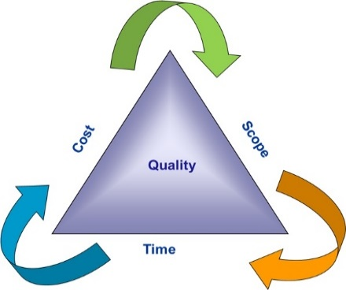
It would be beneficial to explain to the client about the triple constraints process before a decision is made, (see fig 1). According to Dobson (2004), triple constraint issues are at the core of the most crucial decisions about a project. Failure to understand them is enough to trouble any project.
Fig 1

Prakash, V. (2017)

Throughout the project the PM will be in constant communication with the principle contractor, receiving updates on the project reviewing that it is being built to specification and is following schedule, if the project is not on schedule then there would be meetings held to discuss why. The PM can then go back to the client with this information. Should the client require any changes, it will be to the benefit of the project if the client was to speak to the principle contractor and architect to ensure the information about any changes is passed on as soon as possible to avoid any problems or time delays.

Principle contractor – Sub contractors
It is the principle contractor’s responsibility to communicate with the sub-contractors ensuring they are carrying out their work correctly. It is also the duty of the principle contractor to ensure health and safety standards are met and continued to be adhered to throughout the project.

Clerk of works
As previously stated, quality is an important factor of the proposed project, therefore, a clerk of works would be very beneficial. As their role requires them to comprehensively oversee the quality and safety of the work being carried out. It would be their role to ensure building plans and specifications are being followed, carrying out regular inspections of the work and to compare work that has been completed to the design plans and drawings.
Communication Flow chart for traditional procurement
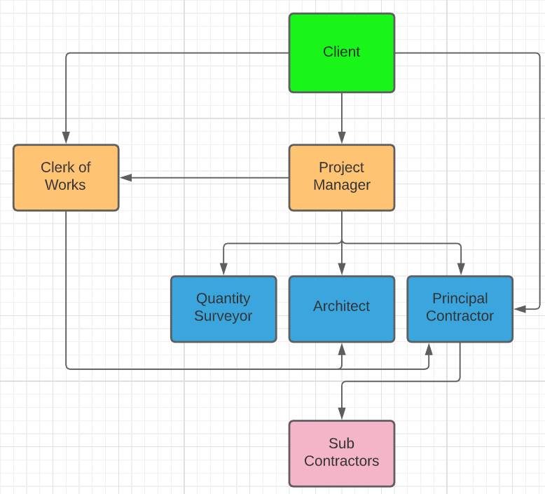

Quality management procedure
Quality control measures are required during the building process to enable the finished product is fit for purpose, able to last the tests of time and quite possibly the most important, the safety of the building and its occupancies. According to the CIOB (2018), due to defects 17 schools in Edinburgh had to close in February 2017, and later that year the tragic fire at the Grenfell towers took place. Due to this the Code of Quality Management was developed.

Quality management system.
The quality of a finished product can be seen as subjective. Everyone has a difference of opinion on what they see as high quality or terrible quality, but there has to be a minimum quality to be achieved to meet guidelines and standards. To achieve at least the minimum a quality management system can be put in place. This system can be adapted in order to fulfil the client’s quality expectations.
According to Jewell, Et al, (2019), clients want good quality, reliability and consistency with projects that meet expectations and requirements.
In order to keep control of quality throughout the build, there are many things that can be done.
One quality system to be used would be a quality checklist. This can lay the foundation for the expected quality from the outright of the project. At the start of the project the checklist can be developed between the client and the project manager and even the clerk of works if one is to be used. This way as the project is progressing the checklist can constantly be referred to and tick off the quality targets as they are achieved.
Another way of ensuring quality would be to employ contractors that are ISO 9001 certified. ISO 9001 is based on strong customer focus, quality management principles and to continually improve. By using contractors with ISO 9001 accreditation helps ensure good quality products and services.
As well as ISO 9001, ISO 9000 and ISO 10005:2018 would be ideal to follow.
ISO 9000 ensures a processed approach using a management process through a Plan, Do, Check and Act (PDCA) cycle. Using this cycle enables Understanding and consistency, Achievement of effective process performance and the improvement processes from the data and information.
ISO 10005:2018 provide quality management guidelines, for quality plans.
In order to continuously monitor the quality and progress of the construction project, a real time integrated communication system would be of benefit. According to Leung, et al, (2008), site monitoring is an indispensable procedure in construction quality control. It minimises defects and human error, while supporting project members in being able to make decisions at critical points during the build. Using this system will be especially beneficial in the current climate with Covid-19.

Quality Assurance (QA) is not only a great way of improving quality standards but gives the client and the end user confidence in the build quality. Quality assurance itself is a way of preventing defects in manufactured products and helps avoid problems when delivering services to clients. Quality Assurance is a quality management process backed by ISO 9000.
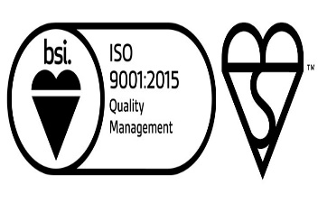
In order to maintain QA there are many tests that can be carried out throughout the construction process. As previously stated testing manufactured products before they are used, only using materials that are kite marked, as BSI, (2021), state it is one of the most recognised symbols of quality and safety and offers true value to customers, businesses and procurement practices.
As well as kite marks, all materials should meet the relevant standards, as should the work carried out. Whether they are British standards (BS), British standard European Norm (BS EN) or globally recognised standards (ASTM). Examples of these would be:
- BS 8004:2015 – Which is the code of practice for foundations
- BS EN 1993-5:2007 – Which is the design of steel structure. Piling
- ASTM E2112 - 18 Standard Practice for Installation of Exterior Windows, Doors and Skylights.

As well as ensuring these standards and codes of practices are met, there are also other tests that can be carried out as the project is ongoing. Concrete testing can be done at varying stages and for different reasons. A sample of fresh concrete can be carried out (ISO 1920-1:2004), the strength of the hardened concrete (ISO 1920-4:2020), and a density and water penetration depth (ISO 1920-5:2018) can be done. Another test that would be done is an air permeability test under part L1A and L2A of the building regulations. Along with these tests on completion there will be electrical, gas and plumbing certificates completed.

Process map

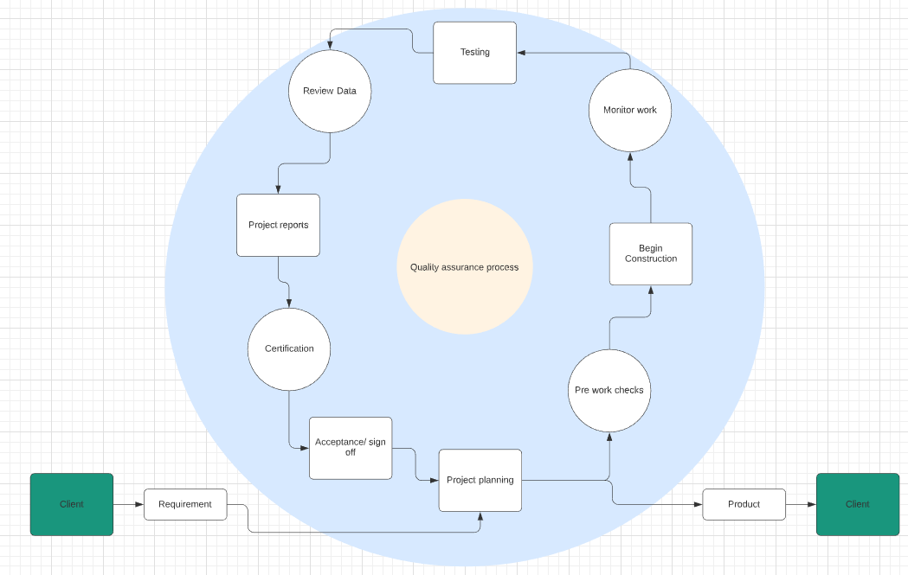

In order to continuously improve quality and ensure the quality standards remain throughout the project, the process map can be continually used at different stages during the build, it acts as an infinite loop cycling through and repeating the sequence of activities.

After sales Flow chart

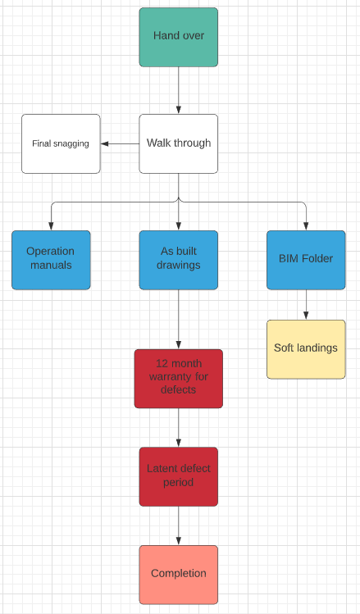

The flow chart identifies how once the build is complete, the next stages that happen. The walk through can be done to show the appropriate personnel functions and controls of the building such as heating and electrics. As well as the walk through operating and maintenance manuals will be provided as well as health and safety files. The final BIM folder with fully working 3D models of all mechanics, training on using the BIM file would be available (soft landings). There is a twelve month contracted warranty period covered by the main contractor for any defects, followed by a latent defects period which can last six to twelve years dependant on the contact, the Limitations Act 1980 states, ‘the Act allows actions for breach of contract and tort, such as negligence, to be brought within a period of six years under a simple contract and twelve years if the contract is executed as a more formal deed.’
Conclusion
The following report has looked in to the communication process through the traditional procurement process. How a construction project is created using this process and the professionals involved. From there it delved into how quality management and a quality management system can be used to ensure quality standards are met through documents and processes. Then showing how even after the build is complete the contractor can remain under the contract for many more years.

References

ASTM E2112-18, Standard Practice for Installation of Exterior windows, Doors and Skylights. Available at: https://www.astm.org/DATABASE.CART/HISTORICAL/E2112-18.htm. [Accessed 01 January 2021].

BS 8004:2015 Code of practice for foundations. Available at: https://www.thenbs.com/publicationindex/documents/details?pub=BSI&DocID=310971. [Accessed 01 January 2021].

BS EN 1993-5:2007 Eurocode 3 – Design of steel structures. Piling. Available at: https://www.thenbs.com/publicationindex/documents/details?pub=BSI&DocID=282375. [Accessed 01 January 2021]

CIOB, (2018). Improving quality in construction. Available at: https://www.ciob.org/industry/politics-government/campaigns/construction-quality-commission. [Accessed 31 December 2020].

Cockram, R. (2005). Briefings in real estate finance. Wiley and sons: Chichester.

Dobson, M. (2004). The triple constraints in project management. Berrett-Koehler: Vienna.

ISO, (2015). Why ISO 9001? Available at: https://www.iso.org/iso-9001--quality-management.html. [Accessed 31 December 2020].

ISO 1920-1:2004, sampling of fresh concrete. ISO 1920-4:2020, Strength of the hardened concrete. , ISO 1920-5:2018, Density and water penetration depth. Available at: https://www.iso.org/committee/49900/x/catalogue/. [Accessed 01 January 2021].

Jewell, C. and Flanagan, R. (2019). Code of Quality Management. Chartered Institute of Building.

L1A: Conservation of fuel and power in new dwellings, L2A: Conservation of fuel and power in new buildings other than dwellings. Approved Document L: Conservation of fuel and power – parts L1A, L1B, L2A and L2B. Available at: https://www.labc.co.uk/professionals/building-regulations-guidance-documents/approved-documents-and-technical-guidance-england/approved-document-I-conservation-fuel-and-power. [Accessed 02 January 2021].

Leung, S., Mak, S., Lee, B. (2008). Using a real-time integrated communication system to monitor the progress and quality of construction works. Automation in Construction. Volume 17, issue 6, pages 749-757.

Pinsent Masons. (2011). Limitation periods under English law. Available at: https://www.pinsentmasons.com/out-law/guides/limitation-periods-under-english-law. [Accessed 2 January 2021].

Prakash, V. (2017). Balancing the triple constraints triangle. Available at: https://www.pmwares.com/blog/balancing-triple-constraints-triangle/. [Accessed 28 December 2020].

The British Standards Institution (2013). Construction prequalification questionnaires. Available at: https://shop.bsigroup.com/upload/PASs/PAS91-2013.pdf. [Accessed 29 December 2020].

