REPORT
BA INTERNATIONAL HOTEL MANAGEMENT
Managing Guest Service Operations
Learning Log for Housekeeping and back-of-house areas
Hotel Placement selected: Premier Inn Bracknell Central Hotel

Student Name: Ana Maria Dobrinoiu
Student Number: 2017713
Module name and number: Hotel Placement – Managing Guest Service Operations (BMIH6003)
Lecturer: Christopher Wilkin
Date: 12/06/2023

List of Figures and Tables used in the report
Figure 1 illustrates Kolb's Reflective Model 6
Figure 2 illustrates the Housekeeping Cleaning Department Services 13
Figure 3 illustrates the Solar Panel services to their guests 13
Figure 4 illustrates the cleaning laundry services of the Backoffice staff and gives the customers an outclass ambience 14

Table of Contents
Introduction 4
Critical Discussion 4
Reflective Analysis 6
Conclusion: 8
References: 9
Appendices 11
My Action Plan 11
Evidence: 1 13
Evidence: 2 13
Evidence: 3 14

Introduction
Premier Inn is a major hotel network, part of the Whitbread Company, operating over 800 hotels with 77,000 guest rooms in the UK. There are also over 20 hotels in Germany in several important cities.
Housekeeping is an integral part of any hotel because it keeps guest cabins and public areas tidy. They supervise the housekeeping staff, ensure that all guest rooms meet quality standards, maintain the security of the hotel's public areas, and preserve the hotel's aesthetic appeal. Moreover, they are essential for creating unforgettable guest experiences (Chan, Gao and McGinley, 2021).
This report critically evaluates my hotel supervisory position inside the Hotel Back Office and Hotel Administration Operations, and I appreciate the value of work-based fundamental skills gained during my shadow placement at the Premier Inn Bracknell Central Hotel. This report systematically analyses management performance in the workplace and tackles Hotel Administration-related concerns. Finally, the report concludes with a conclusion.

Critical Discussion
This section critically discusses my evidence for the most significant management issues I observed in my shadow position in the Hotel's Back-office administration operations.
According to Lin et al. (2019), hotel cleanliness is essential because it directly impacts guests' satisfaction and productivity. Since the hotel's primary source of revenue is the provision of accommodations, the hotel business undeniably impacts the hotel's bottom line (Lin, 2019). The key management issue of the Premier Inn Hotel Back- office and administrative operations is maintaining coordination with the management team to complete the task on time. In order for the customer to have a positive experience, the hotel organisation must maintain high-quality services. The Premier Inn Hotel offers reasonably priced accommodations of superior quality (Baek, Choe and Ok, 2020). The primary responsibilities of a hotel back office include managing the property's financial, administrative, technological, and service delivery issues.
These back offices are typically supervised by senior management or a competent outsourced team that manages remote issues (Chan, Gao and McGinley, 2021).
Based on my experience, I was responsible for cleaning the rooms with the assistance of the housekeeping staff and learning the three-step method (strip, sanitise, and set up). After cleaning, I remained with the Room Checker to observe the inspection procedure. On Mondays, this technique is utilised to handle the room linings. On Sunday, we organised everything that was brought back. In hotels with fewer than 100 rooms, like Premier Inn Bracknell Central, the function of supervisor has been assumed by a trained person called the Room Checker. This person is responsible for cleaning the lobby and hotel entrance, tallying lined and rejected products, loading the dishwasher with mugs and glasses, scrubbing soiled linens, cleaning the hallways, and reporting stock levels to management.
My position at the hotel required me to also complete an online training course which gave me more in-depth knowledge about how the system works in Premier Inn (Naumov, 2019).
As per the lost opportunity, as I was tasked with managing the hotel's back-office operations, I observed a lack of coordination between the various levels of management, which hindered the hotel's ability to provide exceptional service and reward loyal customers.
My proposed actionable solution to this management issue is to improve the customer experience, the Premier Inn Hotel management should be well informed on how to assign tasks based on staff experience to maximise the quality of service provided to guests (Shin, Perdue and Kang, 2019).
I also observed how the Housekeeping and Reception teams handle management issues and organise their staff. The hotel's housekeeping staff, who are responsible for managing and cleaning guest rooms, the lobby, and other public areas, should not be visible to guests, in my view. But their backend support is very useful for processing all the Hotel operations effectively. To effectively complete the task, it is necessary to coordinate the entire staff's efforts. The staff must meet a success measure in the back office. The management must have backup workers ready to finish the task on time if a member of the staff is missing (Sklyar et al., 2019).

Reflective Analysis
This reflective analysis is based on my overall learning experience, significant skill development, theory application, lost opportunities, and prospective career development/skill application. Kolb's reflective model is a well-known method for learning through reflecting on one's prior experiences. In 1984, David Kolb proposed this model based on the idea that true learning takes place only when the learner is involved in and can reflect upon the experience (Morris, 2020).
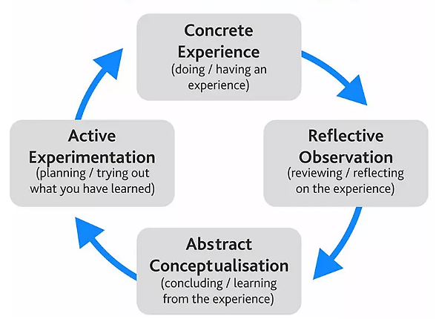
Figure 1 illustrates Kolb’s Reflective Model
Source: (Morris, 2020)
By using the Kolb Reflective Model, my Learning Log is intended to be a self-reflection of my progress and a review of my experience with Hotel Placement. There are four steps to learning from experience:
Concrete Experience
As a supervisory member of the hotel staff, I worked in the back office of Premier Inn Bracknell Central hotel. My goal is to participate in a hotel back-office activity to increase my knowledge and skills in hotel management. When I am responsible for managing multiple cleaning services, I deal with a variety of issues. Due to the hotel's layout, prompt cleaning for guests can be difficult and requires a comprehensive evaluation and staff cooperation (Pathak, Snghal and Rana, 2021). The Manager's first task is to devise a plan that will unite the entire staff.

Reflective Observation
They offer convenient cleaning services to hotel guests, and I have personally witnessed their dedication to client satisfaction. At this stage, I can assess the performance of my emergency response system. When management is able to look back and evaluate a situation objectively, they may use reflective observation. As part of this strategy, we will assess the benefits and drawbacks of the current personnel arrangements (Lee and Lee, 2020).
Abstract Conceptualism
After evaluating the performance of my back-office management staff, I would consider how I could improve and advance in a particular task. This strategy helped me study more efficiently and develop myself in other areas, such as how I respond to certain situations during events or activities. As a shadow supervisor, you are responsible for observing all staff members performing their duties. To develop a solution, the manager will rely on their "natural instinct" and draw upon their extensive experience. This implies that the supervisor must draw from both their own experience and knowledge gained from other sources (Lin, 2019).
Active experimentation
After learning from my colleagues in the back-office operations and observing how various tasks are performed, I can tell that the reception receives the client’s request to remake a room and then it passes on to housekeeping to complete it on time. In addition to learning more about how hotels operate, I strive to develop my interpersonal skills so that I can provide the highest quality customer service possible. This action increased my knowledge and enhanced my abilities for future activities and events. The method which is commonly referred to as "trial and error," is when the manager must continue experimenting the test and trial until an appropriate response is found (Gautam and Gaurav, 2022).
From the above reflective analysis, it is indicated that the model may be utilised by managers in the back offices of Premier Inn hotels as a method for solving problems and learning from experience systematically and efficiently. Consequently, the back-office administrators of Premier Inn hotels can utilise their experience to make more informed strategic and operational decisions (Koh and Hassim, 2021).

Conclusion:
It is concluded that housekeeping is the department of a hotel that takes care of cleaning and maintaining the guest rooms and common spaces. The Room Checker in Premier Inn Bracknell Central is responsible for counting the dirty linen that goes to cleaning station and the clean linen that comes back. The number of guests who book a room at a hotel depends on several factors, including the convenience of its location, the comfort of its rooms, the cleanliness of its bathrooms, and the safety of its hallways and public areas. The hotel should be prepared for any staffing emergencies that may arise. When it comes to guest satisfaction, it all begins with the manager, who is responsible for hiring, screening, and training the staff.

References:
Baek, J., Choe, Y. and Ok, C.M., 2020. Determinants of hotel guests’ service experiences: an examination of differences between lifestyle and traditional hotels. Journal of Hospitality Marketing & Management, 29(1), pp.88-105.
Chan, J., Gao, Y.L. and McGinley, S., 2021. Updates in service standards in hotels: how COVID-19 changed operations. International Journal of Contemporary Hospitality Management, 33(5), pp.1668-1687.
Gautam, T. and Gaurav, S., 2022. A Research on Hotel Management System. International Journal of Research in Engineering, Science and Management, 5(6), pp.153-154.
Inn, P 2023, Bracknell Hotels | Book Hotels In Bracknell Central | Premier Inn, viewed 29 May 2023, <https://www.premierinn.com/gb/en/hotels/england/berkshire/bracknell/bracknell-central.html>.
Koh, W.S. and Hassim, Y.M.M., 2021. Hotel reservation management system. Applied Information Technology And Computer Science, 2(2), pp.973-992.
Lee, S.M. and Lee, D., 2020. “Untact”: a new customer service strategy in the digital age. Service Business, 14(1), pp.1-22.
Lin, Y., 2019. Research on Hotel Service Quality Based on Customer Value Perception. In International Workshop on Education, Development and Social Sciences. (697-700). Tokyo, Japan.
Morris, T.H., 2020. Experiential learning–a systematic review and revision of Kolb’s model. Interactive Learning Environments, 28(8), pp.1064-1077.
Naumov, N., 2019. The impact of robots, artificial intelligence, and service automation on service quality and service experience in hospitality. In Robots, artificial intelligence, and service automation in travel, tourism and hospitality (pp. 123-133). emerald publishing limited.
Pathak, A., Snghal, A. and Rana, B.K., 2021, December. Review the hotel management system. In 2021 3rd International Conference on Advances in Computing, Communication Control and Networking (ICAC3N) (pp. 1834-1837). IEEE.
Shin, H., Perdue, R.R. and Kang, J., 2019. Front desk technology innovation in hotels: A managerial perspective. Tourism Management, 74, pp.310-318.
Sklyar, A., Kowalkowski, C., Tronvoll, B. and Sörhammar, D., 2019. Organising for digital servitisation: A service ecosystem perspective. Journal of Business Research, 104, pp.450-460.
‌

Appendices

My Action Plan
My action plan proposes that I will continue to study and acquire knowledge gained from the numerous experiences I had throughout my hotel experience job in order to enhance the number of skills I have by using the services of the Back-Office Department.
This table demonstrates the responsibility of the Department of Housekeeping.
Back-Office Management | Responsibilities
The Executive Housekeeper | - Their responsibilities include recruiting, training new employees in the appropriate programme, and motivating existing staff.  - Schedules employees in accordance with room occupancy projections and banquet functions.  - Inspects and monitors housekeeping property and equipment.  - plus upgrades
Assistant Executive Housekeeper | - They support the executive housekeeper, take over in their absence, help with all aspects of housekeeping on a regular basis, and do laundry.  - Physically checks the areas for cleanliness, the occupancy report, the room attendants' report, and the staff under her control.  - Makes and hands out room keys and an inventory form for the floor.
Floor Supervisor | - They are in charge of allocating rooms and issuing room keys to housekeepers.  - I conducted room inspections, produced an occupancy report, and emailed it back to the front desk.  - Informs command staff of housekeeping maintenance chores.  - Addresses issues reported by guests, such as a lack of clean towels or bedding or a lack of washing facilities.  - All information about guest room linens is documented.  - Notifies management, the front desk, and the admissions staff when a room is ready for guests to move in.

My Observational Evidence at Premier Inn Hotel (Back-Office Operations)

Evidence: 1
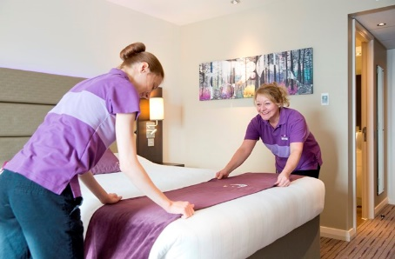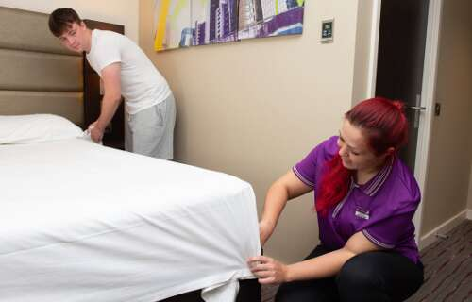
Figure 2 illustrates the Housekeeping Cleaning Department Services
Source: (Chan, Gao and McGinley, 2021)
From the above image, it is indicated that the management of the Housekeeping Department gives premium services to their guests.

Evidence: 2
Extra ecological services: Ecological and environmental considerations are taken into account in the hotel's room service. The Premier Inn hotel has replaced over one hundred thousand incandescent lanterns with LEDs because LEDs are 40 times more durable and consume less energy. Premier Inn has doubled its use of solar panels, and 88 of its hotels are now powered by the sun.

Figure 3 illustrates the Solar Panel services to their guests
Source: (Inn, 2023)
From the above image, it is indicated that the management of the Back-office department of the hotel also implements green strategies to comply with government regulations and provide their clients with an exceptional experience (Inn 2023).

Evidence: 3
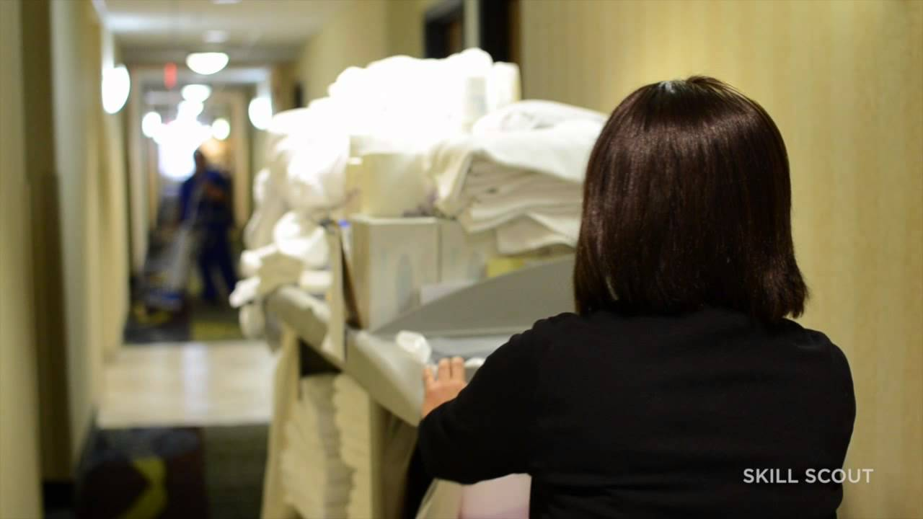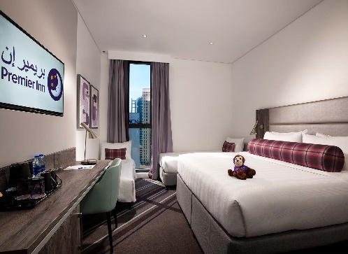
Figure 4 illustrates the cleaning laundry services of the back office staff and gives the customers an outclass ambience.
Source: (Inn, 2023)
From the above images of the cleaning services of the laundry staff, it is indicated that in order to enhance the customer service experience, the back-office management of the hotel provides fast cleaning services in order to deliver superior hotel service (Inn, 2023).

