

Undergraduate assignment feedback form
(to be completed by marker)

Student Name: Charlotte Sophie Harris

Module Code: Roderick Bowen Centre: Archives and Research.  Module title: HUSK6004 | Student number: 1500391
For completion by marker:
Comments:

Marker’s signature: |  | Date:
Provisional mark:
NB. All marks are provisional until confirmed by the final examination board.

Frederick Seaton Smith 1886-1918.
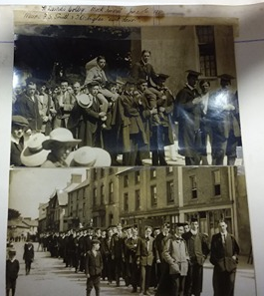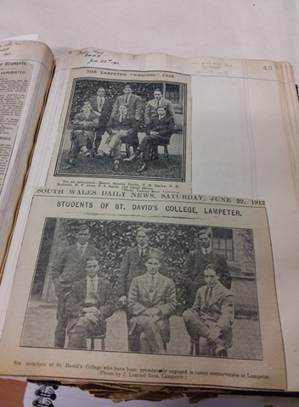
Images of Seaton smith, Top left with Hughes. Top right photo; Smith is front centre. Shown again in photo below.

General Information:
Born:
17/8/1886 in Monk Seaton, Northumberland.

Died:
15/11/1918.

Occupation at death:
Royal Army Chaplain. 4th Class.

Others:
Curate.

Education:
St Peter's School, York – 1899-1902,
St David's College, Lampeter –1910-1913. (BA Ordinary). Register No. 2326.

Biography:
There does not appear to be any large quantity of information on Smith and his background. In his commemoration after his death, his parents are listed as Mr Frank and Mary Jane Smith. It is unclear as to whether he had any siblings. From the Tutor’s register, we know that his family had ownership of coffee plantation suggesting that he was from a relative wealthy background, although no other supporting evidence has been found of this. We also know that he married Martha Lillian Boyden. He married Martha on the 20th of April 1911, interestingly whilst he was away from the college, having been banned for 3 terms (discussed below).
Frederick Seaton Smith started at St David’s College, having come from St Peter’s School York at the beginning of the Academic year in 1910. He was not an exemplary student. Throughout his examinations, Smith did not exceed a 500/1000 mark. In his Responsions in 1910 (December), he gained his highest mark of 486/1000, in his Moderations (1912) he gained only 350/1000 marks. In the final exam of 1913 he gained a marks of 350. This means that he finished in 1913 with a 3rd class Honours degree in Theology (406/1000). It would appear that Smith’s actions after his joining the college may well have had a significant impact on his academic performance.
We can also see that when Smith was dismissed for 3 terms for reasons discussed below, he returned to the university for the last term, although he does not take an exam. This would suggest that he may have been allowed back into the university but not necessarily allowed to study. Or perhaps, his behaviour allowed him back into the college. The sources for this are the kitchen and residency books, these enable us to see how much Smith had been eating and drinking between 15/1/1910 and 20/12/1913 (£34, 4s, 2d overall) and his residency in halls between Lent term 1910 (his 1st term) and Michaelmas term 1913 (His 9th term) meaning he fulfilled the require number of terms with which to obtain a degree.
Smith appears to have been a rebellious student during his time at the College, with multiple records of offenses, including minute book and local papers. Offenses included breaking in to another student’s room (O.H. Hughes) and for assaulting and harming another student (H. Morris) within a group of students over a legislative dispute connected with the church and ‘ragging'. These issues resulted in Smith being removed from the College for 3 terms and Hughes being removed for 2 terms. Ragging is currently an offence within Universities involving humiliation, peer pressure and often younger students being forced into situations with which they are uncomfortable. It is connected with initiations that are taken to far, causing harm or distress to those involved. Smith breaks into another students room, causing damage to its contents. It is not completely sure if this is the incident which is referred to as the ‘Lampeter Ragging Incident’ by the papers. However, seeing as it is both Smith and Hughes referenced and photographed in the article, it is highly likely. We see Smith again referenced and photographed due to the assault on Morris is later, involving 5 students, it is sparked by unrest caused by a Disestablishment Bill and various anonymous student letters to sent to the paper, arguing sides. Rising tensions caused some of the students, including Smith to become violent towards the opposing side. We have various clippings surging relating to this incident of violence and it appears to have been significant enough to require legal action by magistrates, with both sides supported by lawyers. This occasion was of high interest as the paper records proceedings in detail. the unrest caused by the incident caused one unfortunate lecturer to lose his position, presumably Professor Green, who had tried to intercept students as they passed his house and Smith to be removed from the College from 3 terms.
Smith finished at St David’s College in 1913 with 3rd class BA Ordinary. He went on to become a curate, before becoming a Royal Army Chaplain. Smith gained his first curacy in 1913 at St John's Bradford and then moved in 1916 to become Curate for All Saints, Leeds according to his memorial in the College magazine.
A curate is essentially a parish assistant helping the vicar or main personage of the parish in their work as describes in Canon Law. This is generally a position from which to advance from. However, there are records of Bishops, once retiring, becoming curates in their respective parishes.
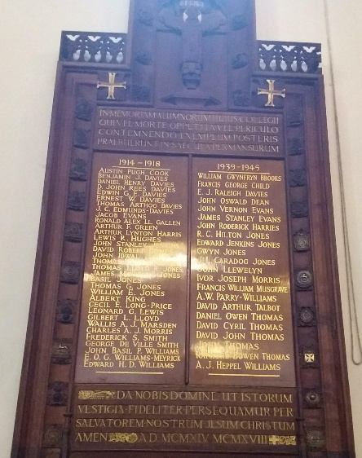
Smith became a Royal Army Chaplain voluntarily in 1918, attached to the 13th Battalion of the York and Lancaster Regiments (1st Barsnley Pals). This battalion was in turn attached to 94th Brigade, 31st Division and saw heavy fighting in France in 1918 then moving to Flanders to rest due to heavy casualties. However, the battalion was then caught in German offensives in Flanders (Nieppe Forest). The battalion then moved to Ypres and the Action of Tieghem. Smith was injured in the final days of the War, evacuated to Wimille and tragically died of his wounds on 15/11/1918. There is a cemetery/memorial reference available: XI. A. 29. He was commemorated in the College magazine, and in Terlincthun cemetery and on the College War memorial shown below.

Bibliography:

Roderick Bowen Archive Sources:
UA/SP/1/75. St David’s College Magazine. P32.
UA/SP/1/9. St David’s College Magazine. Vol. XI, 1913. No. 1. P18-50.
UA/A/38. SDC Examination book.
UA/C/1/7. SDC Minute Book. June 5th, 1911 Entry.
UA/CP/40. Pp26-30
UA/A/18. SDC Tutor Register. No. 2326.
UA/BUR/28/7. Residency book 1900-1914.
UA/X/132/12. 2 Photographs of O.H. Hughes and F.S. Smith. P26.
UA/X/132/12. Cutting of 1911 degree day and address concerning ‘Ragging’. P27.
UA/X/132/12. Cutting of 1912, concerning ‘Ragging'. P32.
UA/X/132/12. Cutting concerning Disestablishment Bill campaign that led to violence with which Smith was involved. P33.
UA/X/132/12. Multiple cuttings of article including photographs of legal action against Smith and others due to Assault on Hughes. P44-46.
SD/2: Kitchen Book. Lent term 1910-Michaelmas term 1913. Pp149-182.

Websites:
Code of Canon Law. Intratext. 2007. Available from: http://www.intratext.com/IXT/ENG0017/_P1T.HTM. Last Accessed: 1/3/18.
Code of Canon Law. Vatican Archive.n.d. Available from: http://www.vatican.va/archive/ENG1104/__P1U.HTM. Last Accessed: 1/3/18.
Frederick (Fred) Seaton Smith. Wales at War. 2018. Available from: http://www.walesatwar.org/cy/individual/detail?id=1920. Last Accessed:1/3/18.
Frederick Seaton Smith Family Ancestry Tree. 2018. Unpublished – Private Member. [Online] www.ancestry.co.uk. Last Accessed: 25/2/18.
Lampeter (St David’s College) War Memorial. West Wales Memorial Project. 2018. Available from: https://www.wwwmp.co.uk/ceredigion-war-memorials/lampeter-st-david-s-college-memorial/. Accessed: 1/3/18.
Record Card of F.S. Smith. Royal Army Chaplains Archive. 2018. Available from: https://www.chaplains-museum.co.uk/archive/record-cards/223767-smith-fs-01jpg. Accessed: 1/3/18.
Smith. The Rev. Fred Seaton. CWGC. Available from: https://www.cwgc.org/find-war-dead/casualty/4027237/smith,-the-rev.-fred-seaton/. Last Accessed:1/3/18.
The Rev. Fred Seaton Smith. N.d. St Peter’s York. Available from: https://www.stpetersyork.org.uk/great_war_memorial/the_rev_fred_seaton_smith. Accessed: 1/3/18.
Unit History: York and Lancaster Regiment. Forces at War. 2018. Available from: https://www.forces-war-records.co.uk/units/328/york-and-lancaster-regiment/. Accessed: 1/3/18.

Books:
Neep & Edinger. A Handbook of Church Law for the Clergy A.R. Mowbray & C° (1928), p.24.

Images:
Lampeter war memorial. 2018. Author. Unpublished.
UA/X/132/12. 2 Photographs of O.H. Hughes and F.S. Smith. P26. 2018. Author. Unpublished.
UA/X/132/12. 2 Photographs of Smith and other students involved in dispute. P43. 2018. Author. Unpublished.

Left. UA/X/132/12. P26. Right: UA/X/132/12. P43.
UA/SP/1/75. P32.
UA/A/18. No.2326.
Frederick Seaton Smith Family Tree. 2018. Ancestry.
The Rev. Fred Seaton Smith. N.d. St Peter’s York.
UA/A/38. SDC Examination book.
SD/2. Ledger folios; Pp149-182. UA/CP/40. P30; UA/BUR/28/7.
UA/X/132/12. Pp26-46.
UA/X/132/12. Pp26-46; UA/SP/1/9. P18-50.
UA/SP/1/75. St David’s College Magazine. P32; UA/SP/1/9; P18-50.UA/SP/1/9. P50; Frederick (Fred) Seaton Smith. Wales at War. 2018; Smith, The Rev. Fred Seaton. CWGC. 2018.
Code of Canon Law. 2009; Code of Canon Law. n.d; UA/SP/1/75. St David’s College Magazine. P32; UA/SP/1/9; P18-50.UA/SP/1/9. P50
UA/SP/1/75. P32; UA/SP/1/9. P18-50; Frederick (Fred) Seaton Smith. Wales at War. 2018.; Smith. The Rev. Fred Seaton. CWGC; Unit History: York and Lancaster Regiment. Forces at War. 2018; Lampeter (St David’s College) War Memorial. West Wales Memorial Project. 2018.

