What helps me learn language and mathematics? An analysis of a child’s learning in mathematics and language with recommendations for ensuring progress.

Introduction
Having a strong Language and Mathematic input from an early age will help learners throughout their lives from day to day activities to job-related prospects.

“Good qualifications in maths and English open the door to a wider variety of careers than would be possible without them.” (Gibb, 2019)

Language is a very tricky subject to teach, but very important, as it varies throughout different cultures and pupils should be made aware of this. (Mukherji and O’Dea, 2000, p10) have found that a person from another culture, may be hard to interact with, even though they may be speaking the same language, as their gestures, expressions and emotions may be different from that of our own. For example, eye contact and the way we use or avoid it or what kind of body contact is appropriate to have with young children. Also, non-verbal signals can be interpreted differently internationally. For example, a thumbs up signal may be depicted as a sign of ‘good-luck’ in the UK however, in Iran it is considered obscene.
Learning Mathematics allows children to gain the skills and strategies needed in everyday life. They are able to understand and make sense of numbers, patterns and shapes that will forever be surrounding them in the world we live in. Mathematics is a powerful way of communicating.
The school being discussed is a small Primary school in Swansea, South Wales. The school is split over two different sites, one being the infant site and one being the Junior site. The pupil being discussed is a nine year old girl in year 4.
It will be discussed how this pupil learned Maths and English and also how she felt about learning these subjects. There will also be outlines for how best this pupil may progress with her learning through recommendations. The pupil was made aware of all the data being collected and was also made aware that she could end her participation at any point. Data was collected through a variety of methods, including a recorded interview, observation and map making. The pupil was very enthusiastic to take part in this process and at no point did she request to ‘opt out’ even though the option was given to her.
All learners learn differently and it has even been proposed that there are seven different learning styles: Visual, Aural, Verbal, Physical, Logical, Social and Solitary.
It was found that this pupil was very verbal and logical throughout all her learning. She loves learning and is not shy to ask questions if she does not understand something. She also was not afraid to challenge what the teacher has said if she thought it was wrong or wanted to get a deeper understanding.

Mathematics
The pupil’s knowledge in Mathematics was strong. She was placed in the top group. She had a strong sense of curiosity and desire to succeed. Two lessons were taught on 3D shapes during this practice. This topic is a hard one for a pupil to understand especially if they cannot physically interact with the 3D shape. However, Hansen and Vaukins suggest that it is very important for pupils as it allows them to become more aware of shapes and spaces around them and having it taught at a young age will allow them to experience the least confusion possible while trying to make sense of the world around them.
“Much of the language when referring to shape can also be found in everyday language. This can cause confusion because the same word may have a completely different meaning. Children not only need to be aware of these differences but need to be able to select and use the appropriate words in different situations” (Hansen and Vaukins, 2012, p54)
This class started the topic of 3D shapes after learning about 2D shapes. Theorists have different opinions on when 3D shapes should be taught. Some suggest that 2D shapes should be taught first and others suggest 3D should be taught first with the argument that we live in a world that is 3D and children will be able to make sense of the world better if 3D is taught first. Other theorists suggest that the two should be taught together. Tsao (2010) and Roth and Thom (2009) delve in to the relationship between 2D and 3D shapes.
To introduce the class to the topic of 3D shapes they started by creating their own 3D nets which got them more hands on in their learning experience which according to an Estyn (2014) report it creates a very positive experience for the children and allows them to become more confident, curious and motivated individuals. This fits perfectly with the new Donaldson curriculum ‘successful futures’ which talks about creating children who are healthy, confident individuals; enterprising, creative contributors; ambitious capable learners and ethical informed citizens.
The pupil has had a very positive attitude towards this task and even though the task at hand was quite difficult as they had to cut and stick the net together to create a 3D shape, she tried really hard and didn’t give up. She also was willing to accept any advice that I gave her like where to glue the tabs, for example.
The main skill being developed during the activity worksheet where they had to understand and identify the properties of a 3D shape (see appendix 1) would be her intellectual skills. She used a variety of thinking skills including identifying, classifying and choosing. She also used E.D.U.C.E.R.E thinking skills as she was: Engaged mentally, focusing and maintaining concentration and also keeping enthusiasm about the task throughout; Desire as she had the inclination to be resilient and tenacious; Understanding as she understood the information by representing it; Create. There was not much room for creation with this activity as the worksheet just required a right or wrong answer; Enquiring as she was continually making links to real life 3D shapes like comparing the sphere to a football, for example and therefore gave depth to the understanding; Reasoning as she gave all the precise language during discussions including the terms ‘edges’, ‘faces’ and ‘vertices’; Evaluating by checking her answers when we went through them as a class and self- marking it.
The pupil had a very good knowledge of 3D shapes and would be able to go on to explain this topic to another student if needs be.

Language
‘Language is essential for human beings for communicating, for organising ideas and, indeed, for survival. Most linguists and psycholinguists agree that it is a rule-governed system of symbols devised by humans, when they had evolved to a certain level, to enable them to communicate. Making one thing stand for another is a symbol. Sounds, words, facial expressions, body movements and letters are all symbols. (Mukherji and O’Dea, 2000, p3)
The pupil’s knowledge in Language is not as strong as her Mathematic knowledge. However, it is still strong. She was placed in the middle group. During this practice the pupils learned how to write a short story using a piece of artwork as inspiration. The welsh artist paints pictures of beaches mainly in the South Wales area. This allowed the children to get in to their stories more and created a sense of belonging within the community.
The pupils started this task by looking at short stories themselves. This allowed them to see first-hand the kind of writing that was going to be required for this task. It is very important that the learners are aware of how to be successful and the Welsh Assembly Government (2010) have created a document that outlines the various stages that teachers need to consider when teaching a class how to write as no child should be simply given an empty sheet of paper and be expected to know how to write a story. Unless the task is a cold task, which most practitioners would argue has positive features as they will be able to see what areas they need to teach and plan their lessons accordingly, the progress a child has made after being taught the lesson and they will be able to analyse the effectiveness of their lesson. However, unless they are taught coping strategies this method can be very demoralising and could even result in the child losing confidence and not wanting to write again.
The Pupil has a very positive attitude towards Language. While looking at short stories she maintained a high level of enthusiasm and she was very keen to get started on her own story. However, when they came to the task of writing the story it appeared that she lacked some confidence in her own abilities of story writing. This led to a little one on one talk which helped her build the confidence and skills in writing her own short story.
Her Reading, Oracy and writing skills were developed during this activity. She developed her reading skills by reading different short stories and gathering the different techniques she would need to use in her own short story. She then, developed her skills again by reading back over her own work after she was finished to see if she had used any of the techniques herself. She developed her Oracy skills during a think, pair, share exercise where the pupils paired up to talk about what their stories were going to be like and what techniques they were going to use. This method allowed the pupils to discuss what they were going to do before doing it and enables them to offer suggestions to one another if needs be. This technique has been found very useful by practitioners as they have found that more learners will engage with what is being talked about opposed to the teacher asking a question and one pupil offering an answer, where all the other pupils can ‘switch off’. They were also asked to read each other’s stories when they were done and give each other two stars and a wish. This Assessment for learning (AFL) strategy allows to give each other two things that they really liked about the other persons work and one thing that they think they could improve on. This technique could be good and bad. The pupils will need to be trained in this AFL strategy as they will need to understand that they should give a wish based on the success criteria given and not their personal opinion. However, if properly implemented it can be very effective as pupils love acting as teachers and can find it very useful when looking at their own work too. The student’s writing skills were developed by writing the short story, where she had learned the different techniques of writing a short story and implementing them herself.
Her knowledge on the subject did improve a great deal over the course of the learning. She would now be considered at a basic level of understanding as she can give basic information about who, what, why, when and how but with not so much detail. (see appendix 2)

Progression
This pupil has a very positive attitude towards her learning of Maths and English. (See Appendix 3) where you will hear an interview given where she explains what she enjoys most about the subjects and why. There was also a map making activity undertaken by the pupil where she was asked to identify a place in the classroom where she likes to learn Language and Mathematics. (See Appendix 4) You will see she has drawn not only her desk with an arrow pointing towards it but also the areas of the classroom where she knows she can find any information she seeks including the spelling wall, the bookshelf and the computers.
In terms of the curriculum, the next steps for the learner in a whole class setting in Mathematics would be to ‘identify congruent shapes and justify whether two or more shapes are congruent’. However, I think the next steps for this pupil individually would be to create links between 2D and 3D shapes and create the understanding that 3D shapes have a dimension to it as she did struggle to grasp the concept when a 3D shape was drawn on a piece of paper. In order to keep her attitude as positive as it is currently it is important to keep challenging her but not too much where she will lose interest because she cannot do it. She responded well to positive feedback which according to studies is normal. According to Pankonin and Myers, 2019 not only is positive feedback used to praise students’ efforts and behaviours but it can also help to mould the pupils behaviour in to a more positive one itself as when used in clear, straight-forward and positively used commands it significantly improves the students compliance to the rules.
Her skills level is proficient as she can perform the skills in a very capable manner, however in order to display outstanding skill with no significant errors and to do so without thinking the next steps for her would be to continue to develop her understanding of 3D shapes and the different dimensions between a 2D shape and a 3D shape. This also applies to her knowledge because at the moment she has a good understanding of 3D shapes and the different properties attached to them, however in order to get that deeper understanding and reach more thorough knowledge she needs to delve deeper into the understanding of the dimensions of the 3D shape.
To progress within her Language she needs to move from determined to completely focused in terms of attitude because at the moment she is focused on her learning and looking for ways to make progress however, she is scared to take creative risks in order to extend her learning. To develop her skills more she needs to be able to perform the skill in a very capable manner, because at the moment she has grasped the concept of short story writing and was able to break it up to begin with before going in to her story writing very well beginning with who the characters were going to be, the setting of the story, the beginning, the build-up, the climax and the ending. She followed the success criteria that was provided and ensured everything was included. However, to move forward it should be encouraged that she try to expand more on what she is writing, thinking about instead of writing ‘suddenly there was a big red crab’ what she could write to expand that, for example where the crab came from, where they were on the beach when they saw the crab etc. However, her knowledge of the subject is good and she was able to include adjectives and correctly use speech marks, which were not included in the success criteria due to the level of the class and therefore had a good understanding of the task at hand. To improve on this, it would be necessary to look at connective words in order to understand their relationship in the sentence and that they connect two sentences together. Another thing she could do in order to progress is to use her own techniques to plan her writing, this may include mind-mapping or sequencing instead of using the template I provided.
The lessons planned were suitable for this pupils as it allowed her to get a good understanding of the task beforehand and complete the tasks as independently as she could. Within the mathematics lesson, the teaching strategy used was modelling as the practitioner modelled how to create the net of a 3D shape before the pupils did in order to show them how to cut it and where to stick the tabs. There are six steps to follow when thinking about modelling in the Primary Classroom:
“They make it explicit what it is they are going to be modelling and why it is important – and exactly what the students will be able to do as a result.
They break the skill down into steps.
They then show them how to do each step – whether this by physically doing it, or getting students to do it with them.
As they do it, they are questioning students about why they are doing it that way, so they develop an understanding of the ‘why’ as well as the ‘what’.
They also point out common mistakes and misconceptions – and how to avoid these.
They use examples of excellent work – to demonstrate the high standards that the students should be aiming for. This may be by using exemplar work as they are producing the piece of work, or the end product itself.” (Class Teaching, 2013)
Different questioning techniques were also used during the Mathematics and Language lessons. It is important to ask questions during the lessons as it helps get learners actively involved and more motivated. It can also be used to go over previous lessons. The questioning technique is useful when trying to encourage more independent learning. It was particularly helpful with this pupil as she was always keen to impress the teacher and is quite an independent learner anyway and therefore the questions asked were to help push her along in her learning. ‘Instruction which includes posing questions during lessons is more effective in producing achievement gains than instruction carried out without questioning students’ (Cotton, 2010) This suggests that questioning techniques are beneficial within classroom situations and helps the learner move forward in their learning.
Different differentiation was used during these lessons. This pupil was placed in the middle set for English and the higher set in Mathematics and there was always planning available if the student found the work too easy and needed to move on. In the English she would be moved on to the higher tier work and for Mathematics there would be planned extended activities. This pupil never did need to move on to higher work as the level that had been planned was perfectly suitable for her.

References
Class Teaching (2013) Modelling for excellence. Available at: https://classteaching.wordpress.com/2013/11/24/modelling-for-excellence/ (Accessed: 1st April 2019)

Corbett, P. and Strong, J. (2014) Formative Assessment: The key to progress. Available at: https://www.talk4writing.co.uk (Accessed: 1st April 2019)

Cotton, K. (2010) Classroom Questioning. Available at: http://learner3.learner.org/workshops/socialstudies/pdf/session6/6.ClassroomQuestioning.pdf (Accessed: 1st April 2019)

Donaldson, G (2015) successful futures. Available at: https://gov.wales/sites/default/files/publications/2018-03/succesful-futures-a-summary-of-professor-graham-donaldsons-report.pdf (Accessed: 1st April 2019)

Estyn (2014) children learn best from first- hand experiences. Available at: https://www.estyn.gov.wales/effective-practice/children-learn-best-first-hand-experiences (Accessed: 1st April 2019)

Gibb, N. (2019) The Importance of Maths and English in our Schools and Colleges Available at: https://www.nickgibb.org.uk/news/importance-maths-and-english-our-schools-and-colleges (Accessed: 28th March 2019)

Hansen, A and Vaukins, D. (2012) Primary Mathematics across the curriculum. London: SAGE.

Mukherji, P. and O’Dea, T. (2000) understanding children’s Language and Literacy. Cheltenham: Nelson Thornes Ltd.

Nottingham, J. (2011) Develop ASK. Available at: https://www.slideshare.net/jabulani4/develop-ask (Accessed: 1st April 2019)

Pankonin, A. and Myers, R. (2019) teachers’ use of positive and negative feedback: implications for student behaviour. Available at: https://wp.nyu.edu/steinhardt-appsych_opus/teachers-use-of-positive-and-negative-feedback-implications-for-student-behavior/ (Accessed: 1st April 2019)

Roth, W-M. and Thom, J. (2009) The emergence of 3D geometry from children’s ( teacher guided) classification tasks. Routledge
Tsao, Y-L. (2010) Integrating the design mathematical trail in mathematics curriculum for the sixth grade student.
Welsh Assembly Government (2003) Developing the Curriculum Cymreig. Available at: https://learning.gov.wales/docs/learningwales/publications/130424-developing-the-curriculum-cymreig-en.pdf (Accessed: 1st April 2019)
Welsh Government (2015) Curriculum for Wales: Programme of Study for Mathematics, Key Stages 2–4. Available at: https://learning.gov.wales/docs/learningwales/publications/150717-nc-maths-en-v2.pdf (Accessed: 1st April 2019)

Appendix 1
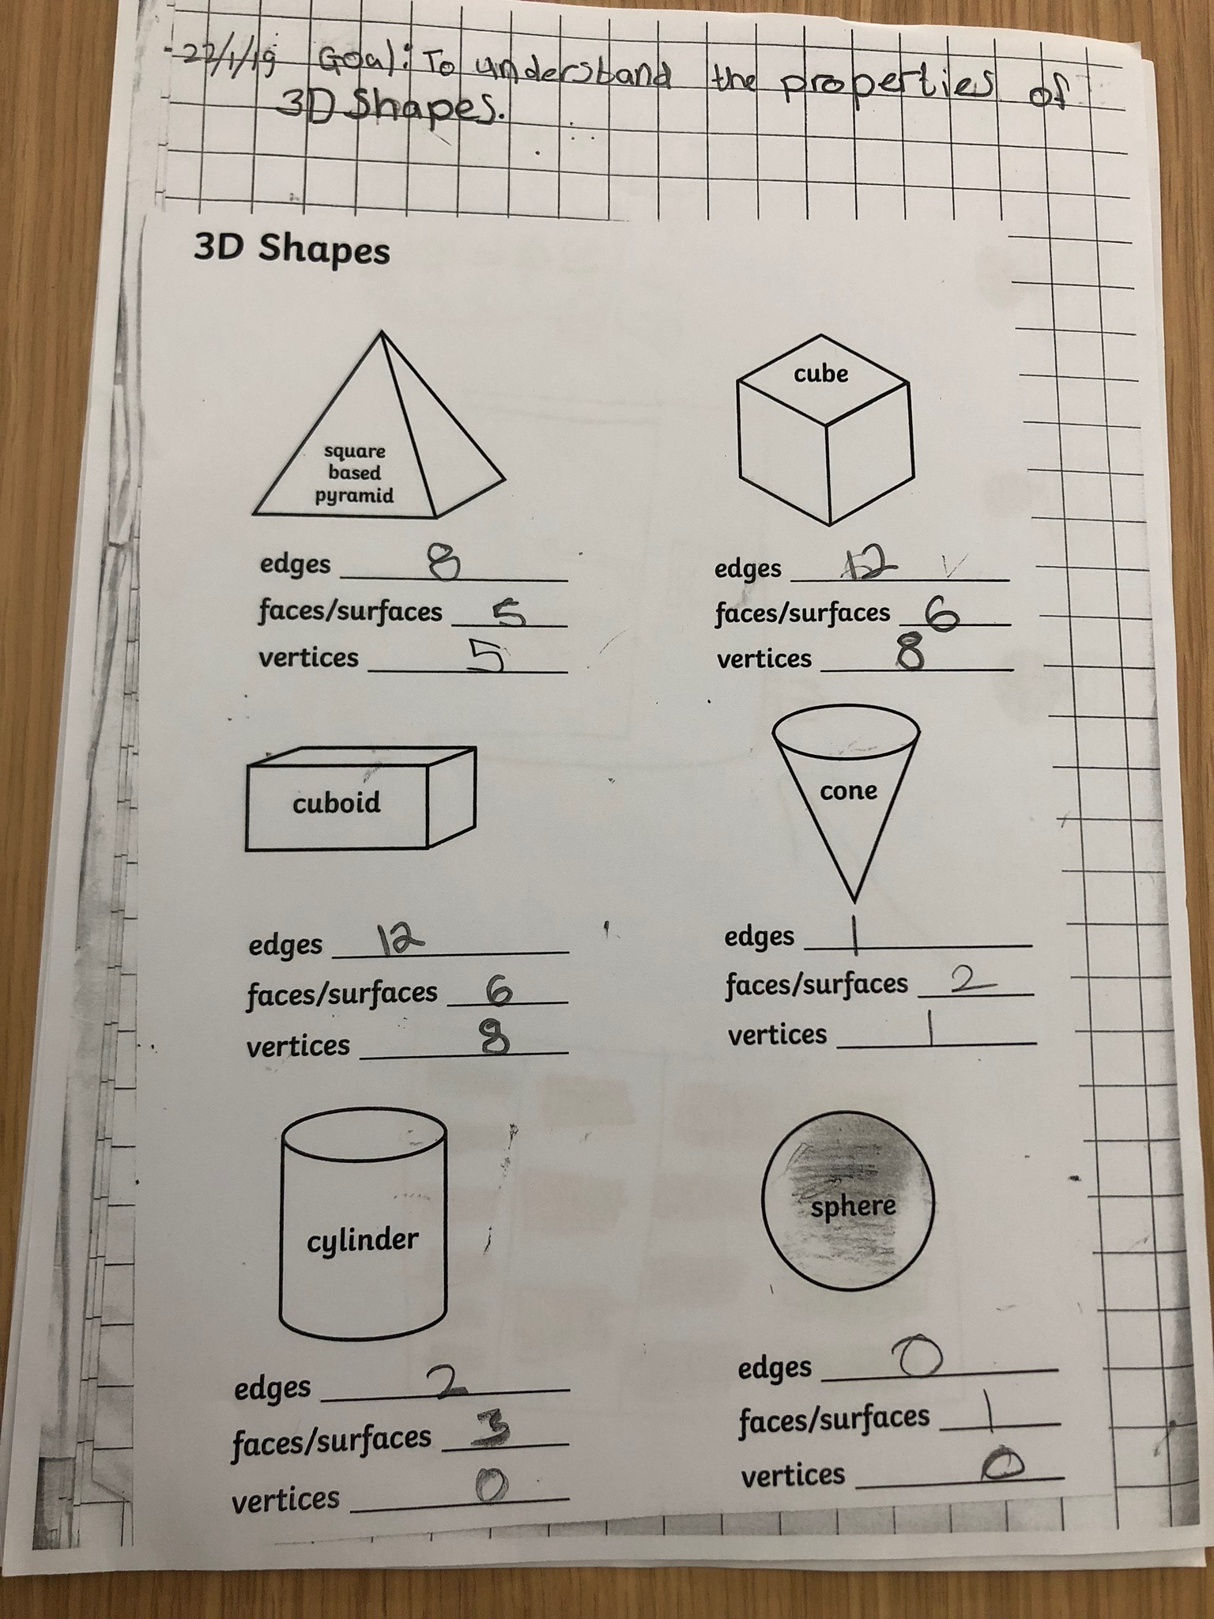

Appendix 2
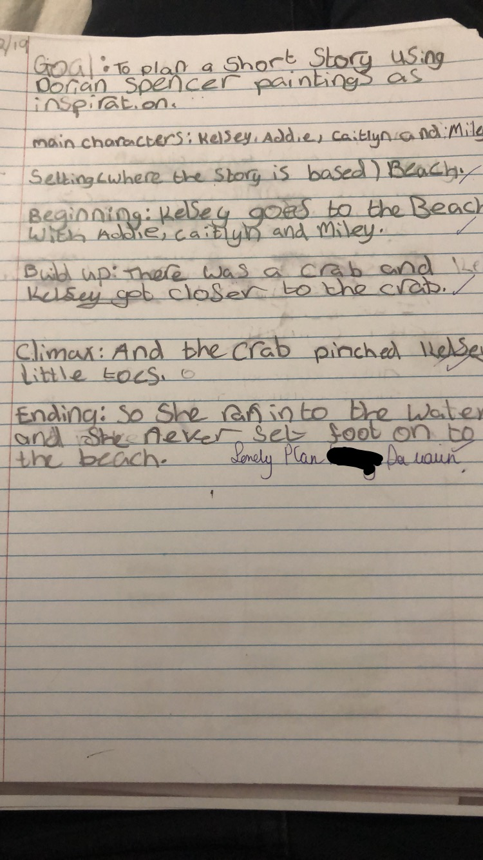

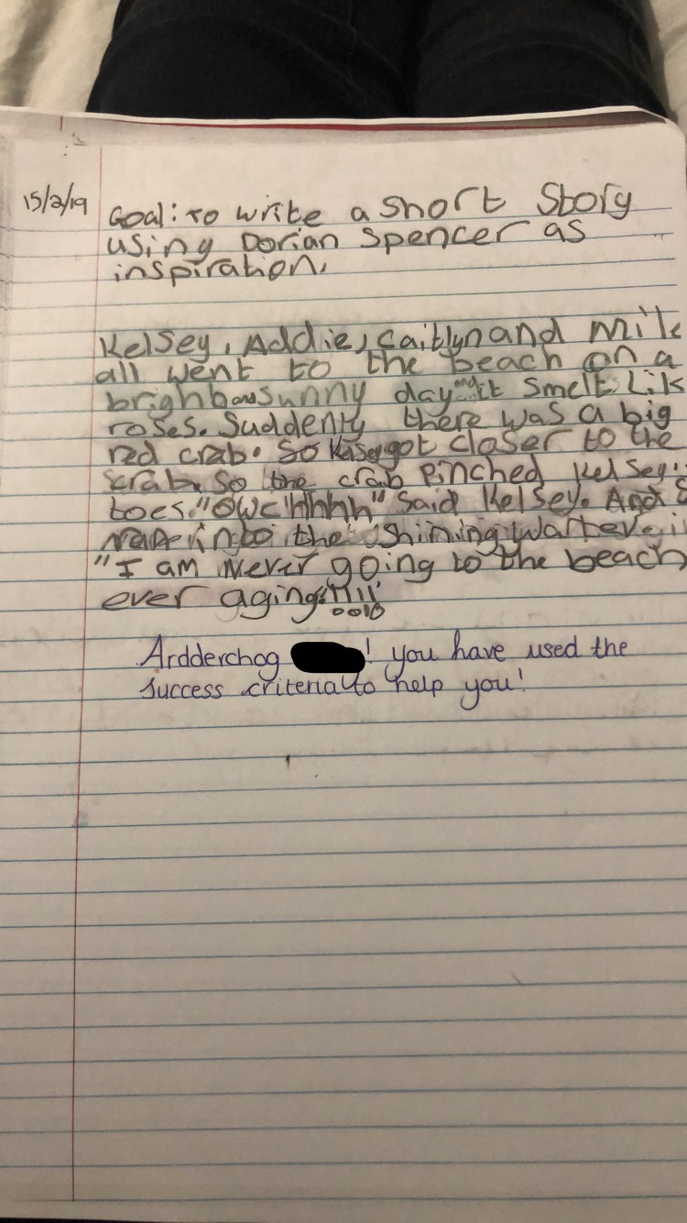

Appendix 3

https://youtu.be/lv2VVuuDXfA

Appendix 4

