Programme: MSc Public Health and Social Care in Practice
Module: Social Epidemiology and Public Health Development
Module code: LCHS7000
Assignment Title: Component 2 Analytical Report
Title: Age and health inequalities and COPD
Student Name: Dhruvi Mukesh Bhai Desai
Student ID:2534275

Table of Contents
Task 1 3
1. Introduction 3
2. Contextual Background and Underlying Factors 3
2.1 Higher Rates of Mental Illness Among Older Adults 3
2.2 Cardiovascular Disease and Other Long-Term Conditions 3
2.3 Mortality and Premature/Excess Death 4
2.4 Social Isolation and Loneliness 4
2.5 Poverty and Financial Inequality 4
2.6 Housing Inequality and Poor Living Conditions 4
3. National Response to Reduce Health Inequalities 5
3.1 NHS/Public Health Prevention and Health Inequality Policies 5
3.2 Government Welfare, Social Care or Healthy Ageing Policy 5
4. Organisation Supporting Older Adults 6
5. Conclusion 7
Task 2: Epidemiological Analysis 8
2.1 Introduction 8
2.2 Public Health Measures: The 3 Ps 10
2.3 Key Determinants and Risk Factors 11
2.4 Epidemiological Studies and Health Needs Assessment 12
2.5 Public Health Monitoring and Surveillance 13
2.6 The Plan and Usage of Epidemiology 14
2.7 Design and evaluation of an appropriate COPD health intervention programme 15
2.8 Strengths and Weaknesses of the Epidemiological Approach 16
Reference list 17

Task 1

1. Introduction
In the UK, older adults are typically considered those over 65 years old (Huang et al., 2025). Systematic and avoidable differences in health outcomes among population groups are indicated by health inequalities. There could be inequalities affecting older people as ageing can often be accompanied by increased sick days, disability, and increased demand for health services, and access to these services may be limited by socioeconomic deprivation in older people. Social isolation and poverty, and housing conditions can also affect health. Hence, this study explores the following six key health inequalities and the national responses and organisational support for older people.

2. Contextual Background and Underlying Factors

2.1 Higher Rates of Mental Illness Among Older Adults
Older adults experience mental-health inequalities, which include depression and psychological distress and anxiety and are sometimes associated with bereavement, loneliness, physical illness and socioeconomic disadvantage. But inequalities aren't necessarily equated to prevalence in every condition; in early 2026, 29% of adults aged 70+ reported high anxieties, a lower rate than the 43% in 16–29-year-olds (Office for National Statistics, 2026a). However, there can be challenges for older persons in terms of diagnosis and appropriate treatment.
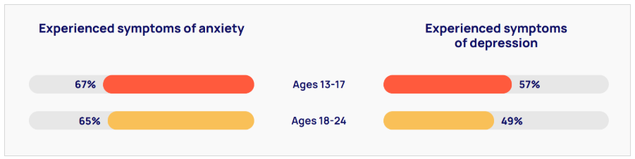
Figure 1: The Trever Projects Survey
(Source: Anxiety Checklist, 2025)

2.2 Cardiovascular Disease and Other Long-Term Conditions
Older people have a disproportionately higher burden of cardiovascular disease (CVD) which leads to morbidity, mortality and growing health care demands. To illustrate the health burden of CVD, per 2026 BHF statistics, more than a quarter of all deaths in the UK are attributed to CVD (British Heart Foundation, 2026). Conditions such as ageing, deprivation, hypertension, obesity and diabetes are risk factors, and deprived people are more likely to have multiple conditions at a younger age and to have poorer outcomes. This can thereby contribute to health inequalities due to inequalities in prevention and treatment.

2.3 Mortality and Premature/Excess Death
The variation in mortality rates among older people is closely linked to socioeconomic deprivation and leads to poorer life expectancy and fewer healthy years of life. There was also a difference in life expectancy between the most deprived areas of England and Wales and the least deprived areas, with males in the most deprived areas having a life expectancy of 73.2 years in 2022 to 2024 and males in the least deprived areas having a life expectancy of 83.6 years in 2022 to 2024, a 10.4-year difference in life expectancy (Office for National Statistics, 2026b).

2.4 Social Isolation and Loneliness
Social isolation and loneliness are key factors that can have a dramatic impact on the mental health, physical well-being, and quality of life of older people. As estimated by Age UK (2026c) 7% of those aged 65 and over, representing approximately 940,000 older people in the UK, are often lonely. Vulnerability (due to bereavement, social isolation, difficulty walking and other mobility problems) can lead to a worse health situation.

2.5 Poverty and Financial Inequality
Having low levels of income is a cause of substantial inequity in the health status of older people through effects on the availability of healthy food, heat, housing and health services. Leaving no stone unturned in pinpointing financial disadvantage, 12% of UK pensioners (1.5m) were experiencing material deprivation, back in 2025 (Department for Work and Pensions, 2025a). Fuel poverty can be exacerbated by low income and has a negative impact on physical and mental health, especially amongst older people with low incomes who live alone.

2.6 Housing Inequality and Poor Living Conditions
Older adults are at greater risk of poor health outcomes, which can be aggravated by poor housing, and include reduced respiratory and cardiovascular health, falls risk, and mental health. 75% of UK adults aged 66+ said that their homes were colder than they would like, and of those whose household income was less than £20,000, 35% said their homes were too cold 'most or all of the time' (Age UK, 2026d).

3. National Response to Reduce Health Inequalities

3.1 NHS/Public Health Prevention and Health Inequality Policies
Through prevention, early diagnosis and improved access to cardiovascular, respiratory, cancer and mental health services, NHS England's Core20PLUS5 aims to benefit the most deprived 20% and disadvantaged groups. While reliable recovery for patients accessing NHS Talking Therapies in 2026 was 47.0%, positive improvement has occurred, and deprivation gaps continue to be identified, suggesting the need for specific community engagement work (NHS England, 2026).
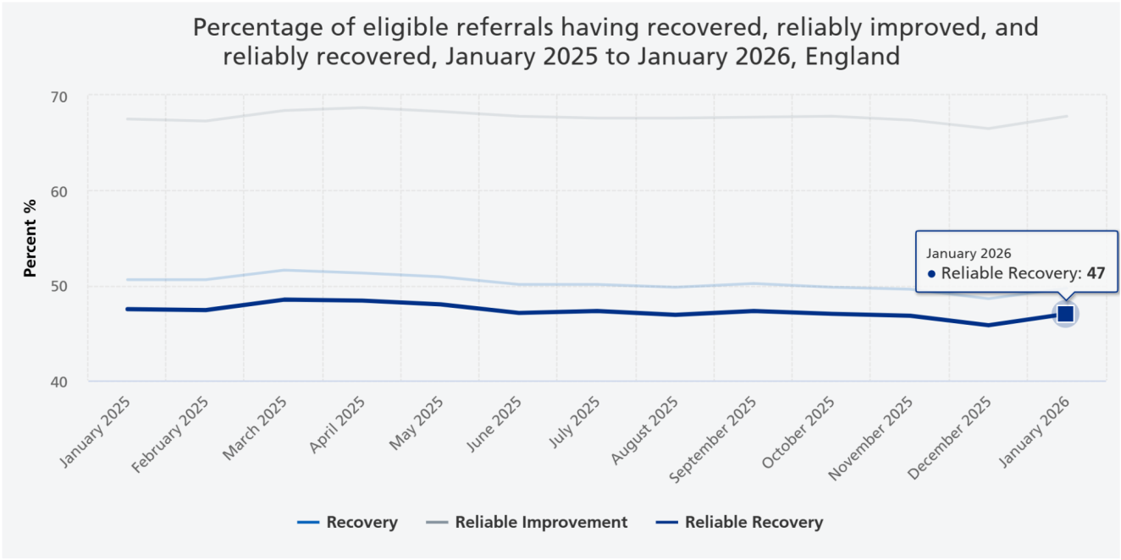
Figure 2: NHS Talking Therapies Recovery Rate
(Source: NHS England, 2026)

3.2 Government Welfare, Social Care or Healthy Ageing Policy
An appropriate policy is Pension Credit as it directly tackles income-related inequalities amongst older people. In 2024/25 DWP spent £5.9 billion, providing financial security for those in the lower-income pension age group (Department for Work and Pensions, 2025b). Despite this, levels of uptake vary geographically, with between 60% and 70% of the population in northern regions, compared with approximately 55% in areas to the east and south (Department for Work and Pensions, 2025c). So, its potential to address health inequities is not widespread.
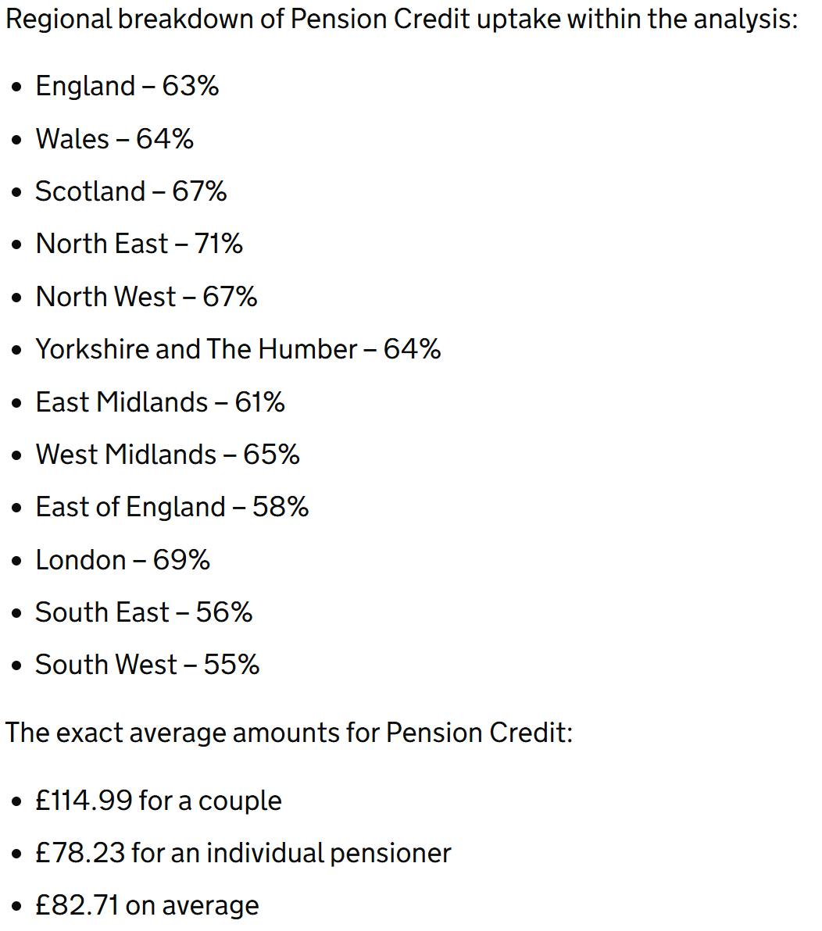
Figure 3: Regional Variation in Pension Credit Uptake Rates
(Source: Department for Work and Pensions, 2025c)

4. Organisation Supporting Older Adults
Age UK is an organisation that gives information, support and advocacy on issues of poverty, loneliness and social isolation. It provides free advice services relating to benefits, pensions, housing, care and health and access for disadvantaged older adults. Age UK estimate that there are 940,000 older people who are often lonely, indicating that there is a significant unmet social need (Age UK, 2025a). Research also reveals there are 2.4 million older citizens without digital access, showing inequities in access to services. But charity-based support cannot substitute for support that is funded properly and is provided by public services (Age UK, 2025b).

5. Conclusion
Older adults face inequalities with respect to mental illness, chronic disease and mortality. These outcomes are interwoven with feelings of loneliness, poverty and poor quality housing. National interventions are important supports but are limited in effectiveness due to unequal access and deprivation. Age UK improves their advocacy, advice and community services. Thus, equality measures need to be based on integrated health/social and socioeconomic interventions and not only health care interventions.

Task 2: Epidemiological Analysis

2.1 Introduction
Chronic obstructive pulmonary disease is respiratory disease which is non-communicable. This disease is characterised by constant airflow obstruction as well as progressive respiratory issues. COPD generally involves emphysema and chronic bronchitis. The main symptoms of COPD are breathless, wheezing, chronic cough, sputum production, and fatigue. COPD is important for epidemiological analysis it can be prevented to an extent and it disproportionately affects marginalised or deprived population. The annual economic burden of COPD on the NHS in the UK is almost £1.9 billion (NHS England, 2026). A recent economic model estimated the wider cost in England at £7.9 billion in 2025, including indirect costs (Boers, 2025).
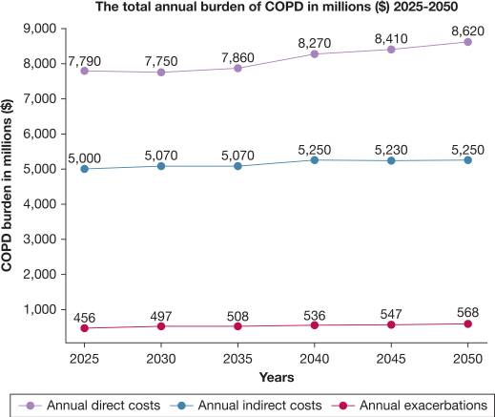
Figure 4: Annual cost of COPD
(Source: Boers, 2025)
Most of people with COPD report work-related impact (Biscevic-Tokic, 2023). The several social consequences of COPD include dependence, social isolation, carer burden, and reduced income.
WHO has estimated that COPD will be the third leading cause of death by 2030 in the world and almost 90% of COPD deaths occur in low- and middle-income countries (WHO, 2026). COPD caused approximately 3.4 million deaths in 2023, around 6% of global deaths (World Health Organisation, 2026). Every 20 minutes someone in the UK dies of COPD, resulting 23,000 deaths in a year (Healthinnovationmanchester, 2026). 1 in 10 adults over the age of 40 suffers from COPD in the UK (King's College London, 2025). Blackpool is a manageable population for the purposes of this study since it has high levels of both COPD incidences and morbidity. In the year 2023/2024, the number of patients suffering from COPD in the Blackpool ICB subsection amounted to 6979 patients, equivalent to 3.9% of the total population, while the average for the rest of England was 1.9%. Consequently, Blackpool has the highest COPD incidence at the sub-ICB level in the entire England (Blackpool JSNA, 2025).
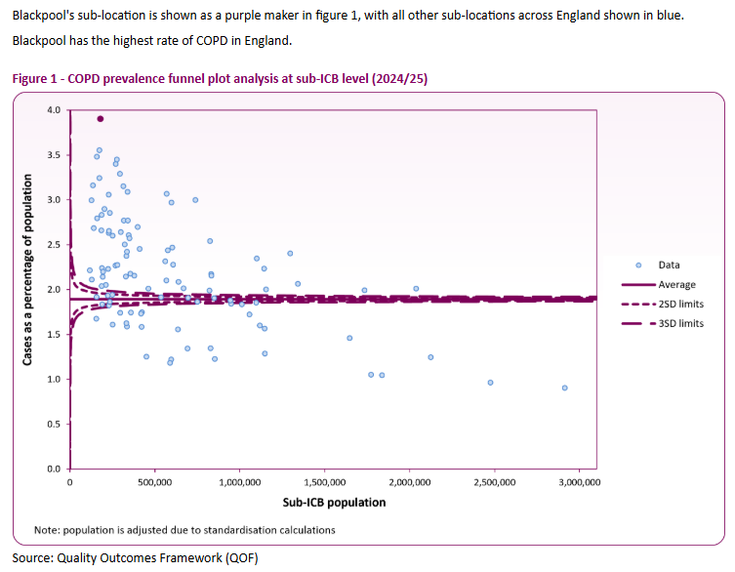
Figure 5: COPD prevalence in Blackpool
(Source: Blackpool JSNA, 2025)

2.2 Public Health Measures: The 3 Ps
A robust COPD strategy for Blackpool must include prevention, protection and promotion. Prevention emphasizes a number of aspects, including support for quitting smoking, interruption of initiation of smoking habits and reduction of occupational exposure. According to NICE, every person with COPD who smokes needs to be encouraged to quit smoking (CDC, 2025).
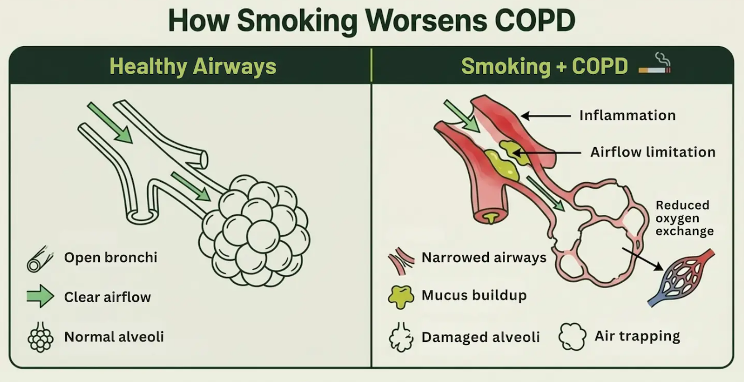
Figure 6: Impact of smoking on a person with COPD
(Source: Elizabeth, 2026)
Protection in this respect deals with minimizing exposure to different respiratory irritants as well as preventing the occurrence of exacerbations. People with COPD should be given the opportunity to receive the flu vaccine if appropriate (Verma, 2025). Additionally, all should be offered pneumococcal vaccination.
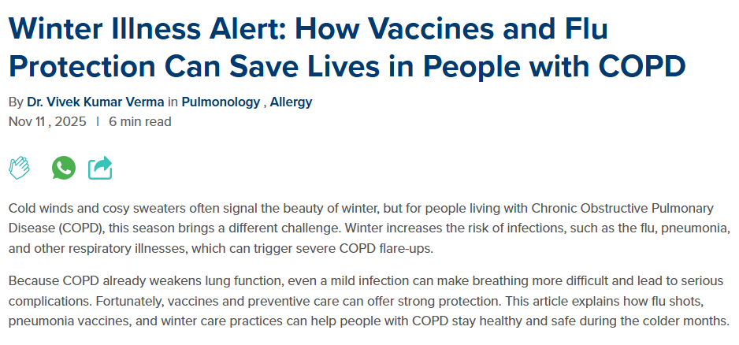
Figure 7: Vaccination for COPD patients
(Source: Verma, 2025)
Furthermore, occupation health measures should be applied to limit the exposure to dust and fumes. Promotion means assuring physical activity, self-management, health literacy and use of health care services. Pulmonary rehabilitation is necessary for people who cannot function normally due to COPD. Pulmonary rehabilitation has to include training, education, nutritional, psychological and behavioural aspects (Shenoy and Paul, 2023).

2.3 Key Determinants and Risk Factors
The epidemiology of COPD highlights significant link between behavioural, genetic, environmental, socioeconomic, and occupational determinants. The main modifiable cause of the disease is smoking and more than 70% of cases are attributed to tobacco, especially in high-income countries (World Health Organisation, 2026). Moreover, frequent exposure to dusts, fumes, and chemicals also causes of COPD. Exposure to air pollution and household biomass-fuel significantly increase risk factors. Additionally, other contributors of COPD are passive smoking, genetics, abnormal lung development, age, and social deprivation, housing, and employment conditions (World Health Organisation, 2026).
As COPD prevalence is directly related with deprivation as well as historical smoking patterns, these determinants are crucial in Blackpool. According to report COPD prevalence in England is higher among older as well as more deprived populations.
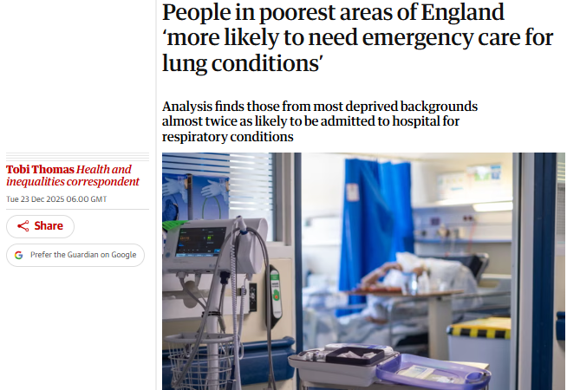
Figure 8: COPD in Poorest areas of England
(Source: Thomas, 2025)
This highlights increasing smoking habits, high air pollution, and occupational risks. Therefore it is important for intervention efforts to focus not only on individual behaviour but also socio economic and environmental determinants.

2.4 Epidemiological Studies and Health Needs Assessment
It is important to start with a health needs assessment by defining the population, identifying inequalities, and examining frequency of disease. Epidemiology focuses on analysing the determinants as well as distribution of health-related states in populations (Ghosh and Mukherjee, 2025). Epidemiology also applies the knowledge to effectively prevent health problems. In context of Blackpool, with the help of descriptive epidemiology the distribution of COPD by person, place, and time can be established with the help of QOF primary care registers, local health needs assessments, hospital admissions, and mortality statistics. 134 deaths were reported in 2022-2024 due to COPD in Blackpool and also emergency admission rate increase to 86.6 per 100,000 which is almost twice the rate in England of 45.5 per 100,000.
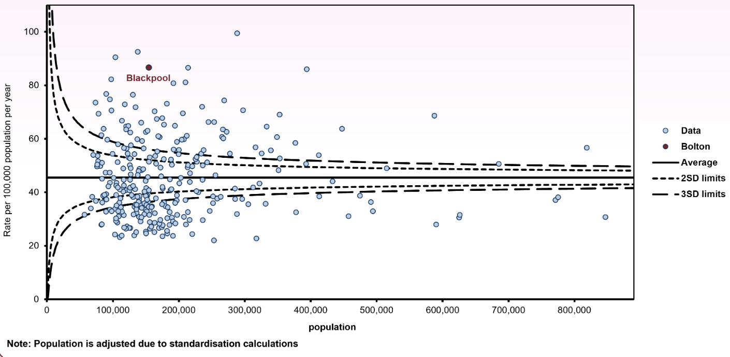
Figure 9: Deaths due to COPD in Blackpool
(Source: Blackpool JSNA, 2025)
It is important to ensure that both prevalence and incidence are interpreted carefully. Prevalence can examine the number of existing cases within a population while through incidence new cases occurring among people at risk in a specific time period can be measured. For service planning COPD prevalence is crucial as it can help in estimating the existing burden which requires long term management. On the other hand, hospital admissions as well as mortality rate reflects more severe consequences.

2.5 Public Health Monitoring and Surveillance
In Blackpool, there has to be multi-facetted systems in the surveillance of COPD. QOF registers in primary care allow diagnosed prevalence to be seen (Medicinesteam, 2026). Hospital Episode Statistics also show emergency admissions where ONS allow mortality statistics to be gained. Smoking prevalence and deprivation markers provide information on upstream risk and the OHID respiratory disease profile allows information to be collated across local authorities and Integrated Care Boards (ICBs).
According to OHID, its respiratory disease profile makes use of risk factors, health care provision and mortality data to help local commissioning, planning and identification of geographical variation (GOV.UK, 2025).
The surveillance system will have to work longitudinally to allow for monitoring prevalence, emergency admissions, readmissions, mortality, smoking cessation, vaccination, uptake of pulmonary rehabilitation and inequalities. In the UK, COPD emergency admissions went up by 9% in 2023-24 (GOV.UK, 2025), explaining why prevalence is not good enough on its own

2.6 The Plan and Usage of Epidemiology
COPD burden can be quantified using indicators of epidemiology, including incidence of the disease, prevalence, hospitalisation, morbidity, mortality and healthcare use in the population. COPD makes for more than 120,000 hospital admissions in the UK every year, placing significant strain on the NHS services across the country (Birmingham, 2026). COPD is the second leading cause of emergency room admission in the UK healthcare system. Short-term outcomes: exacerbation, breathlessness, emergency treatment, hospital admission, worsening of function, need for healthcare. These effects can impact on individuals' daily lives, work, family life and independence, and participation in Blackpool. Long-term effects are chronic disability, low quality of life, multi-morbidity, readmission, premature death. Hence, it was felt that the epidemiology should investigate trends by deprivation, geography, smoking exposure and differences in healthcare access by age in Blackpool. This evidence can help to identify high-risk groups and inform targeted preventive, therapeutic, rehabilitative and follow-up services. Going forward, future interventions need to decrease exacerbations, improve self-management, better support prevention and decrease regional disparities in England.
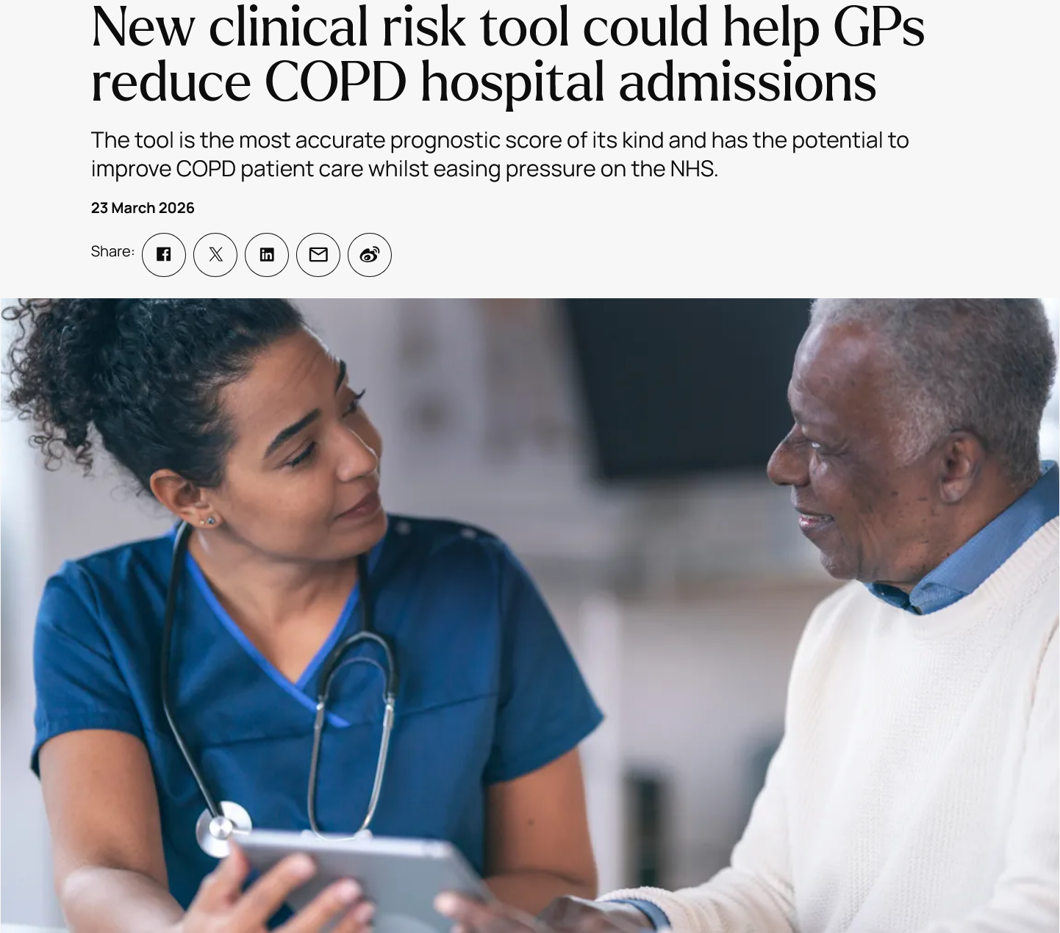
Figure 10: New clinical risk tool could help GPs reduce COPD hospital admissions
(Source: Birmingham, 2026)

2.7 Design and evaluation of an appropriate COPD health intervention program
Blackpool must implement a COPD programme with smoking cessation, pulmonary rehabilitation, vaccinations and support with inhalers. Tobacco dependency remains a significant contributor to poorer outcomes, and approximately 37% of those hospitalised for COPD continue to smoke, and this rate is approximately constant over the ten years (HQIP, 2026). Smokers in deprived neighbourhoods and post-admission smokers should be targeted for cessation support. Pulmonary rehabilitation should offer supervised exercise, education, self-management training and breathing skills to patients eligible for pulmonary rehabilitation. Vaccination and inhaler reviews aim to minimise exacerbations and aim for ongoing local support of self-management through follow-up calls. Evaluation should be against baseline and follow-up admissions, exacerbations, smoking status, rehabilitation attendance and quality of life measures. Process measures will be used to evaluate delivery, and outcome measures will be used to evaluate changes after the implementation of the interventions over time. Success should be reduced admissions, reduced exacerbation, enhanced self-management and enhanced quality of life in the local area.
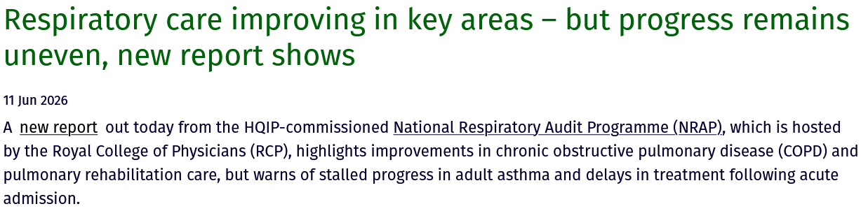
Figure 11: Respiratory care improving in key areas
(Source: HQIP, 2026)

2.8 Strengths and Weaknesses of the Epidemiological Approach
Strength
Epidemiology provides Blackpool with evidence with which to measure burdens of COPD among its population groups. Blackpool had 361.9 emergency COPD admissions per 100,000 registered populations in the locality in 2024/25 (Blackpool JSNA, 2026). This was the local inequality, with an 80-point difference to the corresponding rate in England. This information is useful to inform local prioritisation of high-risk communities for needs assessment and also for planning purposes. Rates are also standardised, so that comparisons can be made, as there can be differences in age profiles across areas.
Weakness
There was unexplained disease burden with 1,117 patients assessed and 576 COPD diagnosed (Yorkshire Humberside, 2026). This vulnerability can lead to an underestimation of prevalence for COPD due to the lack of detection of people living outside of routine datasets. However, for Blackpool, surveillance should be supplemented by proactive case-finding to prevent underdiagnosed, so that epidemiological estimates should reflect this.

Reference list
Age UK (2025a). Information and advice. [online] Available at: https://www.ageuk.org.uk/information-advice/
Age UK (2025b). Age UK warns 2.4 million digitally excluded older people are at risk of being left behind in an increasingly digital world. [online] Available at: https://www.ageuk.org.uk/latest-press/articles/age-uk-warns-22.4-million-digitally-excluded-older-people-are-at-risk-of-being-left-behind-in-an-increasingly-digital-world/
Age UK (2026c) Age UK’s new report shows you are not alone in feeling lonely. Available at: https://www.ageuk.org.uk/latest-press/articles/age-uks-new-report-shows-you-are-not-alone-in-feeling-lonely/
Age UK (2026d) Three in four pensioners admitted they were cold in their own homes in January. Available at: https://www.ageuk.org.uk/latest-press/articles/three-in-four-pensioners-admitted-they-were-cold-in-their-own-homes-in-january
Anxiety Checklist (2025) Anxiety statistics. Available at: https://anxietychecklist.com/anxiety-statistics
Birmingham (2026) New clinical risk tool could help GPs reduce COPD hospital admissions. https://www.birmingham.ac.uk/news/2026/new-clinical-risk-tool-could-help-gps-reduce-copd-hospital-admissions
Biscevic-Tokic, J., Brekalo-Lazarevic, S., Tokic, N., Ajanovic, Z. and Dervisevic, L. (2023). Assessment of work ability of patients with COPD in relation to the workplace. [online] 27(4), pp.333–337. doi: 10.4103/ijoem.ijoem_246_22.
Blackpooljsna (2026). Chronic obstructive pulmonary disease (COPD). [online] www.blackpooljsna.org.uk. Available at: https://www.blackpooljsna.org.uk/Living-and-Working-Well/Health-Conditions/Respiratory-disease/COPD.aspx.
Boers, E., Barrett, M.A., Benjafield, A.V., Barnett, J.H., Ravelo, L.A., Kaye, L., Cistulli, P.A., Pépin, J.-L., Armitstead, J., Sterling, K.L., Nunez, C., Peppard, P.E. and Malhotra, A. (2025). Projecting the 30-Year Burden of Obstructive Sleep Apnea in the United States. CHEST Journal. doi: 10.1016/j.chest.2025.03.029.
British Heart Foundation (2026) cardiovascular disease statistics 2026. Available at: https://www.bhf.org.uk/what-we-do/our-research/heart-statistics/heart-statistics-publications/cardiovascular-disease-statistics-2026
CDC (2025). Chronic obstructive pulmonary disease (COPD). [online] Available at: https://www.cdc.gov/tobacco/campaign/tips/diseases/copd.html.
Department for Work and Pensions (2025a) Households below average income: an analysis of the UK income distribution fye 1995 to fye 2025. Available at: https://www.gov.uk/government/statistics/households-below-average-income-for-financial-years-ending-1995-to-2025/households-below-average-income-an-analysis-of-the-uk-income-distribution-fye-1995-to-fye-2025
Department for Work and Pensions (2025b) Unfulfilled eligibility in the benefit system: financial year ending 2025. Available at: https://www.gov.uk/government/statistics/unfulfilled-eligibility-in-the-benefit-system-financial-year-2024-to-2025-estimates/unfulfilled-eligibility-in-the-benefit-system-financial-year-ending-fye-2025
Department for Work and Pensions (2025c). Fresh drive to boost Pension Credit take up as new figures reveal large regional gaps in those receiving benefit worth around £4,300 a year. [online] GOV.UK. Available at: https://www.gov.uk/government/news/fresh-drive-to-boost-pension-credit-take-up-as-new-figures-reveal-large-regional-gaps-in-those-receiving-benefit-worth-around-4300-a-year
Elizabeth O (2026). Smoking Cessation for COPD. [online] Cardahealth.com. Available at: https://www.cardahealth.com/post/smoking-cessation-for-copd.
Ghosh, D. and Mukherjee, C.G. (2025). Concept of epidemiology – a detailed review. [online] Ijcmph.com. Available at: https://www.ijcmph.com/index.php/ijcmph/article/download/14732/9064/75768.
GOV.UK (2025). Respiratory disease profile: Statistical commentary, june 2025. [online] GOV.UK. Available at: https://www.gov.uk/government/statistics/update-of-indicators-in-the-respiratory-disease-profile-june-2025/respiratory-disease-profile-statistical-commentary-june-2025.
Healthinnovationmanchester (2026). Improving care and treatment for chronic obstructive pulmonary disease (COPD). [online] Health Innovation Manchester. Available at: https://healthinnovationmanchester.com/our-work/copd/.
HQIP (2026) Respiratory care improving in key areas – but progress remains uneven, new report shows. https://www.hqip.org.uk/news/nrap-report-june-2026/
Huang, X., Kang, L. and Bi, J. (2025) “Epidemiology of oral health in older adults aged 65 or over: prevalence, risk factors and prevention,” Aging Clinical and Experimental Research, 37(1), p. 193. Available at: https://link.springer.com/article/10.1007/s40520-025-03110-8
Medicinesteam (2026). Quality and outcomes framework (QOF): What you need to know about QOF codes and updates. [online] The Medicines Management Team. Available at: https://medicinesteam.co.uk/quality-and-outcomes-framework-qof/.
NHS England (2026) NHS Talking Therapies, for anxiety and depression, Monthly Statistics including Employment Advisors, January 2026: Outcomes. Available at: https://digital.nhs.uk/data-and-information/publications/statistical/nhs-talking-therapies-monthly-statistics-including-employment-advisors/performance-january-2026/outcomes
NHS England (2026). NHS England respiratory disease. [online] NHS England. Available at: https://www.england.nhs.uk/ourwork/clinical-policy/respiratory-disease/.
Office for National Statistics (2026a) Public opinions and social trends, Great Britain: February 2026. Available at: https://www.ons.gov.uk/peoplepopulationandcommunity/wellbeing/bulletins/publicopinionsandsocialtrendsgreatbritain/february2026
Office for National Statistics (2026b) Healthy life expectancy by national area deprivation, England and Wales: between 2013 to 2015 and 2022 to 2024. Available at: https://www.ons.gov.uk/peoplepopulationandcommunity/healthandsocialcare/healthinequalities/bulletins/healthylifeexpectancybynationalareadeprivationenglandandwales/between2013to2015and2022to2024
Shenoy, M.A. and Paul, V. (2023). Pulmonary rehabilitation. [online] PubMed. Treasure Island (FL): StatPearls Publishing. Available at: https://www.ncbi.nlm.nih.gov/books/NBK563166/.
Thomas, T. (2025). People in poorest areas of England ‘more likely to need emergency care for lung conditions’. [online] the Guardian. The Guardian. Available at: https://www.theguardian.com/society/2025/dec/23/lung-conditions-emergency-care-poorest-areas-england-research.
Verma, V.K. (2025). Winter illness alert: How vaccines and flu protection can save lives in people with COPD. [online] Maxhealthcare.in. Available at: https://www.maxhealthcare.in/blogs/copd-and-winter-illness.
WHO (2026). Who emro - chronic obstructive pulmonary disease (COPD). [online] Who.int. Available at: https://www.emro.who.int/health-topics/chronic-obstructive-pulmonary-disease-copd/.
World Health Organisation (2026). Chronic obstructive pulmonary disease (COPD). [online] World Health Organisation. Available at: https://www.who.int/news-room/fact-sheets/detail/chronic-obstructive-pulmonary-disease-(copd).
Yorkshire Humberside (2026) Project helps find ‘hidden millions’ with undiagnosed COPD. https://yorkshirehumbersde.nhs.uk/news/project-helps-find-hidden-millions-with-undiagnosed-copd/

