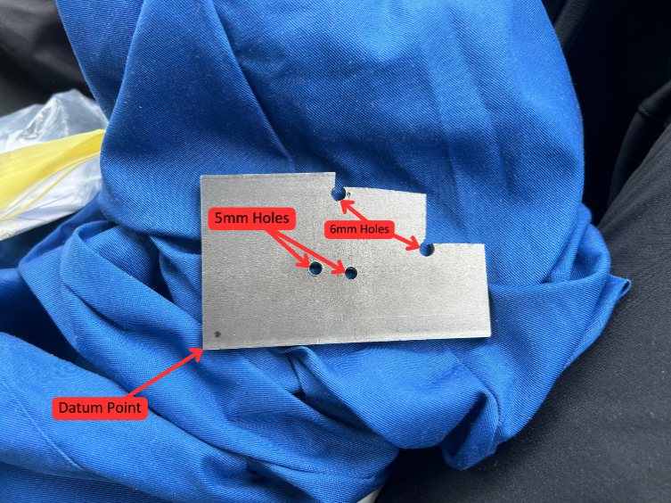
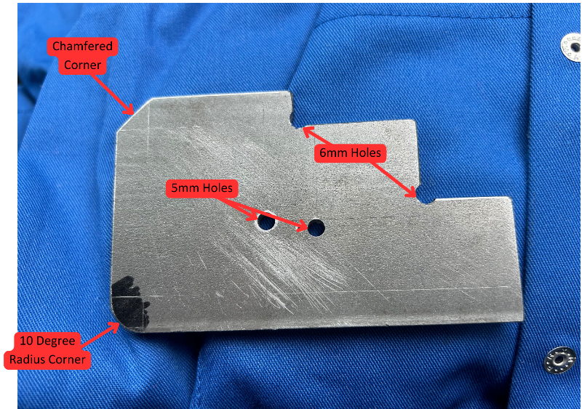
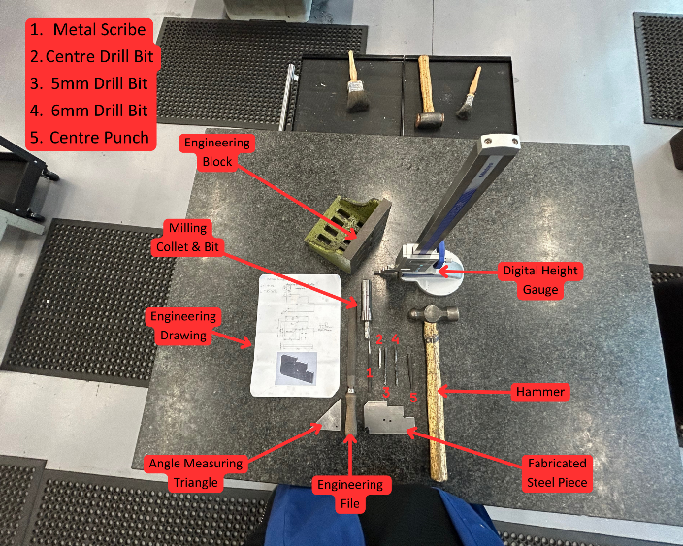
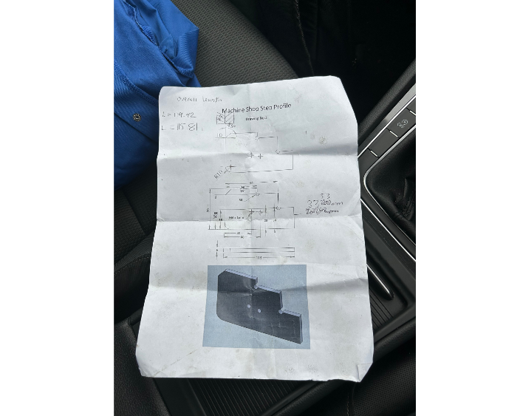
Figure 30 Final Fabrication of the Steel Piece
Figure 28 The Steel Piece after Session 2
Figure 29 A annotated photo of some of the Equipment we've used.
Figure 27 Engineering Drawing we followed.

I completed all the operations on the provided engineering sheet and
gained more confidence in the machine workshop on the milling side and with other equipment.

