
UNIVERSITY OF WALES:  TRINITY SAINT DAVID |  | PRIFYSGOL CYMRU:  Y DRINDOD DEWI SANT

LOCATION: Coleg Sir Gar (Graig) | LLEOLIAD: Coleg Sir Gar (Graig)
LEVEL 6 | LEFEL 6
EXAMINATION PERIOD | CYFNOD ARHOLIADAU
may 2020 | mai 2020

MODULE CODE: SGdm6020
Engineering Management

TIME: 2 HOURS
students must complete 3 questions from 4.

Equipment or materials required
- Calculators are permitted.
- Standard formula sheet provided.
- Control Chart

Adnoddau neu ddefnyddiau sydd eu hangen
- Caniateir ddefnyddio cyfrifiannell.
- Ddarperir taflen fformiwla safonol.
- Siart Rheoli.

THIS PAGE IS INTENTIONALLY BLANK

Question 1
  - Identify and discuss in detail the steps involved in a Taguchi Design of Experiments (DOE). (10 marks)
  - The production of the coating material for DVD discs was subjected to a DOE. One response variable was the deterioration of the disc output signal. (10 marks)
Four parameters were tested at three levels each:
A – Material type B- Process temperature
C – Processing time D – Type of additive
An L9 orthogonal array was used. The results from the experiment are given in the following table:
L9 | A | B | C | D | Deterioration
1 | 1 | 1 | 1 | 1 | 20
2 | 1 | 2 | 2 | 2 | 12
3 | 1 | 3 | 3 | 3 | 10
4 | 2 | 1 | 2 | 3 | 48
5 | 2 | 2 | 3 | 1 | 28
6 | 2 | 3 | 1 | 2 | 20
7 | 3 | 1 | 3 | 2 | 20
8 | 3 | 2 | 1 | 3 | 16
9 | 3 | 3 | 2 | 1 | 8
Determine the optimum parameter levels and predict the outcome.
  - You are provided with the following additional information:
 | LEVEL | 1 | 2 | 3
A | Material cost (£/load) | 2,500 | 2,400 | 2,200
B | Process temperature (ºC) | 600 | 625 | 650
C | Process time (hours) | 2 | 1.75 | 1.5
D | Percentage additive | 2% | 4% | 6%
How would this information affect the decisions you made in part (b) of the question? (5 marks)
Total for question 1, 25 marks
Question 2
Compare and contrast the following three strategic development techniques; SWOT, PESTLE and Porter’s Five Force Analysis.
Describe each technique correctly giving examples of the external and internal factors considered by the techniques.
Total for question 2, 25 marks
Question 3
  - The Japanese academic, Dr Noriaki Kano, developed a model to aid product and service design improvement. It relates 3 factors; basic, performance and delight, and to their degree or level of implementation. Sketch the ‘Kano’ model and comment on each of the factors. (12 Marks)
  - Developed at Mitsubishi’s Kobe shipyard. Quality Function Deployment (QFD) translates the voice of the customer in product design, relating to ‘who’, ‘what’ and ‘how’. Quality Function Deployment
    - Give three reasons why a company should use QFD.
    - Sketch a simplified ‘House of Quality, describing what goes into the rows and columns.
(13 marks)

Total for question 3, 25 marks

Question 4
A CNC machine was set to machine components to a length of 20mm and ten samples of five were taken every half hour from the last made. The following results were obtained:

Sample No. | 1 | 2 | 3 | 4 | 5 | 6 | 7 | 8 | 9 | 10
X1 | 20.11 | 20.13 | 20.12 | 20.06 | 20.22 | 20.13 | 20.21 | 19.96 | 20.13 | 20.2
X2 | 20.12 | 20.04 | 20 | 20.14 | 20 | 20.04 | 20.02 | 19.97 | 20.14 | 20
X3 | 19.97 | 20.1 | 20.15 | 20.23 | 20.15 | 20.11 | 19.97 | 20.21 | 20.1 | 20.5
X4 | 20.05 | 20 | 20.11 | 20.11 | 20.1 | 20 | 20.05 | 19.9 | 20 | 20.11
X5 | 19.88 | 20.2 | 19.9 | 20.12 | 19.9 | 20.22 | 19.88 | 19.9 | 20.12 | 19.99

- Using the formula sheet provided (Appendix 1), plot the sample results on the average and range control chart (Appendix 2, which is to be removed from the examination paper and returned with your answer book) and calculate the upper and lower control limits. (10 marks)

- Discuss the checks for special causes that should be carried out to determine whether or not the process is in a state of statistical control. (6 marks)

- The specification for the component is given as 20 ± 0.25mm. Determine Cp and Cpk and discuss the suitability of the process. (9 marks)

Total for question 4, 25 marks

Appendix 1 Formula Sheet and table of constants
$$σ=\frac{\overline{R}}{d_{2}}$$
$$\bar{\bar{X}}=\frac{\text{Sum of all sample means}}{\text{Total number of samples}}$$
$$UCL=\bar{\bar{X}}+A_{2}\bar{R}$$
$$UCL=D_{4}\bar{R}$$
$$LCL=D_{3}\bar{R}$$
$$C_{p}=\frac{total specified tolerance}{6σ}$$
$$C_{pku}=\frac{upper specified limit-\overline{X}}{3σ}$$
$$C_{pkl}=\frac{\overline{X}-lower specified limit}{3σ}$$

L = K(y-m)²
L = K [S² + ($\overline{y}$ - m)²
$m=\frac{\sum{xy-\frac{\sum{x\sum{y}}}{N}}}{\sum{x^{2}-\frac{{\left(\sum{x}\right)}^{2}}{N}}}$

$c= \frac{\left(\sum{x}\right)\left(\sum{xy}\right)- \left(\sum{y}\right)\left(\sum{x^{2}}\right)}{{\left(\sum{x}\right)}^{2}-N \left(\sum{x^{2}}\right)}$

$$r= \frac{\sum{xy- \frac{\left(\sum{x}\right)\left(\sum{y}\right)}{n}}}{\sqrt{\left[\sum{x^{2}}- \frac{{\left(\sum{x}\right)}^{2}}{n} \right]\left[{\sum{y}}^{2}- \frac{{\left(\sum{y}\right)}^{2}}{n}\right]}}$$

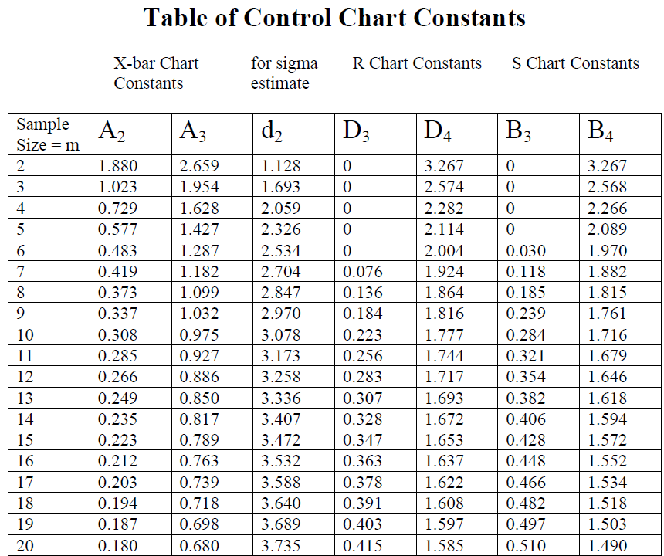

Appendix 2: SPC Control Chart
IF YOU ANSWERED QUESTION 4, REMOVE THIS PAGE AND RETURN WITH YOUR ANSWER BOOK


