7 – Managing Time in PHP

There are a couple of functions that may be used to manage time in PHP.

- date()

The first function is useful for retrieving the date from the server’s system clock:

<?
$currenttime=date("d M Y");
echo $currenttime;
?>

This displays today’s date:

27 November 2020

It is possible to display the date using many other formats, using the following:

a "am" or "pm"
A "AM" or "PM"
d day of the month, 2 digits with leading zeros; i.e. "01" to "31"
D day of the week, textual, 3 letters; i.e. "Fri"
F month, textual, long; i.e. "January"
g hour, 12-hour format without leading zeros; i.e. "1" to "12"
G hour, 24-hour format without leading zeros; i.e. "0" to "23"
h hour, 12-hour format; i.e. "01" to "12"
H hour, 24-hour format; i.e. "00" to "23"
i minutes; i.e. "00" to "59"
I (capital i) "1" if Daylight Savings Time, "0" otherwise.
j day of the month without leading zeros; i.e. "1" to "31"
l (lowercase 'L') day of the week, textual, long; i.e. "Friday"
m month; i.e. "01" to "12"
M month, textual, 3 letters; i.e. "Jan"
n month without leading zeros; i.e. "1" to "12"
r RFC 822 formatted date; i.e. "Thu, 21 Dec 2000 16:01:07 +0200"
s seconds; i.e. "00" to "59"
S English ordinal suffix, textual, 2 characters; i.e. "th", "nd"
t number of days in the given month; i.e. "28" to "31"
T Timezone setting of this machine; i.e. "MDT"
w day of the week, numeric, i.e. "0" (Sunday) to "6" (Saturday)
Y year, 4 digits; i.e. "1999"
y year, 2 digits; i.e. "99"
z day of the year; i.e. "0" to "365"
Z timezone offset in seconds (i.e. "-43200" to "43200"). The offset for timezones west of UTC is always negative, and for those east of UTC is always positive.

- time()

If you need to keep a record of the time which is independent of timezone, we can use the UNIX timestamp. For example, you might want to store the time that a user made an order from a website, or the time a user signed up to a website etc.

time() produces a count of the seconds since 1970.

At the time of writing time() produces the following results:

<?
echo time();
?>

which shows (at the time of writing) that it is 1601877710 seconds since 1970.

This sounds complicated, but we can display this as a readable date by feeding it into the date() function.

<?
$signup=time();
echo date('D d M Y', $signup);
?>

which displays:

Fri 27 Nov 2020

Seconds in an hour: 3600
Second in a day: 86400
Seconds in a month: 2629743.83
Seconds in a year: 31556926

Using dates in the database

There is a TIMESTAMP field in the mySQL database. This displays a date in a format such as the below:

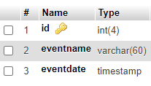

We can then store events in our database, for example:

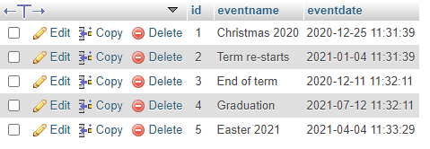

We can use this to show events on the screen, and also order them easily.

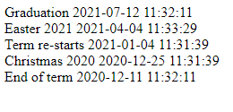

<?include "conninfo.php";

$query="SELECT * FROM events ORDER BY eventdate DESC";
$result=mysqli_query($link,$query);

while($r=mysqli_fetch_array($result))
{
echo $r["eventname"];
echo " ";
echo $r["eventdate"];
echo "<br>";
}?>

To format the date into the required form, convert the date to a timestamp (strtotime) and use the date() function.

echo date('d-m-Y',strtotime($r["eventdate"]));

Note: the server should store timestamps in UTC. If your hosting provider is in (for example) the USA, your time events may behave wrongly for a UK audience.

One way around this is to specify the timezone at the top of your page.

date_default_timezone_set('Europe/London');

Supported timezones can be seen here:
http://php.net/manual/en/timezones.php
Time-sensitive websites

We can also use the time function to make events happen on websites. This can be used to give the impression that a website is well-maintained while taking the strain off a webmaster.

Some examples:

1. The NOW() SQL function can be used to automatically stop showing an event on a website once the event has passed.

Here is a screenshot of an events page of a website:

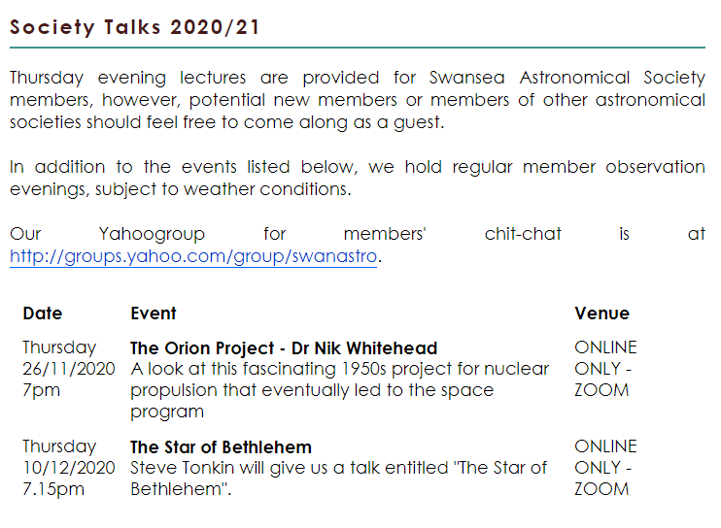

When the 26th November passes, the PHP code will automatically stop showing this event on the website. Here is an extract of the code:

$query=”SELECT * FROM events WHERE eventdate > NOW()”;

$result=mysqli_query($link,$query);

2. Time can also be used to make more stylistic changes to website, for example to change the look of a website according to the season, or wish visitors a happy Christmas. Here are two shots of the same website at different times of the year:

Usual view:

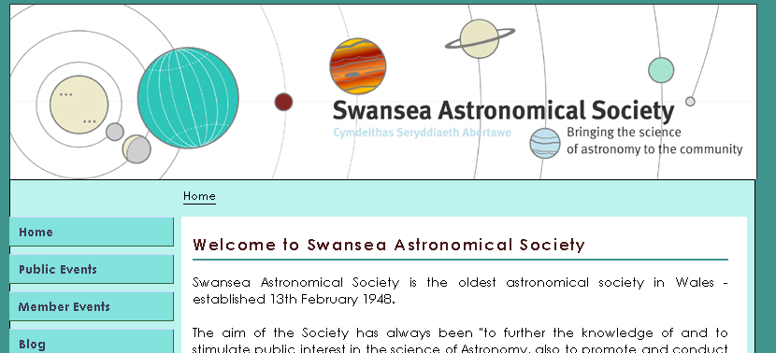

Christmas season view:

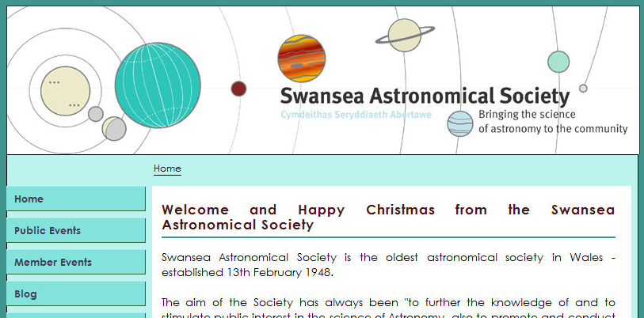

The BBC Website is particularly good at changing web content according to time events. Look at the website of a BBC series you watch, just after the programme has finished broadcasting. It has often changed content as soon as the transmission has ended, even late at night when the webmasters are asleep!

Notes

A useful website for finding out a specific time in seconds is:

http://www.4webhelp.net/us/timestamp.php

