Managing Enterprise In the 21st Century

Business Plan

Name of the students Student Numbers
Faisal Khalid: 2123094
Nicoleta Madalina Stanga: 2118508
Cristian Fota: 2118507
Liviu Hadirca: 2119291

Lecturer: Samuel Ofori

Table Of Contents
Contents
Managing Enterprise In the 21st Century 1
Business Plan 1
1. Executive Summary 3
2. Business / Company Overview 3
3. Market audit 5
4. SWOT Analysis 6
5. PESTLE Analysis 7
6. Target Market 7
7. Marketing and sales plan 8
8. Management team 9
9. Financial plan 9
Start-up costs 10
Monthly cash-flow 10
10. Profit and loss 11
11. Conclusion 12
12. References 13

Executive Summary

This report will describe the start-up and business plan of FEPO diet health food services, which was founded by the students of UWTSD, it’s a humble beginning of an E – Retail company that aims to progress in the food market not only as an online product service but as well as stationary in the future marketing plan, it will further narrate the company’s overview, products, and services that the company offers, differentiation strategy and what makes it unique, to cope with the trends in marketing, FEPO has analysed its market audit, as well as conducting pestle and swot analysis to find out the factors that influence in business.
FEPO has a specific target market to develop its business and reach the desired customers while establishing a marketing sales plan in line with the management team collaboration and assessing the monthly cash flow, FEPO is prospering business, and the estimated first-year profit would be £236,000, determined by its own marketing strategy and knowledge which will be viewed further into details on the report.

Business / Company Overview

Company | FEPO Diet Health Food
Label | In the collaborative process of success
Legal Structure | Partnership
Start off | February 2023
Service | Supplementary diet food, to provide healthy food to customers
Mission | To be recognised as the most reliable, trusted, and convenient ready food in the UK
Vision | The alternative of fast-food consumption to healthy diet meals, in consumer satisfaction by empowering people to create their own choice and taste in food at affordable prices.  From E- Retail to stationary retail globally
Figure1
FEPO is an expert in healthy diet solutions, as well as championing healthy eating balanced diet, the goal is to create an awareness of healthy practices and well-being in our society, to provide professional, reliable, and convenient services which are affordable, with a vision of becoming a leader of worldwide health food distributors, and shifting from E-retail to Stationary globally in the future marketing plan and sustainable products, further information on the company’s products and diet plans can be found on (www.fepohealthfood.co.uk).
- Product
Healthy diet food for individuals who want to gain or lose weight, or practice healthy food consumption, organic food from the source freshly cooked, with natural ingredients, and delivered to the customer’s preferred location, by using FEPO’s online BMI calculator will define the customer’s hight health weight, and with the help of the company’s nutritionist, it will assist customers to set up their healthy diet plan meal which will be successfully prepared and delivered to the customer’s allocated location.
A healthy balanced diet plays a significant role in the human body, it prevents diseases that could affect your life and enables you to maintain good health, and improves your well-being (National Health Service, 2022). A balanced food includes eating the right amount of a wide range variety of food and drinks with the right calories to achieve a healthy body weight, the number of calories that an individual requires will depend on age, metabolism, and levels of physical activity (National Health Service, 2019).
FEPO is offering not only a healthy balanced diet but also food with lots of proteins and minerals, having food groups in your diet will help you improve your lifestyle, fruits and vegetables are key to a healthy consuming diet with the right proportional, starchy foods also are part of the suggested healthy food of vitamins and minerals as well as meat and fish, which are obtained proteins to help the body grow and repair itself, and so do milk and dairy foods where you obtain calcium to improve the health of your bones, the people’s health will be influenced by their consumption of food and beverage ( Dietary Guidelines For American, 2020 ). Having a balanced diet health plan and daily activity would help maintain good health and improve physically, and consuming less saturated fat, sugar, and salt.
FEPO’s fresh products promise defines organic food that comes directly from the source, is freshly cooked, and unforgettably tasty, with affordable prices, Ecco friendly, all the products come in biodegradable packages, with promotions and two weeks trial with a money-back guarantee.

- Services

- Standard Diet Calories: The National Health Service (2019) recommended a daily calorie intake of 2000 for women and 2500 for men.
FEPO is of offering a version of 1100kcal, 1300kcal, 1500kcal, 1700kcal, 2000kcal, and 2500kcal, with options of meat, fish, vegetarian, and vegan.
- Low GI Diet: ( Low Glycemic Index) is a diet plan built in terms of how foods influence the blood sugar level ( Mayo Clinic, 2022). It is designed for individuals with diabetes, it prevents blood glucose level fluctuations, and improves the individual health state, this diet plan is available from a 1000kcal to 2500 kcal.
- Detox Diet: this can be a short period restricted diet plan that enables the removal of toxins from the body and increases the absorption of minerals and vitamins, it consists of juice drinks, fruits, and vegetables, with calorie options from 1000kcal to 2000kcal.
- Sports Diet is designed for individuals who perform any type of sports, every athlete is required to have a diet meal plan to perform better in their professional field, the diet consists of nutrients that athletics require, such as carbohydrates, proteins, fats, and supplements, with calorie options of 2400kcal up to 4100kcal.
- Select, create and plan your menu: this will enable customers to create their own choice of food and ingredients, while the nutritionist will help set up the diet plan on an individual-based plan.
To obtain further details based on a diet plan and health advice please visit the company’s site at (www.fepohealthfood.co.uk)

Market audit
Marketing audits can help businesses find their weak points and enhance their marketing tactics. Analyzing the market in which the company operates and spotting opportunities or threats there are the first steps in marketing audits. The consumer is taken into account as the most significant player in the market for both the organization's and the consumer's value. (Radulescu, Cetina , 2012)

Using a five-star rating system, the top three healthy eating establishments in Birmingham are both takeout and online. Customers' Google reviews are as follows:
Online since 2010, Jane.com
Bcdiets.Uk (online) (online)
Mealpro.net (online) (online)
We can say that the goal of competitor analysis is to identify the weaknesses of the other competitors operating in our market and to create strategies and barriers that can be put in place to prevent new competitors from entering our market.

SWOT Analysis

SWOT Analysis is a tool which can be used by both companies and individuals to evaluate themselves. Outside the business world, SWOT analysis can also be applied at the individual level to further assess an individual's position relative to competitors. Internal and external considerations are built into the tool. “Strengths” and “weaknesses” are internal factors, and “opportunities” and “threats” are external factors. (Theori, Saint-Victores, Anne J, 2022)
Strengths  - The services provided are high quality  - Fast service  - Using ingredients provided by local farmers, which is an advantage in taste and quality | Weaknesses  - Generally unrecognized by the market  - Higher prices compare with fast foods  - Products that are limited in range
Opportunities  - The social media can be used to promote healthy eating and increase customers' favours.  - Finding and attracting new suppliers  - Request governmental support for small businesses. | Threats  - There are other competitors on the market  - Changing customer’s needs and mindset
Figure 2
FEPO is confident that this new business trend is suitable for busy customers in the twenty-first century because we bring innovation and technology to their daily lives and assist them with time management for a better work-life balance. While it will take time to establish a rapport with customers, FEPO represents a potent idea to break into the current market by contrasting strengths, opportunities, and weaknesses as well as threats. FEPO also follows as in next three years to convert their weaknesses in strengths by growing our own vegetables, enlarge our team, expand the range of product, use the social media in our advantage to promote FEPO so we can become one of the most recognized brands on the market.

PESTLE Analysis

Compared to SWOT, PESTLE analyzes a broader range and more in-depth factors affecting businesses, as described by Zalengera et al, (2014).
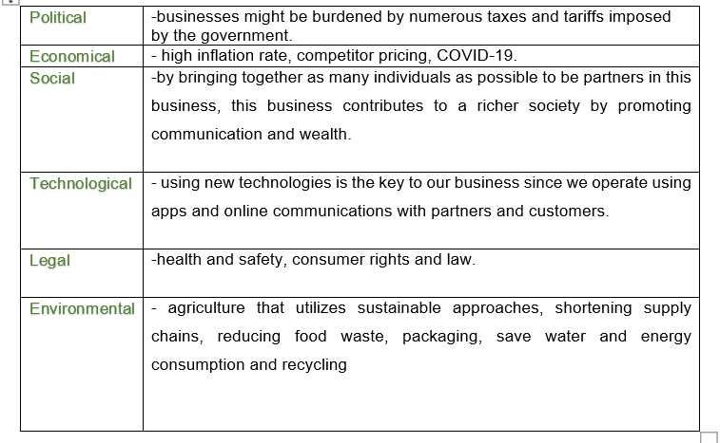
Figure 3
Analysing Figure 3, the business might be affected by numerous factors such as taxes, high inflation rate, competitors, COVID-19, lack of communication, new technologies, health and safety, supply chains, food waste, energy consumption. PESTLE analyse helps FEPO to overcome those by being aware of them in every single day of activity.

Target Market
The target market is that group of recipients to whom a particular product or service is addressed. Initially, target markets were groups of people who were grouped by age, gender or social profile.(Team, 2022)
Based on our research we have come to the conclusion that the following groups of people are predisposed to use our production:
- People who work in offices or big corporations;
- Those who earn enough to afford to set up a diet plan daily (middle class);
- Those who want to practice a healthy lifestyle;
- Those who don't have time to cook and prefer a healthy meal ;
- People between the ages of 25 to 45;
- Athletics

Marketing and sales plan

A marketing plan is a document that is the most important component of an enterprise's strategic plan, which establishes the company's market goals and suggests methods for achieving them. (Valdani & Arbore, 2015)
FEPO is an expert in diet health solutions and the way in which we would market is by advertising on social media sites like Instagram , Facebook and Twitter .Then we would also advertise on billboards , back of buses which will allow for more diverse people to see.
- Instagram: Will be use to post all our products to be sure that the customers know what he is paying for
- Facebook: Will be use to tell people about our discount and promotion
- Twitter: Will be use to collaborate and speak with customers fore them feedback

Management team

This company is composed by five members: Faisal Khalid as a director of the company, Liviu Hadirca as an accountant/ marketing manager, Madalina Stanga as a chef, Cristian Fota as a delivery driver, all of us working together with a nutritionist to operate this business. The job roles given to each investor team member match their prior experience and qualifications.
An organization chart is presented bellows as follows:
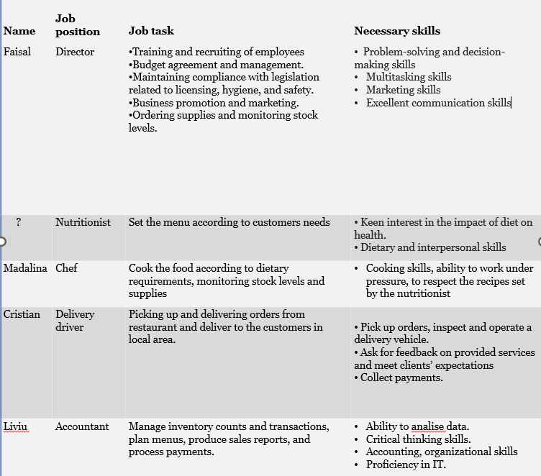
Figure 4

Financial plan

Each investor will make a five-thousand-pound initial investment in addition to the twenty-thousand-pound allowance.
Start-up costs
The Start-up costs are split as follows:

Figure 5

Monthly cash-flow

With the help of the monthly flow chart, we can focus on the factors that contributed to our profit while also identifying the customers who were most plentiful at particular times of the year. This helps us determine where to focus our promotion and investment efforts over the next two years.
Monthly cash-flow for the first three months:
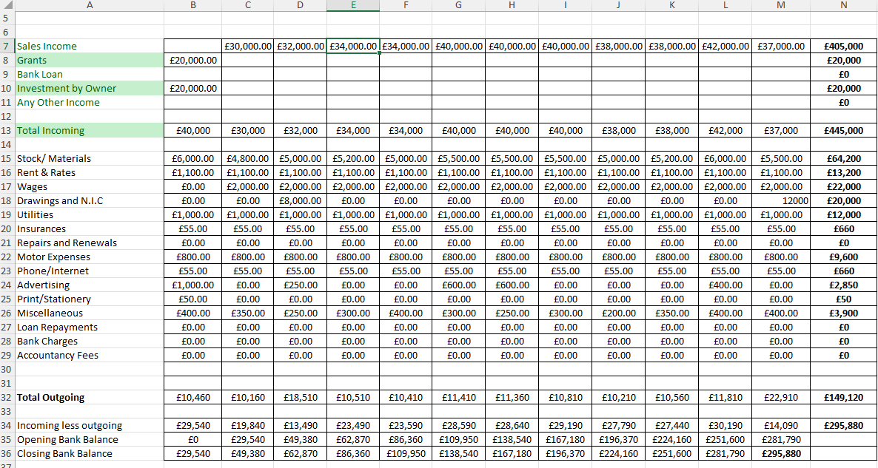
Figure 6

10. Profit and loss
- Sales income: £405,000
- Total expenses: £149,120.00
- Sales less expenses: £295,880.00
- Tax income (20%): £59,176.00
- Net profit: £236,704.00
- Total profit (divide 4 partners): £59,175.00Figure 7
Figure 8

Conclusion

With its innovative idea of creating positive change for the future of the healthy food industry, all the collected and analyzed data, FEPO believes that this venture will be a success and that it will have the potential to positively impact our local economy and community in a number of ways.

References
- National Health Service (2019) What should my daily intake calories be? Available at:
https://www.nhs.uk/common-health-questions/food-and-diet/what-should-my-daily-intake-of-calories-be/#:~:text=Generally%2C%20the%20recommended%20daily%20calorie,women%20and%202%2C500%20for%20men.%20(Accessed%2030%20October%202022)
(Accessed 03 November 2022)
- National Health Service (2022) Eating a balanced diet. Available at:
https://www.nhs.uk/live-well/eat-well/how-to-eat-a-balanced-diet/eating-a-balanced-diet/ (Accessed 04 November 2022)
- Dietary Guidelines for Americans (2020) Make Every Bite Count with the Dietary Guidelines. Available at : https://www.dietaryguidelines.gov/sites/default/files/2020-12/Dietary_Guidelines_for_Americans_2020-2025.pdf ( Accessed 31 October 2022)
- Mayo Clinic (2022) Nutrition and healthy eating. Available at: https://www.mayoclinic.org/healthy-lifestyle/nutrition-and-healthy-eating/in-depth/low-glycemic-index-diet/art-20048478#:~:text=A%20low%2Dglycemic%20index%20(low,effect%20on%20blood%20sugar%20levels. (Accessed 02 November 2022)
- Radulescu, V. and Cetina, I. (2012) Customer analysis, defining component of Marketing Audit, Procedia - Social and Behavioral Sciences. Elsevier. Available at: https://www.sciencedirect.com/science/article/pii/S187704281203491X#:~:text=Marketing%20audit%20is%20a%20tool,marketing%20efforts%20of%20the%20organization. (Accessed: November 20, 2022).
- Teoli D, Sanvictores T, An J, 2022.SWOT Analysis. In: StatPearls. StatPearls Publishing, Treasure Island (FL).
- Team, T.I. (2022) Target market: Definition, purpose, examples, market segments, Investopedia. Investopedia. Available at: https://www.investopedia.com/terms/t/target-market.asp (Accessed: November 8, 2022).
- Valdani, E. and Arbore, A. (2015) Marketing strategies, International Encyclopedia of the Social & Behavioral Sciences (Second Edition). Elsevier. Available at: https://www.sciencedirect.com/science/article/pii/B9780080970868730261 (Accessed: November 8, 2022)
- Zalengera, Collen & Blanchard, Richard E. & Eames, Philip C. & Juma, Alnord M. & Chitawo, Maxon L. & Gondwe, Kondwani T.(2014). "Overview of the Malawi energy situation and A PESTLE analysis for sustainable development of renewable energy," Renewable and Sustainable Energy Reviews, Elsevier, vol. 38(C), pages 335-347

