University of Wales Trinity Saint David’s
L4 - Introduction to Web and Database Concepts (ACCA4023) (Bev)
Cybersecurity (Computing and Networking)
Connor Michael Anthony Wilson (2011592@student.uwtsd.ac.uk)



Context
Introduction – Page 1
Implementation for database creation – Page 2 – Page 5
Database Creation – Page 6 – Page 7
Conclusion – Page 8
References Page 9

Introduction
In this research task, I will be outlining a database system as well as other diagrams for the business flow of Celtic Caterers.
During my initial findings when investigating the company’s business processes is that they will require a system that provides them with signed invoice that can be viewed or printed, if items are purchased by the supplier, they need to be able to see record of a transaction recorded and finally when catering events are booked, they will need to about view and query the information about the event.
The purpose of this database is to give a more robust and efficient system to the company so that they can complete their work better and have system which is going to take information down for the orders and will allow them to see what is working well within the business and what needs improving and giving easy access to things like their expenditure.

Implementation for database creation
In this section I will be implementing a context diagram, a level 0 DFD and finally an entity relationship diagram which investigate the following: Entities, relationships, degree of relationships, membership class and annotated descriptions for each of the relationships.

Context Diagram
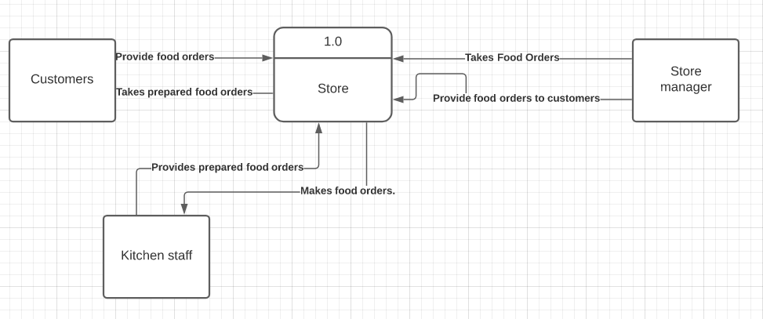
The purpose of using a context diagram is help the understanding of what is a part of the business and the context and boundaries between these systems that are being used in the relationship diagram. It will help to give the business a better understanding of what the most basic structure is for their basic storefront operations.
This is context diagram for the storefront flow without the data being giving more detail in the Level 0 diagram, but these are the most basic data flow for all the fundamental aspects of the store front and how it can complete its work.

Level 0 DFD
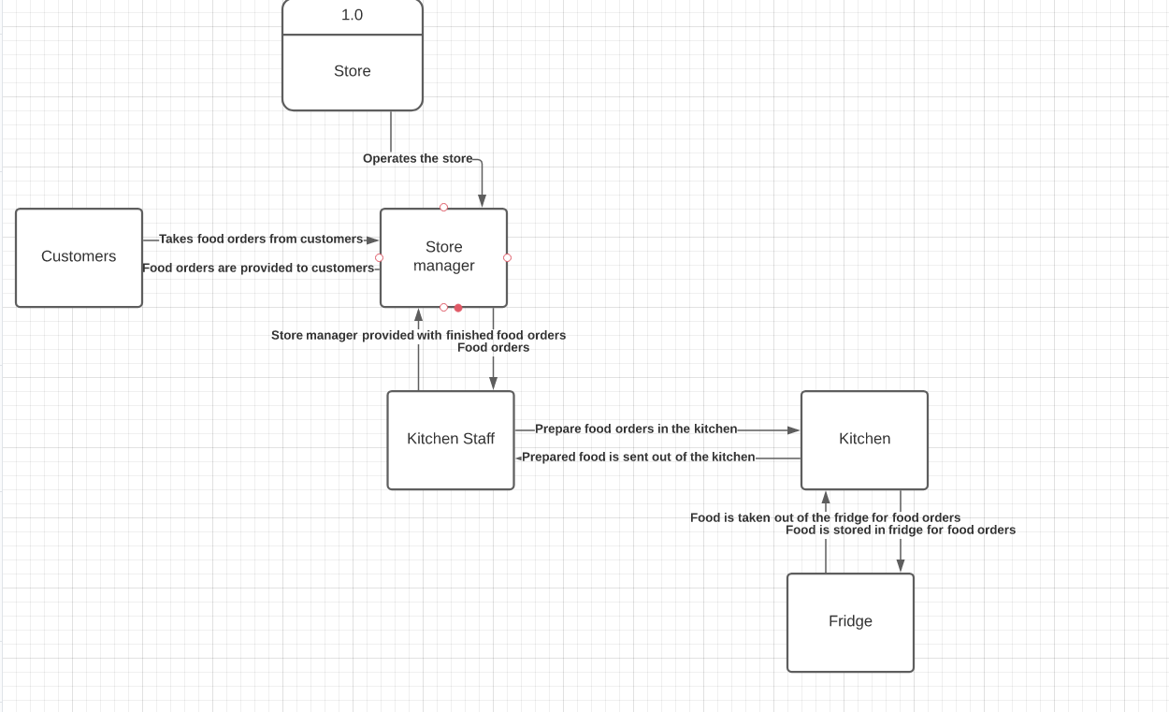
This is the level 0 DFD for the initial process in the store as the store manager are at the top of the data flow in the store, but it was stated that they deal exclusively with customers and then they pass down orders kitchen staff who use the equipment in the kitchen as well as the fridge to fulfil these orders.
It offers a slightly more advanced look at the data flow of the company showing more elements what happens at these stages and each of the relevant parts of the business interact with each other though it does not offer a large amount of detail or only showing the most basic process that is involved at each stage e.g., does not break down all the possible food orders the kitchen staff may take and how they would then prepare the food, etc.
Entity Relationship Diagram
I will next be making an entity relationship diagram which will be showing different relationships between roles and elements in the business with descriptions for each element so that it can be understood what is happening at each stage and its purpose.
The reason for using an entity relationship diagram is to give understanding to how each part of business interacts and the purpose of the interaction like store managers with the customer and all the possible outcomes that can happen as a part of the interaction this gives a complete breakdown on all the parts of the business what they are designed for. This gives more knowledge so that when are making the database as the next part of the process of breaking down the full business process that any essential part of the business will not be missed off which could cause issues to efficiency or potentially stop the business from working all together if the database does not contain this important information.

Firstly, I have made a key for Entity for each of the key components of the store and all the invovled process. As I will be going though and now making keys for all of the relevant parts for each of the parts involved this so it can be later used in the database to link all of the items together.
Next part will be filling in all of the keys for each of the entities this is so we can see how each of these elements link up during the order and
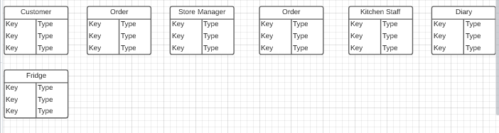
The first key I have chosen is the name of the customer to help identify the customer while the order is processing and making sure that the correct order item gets back to the customer, and I will use a Customer_ID to help identify that specific order when it is kept in the diary. I am making use of the outgoing and incoming ID’s so that orders that have been set out but have not been completed and then food orders that have been completed can be marked and set out.
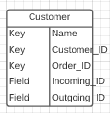

The next key I have filled in is for the order, this references the name and Customer ID from the customer entity which helps to create a connection between the two different options and then has separate keys. I have chosen different options for the food as food is not specific enough and I do not think this will be easy to keep a track of for the kitchen staff or be useful for keeping track of stock in the diary.
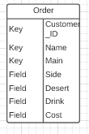

Included below is the finalised diagram. I have included a PK and FK (Primary Keys and Foreign Keys), Relationships between each of the entities/tables in the diagram as well as showing what goes as well as the lines going between all the entities to show what the process involves between and how many of the entity there is.
The relationship between each of the entities is as follows: Customer to store manager (Store manager takes food and drinks orders from the customer. Each unique order will be logged against a customer ID so data flow can be established for each order and that the items from that order can only be tracked that actual order.
Secondly the store manager provides the orders from the customer to the kitchen staff. They receive the Outgoing ID which will contain the information for the food/drinks that have been ordered by the customer which can then be processed.
Thirdly, Kitchen staff will then log any orders into the diary this will help to keep a track of all of the orders which will help to indicate when stock levels are low and need replenishing and they also have to use the fridge to acquire ingredients for the cooking process of preparing the orders or gathering drinks and then the order will be going to the customer from the kitchen staff after this.
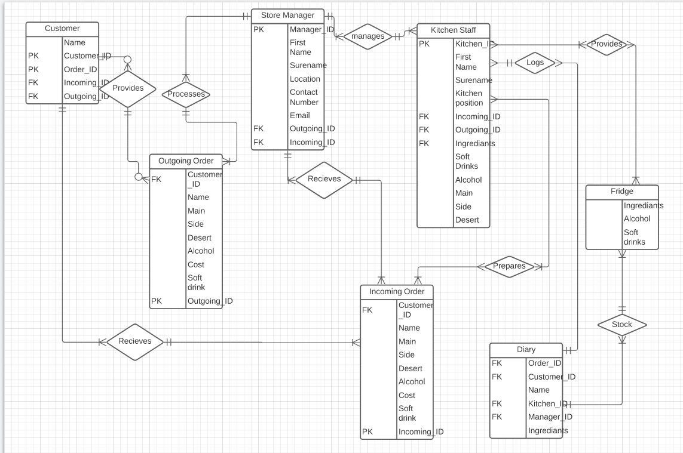

Database
I have started creating the tables within Microsoft access for the database that will be used for the business. I have taken the data that was made in the Entity Relationship Diagram above and transfer into the tables and will now start to apply relationships to each of the entities by applying the primary and foreign keys.
While I have been creating my relationships for my database, I have decided to remove order_ID. These essentially do the same thing as the Customer_ID and was adding unnecessary elements to the tables which was over confusing certain elements.
I have set up all the relationships between the primary keys and foreign keys within the relationship tab and now I can start making producing forms, ect for them to work with this these elements to make the database interactive as nothing has been set up for the staff and workers to use in the store front or the online aspects.
Database Creation
Below is the relationship tab with the primary to foreign keys setup.
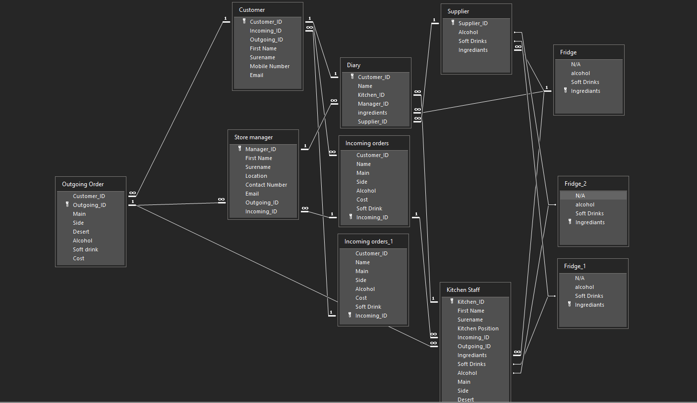
This considers all the possibilities that were outlined in what was required by the business so that booking is possible with the use of the form as well as taking the required details for as well as making sure that all other aspects of the business in store had been considered like the supplier, etc.
As it currently stands the tables do support the third normal form as quite a few different variables are required though this can be condensed further by removing and compacting some of the variables down to make this achievable.
I do not think this will be achievable however as some of the data loss will prevent stock list from being identified in the diary and does not give very much in the way of specifics the database users e.g., user categories like food and drink. It does not give you any information on if the user food orders, etc.

Some of the advantages of third normal form are as follows:

Increased data quality:
There is a smaller chance of storing unnecessary data in the table and there is less required storing of null values within the tables. [1]
Capturing complete business requirements:
The understanding through normalization of the business becomes stronger and requirements of the business are easy to capture.
Data anomalies (Insert, delete and update) are reduced due to less data being required [2]

I have started to create a report for the supplier but looking at the fields that are currently available these do not seem suitable for what they would need to be ordering so more options need to be given.
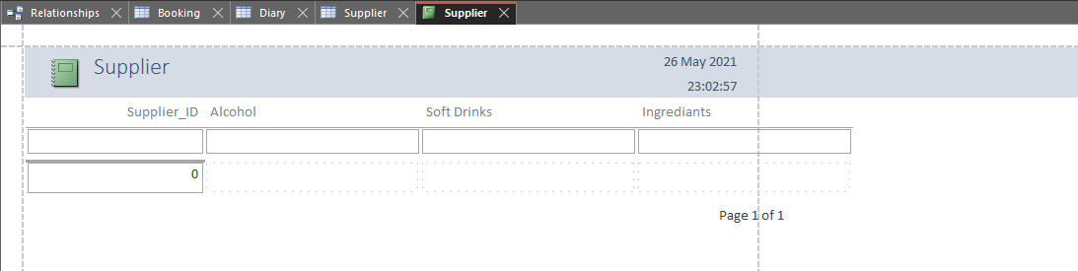

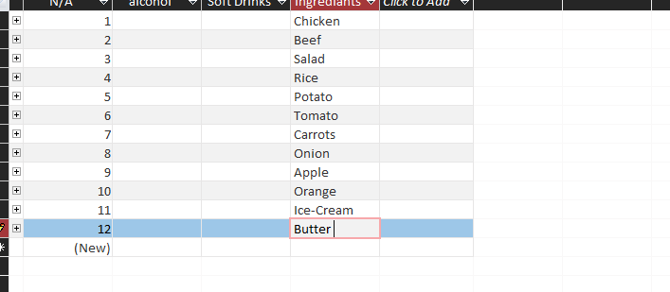
I have started to add food items onto the ingredients list which can be selected report and I will do this for all categories.

Conclusion
In conclusion, if I had more time to work on the database I would of condensed the table content of the groups adding additional entities for specifics like food to link up doing this does stop less errors but also makes a lot more tables which can make the content a lot more confusing for workers to operate which in turn could end up producing more errors which is not what the designated effect of implementing this into the work is.
I would also like have a more interactable and detailed report, so the staff have more options and information is clearer when they are going to purchase items from the supplier for additional stock so that the transactions are clear as well for the user as It was unfinished in my current report but can be added on.

References

[1] P. Pedamkan, “Third Normal Form,” Educba, 2020. [Online] Available: https://www.educba.com/third-normal-form [Accessed May. 25, 2021]
[2] P. Pedamkan, “Third Normal Form,” Educba, 2020. [Online] Available: https://www.educba.com/third-normal-form [Accessed May. 25, 2021]

