UNIVERSITY OF WALES
Trinity Saint David
London
MODULE CODE/ COD Y MODIWL: LCBB4003
INTRODUSING THE MODERN WORKPLACE
ASSIGNMENT 1

Student name: Neno Dinev
Student ID: 1917135
Lecturer: Rula Alousi

Table of Contents
Introduction 3
The structure and culture of Tesco plc and its contribution on the performance 4
Organisation design: 4
Organisation structure: 4
Tesco’s structure and its influence on the performance: 7
Organisational culture: 7
Tesco’s culture and its influence: 9
Conclusion 11
References 12

Introduction
The organisational structure and culture have great influences on the performance of any company. The structure works as a guide to the employees that set the relationships among them. A good structure can motivate them as well as attract skilled people to the organisation. It ensures flexibility of the organisation to any change. And cultures rise the involvement and loyalty among the employees. It increases the productivity and he efficiency of the organisation. The theories and model help to define the culture in the easier way. It helps in taking right decision in time. Tesco plc is the chosen company for the report.

The structure and culture of Tesco plc and its contribution on the performance
Tesco plc is the top player in the groceries market in the UK. It has gained the top third position by total revenue. The business was started by selling surplus items of the wars in early 1900s. It is headquartered in England. It operates in more than 10 countries. It belongs to the retailing industries and offer wide variety of products (Tesco, 2020).

Organisation design:
It deals with the process to adjust the resources and human resources in a structured form that improves the productivity of all. It involves the way teams are formed and work, scheduling the responsibilities, the way and to whom to report, the way decisions will be made, the way people will connect and so on (Stanford, 2007). It has six main elements. First one is work specialisation where every work is distributed among the people working according to their skill and ability. It decreases the time they take to do that job as they specialise on that job. Second one is departmentalisation where a group of work is formed according to the purpose. Later it has chain of command which implies the authority of an individual to whom he or she will report. Then span of control decides the number of people a manager will supervise. Then an organisation can be either decentralised where all levels of managers can take decisions or centralised where the environment is strict (McMillan, 2012). Last of all, in formalisation organisations designs standard work flow. Most of the theories of organisational design is structure based. A popular model is Weber's Bureaucratic Model where some standard rules are designed to direct all personnel. The U-form, M-form and matrix form are basically different organisational structure.

Organisation structure:
It shows activities like job distribution, direction and administration which are executed to reach the goal of the business (Cosh & Hughes, 2012). There are several theories and types of culture. Some of the theories are like- traditional organisational theory, open system theories, Weick’s model of organizing and so on. The first theory is mainly a bureaucratic model where the power is centralised. Authority distributes the responsibilities among all the employees. The fact of motivation is ignored in this theory. The employees are ignored while making any decision. They have to implement the plan of the top management. Open system theory is more human centred than bureaucratic model. It applies motivators for the people and is quite decentralised. Managers of different levels help in taking daily decisions. It also provides different facilities from outsources (Lansley, Sadler & Webb, 2014). The system is modified always as per the requirements of the organisation. The other one is Weick’s model of organizing which is a modern theory of organisational structure. It can tackle the stressful work environs of modern business and eliminates any elements that causes low productivity in the business. This model uses an information system that helps in resolving different issues using the past experiences of the firm. It ensures continuous improvement in the productivity of the employees.
Tesco mainly follows this model as it helps the customers and salesperson to tackle any situation as fast as possible. And the top management also can have proper authority over all. The accountants and regional officers can check the information system and take the proper decisions. It also motivates employees as they feel they are taking the right decisions. It helps Tesco to have consistent performance all the time.
There are different types of organisational structure. Some popular structures are-
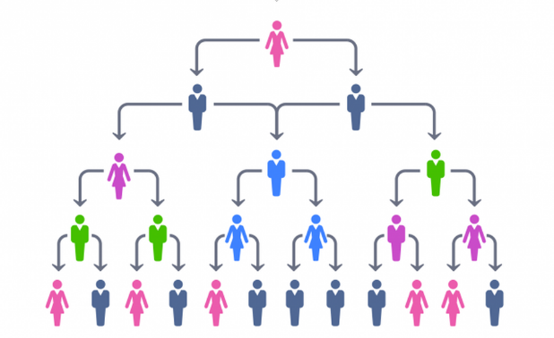
Hierarchical Structure: In this structure, a group of people has one boss to whom they submit their works. The employees can be grouped according to the functions, geographic positions, skills, products and so on. Mainly the authority allocates duties to them and they have to update their supervisor timely (Champness & Beton, 2007).
Figure 1 Hierarchical Structure (Champness & Beton, 2007)
Matrix structure: In this structure, more than one supervisor work to guide a group of people to attain a goal. People with same skills and experience are grouped to execute a plan for the organisation. For example: when salespersons of Tesco work in daily shops, they normally report to the regional officers but when they work in a group for any promotional purpose, they report to the leader of the team.
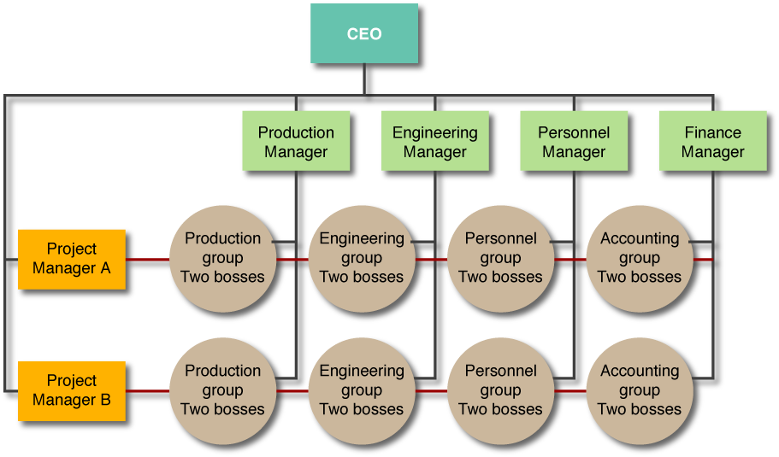
Flat structure: This is an ideal structure for small business as many mid-level employees do not exist in this structure. The employees take decisions mainly on their own. The business needs experienced manpower for this kind of structure. It motivates them as they are considered as important as owners.
Figure 2 Matrix structure
Network: It maintains a good relationship with all the employees and managers. This structure is mainly decentralised and has flexibility. Social networking is the motivation for this kind of structure. It is quite agile and provides more control. But this kind of structures often create complexities.
Divisional structure: For the product processing, organisations need different set of functions and they need to be interconnected to have the job done properly. It can be multi-divisional too where one business directs its subsidiaries. It is called M-form.
Functional structure: It is very popular structure now-a-days. It is mainly like activities-based structure (Holst, 2009). For example, all accountants grouped and made a division. All marketers make a marketing department. Thus, the structure is formed. It makes the employees specialised and their skills get enriched. It helps a company to grow more in future. It also helps in employee’s personal skill development. But they cannot have efficiency in other activities.
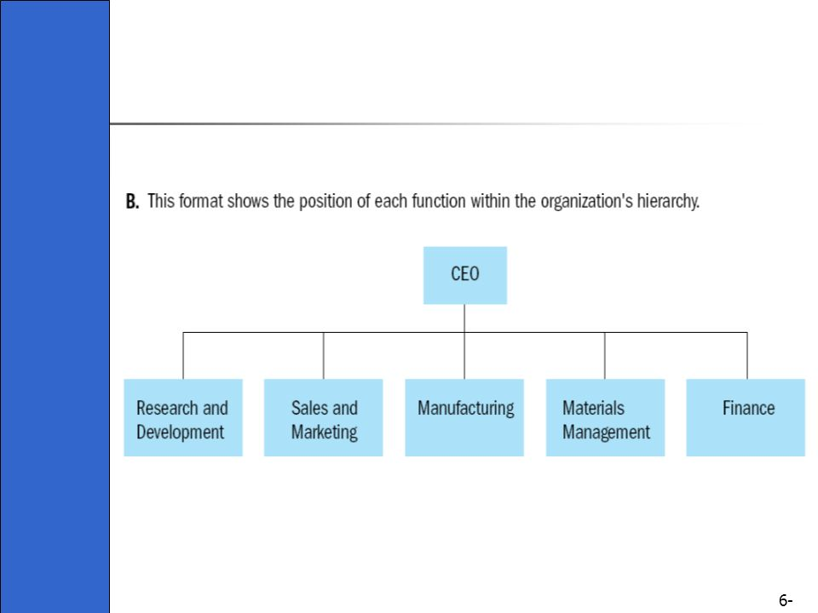
Figure 3 Functional structure (Holst, 2009)

Tesco’s structure and its influence on the performance:
No structure is fully effective for a company. That is why most of the company uses more than two structures for its operation. Tesco’s structure is designed in such a way that it can easily attain its goals. Some professionals say that the company follows hierarchical structure but Tesco mainly follow two types of structure. One for the company and another is for the shops. The top management uses hierarchical for making important but infrequent decisions. The top management decides what to achieve for all the departments of the company. The management oversees the whole organisation and brings changes where needed. But in the shops, the rules are quite flexible. The decision making is more decentralised. The subordinates continuously take the daily necessary decisions but follow their experiences. Only important and unusual situations are tackled by the manager of the shop. It helps the company to provide quick services to the customers. The hierarchical structure helps the company to perform well in every critical situation but the decentralisation in the stores motivates the salespersons and their productivity gets increased. It ensures consistent yet continuous expected performance of the company.

Organisational culture:
It is mainly a system where the rules, norm, etiquette, values etc. design the way employees going to interact. Dr. Elliott Jaques coined the term of organisation culture in 1950s. A good culture motivates all of the people in a business. It also increases the engagement of them. The culture also gives the business a separate image in both internally and externally (Martins & Terblanche, 2013). It also keeps the business its goal oriented. Culture is formed for the goals to achieve. It turns everybody to a team. Handy’s organisational cultures are popular in the business world. Those mostly covers the culture of the businesses. He has introduced four kinds of culture. Those are-
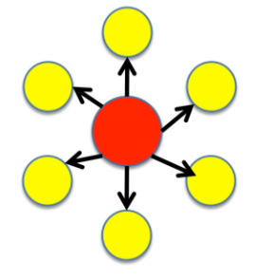
Power culture: In a spider’s net or web, spiders sit in the centre point, the power of a business is also in the centre. This culture is mainly individual oriented. If the individual is close to the spider, he or she become more powerful. The top management is the spider in the case of a large company. This culture can take actions quite swiftly but the success of the business highly depends on the efficiency at the centre of the business. The individuals who loves to control mainly work in this kind of culture. The people have to realize what the top management expects from them and perform accordingly. But confusions can affect the satisfaction of the employees and the company can face high employee turnover which affect the performance greatly (Lok & Crawford, 2014).
Figure 4 Power culture (Tutor2u, 2020)
Role culture: This culture is like a building where every floor has its own responsibilities that means roles to keep the building intact. This culture is similar to Weber's Bureaucratic Model. The culture is designed formally and in a standard way. Different functional departments are formed but supervised by a small group of top managers. The progress of the personnel, the communications and the resolution of any conflict are monitored by the pre-set rules and regulations. So, clearly top positions provide the full authority in here. If the managers can allocate task according to the skills and experience of the employees, this culture will work with full efficiency. But this culture does not accept changes easily.
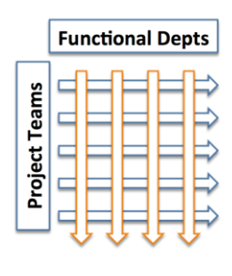
Task culture: This culture is mainly based on the task or project. This culture exists mainly in the matrix structured organisations. It focuses on the efficiency of completing a task. Because of this, the skilled and experienced people and the required resources are grouped together. They are assembled to make them understand the goal of the organisation. It focuses on the team effort of the experts. The teams can be easily formed and broken when needed. It can react to any change as all the members have the power to take decisions (Sinclair, 2013). It motivates the employees as it provides opportunity to all of the people according to their expertise. But the top management has a few controls over the employees.
Figure 5 Task culture (Tutor2u, 2020)
Person culture: This culture is mainly individual oriented. It focuses on the individuals who works for the company. Their interest is the first priority of the culture. But sometimes the business goals are set above their interest. Controlling management or centralisation is not accepted in this culture. The rules and norms are set mutually. Individuals can easily exit the company. This culture is hardly found in any company.

Tesco’s culture and its influence:
Tesco, from the very beginning, follows the one stop shop culture from where the customers can get any products, they want in one shop with full convenience. The founder of Tesco used to bring products at a cheap rate and sell them to people. But he confirmed the good quality of the products. To support its culture, it offers a wide variety of products like organic, farm, cheaper products and so on. The culture of the company is also consumer-centric. The company collects data and analyse the to see if there is any scope of improvement which will be convenient for the customers (Milne, 2017). According to Handy’s model, Tesco follows both power and role culture. As the company has to control the international market, most of the important decisions are taken by the top management. But it has set up an information system which offers the mid-level managers to take decisions according to the system. It is set as kind of rule. This system is managed by the authority (Catherine, 2020).

Conclusion
Tesco mainly follows Weick’s model of organizing for the organisational structure theory as it both lets top manager have full authority but mid-level managers check the information system to take quick decision of any daily situations. So, it is clear that Tesco follows hierarchical structure but, in the stores, the authority is quite flexible as the model provides an information system. Tesco follows around four cultures. Those are- the one stop shop culture, consumer-centric culture, role culture and power culture. The first three cultures are followed in the stores and the regional offices and the power culture is for the company as a whole.

References
Catherine K, (2020), HOW THE STRUCTURE AND CULTURE OF TESCO CONTRIBUTE TO ITS ORGANIZATIONAL PERFORMANCE, [online] Available at: < https://www.123writing.com/free-sample/how-the-structure-and-culture-of-tesco-contribute-to-its-organizational-performance >, [Accessed on: 14 August, 2020]
Champness, N. R., & Beton, P. H. (2007). Hierarchical Organisation on a Two‐Dimensional Supramolecular Network. ChemPhysChem, 8(15), 2177-2181.
Cosh, A., Fu, X., & Hughes, A. (2012). Organisation structure and innovation performance in different environments. Small Business Economics, 39(2), 301-317.
Holst, E. V. (2009). On the functional organisation of drives. Readings in Behavior, 251.
Lansley, P., Sadler, P., & Webb, T. (2014). Organisation structure, management style and company performance. Omega, 2(4), 467-485.
Lok, P., & Crawford, J. (2014). The effect of organisational culture and leadership style on job satisfaction and organisational commitment. Journal of management development.
Martins, E. C., & Terblanche, F. (2013). Building organisational culture that stimulates creativity and innovation. European journal of innovation management.
McMillan, E. (2012). Considering organisation structure and design from a complexity paradigm perspective. Tackling industrial complexity: the ideas that make a difference, 123-136.
Milne, P. (2017). Motivation, incentives and organisational culture. Journal of knowledge management.
Sinclair, A. (2013). Approaches to organisational culture and ethics. Journal of Business ethics, 12(1), 63-73.
Stanford, N. (2007). Guide to organisation design: Creating high-performing and adaptable enterprises (Vol. 10). John Wiley & Sons.
Tesco Plc (2020), Official Website, [online] Available at: < https://www.tesco.com/ > [Accessed on: 14 August, 2020].
Tutor2u (2020), Handy's Model of Organisational Culture, [online] Available at: < https://www.tutor2u.net/business/reference/models-of-organisational-culture-handy > [Accessed on: 14 August, 2020].

