

University of Wales Trinity Saint David

MSc Data and Artificial Intelligence

Exploratory Data Analysis – Report and Demonstration

Data Mining Analysis of Telecom Customer Churn Using Classification and Clustering Techniques

Student Name: | Vera Karakoleva
Student ID: | 2232348
Module: | Data Mining & Visualisation
Module Code: | ACCA7015
Lecturer:  Submission Date: | Dr Nouh Elmitwally  29/07/2026

Contents
Table of Figures 4
Table of Tables 4
Abstract 5
1.Introduction 6
1.1 Background 6
1.2 Business Problem 6
1.3 Aim 7
1.4 Objectives 7
2. Literature Review 7
2.1 Predictive Analytics 7
2.3 Classification Algorithms 8
2.3 Model Evaluation Metrics 9
2.4 Clustering 9
3. Methodology 10
3.1 Dataset Description 12
3.2 Data Preparation 12
3.3 Feature Selection 13
3.4 Experimental Design 15
3.4.1 Data Splitting Strategy 15
3.4.2 Data Leakage Prevention 16
3.4.3 Feature Scaling 17
3.4.4 Evaluation Strategy 17
3.5 Classification Models 17
3.5.1 Logistic Regression 17
3.5.2 Decision Tree 18
3.5.3 Random Forest 19
3.5.4 Model Comparison 21
3.6 Hyperparameter Tuning 22
3.7 Customer Segmentation Using K-Means 23
3.7.1Feature Selection for Clustering 24
3.7.2 Feature Scaling 24
3.7.3 Determining the Number of Clusters 24
3.7.5 Cluster Profiling 26
3.7.6 Cluster Validation 27
4. Discussion 28
5. Business Recommendations 28
6. Limitations 29
7. Conclusion 29
References 30

Table of Figures
Figure 1: Conceptual workflow of machine learning-based customer churn prediction.Source: Author's illustration developed from the literature presented in [1],[2],[3]. 8
Figure 2.Complementary Roles of Classification and Clustering in Customer Retention. Source: Author's illustration based on [15], [17], [18], [19]. 10
Figure 3.CRISP-DM-based analytical workflow adopted in this study.Source: Author's illustration 11
Figure 4. Top numerical features Correlated with Churn. Source: Author's analysis. 14
Figure 5.Feature Selection Using SelectKBest.Source: Author's analysis 14
Figure 6.Random Forest Validation of the Selected Features.Source: Author's analysis 15
Figure 7.Experimental Data Splitting Strategy 16
Figure 8.Logistic Regression Confusion Matrix.Source: Author's illustration 18
Figure 9.Decision Tree Confusion Matrix.Source: Author's illustration 19
Figure 10.Random Forest Confusion Matrix 20
Figure 11.ROC Curve Comparison of the Classification Models.Source: Author's illustration. 22
Figure 12.Tuned Random Forest Confusion Matrix.Source: Author's illustration. 23
Figure 13.Elbow Method for Determining the Number of Clusters.Source: Author's illustration. 25
Figure 14.Silhoutte Score for Different Numbers of Clusters.Source: Author's illustration. 26

Table of Tables
Table 1.Comparison of the Selected Classification Algorithms.Source: Author’s 9
Table 2.Characteristics of the Telecom Customer Churn dataset.Source: Compiled by the author based on the Kaggle Telecom Customer dataset [18]. 12
Table 3. Summary of Data Preparation.Source: Compiled by the author 13
Table 4.Logistic Regression Performance.Source: Compiled by the author based on model outputs. 18
Table 5. Decision Tree Performance.Source: Compiled by the author based on model outputs. 19
Table 6.Random Forest Performance.Source: Compiled by the author based on model outputs. 20
Table 7.Training and Testing Accuracy.Source: Compiled by the author based on model outputs. 21
Table 8.Model Comparison.Source: Compiled by the author based on classification results. 21
Table 9.Optimal Hyperparameters Selected by RandomizedSearchCV.Source: Compiled by the author based on RandomizedSearchCV results. 22
Table 10. Performance Before and After Hyperparameter Optimisation.Source: Compiled by the author based on model outputs. 23
Table 11.Dataset Scope for K-Means Customer Segmentation.Source: Compiled by the author based on the Telecom Customer dataset [18]. 24
Table 12Variables Selected for K-Means Customer Segmentation.Compiled by the author based on the selected variables for K-Means clustering. 24
Table 13.Reduction in Inertia Between Consecutive Cluster Solutions.Source: Compiled by the author based on K-Means results. 25
Table 14.Silhouette Scores for Alternative Cluster Solutions.Source: Compiled by the author based on K-Means results. 26
Table 15.Business Interpretation of the K-Means Customer Segments.Source: Compiled by the author based on K-Means clustering results. 27
Table 16.Statistical Validation of the Identified Customer Segments.Source: Compiled by the author based on K-Means clustering results. 27

Abstract

Customer churn prediction has become an important application of predictive analytics, enabling organisations to identify customers who are at risk of leaving before churn occurs. This report develops and evaluates machine learning models for predicting customer churn using a publicly available telecommunications dataset containing approximately 100,000 customer records. Following the CRISP-DM methodology, the study applies data preprocessing, feature selection, classification modelling and customer segmentation. Logistic Regression, Decision Tree and Random Forest are compared using standard evaluation metrics, while K-Means clustering is employed to identify meaningful customer segments. The proposed approach demonstrates how predictive analytics and customer segmentation can support more effective retention strategies and improve data-driven decision-making in the telecommunications industry.
Keywords: Customer churn, predictive analytics, machine learning, classification, K-Means clustering, telecommunications.

1.Introduction

Background

For a telecom company, customer churn is often visible only when it is already too late. A customer cancels a contract, moves to a competitor, and the company loses both future revenue and the opportunity to intervene. Broad retention campaigns offer one solution, but they are expensive and often target customers who were unlikely to leave. Predictive analytics offers a more focused approach by using customer behaviour, service usage, revenue, device information and demographics to identify risk before cancellation occurs [1], [2].
This report builds on the exploratory analysis (EDA) completed in Assignment 1, in which the telecom dataset was cleaned, prepared, and visualised. The findings showed that usage behaviour and device age contained useful churn-related information, while no single feature had a strong relationship with the target. Churn therefore appears to emerge from a combination of factors, making machine learning suitable for detecting patterns that may be difficult to identify through traditional analysis alone [3].

1.2 Business Problem

The business problem is the difficulty of identifying high-risk customers early enough to apply targeted retention actions without wasting resources on unnecessary offers.

1.3 Aim

This report aims to develop and compare classification models that predict whether a customer will remain or churn. Clustering is also applied to customers with Churn = True to identify distinct groups and support more targeted retention strategies.

1.4 Objectives

The objectives are :
- to prepare and select relevant features for modelling;
- to implement and evaluate at least two classification models;
- to segment churned customers using clustering;
- to compare the techniques and produce actionable business recommendations.

2. Literature Review

2.1 Predictive Analytics for Customer Churn Prediction

Telecommunications is one of the most widely studied application areas for predictive analytics because customer churn directly affects business performance. Predicting churn is challenging, as it depends on multiple customer, service and usage characteristics rather than a single factor [1], [3].
As illustrated in Figure 1, machine learning models analyse these multiple customer characteristics simultaneously to estimate the probability of churn before cancellation occurs. Rather than applying retention incentives across the entire customer base, organisations can prioritise customers with the highest predicted risk[1], [2].
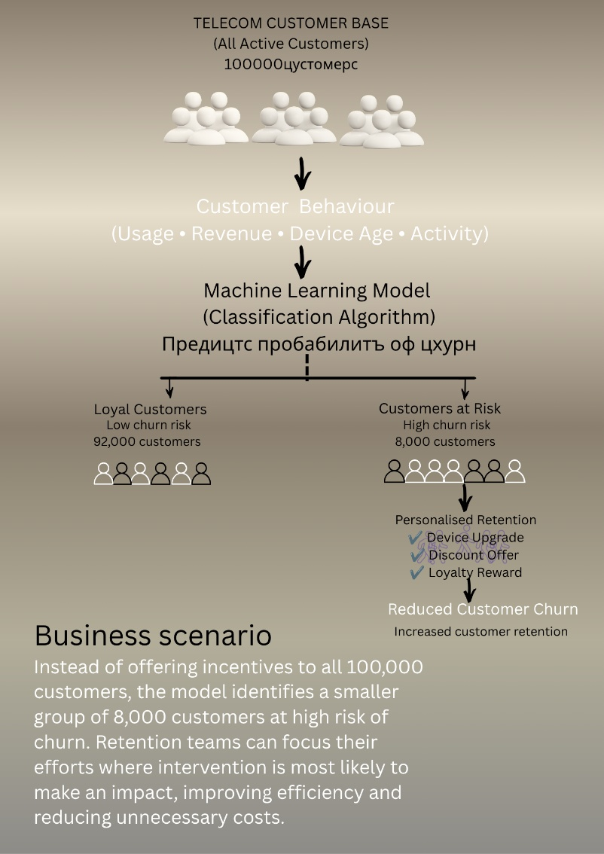

Figure 1: Conceptual workflow of machine learning-based customer churn prediction.Source: Author's illustration developed from the literature presented in [1],[2],[3].

The primary value of churn prediction lies in supporting timely and cost-effective customer retention decisions [1], [2].

2.3 Classification Algorithms
Customer churn prediction requires models that distinguish customers likely to leave from those likely to remain. Since no single classifier consistently outperforms others across different datasets, model performance depends on factors such as data quality, feature selection and parameter tuning [8],[10],[15],[16]. Therefore, three complementary algorithms were selected: Logistic Regression, Decision Tree and Random Forest. Together, they provide a comparison between interpretable traditional models and an ensemble approach. Their main characteristics are summarised in Table 1.
Table 1.Comparison of the Selected Classification Algorithms.Source: Author’s
Algorithm | Main strength | Main limitation | Primary analytical purpose | Supporting literature
Logistic Regression | Transparent probabilistic predictions | Limited modelling of complex nonlinear relationships | Baseline linear classifier | [6], [7]
Decision Tree | Clear nonlinear decision rules | Prone to overfitting and unstable splits | Explainable nonlinear classifier | [5], [7]
Random Forest | Robust and balanced predictive performance | Reduced model transparency | Generalisation benchmark | [6], [7],[9]

Traditional models provide transparent and interpretable predictions, while Random Forest improves predictive performance by combining multiple decision trees. As model effectiveness remains dataset-dependent, all three algorithms are evaluated using the same experimental framework to identify the most suitable classifier [6], [9], [10].

2.3 Model Evaluation Metrics

Because customer churn datasets are often imbalanced, accuracy alone may be misleading. Therefore, model performance is evaluated using recall, precision, F1-score and ROC-AUC, providing a more comprehensive assessment of predictive performance [7], [8], [11].
2.4 Clustering
Unlike classification, clustering is an unsupervised learning technique that groups customers with similar characteristics without using a predefined target label. In churn analysis, it complements classification by identifying distinct customer segments that support more targeted retention and recovery strategies [12], [13], [14]. The complementary roles of classification and clustering are illustrated in Figure 2.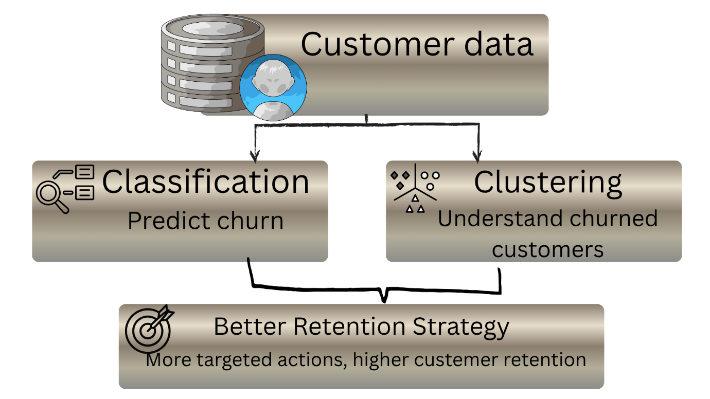

Figure 2.Complementary Roles of Classification and Clustering in Customer Retention. Source: Author's illustration based on [15], [17], [18], [19].

Several clustering algorithms are available. Hierarchical Clustering is useful for exploring relationships between groups but is less suitable for large datasets. Mean Shift automatically determines clusters but is computationally expensive, while Fuzzy C-Means allows overlapping customer membership at the cost of reduced interpretability [12], [13].
K-Means was selected because it provides a practical balance of simplicity, scalability and interpretability. As a distance-based algorithm, it requires feature standardisation, while the optimal number of clusters can be supported using the Elbow Method and Silhouette Score [13], [14], [15]. Although sensitive to outliers and irregular cluster shapes, it remains one of the most widely used methods for customer segmentation.

3. Methodology

This chapter describes the methodology adopted to develop and evaluate the predictive models. Building on the Exploratory Data Analysis (EDA) completed in Assignment 1, the study follows the Cross-Industry Standard Process for Data Mining (CRISP-DM). As one of the most widely adopted data mining frameworks, CRISP-DM provides a structured yet flexible process that aligns business objectives with data preparation, modelling and evaluation [16], [17]. The overall analytical workflow is presented in Figure 3.

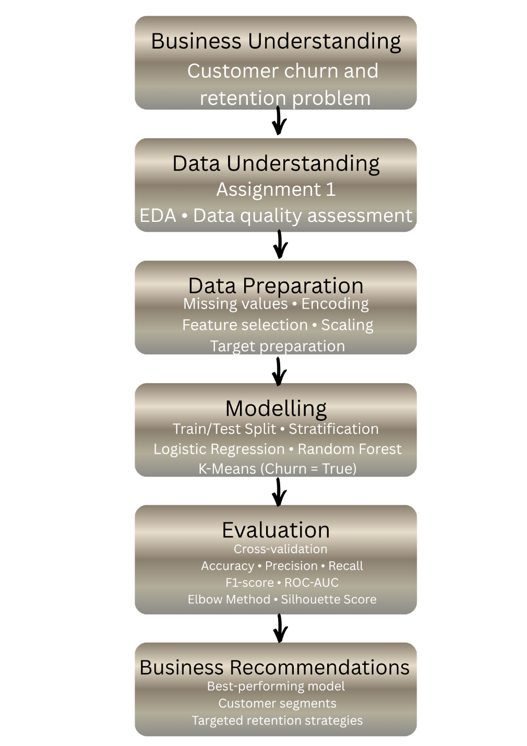

Figure 3.CRISP-DM-based analytical workflow adopted in this study.Source: Author's illustration

CRISP-DM was selected because its iterative structure supports repeated refinement of data preparation, feature selection and model development. Compared with alternative methodologies such as KDD, SEMMA and TDSP, it places greater emphasis on linking analytical results to business objectives, making it well suited to customer churn prediction [16], [17].

3.1 Dataset Description

The analysis was conducted using the publicly available Telecom Customer dataset from Kaggle [18]. The dataset contains approximately 100,000 customer records and around 100 variables describing demographics, service subscriptions, usage behaviour, revenue and device characteristics. The target variable, Churn, indicates whether a customer remained with or left the service provider. Following the preprocessing completed in Assignment 1, only the selected features were retained for the classification and clustering analyses. Table 2 summarises the main characteristics of the dataset.

Table 2.Characteristics of the Telecom Customer Churn dataset.Source: Compiled by the author based on the Kaggle Telecom Customer dataset [18].
Characteristic | Description
Dataset source | Kaggle – Telecom Customer Churn Dataset
Records | ~100,000 customers
Original features | ~100 variables
Target variable | Churn (True/False)

3.2 Data Preparation

Building on Assignment 1, the dataset had already undergone data quality assessment and preprocessing. Missing values were imputed using the median (numerical variables) and mode (categorical variables), duplicate records were checked, Customer_ID was removed, the target variable (Churn) was converted to binary, and categorical variables were encoded using One-Hot Encoding. This approach was selected because the categorical features have no natural ordering, avoiding artificial ordinal relationships that could affect model performance [1], [3]. The main preparation steps are summarised in Table 3.

Table 3. Summary of Data Preparation.Source: Compiled by the author
Data-quality issue | Treatment | Purpose
Missing numerical values | Median imputation | Reduce the effect of missing numerical observations while preserving the distribution
Missing categorical values | Mode imputation | Replace missing categorical values using the most frequent category
Duplicate records | Checked, none identified | Ensure each customer record is unique
Identifier variable | Customer_ID removed | Remove non-informative identifier that has no predictive value
Categorical variables | One-Hot Encoding (where required) | Convert categorical variables into numerical format
Target variable | Converted to binary (0 = Stayed, 1 = Churned),(True/False) | Prepare the target for classification algorithms
Final verification | No missing values remained | Confirm dataset completeness before modelling

One-Hot Encoding increased the number of predictors, making feature selection necessary to reduce dimensionality, remove redundant variables and improve model efficiency before classification and clustering [10], [19].

3.3 Feature Selection

Following One-Hot Encoding, the number of predictors increased from 99 to 210. Although ensemble methods such as Random Forest can handle high-dimensional data, redundant predictors increase computational complexity and reduce interpretability. Therefore, feature selection was applied to retain the most informative variables while improving model efficiency [10], [19], [20].

Correlation analysis was first used as an exploratory step to identify numerical variables most strongly associated with churn. For clarity, Figure 4 presents only the 20 strongest correlations with the target variable and was not used for the final feature selection.
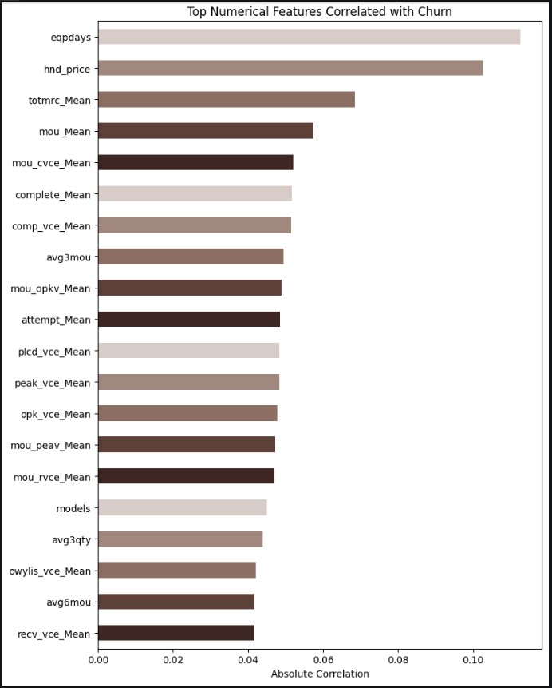

Figure 4. Top numerical features Correlated with Churn. Source: Author's analysis.

Feature selection was then performed using SelectKBest with the ANOVA F-test (f_classif), which evaluates the statistical association between each predictor and the target variable. As illustrated in Figure 5, feature scores decline sharply after the highest-ranked variables, supporting the selection of the 30 strongest predictors as a balance between predictive performance, interpretability and computational efficiency.
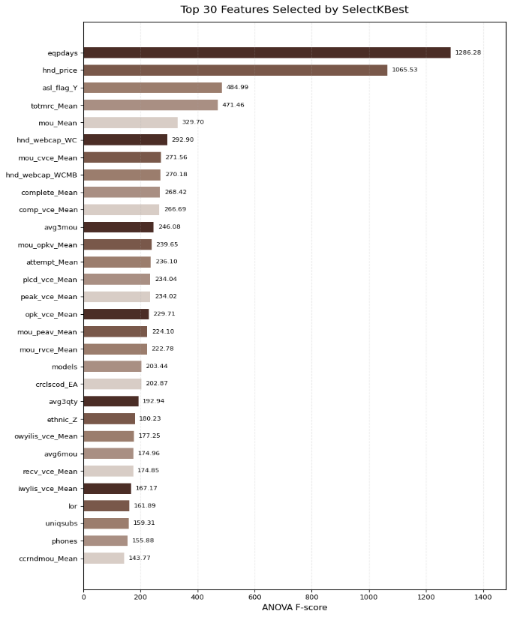
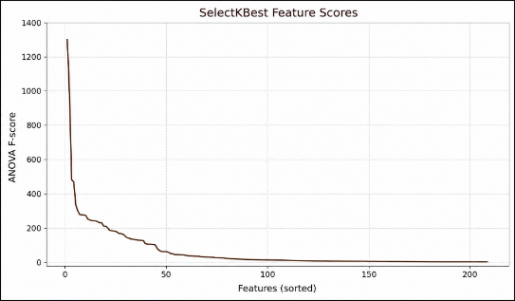

Stage | Observation | Variables
Original dataset | 100,000 | 99
After One-Hot Encoding | 100,000 | 210
Predictor matrix(x) | 100,000 | 209
Target variable | 100,000 | 1
Final selected predictors | 100,000 | 30

Figure 5.Feature Selection Using SelectKBest.Source: Author's analysis
Although SelectKBest evaluates predictors individually, the results were validated using Random Forest feature importance, which considers predictor interactions within an ensemble model.The results are shown in Figure 6.
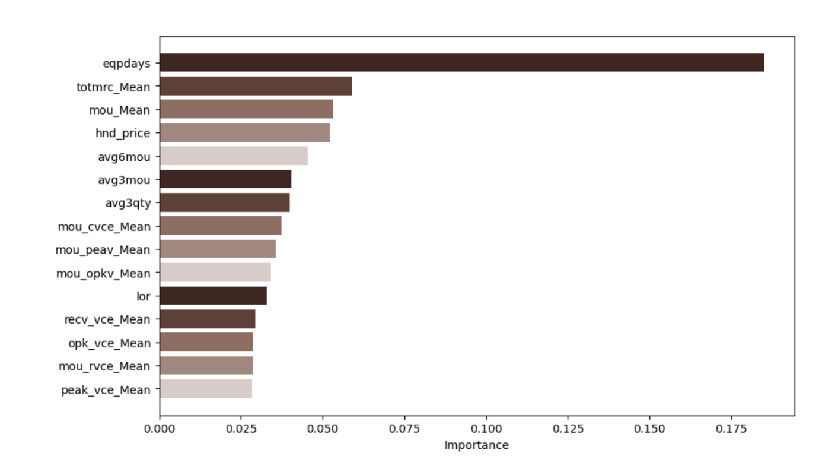

Figure 6.Random Forest Validation of the Selected Features.Source: Author's analysis

The agreement between both methods provides stronger evidence that the retained variables are genuinely informative rather than artefacts of a single selection technique [10], [19], [20].

3.4 Experimental Design

This section outlines the experimental design adopted to develop, evaluate, and compare the selected machine learning models. Emphasis was placed on fair comparison, reproducibility, and unbiased performance evaluation through consistent data splitting and controlled experimental settings.

3.4.1 Data Splitting Strategy

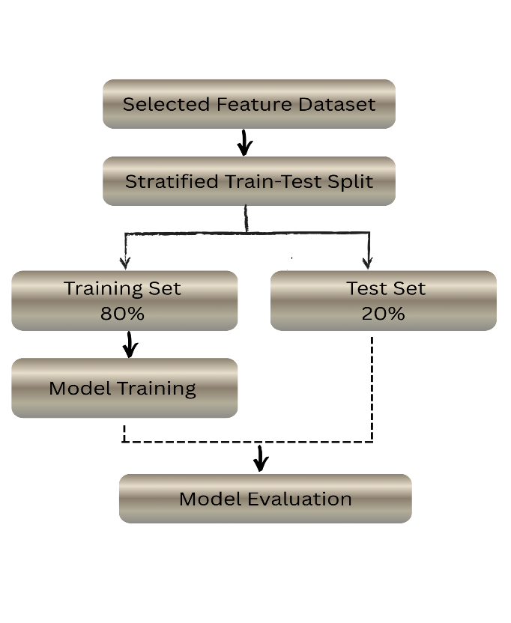
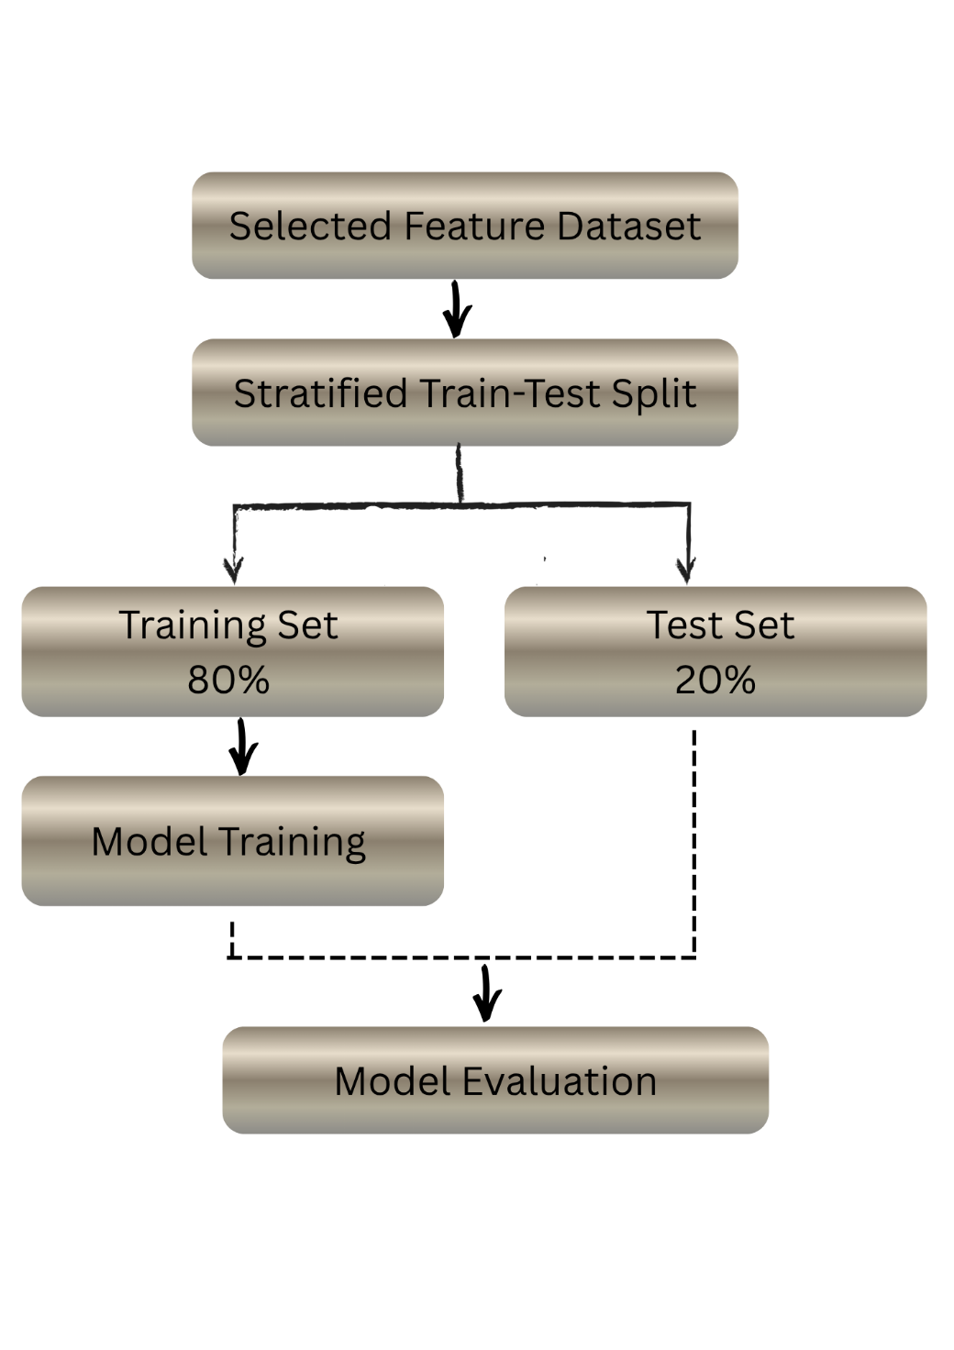
An 80/20 split provides an effective balance between model learning and unbiased evaluation, offering sufficient observations for training while preserving an independent subset for performance assessment. Stratified sampling was preferred over unrestricted random sampling to maintain the original class distribution and ensure proportional representation of retained and churned customers. The variable X_selected, containing the top 30 informative features, was used to split the data, focusing learning on relevant predictors. Parameters test_size=0.20, random_state=42, and stratify=y ensured reproducibility and class balance—critical for churn prediction tasks prone to imbalance. To maintain the independence of the evaluation process, мodel training was performed exclusively on the training subset, while the test subset was reserved for the final evaluation, preventing information from the test data from influencing model development. [1], [21].Figure 7 illustrates the experimental design.

Figure 7.Experimental Data Splitting Strategy
Source: Author’s illustration based on the experimental workflow.

3.4.2 Data Leakage Prevention

To prevent data leakage, feature selection, imputation and scaling were performed only after the train-test split. All transformations were fitted on the training data and then applied to the test set using the learned parameters, ensuring an unbiased estimate of model generalisation [1], [20], [22].

3.4.3 Feature Scaling

Feature scaling was applied only to algorithms sensitive to feature magnitude, namely Logistic Regression and K-Means. Standardisation ensures that all predictors contribute on a comparable scale, while Decision Tree and Random Forest do not require scaling because they split data using decision thresholds rather than distance-based optimisation [1], [20]. After standardisation, the training data had an average mean close to zero (6.57 × 10⁻¹⁷) and an average standard deviation close to one (1.0000), confirming that the transformation was successfully applied before model training.

3.4.4 Evaluation Strategy

Accuracy alone provides an incomplete assessment of customer churn models because false negatives are generally more costly than false positives. Therefore, model performance was evaluated using Accuracy, Precision, Recall, F1-score and ROC-AUC, providing a more comprehensive and reliable basis for comparing the classification models [1], [3], [7].

3.5 Classification Models

Three machine learning classification models were developed and evaluated to predict customer churn. Applying the same training and evaluation procedure allowed their predictive performance to be compared consistently.

3.5.1 Logistic Regression

Logistic Regression was selected as the baseline classifier because of its simplicity, computational efficiency and high interpretability. As a linear model, it provides a useful benchmark against which more flexible algorithms can be evaluated. The model was trained on standardised features using max_iter = 1000, and its performance was evaluated on the independent test set using the metrics defined in Section 3.4.4 [1], [3], [5].
Table 4.Logistic Regression Performance.Source: Compiled by the author based on model outputs.
Metric | Value
Accuracy | 0.5701
Precision | 0.5682
Recall | 0.5524
F1-score | 0.5602
ROC-AUC | 0.5983

The results in Table 4 show only moderate predictive performance. Similar Precision and Recall indicate that the model was reasonably balanced between the two classes, but the overall results suggest that a linear decision boundary is insufficient to capture the complexity of customer churn behaviour. Logistic Regression therefore provides an appropriate baseline for comparison with more advanced classifiers.
Figure 8 shows that the model correctly identified 5,475 churned customers but failed to detect 4,437 actual churn cases. These false negatives are the most costly prediction errors because they represent customers who leave without receiving retention interventions, highlighting the limitations of Logistic Regression for this dataset.
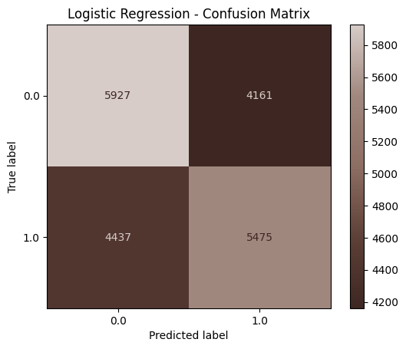

Figure 8.Logistic Regression Confusion Matrix.Source: Author's illustration

3.5.2 Decision Tree
Decision Tree was selected because it can model complex non-linear relationships by recursively partitioning the feature space. To reduce the risk of overfitting, the tree depth was limited to max_depth = 10. As the algorithm relies on threshold-based splits rather than distance calculations, feature scaling was not required. Model performance was evaluated using the same metrics as Logistic Regression to ensure a consistent comparison [1], [5], [20].
Table 5. Decision Tree Performance.Source: Compiled by the author based on model outputs.
Metric | Value
Accuracy | 0.5897
Precision | 0.5785
Recall | 0.6338
F1-score | 0.6049
ROC-AUC | 0.6212

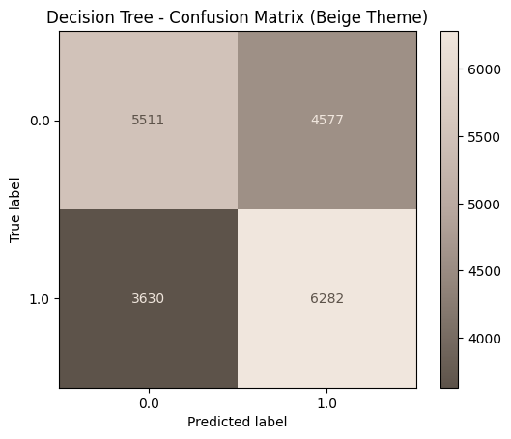
The results in Table 5 show consistent improvements over Logistic Regression across all evaluation metrics. The higher Recall indicates that the model identified more customers who actually churned, suggesting that its non-linear decision boundaries better capture customer behaviour. However, the moderate ROC-AUC indicates that further improvements may be achieved using ensemble methods. Figure 9 confirms this improvement, with false negatives decreasing from 4,437 to 3,630 , and true positives increasing from 5,475 to 6,282 . From a business perspective, fewer at-risk customers remain unidentified, making Decision Tree a more effective classifier than the Logistic Regression baseline.

Figure 9.Decision Tree Confusion Matrix.Source: Author's illustration

3.5.3 Random Forest

Random Forest was selected to improve the generalisation of a single Decision Tree by combining multiple trees through bootstrap aggregation (bagging). The model was configured with 200 trees (n_estimators = 200) and max_depth = 12 to balance predictive performance and overfitting. As a tree-based algorithm, feature scaling was not required. The same evaluation protocol used for the previous classifiers was applied to ensure a consistent comparison [1], [5], [20].
Table 6.Random Forest Performance.Source: Compiled by the author based on model outputs.
Metric | Value
Accuracy | 0.6053
Precision | 0.5921
Recall | 0.6547
F1-score | 0.6218
ROC-AUC | 0.6487

The results in Table 6 show that Random Forest achieved the strongest overall performance, with improvements across all evaluation metrics. In particular, the higher Recall (65.47%) indicates that the model correctly identified a larger proportion of customers who churned, demonstrating the advantage of ensemble learning for modelling complex customer behaviour.
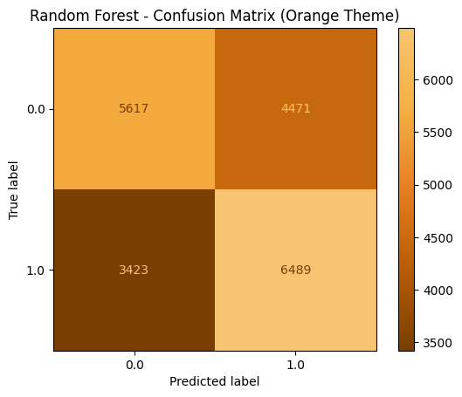

Figure 10.Random Forest Confusion Matrix

Figure 10 further confirms this improvement. Compared with Decision Tree, true positives increased from 6,282 to 6,489 , while false negatives decreased from 3,630 to 3,423 . Although false positives increased slightly, this trade-off is acceptable because missed churners generally have a greater business cost than unnecessary retention offers.
Table 7.Training and Testing Accuracy.Source: Compiled by the author based on model outputs.
Metric | Value
Training Accuracy | 0.7041
Testing Accuracy | 0.6053
Difference | 0.0988

The difference between training and testing accuracy remained below 10%, indicating good generalisation with only limited overfitting.
Random Forest therefore provided the best balance between predictive performance and generalisation and was selected for the subsequent hyperparameter optimisation.

3.5.4 Model Comparison
Table 8 presents a comparative summary of the three classification models, combining predictive performance with key methodological characteristics to support the selection of the most appropriate classifier.
Table 8.Model Comparison.Source: Compiled by the author based on classification results.
Criterion | Logistic Regression | Decision Tree | Random Forest
Accuracy | 0.5701 | 0.5897 | 0.6053
Precision | 0.5682 | 0.5785 | 0.5921
Recall | 0.5524 | 0.6338 | 0.6547
F1-score | 0.5602 | 0.6049 | 0.6218
ROC-AUC |  | 0.6212 | 0.6487
  0.5983
Feature scaling required
Interpretability | High | Medium | Lower
Handles non-linearity | Limited | Good | Excellent
Overfitting risk | Low | High | Moderate
Computational cost | Low | Low | Moderate

Table 8 shows a consistent improvement in predictive performance from Logistic Regression to Decision Tree and Random Forest. While Logistic Regression provided the most interpretable baseline, Decision Tree achieved higher predictive performance by modelling non-linear relationships. Random Forest delivered the strongest overall results, achieving the highest Recall, F1-score and ROC-AUC while maintaining good generalisation. Considering both predictive performance and robustness, Random Forest was selected as the final classification model for the telecom churn prediction task [1], [5], [20].

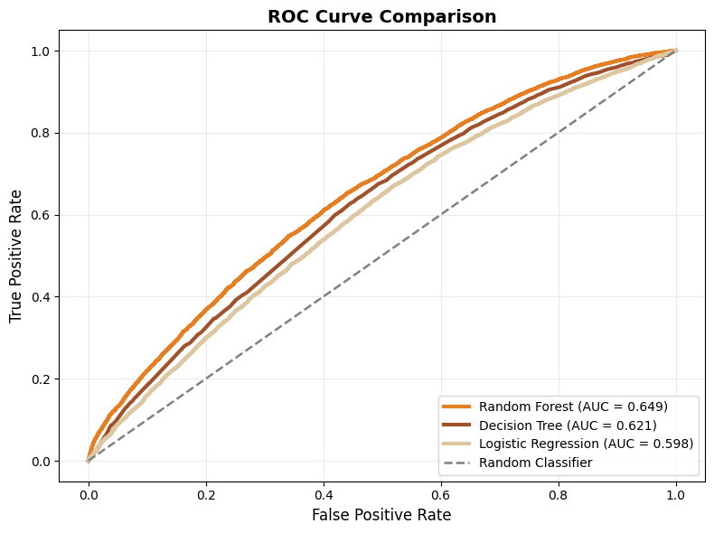

Figure 11.ROC Curve Comparison of the Classification Models.Source: Author's illustration.

3.6 Hyperparameter Tuning

Hyperparameter optimisation was performed using RandomizedSearchCV with five-fold cross-validation to explore a wider hyperparameter space while reducing the computational cost of exhaustive Grid Search. Recall was selected as the optimisation objective because failing to identify customers at risk of churn represents the most costly classification error in customer retention [1], [20]. The optimal hyperparameters are summarised in Table 9.
Table 9.Optimal Hyperparameters Selected by RandomizedSearchCV.Source: Compiled by the author based on RandomizedSearchCV results.
Hyperparameter | Optimal value
n_estimators | 250
max_depth | 8
min_samples_split | 5
min_samples_leaf | 1
max_features
  None
bootstrap | True
Mean 5-fold CV Recall | 0.6616

The tuned model was evaluated on the independent test set, with the results compared against the initial Random Forest configuration in Table 10. Although Recall improved slightly (0.6547 to 0.6575), Accuracy, Precision, F1-score and ROC-AUC declined marginally, indicating that optimising a single metric does not necessarily improve overall model performance [1], [3], [23].
Table 10. Performance Before and After Hyperparameter Optimisation.Source: Compiled by the author based on model outputs.
Metric | Initial RF | Tuned RF | Difference
Accuracy | 0.6053 | 0.5977 | -0.0076
Precision | 0.5921 | 0.5835 | -0.0086
Recall | 0.6547 | 0.6575 | +0.0028
F1-score | 0.6218 | 0.6183 | -0.0035
ROC-AUC | 0.6487 | 0.6407 | 0.0080

Figure 12 confirms this trade-off. Although the tuned model identified slightly more churned customers, it also produced more false-positive predictions. Consequently, the initial Random Forest configuration was retained because it provided the best overall balance between predictive performance and generalisation.

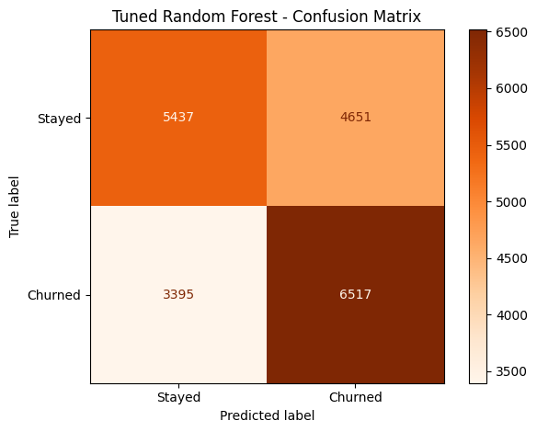

Figure 12.Tuned Random Forest Confusion Matrix.Source: Author's illustration.

3.7 Customer Segmentation Using K-Means

Customer segmentation was performed only on customers who had already churned (Churn = True). Including the entire customer population would primarily separate retained and churned customers rather than reveal meaningful differences within the churned population. The scope of the clustering analysis is summarised in Table 11 [1], [17].
Table 11.Dataset Scope for K-Means Customer Segmentation.Source: Compiled by the author based on the Telecom Customer dataset [18].
Dataset | Customers
Original dataset | 100,000
Churned customers | 49,562

3.7.1Feature Selection for Clustering
The selection of variables for K-Means clustering in this report is not driven by predictive importance, but by business relevance[24]. The selected variables and their underlying rationale are summarised in Table 12.
Table 12Variables Selected for K-Means Customer Segmentation.Compiled by the author based on the selected variables for K-Means clustering.
Category | Selected variables | Selection Criteria
Revenue | rev_Mean, totmrc_Mean | Customer value
Usage | mou_Mean, avg3mou, avg6mou | Service consumption
Device | hnd_price, eqpdays | Device characteristics
Tenure | months | Customer relationship

The selected clusters ensure that each variable represents a distinct dimension of customer behaviour, rather than simply improving classification performance[1],[17],[24].

3.7.2 Feature Scaling

Unlike tree-based classification models, K-Means relies exclusively on Euclidean distance. Applying the algorithm without feature standardisation would allow variables measured on larger numerical scales to dominate the clustering process irrespective of their practical importance. StandardScaler was therefore applied before clustering[24].

3.7.3 Determining the Number of Clusters
Selecting the number of clusters based on a single validity measure may favour statistical optimisation over practical usefulness. Therefore, both the Elbow Method and the Silhouette Score were used to evaluate the clustering solution [18], [19], [25].
The Elbow Method was first applied to examine changes in within-cluster variance as the number of clusters increased. As shown in Figure 13, inertia decreases rapidly before the improvement begins to level off around k = 4, suggesting diminishing returns from adding further clusters.
.
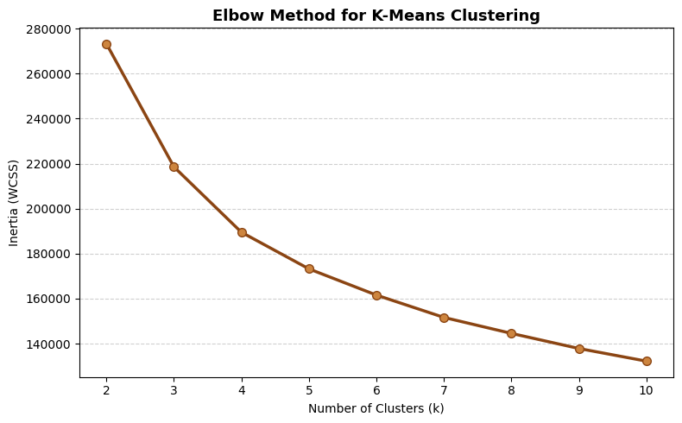

|
|
|
|

Figure 13.Elbow Method for Determining the Number of Clusters.Source: Author's illustration.

To support this observation, the reductions in inertia between consecutive cluster solutions are summarised in Table 13.
Table 13.Reduction in Inertia Between Consecutive Cluster Solutions.Source: Compiled by the author based on K-Means results.
Transition | Inertia reduction
2→3 | 54725
3→4 | 29069
4→5 | 16281

The progressive reduction in inertia confirms the elbow around k = 4. Because the Elbow Method evaluates only within-cluster compactness, cluster quality was further assessed using the Silhouette Score.
Figure 14 shows that the highest Silhouette Score was obtained for k = 2, although the decrease at k = 4 remained moderate, indicating acceptable cluster separation.

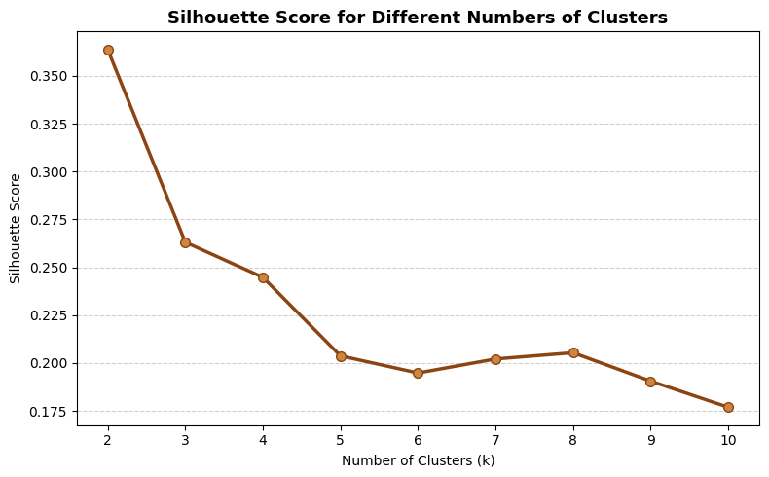
Figure 14.Silhoutte Score for Different Numbers of Clusters.Source: Author's illustration.
Figure 14 shows that the highest Silhouette Score is obtained at k = 2, indicating the strongest separation between clusters. However, the gradual decline in score as k increases suggests a trade-off between statistical cluster quality and segmentation granularity rather than identifying a single unequivocal solution. The corresponding Silhouette Scores for the evaluated cluster solutions are summarised in Table 14.
Table 14.Silhouette Scores for Alternative Cluster Solutions.Source: Compiled by the author based on K-Means results.
k | Score
2 | 0.364
3 | 0.263
4 | 0.245

Although k = 2 achieved the highest Silhouette Score, it would produce only two broad customer groups with limited managerial value. The k = 4 solution provided a better balance between statistical quality and business interpretability and was therefore selected for the subsequent customer segmentation.

3.7.5 Cluster Profiling

Rather than treating clusters as purely mathematical groupings, the interpretation focused on their practical relevance for customer relationship management and retention planning[26]. The resulting cluster profiles are summarised in Table 15.

Table 15.Business Interpretation of the K-Means Customer Segments.Source: Compiled by the author based on K-Means clustering results.
Cluster | Revenue | Usage | Tenure | Busines interpretation
0 | Low | Low | Medium | Low-value customers
1 | Medium | Hight | Medium | High-usage customers
2 | Low | Low | Long | Long-term customers with older devices
3 | Very high | Very high | Medium | Premium customers

The resulting customer profiles demonstrate that the selected clustering variables capture distinct dimensions of customer behaviour rather than merely differences in overall spending.

3.7.6 Cluster Validation
Cluster validity was further assessed by comparing the mean, median and standard deviation of the principal variables within each segment. The results are summarised in Table 16.
Table 16.Statistical Validation of the Identified Customer Segments.Source: Compiled by the author based on K-Means clustering results.
Cluster | Revenue  Mean / Median / SD | Usage  Mean / Median / SD | Monthly Charge  Mean / Median / SD | Tenure  Mean / Median / SD
0 | 41.06 / 37.81 / 18.89 | 248.14 / 230.25 / 172.50 | 37.58 / 39.99 / 16.17 | 14.71 / 13.00 /  5.69
1 | 81.71 / 75.83 / 34.86 | 857.49 / 823.75 / 288.78 | 58.50 / 59.99 / 19.12 | 16.78 / 14.00 /  8.28
2 | 41.40 / 35.60 / 21.41 | 214.11 / 162.75 / 195.19 | 34.36 / 30.00 / 15.20 | 28.60 / 27.00 /  7.96
3 | 167.19 / 147.03 / 118.29 | 1923.71 / 1780.75 / 653.47 | 84.91 / 82.49 / 35.77 | 17.90 / 15.00 / 10.13

Table 16 shows that the mean and median values remain broadly consistent across most variables, indicating that the identified customer profiles are not driven by a small number of extreme observations. Although Cluster 3 exhibits greater variability, its median values remain substantially higher than those of the other clusters, confirming that the premium customer segment represents a genuine behavioural pattern rather than isolated outliers. Overall, these results support the stability and interpretability of the four-cluster solution.

4. Discussion
The results show that customer churn is driven by complex behavioural patterns rather than simple linear relationships. This is reflected in the superior performance of Random Forest, which consistently outperforms Logistic Regression and Decision Tree on all evaluation metrics, while maintaining acceptable generalizability. However, Logistic Regression remains a valuable baseline model due to its transparency and interpretability, providing an objective basis for evaluating the performance improvements of more complex algorithms [1], [3].

Cluster analysis further demonstrates that prediction alone provides only a small fraction of the information needed for effective customer retention. Similar findings have been reported in recent customer segmentation studies, where combining quantitative validation with practical relevance has resulted in more useful market segments [13], [15], [24], [26].

Several limitations must also be acknowledged. The analysis was conducted using a single telecommunications data set, which may limit the generalizability of the results to other industries. Furthermore, K-Means assumes compact and approximately spherical clusters, while customer behaviour may exhibit more complex structures. Future research could evaluate alternative clustering techniques, such as DBSCAN or hierarchical clustering, as well as incorporate explainable artificial intelligence methods to improve model transparency and support business decision-making [3], [7], [22].

5. Business Recommendations

Based on the results of this study, the following recommendations are offered:

- Prioritise customers identified as having a high probability of churn by reaching out to them before contract renewal or termination. Early intervention can reduce customer attrition while focusing retention efforts on customers most likely to churn [1], [2].

- Develop retention campaigns tailored to each customer segment, rather than offering the same incentives to all customers. Personalised offers are more likely to meet the specific needs of different customer groups, improving campaign effectiveness and customer satisfaction [24], [26].

- Regularly monitor the predictive model and retrain it using updated customer data. Customer behaviour changes over time, and periodic model updates help maintain the accuracy of predictions and support better business decisions [1], [25].

- Use forecast results as a decision support tool, not as an automated decision-making system. Combining model predictions with business insights enables more informed and balanced retention decisions, especially for high-value customers [3], [7].

Together, these recommendations can help organisations improve customer retention, optimise marketing resources, and support more effective data-driven decision-making.

6. Limitations
This study has several limitations. The analysis was based on a single telecommunications dataset, which may limit the generalisability of the findings to other industries. In addition, K-Means assumes relatively compact clusters and may not capture more complex customer behaviour. Future research could evaluate alternative clustering methods and validate the proposed approach using additional datasets.

7. Conclusion
This study successfully achieved its objective of developing and evaluating machine learning models for customer churn prediction while exploring customer segmentation using K-Means clustering. Among the evaluated classification models, Random Forest provided the best overall predictive performance, demonstrating its suitability for modelling complex customer behaviour. The results further showed that combining classification with customer segmentation offers complementary insights, supporting more targeted and effective retention strategies. Future research could validate the proposed approach using additional datasets and investigate alternative clustering techniques and explainable artificial intelligence methods to further improve model transparency and practical applicability.

References

[1] A. Manzoor, M. A. Qureshi, E. Kidney, and L. Longo, “A review on machine learning methods for customer churn prediction and recommendations for business practitioners,” IEEE Access, vol. 12, pp. 1–1, Jan. 2024, doi: 10.1109/access.2024.3402092.
[2] A. Sikri, R. Jameel, Sheikh Mohammad Idrees, and H. Kaur, “Enhancing customer retention in telecom industry with machine learning driven churn prediction,” Scientific reports, vol. 14, no. 1, June 2024, doi: 10.1038/s41598-024-63750-0.
[3] Sumana Sharma Poudel, Suresh Pokharel, and Mohan Timilsina, “Explaining customer churn prediction in telecom industry using tabular machine learning models,” Machine learning with applications, vol. 17, pp. 100567–100567, June 2024, doi: 10.1016/j.mlwa.2024.100567.
[4] H. G. Tanhaei, P. Boozary, S. Sheykhan, M. Rabiee, F. Rahmani, and I. Hosseini, “Predictive analytics in customer behavior: Anticipating trends and preferences,” Results in Control and Optimization, vol. 17, Dec. 2024, doi: https://doi.org/10.1016/j.rico.2024.100462.
[5] R. Dodda, C. Raghavendra, M. Aashritha, H. V. Macherla, and A. R. Kuntla, “A Comparative Study of Machine Learning Algorithms for Predicting Customer Churn: Analyzing Sequential, Random Forest, and Decision Tree Classifier Models,” 2024 5th International Conference on Electronics and Sustainable Communication Systems (ICESC), pp. 1552–1559, Aug. 2024, doi: 10.1109/icesc60852.2024.10690131.
[6] A. K. Singh, G. Kori, P. Garg, and G. Srivastava, “Bank Churn Prediction Using Machine Learning,” 2025 IEEE 7th International Conference on Computing, Communication and Automation (ICCCA), pp. 1–6, Nov. 2025, doi: 10.1109/iccca66364.2025.11325204.
[7] M. Imani, Majid Joudaki, A. Beikmohammadi, and Hamid Reza Arabnia, “Customer Churn Prediction: A Systematic Review of Recent Advances, Trends, and Challenges in Machine Learning and Deep Learning,” Machine Learning and Knowledge Extraction, vol. 7, no. 3, pp. 105–105, Sept. 2025, doi: 10.3390/make7030105.
[8] M. Nur, “ADVANCEMENTS IN MACHINE LEARNING FOR CUSTOMER RETENTION: A SYSTEMATIC LITERATURE REVIEW OF PREDICTIVE MODELS AND CHURN ANALYSIS,” Journal of Sustainable Development and Policy, vol. 01, no. 01, pp. 250–284, Mar. 2025, doi: 10.63125/9b316w70.
[9] F. Zhafiri Arshimny and Adiwijaya, “Performance Analysis of Random Forest Algorithm for Customer Churn Prediction in the Telecommunications Sector,” 2024 International Conference on Intelligent Cybernetics Technology &amp; Applications (ICICyTA), pp. 1262–1267, Dec. 2024, doi: 10.1109/icicyta64807.2024.10912859.
[10] A. H. Alkilani and M. I. Nusir, “Enhanced Customer Churn Prediction in Banking: a Comparative Analysis of Machine Learning Techniques with Feature Selection and Dimensionality Reduction,” 2026 International Conference on Artificial Intelligence, Computer, Data Sciences and Applications (ACDSA), pp. 1–10, Feb. 2026, doi: 10.1109/acdsa67686.2026.11467799.
[11] S. K. Singh, A. Tiwari, A. Chakrabarti, and Khushi, “Performance Analysis of Customer Attrition Trend in Telecommunication Sectors using Machine Learning and Deep Learning,” 2025 6th International Conference for Emerging Technology (INCET), pp. 1–4, May 2025, doi: 10.1109/incet64471.2025.11139976.
[12] V. G, B. S. S, C. Ann Vinod, D. R, and K. D, “Customer Segmentation And Churn Prediction Using K Means Fuzzy And Multi-Layer Perceptron Algorithm,” 2024 5th IEEE Global Conference for Advancement in Technology (GCAT), pp. 1–6, Oct. 2024, doi: 10.1109/gcat62922.2024.10923855.
[13] R. Gupta, Sanjeev Subedi, A. Singh, and Shivam Kumar Singh, “Comparative Study of Unsupervised Learning Algorithms for Customer Segmentation,” Feb. 2024, doi: 10.23919/indiacom61295.2024.10498443.
[14] Darshan Anil Jethva, Siya Milind Khamkar, Anish Anand Pachchhapur, and S. Kulkarni, “Customer Segmentation Analysis using K-means Algorithm with Elbow method and Dendrogram,” Dec. 2023, doi: 10.1109/icast59062.2023.10454952.
[15] P. K. Chilla, S. K. Nahak, M. V. Venkata Deepika, B. S. Rohit, T. Hemalatha, and A. K. Dalai, “Efficient Customer Segmentation Using Silhouette Based K-Means Algorithm,” 2024 4th International Conference on Artificial Intelligence and Signal Processing (AISP), pp. 1–5, Oct. 2024, doi: 10.1109/aisp61711.2024.10870813.
[16] C. Shearer, “The CRISP-DM model: the new blueprint for data mining,” Journal of Data Warehousing, vol. 5, no. 4, pp. 13–22, 2000.
[17] A. M. Shimaoka, R. C. Ferreira, and A. Goldman, “The evolution of CRISP-DM for Data Science: Methods, Processes and Frameworks,” SBC Reviews on Computer Science, vol. 4, no. 1, pp. 28–43, 2024.
[18] A. Abhinav, “Telecom Customer,” Kaggle, 2018. [Online]. Available: https://www.kaggle.com/datasets/abhinav89/telecom-customer [Accessed: Jul. 25, 2026].
[19] I. Duru, Nurefşan Ak, and R. Dede, “A Comparative Study of Feature Selection and Resampling Techniques for Customer Churn Prediction with Explainable AI in the Telecommunications Sector,” pp. 1–12, Aug. 2025, doi: 10.1109/acdsa65407.2025.11166474.
[20] S. Abdumalikov, J. Kim, and Y. Yoon, “Performance Analysis and Improvement of Machine Learning with Various Feature Selection Methods for EEG-Based Emotion Classification,” Applied Sciences, vol. 14, no. 22, Art. no. 10511, Nov. 2024, doi: 10.3390/app142210511.
[21] S. Mohammed et al., “The effects of data quality on machine learning performance on tabular data,” Information Systems, vol. 132, p. 102549, Mar. 2025, doi: 10.1016/j.is.2025.102549.
[22] Mitra Baratchi et al., “Automated machine learning: past, present and future,” Artificial intelligence review, vol. 57, no. 5, Apr. 2024, doi: 10.1007/s10462-024-10726-1.
[23] L. Franceschi et al., “Hyperparameter Optimization in Machine Learning,” Foundations and Trends® in Machine Learning, vol. 18, no. 6, pp. 1054–1201, 2025, doi: 10.1561/2200000088.
[24] M. Zaghloul, S. Barakat, and A. Rezk, “Enhancing customer retention in Online Retail through churn prediction: A hybrid RFM, K-means, and deep neural network approach,” Expert Systems with Applications, vol. 290, p. 128465, June 2025, doi: 10.1016/j.eswa.2025.128465.
[25] F. F. Mlambo, M. Musuphi, and K. Letsela, “A Hybrid Machine Learning and Survival Analysis Framework for Churn Prediction in the Telecom Sector,” Information, vol. 17, no. 7, p. 680, July 2026, doi: 10.3390/info17070680.
[26] S. Shanmugam, E. Elavarasan, N. Madhavarao Seshadri, D. Ashokkumar, S. Senthilkumar, and T. Mohanavelu, “A Segmented Machine Learning Approach to Predicting and Mitigating Churn in the Gig Economy,” Journal of Theoretical and Applied Electronic Commerce Research, vol. 21, no. 3, p. 93, Mar. 2026, doi: 10.3390/jtaer21030093.

