Research report-

“How do we use technology to collaborate at UWTSD?”
Digital Skills and Research Methods
(BMSW4003)
Lecturer:Dale Clarke
Carolina Griza
(2115255)
Executive summary

In the changing era of digital technology the role of technology and its related advancement is creating an impact on the lives of staffs and student. The present report curtailed detailed analysis about the ways in which digital technology creates an impact on shaping the confidence level. The report involves collection of data from primary and secondary qualitative measure followed by questionnaire and thematic analysis.

Table of Contents
Background 4
Rationale 4
Aims 5
Significance of research 5
Research design 6
Research question 6
Research methods 6
Ethical consideration 6
Results 7
Discussion 12
Conclusion 13
Reference list 15
Appendix 16

Introduction
In the present situation of globalisation and technological development, there is a greater dependency of people on technology for reducing their work and making effective relationships with people. Therefore the main objective of the present report is to present an understanding of the dependency of students and teaching staff in making collaboration at the workplace. The present report comprises different research methods infused for data collection and research questions.

Background
Contemporary technology is becoming an eventful adoption of technology in the workplace due to increasing complexities and improving the efficiency of an individual. In the changing environment of learning, technology is becoming an essential component in the life of students as well as staff for improving the process of learning and making effective collaboration with each other that can generate better results. The introduction of technology not only helps an individual to facilitate its learning but also comprehensively helps in developing an understanding that ultimately improves the efficiency as well as the performance of an individual in a considerable manner.

Rationale
As per Raja and Nagasubramani (2018.), the adoption of technology in the lives of an individual plays a greater role in building up confidence in both positive and negative aspects. The main issue of the present report is the relation between the development of confidence in the lives of students and staff. It is considered as an issue as in the time of technological adoption the inclusion of contemporary technology has improved the learning process of students and also created an impact on the adoption of new technology on staff and students for making an effective collaboration with each other. From the below graph it is identified that the use of internet and technology is considerably higher among students thus creating a resulting impact on the confidence level in both positive as negative aspects.
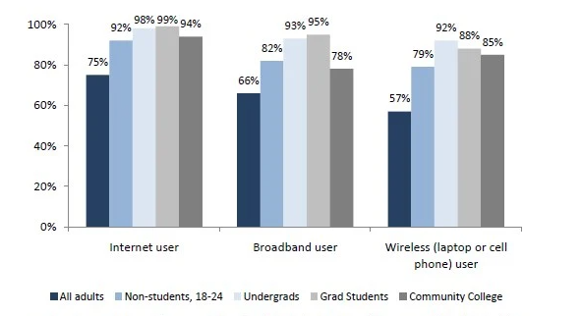
Figure 1: internet usage by students
(Source: Raja and Nagasubramani (2018)

Aims
The report aims to “understand the implication of technology in confidence levels of students and staff for collaboration.”

Significance of research
The present report curtails understanding about the implication of using technology in the lives of students and staff. In order to develop an understanding of the research topic information related to positive and negative impact along with its resulting effect on the confidence level. Therefore the involvement of all these aspects is significant in understanding the positive as well as the negative impact of technology on students and staff in shaping the confidence level. Along with that, it is also significant in developing an understanding regarding the viewpoints of students as well as staff in respect to technological adoption.

Research design

Research question
In the present report, the research question is
- Are staff and students confident in using technology to collaborate?

Research methods
The present report deals with understanding the implication of technology in the confidence level of staff and students for collaboration. Therefore in order to collect the data related to technological implications, there is an adoption of primary qualitative data as well as secondary qualitative data. According to Haynes et al. (2019), in primary qualitative data collection methods, the data are collected directly from the primary sources that involve the collection of data following an interview. In this research method, the primary data is collected by framing 6 open-end questions that generally involve questions that are based on a research topic. Moreover, 20 participants are interviewed in this research method consisting of both students and working staff that uses technology in everyday life. Out of 20 participants, responses of 15 respondents are taken into consideration for analysis based on technological usage experience. Moreover, the interview is performed through online mode and the resulting data derived from primary sources is narrative analysed by narrative method. On the other hand in the secondary qualitative data collection method, the data are collected from various secondary sources such as Google scholar where mostly the publication before 2018 is taken. Along with that various newspaper articles, 10 journals and online websites having information related to the use of technology and its impact on students and staff are adopted. The secondary data collected from different secondary sources is effectively evaluated following thematic analysis.

Ethical consideration
As per Naval et al. (2019), consideration of ethics is an integral part of any research project to add flexibility and integrity to the research. Moreover in the present study where the data are collected following mixed methods consisting of primary as well as secondary data collection methods is performed with proper ethics. In the primary qualitative data collection method in the interview, there is an inclusion of voluntary participation and only related research topics are framed in the questionnaire. Along with that majority of the secondary data collected from credible sources is subjected to the respective author and given due consideration.

Results
Theme 1: Use of communication and collaboration technology such as Zoom is higher among students in developing the learning process
In the changing sphere of technology and innovation, the use of digital technology has taken an integral part in every industry including the education sector and learning process. As per Mids. Lund et al. (2021), there is a gradual increase in communication and collaboration technology after the advent of online courses and classes. The facilitation of interactive online learning classes has led to an increase in the collaboration level among students in the learning process. After the outburst of Covid 19, there is a witnessing of high growth in the adoption of education technology making a global tech investment worth US$18.66 billion in 2019 .on the other hand the overall market for online education is projected to reach with an evaluation of $350 Billion by 2025(). Online collaborative learning is one of the most widely accepted teaching methods in the present education scenario based on different components that comprehensively improve the learning process of students and at the same time provides an opportunity to facilitate effective collaboration with each other.
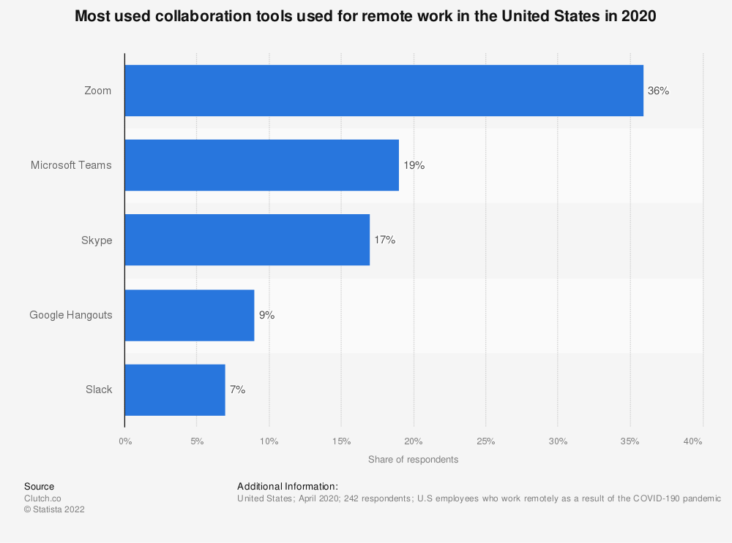
Figure 2: Collaboration technique usage
(Source: Statist, 2020)
The above graph presents the graphical presentation of different collaborative technologies being widely adopted by students. With the adoption of these collaborative technologies, the learning process of the students is comprehensively improved as it provides an opportunity for the students to develop communication with their peers in distance learning (Ens et al. 2019).
Theme 2: peer collaboration and advanced technological platforms impact students' confidence level.
As per Li et al. (2021), Communication is one of the most crucial aspects required for improving the confidence level within an individual. On the other hand, there is a gradual increase in the growth of advanced technology in the education sector over a period of time.
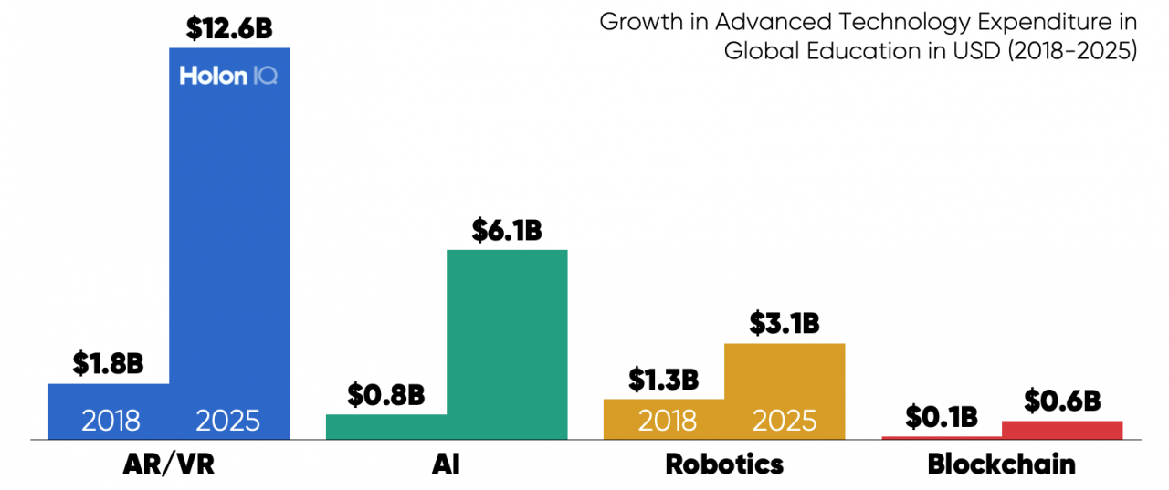
Figure 3: advanced technological growth in the education sector
(Source: HoloniQ, 2021)
Increasing adoption of communication tools in the education sector intends to improve the relationship of students among their peers and enhance cooperation in a considerable manner. The facilitation of different collaboration platforms used among peers creates an impact on students in improving their learning process of students. The below graph provides information related to the positive impact of digital technology in doing homework, accounting for over 43%. On the other hand, there are a number of advanced technologies being adopted in the education sector such as artificial intelligence and many other integrated technologies that have improved the learning process of students by providing an opportunity to make collaboration with peers and at the same time improving the learning process of students. The consideration of these factors plays a greater role in enhancing the confidence level of students as it makes the student embedded with knowledge and a pool of information.
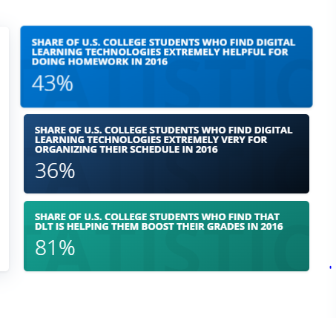
Figure 4: Impact of digital technology on student
(Source: Statista, 2019)
Theme 3: VR and augmented reality improves employees efficiency level in the workplace
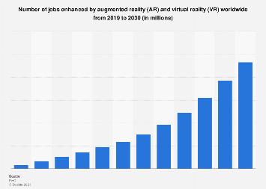
Figure 5: growth of AR and VR worldwide from 2019-2030
(Source: Statista, 2021)
The above graph represents the projected growth of virtual and augmented reality over the past few years and its receding growth for its effective technological capabilities. As per Schall (2019), in remote working one of the biggest barriers to communication is not having an effective platform to collaborate, in this respect augmented reality provides an opportunity to involve workers in a single platform used for imparting training and education to workers. With the application of augmented technology, the working efficiency of the employees is reduced effectively as it reduces the physical movement of employees from one place to another. This results in improved performance and efficiency levels in a considerable manner.
Theme 4: Adoption of technology distracts students from learning
In the words of Singh and Thurman (2019), there is a gradual shift in the demand and usage of technology in the lives of students and their learning process after the development of different educational platforms and communication channels.
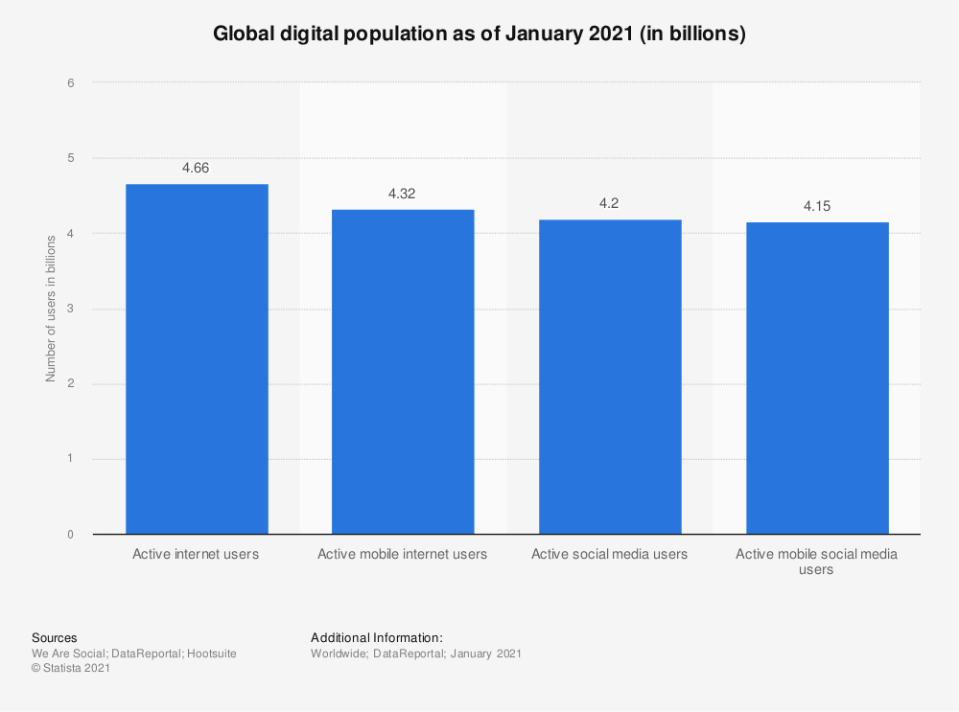
Figure 6: global digital population
(Source: Statista, 2021)
The above graph presents statistical information relating to the growth of digital technology and its usage by the population is increasing day by day. In the present education sector, there is a wider usage of technology for improving the learning process. It has been identified that in the US, around 48% of students use a desktop computer, 42% use a smartphone, 20% use tablets and over 33% use interactive whiteboard(). The increasing dependency and utilisation of technology by students is making students distracted from core learning. There is a wider acceptance of technology in making relations with peers in comparison to physical interaction. As per Wei et al. (2020), there is vast information present on the internet leading to the reduction in learning habits and making students dependent on available information on the internet.

Discussion
Findings 1: collaboration technology improves the learning process and confidence level
The main findings derived from Theme 1 and Theme 2 relate to the use of collaboration technology in improving the learning process of students and the impact of advanced technology respectively. From the above theme presented it has been found that there is a gradual increase in online learning platforms and collaboration technologies making it easier for students to develop their learning process and enhance confidence levels. One of the most accepted collaboration technology used in the present situation is Zoom. On the other hand, theme 2 discusses the impact of advanced technology on the confidence level of students. The increasing dependency of students on advanced technology helps in improving the collaboration level among peers in a considerable manner.
Findings 2: Advanced technologies such as VR improves efficiency level and also distract students
The main findings derived from theme 3 and 4 postulates the fact that adoption of improved technology such as virtual reality and augmented reality help in improving the efficiency level of the employees as it provides an opportunity to the workers to develop the communication channel with each other and at the same time integration platforms that can initiate collaboration effectively. The inclusion of advanced technology not only facilitates action for improving collaboration channels rather it also provides an opportunity to impact training and development to employees. On the other hand theme, 4 provides relevant information related to the negative impact of technology in distracting the students from the learning process. There is a major section of the student in the US reporting to use technology in their learning methods, there are certain advantages of imparting technology in the education sector, moreover, the increasing dependency of students on technology is also distracting students from the traditional learning process that ultimately reduces the confidence level of students and develop effective results.

Conclusion
The conclusion that can be drawn after the analysis of the present research report relates to the concept of developing an understanding of the impact of technology on students and staff. In the era of digital technology and learning infrastructure, there is wider use of technology, however, the adoption of these collaboration technology and educational platforms has improved the confidence level of students. As it provides an opportunity to improve their learning thus making students and staff confident in adopting collaboration technologies. On the other hand, the over-dependency on technological learning reduces the collaboration level on physical grounds.

Reference list

Ens, B., Lanir, J., Tang, A., Bateman, S., Lee, G., Piumsomboon, T. and Billinghurst, M., 2019. Revisiting collaboration through mixed reality: The evolution of groupware. International Journal of Human-Computer Studies, 131, pp.81-98.
Haynes, E., Garside, R., Green, J., Kelly, M.P., Thomas, J. and Guell, C., 2019. Semiautomated text analytics for qualitative data synthesis. Research synthesis methods, 10(3), pp.452-464.
HoloniQ, 2021. 10 charts to explain the Global Education Technology Market. Available at: https://www.holoniq.com/edtech/10-charts-that-explain-the-global-education-technology-market/. [Accessed on 15th February 2022]
Li, J., Vinayagamoorthy, V., Williamson, J., Shamma, D.A. and Cesar, P., 2021, May. Social VR: A New medium for remote communication and collaboration. In Extended Abstracts of the 2021 CHI Conference on Human Factors in Computing Systems (pp. 1-6).
Midtlund, A., Instefjord, E.J. and Lazareva, A., 2021. Digital communication and collaboration in lower secondary school. Nordic Journal of Digital Literacy, 16(2), pp.65-76.
Navalta, J.W., Stone, W.J. and Lyons, T.S., 2019. Ethical issues relating to scientific discovery in exercise science. International Journal of Exercise Science, 12(1), p.1.
Raja, R. and Nagasubramani, P.C., 2018. Impact of modern technology in education. Journal of Applied and Advanced Research, 3(1), pp.33-35.
Schall, M.A., 2019. The relationship between remote work and job satisfaction: The mediating roles of perceived autonomy, work-family conflict, and telecommuting intensity (Doctoral dissertation, San Jose State University).
Singh, V. and Thurman, A., 2019. How many ways can we define online learning? A systematic literature review of definitions of online learning (1988-2018). American Journal of Distance Education, 33(4), pp.289-306.
Statista, 2019. Percentage of students in the United States taking distance learning courses from 2012 to 2019. Available at: https://www.statista.com/statistics/944245/student-distance-learning-enrollment-usa/. [Accessed on 15th February 2022]
Statista, 2020. Most used collaboration tools used for remote work in the United States in 2020. Available at: https://www.statista.com/statistics/1123023/top-collaboration-tools-for-remote-workers-in-the-us/. [Accessed on 15th February 2022]
Statista, 2021. Global digital population as of January 2021. Available at: https://www.statista.com/statistics/617136/digital-population-worldwide/. [Accessed on 15th February 2022]
Statista, 2021. Number of jobs enhanced by augmented reality (AR) and virtual reality (VR) worldwide from 2019 to 2030. Available at: https://www.statista.com/statistics/1121601/number-of-jobs-enhanced-globally-by-vr-and-ar/. [Accessed on 15th February 2022]
Wei, H.C. and Chou, C., 2020. Online learning performance and satisfaction: do perceptions and readiness matter?. Distance Education, 41(1), pp.48-69.

Appendix
Questionnaire
Question 1: what is your age?
Question 2: How much experience do you have in using technology?
Question 2: How likely are you to adopt technology for learning?
Question 3: Do you think collaborative technology is useful in your workplace?
Question 4: To what extent do you think VR improves collaboration in the workplace?
Question 5: Do you think using advanced technology distracts you from your study?
Question 6: To what extent do you think implementation of advanced technology is useful in your workplace to increase work efficiency?

