Question 1: When will advertising embrace diversity, gender and race equality, and start reflecting the real world? Critically discuss and respond. (Delivered by Martin Bush)

Name: Corey Harry James McComb

Student Number: 2004966

Module Course: Research in Context ADA5003

Course: BA (hons) Graphic Design

Word Count: 2424

How do corporations get it so wrong? To simply state the issue, we have a diversity problem

that has been on-going since the dawn of advertising. Negative connotations associated

within groups of our society have done harm, strengthening prejudice in consumers. An

example from the effects of television stated by Dennis E:

Of course, our understanding of the world outside our immediate personal experience is influenced by a number of sources—including close friends, colleagues and acquaintances—but the media’s influence is more substantial than we may recognize. The work of media scholar George Gerbner and his colleagues has led a virtual army of researchers to demonstrate over and over again that the amount of time an individual spends watching television predicts a tendency to describe the world in the same distorted way as it has been presented on the tube in news and fiction.

(Dennis, E. 2020, P.12)

With this in mind It paints an alarming picture, stereotyping is getting confused for reality.

Subconsciously we have implicit biased as our brains run on 98% subconscious thoughts

(World Economic Forum, 2017). I wish to peel back layers and delve into the ideas behind

the upcoming campaigns. From the perspective of the designer down to the intended target

audience. Lack of Diversity is harmful, it implements old fashioned ideologies, leaving

individuals feeling discriminated and lesser than due to damaging tropes and bias’. Course

of action must be taken in the advertising industries to ensure a reflection of the real world.

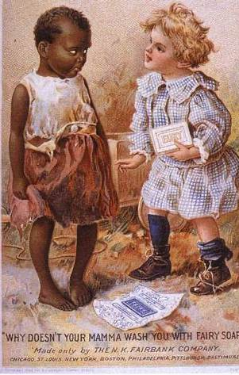
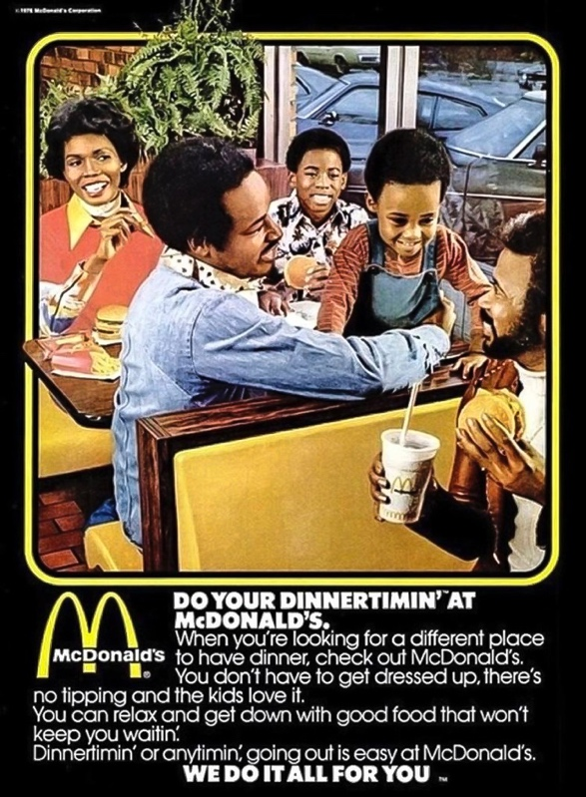

Fig One Fig Two

“WHY DOSEN’T YOUR MAMMA WASH YOU WITH FAIRY SOAP?”. What’s terrifying about this

era of advertising is how common ads like this were. Such advertisement’s hurt the black

community due to negative connotations being held over their head. (Green (2016) was an

informative source of Dialogue. Perhaps the designers at the time felt this was embracing

diversity as they featured a black girl, however this was at the expense of being the butt of a

cruel joke that would only further segregate while pushing further racism from white peers.

(Byrne, K. J. 2020, P.9) highlights how verbal language during this time was acceptable and

commonly used in advertising to sell a product. To a degree one could debate that this

advertisement did reflect the real world at the time as this marketing scheme reflected the

transparent racism of society. Not to say its right, however language like this was not rare.

Mid 20th century racially motivated advertisements were a trend. If advertisers could tap

into racist cliches it would win approval over their white target audience. In years to come

advertisers would broaden their marketing to black communities however it still feels out of

touch imposing slang that has been commonly associated with African Americans. An effort

was made but it falls flat, hardly a win. Many people absorbed this information,

repercussions which can still be felt today. Not so much in advertising but in peoples

etiquette and spiteful attitudes towards the black community. How else do you learn

something you are not born with? Epitomized by ‘Roots’ author Alex Haley -

“Racism is taught in our society... it is not automatic. It is learned behaviour toward persons

with dissimilar physical characteristics”.

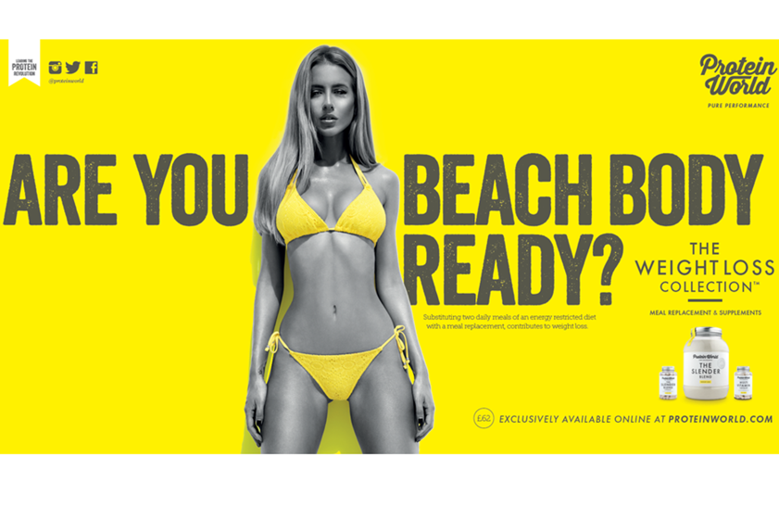
Fig Three

Into the 21st century unfavourable advertising is still evermore present. Fig 3 is imposing the

idea that having a ‘Beach body’ is a necessity to go to the beach. In reality your physical

outer appearance has nothing to do with wanting to lay on a beach. Here we are being told

we must look a certain way to enjoy an environment that is primal to us which is the

outdoors. On the surface it may not seem that bad. We neglect to think of the damage

eating disorders and body image has played in people’s lives. More often than not death.

(Schnackenberg, N. 2018. P. 14) With the use of a question mark it forces the consumer to

question their own appearance as they are asking you a question, This ad aims to be

invasive and feed off the self-loathing of individuals who feel insecure presumably because

they do not match the unrealistic standards of the model shown. Worth mentioning is the

demographic of people who even upon consuming such products still cannot attain this look

perhaps from disability etc. In the case this leaves a huge margin of a population feeling

outcasted/depressed. (Roth, L. 2020. P. 15) backs up my argument relating to body image

and self-worth.

What I find fascinating about this campaign is how ill received the advertisement was yet it

was a marketing success! (Business Insider, 2015) states although the poster got a massive

backlash globally on social media alongside individuals vandalising the campaign

promotional. ‘Protein World’ racked up an astonishing One Million pound, only Four days

following the release of the loathed campaign. This opens up an interesting dialogue, is all

publicity good publicity? Yes this campaign has undertones of sexism and largely infiltrates

the world of eating disorders, however in the eyes of capitalism does this matter? ‘Protein

World’ made their money, without a controversial campaign I myself would not be writing

about it. isn’t that the point of marketing to get your brands name on everybody’s tongue.

From that warped perspective the ad was a success but I find the whole display villainise.

Unbelievably the approach the company took in response to criticism was self-defensive

and blunt. Calling out women who spoke out about their concerns online “sympathisers for

fatties” (Twitter, Protein World. 2015) It begs to ask, can we measure success in sales or

does success come from inclusion?


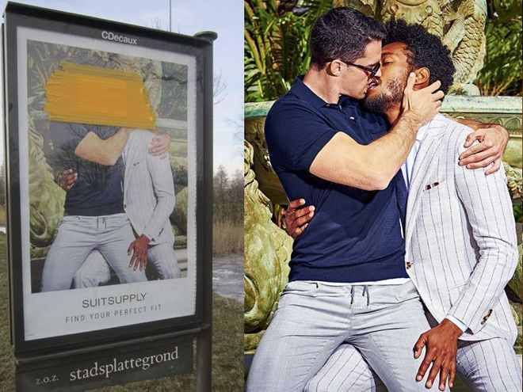
Fig Four Fig Five

When we talk about embracing diversity and how we want to see better representation we

can be blindsided to the brands that work hard to bring inclusion into their campaigns to

remove stigma and tropes. Above is a Men’s suit campaign by suit supply. Heterosexual

couples locking lips whilst being intimate is a trope often played out time and time again in

High end fashion brand campaigns. Yet when a Homosexual couple are depicted doing the

same thing a storm of hatred brews on social media, alongside Brand boycotts. (BBC, 2018)

So why do people find it so difficult to see representation when it finally arrives? (The

Psychology of Social and Cultural Diversity. 2011) Portrays those who feel threatened by

representation are ignorant and self-involved in their own representation. When you are

not a minority and are so involved in seeing images that represent yourself in advertising,

once that comfort zone has been breached the individual rejects the new information as it is

not a familiarity, thus it is negative. This is challenging to unlearn which is why the demand

for more diverse advertising is essential. Homophobia soared in the 1980s when

misinformed campaigns about the AIDS epidemic pointed the finger on members of the

LGBT. (McDonnell, T. 2016) Sheds light on the scare tactics that were first introduced in

many main stream advertising campaigns surrounding aids, This linked the fear of aids with

the fear of homosexuals even to this day. Yet we know so much more about the disease. We

know heterosexual couples can get AIDS but due to forced/uneducated perception in the

early 1980s this stigma still hold prevalent today. Tactile smear campaigns instilled fear into

the general public, this use of Graphic design was harrowingly negative and demonised the

community, disastrous headlines including ‘gay plague’ outcasted the LGBT community

further (Avert. 2017)

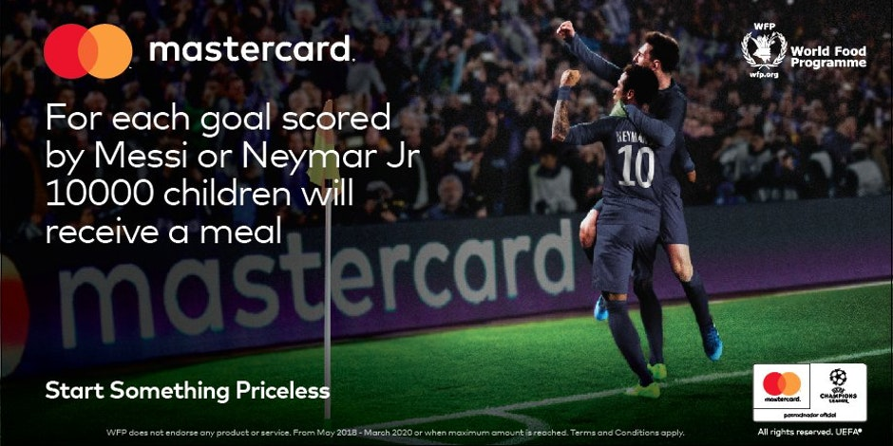

Fig 6

Charity of hunger games? We cannot discuss Diversity in advertising without mentioning the

shameful and embarrassing pantomime know as ‘tokenism’. Tokenism is when a brand tries

to pass off displays of acceptance and politically woke policies in an attempt to garner

approval from the general public. The brand acts as a social justice warrior in the name of

keeping a squeaky clean reputation…more often than not this is painstakingly obvious, with

most brands getting backlash from consumers as they feel they want to be represented in a

way that’s adequate, correct and serves a purpose to be inclusive with intent. As we can see

from fig 6 this eye watering advertisement from Mastercard plays Russian roulette with

starving children’s meals in a bid to draw more hype around the Premier league. Outrage

ensued quick as people stated this was a distasteful marketing scheme. Worth noting they

only three goals between them.

It’s time to move on from activism and focus on actually doing something. (Ann Miles. 2019)

While trying to embrace diversity they metaphorically shot themselves in the foot, further

discriminating children out of meals based on a set of millionaires shooting a goal. I am

surprised a designer agreed to make this, even with good intent the morality of this idea is

questionable at every angle you look at it. I am delighted the public raised their concerns

ultimately getting the AD scrapped. My hope is that creators and advertisers do not lean

into the pitfall of tokenistic advertising, instead rely on good morals out of the public’s eye

in a bid to get an applause. I believe the people involved in orchestrating media campaigns

should voice concerns for lack of inclusion, Designers set the tone for what the audience

consume. Graphic designers should have a personal moral response when briefed to reach

as many consumers as possible. The small change in the present will be a domino effect for

the future of design/advertising.

“By understanding the diversity that exists within your audience or category you can develop campaigns that speak to communities as consumers rather than utilise them as a creative platform”. (Tidmarsh. Mediatel News. 2021)



Fig 7

I have highlighted ads that consist of no diversity, while shedding some light on ads that

have tried but were not well received by the public. I now want to focus on advertising that

was praised by consumers. ‘Google Pixel: The Picture Perfect Life’ depicts the real world of

mental health issues. Showing 4 individuals in different stages of their life, we see each

person capturing the world around them on the Pixel phone. Seemingly when viewing these

images online, automatic assumption states they are happy people who have great personal

lives. The end of the ad discusses that behind the lens if a different reality to what we are

sold. suicidal thoughts accompanying depression are emotions each person has felt. The

takeaway is to show that what we portray to others online is not factual, because someone

seems “fine’ does not mean it’s the truth. Consistent research has been published

surrounding the dangers of perpetual use of sites such as Facebook and Instagram including

suicidal thoughts/tendencies. (Forbes, 2017) draws attention to withdrawal symptoms and

the psychological damage social media has even when taken away from you. This is due to

FOMO, we cannot help but ingest the media that is so harmful to us. Social media is

extremely unrepresentative of how real people live their lives. ‘Question your Lens’ a brash

statement that allows you to walk away examining whether you contribute to this sky

rocketing issue, or do you fall victim of the trap of believing everyone’s life is more valuable

than your own (Mahon, C. M. 2019. P.9) mentions the damages we create for our peers

posting the highlights of our lives online. The closing scene flashes rapper Logics song"1-

800-273-8255,” titled after the suicide prevention hotline, with further information as the

ad draws to an end. This campaign works on many levels due to the diversity of the actors

shown while educating and offering a resolution to those who need such resources. Brutal

honesty and vulnerability as shown is such a breath of fresh air from glamourised media and

advertising. I personally feel more connected and moved by this campaign because of how

authentically thought provoking the message is. Creative directors could use this as a prime

example of how to broaden a market positively while also selling a product. Members of the

public have stated how helpful hearing stories on a mainstream campaign have been to

make them feel less alone.

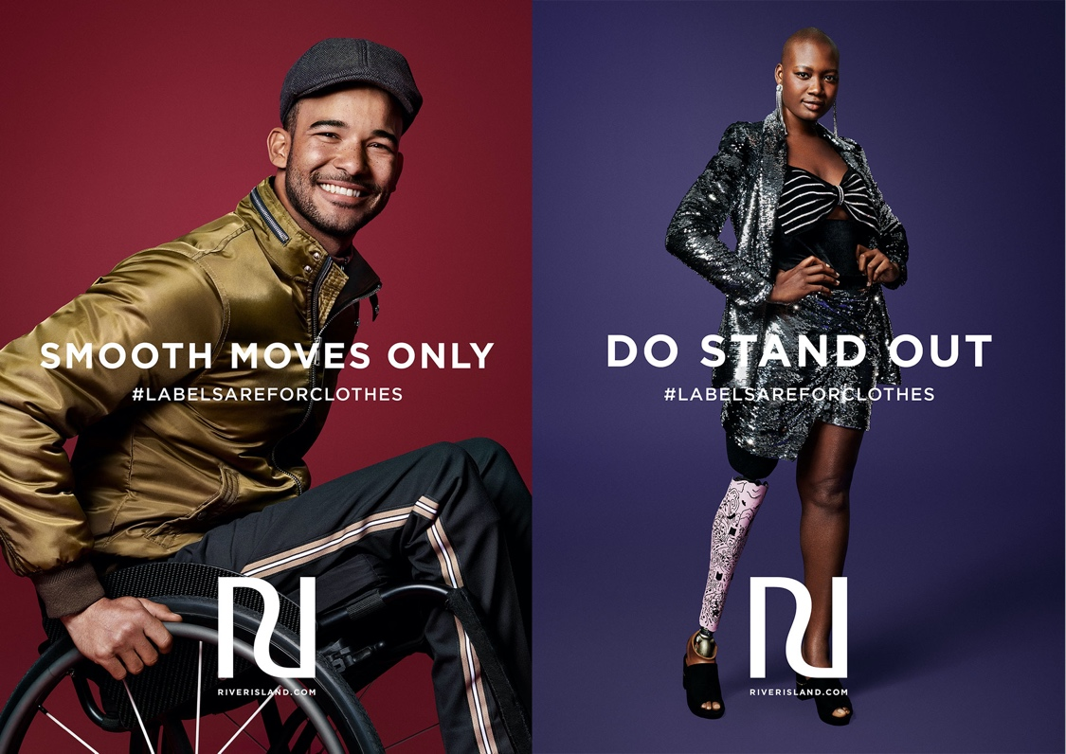

Fig 8

#Labelsareforclothes. From my research I have seen a lacklustre pattern for disability in

media advertising. Physical disability seems to have been foreshadowed by other such

issues which I have covered. With 14.6 million people in the U.K alone with disabilities this

sector for advertising is missing out a large sum of the population (Scope, 2019) This

campaign not only brings forward individuals who are rarely featured In advertising but the

visual is accomplished by the humbling hashtag. This campaign wanted to illustrate that

disabled people are not defined by their conditions. They simply are people who just have

conditions. I admire the narrative of each image referencing the model with a positive

affirmation. Often we only see negative connotations associated with disability. (Johanssen,

Garrisi. 2020. P. 10) peruses conversations of Non-disabled people enquiring a narrative

that disability is a miserable lifestyle, a prospect deriving from negative views in the media.

This campaign however is a positive spin, embracive without falling peril to tokenism.

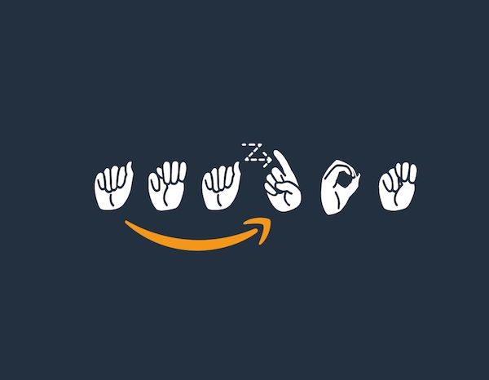

Fig 9

Lastly I want to bring attention to this spectacular logo by Amazon, changing the traditional

letter format to gestures used in the deaf community. This move was successful in not only

making individuals feel represented, it had a massive impact in the employability sector with

applications soaring in from people who are hard of hearing. Often those who do not have

physical disabilities get neglected in the field of employability, for Amazon to recognise a

sector of its employees in this way got approval around the world. This act was not

tokenistic either as Amazon runs a scheme alongside organisations that bring in interpreters

to help deaf interviewees feel comfortable. It goes to show how a simple design can spark a

positive outcome for communities and companies involved. (Coleman, R., Clarkson, J. and

Cassim, J. 2016) conversates the success of such applicable methods.

In conclusion there seems to be a pattern of what people wish to see versus what they do

not wish to see. I asked when will advertising embrace diversity. However in the examples I

have listed when a brand does include minorities in their advertising it is met with criticism.

The pattern unfolds when trying to showcase the black community and the LGBT

community specifically. Disability and mental health campaigns are mostly a raging success.

So what I actually wish to ask is when will SOCIETY embrace diverse advertising as a whole

without being selective of what minorities deserve to be represented?

Bibliography

Dennis, E. (2020) The Media in Black and White. 1st edn. Taylor and Francis. (Accessed: 24th November)

https://www.weforum.org/agenda/2017/03/advertising-versus-bias-prejudice-discrimination-ad-council/ (Accessed: 24th November)

https://www.ferris.edu/htmls/news/jimcrow/links/essays/vcu.htm (Accessed: 24th November)

Byrne, K. J. (2020) Minstrel Traditions. 1st edn. Taylor and Francis. (Accessed: 26th November)

https://www.goodreads.com/author/quotes/17434.Alex_Haley (Accessed: 26th November)

Schnackenberg, N. (2018) False Bodies, True Selves. 1st edn. Taylor and Francis. (Accessed: 29th November)

Roth, L. (2020) Psychoanalytic Perspectives on Gaze, Body Image, Shame, Judgment and Maternal Function. 1st edn. Taylor and Francis. (Accessed: 29th November)

https://www.businessinsider.com/protein-world-makes-1-million-immediately-after-the-beach-body-ready-campaign-backlash-2015-4?r=US&IR=T (Accessed: 30th November)

https://www.bbc.co.uk/news/world-europe-43154607 (Accessed: 1st of December)

(2011) The Psychology of Social and Cultural Diversity. 1st edn. (Accessed: 1st of December)

McDonnell, T. (2016) Best Laid Plans. (Accessed: 1st of December)

https://www.avert.org/professionals/hiv-social-issues/homophobia (Accessed: 3rd of December)

https://mumbrella.com.au/in-trying-to-be-diverse-marketers-are-damaging-brands-and-creating-further-bias-599296 (Accessed: 3rd of December)

https://mediatel.co.uk/news/2021/04/16/building-meaningful-intersectional-representation-in-advertising/ (Accessed: 3rd of December)

https://www.forbes.com/sites/alicegwalton/?sh=7dbeca0822dc (Accessed: 3rd of December)

Mahon, C. M. (2019) The Psychology of Social Media. 1 (Accessed: 4th of December)

https://www.scope.org.uk/media/disability-facts-figures/ (Accessed: 4th of December)

Johanssen, Garrisi (2020) Disability, Media, and Representations. 1st edn. Taylor and Francis. (Accessed: 5th of December)

Mahon, C. M. (2019) The Psychology of Social Media. 1st edn. Taylor and Francis. (Accessed: 5th of December)

Coleman, R., Clarkson, J. and Cassim, J. (2016) Design for Inclusivity. 1st edn. Taylor and Francis. (Accessed: 7th of December)

Photos

Fig One https://thesocietypages.org/socimages/2008/08/24/vintage-ads-depict-african-americans-as-dirty-simpletons/ (Accessed: 24th November)

Fig Two https://www.theatlantic.com/entertainment/archive/2015/06/casual-racism-and-greater-diversity-in-70s-advertising/394958/ (Accessed: 24th November)

Fig Three https://www.theguardian.com/media/2015/jul/01/protein-world-beach-body-ready-ads-asa (Accessed: 24th November)

Fig four https://www.businessinsider.com/suitsupply-ad-gay-men-backlash-2018-2?r=US&IR=T (Accessed: 29th November)

Fig Five https://www.businessinsider.com/suitsupply-ad-gay-men-backlash-2018-2?r=US&IR=T (Accessed: 29th November)

Fig Six https://www.thedrum.com/news/2018/06/02/the-worst-marketing-ive-ever-seen-mastercards-world-cup-childrens-meals-campaign (Accessed:1st December)

Fig Seven https://www.adforum.com/creative-work/ad/player/34561816/the-picture-perfect-life/google-pixel-2 (Accessed:1st December)

Fig Eight https://twitter.com/janicedeul/status/1044304388628590592 (Accessed:1st December)

Fig Nine https://designtaxi.com/news/404521/Amazon-Unveils-American-Sign-Language-Logo-To-Support-Hard-Of-Hearing-Employees/ (Accessed:3rdDecember)

