
Effective teamwork and Communication
Keila Ribeiro
1917702
Lecturer: Akinseye Aluko
Module code: BMSW4002
2020

Effective Teamwork and Communication
Introduction
This report is vital for exploring all requirements and effective models for effective teamwork and communication. Team effectiveness is the most important strategy to make any project successful. If the team has the capacity to accomplish the goals set by the organization, then effective teamwork plays an important role in achieving that goal. Communication is an effective part to achieve that goal. All hurdles and obstacles faced by the teams can easily be solved due to communication and effective teamwork. This helps an organization and teams in achieving their goals. This report explores the factors encompassing effective teamwork and communication.
- Communication
This is defined as a transfer of information from a place or group to another one. Every communication has a sender, recipient, and message. This is a complication method that is not simple. The transmission of the message can occur in many ways. It can be affected by many things. The cultural situation in an organization and medium or location is the most important factor of communication. Good communication skills are most effective in acquiring projects or even outsourcing the projects of an organization. Communication skills are the most in-demand skills for all employers globally.
Communication is also defined as: “The imparting or exchanging information by using any medium like speaking, writing or reading is effective. The accurate way of communication aids in making a strong connection with other clients or organization.” (Vangelisti, 2016). The successful sharing of ideas is effective communication. Communication is more than transmission. This communication can be of strategies, ideas, or information imparted successfully. The message is encoded by ‘Sender’, with words’ mixture and verbal, non-verbal communication (Vangelisti, 2016). Mode of transmission is speaking and writing and the recipient decodes it. There can be many senders and recipients but it depends upon message.
- Importance of Communication
In an organization, the importance of communication is most important.
- Motivation is promoted and employees are clarified about work details. The mannerism and performance of a task are also dependent upon it. Performance can also be made up to the mark.
- All information’s source is provided to the members of the organization and decision-making actions are easy. The process can be short in this way.
- Individual’s attitudes are easy to handle by communication. It will create a difference between informed and not much-informed people. Attitudes of employees can be improved by communication.
- Socialization can be promoted by communication. The individuals meet up fosters communication in a better way.
- Control processes are assisted by communication. Organization members’ behavior can be handled by communication (Vangelisti, 2016). Any problems related to work discipline, behavioral issues, and guidelines are handled by communication to office administration. Communication helps in controlling management issues.
- Importance of Effective Communication
- Managers use effective communication for performing basic management functions like organizing, leading, and planning.
- Jobs and responsibilities are easy to perform for a planning foundation. All important information is communicated to employees through managers through effective communication. For planning implementation, this is the most effective method. All team goals are achieved through communicating with subordinates. Verbal or non-verbal communication is not possible without communicating with the team to achieve tasks and goals.
- Face to face and other methods of communication are usually applied for effective teamwork that includes customers, employees, and managers. Written communication is more effective in the form of letters or memos. For building a successful business, effective communication is the hidden ingredient.
- Methods of Communication
There are two main methods of communication: Verbal or non-Verbal.
  - Verbal:
Verbal communication is the most used mode of communication, and it is a powerful tool. Individuals can use words to share information. Writing is also a way of verbal communication. Most people use verbal communication as writing or speaking. Both of them use words. Formal communication and informal written communication are forms of communication. Synchronous and Asynchronous communication occurs in real-time and with emails, letters, and memos respectively. Recorded and unrecorded information is written communication and spoken communication respectively (Valo & Sivunen, 2019).
Spoken communication is the most powerful with a speech or even meeting. Spoken communication is the part of the social communication model. Encoding and decoding the messages by conversation is the best thing. Feedback can also be received. Spoken communication helps in creating relationships. Establishing a rapport and effective teamwork is important for this. This also helps in emotional bonding. It helps in clearing out misunderstandings.

4.2 Non-verbal Communication
Active listening skills are more important while using non-verbal communication. Facial expressions also show interest. Body language can be predicted easily. It is estimated 35% of communication is verbal and 65% communication is non-verbal (Valo & Sivunen, 2019). Several types of non-verbal communication help in working effectively.
- Facial expressions: Facial expressions are most effective in conveying the message. While in meeting with the team, facial expression can easily be judged. Always remain in control of your facial expressions.
- Gestures: Pointing out something is the gesture as several others. Listener and talker can communicate easily for understanding the message. Co-workers can effectively form a strong team while working on their gestures for engaging their audience or higher management.
- Touch: Firm shake hand and tap on your co-worker’s shoulder can put everyone at the ease. Affection can be communicated between co-workers but strength too. Communicating power is different for everyone.
- Eye contact: An eye-contact can easily point out many things like confidence and listening power with the affirmation of nod. Good eye contact helps in listening to the audience.
- Theories of Communication
There are several theories of communication which represent effective communication methods and theories. These 3 models represent the theory and explanation of each model.
  - Shannon and Weaver Model of Communication
This model is known as ‘mother of all models’. This also explains that communication has six concepts. This was represented as a linear model but converted to a cyclical model (Al-Fedaghi, 2012). This is called ‘Shannon theory’ as he introduced the theory. The model explains how messages are broken into parts and distorted to convey in a channel of communication. This linear model analyzes how messages are sent in communication. It also explains the distortion and misinterpretation of messages while sending them.
Claude Shannon and Warren Weaver explained in the 1948 journal article “A Mathematical Theory of Communication” article where he explained the model’s goal was:
“The fundamental problem of communication is that of reproducing a message sent from one point, either exactly or approximately, to another point” (Al-Fedaghi, 2012).
He hoped to introduce distortion points in communication while using this model.
Six concepts are Sender, encoder, channel, Noise, Decoder, and Receiver. All of these channels help in sending the encoded message through a channel and decode it at the receiver by eliminating noise.

Figure 1: Shannon-Weaver model of Communication
  - Schramm Model of Communication
This Model is a cyclical form of communication model that explains all general communication models. It explains the exchange of information between two individuals. In 1954, Wilbur Schramm published the circular communication model. Schramm explained the model in his book titled ‘The Process and Effects of Mass Communication’ (Schram, 1954). He explained all functionality conducted between the sender and receiver. This model explains about two-way communication path. There exists a sender and recipient along with the message itself. This is interpersonal communication. The recipient and sender can be one which is called intra-personal communication. This model is not linear but circular in nature. Message can be encoded and decoded at both places respectively. An encrypted message is passed onto the end person. The recipient receives and decrypts the message and can encode it to send it to a new recipient.
Source (Encoder)
The source sent the message as a sender and clearly shows the importance of the message to be sent. The accurate information should be fed to the message (Schramm, 2015). It has to be ensured that the message is encoded. The recipient has to know the sender in order to decode the information.
Recipient
The recipient is the decoder of a message and message is sent to him. Decoding of message is dependent upon many factors. The topic and source of the message must be known for interpretation. After the message is received, the mind interprets it. This processing phase is called decoding (Schramm, 2015). The correct interpretation of the message makes the decoding of message successful.
Message
In a literal way, information can be called as a message. Words are needed for communication. It can be non-verbal or verbal and it plays a vital role (Schramm, 2015). WhatsApp, emails, and calls are verbal types of messages while eye contact and gestures or behavior are non-verbal.
Feedback
Recipients are important for feedback and they play an important role. They receive the message and respond to it. Feedback is a response of recipient to sender by a verbal message.
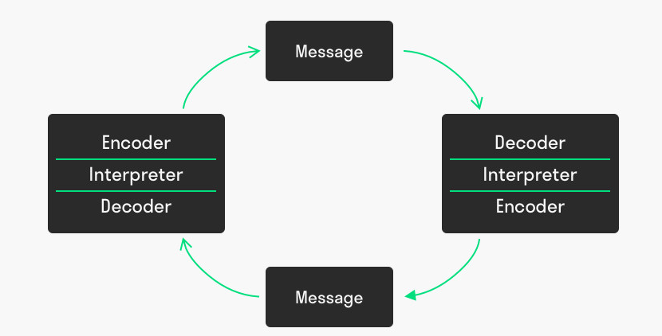
Figure 2: Schramm model of communication
5.3 Berlo’s Model of Communication
This model represents the simplest communication process. Berlo’s SMCR Model of Communication explains all different factors used for basic communication. This also helps in coding and decoding the message which is effective for communication (Turaga, 2016). The acronym SMCR stands for Sender, Message, Channel, and Receiver. The basic form of communication is the sender, message, and receiver. The receiver is the one who can interpret the message. This is the simplest form of communication.
Main Components:
All included components define the method of communication. It includes the four components which are affected by many factors.
Sender:
The sender is the outsourcer of the message who sends the message after creating it. The encoding of messages is the communication process part which helps in going to the next step. Factors influencing the sender are also for the receiver (Turaga, 2016). Communication skills, attitude defining the consequences of the message, subject’s information, location/ region of the sender, and culture differences help in the interpretation of a message.
Message
This is often referred to as the package sent from the sender to the receiver. It exists in various forms like audio, text, speech, and video. Sender interprets whole message in a peculiar method. The source message is converted into encrypted message. The accuracy of the receiver helps in understanding the message (Janse, 2018). The message is influenced by many factors such as the content of the message, elements like gestures or signs, way of sending a message, the structure of the message, and type of message including music, video or text files, etc.
Channel The channel helps in sending the message and is used as a medium. The sensory system of the receiver includes vision, touch, and other senses (Janse, 2018). Most of the time, messages are transmitted via sound.
Receiver
The receiver helps in decoding the message and interpreting it in an effective manner. It also helps in making the communication according to the receiver’s pattern. All these factors influence the receiver and the receiver interprets the message by giving it meaning.
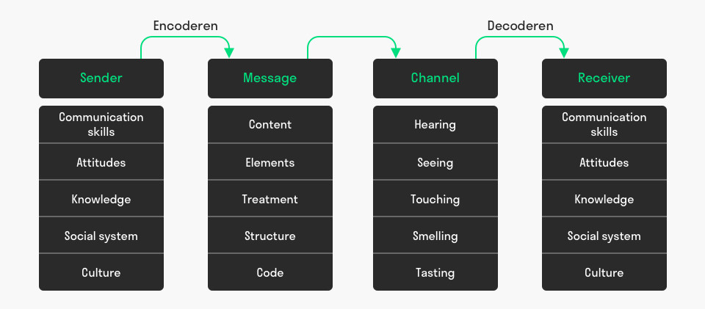
Figure 3: Berlo’s Model of Communication
  - Justification of the models
All of the models discussed above are developed and explained with enough knowledge but all have the same main components which include sender, channel, message, and receiver. In every model, the importance of all components is discussed in great detail. Loss or disruption of a channel is the issue which can complicate it and it should be avoided. Noise may occur and it can be eliminated easily (Turaga, 2016). All of these models can be easily applied in terms of effective teamwork and communication in the workplace.
- Communication at the Workplace:
Communication is an effective mode of communication for any organization and it helps inflow of information (Mikkola & Valkonen, 2019). All colleagues, staff, and management can easily manage their projects with effective communication.
- The discussion should be encouraged and contributed among co-workers.
- Face-to-face opinions can be given which can prove to be effective and emails or letters can also help in communication at the workplace.
- Email communication channel must remain formal at every cost. The message should be clear to understand for all co-workers.
- Body language must be in work-mode.
- Meetings should be conducted with conversations and it can be proved meaningful.
- Conclusion
It can be concluded that communication plays an important role in our everyday lives and communication should be effective enough for everyone. Communication channels are always made for sending the messages and messages of every type should be clear enough to be decoded. Communication is also effective for teamwork and can help individuals with a better transmission of messages. Communication at the workplace is the most important part which should be followed with effective methods.

References:

Al-Fedaghi, S. (2012). A conceptual foundation for the Shannon-Weaver model of communication. International Journal of Soft Computing, 7(1): 12 – 19.
Andrew Maund, Michaela Schriek and Paul K. Tinkler (2017) Skills for the workplace Student book, (chapter 3 and 4)
Al-Fedaghi, S. (2012). Codeless Communication and the Shannon-Weaver Model. International Conference on Software and Computer Applications.
Janse, B. (2018). Berlo’s SMCR Model of Communication.
Mikkola, L. & Valkonen, T., 2019. Developing Workplace Communication. Workplace Communication, pp.179–192.
Schramm, H., 2015. Parasocial Interactions and Relationships. The International Encyclopedia of Communication.
Schram, W. E. (1954). The process and effects of mass communication.
Turaga, R. (2016). Organizational models of effective communication. The IUP Journal of Soft Skills, 10(2), 56-65.
Valo, M. & Sivunen, A., (2019). Future Directions in Workplace Communication. Workplace Communication, pp.193–206
Vangelisti, A.L., (2016). On the importance of communication research. Communication Education, 65(4), pp.501–504.

