Marketing plan written for

Ritz Carlton

Student Name:Oana Girtu

__________________________________________________

Student ID number
2209481

Marketing Essentials BMIH4005

Lecture’s name:Luciana Suardi

________________________________

Table of Contents
1 Introduction 3
2 Situational Analysis 3
2.1 SWOT Analysis 3
2.2 Segmentation and Targeting 4
2.3 Perceptual Positioning Map 4
2.4 PESTLE Analysis 4
3 Objectives 5
4 Strategy 6
5 Tactics 6
5.1 Product 6
5.2 Place 7
5.3 Pricing 7
5.4 Promotion 7
6 Action 8
7 Control 8
8 Conclusion 9
9 References 10
10 Appendix 12

Introduction
Ever since the world was shaken to the core by the nearly-catastrophic COVID-19 pandemic, nothing has been the same, and the UK is no less different in this impact. However, its conditions are worsened due to political unrest, its imminent departure from the EU, and people still recovering from the pandemic. Therefore, the country's current environment has surged new customer preferences almost everywhere, so the hospitality industry has to take note of these, too. Hence, this marketing report is for Ritz Carlton, an American multinational luxury hotel chain with operations expanding in more than 30 countries and working under its parent organization, Marriott (About Us – Ritz Carlton, 2022). The targeted geographical area is London, UK, as the hotel's biggest presence on this island is here.

Situational Analysis

SWOT Analysis
Strengths | Weaknesses
- High-quality service.  - Strong brand presence.  - Empowered employees, mostly due to the robust reward system (Xiong et al., 2019).  - The parent company, Marriott, adds brand value due to its popularity.  - Customers have widely reported positive experiences (Krismasari et al., 2020). | - The brand name is associated with extravagance, so people in financial crises are hesitant to approach it.  - UK’s economic status can take a toll on spending power.  - Declining business due to COVID-19 aftermath.
Opportunities | Threats
- Obtain flexible pricing for different types of customers.  - Increase customer base by presenting special packages or deals.  - Establishing new branches in London, especially near popular areas like Trafalgar Square. | - Intense competition by other luxury hotels in London.  - Increasing operational costs due to economic upheavals.  - Declining tourism still due to people’s disinterest in travelling after the pandemic (Sheresheva, 2020).

Segmentation and Targeting
Typically, Ritz Carlton targets those customers who can afford its premium-priced services, namely people who belong to the upper class, are businessmen, or who prefer luxury mixed with comfort (Krismasari et al., 2020). It is positioned as a brand that aims to create memorable moments for its guests, but considering the current UK situation, the segments will also include customers who are willing to try flexible pricing and prefer cleanliness over anything else.

Perceptual Positioning Map
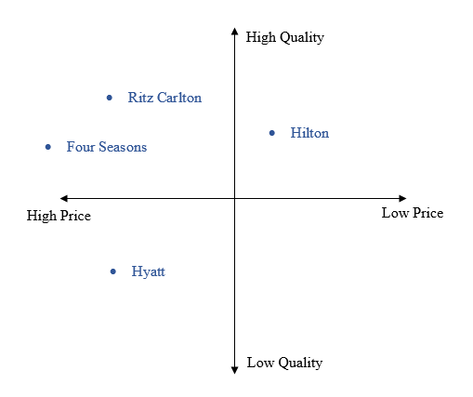

PESTLE Analysis

Factors | The Trends
Political | Political unrest due to the recent Prime Minister change, Her Highness's death, and the country's astonishing departure from the European Union impacted the industries present.
Economic | After ricocheting due to the pandemic and Brexit, the UK’s economy still has a long road to cross for recovery, but its GDP is healing, with its current stance at 3.18 trillion USD (World Bank, 2022). The country’s hotel sector is now worth more than 16 billion pounds (IBIS World, 2022).
Social | As the 21st century moves on, so do people’s preferences. Trends play a major role here, so hotels concentrate on the growing popularity in social media travel blogging, online hotel reviews, and the appreciation of diverse services, which is why digital marketing is considered (Moore et al., 2015).
Technological | The UK's hotel industry is no stranger to technology due to its continuous innovation and improvement in various functions – a behaviour that accelerated after the pandemic. Now, the industry boasts chatbots for questions, contactless payments, online bookings, and even automated receptions (Kim et al., 2017).
Legal | Several laws in the UK apply to the hotel industry, and international brands like Ritz Carlton have to pay extra heed to them to stay in the country’s good graces. These include a lot of liabilities, including safety regulations and copyright laws (Assetsure, 2022)
Environmental | Air pollution is becoming more alarming by the minute in the UK, mainly because of its industrial and urban activities, and this increases climate change threat (Carnell et al., 2019). Hence, companies like hotels are expected to exhibit responsible behaviour to combat this threat.

Objectives
The new marketing objectives for Ritz Carlton London are shown below:
- To adopt flexible pricing for different types of customers.
- To introduce various rooms for different types of customers.
- To gain at least 5% increase in London’s occupancy rate before the year ends.
- To advertise cleanliness and comfort besides the elegance and luxury in new digital and traditional posters.
- Gain 10% boost in revenue in the early half of 2023.

Strategy
Ritz Carlton is a worldwide renowned hotel chain whose value proposition is designed around their customers' genuine care and comfort. Retrospectively, the hotel brand obliges to the value proposition by providing their guests with esteemed care, highly optimized services and specialized facilities to cater for them with a comfortable ambience (Ritz Carlton, 2022). The hotel's staff customer obsession sets them apart from their competitors. Additionally, given the circumstance in this post-pandemic era, Ritz Carlton seeks to include sanitary products and facilities in its room services because the majority of its consumer base expects the chain to value cleanliness after COVID. Such facilities would include frequent changing of bed sheets, sanitizers available anywhere and sterilized toilets. Further, due to Brexit’s effect on the UK, Ritz Carlton suffered a loss in audience and market (Econbrowser, 2018). Thus, after including COVID precautions in its services, the hotel can cover the audience and market gap.

Tactics

Product
The luxury hotel chain currently offers beds, bed sheets, curtains, linens, pillows, spa facilities, fragrances and interior decorations other than hotel rooms and resorts. Ritz Carlton also offers travelling packages which comprise gifts such as travelling moisture creams, boots and slippers and fragranced candles (Ritz Carlton Shop, 2022). However, after COVID, Ritz Carlton would indulge in a policy for cleanliness and refinement in the production and deliverance of the products. Further, the hotel intends to monitor frequent changing bed sheets and toiletries while providing safe food products.

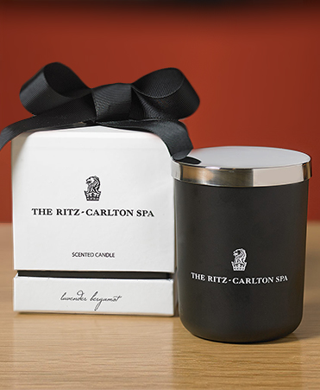

Place
Ritz Carlton is present in over thirty premium countries, including the UK, China and Qatar. The hotel chain's headquarters lie in Maryland, US, while its distribution channels are various to note. Customers of the renowned hotel chain can locate it on their official website or contact the staff through social media apps, such as Twitter and Instagram (Lee and Kwag, 2017). In hindsight, in the post-pandemic era, Ritz Carlton is looking forward to focusing on the distribution of its products through social media applications since such distribution is a lot accessible, and customers are likely to stay engaged with the hotel's newly released products and discounts.

Pricing
At the moment, Ritz Carlton has possessed a premium pricing strategy, which permits the hotel to charge their high-profile elite-class clients more than the general ones. The hotel caters to more beneficial gifts and services for higher and premium prices, focusing more on customer satisfaction (Lee and Kwag, 2017). Now, considering the situation after COVID and Brexit, Ritz Carlton plans on slightly modifying its pricing strategy. They will continue to use their premium strategy but will make it more flexible and accessible for general clients.

Promotion
Ritz Carlton reportedly obliges to their mouth of the word strategy. This strategy enables the hotel chain to get advertised physically, which evidently has more effect on the audience than digital promotion. On the other hand, Ritz Carlton has initiated a reward program in light of its promotional strategy, where its clients are rewarded with points for longer stays and recommended visits, which makes them earn gifts. They also promote through online advertisements (Lee and Kwag, 2017). After COVID, Ritz Carlton seeks to market their brand visibility through social media apps and focus its promotion through its official website as well.
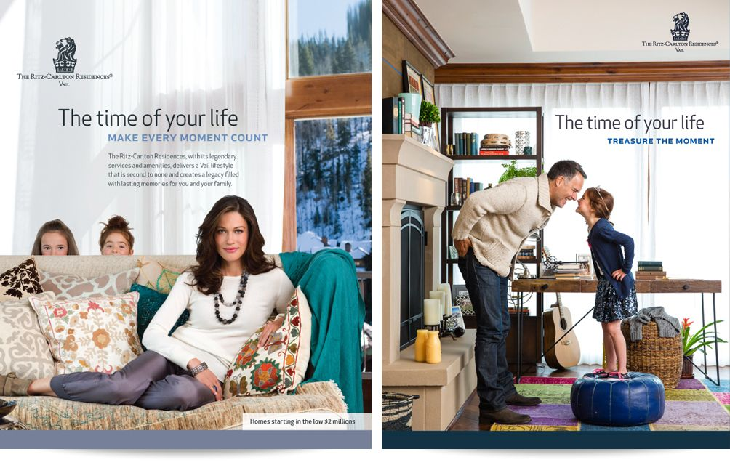

Action
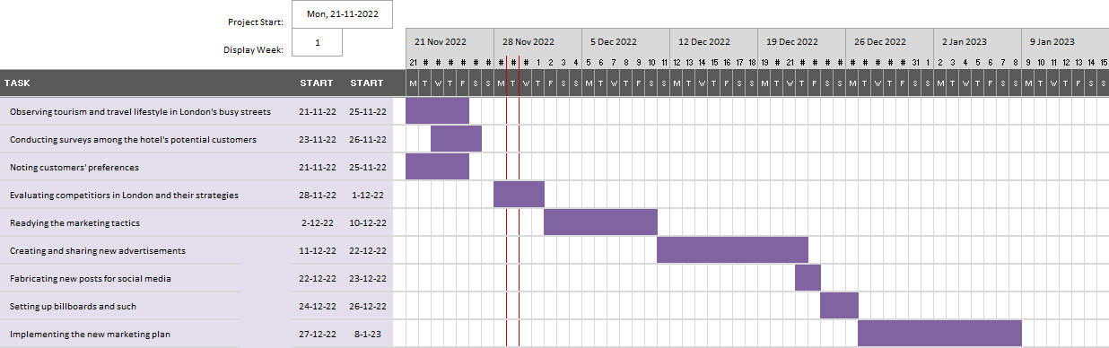
In order to detail the company’s actions in light of the new marketing plan, the Gantt chart above can be observed. The different activities with specific set timelines are given, but these may not be accomplished as scheduled due to busy days and wavering hours where time and energy might not be enough to complete these tasks as per the chart. However, this timeline gives an idea on the set actions required for making these new marketing tactics a success.

Control
Hotels need to have a Unique Selling Point (USP) because amidst the highly competitive market, they need to be different (Sunil et al., 2018). Hence, Ritz Carlton’s USP for attracting new customers would picture a hotel brand that empowers its employees to ensure excellent guest service, values customer experience and making it memorable and ensuring luxury is being provided with top-tier cleanliness, eco-friendliness, and comfort. London tourists and travelers are usually advanced, so selling the hotel’s brand perception as per their preferences would give Ritz Carlton an edge over its competitors. Therefore, this message will be delivered via digital and traditional marketing.

Conclusion
In conclusion, it can be noted that since Ritz Carlton already has a well-reputed brand in London, UK, it does not have to change its image or perception a lot, mainly because customers staying temporarily in London will continue to find great experiences within the hotel. However, this does not mean new customers should be brushed aside with this marketing plan because it is equally as important. The changing landscape of the UK means constant alteration to costs and customer preferences, which is why taking a new stance would help Ritz Carlton build an even better brand that could appease even the hardest of hearts.

References
Carnell, E., Vieno, M., Vardoulakis, S., Beck, R., Heaviside, C., Tomlinson, S., Dragosits, U., Heal, M.R. and Reis, S., 2019. Modelling public health improvements as a result of air pollution control policies in the UK over four decades—1970 to 2010. Environmental Research Letters, 14(7), p.074001.
Econbrowser (2018) Comparative Performance of the UK Economy. Available at: https://econbrowser.com/archives/2018/04/comparative-performance-of-the-uk-economy (Accessed: November 29, 2022).
Hotels laws UK | hospitality legislation UK - assetsure (2022). Available at: https://www.assetsure.com/business/hotel-insurance/hotels-laws-uk/ (Accessed: November 23, 2022).
Industry market research, reports, and Statistics (2022) IBISWorld. Available at: https://www.ibisworld.com/united-kingdom/market-size/hotels/#:~:text=What%20is%20the%20market%20size,to%20increase%2045.5%25%20in%202022. (Accessed: November 23, 2022).
Kim, S.Y., Kim, J.U. and Park, S.C., 2017. The effects of perceived value, website trust and hotel trust on online hotel booking intention. Sustainability, 9(12), p.2262.
Krismasari, M.A., Astawa, I.K. and Triyuni, N.N., 2020. Commission of online travel agent to increase room occupancy at The-Ritz-Carlton, Bali. International Journal of Green Tourism Research and Applications, 2(2), pp.96-103.
Lee, J.W. and Kwag, M., 2017. Corporate marketing strategy using social media: a case study of the Ritz-Carlton Seoul. Journal of Asian Finance, Economics and Business, 4(1), pp.79-86.
Moore, J.N., Raymond, M.A. and Hopkins, C.D., 2015. Social selling: A comparison of social media usage across process stage, markets, and sales job functions. Journal of Marketing Theory and Practice, 23(1), pp.1-20.
Ritz Carlton (2022). About Us. Available at: https://www.ritzcarlton.com/en/about (Accessed: November 29, 2022).
Ritz Carlton (2022). Luxury Hotels & Resorts: The Ritz Carlton. Available at: https://www.ritzcarlton.com/en/about/gold-standards#:~:text=The%20Ritz%2DCarlton%20is%20a,%2C%20relaxed%2C%20yet%20refined%20ambience. (Accessed: November 29, 2022).
Ritz Carlton Shop (2022). Ritz-Carlton Hotel Shop – Luxury Hotel Bedding, Linens and Home Decor. Available at: https://www.ritzcarltonshops.com/ (Accessed: November 29, 2022).
Sheresheva, M.Y., 2020. Coronavirus and tourism. Population and Economics, 4(2), pp.72-76.
Sunil, M.P., Shobharani, H., Mathew, A.K. and Rose, A.E., 2018. Validation of SERVQUAL model in star hotels pertaining to Bengaluru City. Asian Journal of Management, 9(1), pp.393-399.
World Bank (2022). Great Britain GDP. Available at: https://data.worldbank.org/indicator/NY.GDP.MKTP.CD?locations=GB (Accessed: November 29, 2022).
Xiong, L., So, K.K.F., Wu, L. and King, C., 2019. Speaking up because it’s my brand: Examining employee brand psychological ownership and voice behavior in hospitality organizations. International Journal of Hospitality Management, 83, pp.274-282.

Appendix


