A critical evaluation and the identification of next teaching and learning steps focusing on a case study of an individual learner or a group of learners, based on an observed critical incident.

The aim of this assignment is to critically evaluate an observed critical incident within a classroom setting to further identify future teaching and learning steps. To begin the assignment will provide a definition of what a critical incident is, moving on to the importance of recognising these incidents within settings. There will then be a brief overview of the setting in which the observations took place, ensuring the British Educational Research Association (BERA) (2018) guidelines are followed to maintain the required anonymity and confidentiality of all participants within the setting. A range of observation methods will then be discussed, highlighting the positive and negative aspects of each when being used within a classroom. Moving on to the critical incident specifically chosen for this assignment, which will be linked to theory, practise and the four purposes of the Successful Futures Report (Donaldson, 2015). Finally, the assignment will explore the importance of reflective practise within education and discuss next steps considered by the observer to improve future practise linking to The Teaching Standards for Wales (TES, 2017).
The critical incident methodology approach has been used within educational settings for many years as suggested by Flanagan (1954) cited in Philpot et al (2020), critical incidents are seen as a qualitative research method, where significant factors are identified that contribute to the success or failure of an event. The information is collected through direct observations and first-hand information is recorded.
According to Tripp (2011, p8):
“... a critical incident is an interpretation of the significance of an event. To take something as a critical incident is a value judgment we make, and the basis of that judgment is a significance we attach to the meaning of the incident”
Tripp (1993) goes on to explain anything can be viewed as a critical incident as it is how an observer peruses and explores the significance of the incident that makes it critical. Mc Garr and McCormack (2016) would agree with Tripp (1993) insisting critical incidents are not always that of a ‘critical’ nature and more incidents that can be further explored in order for practitioners to reflect and improve on future practise. Bleach (2014) states, reflective practitioners can have an impact of not only their own professional development, but on those around them impacting on the learning experience of the children within the setting.
In addition, Tripp (2011) states how critical incidents are not planned in advance or events the observer is waiting to happen, but events that are spontaneous and created by an individual, whether it be the practitioner or the learner or group of individuals. Angelides (2001) would agree that critical incidents can be used to improve a settings performance, however, also suggests critical incidents can also be used as a method of data collecting quickly for a specific study. Furthermore, McGarr and McCormack (2016) also discuss how such incidents are often assumed to have a negative impact on the practitioner or learner, however this is not the case and insists that critical incidents are often positive events. This is agreed by McGrath (2010) and Meggit (2015) who insist reflecting on both positive and negative experiences within the classroom will contribute to the personal growth of practitioners to enhance professional development. In addition, Blatchford et al (2000) would also insist critical reflection also impacts each and every learner within the setting.

As stated above to follow the recommended BERA (2018) guidelines, the school observed for the purpose of this assignment will be referred to as School A to maintain the confidentially and anonymity of the setting.
School A is situated in a small village, considered to be an affluent area, with a very small number of children receiving free school meals averaging at only 6% which is well below the national average. There are approximately 120 pupils currently attending the school between the ages of three and eleven. The school offers a morning nursery, reception class, mixed year one/two class, year three class, year four class and a mixed year five/six class, all with a range of mixed ability pupils. There were three outdoor areas available to the children, one for the nursery, another for the foundation phase and a third for key stage two. In addition, there is a Special Teaching Facility (STF) for the foundation phase pupils within the school. Approximately 20% of the children have additional learning needs (ALN) which is around the national average. Nearly all children attending the school are from English speaking homes (ESTYN, 2019). The school is part of the Erasmus Project linking to outdoor learning.
According to Rozsahegyi, cited in Lambert (2019) observation is one of the most used methods of data collection within educational settings. This is because unlike other data collection methods, observation is based on a ‘real-life’ experience and not perception. Barber and Paul-Smith (2012) insists when making observations you must be objective and not subjective, and detailed and clear note taking is key. They go on to discuss a range of observation methods, from snapshot observations, where little bullet point notes are made, to narrative observation, which consists of everything being written down, such as the environment, setting, atmosphere and so on. Also discussed is a spontaneous observation, which means impulsive.
For the purpose of the module the observer will be taking spontaneous observations but recording it using the narrative style. As there are a number of observations being made, and these are not planned as previously stated critical incidents can happen at any time. However, to ensure a thorough literature review can be undertaken, the notes need to be detailed to get a clear understand of the research required.
The critical incident took place within the Year one/two classroom, which combined thirteen year one pupils and six year two. There was one class teacher and one teaching assistant working with the children. The observation took place on a dry autumn day during a numeracy lesson, where focus was subtraction. With this being a mixed class of both year one and two children, immediately it was apparent in their need for differentiation, however, the task was differentiated between year one and year two, not taking into consideration each individual child’s needs as recommended by Donaldson Successful Futures Report (2015) and furthermore, the new approach to teaching as suggested by Welsh Governments (2021) Curriculum for Wales 2022, where children are taught based on stage and not age. Most of the children seemed to have an understanding of the lesson and engaged happily in the task, however there were a group of lower ability children that didn’t seem to understand the concept of subtraction and within the classroom environment with others shouting out the correct answer they seemed to become disengaged, frustrated and began misbehaving between themselves, resulting in lack of confidence, which could lead to poor well-being. The teaching assistant tried to encourage the lower ability group, but the lack of resources available for them children to subtly acquire themselves was apparent, the same could be said for the group in the earlier literacy session.
This led me to question why the class teacher or teaching assistant didn’t make use of the outdoor space, as it is one element the school promotes and was also recognised within the schools most recent Estyn report. And in addition, the use of natural outdoor resources, allowing children to play and explore through self-directed play with leaves, stones etc to give these children a more hands on experience, giving them a clearer understanding of the concept linking to Dewey and Vygotsky’s theories on a hands-on learning approach, which can also have a positive impact on the holistic development of children. This led me to research further into the benefits of outdoor learning.
The observed critical incident links specifically to two of the four key purposes in relation to Donaldson’s Successful Futures Report (2015). The first; creating ambitious capable learners. As an observer, the children did not engage in the basics of the activity due to a lack in knowledge and confidence in their own abilities, not enabling them to want to further explore to improve their own understanding and want to learn. Secondly, creating healthy, confident individuals. I believe the children observed lacked confidence in their own abilities which led to a lack of engagement within the task. They could see their peers answering questions easily to which they didn’t have the basic knowledge of the concept which will lead to a lack of self-confidence, which can have a detrimental impact of the child’s well-being.

Literature Review
Research was undertaken in-regards the benefits of children participating in regular outdoor play and how to use of loose parts and natural materials can improve the learning experience for all learners but especially for those of a lower ability children. This research seeks to confirm if children’s development is restricted when learning is primarily classroom based and lacking in hands-on experiences and what the use of the outdoors can do for the holistic development of the child.
Machan (2016) states how Margaret McMillan realised the potential of outdoor learning over one hundred years ago, with McMillan emphasising the importance of children being outdoors not only for their health and wellbeing, but for their holistic development.
Froebel’s greatest passion as a child was having the ability to explore the outdoors and nature (Frost and Sutterby, 2017) and this work was drawn upon by Macmillan. According to Early Childhood Today (2000) Pestalozzi was the influence in Froebel’s life who later went on to teach with the belief that in order for children to learn they had to be active learners. Froebel went on to insist there was a spiritual connection between humans and nature, introducing a ‘children’s garden’ or as it is now known a kindergarten back in 1837 in Blakenburg, Germany. Froebel believed children could holistically grow ‘in harmony’ with the natural environment, naming it a garden and not a school (Early Education 2000). Frobel suggested children thrived in a spiritual environment with activities that encouraged curiosity and a want to play, moving away from set curriculums (Bruce 2005). Within the kindergarten not one subject area, or developmental strand took priority over another, as Frobel ensured each individual child’s needs were met at the right time for the child to develop holistically.
A further pioneer in outdoor play was Montessori, however Montessori had very different views to Froebel, and her approach to learning was a free flow approach, allowing children to flow between the indoors and outdoors. Children learnt from hands on experiences using child sized objects focusing on life skills, learnt through repetition. Kolb’s learning cycle also links to a hand-on learning approach allowing children to visualise experiences transformation before them, which also links to Piaget’s theory on hands on learning (Macintyre, 2001) in addition, Vygotsky and Bruner’s approach to learning by doing, through first-hand experience, repetition and play (Overall, 2007 and Siraj-Blatchford, 2015).
A holistic approach was encouraged by Montessori who also believed in incorporating nature as much as possible very similar to Froebel (Montessori Educational Centre, 2019.) In the same way Steiner believes in the child’s spiritual growth by having access to the environment and the ability to explore and have a closeness with nature (Knight, 2013). The work of McMillan, Froebel and Montessori heavily influence today’s practice, with Forest Schools adopting much of their approach in its emphasis on outdoor learning (Knight, 2013). Within the UK, Wales leads in its development of learning outdoors and the Foundation Phase introduced in 2010 further ensured the range of hands on, experiential learning for young children. The Welsh Assembly Government (2009) introduced the Foundation Phase, Outdoor Learning Handbook, to support practitioners. It also advises the benefits of outdoor play, and how it helps develop the child holistically, this is supported by Knight (2012) and (2013), Bruce (2005) and May (2011).
Not only is Wales making progress in outdoor learning, but the Department of Children, Schools and Families (2008) in England encourages the linking of seamless learning between the indoor and outdoor environments and also The Scottish Government (2020) have recently implemented ‘Out to Play’, a guide for all practitioners to encourage the regular use of outdoor play within settings. Estyn (2011) supports outdoor play and learning in Wales, and measure this during school inspections. Estyn stated as a result of outdoor learning within the early years sector, children’s wellbeing, physical and behavioural developments had all improved. As well, as the introduction to the foundation phase Wales has a country values the importance of play and is a member of the International Play Association which was introduced in 1961 to protect, preserve and promote a child’s right to play, both in and outdoors (Play Wales, 2020). This links to the United Nation Convention on the Right of the Child, Article 31; children have a right to relax and play, and Article 13: children have the right to freedom and expression (Unicef, 2020). More recently Donaldson Successful Futures Report (2015) encourages educational settings to learn through a range of ways, enhancing a depth of learning, including regular use of the outdoors throughout Primary schools, but especially the Foundation Phase.
According to Moyles (2005) and Tovey (2007) children engaging in play in an outdoor environment get a richer experience and gain a greater understanding and knowledge of the world. Tovey (2007) goes on to state how children can express their experiences through bigger movements and express emotions louder as outdoor spaces are more diverse. Enabling children the unique experience of an outdoor environment to learn within their setting ensures an extension of the classroom teaching. A space the child can practise hand-on what topic they have been learning, allowing them the space to explore further and make mistakes (Orion and Hofstein (1994), cited in Harris (2017)). This is echoed by (Ashmed, et al, (2007) and Trudeau and Shephard, (2008), cited in Harris (2017)) in rich, messy activities that holistically develop the child by using both fine and gross motor skills.
This led to further research as to what children see as work and what children see as play when learning. McInnes et al (2011) suggest whilst children are participating in an activity they believed to be play, they displayed a higher level of emotional well-being. Eisenmann and Hadani (2019) would agree insisting whist learning through play the child’s engagement level become higher, problem solving improves, and an increase in confidence and self-esteem can be seen by practitioners. Whereas according McInnes et al (2013) study, when children are sat at a desk those skills are to be limited, as the child see’s the activity as work having a negative effect of some children’s emotional well-being, resulting in the children being distracted, children can shut down and changes in behaviour can be seen.
In the 1970’s Simon Nicholas was an architect who introduced his theory on loose parts and how they can benefit the development of children. Nicholas insisted allowing children access to loose parts from nature enriched a child’s creative abilities, enabling children to take control and engage in rich play experiences where these parts can be turned and made into anything. Daly and Beloglovsky (2014) agree with Nicholas suggestion open ended natural materials and loose parts encourage a child’s curiosity and opens the mind to the ‘what if’, linking children to become ‘ambotious’ in their learning. Loose parts also had a large role in the development of a child’s social and communication abilities, give children a sense of belonging when den building, role play and inventing and exploring together. Ensuring the use of loose parts not only outdoors but also within the classroom can deepen a child’s learning experience through their senses. Loose parts don’t have to be big planks of wood or typres, they can be shells, pinecones or leaves, linking to Donaldson (2015) and Welsh Government (2015) Curriculum for Wales, learning through a range of experiences to deepen understanding.

Within education there is a need for practitioners to be reflective on all their experiences in order to continually improve how their professional development. According to Dallos and Steadman (2009) Dewey was one of the first theorists to discuss reflection which has led to how reflective practise is used in a wide range of organisations today, specifically education, medicine and management. To reflect upon on event alone was not enough according to Dewey, and he insisted experiences were questioned, as to why things happened, how those things could have been changes and so on, resulting in the practitioner thinking one step ahead should the event occur again (Popova, 2020). The University of Cambridge (2020) states people are continually reflecting on experiences, some without even knowing, however, to ensure reflective practise there much be a purpose, a want to develop further and make future changes.
During this module I research reflective models and came across a number, but I found two stood out; Schon’s reflective model and Gibb’s reflective model. Smith (1999) Schon’s models follows on from the work of Dewey, however Schon believed reflection was not only something performed by a practitioner at the end of an event or experience, Schon believed in reflection during an activity aswell, know as ‘reflection in’ as opposed to ‘reflection on’; reflecting after the activity (Schon, 1983).
The observer’s reflection is based upon Gibb’s reflective model, this is due to Schon’s model requiring the observer prior knowledge and with this being the first visit to the setting this wouldn’t give a true reflection (Meierdirk, 2017). The incident explored was one that if highly lightly to occur again, not only in this setting, but in other settings throughout primary school age.
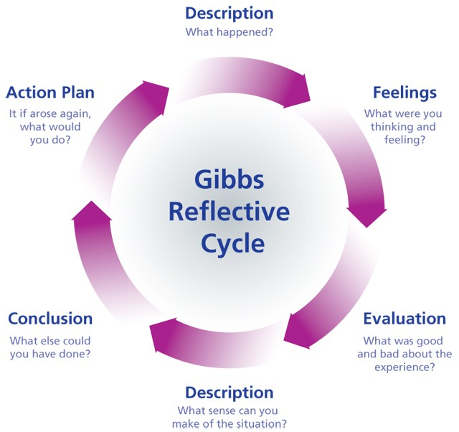
(Source: Gibb’s Reflective Cycle, 2021)

The observer was able to make detailed, descriptive notes during the incident, including who was involved, the environment and the task in hand. Secondly, take time to consider the feelings of those involved, but also, how the observer felt as what they had seen. The children involved were frustrated and not engaged in the activity and the observer could see they were almost disheartened. As an observer this was difficult to watch, as these children were full of life, but were just not ready to be sat learning at a desk, with no resources available to them to have a concrete understanding. The next step was having the time to process and evaluate the positive and negative points from the situation, and to ask questions as to why this incident may have happened, which leads to the description part of the cycle. There were a number of positives from the incident, the other children within the class were fully engaged, and taking part in the lesson. The teacher and assistant used encouraging language and positive reinforcement, modelling on a large whiteboard. But unfortunately, those with no basic understanding of the concept were left behind. This led to the question as to why these children weren’t taken to the outdoor environment, not only the small handful that found it difficult, but the whole class. As it can been seen from the research the outdoor environment can have a huge impact on a child’s holistic development. Introducing subtraction games with stones, pinecones or leaves as suggested in the literature review gives the children the hands-on experience of seeing the difference through the stages of doing. As an observer should I do this lesson again, I would look to ensure the use of the concrete, pictorial and abstract (CPA) approach and to differentiate the work from there as recommended by Johnson, 2021).
To conclude, this module has taught me exactly what a critical incident is, it isn’t something ‘critical’ as referred to, but an event or experience that can be analysed further through a range of research into the history of education, child development, theorists and also the new and existing curriculums and policies. As practitioners we generally reflect on the negative experiences and events within out practise that didn’t go as well as we had hoped or planned. However, this module had taught me that it is just as important to reflect on positive experiences, not only to improve our professional development, but to be able to share our experiences with other practitioners to help them progress also. Tarrant (2013) would insist all educational practitioners are required to take full control of their continuous and professional development to ensure best practise, which not only effects them but also the learners within their care, which links to The Teaching Standards for Wales (TES, 2017) professional learning and Innovation strand, and this is something I will strive to do.
In addition, I aim to get to know all pupils within my class and their abilities, enabling tasks to be differentiated in accordance to each individual. I aim to allowing the children access to hands on resources indoors, such as numicon, number lines etc and where possible open access to the outdoors so the children can explore new concepts with natural materials.

Reference List
Angelides, P. (2001) Using critical incidents to understand school cultures. Improving Schools, 4(1), 24–33. https://doi.org/10.1177/136548020100400105.
Barber, J. and Paul-Smith, S. (2010) Early Years Observation and Planning in Practice. London: Andrews UK. Available at: https://search-ebscohost-com.ezproxy.uwtsd.ac.uk/login.aspx?direct=true&db=nlebk&AN=467705&site=ehost-live (Accessed: 22nd October 2021).
Blatchford, S,I. et al. (2000) Researching Effective Pedagogy in the Early Years. London: Department of Education.
Bleach, J. (2014) ‘Developing professionalism through reflective practice and ongoing professional development’, European Early Childhood Education Research Journal, 22(2), pp185-197. DOI: 10.1080/1350293X.2014.883719.
British Educational Research Association (BERA). (2018) Ethical Guidelines for Educational Research. 4th Ed. London. Available at: file:///D:/Users/Gemma%20Harris-Evans/Downloads/BERA-Ethical-Guidelines-for-Educational-Research_4thEdn_2018.pdf (Accessed: 12th October 2020).
Bruce, T. (2005) Early Childhood Education. 3rd Ed. Oxon: Hodder Education.
Dallos, R. and Steadman, J. (2009) ’Flying over the swampy lowlands: Reflective and Reflexive Practice’, Reflective Practice in Psychotherapy and Counselling. Milton Keynes: Open University Press.
Daly, L. and Beloglovsky, M. (2014) Loose Parts: Inspiring Play in Young Children. St Paul: Red Leaf Press.
Department of Children, Schools and Families. (2008) Strategy framework for the Early Years Foundation Stage. Available at: https://dera.ioe.ac.uk/6413/7/statutory-framework_Redacted.pdf (Accessed 19th October 2021).
Donaldson, G. (2015) Successful Futures. Available at: https://gov.wales/sites/default/files/publications/2018-03/succesful-futures-a-summary-of-professor-graham-donaldsons-report.pdf (Accessed: 23rd October 2021).
Early Childhood Today. (2020) Pioneers in our field: Fredrich Froebel – Founder of the first kindergarten. Available at: https://www.scholastic.com/teachers/articles/teaching-content/pioneers-our-field-friedrich-froebel-founder-first-kindergarten/ (Accessed: 19th October 2021).
Early Education. (2000) Who was Fredrich Froebel? Available at: https://www.early-education.org.uk/about-froebel (Accessed: 16th October 2021).
Eisenmann, A. and Hadani, H. (2019) State of Flow: The Benefits of Child-Directed Play. Available at: https://www.thegeniusofplay.org/genius/expert-advice/articles/state-of-flow-the-benefits-of-child-directed-play.aspx#.XiTOJW52tPY (Accessed 19th October 2021).
Estyn. (2011) Outdoor learning: An evaluation of learning in the outdoors for children under 5 in the Foundation Phase. Available at: https://www.estyn.gov.wales/thematic-reports/outdoor-learning-evaluation-learning-outdoors-children-under-five-foundation-phase (Accessed 21st October 2021).
Estyn. (2019) Estyn School Report. Available at: https://www.estyn.gov.wales/system/files/2021-08/Inspection%20report%20Crwys%20Primary%20School%202019.pdf. (Accessed: 15th October 2021)
Frost, J. and Sutterby, J. (2017) ‘Outdoor Play Is Essential to Whole Child Development’, Our Proud Heritage, 2020(7), pp. 82-85. Available at: https://web.a.ebscohost.com/ehost/pdfviewer/pdfviewer?vid=1&sid=7a983ddb-1cf6-4381-af86-0e212fdbeea3%40sdc-v-sessmgr03 (Accessed 17th October 2021).
Gibb’s Reflective Cycle. (2021) [Google Image] Available at: https://www.google.com/search?q=gibbs+reflective+cycle&rlz=1C1GCEA_enGB866GB866&source=lnms&tbm=isch&sa=X&ved=2ahUKEwjkyM_9lfDzAhU3gv0HHSoFAbEQ_AUoAXoECAIQAw&biw=1396&bih=685&dpr=1.38#imgrc=aycK8j9KbY8yEM (Accessed: 27th October 2021).
Harris, F. (2017) ‘Outdoor Learning Spaces: The case of forest school’, Department of Biological and Environmental Sciences, 2018(50), pp. 222-231. DOI: 10.1111/area.12360.
Johnson, E. (2021) What is the concrete, pictorial and abstract (CPA) approach and how Do I use it in maths? [Blog]. Available at: What Is The Concrete Pict https://thirdspacelearning.com/blog/concrete-pictorial-abstract-maths-cpa/orial Abstract Approach? CPA Maths: A Guide For Primary Teachers (thirdspacelearning.com) (Accessed: 28th October 2021)
Knight, S. (2012) Forest School for All. London: Sage Publications.
Knight, S. (2013) Forest School and Outdoor Learning in the Early Years. 2nd Ed. )London: Sage Publications.
Lambert, M. (2019) Practical research methods in education an early researcher’s critical guide. Abingdon, England: Routledge.
Machan, M. (2016) ‘The historical context of outdoor learning and the role of the practitioner’, Teaching and Learning, 2016(6), pp. 1. Available at: https://eyfs.info/articles.html/teaching-and-learning/the-historical-context-of-outdoor-learning-and-the-role-of-the-practitioner-r206/#:~:text=Besides%20McMillan%20and%20Froebel%2C%20Pestalozzi%20%281746-%C2%AD1827%29%20and%20Isaacs,learning%20is%20central%20to%20understanding%20modern%20day%20practices. (Accessed: 14th October 2021).
Macintyre, C. (2001) Enhancing Learning Through Play. London: David Fulton Publishers.
McGarr, O. and McCormack, O. (2016) ‘Counterfactual mutation of critical classroom incidents: implications for reflective practice in initial teacher education’, European Journal of Teacher Education, 39(1), pp. 36–52. doi: 10.1080/02619768.2015.1066329.
McGrath, C. (2010) Supporting Early Mathematical Development. Oxon: Routledge Publications.
McInnes, K. et al. (2011) ‘Differences in practitioners’ understanding of play and how this influences pedagogy and children’s perceptions of play’, Early Years, 31(2), pp 121-133. DOI: 10.1080/09575146.2011.572870.
McInnes, K. et al. (2013) ‘The nature of adult–child interaction in the early years classroom: Implications for children's perceptions of play and subsequent learning behaviour’, European Early Childhood Education Research Journal, 21(2), pp 268-282. DOI: 10.1080/1350293X.2013.789194.
Meggitt, C. (2015) Introduction to Early Years Education and Care. Oxon: Hodder Education.
Montessori Educational Centres. (2019) The importance of outdoor play for children. Available at: https://omahamontessori.com/the-importance-of-outdoor-play-for-children/ (Accessed 19th October 2021).
Moyles, R. (2005) The Excellence of Play. 3rd Ed. Berkshire: Open University Press.
Overall, L. (2007) Supporting Children’s Learning; A guide for teaching assistants. London: Sage Publications.
Play Wales. (2020) Play policy across Wales. Available at: https://www.playwales.org.uk/eng/playpolicy (Accessed 21st October 2021).
Popova, M. (2020) How We Think John Dewey on the Art of Reflection and Fruitful Curiosity in a time of Instant Opinions and Information Overload. Available at: https://www.brainpickings.org/2014/08/18/how-we-think-john-dewey/ (Accessed: 22th October 2021).
Schon, DA. (1983) The Reflective Practitioner. New York: Basic Books.
Scottish Government. (2020) Out to Play, Practical guidance for creating outdoor play experiences in early learning and childcare. Available at: file:///D:/Users/Gemma%20Harris-Evans/Downloads/out-play-practical-guidance-creating-outdoor-play-experiences-early-learning-childcare.pdf (Accessed 21st October 2021).
Siraj-Blatchford, J. (2015) Taking play more seriously: A Montessori approach to understanding Free Flow Play. University of Plymouth. Available at: http://www.schemaplay.com/Docs/Research%20Brief%20Final%20P.pdf (Accessed: 21st October 2021).
Smith, M, K. (1999) Reflection, Learning and Education. Available at: https://infed.org/mobi/reflection-learning-and-education/ (Accessed: 27th^{th} October 2021).
Spencer, RA. Joshi, N. and Branje, K. et al. (2019) ‘Educator perceptions on the benefits and challenges of loose parts play in the outdoor environments of childcare centres’, AIMS Public Health, 6(4), pp. 461-476. Available at: https://www.ncbi.nlm.nih.gov/pmc/articles/PMC6940583/ (Accessed: 24th October 2021).
Sutton,MJ. (2001) ‘In the Hand and Mind: The Intersection of Loose Parts and Imagination in Evocative Settings for Young Children’, Children, Youth and Environments, 21(2), pp. 408-24. Available at: http://www.jstor.org/stable/10.7721/chilyoutenvi.21.2.0408 (Accessed 24th October 2021).
Tarrant, P (2013) Reflective Practise and Professional Development. Sage Publication: London.
TES. (2017). Professional Teaching Standards for Wales. Available at: PGCE Teachers' Standards (Wales, 2017) | Teaching Resourceshttps://www.tes.com/teaching-resource/pgce-teachers-standards-wales-2017-12417756 (tes.com) (Accessed: 12th October 2021).
Tovey, H. (2007) Playing Outdoors. Berkshire: Open University Press
Tripp, D. (2011) Critical Incidents in Teaching (Classic Edition) : Developing Professional Judgement. London: Taylor & Francis Group.
Unicef. (2020) How we protect children’s rights. Available at: https://www.unicef.org.uk/what-we-do/un-convention-child-rights/ (Accessed 9th October 2021).
University of Cambridge. (2020) What is Reflective Practice? Available at: https://libguides.cam.ac.uk/reflectivepracticetoolkit/whatisreflectivepractice (Accessed: 28th October 2021).

Welsh Assembly Government. (2009) Foundation Phase, Outdoor Learning Handbook. Available at: https://hwb.gov.wales/storage/fcb8539c-9be7-4883-8542-35d7b54b56f2/foundation-phase-outdoor-learning-handbook.pdf (Accessed: 10th October 2021).
Welsh Government. (2020) Curriculum for Wales. Available at: https://hwb.gov.wales/curriculum-for-wales/ (Accessed: 19th October 2021).

Appendices
Observation 1
22nd September 2021. 9.20am.
Where and When:
Year one/two classroom.
The class had finished the registration and independent tasks were being undertaken.

What happened:
The children sat at tables based on ability. There were two independent tasks for the children to par-take in, some maths questions and a sentence writing task. Child A, a lower ability child was disengaged, fiddling with items on the table, moving up and down from seat wandering around the classroom distracting other children. It raised the question as to how this activity was helping develop this child.

Areas of possible exploration:
Why was the child not engaged?
Were independent task differentiated so all children could participate?
What was the child’s home life like?
Did the child have and ALN?
Is sitting children on ability based tables good for them?
Would a morning check in board help the child express how they were feeling?

Notes:
On discussion with the class teacher this child has a disruptive homelife and there were believed to be underlaying needs, with the child moving schools a number of times in such a short period an assessment had not been completed, meaning the child wasn’t retting the possible support required.
Urie Bronfenbrenner, Albert Bandurra suggest the environment in which a child lives can have an impact on their holistic development. And additionally Abraham Maslow’s hierarchy of needs.
This led the research to question if the school could use the time first thing in the morning when other children completed the independent task for a member of staff to talk to Child A about how they were feeling, possible use of social stories to gain trust and feel that school is a safe place. Later possibly referring child for additional support through a multiagency approach, linking to the collaboration and innovation sections of the pedagogy.

Observation 2
22nd September 2021. 11.00am.
Where and When:
Year one/two classroom
After break, children were completing a literacy task, the LO was to include or add adjectives to sentences.

What happened:
On completion of a written task the children were asked to self-assess their work using a range of woodland creatures. Each creature had a different meaning as can be seen in the power point. Child B chose a rabbit because they were happy with their work, and this was stuck in their book. There is a range of research on the importance of peer and self-assessment for children, to enable them to take control of their learning. This was observed within the classroom, with children being able to openly discuss with the class teacher what they had done well and what they could improve on.

Areas of possible exploration:
How does a lower ability child or child with ALN would feel when self-assessing their work, and could it have a social and emotional detriment?
Does a MAT child automatically give themselves the ‘best’ character and not push themselves to develop a skill further?
Does self assessment work in the foundation phase?
Should young children be responsible for their own learning?

Notes:
Self assessment characters used.
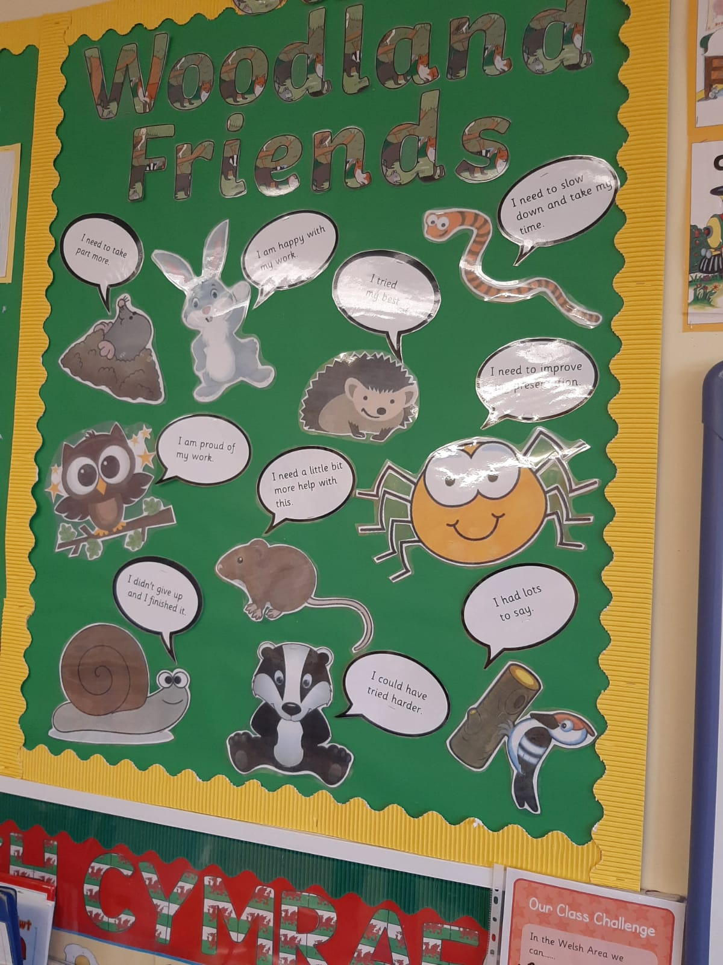

EXPERIENCE TEMPLATE

- What did you do and why?
I really enjoyed my professional experiences and took full advantage of what the school had to offer. I made sure I interacted with the children to get an insight to the schools and how the children enjoy their learning experience. I also made the most of asking questions to the teaching staff and assistants to get a clearer understanding of the day to day running of the classroom and also get a clearer understanding of the children that were in my care.
During lessons I engaged and supported children with tasks, I read with children and enjoyed seeing them enjoy their playtime, as I feel this is when the children are more relaxed and open to discussion.

- What have you learned?
I am very fortunate to have had previous experience working as a TA for many years, however it is surprising and yet exciting how schools differ. I learn so much about the school and the children in these two days and I feel I met my intended goals during my visit to the school, by getting an understanding of the ethos and day to day running. I feel I made a good first impression and am really excited to return for our further observation week before half term.

- What Next?
Is there anything you intend to do as a result of this experience? You might want to consider some of the following questions: Are there any specific actions that you will take? What would you do in similar circumstances in the future? Is there anything you intend to change? Do you have plans for any further learning or development opportunities? If so, who or what can help - using the standards, people, written resources, online materials, workshops etc? How will you share what you’ve learned?

TARGET  What area do you want to develop in your own practice? | Get a clearer understanding of the progression steps in the new curriculum and being able to link these to the previous curriculum outcomes in order to help me plan detailed but effective lessons, with clear learning objectives.
TIMESCALE  When do you want to achieve this by? | Observation week – 18th October.
RESOURCES  What do you need to help you achieve this? | I aim to print off both the outcomes and progression steps for each Aole and have them to have when planning lessons. These are available online.
SUCCESS CRITERIA/  OUTCOME  How will you judge whether it has been successful or not? What impact do you hope to see in teaching and learning? What reserach/literature is this based on? | To know if I have been successful I will have to see what my class teacher thinks of my planning. I aim to use their knowledge and experience to guide me to ensure effective planning.
MONITORING/  EVALUATION  How will you check that you have successfully achieved your target? Lesson observation? Book scrutiny? Pupil voice? | As above but also lesson observations and pupil voice to ensure t=what I am planning is happening in lessons.

