

Methods and Search Strategy Academic Poster

Student name: Somia Kausar
Student ID: 2239088
Module name: Independent Project
Module code: BMHP6020

The Impact of Family Support in Improving Mental Health Outcomes Among Adults with Chronic Conditions in the UK
01 Introduction and Research Aim  The poster summarises the qualitative systematic review methodology. It maps data search, research findings and thematic analysis to how academic rigour and transparency is maintained (Chris, 2021). It used existing literature on the Impact of Family Support on Improving Mental Health Outcomes Among Adults with Chronic Conditions in the UK.  Aim: The study aims to examine the role of family support in improving mental health and wellbeing of adults suffering from long term conditions in UK context. | 02 Search Strategy  Search Strategy in secondary research is a structured approach aimed to identify and select academic literature for a research topic it is a targeted and systematic process to make sure that the selected evidence is credible, relevant and transparent. the search strategy also helps other researchers to repeat the process considering it authentic (Chigbu, Atiku, and Du Plessis, 2023).  Key words: Long-term conditions, chronic illness, mental wellbeing, health outcomes, person-centred care and family support are the key words. Boolean (AND/OR) operators were used to refine the results.
03 Searching for Information  Information was gathered from academic resources, including Google Scholar, PubMed, Science Direct, and university library databases. Publication date, peer-reviewed status, and relevance to topic were the filters applied. (Gusenbauer and Haddway,2020). All of the papers were screened for relevance and credibility. | 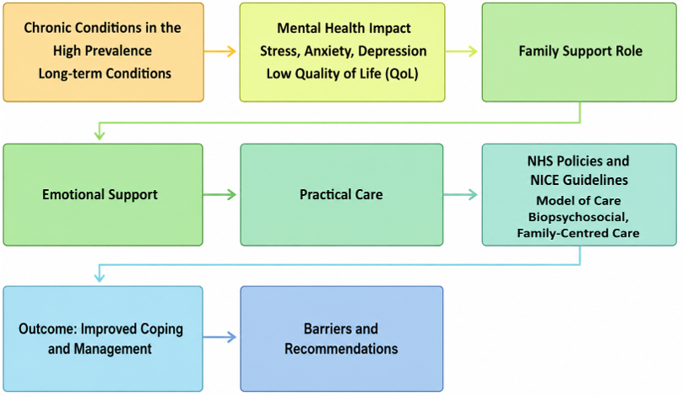  04 Picture / Graph / Visual Aid / Statistics
05 Research Validation and Analysis
To strengthen the credibility of the findings, the selected secondary resources were critically assessed for credibility (Wickham, 2020). Priority was given to peer-reviewed journals using rigorous and clear methodology. Thematic analysis was used in this study to identify recurring themes, such as the role and impact of family support in improving mental health outcomes among adults living with chronic conditions in the UK, how emotional support from family members influence mental wellbeing. Ethical concerns are maintained during research process.
06 Inclusion Criteria  - Studies published in peer-reviewed journals during 2015-2026, except published books and theories.  - Evidence supporting family support, effectiveness, of emotional support by family, socio economic factors, caregiving burden and person-centred care.  - Publications in English  - Full text articles available online | 07 Exclusion Criteria  - Older articles released more than ten years before  - Studies that do not examine adults with long-term conditions, their mental wellbeing and family support.  - Studies published on children.  - Publications that are not peer reviewed or non-scholarly articles.  - Sources published in other than English language.  - Studies for which full text is not available.
08 Ethical Considerations
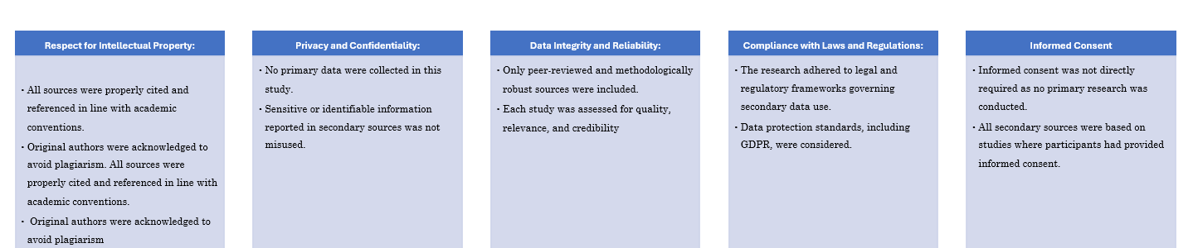
- Research ethics in secondary research is the approach to validate data without bias, misinterpretation or taken out of context. The original sources and authors are acknowledged to avoid plagiarism and academic integrity is adhered strictly during research process (Juliusson, 2025).

References
Ali, M. et al. (2025) ‘Ethics and Integrity: Essential Pillars of Research’, BioScientific Review, 7(4), pp. 01–06. Available at: https://doi.org/10.32350/bsr.74.01.
Chigbu, U.E., Atiku, S.O. and Du Plessis, C.C. (2023) ‘The Science of Literature Reviews: Searching, Identifying, Selecting, and Synthesising’, Publications, 11(1), p. 2. Available at: https://doi.org/10.3390/publications11010002.
Chris, M.J. (2021) What Information Should You Include in the Methodology? Available at: https://www.sjsu.edu/writingcenter/docs/handouts/Methodology.pdf.
Gusenbauer, M. and Gauster, S.P. (2024) “How to Search for Literature in Systematic Reviews and meta-analyses: A Comprehensive step-by-step Guide,” Technological Forecasting and Social Change, 212, p. 123833. Available at: https://doi.org/10.1016/j.techfore.2024.123833.
Morin, A. (2019) The 7 Best Mental Health Apps of 2019, Verywell Mind. Verywell Mind. Available at: https://www.verywellmind.com/best-mental-health-apps-4692902.
Naeem, M. et al. (2023) ‘A step-by-step Process of Thematic Analysis to Develop a Conceptual Model in Qualitative Research’, International Journal of Qualitative Methods, 22(1), pp. 1–18. Available at: https://doi.org/10.1177/16094069231205789.
Wickham, R. (2020) ‘Secondary Analysis research’, Journal of the Advanced Practitioner in Oncology, 10(4), pp. 395–400. Available at: https://doi.org/10.6004/jadpro.2019.10.4.7.

