Group Project PID
Project Management and research methods
Rhys Lewis (1802146)
2019
Contents
Background 1
Objectives: 1
Scope: 2
Features the project will have: 2
Features the project should have: 2
Features the project could have: 2
Features the project won’t have: 2
Constraints: 2
Authority: 2
Project Sponsor: 2
Project Manager: 3
Stakeholders: 3
Project Organization Chart/Structure: 3
Resources: 4
Team Members: 4
Budget: 5
Time: 5
Key Points 5
Assignments: 5
References 6

I declare that this assignment is all my own work and that I have acknowledged all materials used from the published or unpublished works of other people. All references have been duly cited.

Background

Objectives:
By the end of this process, the team hopes to create a mobile app which, using a weighing scale connected by Wi-fi, awards points for creating meals. Pictures of the meal can then be uploaded to social media, where you can be awarded more points by receiving likes from others, who can then try the recipes for themselves. More recipes are locked behind point thresholds, provoking the user to play more often. This app will entertain those who dislike cooking by gamifying it and rewarding good performance.

Scope:

Features the project will have:
At least 1 recipe, spaghetti bolognese, this dish was selected as it’s easy to prepare with a few complexities.
Voiced menus/recipe steps for accessibility.
Social Media integration.
Working Scale peripheral.

Features the project should have:
3 fully implemented recipes.
Extended Accessibility options (Font size changing, colour-blind options etc.)

Features the project could have:
Animations for each step of the recipe.
Dark mode for better visibility at night.

Features the project won’t have:
Multiple menu layouts/menu themes.
Custom Recipes.

Constraints:
The budget for the project is set to the bare minimum which will be used for essentials. The following is what we plan on purchasing with the money given.

HX711- £7.99 [1]
Arduino Uno R3 - £17.14 [2]
Component kit - £13.99 [3]
ESP8266 - £5.99 [4]
Battery - £15.99 [5]
USB to USB cable - £2.40 [6]
Power cable for battery - £4.79 [7]
TOTAL: ~£68.29

The timescale, while being lenient is quite short due to assignment submission deadlines. This task will have to be prioritised over others to guarantee success.

Authority:

Project Sponsor:
James Williams and University of Wales Trinity Saint David are the main sponsors of this project as they are supplying the team with a small budget to help make this idea a reality.

Project Manager:
Rhys Lewis (The Author) is the team manager of the project, through this, he can oversee the project to make sure everything is run smoothly while also helping other team members with their struggles or development issues.

Stakeholders:
The stakeholders in this product are as follows: -
The team members: As the team behind the product, the university grades received by the team will be massively affected by the success of the product. If the product fails to be developed, the team will receive low marks for the module.
Scale suppliers: The stores that sell the scales developed by the team will lose money if the scale fails to sell.
App Store: The app store hosting the app stands to gain money if the app succeeds through in-app sales. The App does not stand to lose much if the app fails.
Customers: App users may be relying on our app as their main form of cooking so failure could result in them losing a tool that they enjoyed using.
It is possible that, in the future, objectives could fall out of scope which would lead to an overall less desirable product, possibly resulting in either a loss of interest or a complete loss of stakeholders. It is therefore crucial that the team makes sure that the stakeholders are appeased.

Project Organization Chart/Structure:

Gantt Chart:
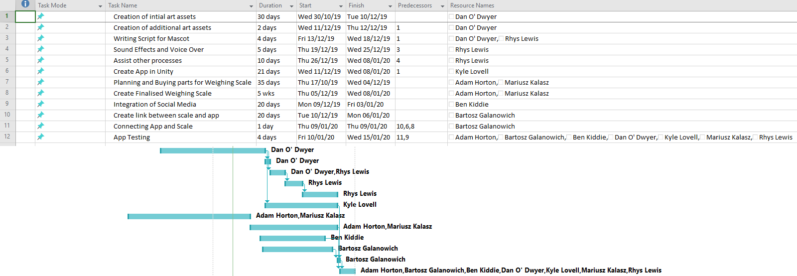
The Gantt chart shown here will be used to help the team organise where each task fits into the greater whole. The chart lasts up until the deadline for the prototype demonstration and the deadlines have been extended very slightly in order to provide a margin for error for every team member. If events proceed according to the chart all the tasks will be completed in time and a fully functioning prototype will be ready for demonstration by the 15th of January.

Network Diagram:
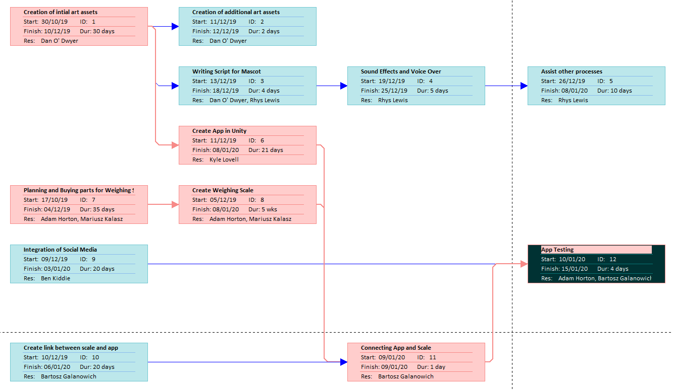
This is a network diagram of tasks; the red boxes represent the critical path of the project. If a process in the critical path is delayed, the entire project is delayed. The author’s tasks mostly consist of off-critical tasks as his work can be simply slotted into the work upon completion.

Resources:

Team Members:
Below is a list of the team members and the skills they contribute to the team.
Rhys Lewis (The Author): Experienced Voice Actor, confident public speaker, comfortable leader and listener, can easily prioritise tasks in order of importance to maximize efficiency.
Kyle Lovell: Problem solving, good communication skills, skilled coder.
Dan O’Dwyer: Skilled Artist, creative mind.
Adam Horton:
• Willing to go the extra mile for the team/company
• Is willing to assist with other areas within the company to ensure maximum efficiency/production of our product.
• Can organize tasks from most critical to least and allocate appropriate time for each task/objective
• Will remain focused and reliable to the work at hand
• Will ensure that all work is present and correct before any deadline/submission date
Mariusz Kalasz: Good problem solving, communication, decent organisation, a good understanding of the topic.
Ben Kiddie: Good deliberator, innovator and collaborator
Bartosz Galantowicz: Confident programmer.

Budget:
With just enough budget to fulfil our design requirements, the team cannot afford to purchase anything that isn’t needed. Thankfully, we have taken precaution and only ordered the essentials. If future resources are needed, they will need to be funded out of pocket.

Time:
Due to the nature of this task being an assignment, time is very limited. The author has attempted to make the best use of the time given by constructing a Gantt chart for the team, allowing them to properly coordinate their efforts to finish the product on time.

Key Points

Assignments:
- The project will be finished in time
- The project’s hardware (weighing scale) and software (app) will be linked
- The app will be completed in the Unity engine.
- The learning curve of developing touch screen applications on unity will be a problem.
- Developing a method to connect hardware and software will be a challenge.

References
[1] Load Cell 5KG Amplifier HX711 Breakout, Digital Portable Kitchen Scale Weight Sensor AD Module Weighing for Arduino Raspberry Pi, DIYmall: https://www.amazon.co.uk/Amplifier-Breakout-Portable-Weighing-Raspberry/dp/B07L81BQB6/ref=sr_1_3?crid=6B8217TGTHK1&keywords=hx711&qid=1573648280&sprefix=HX%2Caps%2C171&sr=8-3
[2] ARDUINO UNO REV3 store page: https://store.arduino.cc/arduino-uno-rev3
[3] ELEGOO Upgraded Electronics Fun Kit w/Power Supply Module, Jumper Wire, Precision Potentiometer, 830 tie-points Breadboard for Arduino UNO R3, MEGA 2560, Raspberry Pi, STM32, Datesheet Available: https://www.amazon.co.uk/ELEGOO-Electronics-Potentiometer-tie-points-Breadboard/dp/B01LZRV539/ref=asc_df_B01LZRV539/?tag=googshopuk-21&linkCode=df0&hvadid=310818960639&hvpos=1o1&hvnetw=g&hvrand=8213789422984004224&hvpone=&hvptwo=&hvqmt=&hvdev=c&hvdvcmdl=&hvlocint=&hvlocphy=1007460&hvtargid=pla-562517395362&psc=1
[4] IZOKEE ESP8266 ESP-01 Serial WIFI Wireless Transceiver Module with USB to ESP8266 Adapter for Arduino UNO R3 Mega2560 Nano Raspberry Pi: https://www.amazon.co.uk/IZOKEE-Wireless-Transceiver-Mega2560-Raspberry-ESP-01-USB/dp/B07D388RX6/ref=sr_1_5?adgrpid=52880545386&gclid=CjwKCAiA8K7uBRBBEiwACOm4d_u7YMIYiB1Juii3pShfwe7WTsMg1G49lTL9miHUkhXVLfXCrTKSvBoCxEgQAvD_BwE&hvadid=259080529370&hvdev=c&hvlocphy=1007460&hvnetw=g&hvpos=1t2&hvqmt=e&hvrand=15478815179281125352&hvtargid=aud-612189424446%3Akwd-300973287586&hydadcr=28149_1724799&keywords=esp8266+module&qid=1573649283&sr=8-5
[5] HETP Power Bank, Portable Charger 25800mAh [Newest Black-Red Design] High Capacity Power Banks with 2 USB Ports External Battery Pack with 4 LED Lights for Smart Phones,Tablet and Other Devices: https://www.amazon.co.uk/HETP-Portable-25800mAh-Black-Red-Capacity/dp/B07W5YG32K/ref=asc_df_B07W5YG32K/?tag=googshopuk-21&linkCode=df0&hvadid=383990402380&hvpos=1o1&hvnetw=g&hvrand=3140772155848515769&hvpone=&hvptwo=&hvqmt=&hvdev=c&hvdvcmdl=&hvlocint=&hvlocphy=9045394&hvtargid=pla-828711382722&psc=1&tag=&ref=&adgrpid=81030823329&hvpone=&hvptwo=&hvadid=383990402380&hvpos=1o1&hvnetw=g&hvrand=3140772155848515769&hvqmt=&hvdev=c&hvdvcmdl=&hvlocint=&hvlocphy=9045394&hvtargid=pla-828711382722
[6] C2G 1 Metre USB 2.0 A Male to A Male USB Cable, 480 Mbps High Speed Data Transfer Lead: https://www.amazon.co.uk/C2G-Metre-Cable-Speed-Transfer-Black/dp/B001U3ZP0Q/ref=asc_df_B001U3ZP0Q/?tag=googshopuk-21&linkCode=df0&hvadid=205235603981&hvpos=1o1&hvnetw=g&hvrand=17198976203137742944&hvpone=&hvptwo=&hvqmt=&hvdev=c&hvdvcmdl=&hvlocint=&hvlocphy=1007460&hvtargid=pla-464700947979&psc=1&th=1&psc=1
[7] USB to 5.5mm Power Cable - Type N Barrel - 1m: https://www.startech.com/uk/Cables/USB-2.0/USB-Adapters/1m-USB-to-Type-N-Barrel-5V-DC-Power-Cable-USB-A-to-5mm-DC~USB2TYPEN1M

