Intercultural Competence Report

Student name: Ana Maria Stoica
Student number: 2210328
Lecturer name: Giulia Chifari
Module code: BMIH5003
Module name: Foreign Languages & Cultural Awareness
Word count: 1429

Executive Summary
The cultural awareness is an important factor in the success of the business. It also helps in understanding the dynamic beliefs and values of culture. The report has provided good information regarding the cultural values and leadership in Italy. The leader in the organisation should have proper information regarding the culture of the country. The General Manager of “Diversity Hotel & Spa” can perform effectively in Italy because it has analysed the cultural values and leadership in Italy.

Table of Content
Introduction 4
Main Body 5
Conclusion 8
Recommendations 9
References 10

Introduction
Observing the ever-changing values and principles of many cultures is referred to as cultural awareness. Since workers in the hotel industry interact with people from many cultural backgrounds which make it very important to have cultural sensitivity (Litmos Heroes, 2019). Additionally, collaborating and working with individuals from diverse cultures requires cultural knowledge. Therefore, it is crucial to facilitate communication and the sharing of accurate information, particularly in hotels (Wang and Chin, 2020). The Diversity Hotel & Spa, located in London has been planning to start its operations in Italy's hospitality industry because the rate of inbound and international tourism is at its peak within the nation.

Main Body
The culture of the nations has a big contribution to the hospitality business operating within their geographical boundaries since it effectively assists in luring international visitors and investors to financially invest in the country's hospitality sector. Italy as a country is renowned for its cultural heritage due to their rich history which dates back to Roman Empire. People in Italy prefer more equality and decentralised power. In Italy, there is a more individualistic culture people prefer to do their tasks on their own. They are also highly success-oriented people and always try to achieve success. People in Italy are not very comfortable in ambiguous circumstances. Further, since the country is previewed as the place which is the hub of Catholicism, it attracts many spiritual travellers to visit Italy for their spiritual journey (Christiansen et al., 2020). Additionally, there are various tourist destinations such as Milan, Rome and Venice, which are popular all across the world due to their cultural significance and scenic beauty. Therefore, as per the data of Ceicdata (2023), the total number of inbound visitors in Italy for the financial year of 2022 was nearly 50 million.

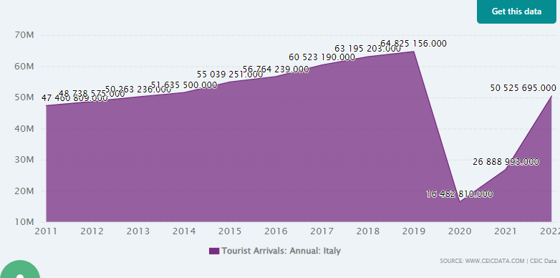
Figure 1: No of inbound Tourist in Italy
(Source: Ceicdata, 2023)

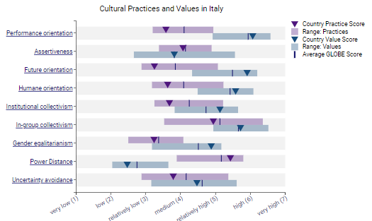
Figure No.2: Italy’s Cultural practices and values
(Source: Globeproject, 2023)
Cultural practices and values play a major role in the performance of the organisation (Maheshkar and Sharma, 2018). This helps in developing the culture of the organisation which helps in employee retention. As per the Globe project, it shows that in Italy people are much more performance-oriented and value performance. The reward system is one of the effective methods that can be used by the general manager. This will help them to manage the employees in the organisation properly. Further, it is also found that the degree and value of assertiveness is medium in Italy. People communicate with each other in a short, general manager in such a situation can just use a few sentences or words while communicating. People in Italy are motivating other people's initiative in the country and also collaborate more to complete the task. For example, “Best Western” is an organisation which promotes more collaboration (Bestwestern, 2023). It is also found that the people in Italy are not the future orientation but value them, in such a situation the General managers might face some problems in managing the people. People with low future orientation prefer more gratification. In such a situation, the general manager needs to satisfy their present needs. They need to develop short-term goals which will help in treating the employees. The degree of human orientation is also relatively low, which means the person is not having good relationships with other people. General managers in such a situation need to provide their employees with clear expectations.

Leadership visualisation
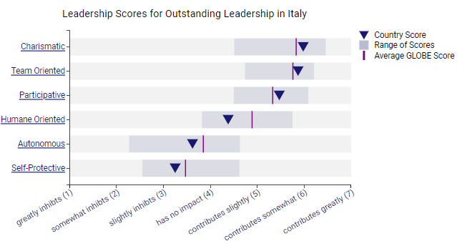
Figure No.3: Italy’s leadership scores
(Source: Globeproject, 2023)
Leadership refers to the practice of leading a group of people towards the targeted goal of a team (Abramson and Moran, 2018). The globe project shows that the people in Italy prefer a more charismatic leadership style. The charismatic leader always influences and motivates the employees (Spoelstra, 2019). The general manager of “Diversity Hotel & Spa” can use the charismatic leadership style to motivate the employees in the Italy market. They should be influential to their team members in the organisation. Team-oriented is also a leadership style where the team leader focuses more on the development of the team. (Ayuni et al., 2023) They always create opportunities for their team members in the organisation. The general manager of the “Diversity Hotel & Spa” can always provide a career development opportunity. It is one of the major factors of motivation of employees; employees get motivated when they are provided with more career development and personal development opportunities. The global project has also shown that the participative leadership style is preferred more in Italy. It is a leadership style where leaders always encourage their team members to contribute to the decision-making (Wang et al., 2022). General Managers can also use this leadership style because it will help in understanding the demand of the Italy market.
Cultural intelligence is important for hotel personnel because it helps in recognising and adapting to the culture of the place where they are working. Such kind of activities helps in increasing the customer satisfaction levels. Cultural sensitivity is also important because it helps in being aware of cultural differences and similarities between people. Hotel personnel with good knowledge of cultural sensitivity can create a more harmonious and inclusive environment by welcoming their guest from different cultures and backgrounds.

Conclusion
Culture refers to the beliefs, behaviours and values which influence a person. The culture and customer of Italy is good and it is favourable for the tourism business to operate effectively. People in Italy are performance-oriented in such a situation general manager of “Diversity Hotel & Spa” can get skilful employees in the organisation. Further, it also showed that charismatic leadership will be effective in implementing and leading the whole team towards the targeted goal and objectives of the organisation.

Recommendations
- Providing valuable insight into cultural awareness to hospitality employees would effectively assist the organisational managers in successfully educating employees and improving their knowledge (Darvishmotevali and Altinay, 2022).
- Further, being self-aware of the needs and requirements of hospitality workers would effectively inspire and motivate hotel staff to perform at their level best.
- To effectively establish a strong connection with the hotel staff, the organisational leaders and managers have to focus on dividing power adequately and measure the overall activities of employees through effective communication (Krizanova et al., 2019).
- To effectively boost the morale, involvement and sense of belonging among employees, the management of Diversity Hotel & Spa can inspire them to take part in the overall decision-making.
- Since there is less assertiveness, managers might search for more collaborative decision-making (Karami et al., 2023). As a result, the manager must establish attainable goals that will inspire the staff.

References
Abramson, N.R. and Moran, R. (2018) Managing Cultural Differences: Global Leadership for the 21st Century. 10th Ed. Abingdon: Routledge.
Ayuni, S., Kusumawati, D.A. and Wasitowati, W., (2023). TEAM ORIENTED LEADERSHIP: A NEW APPROACH TO MOTIVATE SALESPERSON. Fokus Ekonomi: Jurnal Ilmiah Ekonomi, 18(1), pp.93-110.
Bestwestern, B. (2023). Leadership Team. [online] www.bestwestern.com. Available at: https://www.bestwestern.com/en_US/about/leadership-team.html.
Ceicdata, C., (2023). Italy Visitor Arrivals Data. Available at: https://www.ceicdata.com/en/indicator/italy/visitor-arrivals (Accessed: 5 October 2023).
Christiansen, B., Branch, J.D. and Karmowska, J. (2020) Cultural Factors and Performance in 21st Century Businesses. Hershey : IGI Global.
Globeproject, G., (2023) Results - Italy GLOBE Project (no date) GLOBE Project. Available at: https://globeproject.com/results/countries/ITA?menu=country#country (Accessed: 7 November 2023).
Litmos Heroes (2019) Cultural Awareness in Hospitality [video]. Available at: https://www.youtube.com/watch?v=Kr1-32f4jaE (Accessed: 24th August 2023).
Maheshkar, C. and Sharma, V. (2018) Handbook of Research on Cross-Cultural Business Education. Hershey: IGI Global.
Spoelstra, S., (2019). The paradigm of the charismatic leader. Leadership, 15(6), pp.744-749.
Wang, Q., Hou, H. and Li, Z., (2022). Participative leadership: a literature review and prospects for future research. Frontiers in psychology, 13, p.924357.
Wang, S. and Chin, T., (2020). A stratified system of knowledge and knowledge icebergs in cross-cultural business models: Synthesising ontological and epistemological views. Journal of International Management, 26(4), p.100780.

