Become a trainer!
Dog A.I.D is an outstanding charity. They train multiple of dogs to change disabled people's lives. Their charity exists on the commitment and enthusiasm that their dedicated volunteers bring to the charity.

If you are a dog lover with a passion for making a difference dog A.I.D is looking for talented dog trainers who are dedicated to reward-based training methods. If anyone has spare time and would like to use your expertise to a positive impact that would change lives of disabled individuals in your community, then dog A.I.D is the one to investigate if you would like to make a massive difference and give people the life, they can have weather that’s going outdoors more or just day to day activities. Your commitment and effort can go a long way to change someone’s confidence and make them feel a lot safer when going out and doing activities.

By joining their team, you will have the opportunity to become a part of a life changing mission. Dog A.I.D believe in the power of dogs to enhance the independence and quality of life for those who are in life changing or physical disabilities. They have reward-based training where they can unlock all the potential of these extraordinary animals, which will be enabling them to become more reliable companions and invaluable support for the charity and those who need help.

If anyone is interested in becoming a dog trainer for the organization of dog A.I.D, you can go to their website where they would like you to just take a minute out of your day and fill in an expression of interest form. Once you have filled in the form, your submission will then allow dog A.I.D to gauge your experience and they will then determine if you are a perfect fit for their program. Dog A.I.D value trainers who have a deep understanding of reward-based training techniques and a genuine commitment to the well-being of both dogs and humans.
Trainer’s story:
This trainer applied to be a volunteer with dog A.I.D in 2014 and was absolutely thrilled when was accepted. They mentioned that “it’s just brilliant” and they absolutely love their role as a volunteer trainer with dog A.I.D. they also suggested that if you want to be a volunteer trainer with dog A.I.D then you will need compassion, empathy, patience, positive communication skills and solid practical and theory knowledge of positive. They mentioned that it will not disappoint you and it is an experience of a lifetime to help someone be free and you will not regret it, so it is worth to try it if interested about it. this trainer gained experience in the world of training dogs and handling them, she eventually set out on her own as a dog trainer. She started working part time from village halls and community centres building on her own experiences from dog A.I.D. she then started working full-time running her own dog business. She absolutely loves all training sessions in her clients home and she even takes her tasks further by trips out to the local towns, garden centres and cafes. She also does online zoom calls with clients which is extremely helpful plus she loves the online learning. This charity had a massive impact on this trainer’s life, from training with dog A.I.D to starting her own business. This charity is outstanding with the amount of support they give and help so many people in their own way.

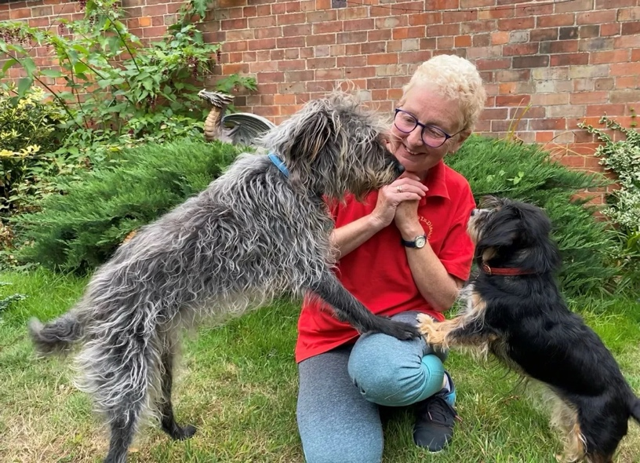

Case studies
Talya and Coby:
Talya is at university where she is studying veterinary nursing. She has a range of medical conditions including EDS (Ehlers-Danlos syndrome) and POTS (postural tachycardia syndrome). She explains that no day can be a normal day for her as she is frequently in chronic pain and suffers from blackouts and funny turns that involve her to have hot flushes, shakes, loss of vison and heart palpitations. Her health affected her from an incredibly early age when she had to give up various sports that she loved. Talya got Coby with the idea that he might be able to be her assistance dog. She joined the dog A.I.D programme and within 6 months of joining them Coby was then her fully-fledged assistance dog. He brings her medication multiple times a day as well as in emergency situations. He can also find her phone, take her bottles of water, and pick up almost any item she drops. She also mentioned that Coby can take her socks of, and he performs deep pressure therapy for pain relief and joint relocation. if Talya has a funny turn he will continuously paw her leg to alert her. She also feels a lot more confident going out alone and not needing to rely on other people as much now she has Coby. Talya also stated that “I owe my new lease of life to this charity. I am so lucky to be part of a wonderful community of clients and trainers who support each other through all the highs and lows.”



Ruth and willow:
Ruth suffers from EDS (Ehlers Danlos syndrome), which causes multiple systemic problems throughout her body. EDS is a rare group of genetic connective tissue disorder which effects the collagen in every part of the body. Her condition means that daily life is harder than most and she must rely heavily on family members, friends, and carers to do the littlest of things. Ruth and willow become one of the fastest to qualify with dog A.I.D. they completed all three levels to full qualification in under 5 months, which is amazing. Willows tasks were so varied, from opening and closing the doors, helping ruth get undressed and taking the washing out. In June ruth suffered from a burn and collapsed in her kitchen to wake up with willow lying on her chest with her phone in her mouth, ruth was then able to ring the ambulance, without willow being there to help this could have gone a completely different direction. Ruth stated that “willow is not only my assistance dog, but she is also my real-life hero too.” Now she has willow by her side everything is possible, she can be so much more independent with tasks that other people had to do for her. Ruth is so grateful that dog A.I.D is even a thing, she now has a new lease of life with her best friend willow by her side. She also stated that “I can’t change the future or my illness, but what I do know is that whatever happens I’ll be okay as I have willow by my side, and we are an unstoppable team.” In 2019, willow was honoured with a “shining world heroine award for the life changing difference she has made to Ruth’s life”.

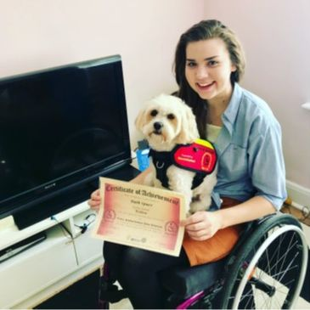
Evaluation:

- How does your blog contribute to the marketing of your charity?
Just raising awareness about the dog, A.I.D charity and what is happening around us and how much people suffer from disabilities and without this charity they would not have half the help they do right now. Everyone can donate if they would like, the littlest bit of money will help towards this charity, and it is life changing.
- who is your target audience?
My target audience is those who benefit from the dog A.I.D charity, people who would like to donate to this amazing and outgoing charity and people who generally need help like all their clients, a lot of people might need this help but are too scared to reach out but dog A.I.D is such an outgoing charity who have the power In them to help anyone suffering and give them the best life and confidence needed.
- what was your objective of your individual post?
My objective for this post was just to raise awareness to the world and to let people know how much other people are struggling and a little donation would mean so much to this charity to keep making this world a better environment for disabled people who need the help.
- who do you think would read this post?
Personally, I think a lot of young adults and teenagers would read this post as its full of interesting information and some parts can be a bit emotional, hopefully this reaches the right people, and they can have a good think about what they have read and might want to donate to this charity to help.
- How would you engage the audience with your blog posts?
I think by me adding lots of interesting information and pictures the audience will be intrigued with my blog posts.
- how will I measure the effectiveness of my blogs?
I will measure the effectiveness of my blogs by seeing how the audience responds to them.

https://dogaid.org.uk

