Changemakers: Creativity and Value Creation

Name: Adam Sadiq

Student number: 1912209

Module code: BMHP5014_BIRM

Lecture’s name: Dr Azora Hurd

Assignment Title: E-Portfolio evidence of learning comprising of 4 separate items

References

Iati,M. (2021) More experts now recommend medical masks. Good ones are hard to find. (WEB): Why the U.S. still has a shortage of N95 masks - The Washington Post (Accessed 25/6/21)

Catalin, M et,al (2020) Filtration Efficiency, Effectiveness, and Availability of N95 Face Masks for COVID-19 Prevention (WEB): WEB): Why the U.S. still has a shortage of N95 masks - The Washington Post (Accessed 25/6/21)

Task 6

Dear whom it concerns,
I am writing this letter to bring to attention, I have been working hard on a new project. The project I am working on is N95 masks, the reason why I thought this project is beneficial and will become successful is due to pandemic Covid-19, Masks are in demand as society are wearing masks on a regularly as they are expected to wear them following the outcome of the new laws and restrictions. This project I have been working on will become remarkably successful in the future as it will benefit society and many businesses for example Health care sector (NHS), care working sector, schools and many more. The reason why It will benefit businesses is because these masks are in high demand at the moment as health care sectors are in shortage of mask as majority of the society are wearing masks as it is the new law. Not only that these masks are so different to all the other masks for example quality and material, but these masks are also long lasting so society and health care sectors can wear them longer to the normal mask. That beneficial alone will make society buy these masks rather than the other ones as it is cheaper in the long run. Overall, by explaining how important these masks will be to society and businesses and this project will definitely be accomplished, profitable, popular the reason given above states it all, I was hoping that you can support my project by funding towards this project to start the success.
Please do not hesitate to get in contact if you any questions. Looking forward hearing from you soon.

Your sincerely
Adam Sadiq

Task 3:

Hello everyone, First I want to say a big thank you for coming today to support my new project, which is the N95 masks. They are several reasons why I started this new project for example, helping NHS, they are more efficient which will benefit businesses and society and most importantly cheaper in the long run.
Ok let me get straight to the point, these masks are so different to all other masks, and many people ask how?
Well, first of all these masks are reusable so no more throwing them in a bin after a couple hours, they are long lasting you can wear them up to 24 hours and then put them straight in the wash and wear them again… how great is that? This is money saving product and no more wastage why wouldn’t you buy it!
If that is not enough for you to try this mask out then I think this will help you make your decision, these masks are more breathable, comfortable, and wearable.
Having a mask on all day especially them who work in Health care sector and educational sector, you need to be always comfortable, and these masks are easy to breath out from and are super comfortable compared to the ordinary masks.
Finally, and most importantly, we are going through at the moment of shortage of mask so I think these masks will be a great seller and are affordable price which will help make things less complicated by defaulting the shortage.
Thank you for listening, go and get your masks!

N95 Mask MMMASMAMmask masmasks

Task 5

29th of July 2021 at 6pm in Birmingham more detail please contact me on 07775998954.

Please attend to our conference to hear about our amazing new product-The N95 mask! Do not miss out…

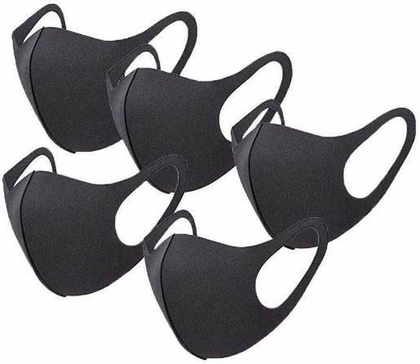
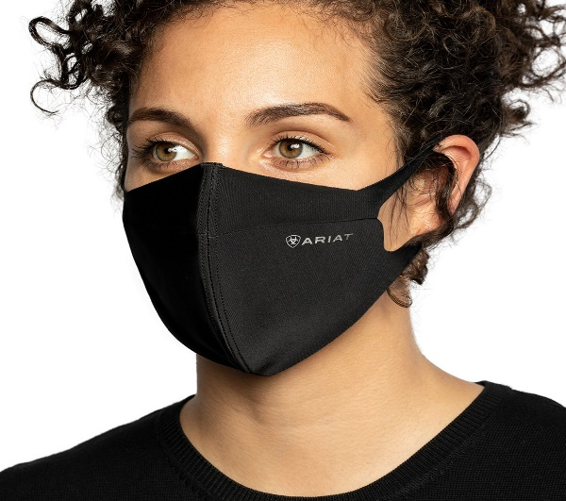
Things we will be discussing during this conference:

The beneficial of these masks to Society and businesses.

How long do these masks last?

Why they are better than other masks?

Where there available from?

Task 1
Catalin et. Al. (2020) states The normal grade mask that are available to public the expiration date is short however, the N95 mask have shelf life up to 11 years.
Lati (2021) suggest Due to the shortage of N95 masks, doctors and nurses are having to wear their masks over the recommended time period as they are no fresh masks available.
The reason why the N95 face mask are essential is because the current face masks that are availabe to the public are not actually protecting indivduals from the Covd-19 or any aother forms of infection which is vital for the Health sector as they are coming in contact with indivduals who are infected on a daily basis.
I am developing a campaign on a shortage of grade N95 masks which I will be promoting and giving reasons why this mask is important to society and why I am so passionate about it.
Shortage of grade N95 (face mask)

