
Unsafe Staffing and Skill Mix Failures at Mid Staffordshire NHS Foundation Trust (2005–2009)

Student Name and ID: Dhartiben Chauhan (2431584)
Programme: MSc Public Health and Social Care in Practice
Module Title: Quality Assurance and Service Improvements
Module Code: LCHS7006
Assignment Title: Component 2 – Service Improvement Report
Lecturer: Shepherd Ziko

Service Improvement Report:

Contents
1. Introduction 2
2. Root Cause Analysis and Strategic Quality Evaluation of Unsafe Staffing at MSFT 3
2.1 Root Cause Analysis of Unsafe Staffing and Poor Skill Mix at MSFT 3
2.1.1 Fishbone Diagram Analysis: Categories of Root Causes 4
• Leadership and Governance: 4
• Workforce and Staffing: 5
• Clinical Processes: 5
• Communication and Safety Intelligence: 5
• Organisational Culture: 5
2.1.2 5 Whys Analysis: Drilling Down to the Core Drivers 6
2.1.3 Donabedian Structure–Process–Outcome (SPO) Analysis 6
Section 2.2 - Analytical Approaches: 7
2.2.1 SWOT Analysis 7
Benefits 8
Challenges 9
Prospects 9
Barriers 9
2.2.2 Supporting PESTLE Analysis 10
3. Recommendations 11
Recommendation 1: Restore Safe Staffing Levels Using Acuity-Based Planning 11
Recommendation 2: Strengthen Skill Mix and Clinical Leadership 11
Recommendation 3: Implement a Structured PDSA Cycle to Test and Scale Improvements 12
Recommendation 4: Apply Lean Principles to Redesign Unsafe Processes 12
Recommendation 5: Strengthen Governance, Escalation and Safety Intelligence 13
Recommendation 6: Encourage a Safety-Oriented and Psychological Security 13
4. Conclusion 13

Introduction

Mid Staffordshire NHS Foundation Trust represents Among the leading serious NHS quality shortcomings, with events from 2005–2009 exposing major weaknesses in governance, organisational culture, and patient safety (Francis, 2013).
(The Guardian, 2013)
Investigations showed that hundreds of patients experienced unsafe conditions, poor basic care, missed observations and delays in escalation (Healthcare Commission, 2009). Unsafe staffing and a weak skill mix were key drivers of this breakdown, reducing MSFT’s ability to provide safe and person-centred care (Healthcare Commission, 2009; The King’s Fund, 2013). Component 1 confirms that around 150 staff posts were removed without risk assessment, creating operational gaps, weakened supervision and more missed care.
Unsafe staffing has long been recognised nationally as a critical determinant of hospital quality, with NHS England emphasising the importance of ensuring the qualified workforce, at optimal locations, with relevant expertise to ensure safety and prevent avoidable harm (NHS England, 2014). Evidence from the Francis Inquiry (2013) showed that MSFT prioritised financial performance and its application for Foundation Trust status over safe staffing levels, leading to understaffed wards where high patient acuity was poorly matched to workforce capacity.
The Healthcare Commission (2009) similarly found that essential nursing tasks-including hydration, nutritional support, toileting, and routine monitoring-were frequently missed due to insufficient staffing and weakened skill mix, illustrating how structural deficits translated into unsafe care processes. This represents a major public health concern because staffing deficits are directly linked to higher mortality, increased complications, delayed recognition of deterioration and reduced patient satisfaction (Aiken et al., 2014; Griffiths et al., 2018).
Unsafe staffing is not only an organisational issue but a wider national concern linked to workforce planning, patient safety regulation and the balance between quality and efficiency (CQC, 2022). The CQC recognises staffing levels as central to judging whether services are safe, effective, and well-led (CQC, 2022). At MSFT, insufficient staffing harmed patient care and reduced the ability to report incidents or raise concerns, creating system blindness to worsening conditions. As noted in Component 1, the normalisation of poor practices and absence of clinical leadership further embedded this decline, making poor outcomes increasingly inevitable.
This report critically examines unsafe staffing and poor skill mix as the core quality problems behind MSFT’s failures. Using the Fishbone Diagram, 5 Whys, and Donabedian model, it identifies the root causes of staffing-related issues. SWOT and PESTLE analyses are applied to show how these problems fit within broader organisational and policy contexts. Finally, evidence-based recommendations are developed through PDSA and Lean methods to guide sustainable staffing improvements across NHS settings. Overall, the report aims to show how workforce deficits compromise care quality and how structured quality-improvement tools can strengthen safe and resilient service delivery.

2. Root Cause Analysis and Strategic Quality Evaluation of Unsafe Staffing at MSFT

2.1 Root Cause Analysis of Unsafe Staffing and Poor Skill Mix at MSFT
Unsafe staffing and poor skill mix were major structural failings at MSFT from 2005–2009, leading to serious harm and poor-quality care (Francis, 2013). Using key methods used for investigating underlying issues include the Ishikawa (Fishbone) Diagram and the Five Whys technique alongside Donabedian’s SPO model-helps explain how these staffing deficits developed, how they interacted with organisational weaknesses and how they produced unsafe outcomes. Evidence from the Healthcare Commission (2009), the Francis Inquiry (2013) and Component 1 shows that understaffing, reduced skill mix, weak leadership, and limited safety intelligence collectively drove MSFT’s failure.

2.1.1 Fishbone Diagram Analysis: Categories of Root Causes
The Fishbone Diagram is a common healthcare tool for identifying systemic causes of adverse events (Carayon et al., 2014). Applied to MSFT, it reveals five linked root-cause domains: leadership and governance, workforce and staffing, clinical processes, communication and safety intelligence, and organisational culture. These mirror Component 1 findings, which showed major staff cuts, weak supervision, and ongoing failures to act on mortality alerts and complaints.
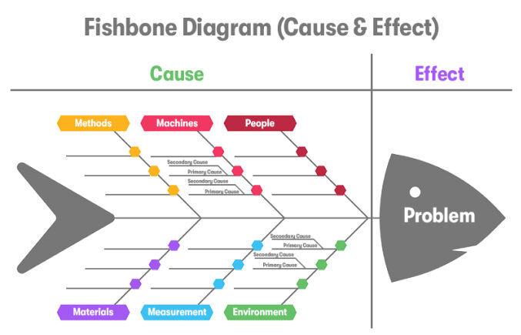
(Qodo, 2025)
- Leadership and Governance:
Leadership and governance failures were central, as the Board prioritised financial targets and Foundation Trust status over maintaining safe staffing (Francis, 2013). Board records from 2005–2007 show a strong emphasis on cost-cutting instead of patient safety, resulting in reduced staffing capacity (Healthcare Commission, 2009). The lack of senior clinical leadership further weakened oversight and left frontline staff without proper support or escalation routes.
- Workforce and Staffing:
Between 2004 and 2007, approximately 150 posts-including experienced nursing roles-were removed, with no risk assessment to evaluate the impact on patient care (Healthcare Commission, 2009). My component 1 highlights weakened skill mix and an absence of senior nurses on shift as critical contributors to missed care episodes and unmonitored patient deterioration.
- Clinical Processes:
Understaffing reduced the capacity to undertake basic care processes such as hydration, nutritional support, routine observations, and timely escalation. These omissions represent classic indicators of “missed nursing care,” a validated predictor of morbidity and mortality in acute settings (Griffiths et al., 2018).
- Communication and Safety Intelligence:
Safety and risk information-including high mortality rates, staff survey concerns, and complaints-was not adequately escalated. Leadership often dismissed mortality data as “coding errors,” illustrating a failure to interpret or act on critical warning signs (Healthcare Commission, 2009).
- Organisational Culture:
The organisational culture discouraged staff from speaking up, as highlighted by the Francis Inquiry (2013). Frontline staff did not feel safe reporting risks, allowing poor care to become normalised. Overall, these factors show that unsafe staffing resulted from multiple interconnected system failures rather than a single operational issue.

2.1.2 5 Whys Analysis: Drilling Down to the Core Drivers
The 5 Whys technique enables deeper exploration of the most critical causal pathways identified in the Fishbone Diagram (NPSA, 2008). Applying this method to MSFT’s staffing crisis highlights how structural and strategic decisions escalated into frontline risks.
- Why were wards dangerously understaffed?
Because MSFT removed over 150 staff posts as part of a financial recovery plan (Healthcare Commission, 2009).
- Why we are staffing cuts prioritised over patient safety?
Because the Board focused on achieving Foundation Trust status, which required demonstrating financial stability (Francis, 2013).
- Why did leadership pursue Foundation Trust status despite clinical warning signs?
Because national policy incentives emphasised financial performance, and regulators did not challenge the Trust’s assurances (Health Committee, 2013).
- Why we are warning signs not challenged by regulators or internal committees?
Because of fragmented oversight, poor communication, and reliance on coding explanations for high mortality (Healthcare Commission, 2009).
- Why were there fragmented oversight and inadequate challenge?
Because governance structures lacked clinical representation, and safety systems were not embedded across organisational levels (CQC, 2022).
This shows that unsafe staffing was not just due to limited resources, but stemmed from misaligned organisational priorities, external policy pressures, and weak governance.

2.1.3 Donabedian Structure–Process–Outcome (SPO) Analysis
Donabedian’s model offers a validated framework for analysing how structural conditions shape care processes and patient outcomes (Donabedian, 1988). Applying SPO to MSFT reinforces how unsafe staffing functioned as a structural failure that cascaded through clinical systems.
Structure:
Structural deficits included reduced staffing levels, weakened skill mix, insufficient senior nurse leadership, and inadequate governance mechanisms. These conditions limited the Trust’s ability to maintain safe care environments (Healthcare Commission, 2009).
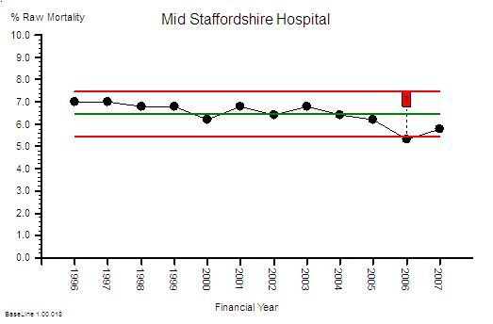
Process:
As a result of structural weaknesses, essential processes-including monitoring, hydration, toileting, and deterioration management-were inconsistently delivered. Incident reporting and complaint handling were also deficient, preventing learning and corrective action (Francis, 2013).
Outcomes:
These process failures contributed to elevated mortality rates, severe patient suffering, prolonged hospital stays and widespread loss of public confidence. The SPO model thus demonstrates the direct, predictable pathway from unsafe staffing structures to harmful outcomes.
(HCSE Blog, 2025)

Section 2.2 - Analytical Approaches:

2.2.1 SWOT Analysis
Using a SWOT The framework makes it possible to systematic evaluation associated with ways MSFT’s internal assets and constraints relate to external possibilities and challenges that impact quality outcomes and organisational performance (Gurel and Tat, 2017). It is widely used in healthcare because it helps organisations understand how resource limitations and external pressures shape outcomes (NHS England, 2021). SWOT is well suited to MSFT, as its failings arose from internal issues-such as culture, staffing and governance and external drivers, including Foundation Trust pressures and regulatory gaps (Francis, 2013). Component 1 evidence confirms that unsafe staffing and declining care quality resulted from both internal decisions and wider system factors.
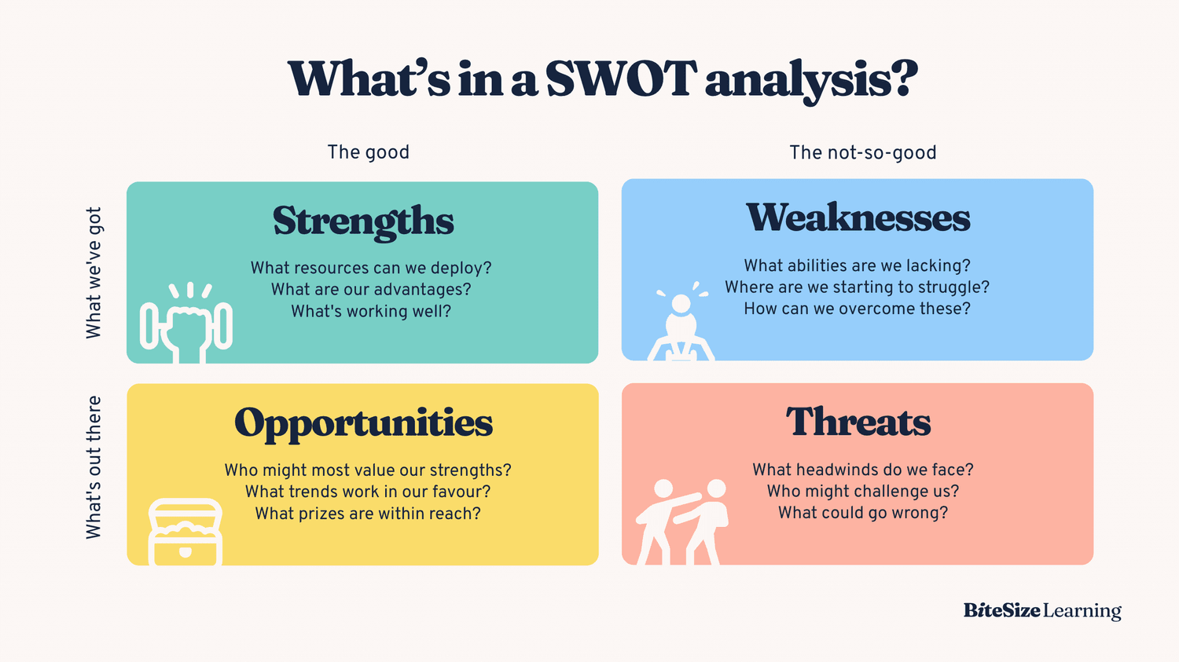
(BiteSize Learning, 2024)

Benefits
MSFT still had some strengths that could have supported improvement. These included access to national NHS frameworks on governance and workforce standards (NHS England, 2014), national clinical guidance, mortality monitoring tools and oversight from bodies such as the Healthcare Commission (2009). The Trust’s large acute hospital setting also offered opportunities for multidisciplinary working, which normally supports safer care (The King’s Fund, 2013). Component 1 findings further show that some staff were willing to speak up, indicating that useful safety intelligence existed even if it was not fully utilised.

Challenges
MSFT’s key weakness was unsafe staffing and a poor skill mix, which severely compromised safe care delivery (Healthcare Commission, 2009). Cutting around 150 posts without risk assessment created major structural gaps that reduced supervision and frontline capacity (Francis, 2013). Weak leadership worsened this, as the Board prioritised finances and Foundation Trust status over safety (Health Committee, 2013). A poor organisational culture further discouraged staff from raising concerns, allowing substandard care to become normalised (Francis, 2013). Component 1 confirms that missed care and worsening conditions became routine under these weaknesses.

Prospects
MSFT had several opportunities to strengthen safety, including national safe-staffing guidance and acuity-based workforce planning promoted across the NHS (NHS England, 2014). The National Quality Board’s early-warning frameworks also offered tools to integrate mortality alerts, complaints, and incident data to support learning (National Quality Board, 2013). Regulatory changes after concerns raised about the Trust created further opportunities for improved oversight through the CQC’s revised inspection model (CQC, 2010). Component 1 highlights that MSFT could have acted earlier on mortality data and complaints, which might have driven improvement if leadership had engaged with them effectively.

Barriers
MSFT faced major threats, including national pressure to meet Foundation Trust requirements, which prioritised finances over safety and staffing stability (Health Committee, 2013). Regulation was fragmented across multiple bodies, weakening accountability and allowing problems to persist (Francis, 2013). Wider NHS workforce shortages also threatened recruitment and retention, making safe staffing harder to sustain (The King’s Fund, 2013). Component 1 shows that these external pressures and regulatory gaps created conditions in which unsafe staffing could worsen unchecked.

2.2.2 Supporting PESTLE Analysis
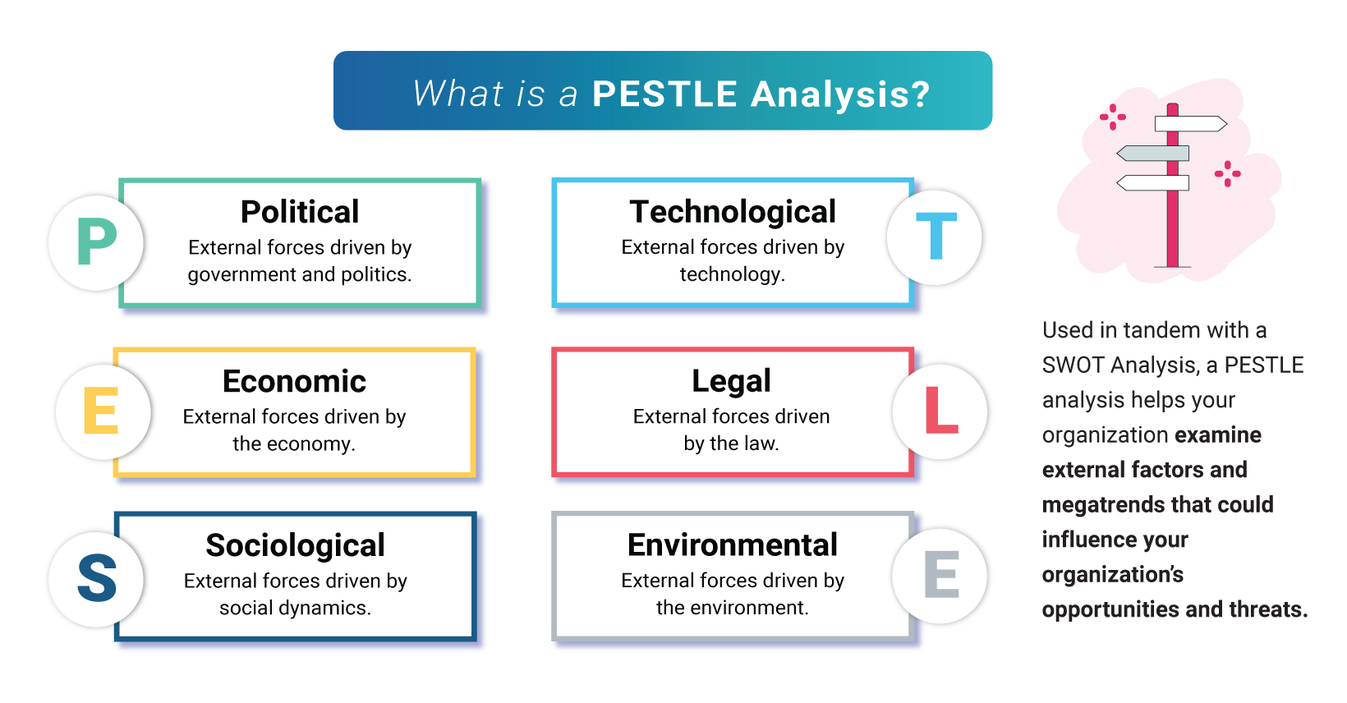(OnStrategyHQ, 2024)
The PESTLE approach complements the SWOT evaluation by mapping the broader political, economic, social, technological, legal, and environmental determinants that affected MSFT’s unsafe staffing situation (Friends and Zeadally, 2021). Politically, Foundation Trust policy placed intense pressure on MSFT to demonstrate financial stability, incentivising staffing cuts despite clinical risks (Health Committee, 2013). Economically, national efficiency programmes encouraged cost-reduction strategies that were not accompanied by adequate safeguards to protect patient safety (Department of Health, 2013).
Socially, MSFT served an ageing local population with high levels of dependency, increasing demand for nursing care that understaffed wards were unable to meet (Healthcare Commission, 2009). Technologically, limitations in data systems contributed to failures in mortality monitoring and feedback loops, reducing leadership’s ability to interpret early warning signs (The King’s Fund, 2013). Legally, MSFT had obligations under the NHS Constitution to provide safe and high-quality care, obligations that were breached as systemic failures multiplied (Department of Health, 2013). Component 1 shows that these external pressures shaped the context in which unsafe staffing and skill-mix deterioration progressed unchecked.

3. Recommendations
Improving unsafe staffing and poor skill mix at MSFT requires a structured, evidence-based approach using PDSA and Lean methods (NHS England, 2014). The failures at MSFT show that lasting improvement must address workforce deficits, unsafe processes, weak governance and promote continuous learning (Francis, 2013). Component 1 evidence confirms that staffing cuts, poor leadership, and weak escalation systems undermined safety, demonstrating the need for systematic workforce and process reform.

Recommendation 1: Restore Safe Staffing Levels Using Acuity-Based Planning
Restoring safe staffing requires implementing acuity-based workforce planning tools that match staffing numbers and skill mix to patient dependency and ward complexity (NHS England, 2014). The Healthcare Commission (2009) identified that MSFT removed more than 150 posts without any assessment of clinical risk, illustrating the need for systematic workforce modelling. Acuity assessment frameworks, for example the Safer Nursing Care Tool (SNCT) are recommended nationally as well as have been shown to reduce missed care episodes and improve mortality outcomes (Griffiths et al., 2018). The Francis Inquiry (2013) emphasised that safe staffing must be embedded in governance systems so that boards receive real-time data on staffing gaps and patient acuity.
Component 1 demonstrates that MSFT lacked a reliable process for matching staffing to workload, supporting the need for structured acuity assessment as a core intervention.

Recommendation 2: Strengthen Skill Mix and Clinical Leadership
Improving skill mix is essential for ensuring safe supervision, decision-making and escalation of deteriorating patients (CQC, 2022). MSFT’s loss of senior nurses significantly weakened clinical leadership, contributing to widespread failures in basic care processes such as hydration, nutrition, and monitoring (Healthcare Commission, 2009). Evidence shows that wards with higher proportions of registered nurses have significantly lower mortality and fewer adverse events (Aiken et al., 2014). The Francis Report (2013) calls for organisations to ensure senior clinical leaders are visible, accountable, and engaged in frontline quality surveillance.
Component 1 highlights the absence of strong clinical leadership at MSFT, reinforcing the importance of rebuilding supervisory capacity.

Recommendation 3: Implement a Structured PDSA Cycle to Test and Scale Improvements
The Plan–Do–Study–Act approach establishes a systematic framework to trialling service improvements on a limited scale prior to broader adoption (Langley et al., 2009). A first PDSA cycle should focus on piloting acuity-based staffing levels on one high-risk ward, enabling leaders to assess workload, staffing gaps and escalation needs (NHS England, 2014). The Healthcare Commission (2009) notes that MSFT failed to use data effectively, making iterative learning through PDSA cycles particularly valuable.
A second PDSA cycle should test enhancements in senior nurse leadership presence, evaluating indicators such as incident reporting, staff confidence, and patient outcomes (CQC, 2022). The Francis Inquiry (2013) emphasises iterative learning as essential for embedding safety culture, supporting the use of PDSA cycles as a continuous improvement mechanism. Component 1 shows that lack of feedback loops contributed to MSFT’s failures, making PDSA implementation a necessary corrective strategy.

Recommendation 4: Apply Lean Principles to Redesign Unsafe Processes
Lean methodology focuses on reducing waste, improving work-flow and standardising procedures to enhance reliability in care delivery (Institute for Healthcare Improvement, 2020). MSFT exhibited extensive process waste, including delays in escalation, duplicated work, and inconsistent monitoring, resulting in missed care and preventable harm (Healthcare Commission, 2009). Lean techniques such as process mapping can identify inefficiencies in patient observation workflows, enabling redesign to reduce delays in recognising deterioration (The King’s Fund, 2013).
Standardising hydration and nutritional care rounds are supported by Lean evidence showing improvements in reliability and patient experience (IHI, 2020). The Francis Inquiry (2013) emphasised that inconsistent processes contributed to harm at MSFT, making Lean process redesign essential for restoring safe care. Component 1 provides examples of inconsistent care routines, reinforcing the need for standardised Lean workflows.

Recommendation 5: Strengthen Governance, Escalation and Safety Intelligence
Governance must be strengthened so staffing, safety and quality data are routinely reviewed at Board level (CQC, 2022). MSFT’s failure to respond to mortality alerts and complaints reflected poor oversight and weak data integration (Healthcare Commission, 2009). National guidance recommends real-time dashboards for staffing, incidents, and outcomes to enable timely escalation (NHS England, 2014). The Francis Inquiry (2013) emphasised that Boards need accurate, triangulated data to avoid false reassurance. Component 1 shows that private Board meetings and weak challenge at MSFT allowed failures to persist, highlighting the need for transparent, quality-focused governance.

Recommendation 6: Encourage a Safety-Oriented and Psychological Security
A collective mindset that supports staff to speak up is vital for maintaining safety improvements (NHS Improvement, 2018). MSFT discouraged reporting, which normalised poor care and hid early warning signs (Francis, 2013). Psychological safety is shown to increase incident reporting, team learning and patient outcomes (Edmondson, 2019). Freedom to Speak Up Guardians and routine cultural audits are recommended to promote openness and organisational learning (NHS Improvement, 2018).

4. Conclusion
The analysis of Mid Staffordshire NHS Foundation Trust (MSFT) demonstrates that unsafe staffing levels and a poor workforce skill mix were central structural failures driving widespread harm between 2005 and 2009 (Healthcare Commission, 2009). Every major inquiry, including the Francis Report, concluded that inadequate staffing fundamentally weakened MSFT’s ability to deliver safe, effective, and patient-centred care (Francis, 2013). Evidence from Component 1 further confirms that more than 150 staffing posts were removed without risk assessment, resulting in severe supervision failures and extensive missed care.
Root cause analysis using the Fishbone Diagram showed that leadership weakness, workforce shortages, inconsistent clinical processes, poor safety intelligence, and a dysfunctional organisational culture were the primary contributors to the staffing crisis (Francis, 2013). The 5 Whys analysis highlighted that staffing cuts occurred because organisational priorities were misaligned with patient safety due to pressures to achieve Foundation Trust status (Health Committee, 2013).
The Donabedian Structure–Process–Outcome model demonstrated how structural workforce deficiencies led directly to failures in care processes and harmful clinical outcomes (Donabedian, 1988). Complementary SWOT and PESTLE analyses illustrated that MSFT’s internal weaknesses were exacerbated by external political, economic, and regulatory pressures, creating an environment where unsafe staffing could deteriorate unchecked (NHS England, 2014). Component 1 reinforced that leadership inaction and regulatory fragmentation allowed these failures to persist over several years.
The recommendations developed in this report demonstrate that improvement is achievable through evidence-based methods such as acuity-based staffing models, strengthened clinical leadership, iterative PDSA cycles and Lean process redesign (Langley et al., 2009). National policy guidance supports these interventions as effective mechanisms for rebuilding safety, improving workflow reliability, and embedding a culture of continuous learning (CQC, 2022). The overall analysis shows that sustainable improvement requires addressing the structural causes of unsafe staffing, strengthening governance oversight, and fostering psychological safety so that concerns can be raised without fear (NHS Improvement, 2018).
Ultimately, the MSFT case illustrates that protecting patients depends on aligning workforce capacity, organisational culture, and system-wide accountability, ensuring that safety remains the core priority of medical and social assistance provision (Francis, 2013).

References:
- BiteSize Learning (2024) Overview of SWOT analysis with examples and template guidance. Available at: https://www.bitesizelearning.co.uk/resources/swot-analysis-explained-examples-templates (Accessed: 5 December 2025).
- Department of Health (2013) Initial response to the Francis Inquiry: Patients First and Foremost. London: Department of Health. Available at: https://assets.publishing.service.gov.uk/government/uploads/system/uploads/attachment_data/file/170701/Patients_First_and_Foremost.pdf (Accessed: 5 December 2025).
- Francis, R. (2013) Public Inquiry into Mid Staffordshire NHS Foundation Trust. London: The Stationery Office. Available at: https://assets.publishing.service.gov.uk/government/uploads/system/uploads/attachment_data/file/279124/0947.pdf (Accessed: 5 December 2025).
- Healthcare Commission (2009) Investigation report into Mid Staffordshire NHS Foundation Trust. London: CHAI. Available at: https://cdn.ps.emap.com/wp-content/uploads/sites/3/2009/06/Investigation_into_Mid_Staffordshire_NHS_Foundation_Trust.pdf (Accessed: 5 December 2025).
- Health Select Committee (2013) Post-Francis recommendations for service improvement. House of Commons. Available at: https://publications.parliament.uk/pa/cm201314/cmselect/cmhealth/657/657.pdf (Accessed: 5 December 2025).
- The King’s Fund (2013) Summary of the Francis Report and its implications. London: The King’s Fund. Available at: https://www.kingsfund.org.uk/publications/francis-report (Accessed: 5 December 2025).
- NHS England (2014) Guidance on workforce planning for safe and effective staffing. National Quality Board. Available at: https://www.england.nhs.uk/wp-content/uploads/2013/11/nqb-how-to-guid.pdf (Accessed: 5 December 2025).
- NHS Improvement (2018) Developing People, Improving Care: National framework for quality improvement. Available at: https://improvement.nhs.uk/resources/developing-people-improving-care/ (Accessed: 5 December 2025).
- Care Quality Commission (2022) Regulation 18 – Staffing requirements. CQC. Available at: https://www.cqc.org.uk/guidance-providers/regulations-enforcement/regulation-18-staffing (Accessed: 5 December 2025).
- Care Quality Commission (2010) Essential standards for safety and quality in healthcare. Available at: https://www.cqc.org.uk/sites/default/files/documents/gac_-_dec_2011_update.pdf (Accessed: 5 December 2025).
- National Quality Board (2013) Review and evaluation of Early Warning Systems in NHS care. Available at: https://www.england.nhs.uk/wp-content/uploads/2013/08/nqb-rep-ews.pdf (Accessed: 5 December 2025).
- Aiken, L. et al. (2014) ‘Hospital nurse staffing, education level, and mortality outcomes across nine European countries’, The Lancet, 383(9931), pp. 1824–1830. DOI: https://doi.org/10.1016/S0140-6736(13)62631-8
- Griffiths, P. et al. (2018) ‘Links between nurse staffing levels and missed nursing care’, BMJ Quality and Safety, 27(7), pp. 592–599. DOI: https://doi.org/10.1136/bmjqs-2017-006778
- Ball, J. et al. (2018) ‘Analysis of nursing skill mix and implications for patient care’, BMJ Open, 8(2), e019575. DOI: https://doi.org/10.1136/bmjopen-2017-019575
- Needleman, J. (2017) ‘Skill mix in nursing and patient outcomes’, The Lancet, 389(10071), pp. 1780–1781. DOI: https://doi.org/10.1016/S0140-6736(17)30566-7
- Ausserhofer, D. et al. (2014) ‘Outcome trends linked to nurse staffing levels’, International Journal of Nursing Studies, 51(5), pp. 584–594. DOI: https://doi.org/10.1016/j.ijnurstu.2013.09.004
- Donabedian, A. (1988) ‘Framework for assessing healthcare quality’, JAMA, 260(12), pp. 1743–1748. DOI: https://doi.org/10.1001/jama.260.12.1743
- Institute for Healthcare Improvement (2020) Science of Improvement – principles for quality enhancement. Available at: http://www.ihi.org/resources/Pages/HowtoImprove/ScienceofImprovementHowtoImprove.aspx (Accessed: 5 December 2025).
- NHS England (2016) PDSA Improvement Tool for service change. Available at: https://www.england.nhs.uk/improvement-hub/wp-content/uploads/sites/44/2017/11/NHSI-PDSA.pdf (Accessed: 5 December 2025).
- Lean Enterprise Institute (2015) Introduction to Lean thinking. Available at: https://www.lean.org/explore-lean/what-is-lean/ (Accessed: 5 December 2025).
- Institute for Healthcare Improvement (2020) Lean methodology in health process improvement. Available at: http://www.ihi.org/resources (Accessed: 5 December 2025).
- The King’s Fund (2017) Current leadership challenges in the NHS. Available at: https://www.kingsfund.org.uk/publications/leadership-todays-nhs (Accessed: 5 December 2025).
- West, M. et al. (2015) Collective leadership models for healthcare services. London: The King’s Fund. Available at: https://www.kingsfund.org.uk/sites/default/files/field/field_publication_file/collective-leadership-may-2015.pdf (Accessed: 5 December 2025).
- Care Quality Commission (2019) State of care across acute NHS hospitals. Available at: https://www.cqc.org.uk/publications/major-report/state-care-nhs-acute-hospitals (Accessed: 5 December 2025).
- National Audit Office (2015) Hospital staffing safety: evaluation and recommendations. Available at: https://www.nao.org.uk/reports/safer-staffing-in-hospitals/ (Accessed: 5 December 2025).
- NHS England (2022) Patient Safety Incident Response Framework (PSIRF). Available at: https://www.england.nhs.uk/patient-safety/psirf/ (Accessed: 5 December 2025).
- UK Government (2019) Guidance on Duty of Candour in healthcare practice. Available at: https://www.gov.uk/government/publications/duty-of-candour (Accessed: 5 December 2025).
- NHS England (2019) Interim NHS People Plan. Available at: https://www.england.nhs.uk/ournhspeople/ (Accessed: 5 December 2025).
- NHS Education for Scotland (2018) Guidance for workload assessment and workforce planning. Available at: https://www.nes.scot.nhs.uk (Accessed: 5 December 2025).
- Health Education England (2020) NHS workforce development strategy. Available at: https://www.hee.nhs.uk/our-work/workforce-strategy (Accessed: 5 December 2025).
- The Health Foundation (2016) Impact of staffing and funding on service safety. Available at: https://www.health.org.uk/publications/staffing-matters-funding-counts (Accessed: 5 December 2025).
- Gurel, E., and Tat, M. (2017) ‘Theoretical discussion of SWOT analysis’, Journal of International Social Research, 10(51), pp. 994–1006. DOI: https://doi.org/10.17719/jisr.2017.1832
- Friends, A. and Zeadally, S. (2021) ‘Environmental analysis using PESTLE in business strategy’, Journal of Business Strategy, 42(4), pp. 220–230. DOI: https://doi.org/10.1108/JBS-12-2019-0266
- Francis, R. (2010) Independent Inquiry into Mid Staffordshire NHS Foundation Trust (2005–2009). Available at: https://assets.publishing.service.gov.uk/government/uploads/system/uploads/attachment_data/file/279109/0637.pdf (Accessed: 5 December 2025).
- NIHR (2017) Missed nursing care associated with poorer clinical outcomes. Available at: https://evidence.nihr.ac.uk/alert/missed-nursing-care-linked-to-poorer-outcomes/ (Accessed: 5 December 2025).
- On Strategy (2024) PESTLE analysis explained. Available at: https://onstrategyhq.com/resources/pestle-analysis/ (Accessed: 5 December 2025).
- Qodo (2025) Root cause analysis overview. Available at: https://www.qodo.ai/glossary/root-cause-analysis/ (Accessed: 5 December 2025).

