
Divisional Benefits Intelligence Programme
BMDS 7009 - Programme, Project and Change Management in Health and Social Care



March 1, 2026
Joanne James - 2516963
MSc in Digital Transformation for the Health and Care Professions

I did not use generative AI to produce any of the text in this essay

Introduction
The Division of Surgery within a large NHS health board operates across multiple acute sites and speciality directorates, including Trauma and Orthopaedics, Ophthalmology, Dermatology, Haematology, Rheumatology, Urology, ENT, OMFS and General Surgery. The operational context is characterised by high elective demand, constrained workforce capacity, financial pressures, national performance targets, and an increasing reliance on both digital and service redesign initiatives to maintain safe and sustainable care delivery. In this environment, transformation activity is continuous and multi-layered, with numerous business cases and improvement projects progressing concurrently across clinical and corporate domains.
Over recent years, Divisional business cases have included digital initiatives such as digital dictation systems, electronic trauma boards and robotic process automation (RPA), alongside non-digital interventions including workforce redesign, pathway reconfiguration, service redesign and capital investment initiatives. Additional proposals, such as a digital consent pilot, are currently under development. These initiatives are typically justified through projected modelling of activity, demand, financial savings, or quality-improvement benefits. However, while considerable attention is given to business case development and approval, there is comparatively limited structured post-implementation evaluation to determine whether projected benefits are realised, sustained or adapted over time. As Jenner (2012) argues, benefits do not arise automatically from change; they require active management and governance (Jenner, 2012).
This creates a governance and value realisation gap between strategic intent and operational delivery. Healthcare transformation frequently equates implementation with success; yet implementation alone does not guarantee that intended clinical, operational or financial outcomes materialise in practice. Wachter (2016) highlights that digital transformation in healthcare is shaped by socio-technical complexity, including workflow integration, behavioural adaptation and organisational culture (Wachter, 2016).
Without structured mechanisms to reconcile projected assumptions against real-world performance, organisations risk embedding initiatives that are operationally accepted but misaligned with their original objectives or financial forecasting. Ward and Daniel (2012) emphasise the importance of clearly defined measurable and owned benefits from the outset of transformation initiatives (Ward and Daniel, 2015).
The aim of this essay is to design a Divisional Benefits Intelligence Programme embedded within existing governance structures of the Division of Surgery. The aim of the programme is to provide a structured and consistent method of tracking, evaluating and reviewing transformation initiatives, to ensure the intended clinical, operational and financial benefits are not only achieved but sustained. The scope of the programme includes embedding structured benefits baselining at the point of business case approval. Introducing defined post-implementation review checkpoints at six, twelve and eighteen months, Integrating quantitative performance metrics with qualitative stakeholder feedback, and reporting through established Divisional management and assurance forums. The programme would initially be implemented within the Division of Surgery, with the potential for health board-wide scalability should demonstrable value be achieved.

Methods
The proposed Benefits Intelligence Programme is designed as a programme-level intervention rather than a standalone project. Although individual business cases and improvement initiatives can be delivered through established project management methods, there is currently an absence of a consistent framework to track, evaluate, and adjust the benefits delivered across multiple initiatives over time. As Jenner argues in Managing Benefits, benefits do not arise automatically from change; they require active management, ownership and governance. Without this discipline, organisations risk assuming that implementation equates to value creation (Jenner, 2012).
Within the Division of Surgery, multiple initiatives progress concurrently across all specialities. Examples range from digital initiatives like dictation platforms, electronic trauma boards and RPA, to wider service redesign work and capital investment projects. Although these initiatives are supported by business cases with defined projections, there is currently no consistent Divisional framework requiring structured post-implementation reconciliation against original assumptions. The programme, therefore, seeks to formalise that process.
The Benefits Intelligence Programme would consist of four interrelated components and is illustrated in Figure 1 as a continuous lifecycle.
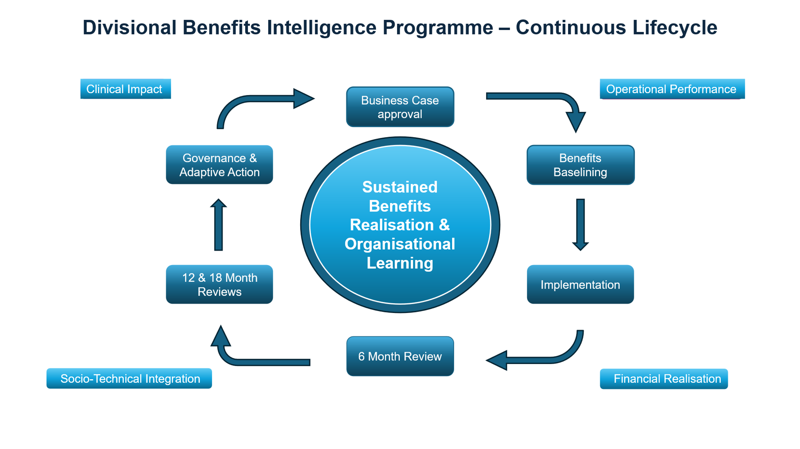
Figure 1: Proposed Divisional Benefits Intelligence Programme – Continuous Benefits Realisation Lifecycle
Drawing on the work of Ward and Daniel, benefits must be clearly defined, measurable and traceable to strategic objectives from the outset (Ward and Daniel, 2015). Under this programme, all new business cases would include explicit baseline data, quantified projections and named benefit owners. For example, where a digital consent pilot is proposed, baseline data relating to documentation compliance, medico-legal claims and patient understanding would be specified at the proposal stage, rather than assumed to be measurable retrospectively.
In line with Managing Successful Programmes (MSP), benefits realisation would be reviewed at defined intervals via structured post-implementation review checkpoints (AXELOS Limited, 2020). These are proposed at six, twelve and eighteen months post-implementation. These reviews would reconcile forecast activity, financial modelling and quality improvements against actual performance data. Where variance is identified, adaptive action would be agreed through existing governance forums.
Wachter’s analysis of digital transformation in healthcare highlights that success is influenced not only by technical deployment but by socio-technical factors, including workflow integration, culture and user behaviour (Wachter, 2016). This will be measured with both quantitative and qualitative KPIs. To reflect this, the programme would incorporate stakeholder feedback alongside quantitative performance indicators. This will ensure that benefit evaluation considers operational practicality, clinical and non-clinical experience, as well as financial impact.
Findings would be presented through established Divisional management meetings and assurance forums. Embedding the review processes within existing governance structures will strengthen accountability, maintain close alignment with financial planning cycles and reduce any duplication of reporting. By integrating benefit reconciliation into routine oversight processes, the programme aims to strengthen feedback loops between operational delivery and strategic intent. To ensure that this design is not purely conceptual, this essay critically justifies the methodological framework underpinning the programme.
Managing Successful Programmes (MSP) will be used as the primary framework for this programme. MSP is well-suited to environments where several interconnected initiatives need to come together to achieve wider strategic goals and objectives. MSP’s focus on benefits realisation, aligned governance, and phased delivery fits naturally with the operational challenges experienced within the Division of Surgery (AXELOS Limited, 2020).
Project management approaches like PRINCE2 offer provide a solid foundation for controlling scope, managing risk, and ensuring outputs are delivered as planned. They also require a business case to justify any investment. However, once a project is closed, the methodology provides no real mechanism for returning to those expected benefits or assessing whether they were actually realised. From a Divisional point of view, where multiple improvement initiatives run concurrently and often shape one another due to operational pressures, this limitation makes PRINCE2 less suitable as a standalone approach. (PRINCE2, 2025).
Quality improvement methodologies, including Plan–Do–Study–Act cycles, offer valuable mechanisms for frontline testing and iterative learning. However, they are generally applied on a small-scale operational level and lack the structural architecture necessary for cross-directorate, portfolio-level oversight. Similarly, while Lean and Six Sigma provide rigorous methodologies for analysing variation and optimising processes, they do not offer explicit governance structures for the strategic tracking of benefits across complex and diverse transformation portfolios (Taylor et al., 2014; Antony et al., 2018)
MSP, complemented by established benefits management theory, offers a more coherent structure. Jenner’s work reinforces that benefits must be actively managed within governance systems rather than treated as a retrospective reporting exercise (Jenner, 2012). By combining MSP’s programme-level oversight with Ward and Daniel’s principles of benefit identification, ownership and measurement, the proposed programme integrates strategic governance with practical evaluation mechanisms (Ward and Daniel, 2015; AXELOS Limited, 2020).
In addition to programme governance theory, the design is informed by behaviour change principles. The Behaviour Change Wheel (Michie, van Stralen and West, 2011) conceptualises behaviour as arising from interactions between Capability, Opportunity and Motivation (COM-B). Within the Divisional context, inconsistent benefits tracking is not solely a technical issue but a behavioural one: analytical capability often varies across teams, organisational opportunity for structured review may be constrained by inconsistent reporting processes, and motivational drivers often declines once funding has been secured and implementation complete. By embedding baselining requirements, structured governance checkpoints, and transparent variance reporting, the programme seeks to influence behavioural influences that underpin sustainable benefit realisation.
A key assumption underpinning this programme is that implementation does not guarantee value realisation. Wachter’s examination of health IT implementation demonstrates that technological deployment frequently encounters socio-technical challenges, including workflow misalignment, resistance to behavioural change and unintended consequences (Wachter, 2016). Similarly, socio-technical evaluation frameworks such as STAT-HI emphasise the importance of assessing health informatics initiatives across organisational, workflow and human domains rather than focusing solely on deployment milestones (Scott and Briggs, 2010).
Following discussion of implementation risk and socio-technical complexity, it is important to recognise that benefits realisation is not solely determined by technical deployment or financial modelling. It emerges from the interaction of multiple socio-technical domains operating within the organisational environment. Figure 2 illustrates these interacting factors, including governance oversight, technology configuration, workflow integration, human behaviour and wider external pressures.
This theoretical perspective aligns with socio-technical perspectives on health informatics implementation (Scott and Briggs, 2010; Wachter, 2016) and reinforces the need for structured evaluation mechanisms that extend beyond implementation milestones.
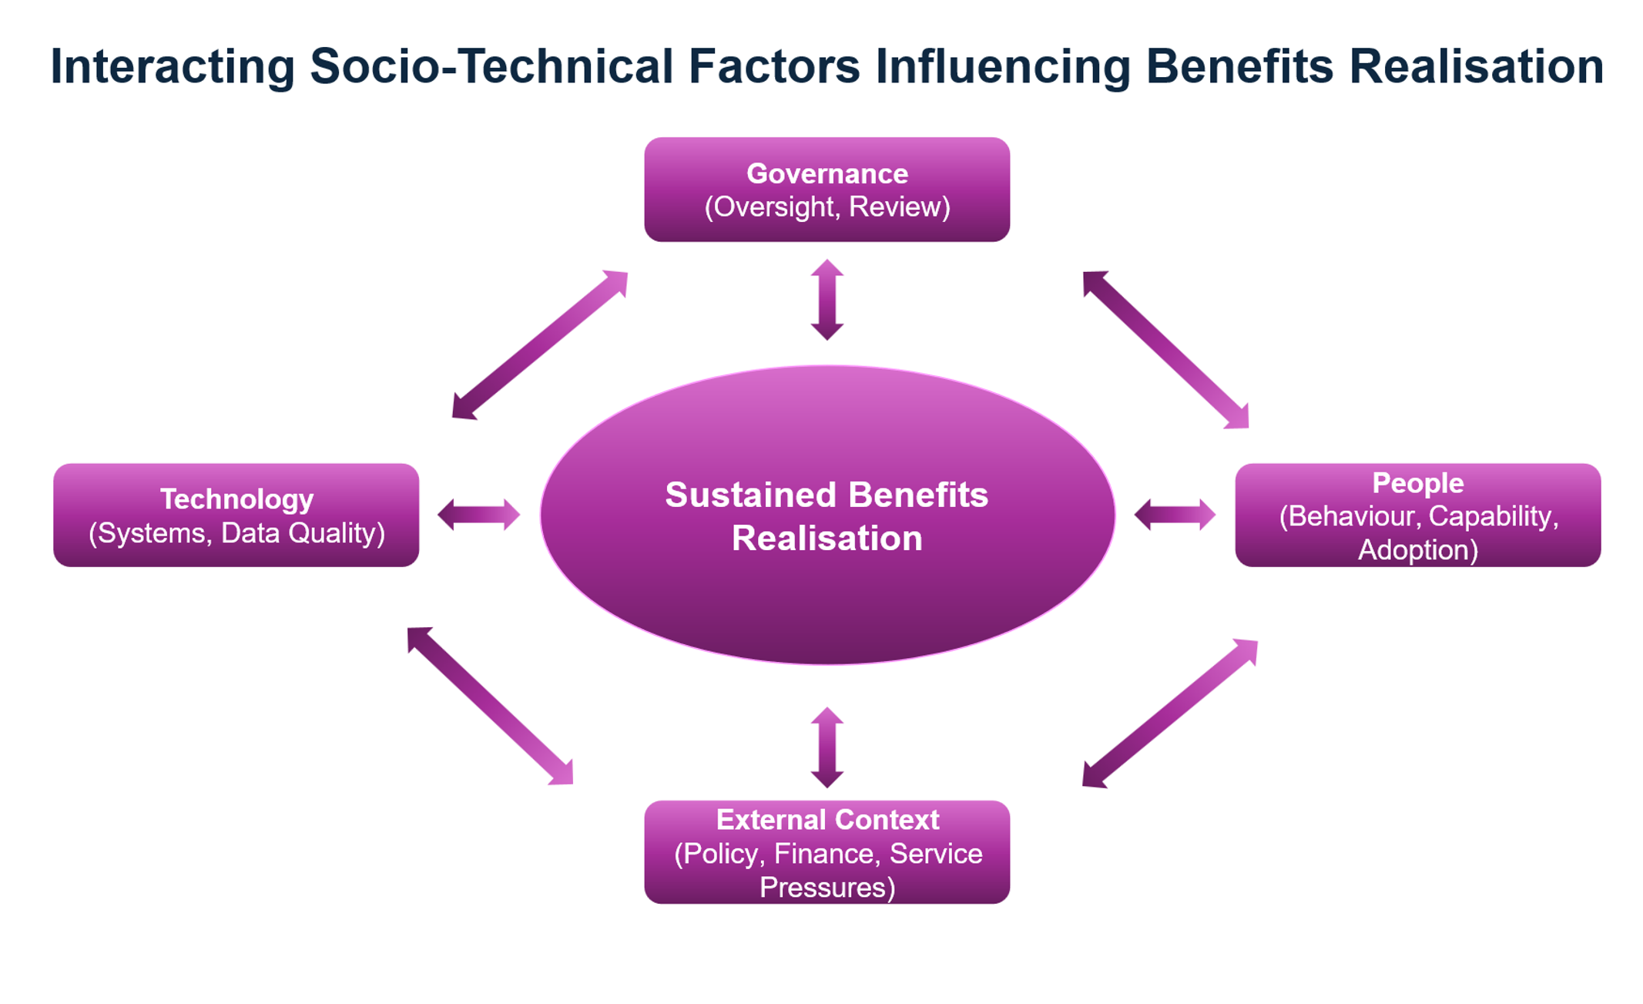
Figure 2: Interacting Socio-Technical Factors Influencing Benefits Realisation
Within the Division of Surgery, future initiatives such as a digital consent pilot may provide improved documentation quality and reduced legal exposure. However, if adoption is inconsistent or workflow integration is inadequate, realised benefits may differ from projections. RPA may predict administrative time savings, yet oversight and exception handling requirements may limit the anticipated gain. An electronic trauma board may aim to improve theatre utilisation, but benefits will depend on data accuracy and multidisciplinary engagement.
Without structured evaluation, any deviation from the expected outcomes may go unnoticed. The Benefits Intelligence Programme therefore incorporates scheduled review and reconciliation to identify benefit drift, identify unintended consequences and enable corrective action.
This staged review structure reflects a Theory of Change orientation by explicitly linking the achievement of sustainable value realisation with enhanced visibility of benefit variance, while also enabling targeted intervention through structured baselining and clearly defined governance checkpoints.
The effectiveness of the Programme would be evaluated using defined process and outcome indicators, including clearly defined baseline metrics, completion rate of scheduled review checkpoints and assignment of named benefit owners.
Outcome measures would examine variance between projected and realised financial savings, activity modelling and operational performance indicators. Where significant variance is identified, an examination will be undertaken to assess if appropriate actions have been taken.
Indicators of organisational learning will be assessed, including an analysis of the extent to which stakeholders report increased confidence in the governance processes when supporting Divisional transformation, which will in turn inform subsequent business case modelling.
Even though MSP provides a structured and disciplined approach, the formal nature of the framework may generate a perception of increased administrative burden among staff. There is also a potential risk that emphasis on quantifiable metrics may overshadow important qualitative areas of improvement. To mitigate this, proportionality principles will be applied, ensuring that the intensity of evaluation is aligned appropriately with the scale, complexity, and risk of each initiative. High-value digital or capital investments should warrant comprehensive benefit tracking, whereas smaller-scale improvements may require a lighter-touch evaluation. The aim is not to increase bureaucracy but to strengthen strategic alignment.

Discussion
The introduction of a Divisional Benefits Intelligence Programme would represent a shift in how transformation is governed within the Division of Surgery. Although the idea is relatively straightforward, putting it into practice is likely to surface resistance and introduce a degree of risk. Bringing greater visibility to gaps between projected and actual benefits can feel uncomfortable in complex healthcare settings, where such transparency is sometimes interpreted as scrutiny rather than support (Cheraghi et al., 2023).
One of the principal risks relates to organisational defensiveness. Business cases are usually developed when there is considerable uncertainty, and the modelling reflects only the best information available at the time. Subsequent divergence from projections could reflect external pressures, fluctuating demand, workforce instability, and policy change rather than poor design. Without careful framing, post-implementation review processes could be interpreted as retrospective judgement rather than adaptive learning. To mitigate this, the programme would require clear positioning as a mechanism for organisational improvement rather than individual accountability.
Data quality presents additional challenges. Many transformation initiatives influence shared performance indicators, such as waiting times or theatre utilisation. Determining the specific effect of a single intervention within a constantly shifting operational environment is inherently challenging, as outcomes are shaped by multiple interconnecting factors. As Wachter notes in his examination of digital transformation, healthcare systems are socio-technical environments where causality is rarely linear (Wachter, 2016). The programme will need to take a practical view, accepting that variance analysis may show an intervention has influenced an outcome, even if it cannot be credited with causing it outright.
Stakeholder engagement will be central to programme viability. MSP emphasises leadership and stakeholder alignment as core principles, and Jenner highlights the importance of named benefit ownership (Jenner, 2012; AXELOS Limited, 2020).
It is important that engagement begins at business case development stage, where benefit assumptions are first articulated. Clarification regarding baselines, ownership and review expectations early on reduces the risk of misalignment. Power-interest dynamics may also occur; Senior leaders may welcome an improved visibility of transformation performance, but frontline teams may question additional oversight. Transparent communication of the intended purpose, framing the programme as a learning and optimisation tool will be essential. By formalising feedback loops, the programme will seek to strengthen, rather than undermine, clinical autonomy (Michie, van Stralen and West, 2011).
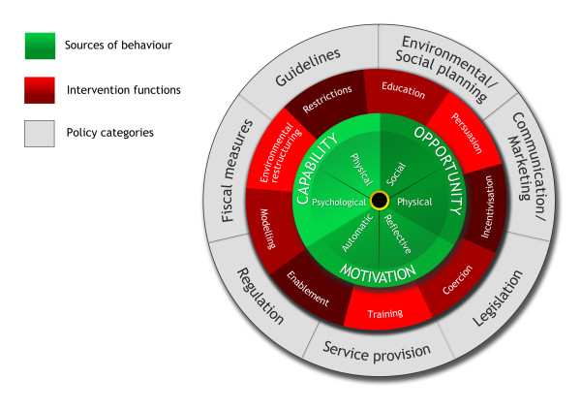
Figure 3: The Behaviour Change Wheel (Michie, van Stralen and West, 2011)
The proposed model offers the potential for wider organisational roll-out. If demonstrable improvements in benefit management, and modelling accuracy are achieved within the Surgery Division, the framework could be adapted across other Divisions within the health board. This aligns with principles associated with Learning Health Systems, in which continuous data feedback, evaluation and adaptation are embedded within routine organisational processes rather than treated as discrete exercises (Friedman, Rubin and Sullivan, 2017).
By formalising structured review checkpoints and linking variance analysis to future business case modelling, the programme will begin to establish a localised learning architecture. However, to scale effectively, the programme would need to connect with Health Board-wide governance and digital systems, ensuring that measurement standards and reporting processes remain consistent.
It is important to recognise that no framework can remove uncertainty entirely. Healthcare systems are, by nature, complex and unpredictable. The aim of the Benefits Intelligence Programme is therefore not to lock organisations into early assumptions, but to support thoughtful, evidence-informed adjustment as circumstances evolve. By normalising variance analysis and embedding review within governance cycles, the programme seeks to reduce the risk that transformation initiatives become operationally embedded without delivering their intended value.
The proposal represents a move from viewing transformation as a chain of isolated implementations, towards understanding it as an ongoing lifecycle of value, and accountability. Within an NHS context, such ownership is not optional but essential.
This essay has proposed the design of a Divisional Benefits Intelligence Programme to address a recognised governance gap within the Division of Surgery: the absence of a structured mechanism to reconcile projected transformation benefits against realised outcomes over time. In complex NHS environments characterised by workforce pressures, financial constraints and increasing reliance on digital and service redesign initiatives, implementation alone cannot be assumed to equate to value delivery.
By creating a programme-level framework based on MSP principles and established benefits management theory, the proposed model moves the focus from implementation milestones to sustained value realisation. By establishing baselines, agreeing review points, and drawing on both quantitative and qualitative evidence, the programme aims to embed learning within the Health Board’s existing governance processes.
The proposal recognises the socio-technical nature of healthcare transformation. Variance between projected and realised benefits should not be interpreted as failure but as an opportunity for reflection and recalibration. In this sense, the programme promotes transparency, organisational learning and responsible ownership of finite resources.
Although the initial scope is within the Division of Surgery, the framework offers potential scalability across the wider Health Board, provided that alignment with existing governance and data infrastructure can be achieved.
The proposed Benefits Intelligence Programme represents a change from viewing transformation as a series of discrete initiatives towards understanding it as an ongoing, accountable process of value management, strengthening the link between strategic intent and operational reality.

Reference List
Antony, J. et al. (2018) “Six Sigma in healthcare: a systematic review of the literature,” International Journal of Quality and Reliability Management. Available at: https://doi.org/10.1108/IJQRM-02-2017-0027.
AXELOS Limited (2020) Managing Successful Programmes. Stationery Office.
Cheraghi, R. et al. (2023) “Reasons for resistance to change in nursing: an integrative review,” BMC Nursing, 22(1). Available at: https://doi.org/10.1186/s12912-023-01460-0.
Friedman, C.P., Rubin, J.C. and Sullivan, K.J. (2017) “Toward an Information Infrastructure for Global Health Improvement,” Yearbook of medical informatics, 26(1). Available at: https://doi.org/10.15265/IY-2017-004.
Jenner, S. (2012) Managing Benefits. The Stationery Office.
Michie, S., van Stralen, M.M. and West, R. (2011) “The behaviour change wheel: A new method for characterising and designing behaviour change interventions,” Implementation Science, 6(1). Available at: https://doi.org/10.1186/1748-5908-6-42.
PRINCE2 (2025) PRINCE2® project management version 7 : global best practice for everyone aiming to enhance their project management skills. PeopleCert.
Scott, P.J. and Briggs, J.S. (2010) “STAT-HI: A Socio-Technical Assessment Tool for Health Informatics Implementations,” The Open Medical Informatics Journal, 4(1), pp. 214–220. Available at: https://doi.org/10.2174/1874431101004010214.
Taylor, M.J. et al. (2014) “Systematic review of the application of the plan-do-study-act method to improve quality in healthcare,” BMJ Quality and Safety. Available at: https://doi.org/10.1136/bmjqs-2013-001862.
Wachter, R.M. (2016) Making it work: harnessing the power of health information technology to improve care in England, Making IT Work.
Ward, J. and Daniel, E. (2015) Benefits Management: How to increase the business value of your it projects, Second Edition, Benefits Management: How to increase the business value of your it projects, Second Edition. Available at: https://doi.org/10.1002/9781119208242.

