Section 1
My placement this term has been helping to manage and understand how an a la carte restaurant is run for efficient service of food. This portfolio outlines the steps needed for correctly setting out a lunchtime service for 8 guests, ensuring customer needs and expectations are met. I will also explain how to prepare a seafood platter for 2 guests on the table, explaining each element of the dish, should I be asked by the customers. An a la carte restaurant is where you can choose from a menu with a large variety of dishes, instead of a menu with a fixed combination of dishes, at a fixed price like a set or taster menu. Auguste Escoffier revolutionized this concept which is widely used in industry today. Under the guidance of Escoffier, guests were served a dish they chose from a printed menu. "A la carte,” is a French word for "by the card,”. Dishes were listed along with prices for customers to consider (Welsch, 2024). This allowed customers to have a more personalized experience when dining. The Grove of Narberth has embedded both a la carte and taster menus into their dining elements, giving greater choice and broader experience to customers.
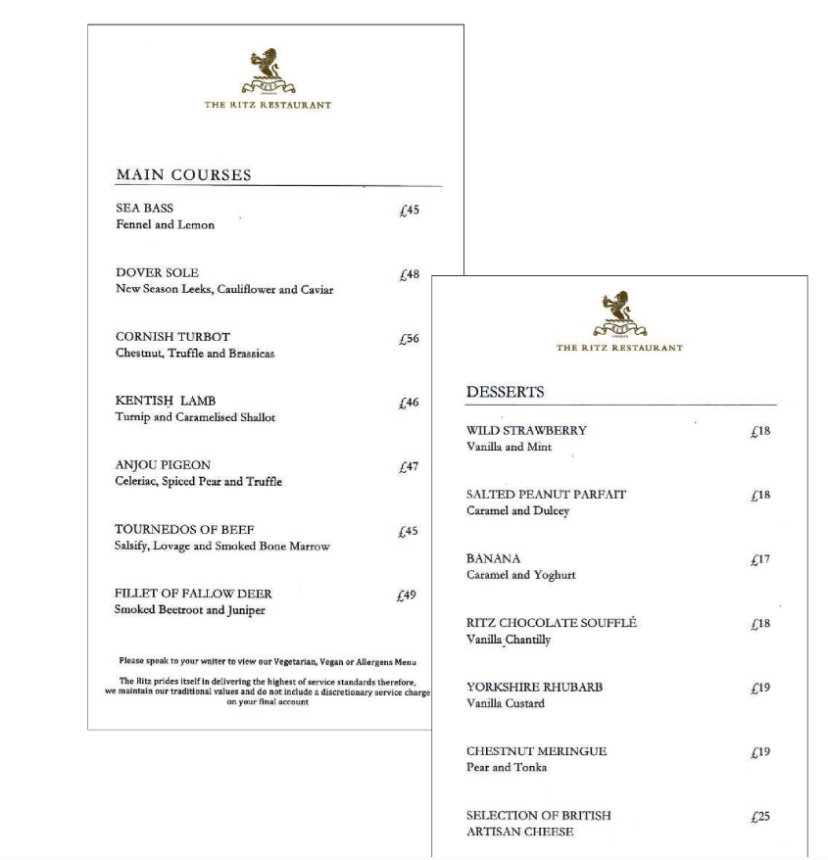
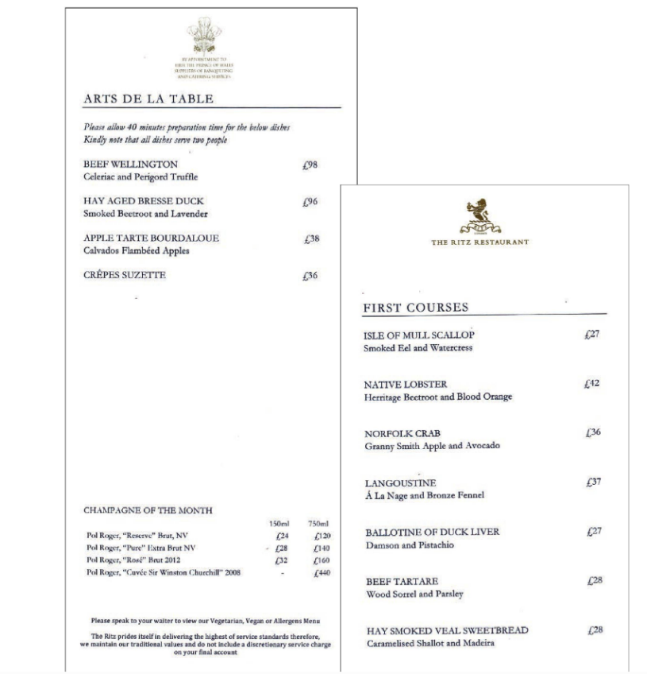
An example of an a la carte menu is shown below (Cousins, Weekes, 2020):

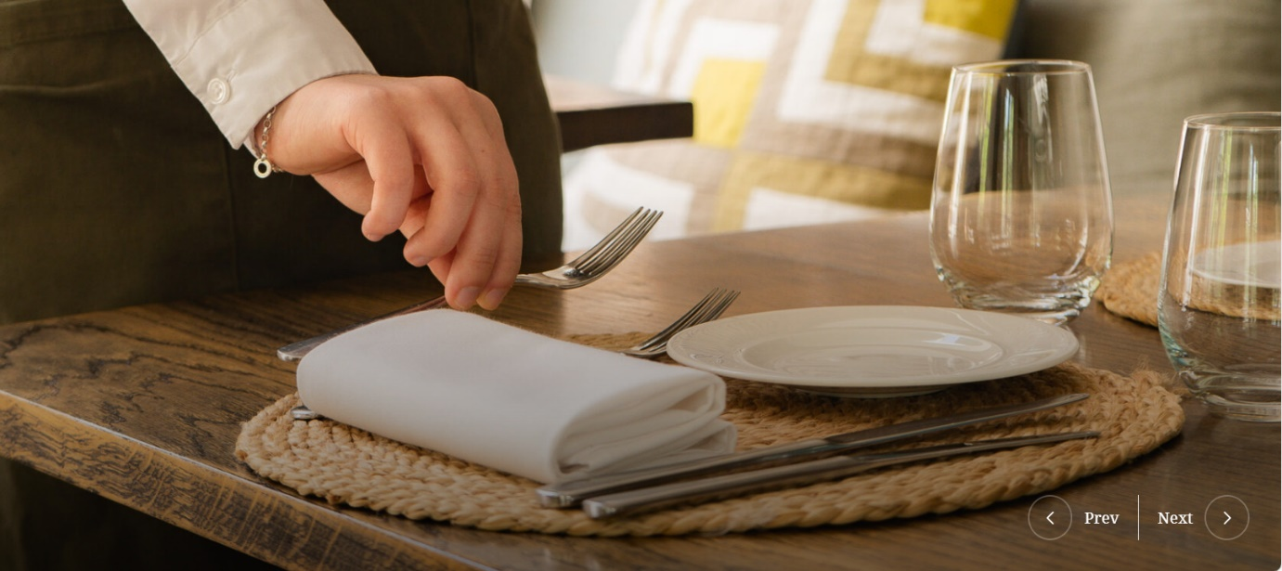
(The Grove of Narberth,2024)
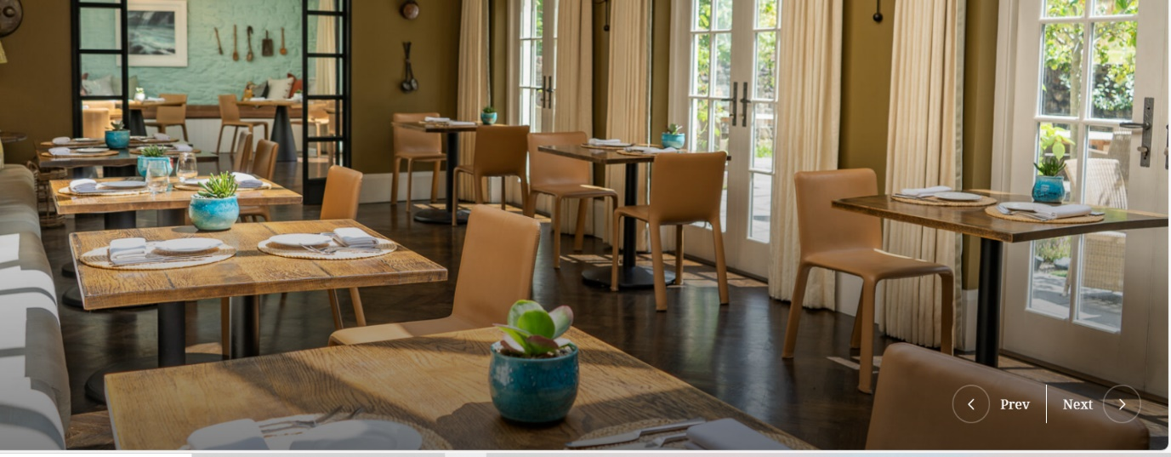
I have firsthand experience in reviewing the 8 expected guests’ special dietary requirements, intolerances, or allergies, while incorporating my communication skills to correctly communicate this with the chefs before service. This helps them plan and make alternative dishes more suitable for the customers so that expectations are met. I have learnt that front of house and back of house communication is imperative for correct mise en place organisation for lunchtime service. Once any changes have been communicated a new menu will be created with alternative dishes as discussed with the chefs (Placement,2024).
The table preparation is important in any restaurant and should be completed as soon as possible, preferably before lunchtime service begins. As we can see above this is how The Grove of Narberth set up the tables in the restaurant, with utensils correctly laid for precision and consistency of dining experience. Firstly, the cutlery is polished with vinegar solution to ensure cleanliness and shining of tableware. This is done back of the house as this process is completed once the cutlery has been washed by the pot washer (Placement,2024). You normally work from outside proceeding inside when eating at a restaurant. I have learnt that the outside knives, or forks are generally used for starter plates, while main knives are placed closer to the dinner plate with cutting edge turned towards the plate, as shown above. Forks are placed on the left-hand side with tines pointed upwards. Knives and forks are placed 9 inches apart so that the plate can fit exactly in the middle of the cutlery. Glasses are placed on the right-hand side directly above the placement of the pointed knives. If wine or soft drinks are ordered, they are placed to the right of the water glass. Lastly, placement of the napkin fold is in front of the customer for easier handling (Brown,2019).
I have learnt that complex napkin folds are considerably less hygienic and involve greater handling when preparing. Also, when the napkins are draped over the customers lap the napkin will appear to have more creases. It is time consuming to do big volumes of complex folds. This is disadvantageous if there are more jobs to complete before service (Cousins, Weekes, 2020).
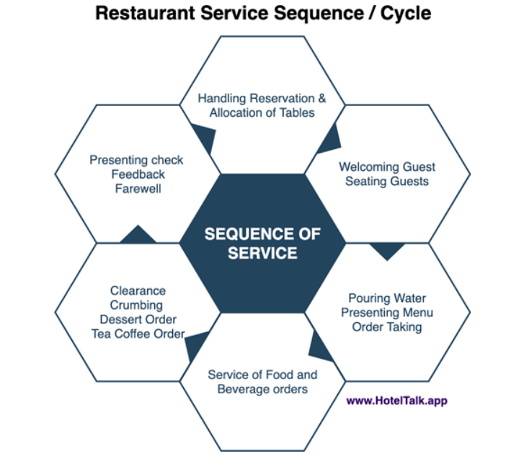
There will be 2 rectangular tables of 4 pushed together to accommodate the expected table of 8. We use rectangular tables approximately 137cm x 76cm. This will accommodate everyone comfortably. All utensils should be made available before service, such as options for still or sparkling water, trays ready to deliver food to customers, cutlery, and tableware storage on the correct station of the dining area. As it’s a large table I will make a diagram showing where each person is sitting, adding what they have ordered so when food is delivered each waiter knows which person the dish is for. Giving synchronizing table service adds to the customer experience.

Here is the sequence of service I would commonly follow from my experience at The Grove of Narberth, from welcoming guests to taking them to the designated table (HotelTalk. ,2022). Customers will be shown the a la carte menu so they can ponder and decide what they would like to eat. Communication skills are a key component in each department from taking orders, and relaying them back to the chef, to speaking to customers about their preferences. They are a small group for lunch but must be treated like any other service and made to feel welcome. Once customers have finished eating this is when the removal of dishes from the right of the customer is completed. Once customers have finished dining there will be a farewell and a hopeful reassurance of becoming a repeat customer in the future.
To be able to correctly deliver the perfect service I would need sound product knowledge of the menu which allows managers like me to advise on aspects such as the content of dishes, methods used in making dishes and accompaniments offered with each dish. I have developed interpersonal skills and technical skills which have allowed me to take food orders and increase booking numbers. I also have a greater ability to work in a team through this experience.
The skills needed to ensure an appropriate dining experience are making sure customer satisfaction has been exceeded and allowing for repeat customers in the future. This is done by understanding the restaurant sector and understanding that delivering a positive attitude, actively listening and personalising experiences is important to exceed expectations further. This makes customers feel welcome and will help to increase brand recognition and loyalty. It’s not all about the food, it’s about the front-facing service and how customers feel during their meal. Do they feel welcome, are they happy to dine with us?

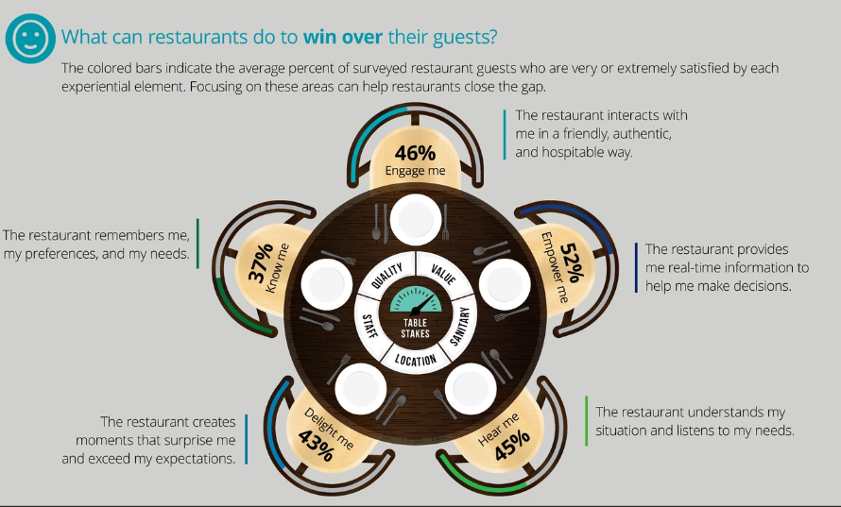
(Deloitte ,2024)
Being able to give customers the opportunity to have a great dining experience is important in the restaurant industry. It allows for repeat customers and helps increase brand name and loyalty as more and more customers will come to the restaurant. The knowledge I have gained through this experience and the communication skills, teamworking skills, and interpersonal skills I have learnt, will help me develop a career in the industry and be an asset to any future employer.
Section 2
I would first ask the kitchen brigade team if it was possible to produce the seafood platter, free of lobster shell, as soon as the request was made by the guests. This will ensure preparation of ingredients and correct order of produce is made for service.
(Hill Street ,2024)
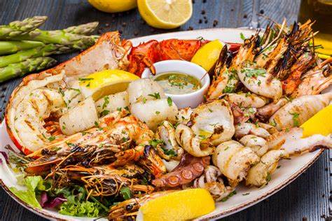
The 2 guests that have ordered a seafood platter on the table of eight will have some additions to the table. For example, there would be a bowl of lukewarm water with lemon juice needed for cleaning fingers, there would also need to be separate cutlery placed on the table such as fish knives and forks. These make it easier to handle and eat the seafood on the platter. There will also be a small bowl for disposing of shells from prawns and mussels. These will be imperative for customer experience and efficiency of service (Placement,2024). The dish will consist of mussels, prawns, lobster meat, snapper meat and scallops. They will be served with additional lemon wedges and lemon herb butter dipping sauce. It will be placed in the middle of the two guests for ease of access.
Another word for lobster is ‘Homard’. Below are instructions I would use for cooking lobster. (Culinary Ambition,2024)
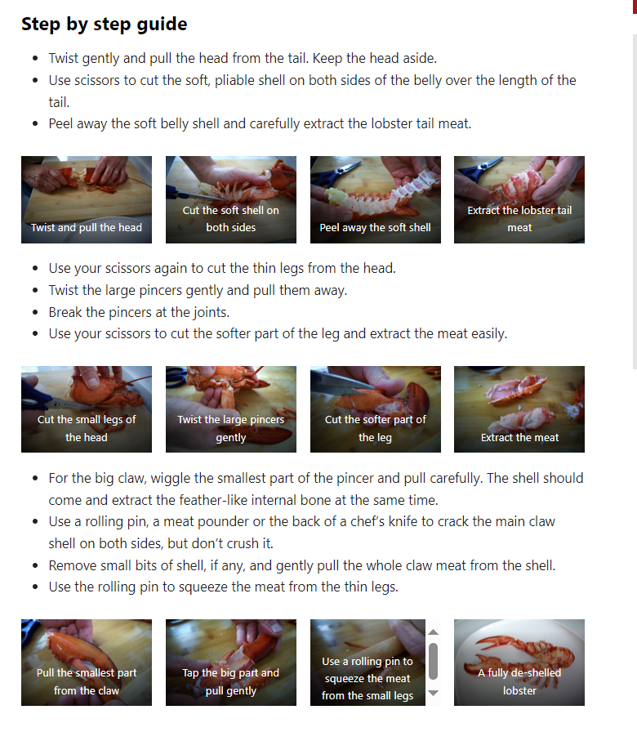
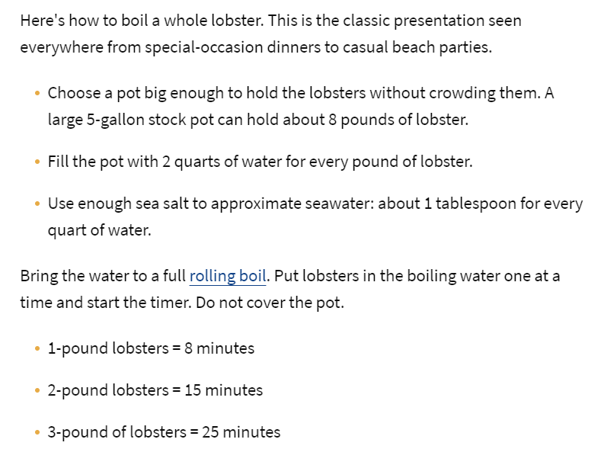
(Greaves, 2020)

Once the lobster is cooked and transferred into ice cold water, all the meat will be removed from the shell and carcass. This is because the guests specified the meat to be removed and not left in the shell. The picture above clearly states how to efficiently remove meat from lobster. This could be a Standard Operating Procedure for correct and consistent completion of this task. Next the mussels will be cleaned and prepared, ensuring the removal of the beards from the mussels. The mussels will then be steamed using water or wine to add flavor until all shells have fully opened. These would take about 3-4 minutes to cook (Stein, 2024). The prawns will be fried with oil for approximately 2 minutes until the meat turns pink (Good Housekeeping ,2015). The scallops will be seared for 1½ minutes each side. It should have ½ cm golden crust on both sides while being translucent in the middle (Food Network,2024). Lastly, the snapper meat will be fried with oil for 2 minutes each side (Shoalhaven,2017).
The knowledge I would need to have when delivering this platter to the customer is the method of cooking. The customer may want to know how the seafood platter was prepared. I would have to have a sound knowledge of this dish and would therefore ask the chefs for clear instructions to reiterate this to the customer. Communication and listening skills are important here as it will increase customer satisfaction and experience. In many cases customers like to ask questions about the dishes they are served, and I would have to be able to answer these questions comprehensively. The questions that may be asked are: “Where did you source your produce from, is it locally sourced?’’ To answer, I would gather information about where it was sourced, was it sustainably caught and whether the company ensure no damage is done to the environment?
To conclude, I have learnt many new skills at The Grove during my kitchen, front of house and management placement. These skills will be invaluable to me when I begin my career in this exciting industry.

References
Brown, D.R. (2019) “How to set up a dinner table”. The Restaurant Managers Handbook. How to set up, Operate, and Manage a Financially Successful Food Service Operation. 5th edition. Florida: Atlantic Publishing Group.
Cousins, J. and Weekes, S. (2020) Food and Beverage Service. ‘A La Carte Menu’. 10th. Place of publication: London: Hodder Education.
Cousins, J. and Weekes, S. (2020) Food and Beverage Service. ‘Napkin Folding Advantages and Disadvantages’. 10th. Place of publication: London: Hodder Education.
Culinary Ambition. (2024) How to de-shell Lobster. Available at: How to De-shell a Lobster - Culinary Ambition (Accessed: 28th February 2024).
Deloitte. (2024) Serving up a Great Restaurant Customer Experience . Available at: Serving up a great restaurant customer experience strategy | Deloitte US (Accessed: 28th February 2024).
Food Network. (2024) How to cook Scallops Available at: Seared scallops Recipe | Food Network UK (Accessed: 28th February 2024).
Greaves, V. (2020) How to cook Lobster. Available at: How to Cook Whole Lobster (allrecipes.com) (Accessed: 28th February 2024).
Good Housekeeping. (2015) How to Cook Prawns. 2015. Available at: Bing Videos (Accessed: 28th February 2024).
HotelTalk. (2022) Restaurant Sequence of Service. Available at: Restaurant Sequence of Service or Service Cycle - HotelTalk - For Hoteliers | Guests | Hotel Management Students (Accessed: 28th February 2024).
Hill Street. (2024) Seafood Platter. Available at: Seafood Platter with Thai Dipping Sauce (hillstreetgrocer.com)(Accessed: 28th February 2024).
Placement Tutor. (2024) 'How to polish cutlery'. BMGM4004: Restaurant Management. The Grove of Narberth. Unpublished.
Placement Tutor. (2024) 'Communicating changes to Chefs '. BMGM4004: Restaurant Management. The Grove of Narberth. Unpublished.
Placement Tutor. (2024) 'Equipment needed for seafood platters '. BMGM4004: Restaurant Management. The Grove of Narberth. Unpublished.
Stein, R. (2024) How to Cook Mussels. Available at: Moules marinière with cream, garlic and parsley recipe - BBC Food (Accessed: 28th February 2024).
Shoalhaven. (2017) How to cook Snapper meat. 2017. Available at: Snapper with Oranges & Capers Recipe, with Rick Stein | Our South Coast | Shoalhaven (youtube.com) (Accessed: 28th February 2024).
The Grove of Narberth. (2024) Table setting. Available at: Photo Gallery | Grove Of Narberth (grovenarberth.co.uk) (Accessed: 20th February 2024).
Welsch, M. (2024) How Escoffier paved the way for A La Carte. Available at: How Auguste Escoffier Paved The Way For A La Carte Dining (tastingtable.com)(Accessed: 28th February 2024).

