University of Wales, Trinity Saint David

AI and Machine Learning (ACCA6011)
Anton Hall 1809131

Contents
1.Task 1 – Depth First Search 1
1.1 User Guide 2
2. Task 2 – K-Means Algorithm Evaluation 4
3. Task 3 – K-Means Algorithm Example 5
References 8
Appendix 1 – DFS Source Code 9
Appendix 2 – K Means manual method 1
Appendix 3 – K means in R 1
Source Code: 1
Elbow Method Results: 2
Results: 2

1.Task 1 – Depth First Search
Depth first search is an algorithm that is used for searching a tree or graph data structure. The algorithm starts at a node then traverses as far as possible along each path before backtracking on itself. The idea of the algorithm is to start from a node, move to any available adjacent node, mark the node as visited, move to any available adjacent node, and continue this until there is no adjacent node available to move to. Then the algorithm will backtrack and check for other unmarked nodes and traverse from there. [1] Norvig and Russel describe Depth First Search as,
“The search proceeds immediately to the deepest level of the search tree, where the nodes have no successors”[2]
To complete task 1 a depth first search algorithm has been developed in the programming language C. A full programme listing can be viewed in Appendix 1. The way to implement the depth first search in a programming language is through the use of a Stack. A stack is an array or list structure where elements are added or removed from the top of the stack in a last in first out order. The important functions used in the C program are:
- Stack.push() – Stores an element in the stack
- Stack.pop() – Removes an element from the stack
- Stack.top() – The top most element of a stack
In the program designed for this task the depth first search is executed inside a while loop. First, we need to initialise the stack with the start position for the depth first search, then we can enter the while loop with the argument of while the stack is not empty do the following. If the Stack is not empty and the current position of the search is not equal to the user input, then the search will loop until one of those arguments in true. After we initialise the stack with the start position, we pop the stack and begin searching for adjacent nodes that are available to us on the map. Any available node gets pushed onto the stack then we pop the stack and repeat the process until everywhere has been searched or a user input selection has been found.

1.1 User Guide
1. Open the Depth First Search Anton Hall.sln in visual studio code.
2. Click on the Local Windows Debugger icon - This will build the program.
3. First you will need to load a floor plan so type 1 and press enter
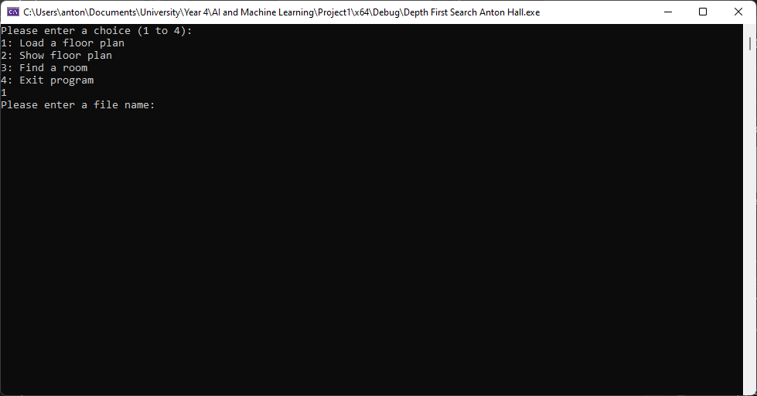
4. Enter the file name. In this case enter FloorPlan.txt
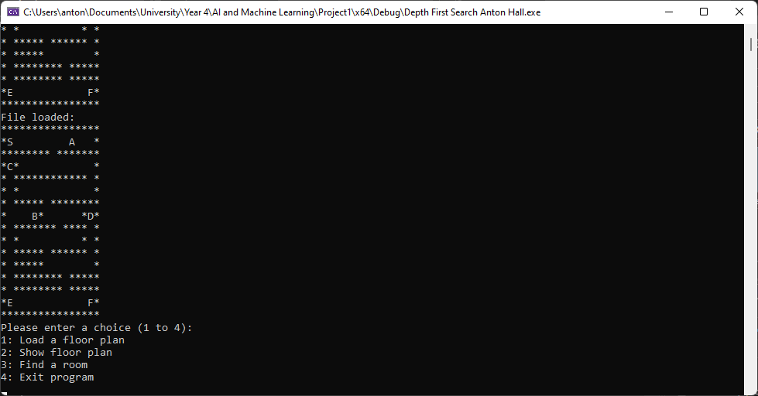
This will load the floor plan and display it to the user.
5. Choose open 2 to view the floor plan:
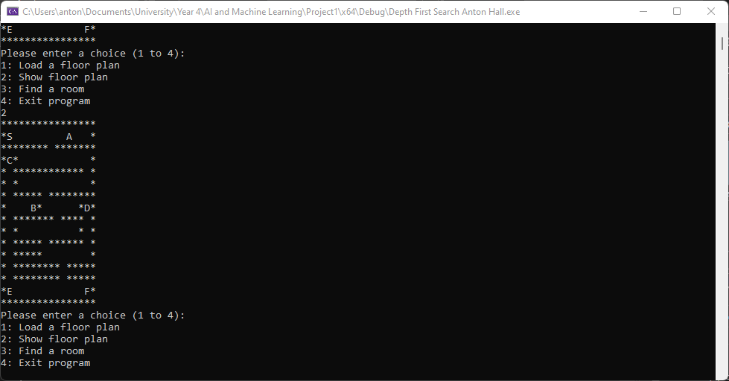
6. Choose option 3 to search for a room on the map:
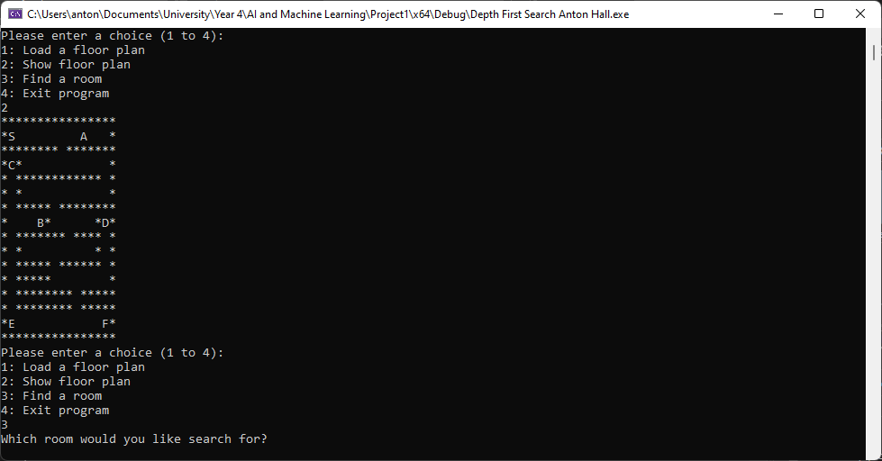
7. Enter the letter of the room you want search for as you see it on the map. The letter B will be used in the example below:
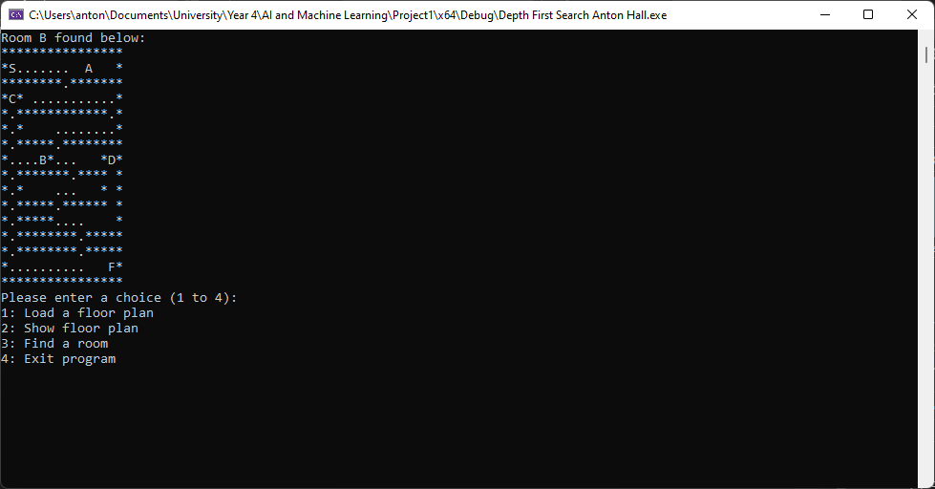
The program will search for the requested room and display the route it took to find that room.
8. Press 4 to exit the program.

2. Task 2 – K-Means Algorithm Evaluation
The K-means algorithm is a machine learning clustering algorithm that is used to partition data into a set of k groups (k-clusters). The number of k groups is pre specified by the user. The main purpose of the algorithm is to classify similar data into clusters which are then represented by its centroid which will correspond to the mean of points assigned to that cluster. [3] “A larger K value will be indicative of smaller groupings with more granularity whereas a smaller K value will have larger groupings and less granularity.” [4]
The K-means algorithm is unsupervised meaning that the algorithm will, “make inferences from datasets using only input vectors without referring to known, or labelled, outcomes.” [5] This means that the algorithm doesn’t need any additional data in terms of pre-defined labels, also meaning there is no additional work required or human intervention which is a huge benefit to the speed in which the k-means can be implemented. Scikit learn define the algorithm as:
“The k-means algorithm divides a set of N samples X into K disjoint clusters C, each described by the mean $μ_{j}$ of the samples in the cluster. The means are commonly called the cluster “centroids”; note that they are not, in general, points from X, although they live in the same space.
The K-means algorithm aims to choose centroids that minimise the inertia, or within-cluster sum-of-squares criterion:
$$\sum_{i=0}^{n}{}\min_{μ_{j}∈C}(||x_{i}-μ_{j}||^{2})$$
“ [6]
There are five steps to implementing the k-means algorithm:
- Choose the number of clusters, k
- Select k random points from the dataset as centroids
- Assign the datapoints to the closest centroid
- Recompute with centroid of newly formed clusters
- Repeat steps three and four until constant centroid is achieved
Although the K-means clustering algorithm is simple and fast there are some weaknesses. It requires the user to choose an appropriate number of clusters in advance, assuming knowledge of the data before running the algorithm. The results are dependent on the selected cluster centres, meaning you could get different results depending on what you initially select. It is also sensitive to outliers. [7] One way to overcome these weaknesses is to use a common industry method to select the k value. It’s referred to as the elbow method and it uses the sum of squared distance to identify an ideal K value based on the distance between the data points. This method displays a chart that resembles an elbow shape, and the user would use this chart to select a value of K where the data begins to flatten out. [8] An example of this can be viewed in appendix 3.

3. Task 3 – K-Means Algorithm Example
This task requires a list of datapoint to be placed into two clusters utilising the k-means algorithm using two, two dimensional centroids as the starting centroid as each cluster.
The new data point labels along with the new centroids are shown below:
X | Y | Cluster
5 | 5 | C2
0 | 5 | C1
2 | 3 | C1
2 | 2 | C1
5 | 1 | C2
3 | 3 | C2
1 | 4 | C1
5 | 3 | C2
1 | 2 | C1
4 | 2 | C2

Final
New Centroids | X | Y
Centroid 1 | 1.2 | 3.2
Centroid 2 | 4.4 | 2.8

The first iteration of the calculation is explained below. The full iterations calculated manually as well as the final calculation completed in R are shown in appendix 2 and 3 respectively.

The data points are as follows:
X | Y
5 | 5
0 | 5
2 | 3
2 | 2
5 | 1
3 | 3
1 | 4
5 | 3
1 | 2
4 | 2

The starting centroids are as follows:
X | Y
4.19 | 2.08
3.35 | 3.81

1. The first step in the calculation is to start calculating the distance from each point to each of the centroids using the Euclidean Distance calculation.
Centroid 1 Distance =SQRT(((B3-$B$15)^2)+((C3-$C$15)^2))
Centroid 2 Distance =SQRT(((B3-$B$16))^2+((C3-$C$16)^2))
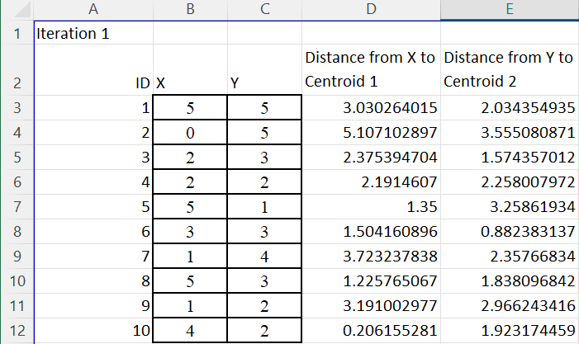
2. Next we need to assign each data point to its nearest cluster, in the above example, data point ID 1 is closest to Centroid 2.
=IF(MIN(D3:E3)=D3,"C1","C2")
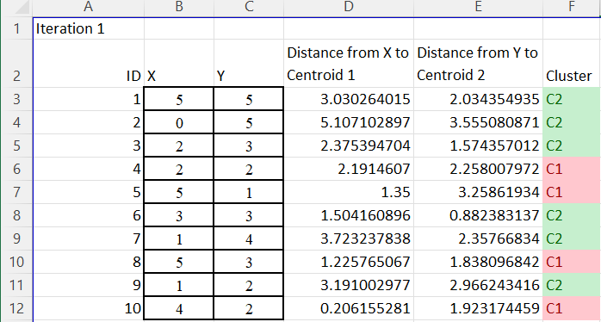

3. Next we calculate the mean of the values of each cluster we have assigned.
X Centroid 1 =(SUMIFS(D3:D12,F3:F12,"C1")/COUNTIFS(F3:F12,"C1"))
Y Centroid 1 =(SUMIFS(E3:E12,F3:F12,"C1")/COUNTIFS(F3:F12,"C1"))
X Centroid 2 =(SUMIFS(D3:D12,F3:F12,"C2")/COUNTIFS(F3:F12,"C2"))
Y Centroid 2 =(SUMIFS(E3:E12,F3:F12,"C2")/COUNTIFS(F3:F12,"C2"))
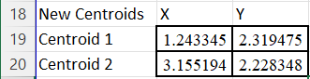
4. We then iterate through this process until using the new centroid in the distance calculation until the centroids calculated are constant.

References
[1] “Depth First Search or DFS for a Graph - GeeksforGeeks.” [Online]. Available: https://www.geeksforgeeks.org/depth-first-search-or-dfs-for-a-graph/. [Accessed: 14-Dec-2021].
[2] S. Russel and P. Norvig, Artificial Intelligence: A Modern Approach.
[3] A. Kassambara, “Practical Guide To Cluster Analysis in R,” Multivar. Anal. I, p. 188, 2017.
[4] “What is Unsupervised Learning? | IBM.” [Online]. Available: https://www.ibm.com/cloud/learn/unsupervised-learning. [Accessed: 14-Dec-2021].
[5] “Understanding K-means Clustering in Machine Learning | by Dr. Michael J. Garbade | Towards Data Science.” [Online]. Available: https://towardsdatascience.com/understanding-k-means-clustering-in-machine-learning-6a6e67336aa1. [Accessed: 14-Dec-2021].
[6] “2.3. Clustering — scikit-learn 1.0.1 documentation.” [Online]. Available: https://scikit-learn.org/stable/modules/clustering.html#k-means. [Accessed: 14-Dec-2021].
[7] “K-Means Clustering in R: Algorithm and Practical Examples - Datanovia.” [Online]. Available: https://www.datanovia.com/en/lessons/k-means-clustering-in-r-algorith-and-practical-examples/. [Accessed: 19-Dec-2021].
[8] “K-Means Explained. Explaining and Implementing kMeans… | by Vatsal | Towards Data Science.” [Online]. Available: https://towardsdatascience.com/k-means-explained-10349949bd10. [Accessed: 19-Dec-2021].

Appendix 1 – DFS Source Code

Depth First Search source code:
//include libraries
#include <iostream>
#include <fstream>
#include <string>
#include <stack>
#include <time.h>

using namespace std;

#define WIDTH 16 //Set width of floor plan
#define HEIGHT 16 //set height of floor plan
typedef struct { //user defined data type
int x;
int y;
}position;
std::stack<position> dfsStack; //initialise stack
char text[WIDTH * HEIGHT]; //initilise text
int loadFile(string); //initilise loadfile
void printArray(void);//initilise printArray
void delay(int milliseconds); //initilise delay

int main(void) //initilise main function
{
int x = 0; //declare variables
int fileLoaded = 0;
char r;
string fname;
while (x < 4) //while x is less than 4 do the following
{
cout << "Please enter a choice (1 to 4):" << endl; //print user input instructions
cout << "1: Load a floor plan" << endl;
cout << "2: Show floor plan" << endl;
cout << "3: Find a room" << endl;
cout << "4: Exit program" << endl;
cin >> x; //store user input
if (x == 1) //user chooses load floor plan
{
cout << "Please enter a file name:" << endl; //ask user for file name of floor plan
cin >> fname; //store file location
if (!loadFile(fname)) exit(0); //call loadfile function, exit if file doesnt exist
fileLoaded = 1;
cout << "File loaded:" << endl;
printArray(); //call print array function to display floorplan

}
if (x == 2 && fileLoaded)//user chooses display floor plan
{
printArray(); //display floor plan if user selects 2

}
if (x == 3 && fileLoaded)//user chooses to find a room
{
cout << "Which room would you like search for?" << endl;
cin >> r; //store user input
cout << "Searching for: " << r << endl; //notifiy user of the room they have selected
delay(500); //delay to screen changing so the user has chance to read

position current; //initialise start position
current.x = 2;
current.y = 1;
dfsStack.push(current); //initialise stack with start position for DFS

position adjPosition; //initialise adjacent position
adjPosition.x = current.x;
adjPosition.y = current.y;

while (!dfsStack.empty() && (text[WIDTH * current.y + (current.x)] != r)) //start DFS loop, while stack is not empty and while current position is not equal to the room being searched
{
system("cls"); //clear screen after each loop
printArray(); //display floor plan
current = dfsStack.top(); //set current position to top of the stack
dfsStack.pop(); //pop the stack

if ((text[WIDTH * current.y + (current.x + 1)] != '*') && (text[WIDTH * current.y + (current.x + 1)] != '.')) //if position right is not a wall or . then move
{
adjPosition.x = current.x + 1;
adjPosition.y = current.y;
dfsStack.push(adjPosition); //push position onto stack
if (text[WIDTH * current.y + (current.x)] != r) { //check current position is not the room being search before overwriting
text[WIDTH * current.y + (current.x)] = '.';
}
}

if ((text[WIDTH * current.y + (current.x - 1)] != '*') && (text[WIDTH * current.y + (current.x - 1)] != '.'))//if position left is not a wall or . then move
{
adjPosition.x = current.x - 1;
adjPosition.y = current.y;
dfsStack.push(adjPosition);//push position onto stack
if(text[WIDTH * current.y + (current.x)] != r){//check current position is not the room being search before overwriting
text[WIDTH * current.y + (current.x)] = '.';
}
}

if ((text[WIDTH * (current.y - 1) + (current.x)] != '*') && (text[WIDTH * (current.y - 1) + current.x] != '.'))//if position up is not a wall or . then move
{
adjPosition.x = current.x;
adjPosition.y = current.y - 1;
dfsStack.push(adjPosition);//push position onto stack
if (text[WIDTH * current.y + (current.x)] != r) {//check current position is not the room being search before overwriting
text[WIDTH * current.y + (current.x)] = '.';
}
}

if ((text[WIDTH * (current.y + 1) + (current.x)] != '*') && (text[WIDTH * (current.y + 1) + (current.x)] != '.'))//if position down is not a wall or . then move
{
adjPosition.x = current.x;
adjPosition.y = current.y + 1;
dfsStack.push(adjPosition);//push position onto stack
if (text[WIDTH * current.y + (current.x)] != r) {//check current position is not the room being search before overwriting
text[WIDTH * current.y + (current.x)] = '.';
}
}
}
cout << "Room " << r << "found below:" << endl;// notify the room has been found
printArray();// print floor plan with route
}
}
}

int loadFile(string fileName) //initialise load file function
{
string line;
ifstream myfile(fileName);
if (myfile.is_open())
{
int count = 0;
while (getline(myfile, line))
{
cout << line << endl;

line.copy(&text[WIDTH * count], WIDTH, 0);
count++;
}
myfile.close();
return 1;
}
else return 0;
}

void printArray(void) // initialise printArray function
{
for (int y = 0; y < HEIGHT; y++)
{
for (int x = 0; x < WIDTH; x++)
{
cout << text[WIDTH * y + x];
}
cout << endl;
}
}

void delay(int milliseconds)// initialise delay function
{
long pause;
clock_t now, then;

pause = milliseconds * (CLOCKS_PER_SEC / 1000);
now = then = clock();
while ((now - then) < pause)
now = clock();
}

Appendix 2 – K Means manual method
Full K means algorithm in excel
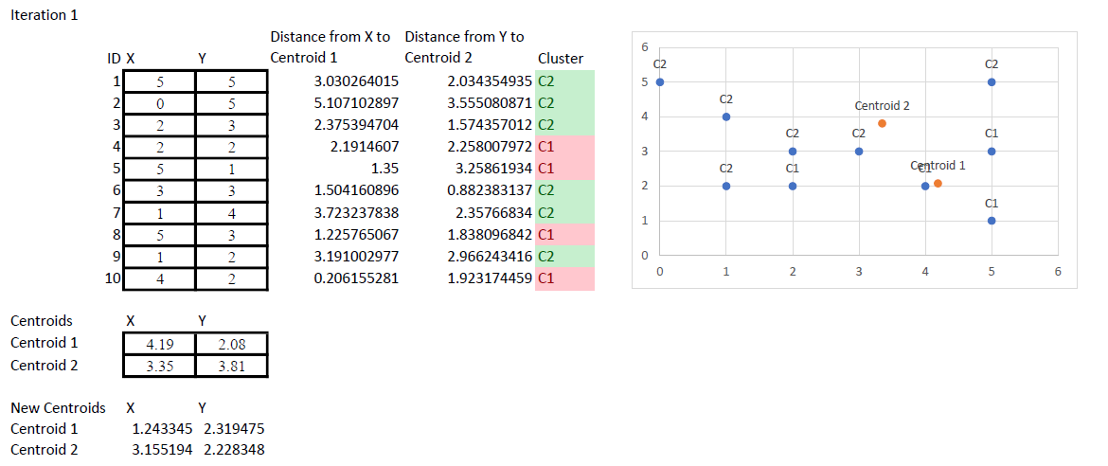

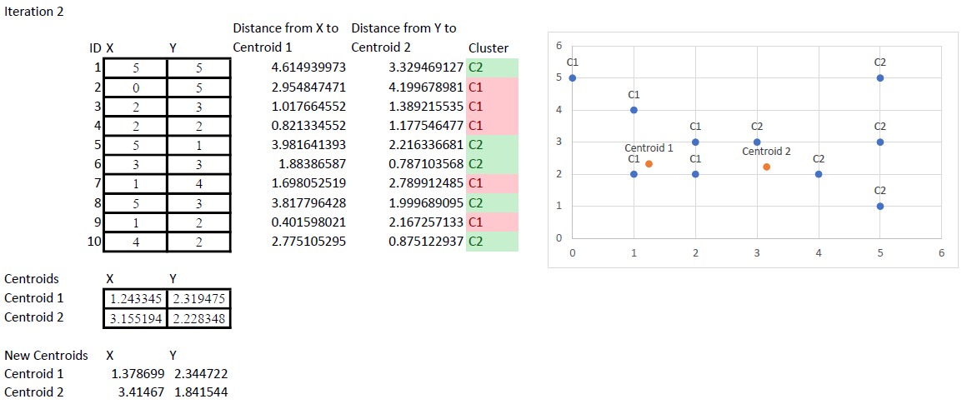

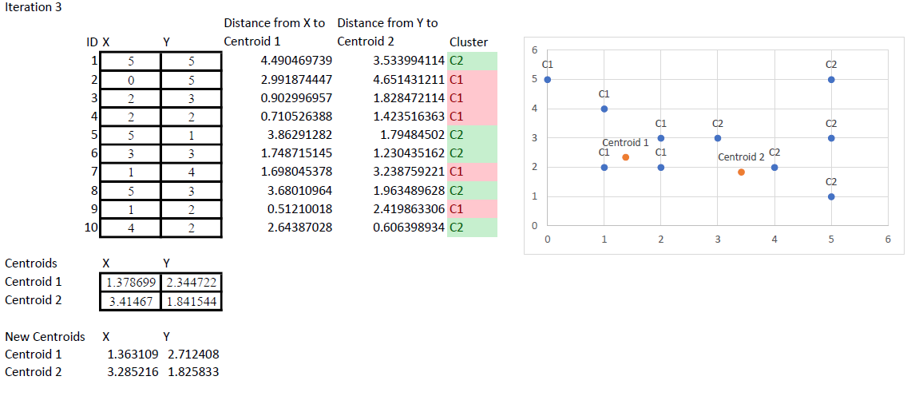

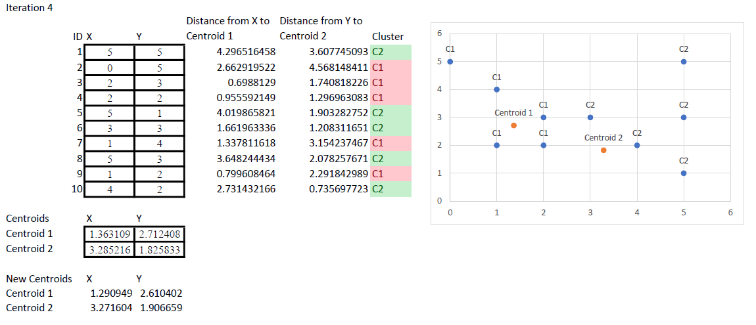

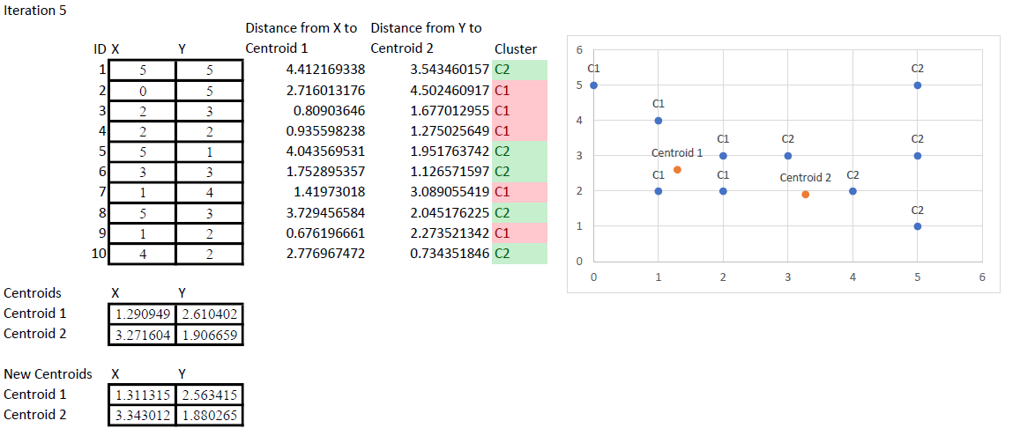

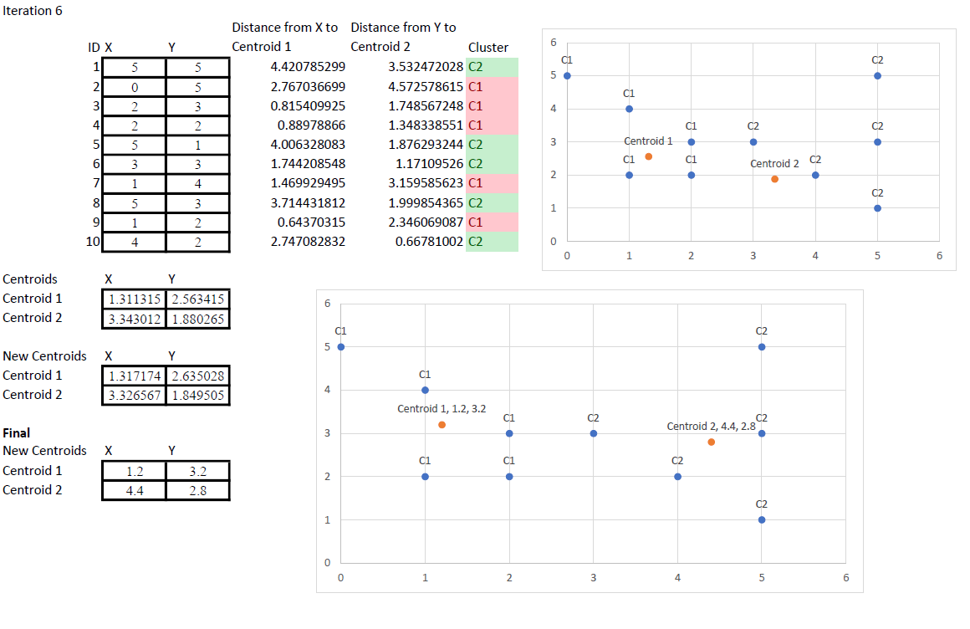

Appendix 3 – K means in R

R studio K means final solution

Source Code:
# load required packages
library(factoextra)
library(NbClust)

K.means.data <- read.csv("~/University/Year 4/AI and Machine Learning/K means data.csv") #read data to data frame
View(K.means.data)

plot(K.means.data)#plot data

fviz_nbclust(K.means.data, kmeans, k.max = 9, method = "wss") +
geom_vline(xintercept = 2, linetype = 2) #calculate elbow method

k2 <- kmeans(K.means.data, centers = 2, nstart = 25)
str(k2) #calculate k.means

k2
fviz_cluster(k2, data = K.means.data) #plot k means results

Elbow Method Results:
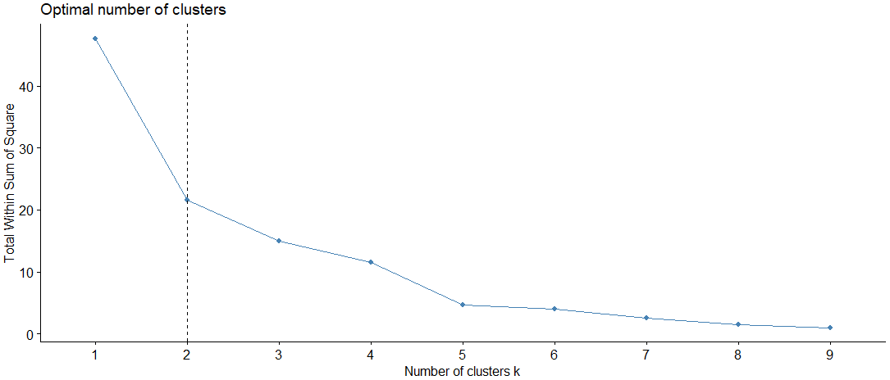

Results:
> # load required packages
> library(factoextra)
> library(NbClust)
>
> K.means.data <- read.csv("~/University/Year 4/AI and Machine Learning/K means data.csv") #read data to data frame
> View(K.means.data)
>
> plot(K.means.data)#plot data
>
>
> fviz_nbclust(K.means.data, kmeans, k.max = 9, method = "wss") +
+ geom_vline(xintercept = 2, linetype = 2) #calculate elbow method
>
>
> k2 <- kmeans(K.means.data, centers = 2, nstart = 25)
> str(k2) #calculate k.means
List of 9
$ cluster : int [1:10] 2 1 1 1 2 2 1 2 1 2
$ centers : num [1:2, 1:2] 1.2 4.4 3.2 2.8
..- attr(*, "dimnames")=List of 2
.. ..$ : chr [1:2] "1" "2"
.. ..$ : chr [1:2] "x" "y"
$ totss : num 47.6
$ withinss : num [1:2] 9.6 12
$ tot.withinss: num 21.6
$ betweenss : num 26
$ size : int [1:2] 5 5
$ iter : int 1
$ ifault : int 0
- attr(*, "class")= chr "kmeans"
>
> k2
K-means clustering with 2 clusters of sizes 5, 5

Cluster means:
x y
1 1.2 3.2
2 4.4 2.8

Clustering vector:
[1] 2 1 1 1 2 2 1 2 1 2

Within cluster sum of squares by cluster:
[1] 9.6 12.0
(between_SS / total_SS = 54.6 %)

Available components:

[1] "cluster" "centers" "totss" "withinss" "tot.withinss" "betweenss" "size" "iter" "ifault"
> fviz_cluster(k2, data = K.means.data) #plot k means results


