Developing a new landscape for customer care
Executive summary
According to the influence of COVID-19, this report focuses on the strengths, weaknesses, opportunities and threats of Hilton Global Holdings through SWOT analysis. The results showed that its main strengths include Multi-Brand Portfolio Strategy, loyalty program and high-cost efficiency, while its Over-reliance on the U.S. market and Deficit of working capital remain the weaknesses of the company. However, Expansion strategy, Cooperation agreement and the reshuffling of the hotel industry market in the post-epidemic period may provide new opportunities for the company. In the future, the impact of COVID-19 on the global economy, Intense competition and currency risk may affect the operating performance of the company. Finally, I put forward my own feasible suggestions on the customer care strategies proposed by Hilton this year, such as putting forward CleanStay to dispel customers' worries about COVID-19, upgrading loyalty plans and extending the validity period of points, so that the interests of loyal customers can be guaranteed during the epidemic.
1.Introduction
As the main resting place for people to go out for work or travel, the development of hospitality industry has entered a new period (Sun, 2019, p. 2). However, the hotel industry is undergoing a global restructuring under the influence of COVID-19. Therefore, if the hotels want to survive the crisis, it needs to put forward a strategy based on customer care. Customer care is based on the need of customers to make actions. Even small actions, as long as they can meet customer needs, are successful. So as to achieve the purpose of reducing customer losses, improving customer loyalty and prolonging customer life cycle (Dowling and Uncles, 1997, p. 4).
This report takes Hilton Worldwide Holdings as a case to analyze its customer care strategy. Hilton Global Holdings, formerly known as Hilton Hotels Group, is a multinational hotel management company founded in 1919 by Conrad Hilton's acquisition of the Cisco Mobley Hotel in Texas (Marketline, 2020). After 100 years of growth and development, Hilton Worldwide Holdings has covered 118 countries around the world, covering cities on five continents, managing more than 6,300 hotels, with nearly 1 million hotel rooms in the world, and owning 18 brands, including CONRAD, an ultra-luxury hotel providing the highest level of service, and Hilton, WALDORF ASTORIA, etc (Hilton Worldwide Holdings Inc, 2020). Now, Hilton provides excellent customer service with great enthusiasm, which has won recognition and appreciation from all over the world.
However, the global hotel industry has been fatally hit by COVID-19, and Hilton is no exception. According to the financial report of the third quarter of 2020 on Hilton official website, the revenue of Hilton in the third quarter was 933 million, declined 59% compared to the same period last year, and the net profit was -79 million, declined -127% compared to the same period last year (Hilton Worldwide Holdings Inc, 2020). In response to the negative impact of the global crisis, Hilton announced at the end of March that it would suspend all stock repurchase and distribute dividends. Starting from April 4 this year, some Hilton employees will be able to take a 90-day vacation while still enjoy medical benefits; Employees who have not taken leave will have their pay reduced by up to 20 percent during the crisis of public health events (Donna M Airodi, 2020).
Faced with serious losses, Hilton has also proposed various customer care strategies to meet the needs of customers at the present stage and improve customer satisfaction.
2.SWOT Analysis
As is known to all, Hilton Worldwide Holdings (HWHI) is an internationally recognized hotel management company with 18 outstanding hotel brands in 118 countries around the world (Hilton Worldwide Holdings Inc, 2020). This report will analyze the internal strengths and weaknesses of the company as well as external opportunities and dangers through SWOT analysis. The analysis is shown below.
2.1Strengths
2.1.1Multi-Brand Portfolio Strategy
According to the latest news from Hilton Worldwide Holdings official website, as of October 31, 2020, Hilton Worldwide has a portfolio of multi-portfolio and operates in 118 countries around the world, with nearly 1 million rooms. In order to meet the needs of different customer groups in the world (Hilton Worldwide Holdings Inc, 2020), Hilton adopts the multi-brand portfolio strategy for market segmentation (Marketline, 2020). This company has a portfolio of 18 well-known bands covering the major business customers and a large number of tourists in the world. In the luxury segment, Waldorf Astoria Hotels & Resorts, and Conrad Hotels & Resorts are the two well-recognized brands, which target the affluent group of the society. Hilton Hotels & Resorts and Embassy Suites Hotels are representatives of upper upscale segment. Doubletree by Hilton, Hilton Garden Inn, and Homewood Suites by Hilton constitute the mid-to-high-end market of Hilton, which provides travelers with home-like accommodation to extend their stay. In recent years, Hampton by Hilton aims at leisure travelers who are exploring the mid-market and developed budget hotels in Asia Pacific. Hilton Grand Vacations is Hilton's timeshare brand (Marketline, 2020). Almost every brand corresponds to a segment of the market. By classifying guests' identities, hobbies, hotel locations and sizes, Hilton provides guests with professional and thoughtful hotel services, thus increasing Hilton's market share in the global hotel market. Among the many hotels owned by Hilton, there always seems to be one type of hotel, one place to meet the needs of all guests.
The multi-brand portfolio strategy enables companies to develop products related to a specific market segment, generate economies of scale in advertising, sales and merchandising, distinguish their products from peers, and increasing brand awareness and brand recall rate (Andrew, 2002, p20). In addition, it helps Hilton attract new customers, thus increasing its customer base and gaining a competitive advantage.
2.1.2Loyalty Programs
Customer satisfaction measures customers' expectations and feelings, while loyalty reflects the future purchasing actions and commitments of customer. Customer satisfaction surveys reflect customers' opinions and thoughts on past purchasing experiences and can only reflect past behaviors rather than be a reliable forecast of future behaviors. Loyalty surveys, on the other hand, can predict what products customers want to buy, when they want to buy them, and how much revenue those purchases generate (Shankar, 2003, p. 3). There may not be a direct link between customer satisfaction and the actual purchase behavior of customers, because satisfied customers cannot guarantee loyalty to the company forever, thus resulting in repeated purchase behavior. But there is no denying that customer satisfaction is the most important factor leading to repeat purchase. When customer satisfaction reaches a certain height, loyalty will be greatly improved (Fornell, 1992, p. 16).
Therefore, Hilton provides customers with loyalty programs, not only to ensure the specific rights and interests of customers, but also for the long-term development of the company. Hilton HHonors is a customer loyalty program of Hilton, which operates under the company's 18 hotel brands. As long as spending is generated in any Hilton hotel in the world, the program provides points for all members to stay. Thus, a large number of repeat customers are created to get points, which can be exchanged for a free hotel stay and other rewards. HHonors Members can also earn points through more than 140 partners, including credit card providers, airline companies, railway companies and others (USNewsTravel, 2020). The program offers targeted marketing, promotion and customized guest experiences to about 110 million members, who account for 62 percent of their total hotel occupancy in 2019 (Zacks Equity Research, 2020).
Loyalty programs encouraged HHonors members to allocate more travel expenses to hotels, which in turn improved customer satisfaction.
2.1.3Cost Efficiency
The financial report released by Hilton in 2019 shows that the cost efficiency of Hilton Worldwide Holdings has improved. Hilton Worldwide Holdings' operating costs accounted for 82.5% of revenue in 2019, while this figure was 83.9% in 2018. This is because the revenue of the company increased from $8.906 billion in 2018 to $9.452 billion in 2019, an increase of 6.1%. At the same time, we can also see from the financial report that the improvement of cost-to-sales ratio leads to the improvement of operating profit margin. The increase in revenue was due to an increase of 7.3% in management and franchise revenue. Operating profit margin increased from 16.1% in 2018 to 17.5% in 2019. The company's strong operating profit margin can be attributed to the optimal pricing strategy and operational efficiency. It also shows that the company has the ability to create value for shareholders and fulfill its obligations to creditors with active operating cash (Hilton Worldwide Holdings, 2019, 2020).

2.2Weaknesses
2.2.1Over-reliance on the US market
Although Hilton is a global company with different businesses in 118 countries around the world, according to the data of Marketline research report, most of Hilton's revenue comes from the United States. For example, 78.5% of the revenue of Hilton in 2019 comes from the United States. Although the United States is the headquarters of Hilton, such a large proportion of revenue from the United States will increase the operational risk of Hilton. If there are any factors that are not conducive to economic and political stability in the United States, this geographical dependence will increase the company's losses in the region. That is, as economics warns investors, don't put all your eggs in the same basket.
2.2.2Deficit of working capital
Hilton reported a working capital deficit of $778 million in 2019 and $632 million in 2018. This is because the total current liabilities are higher than the total current assets. The current assets of the company increased from $1.983 billion in 2018 to $2.093 billion in 2019, an increase of 5.5%, while current liabilities increased from $2.615 billion in 2018 to $2.871 billion in 2019, an increase of 9.8% (Hilton Worldwide Holdings, 2019, 2020). The deficit of working capital will increase the company’s financial risk, fund-raising risk and other issues, and the company's heavy debt will affect its reputation. More importantly, the deficit of working capital will affect the stock price of the company and the stability of paying stock interest, and investors will lose confidence in the company.

2.3Opportunities
2.3.1Expansion strategy
Hilton adopts an expansion strategy to expand its share in the global market, and also to reduce its dependence on the U.S. market. In this direction, Hilton will launch Las Vegas multi-brand resort in Las Vegas in February 2020. In October, 2019, Hilton launched three brands in the Spanish capital, namely the crown of Hilton Castellana Madrid, Metropolitan Hotel Madrid and Atocha Hotel Madrid. At the same time, the company's Hilton tapestry series has opened a canvas Moncton brand in Canada. In April this year, the company also announced the opening of the world's largest Hilton Garden Hotel in Saudi Arabia. These expansion strategies are conducive to Hilton's expansion of its business. It also shows that even under the influence of the COVID-19, the expansion strategy is being carried out, which gives the hotel market certain confidence. At the same time, the increased proportion of hotel rooms outside the US market expanded the geographical distribution of Hilton Hotels and reduced the company's dependence on the US market. (Hilton Worldwide Holdings, 2019, 2020).
2.3.2Cooperation agreement
In 2019, Hilton has reached cooperation agreements with many companies, which will improve the company's performance through collaborative management. In December 2019, the company signed an agreement with Knowledge Economy City Company to operate and manage 300 DoubleTree at Hilton Medina Gate (Sam, 2019), and signed a franchise agreement to represent the brand's debut in the Caribbean and Latin America at Hilton New Motto Hotel in Lima, Peru (Travelweek, 2020). In March 2019, the company signed a partnership with Hilton and Shomoul to develop and operate four landmark hotels in Avenues in Riyadh (Hilton Worldwide Holdings Inc, 2019). The cooperation agreement can not only enable the company to seize the local market, but also improve the company's popularity and establish a good reputation. While reducing unnecessary competition with each other.
2.3.3Market Reshuffle
COVID-19 will deeply influence the composition of the global hotel industry. The chain hotel brands may be the main hotel management mode that the hotel industry will adopt in the future (Dassen,2020). Take China's hotel market as an example, almost 80% of China's hotel industry consists of independent hotels, and only about 20% of hotels are operated by chain hotel brands (OYO, 2019). Due to the COVID-19, independent hotels may be more severely affected than other actors; this is because hotel chains are inherently more vulnerable to disasters than hotel chains (Zhou, 2020). Their management is disorganized; the quality of service is unstable; poor hygiene conditions; low customer loyalty; unprofessional cost control; and even unqualified fire, sanitation, security (China Hospitality Association ,2020). However, during the pandemic, international brand chains such as Hilton became more competitive due to their business model, disaster management mechanisms and operational proficiency. Therefore, the large hotel chain with abundant resources will be the final winner of the hotel industry after getting out of the epidemic.
2.4Threats
2.4.1Coronavirus Impact
COVID-19 in 2019 is the most destructive and observable of all the observed impacts on human health (Hao, 2020, p1). It has caused huge human losses, however, the ongoing economic disaster caused by this epidemic makes the latter different from any disaster in life memory (Huang, 2020). Necessary protective measures, such as isolation, blockade, isolation and social distance, to curb the spread of the virus have seriously affected economic activities. Since the outbreak of COVID-19 at the end of 2019, almost all industries have been plagued by uncertainty, which has affected international economic and trade activities, from tourism and hospitality, medical supplies and other global value chains, consumer electronics and financial markets to energy, transportation, food and various social activities, especially in the tourism and hotel industry (Gallen, 2020). According to the current pandemic situation and the containment measures that most countries need to take in the third quarter. The global growth will be -4.4% in 2020 and 2.8% in 2019. If the epidemic lasts longer this year, it is predicted that the growth will drop by another 3% in 2020, and if it lasts until 2021, the global economy may drop by 8%. It is estimated that the growth rates of advanced economies, emerging market economies and developing economies will be -5.8% and -3.3% respectively in 2020, and 1.7% and 3.7% respectively in 2019 (International Monetary Fund, 2020). The epidemic has led to the closure of bars, clubs and restaurants around the world. As an industry based on human mobility and close interaction, tourism and hotel industry are the co-creators and main recipients of this epidemic and its impact (Gallen, 2020). HWHI, which exists in the accommodation industry, may find its business and financial situation affected by this epidemic.
Under the influence of COVID-19, the global hotel industry has suffered a fatal blow, and Hilton is no exception (Hakseung, 2020). According to the financial report of the third quarter of 2020 on Hilton official website, the revenue of Hilton in the third quarter was 933 million, declined 59% compared to the same period last year, and the net profit was -79 million, declined -127% compared to the same period last year (Hilton Worldwide Holdings Inc, 2020). In response to the negative impact of the global crisis, Hilton announced at the end of March that it would suspend all stock repurchase and distribute dividends. Starting from April 4 this year, some Hilton employees will be able to take a 90-day vacation while still enjoy medical benefits; Employees who have not taken leave will have their pay reduced by up to 20 percent during the crisis of public health events (Hilton Worldwide Holdings Inc, 2020).
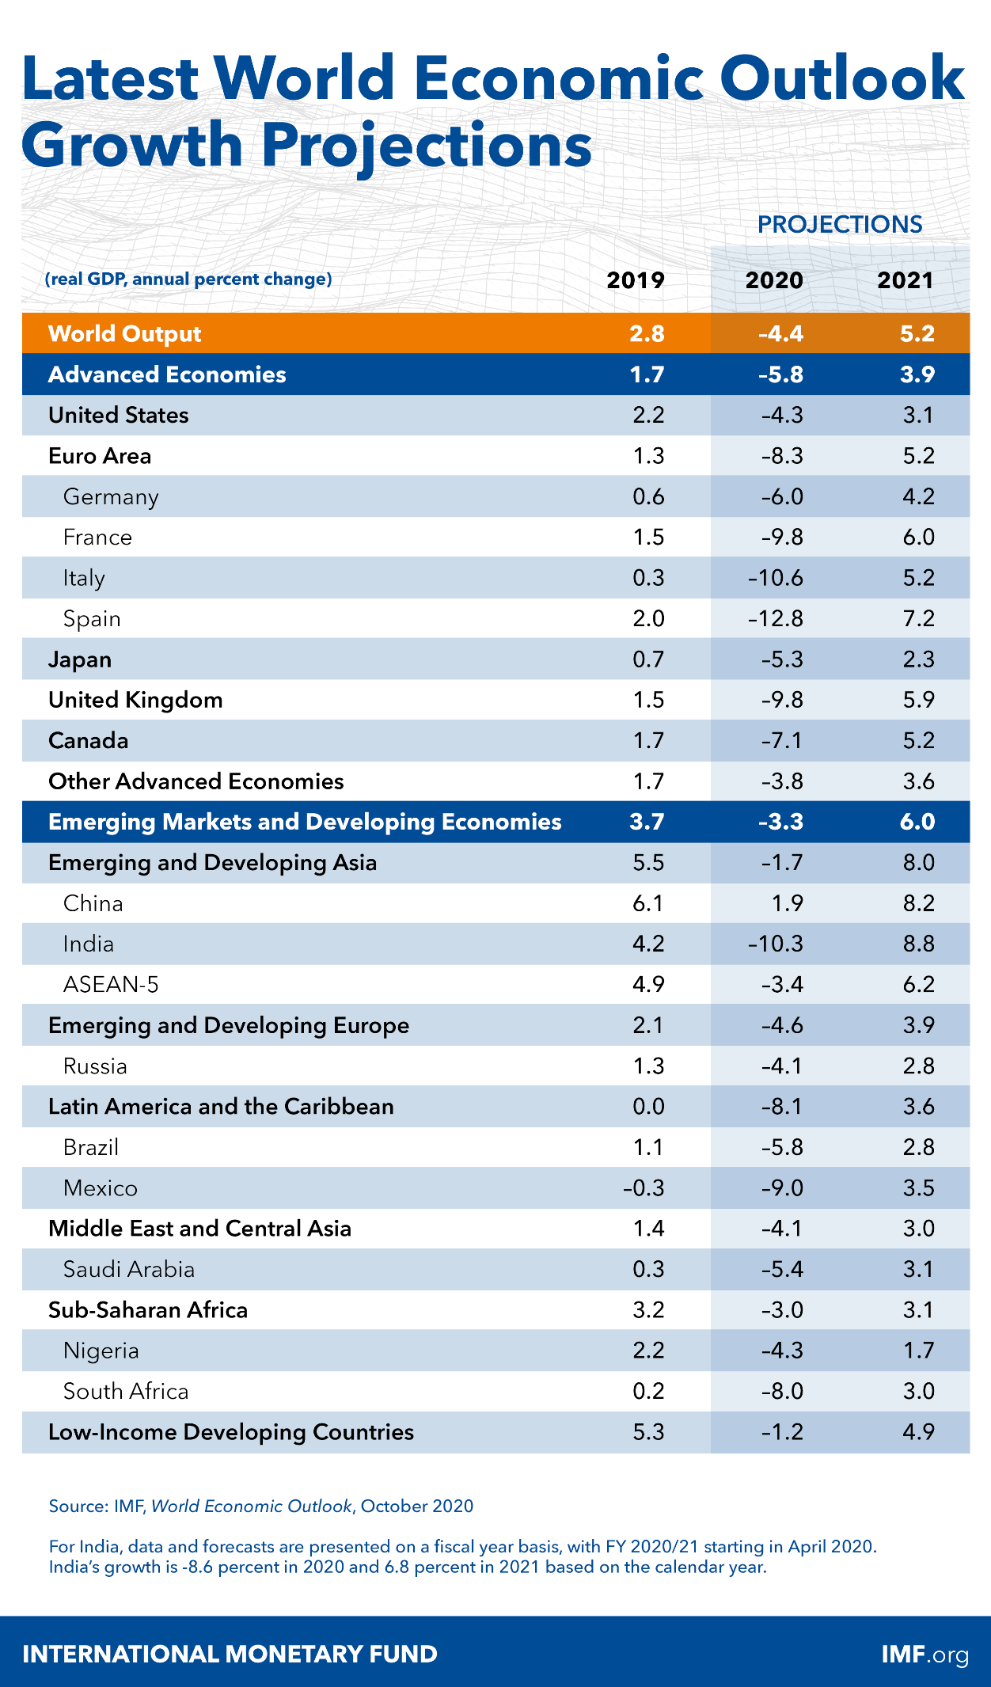
2.4.2Intense competition
Hilton has many competitors. This is due to the huge market of hotel industry, which is characterized by numerous participants. These include hotels of the same level as Hilton, such as Marriott International and Hyatt Regency. There are also many cheap hotels that occupy a part of the market. More importantly, the existence of a shared hotel like Airbnb has a great impact on Hilton. But now, due to the impact of the COVID-19, Airbnb has been hit hard by tourism stagnation and health problems. In addition, some competitors of the company have greater financial firepower, which gives them greater purchasing power, greater financial flexibility and more capital resources to expand and improve, so that they can compete with Hilton more effectively. The trend of intensified competition in the hotel industry may affect Hilton's charge structure and force the company to lower its charges or prices. (marketline, 2020)
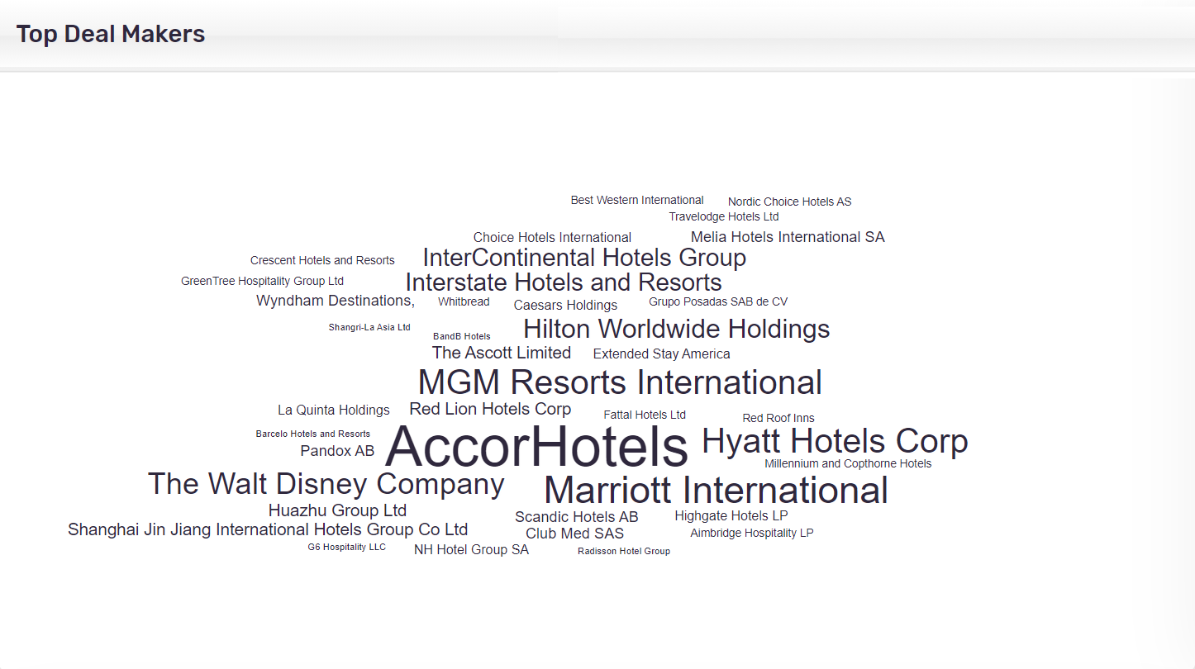
Source：Marketline
2.4.3Currency Risk
In 2020, the company reported the currency risk in the financial report, which reduced the ownership department's retirement (Hilton Worldwide Holdings Inc, 2020, Q3). This is because Hilton Worldwide Holdings is a global company, and its business covers five continents, so its income will be affected by the value of local currency. Its business is conducted in multiple currencies, which results in currency risk. Adverse changes in currency will directly affect the company's actual income, thus affecting the company's profitability. More importantly, the value of the company's equity investment abroad may fluctuate according to the change of foreign currency exchange rate.
3.The Customer Care Strategy
Since the outbreak of new crown pneumonia in late 2019, as an industry based on mobility and close interaction, tourism and hospitality are co-creators and principal recipients of the epidemic and its consequences (Galen ,2020). As an internationally renowned hotel management company, Hilton has also provided relevant strategies to improve customer satisfaction in response to the epidemic.
3.1Hilton CleanStay with Lysol protection
COVID-19 has had a disastrous negative impact on the global hotel industry. Most countries have taken preventive measures, such as isolation, keeping social distance and closing unnecessary gathering places, such as cinemas. This is because many countries lack testing facilities, and scientists are still studying vaccines to prevent COVID-19. Eventually, COVID-19 caused all hotels and resorts to be empty. Therefore, under this situation, consumers pay close attention to the sanitary condition of hotels, and establishing a high-level cleaning mechanism is very important for the recovery of the hotel industry.
Therefore, Hilton has designed a strict hygiene system for its clients, named Hilton CleanStay with Lysol Protection (Hilton Worldwide Holdings Inc, 2020), which is designed to provide assurance and peace of mind for guests. Combining the professional knowledge and scientific methods of Reckitt Benckish in the field of disinfection, and the guidance of experts from the infection prevention and control team of Mayo Clinic, Hilton CleanStay will provide a perfect solution for the disinfection process of the hotel.
It is reported that Hilton CleanStay was announced in June this year and will be implemented in all Hilton hotels. The specific operating standards of the project are as follows: ①After the room is thoroughly cleaned, the cleaners will put a sealing strip on the door to ensure that the next guest stays. No one else enters before; ②After 10 o'clock every night, the hotel will disinfect again in the most frequently contacted areas, such as light switches, door handles, TV remote controls and other places that are exposed to high frequencies; ③Reduce the use of pens and paper in the front desk and guest rooms, and replace the use of these items with other digital methods; ④Focus on the fitness center and strictly implement the disinfection guidelines of the fitness center, that is, disinfect many times a day to control the number of guests in the fitness center; ⑤Improve the cleaning frequency of public areas; ⑥Disinfection stations shall be set up in areas with high traffic such as main entrance and elevator, so that guests can wipe the button before entering the door or pressing the elevator; ⑦Innovative disinfection: Hilton Hotel is exploring new technologies, such as using electrostatic spray and ultraviolet lamp to disinfect the surface.

3.2Loyalty program
Hilton Loyalty program for about 40 million members of the targeted marketing, promotion and customization of the guest experience, and in the face of COVID-19 almost a devastating impact on the global hotel industry, almost all of the hotels, motels and resorts are completely empty, Hilton also member of the hotel to upgrade the existing Loyalty program, for 2019 distinguished membership relegation standard members to extend the membership will be valid until March 31, 2022, the measure would greatly degree of retain the loyal customers, because this strategy to a certain extent, retained the rights and interests of clients It will enhance customer experience and ultimately enhance customer loyalty. (Victoria M. W, 2020)
4.Critical evaluation of the strategic options
4.1Loyalty program
Loyalty programs are designed to improve customer care. They have two main purposes. The second is to capture consumer data with the support of big data. The first is to stimulate sales, extend the relationship between customers and the brand, and reduce customer turnover to achieve the ultimate profit increase.
Customized according to consumers' preferences, very timely and valuable in content, to provide different targeted marketing communication, according to the behavior of consumers to optimize browsing or buying experience, from the side to enhance sales.
In response to the epidemic, Hilton should cooperate with more industry enterprises. The acquisition of points should not be limited to staying in Hilton hotels. Hotels can cooperate with specific aviation enterprises, and one air flight can also be changed into Hilton Hotel points. In cooperation with scenic spots, admission fees can also be points, etc. Hilton also can use in the cooperative enterprise, integral for air tickets, attractions tickets, etc. to take the way of cooperation with other enterprise, mutually beneficial win-win, consumers can produce more of the consumer with a double integral, loyalty programs have evolved to award scheme, is to encourage more consumption, rather than to force on a single brand loyalty.
Take Asia miles for a example，Asia miles was in cathay Pacific airways flight rewards programs (Michael, 2020), from two years ago as an independent brand, evolved into the brand of the incentive plan every day, in addition to reward your book ticket (shopping) + aircraft flight consumption, anything else will reward behavior: booking hotel or Shanghai tao, specify restaurant consumption and even go to the supermarket to buy food, can get the corresponding mileage of the plane. The program is well known in Hong Kong, with 4 million members, one out of every two Hong Kongers, and its penetration rate is very high.
Therefore, Hilton's current loyalty program is only limited to obtaining customer data and maintaining customer loyalty to the hotel. If it can be upgraded to a reward program, it will drive consumption and improve hotel occupancy rate under the impact of the current epidemic.

4.2 AI customer service
In the post-epidemic era, consumer demands are increasingly diversified, and smart technology is the gold standard for winning the tourism market today. The introduction of AI customer service as a part of hotel management by international hotels is in line with the future development trend of digitalization and mobility, which has always been the direction of Hilton to create excellent experience for guests. In order to win the favor of consumers, Hilton to get through all means, so that guests in the mobile phone mobile terminal can also enjoy the hospitality of Hilton excellent service. For example, since 2017, Hilton's official customer service team has cooperated with major social media platforms in China to provide online customer service services to provide a full range of customer experience services. Especially in the post-epidemic era, tourists are more dependent on online services and authoritative information, and spend more time using online resources to choose tourist destinations and products, so as to better experience offline services. Consumers are more likely to trust digital platforms directly owned by enterprises. For the hotel industry, how to flexibly use its own online platform to communicate effectively with consumers also puts forward higher requirements for the hotel industry to continuously develop convenient and efficient online services in the future. In the future, hotel AI customer service will not only deal with core business problems, but also develop intelligent language chatting ability, life assistant function, life entertainment interaction, anthropomorphic emotion and other functions.
4.3 Smart Rooms
In order to enhance the customer's room experience, similar to the Internet of Things in the home, Hilton can develop a "Smart Room" strategy, cooperate with various mobile Internet companies (such as Samsung and Legrand), and launch the Internet of Things room technology exclusive to Hilton, which can adopt voice and mobile activation technology to provide guests with a high level of control and personalized experience, so that customers can feel at home at Hilton.
For example, Smart Room Virtual Voice Assistant can provide guests with various information, such as weather forecast, driving navigation, etc., and can also help guests arrange trips and book restaurants, etc. To provide more intelligent customer care, for example, guests can experience more intelligent and personalized service in the guest room. For example, set the room environment in advance according to the member information and guest reservation information, and update the settings in real time: the TV channel of the business traveler's room will be directly set as financial news; After returning to the r
4.Conclusion
The purpose of this report is to propose a better customer care strategy for Hilton Worldwide Holding under the influence of COVID-19. First of all, this report uses SWOT analysis, focusing on the strengths, weaknesses, opportunities and threats of Hilton. Multi-brand strategy and hotel mix, loyalty plan and high-cost efficiency are the main advantages of Hilton, while over-reliance on the US market and its working capital deficit are still the weaknesses of Hilton. However, strategic initiatives and strategic agreements and the restructuring of the hotel industry market in the post-epidemic era may provide new growth opportunities for the company. In the future, the impact of coronavirus on the global economy, fierce competition and currency risk may affect the company's operating performance. Secondly, in the face of the disastrous impact of the epidemic, Hilton also put forward the upgrade policy of Hilton CleanStay and Loyalty program, which can dispel customers' worries about COVID-19, upgrade loyalty plan and extend the validity period of points, so that the interests of loyal customers can be guaranteed during the epidemic. However, the impact of COVID-19 epidemic may be long-term, and Hilton should make strategies response for long-term isolation and social distance.
5.Recommendations
According to the threats Hilton is facing now, this report puts forward some suggestions including upgrading loyalty programs, AI customer service and Smart Room. The purpose of upgrading loyalty programs is to guarantee the rights and interests of customers in this special period and reduce the loss of customers. The AI customer service policy is in line with the development trend of digitalization and mobility in the future, and also provides the ultimate customer care. Smart Room can provide customers with more intelligent and convenient accommodation experience.

6.Reference
[1] China Hospitality Association (2020) The Impact of COVID-19 on China’s lodging Industry. Available at: http://www.xinhuanet.com/food/2020-03/02/c_1125652997.htm (Accessed: 17 November 2020).
[2] Dassen, J. (2020) How to manage the COVID-19 impact: Tips and recommendations from 10 Hotel Industry Experts (Part 3). Available at: https://www.hospitalitynet.org/news/4098055.html (Accessed: 24 November 2020).
[3] Donna, M. A. (2016) Hilton to Furlough Employees, Reduce Salaries. Available at: https://www.businesstravelnews.com/Lodging/Hilton-to-Furlough-Employees-Reduce-Salaries (Accessed: 26 November 2020).
[4] Dowling, G. R. and Uncles, M. (1997) ‘Do customer loyalty programs really work?’, Sloan Management Review 38(4), p. 71-83.
[5] Fornell, C. (1992). A national customer satisfaction barometer: The Swedish experience. Journal of Marketing 56, p. 6-21
[6] Gallen, S. (2020) The response of tourism businesses vis-à-vis the economic ramifications of SARS-CoV-2. Available at: https://www.aiest.org/news/ (Accessed: 19 November 2020).
[7] Hao, F., Xiao, Q. and Chon,K. (2020) ‘COVID-19 and China’s Hotel Industry: Impacts, a Disaster Management Framework, and Post-Pandemic Agenda’, International Journal of Hospitality Management 90, p. 1-11
[8] Huang, C (2020) Coronavirus: For China, the economic pain has only just begun. Available at: https://www.scmp.com/week-asia/opinion/article/3076175/%20coronavirus-china-economic-pain-has-only-just-begun. (Accessed: 15 November 2020).
[9] Hilton Worldwide Holdings Inc (2020). Available at: https://www.hilton.com/en/corporate/ (Accessed: 30 November 2020).
[10] Hilton Worldwide Holdings Inc (2020). Annual report. Available at: https://ir.hilton.com/financial-reporting/quarterly-results/2020 (Accessed: 30 November 2020).
[11] Hilton Worldwide Holdings Inc. (2019) Hilton Introduces Trio of New Hotel Brands to Spain’s Capital. Available at: https://newsroom.hilton.com/corporate/news/three-new-hilton-hotel-brands-to-open-in-spains-capital (Accessed: 23 November 2020).
[12] Hilton Worldwide Holdings Inc. (2020) Resorts World Las Vegas and Hilton Partner to Introduce New Multi-Brand Las Vegas Resort. Available at: https://newsroom.hilton.com/corporate/news/resorts-world-las-vegas-hilton-partner (Accessed: 23 November 2020).
[13] Hilton Worldwide Holdings Inc. (2019) Hilton Expansion Brings New Brands to Canada. Available at: https://newsroom.hilton.com/corporate/news/hilton-announces-expansion-plans-in-canada (Accessed: 23 November 2020).
[14] Hilton Worldwide Holdings Inc. (2019) Hilton Continues Its Dynamic Expansion in Saudi Arabia with the Addition of 2,000 Rooms. Available at: https://newsroom.hilton.com/corporate/news/hilton-continues-its-dynamic-expansion-in-saudi-arabia-with-the-addition-of-2000-rooms (Accessed: 23 November 2020).
[15] Hilton Worldwide Holdings Inc (2019). Annual report. Available at: https://ir.hilton.com/financial-reporting/quarterly-results/2019 (Accessed: 30 November 2020).
[16] Hilton Worldwide Holdings Inc. (2019) Partnership Signed Between Hilton and Shomoul Company to Develop and Operate Four Landmark Hotels at The Avenues – Riyadh. Available at: https://newsroom.hilton.com/corporate/news/partnership-signed-between-hilton-and-shomoul-company-to-develop-and-operate-four-landmark-hotels-at-the-avenues-riyadh (Accessed: 23 November 2020).
[17] Hakseung, S. and Juhyun, K. (2020) ‘Reducing perceived health risk to attract hotel customers in the COVID-19 pandemic era: Focused on technology innovation for social distancing and cleanliness’, International Journal of Hospitality Management 91, p. 1-10
[18] Hilton Worldwide Holdings Inc. (2020) Hilton Corporate Response to COVID-19. Available at: https://newsroom.hilton.com/corporate/news/hilton-corporate-response-to-covid19 (Accessed: 26 November 2020).
[19] Hilton Worldwide Holdings Inc. (2020) A CLEANER STAY FROM CHECK-IN TO CHECK-OUT. Available at: https://www.hilton.com/en/corporate/cleanstay/ (Accessed: 17 November 2020).
[20] Marketline (2020) Financial and Strategic Analysis Review. Available at: https://advantage-marketline-com.ezproxy.uwtsd.ac.uk/Company/Summary/hilton-worldwide-inc (Accessed: 30 November 2020)
[21] Marketline (2020) SWOT Analysis. Available at: https://advantage-marketline-com.ezproxy.uwtsd.ac.uk/Company/Profile/hilton-worldwide-inc?swot (Accessed: 30 November 2020)
[22] International Monetary Fund (2020) World Economic Outlook, October 2020: A Long and Difficult Ascent. Available at: https://www.imf.org/en/Publications/WEO (Accessed: 15 November 2020).
[23] Michael M. (2020) Cathay Pacific Asia Miles Loyalty Program Review (Marco Polo). Available at: https://upgradedpoints.com/airline-loyalty-programs/cathay-pacific-asia-miles/ (Accessed: 20 November 2020).
[24] OYO. (2020) Big data report of China’s individual hotel owners. Available at: https://caijing.chinadaily.com.cn/a/201911/27/WS5dddf15da31099ab995ee384.html (Accessed: 15 November 2020).
[25] Sun, Y. (2019) Research on Customer Loyalty of Hotel and Promotion Countermeasure. Unpublished PhD thesis. Dalian Maritime University.
[26] Shankar, V., Smith, A. K. and Arvind R. (2003) ‘Customer Satisfaction and Loyalty in Online and Offline Environments’, International Journal of Research in Marketing 20(2), p. 153-175
[27] Sam B. (2020) Hilton inks deal to run Saudi high speed railway hotel. Available at: https://www.arabianbusiness.com/travel-hospitality/435712-hilton-inks-deal-for-saudi-high-speed-railway-hotel (Accessed: 24 November 2020).
[28] Travelweek Group. (2020) Motto by Hilton enters Latin America market with new hotel in Peru. Available at: https://www.travelweek.ca/news/motto-by-hilton-enters-latin-america-market-with-new-hotel-in-peru/#:~:text=LIMA%20%E2%80%94%20A%20new%20Motto%20by%20Hilton%20hotel,2020%20with%20an%20expected%20opening%20date%20in%202022. (Accessed: 25 November 2020).
[29] USNewsTravel. (2020) Hilton Honors. Available at: https://travel.usnews.com/rankings/travel-rewards/hotel-rewards/hilton-honors/ (Accessed: 24 November 2020).
[30] Victoria, M. W. (2020) Hilton Honors becomes latest program to extend loyalty benefits. Available at: https://thepointsguy.com/news/hilton-new-loyalty-extensions/ (Accessed: 17 November 2020).
[31] Zacks Equity Research. (2020) Hilton (HLT) Banks on Unit Expansion Amid Low Occupancy Rates. Available at: https://www.nasdaq.com/articles/hilton-hlt-banks-on-unit-expansion-amid-low-occupancy-rates-2020-12-02 (Accessed: 9 December 2020).
[32] Zhou, M (2020) 920,000 individual hotels are dying in loneliness? Where is the new journey?. Available at: https://www.meadin.com/jd/213397.html (Accessed: 15 November 2020).

